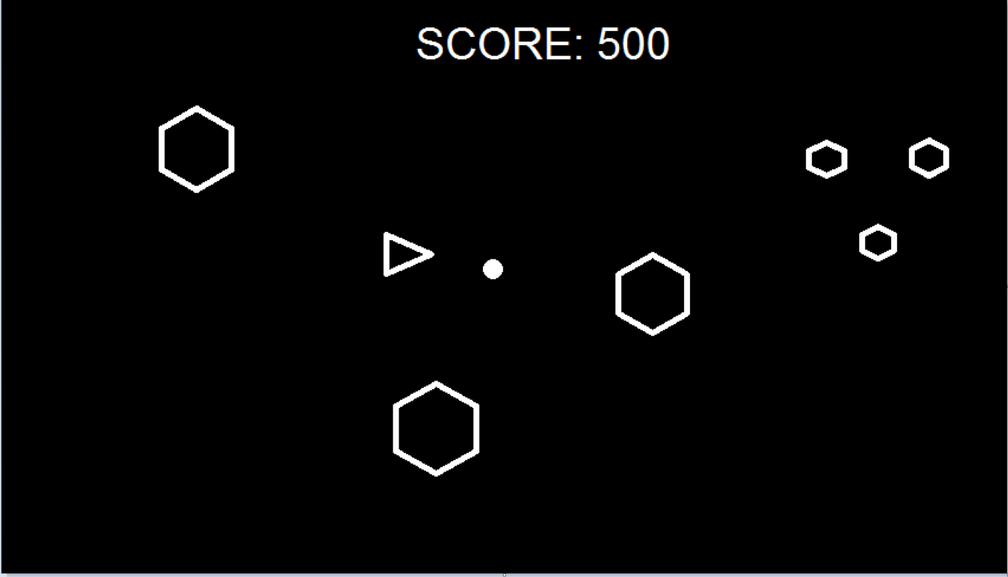

The simulation is to be designed in the same vein of the Atari classic Asteroids. The ship would be controlled by the computer and would be able to shoot the asteroids and move around the space with possibility to add vertical and horizontal screen wrapping. The asteroids themselves would be spawned in off screen and would come in at a random angle and random speed. When shot, they would be split into three. Alien ships which shoot back could also be a later addition if time permits.