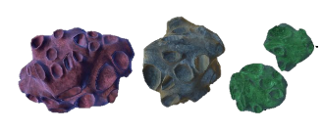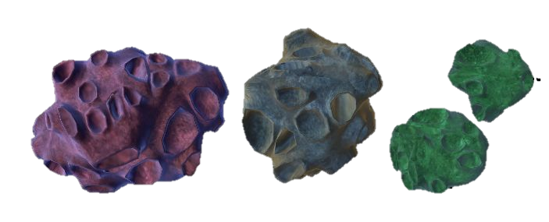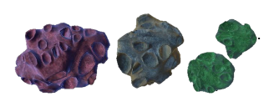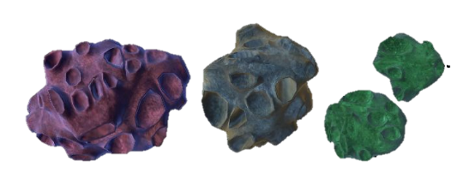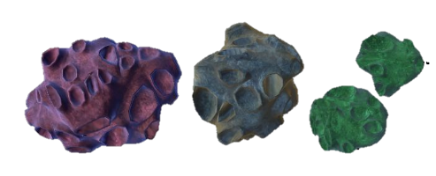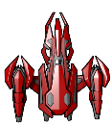**Storyboard**

There are going to be multiple levels

Our simulation is based in mid-air or the space

Power-up: None

Level 2

There are going to be different size and different type of asteroids.

There will be a tracker of how many asteroids have been destroyed.

There will be power ups.

Asteroids Destroyed: 10

Our group has decided that we are going to create a simulation which will be a spaceship destroying asteroids. There are going to be multiple levels I simulation, the higher the level of the simulation, the more asteroids there are going to be which will increase difficulty. There are going to be power ups which will help to destroy the asteroids quicker and there are going to be multiple spaceships for the user to choose. There are going to be different asteroids which differ in shape and size.