Andrew Skeen & Cole Dustin
Professor Alexander Stoychev
CPR E 281: Digital Logic
December 8, 2021

Final Project: Bubble Sort

Overview
For our final Project We tried to make a bubble sorting algorithm. We included all the main parts needed on the final project. We had a register file, a finite state machine and lots of other logic. We started by copying the register file from Lab 12 as we wanted to sort eight three bit numbers and that register stored exactly that many numbers.
We had two parts to our project. The first part was us loading the eight numbers ,using the SB3-SB0 switches on the daughter board, a four bit BUSMUX and a FSM that counted down from 7 to 0. It would display the numbers on the eight corresponding LED displays as soon as the clock is pulsed, whether that be us or the board's automatic clock. The same clock pulse would trigger the finite state machines to count down from 111 or seven, this would change the select line. This action would make sure the new information could be loaded into the next register.
The next part of our project would be the sorting algorithm part. We needed to look at two different registrars at the same time. We accomplished this by having two finite state machines. One would count from seven to zero the other would count from six to zero. After we found the two desired registrars we would put them into a 4 bit adder. We would then subtract the two numbers together. Using the output of the first bit we could determine if the number is a negative or not. In 2’s complement if the number is positive the most significant bit will be 0. But if the number is negative the most significant bit will be 1. So, the adder/subtractor is the piece of logic that compares the values of the 2 registers. Then we would load these sorted values into two auxiliary registers. We then would load them back into the register file in the correct order.
Execution & Problems
In the end we unfortunately didn’t get our project working but we did get it to do some interesting things, we also did a lot of testing to try to isolate the problems we were having. We used many things from previous labs that we knew worked, so that eliminated several parts for us to test. But this gave us points where we knew the project could and would go wrong. We eliminated the problems that came up from logic first. The first problem we had once we had combined everything together is that we couldn’t even input the numbers. We believed this was because there wasn’t a clock pulse on the register file, so the values go into the D input but there is no clock pulse to set the values. This was by far one of the easier things to fix and we just had to add some simple logic for it to run off the computer clock or our manual clock, a push button. We then recompiled and uploaded and it seemed to work fine and took our inputs as soon as we pulsed the manual clock. We also wrestled with the idea of having one or two auxiliary registers.
Then we started working on the timing issues. This seemed to be the thing that ultimately killed our project in our minds. We could not get the circuit to reload the sorted numbers into the register file before the clock ticked over so we would be looking at two completely different numbers. We haved the speed of one clock(335ms) and double the speed of another(1340 ms). We used a clock of 670 ms as our base clock. We used all these different clocks to tick counters and loaders at different times so we could make this project fully automatic when it started to sort. But we unfortunately could not figure out the correct timing.

The Project Top-Level
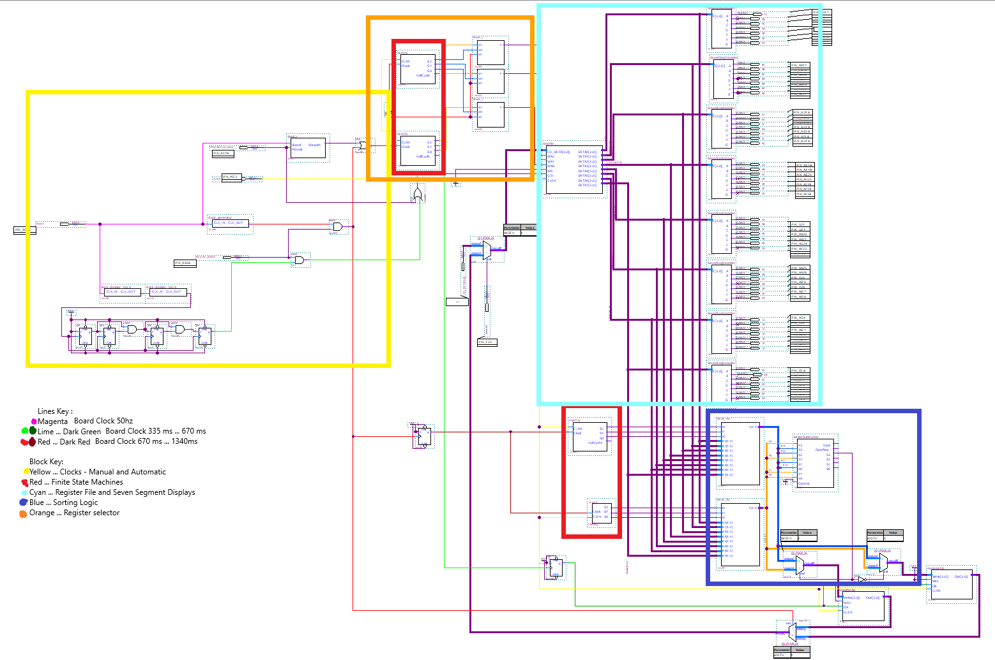
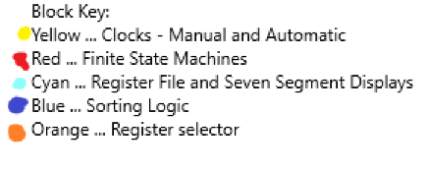
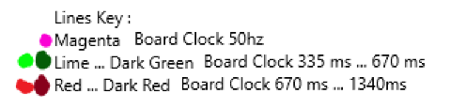

Register File

The register file is arguably the most important part of any project containing digital logic because if it's not there nothing gets saved long term to be recalled later. Our register file is used on every clock cycle of our project and is directly connected to the LEDs. It’s the core of everything that happens.
Our register file contains 8 registers. These registers contain D flip flops, this is the part that has the ability to hold bits.

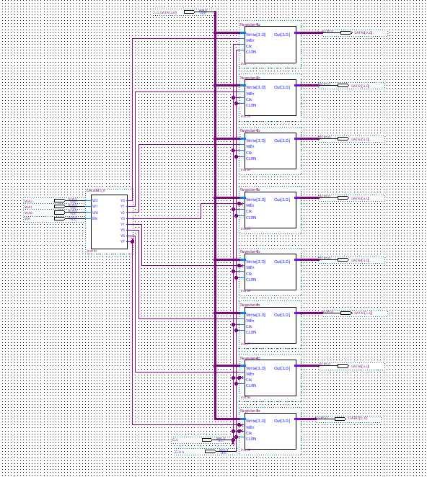

Clock

The clock was by far the most complex part of our project. We spent an overwhelming majority of our time on this one aspect of the project and its the main reason we couldn't get it to work. We had one simple problem that stopped us from finishing the project. We couldn't write to two registers on one clock cycle.
We used the clock on five parts of our project
- Register File
- Auxiliary registers
- Sorting MUXs
- Manual register input
- FMS
Almost all of these needed a different clock speed. The register file needed to write every clock cycle, the auxiliary registers and the sorting MUXs need to be half as fast so they are overwritten before they complete their job. The manual register input needs a pushbutton as a clock.

Finite State Machines

We had two separate finite state machines on our project. They are used to pick which register from the register file was selected by each of the two 8x1 MUXs. We created these by first making a state table that would count through the numbers we wanted to compare. In our case we chose a 7-0 counter and a 6-0 counter. Once we decided on those two state machines we started on the state tables for each. Once you have a state table that will work you create a truth table and start working on the logic expressions that will be the input of the D flip flops. You will also need to find the logic expression for the output(Z). The final step in creating the FSM is actually drawing it out in quartus. This gets messy in a BDF and if there would've been 4 DFF we would have opted to write it in verilog to keep it cleaner.We are doing bubble sort so we want to compare the numbers in adjacent registers. The first two registers we wanted to compare were register seven and register six. The next two were six and five, then five and four, so on and so forth. If the FSMs output 7 6 5 4 3 2 1 0 and 6 5 4 3 2 1 0 0 (having zero twice is important). From this point on the FSM with 7 6 5 4 3 2 1 0 will be called the larger FSM and the other will be called the smaller FSM. This would create an upper boundary at seven and a lower boundary at zero because you never compare zero and seven. It would also keep them in sync because they have the same number of states.

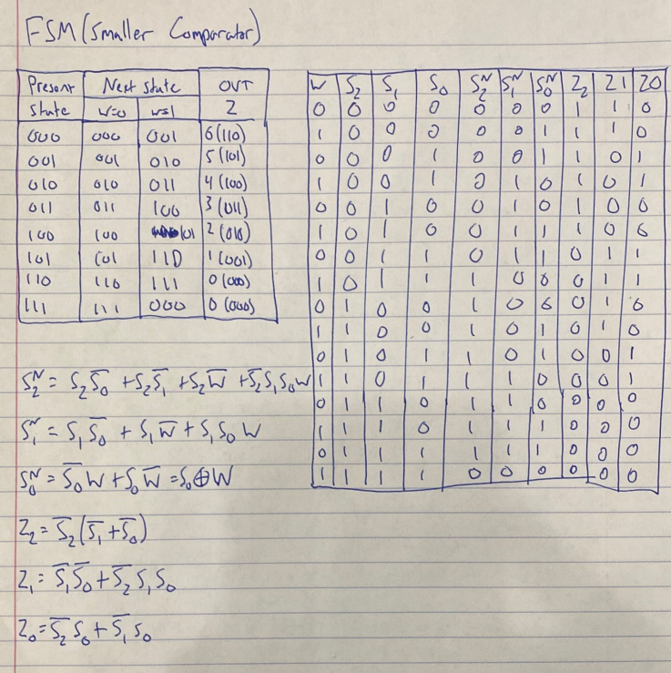
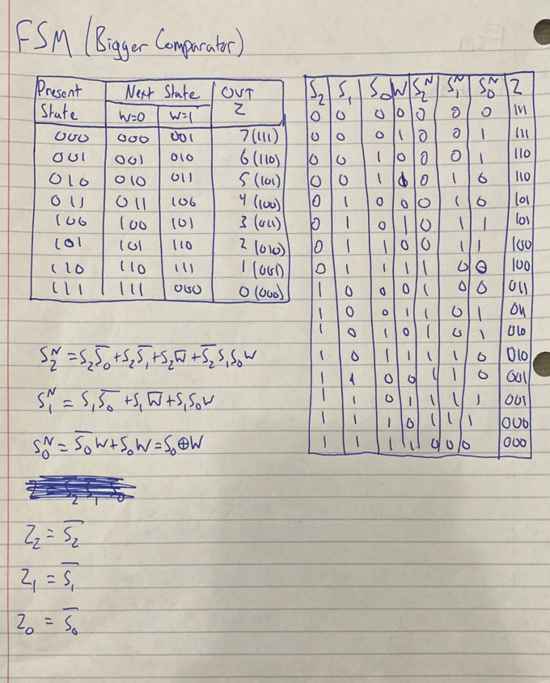

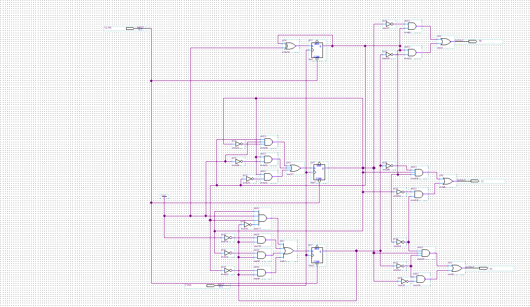
Bdf of 6-0 FSM

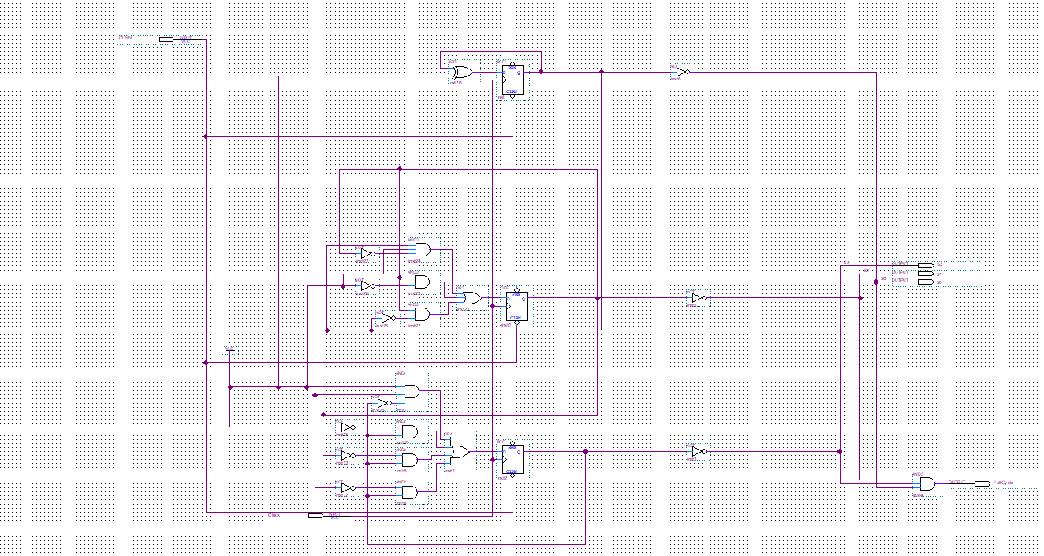
BDF of 7-0 FSM

While testing the FSM to make sure they worked we started to notice some potentially major issues with the FSMs. It looked like they were completely wrong and outputted seemingly random numbers on the hardware. After double and even triple checking the logic and even using an online K-map site we realized that the push button we were using wasn't debounced. Once we added the debouncing logic they worked flawlessly.

The Debouncing Circuit
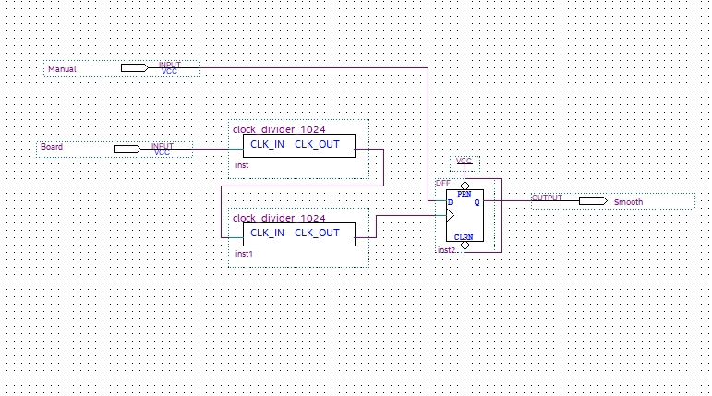
The larger finite state machine is used in one other spot.we later decided to use it as the selecter on the register file while manually inputting the numbers. This was a huge improvement over our previous method of using 3 slide switches that corresponded to each register. Not only did this save us time during our testing it had a cleaner look and feel in our finished project. We later realized that the FSM being used in that place would cause an issue in the rewriting of the register file. We then added a second larger FSM to count on the off-tick so it would write to the correct register. This combined with 2x1 MUXs allowed us to select the register behind the first counter. We thought after this major correction to logic it would go a long way to fixing the issue we were experiencing at the time, but unfortunately it did not.

The Register Selecting Section
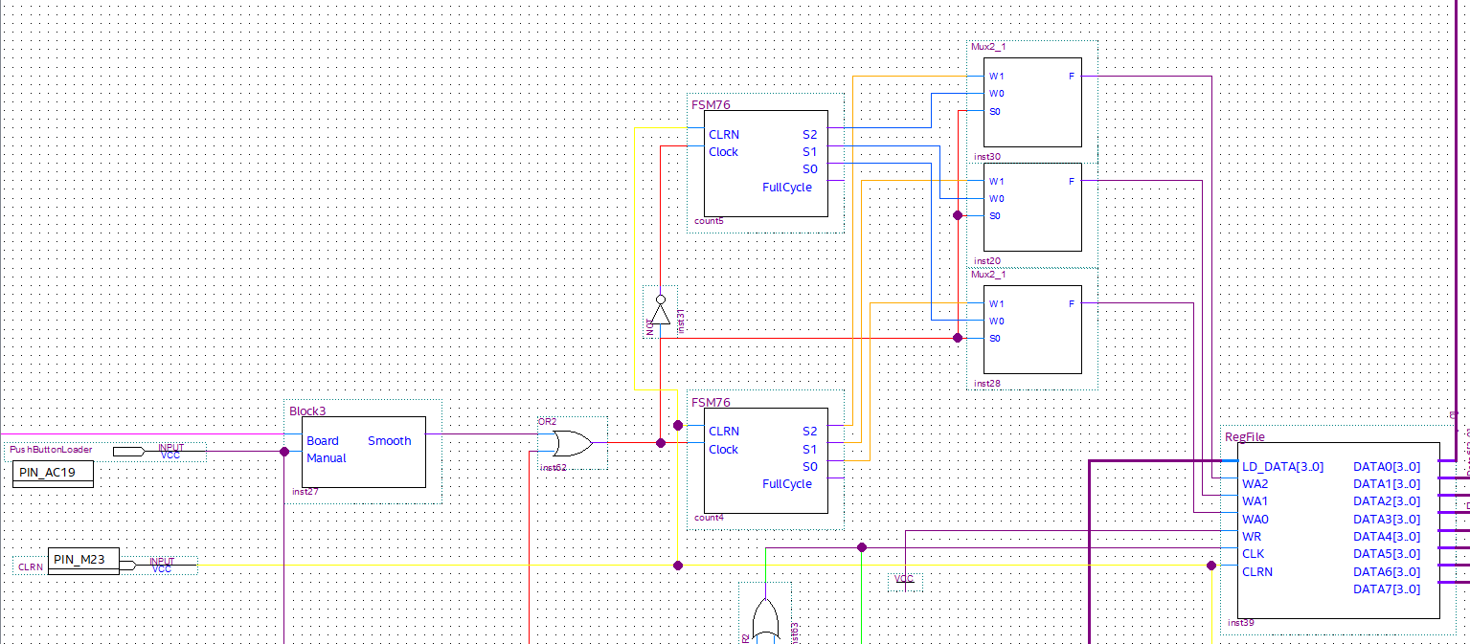

4-bit 8:1 MUX

A critical part of our project is the 8x1 MUX that takes in a 4-bit bus and outputs the correct 4-bit bus lines. This allows us to move whole registers out of the register file without 32 messy lines. It also made it easy to implement the FSM as it takes them as selector lines. It also was surprisingly easy to create. It took only 19 lines of verilog to write. This compiled all the knowledge we gained on verilog throughout the semester. It used case statements, bus inputs, binary number as the selectors and several other basic verilog ideas.
The MUX is important to our project because it directly inputs the numbers into the comparator, in our case the adder/subtractor. The 4-bit 8:1 MUX is like the middle man in our project. It doesn't do any of the comparing or counting, it just takes information from one place and safely moves it to another place. Without this block this project would have been even harder than it already was.
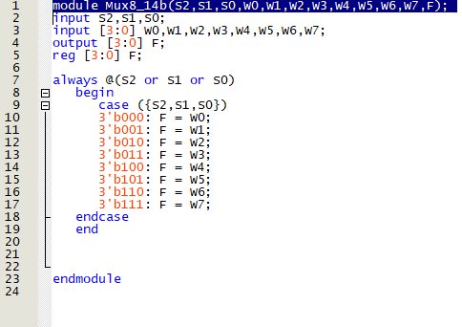
Adder/Subtractor
This block is the brains of the operation. Its logic decides what number gets written in what register. The way it works is by subtracting numbers in 2’s complement. It is important they are in 2’s complement for one reason, the signed bit.This tells us which of the two numbers is bigger. The larger finite state machine corresponds to the ‘X’ input and the smaller finite state machine corresponds to the ‘Y’ input. If X is bigger than Y, the most significant bit is a zero. If the Most significant bit 1 the Y is the larger of the two numbers. If the most significant bit is zero then the two auxiliary registers will be rewritten in the same order as they were. If the most significant bit is one the two auxiliary registers will be rewritten in the opposite order thus swapping the two registers. How they get flipped will be explained later in the next section.
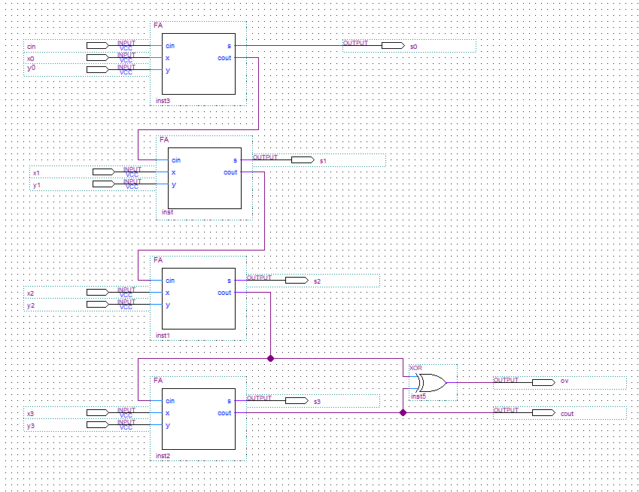
BusMUXs & Auxiliary Registers
This part of the project is where the sorting actually happens. Two 4-bit 2x1 BusMUXs direct the register file traffic to auxiliary registers used as a buffer in between being compared in the adder/subtractor and being rewritten to the main register file again. Both MUXs took the same outputs from the 8x1 MUX that the comparator took. One of the MUXs directly took the signed bit number from the comparator and the second MUX took the negated version of that same number. This made sure they never output the same register into their auxiliary registers.

A final BusMUX is used to take the outputs from the auxiliary registers as inputs and uses the board clock at 670 ms as the selector input. This way it selects one register on the up tick to be rewritten and one on the down tick to be rewritten. Using it in this way we can use the clock that is ticking at 335 ms as the rewrite clock for the register file.

There are many ways we could have tried to implement this rewriting logic. This is also where we think the project had the majority of timing issues. If we were able to start again we would have taken a different approach. We think it would be better to write both registers, coming out of the comparator, on the same clock cycle. One way this could be implemented is by tweaking the register file and allowing it to take two writes on the same clock cycle. With this change implemented we believe that the time issues would be eliminated and it would be just our logic holding us back from completing this circuit. 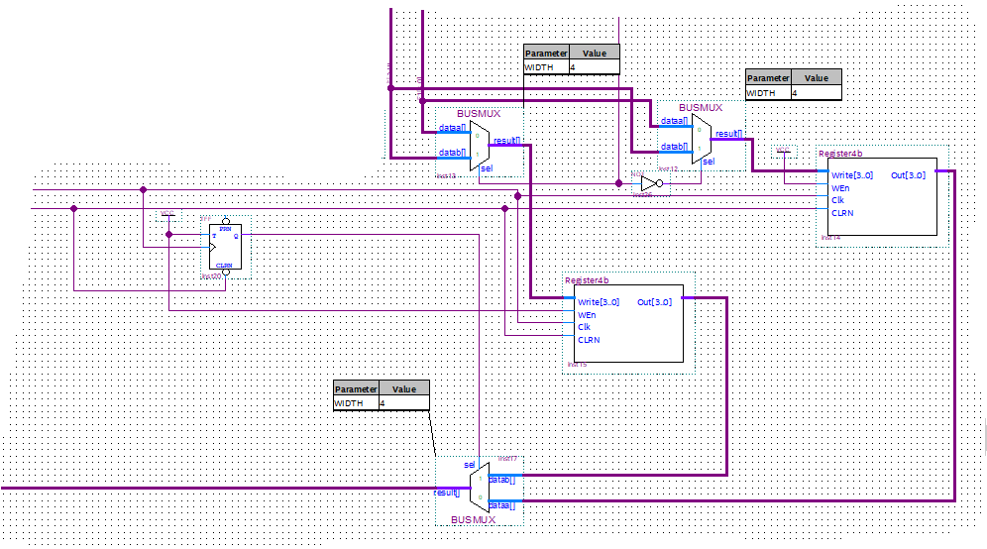

Changes

The Register file is adapted from lab 12 we used the design but took out the back end logic which subtracted the two registers. But we kept the logic that allowed us to rewrite over the registers.
With more consideration we could have modified the file more so that it could have written to two registers at once. This we could have done by putting a second 3 to 8 decoder with three new selectors that could have or’ed into the write enable input of the register block.
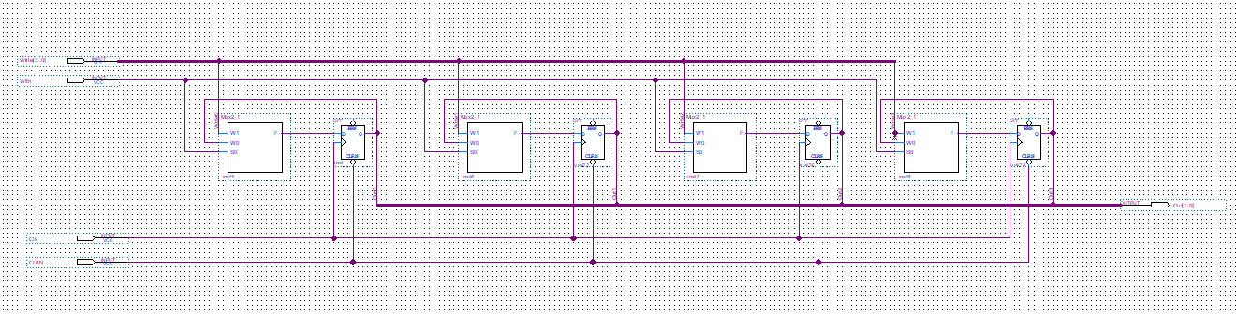
4-bit Register Block

This block was taken from the lab 12 section where it had us make a 4-bit register block that could be cleared and written to.

The Register File Circuit
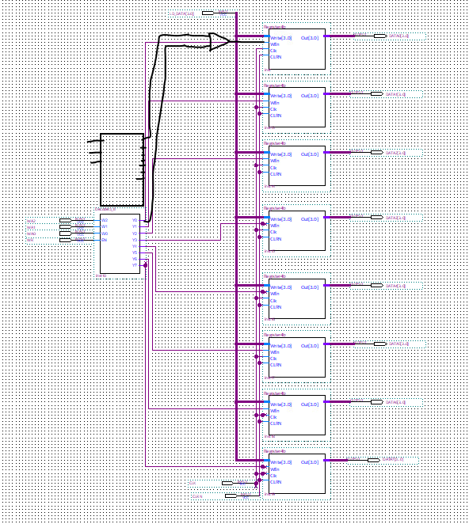
With the addition of a second 3 to 8 decoder and or gates connected to the WEn input on each of the registers. Plus adding in two 8x1 MUXs we could have written to two registers at the same time. Which also would have helped to solve our timing issues.

