- Problem statement:
  - The real world application of a maze solving robot has three primary use cases; Cave mapping/Spelunking, Police/Military sweeping a house and search and rescue(SAR). The secondary applications could be solving corn mazes or other man-made mazes for fun.
  - If you are familiar with spelunking, sweeping houses, or search and rescue; you know the risks associated with your field of work. Wouldn’t it be desirable to take the risk out of your job while being able to accomplish all of the same objectives effectively and efficiently? With a robot that has sensors specifically suited to complete these tasks you can feel safe and secure knowing that the job is going to be done without risking human life.

  - POV Statements:
    - “We would rather send a robot into a hostile building than a real person”
    - “We don’t want to risk people getting lost in a cave”
    - “Finding a person in rubble or a mountain range is very difficult, but could be done by a robot much faster than a human”
    - “I am stuck in this corn maze”
  - Empath Map

Do:  - Belong to a large organization  - Want to solve a problem without using humans  - provide life saving services  - Have safety in mind | Think:  - "I wish we didn't have to risk lives for this"  - "This is a very complicated-think heavy task"  - "We don't want to put our people's lives in danger"  - "We would try anything to increase our effectiveness"
Say:  - "Am I going the right way?"  - "Have we been here before"  - "We should find a safer way to do this"  - "How can we find people faster" | Feel:  - Losing time is very bad  - disheartened if they fail the task  - Thinking they could have done better if failed  - Pressure and stress  - Bullets/ Shrapnel

- Application Narrative/Story

In recent years, many types of robots have been used for human assistance, amusement, and welfare. Robots can measure and detect variables beyond human perception. Robots have been used to defuse bombs, fly to far away planets, and explore the bottom of the sea. The use of robots for otherwise dangerous activities makes them non-dangerous. Our goal is to take the human risk out of certain jobs by providing a safe, and automated solution. We believe that by doing so, we can help businesses, government organizations, and normal consumers do things more safely, efficiently, and effectively.
Instead of cave mappers risking getting lost or stuck, a robot could do all of the mapping without the risk. Safely clearing out a cave through each and every tunnel, without risking human lives. Avoiding obstacles and dangerous areas, so people do not go into caves without some knowledge about what's going to lie ahead. This is just one application of how a robot can help humans yet again. Another application is search and rescue operations. Traversing through buildings and other structures to search for people can be difficult. With the use of robots, you can do many things that can be nearly impossible with people. The search party can be increased by adding more robots. The traversal of tough terrain can be done by robot, as well as automatically searching while humans can do other important things in the background.
The vision of the approach our team is going to take to solve these problems, is to first build a prototype. Starting small and being able to traverse a maze filled with obstacles, will be a big step forward in building a robot that can fulfill the applications mentioned above. A small scale testing setting will allow for the major detection and movement capabilities to be made quickly, while keeping the large scale applications in mind. By following this vision it will keep us moving forward towards our goal of taking human risk out of certain jobs by providing a safe, and automated solution.

- Prototype Sketches -

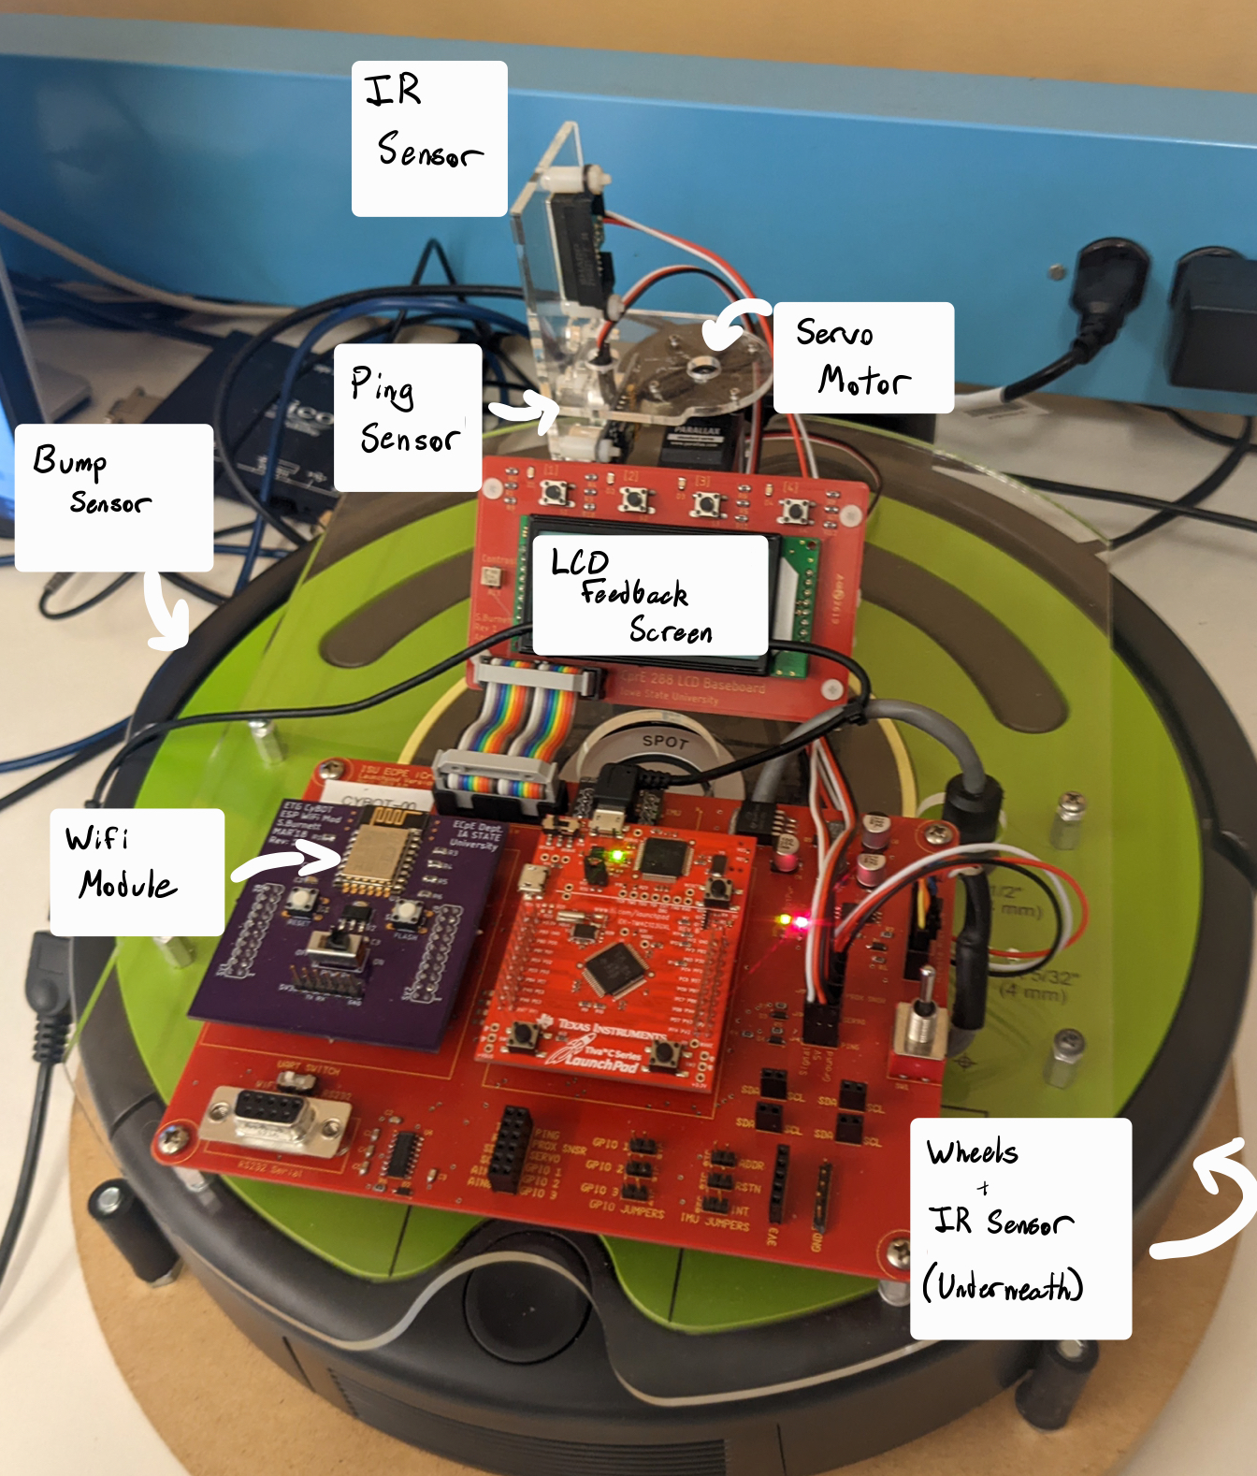

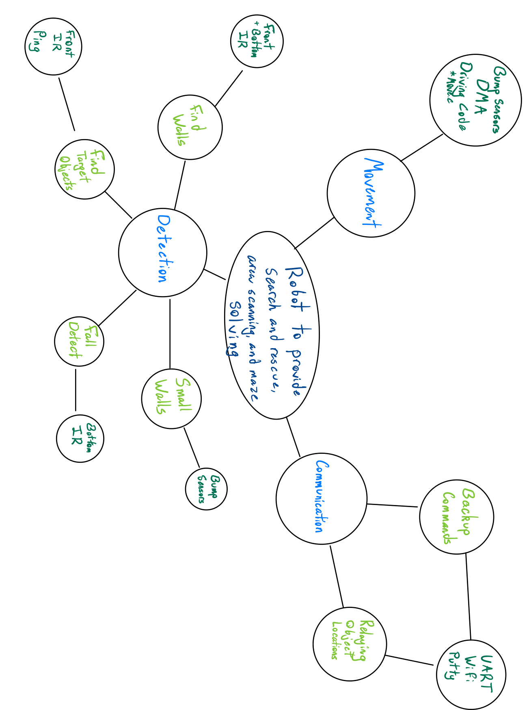

Prototype Machinery

1 - IR Sensor - Detects the distance from objects in front of it, and is used to find the target objects around the building/maze.

2 - PING Sensor - Used for more general observation of walls.

3 - Servo Motor - Spins the PING and IR sensors to scan a 180* area in front of the bot.

4 - LCD Board - Displays key information used for both testing and real-time information. Can display current location, object count, and other information.

5 - Cliff Sensor - Prevents the robot from falling into a hole in the ground that the bump sensor won’t feel.

6 - Bump Sensor - Prevents the robot from running into short walls and small objects that the PING and IR sensor can’t detect.

7 - Wheels - 2 powered wheels used to move and spin the robot.

8 - Wifi - Used to communicate with the bot in order to return object locations, find the current robot location, and manually control the robot if desired.

- Test Field Sketch
Detailed drawing of what situation it might be used in, and describing the order of events it would go through if/when the task is triggered (a person/object is found, and/or it leaves the maze/house).

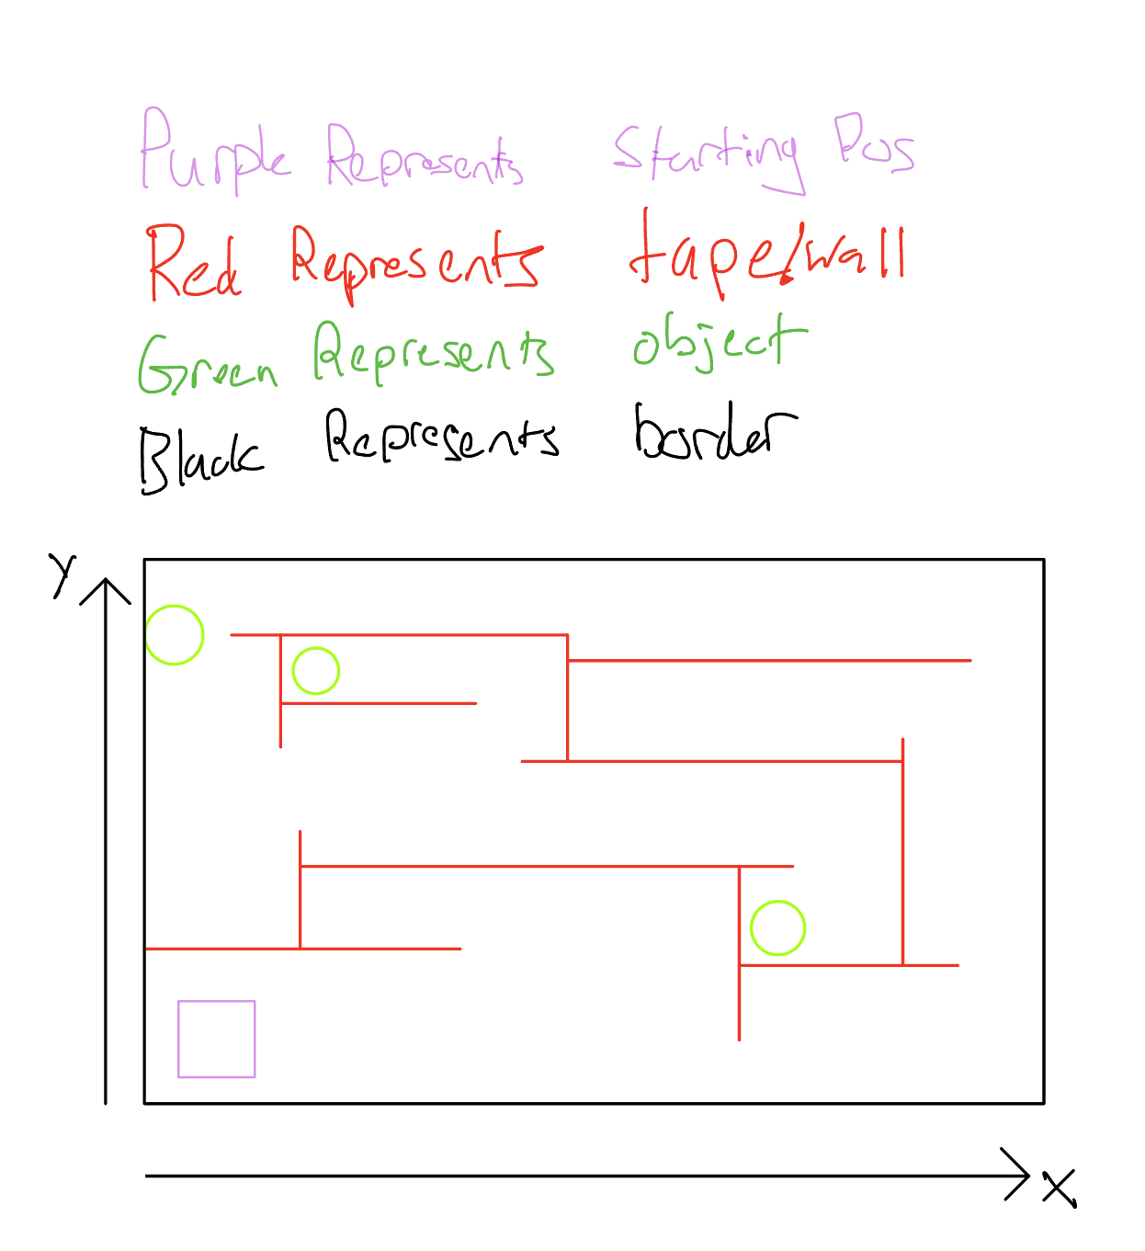

The robot will start at a predetermined starting point and will navigate around the maze attempting to find objects, once it finds these objects it will return their location as an (x, y) coordinate in centimeters. It will also return an ordered list of the turns the robot made and where those were located i.e. {(100, “left”) , (50, “Right”), (300, “Right”), Ect..}. The robot will know where the boundaries are due to the sonar/IR sensor telling it the distance to the boundaries.

Citations:

Bryant, C. W. (2008, February 4). How search and rescue works. HowStuffWorks. Retrieved November 2, 2022, from https://adventure.howstuffworks.com/search-and-rescue.htm

Los Angeles Times. (2004, May 28). SWAT team robot is ready to roll. Los Angeles Times. Retrieved November 2, 2022, from https://www.latimes.com/archives/la-xpm-2004-may-28-me-onthelaw28-story.html

