Iowa State University
Electrical And Computer Engineering

EE 230
DESIGN PROJECT REPORT
OPTICAL SIGNALING DEVICE

April 10, 2023

Cayden Kelley
Cole Dustin

Introduction
The project we chose to take on was the optical signaling device. This project required two completely separate circuits, one to send and one to receive the signal. The circuit that sends the signal needs to be able to output two different signals to the infrared LED. The second circuit, which receives the signal, must use filters to differentiate the signals the photodiode receives. After filtering, there must be enough amplification to cause one of the two LEDs to light. There should be two different colored LEDs to signify which of the two signals is being received from the transmitter circuit, and neither of the LEDs should light when the transmitter is not sending a signal. The transmitter and receiver circuits should work at distances of up to two feet apart. These circuits can use up to three DC power supplies.

Design Process - Transmitter
We started off designing the transmitter portion of the project. We decided to design two oscillator circuits using the Wein-bridge oscillator we had gone over in class. We chose to have one oscillate at 1 kHz, and the other oscillate at 10 kHz.

The following are the basic equations for the Wein-bridge oscillator from class:
$w_{osc}=1/RC$ $\frac{R_{2}}{R_{1}}=2$

1 kHz oscillator:
$6283.19=\frac{1}{R(.47*{10}^{-6})}$ $\frac{220}{R_{1}}=2$
$R=338.6Ω$ $R_{1}=110Ω$
Chosen values for 1 kHz oscillator:
$C=.47μF, R=330Ω, R_{1}=100Ω, R_{2}=220Ω$

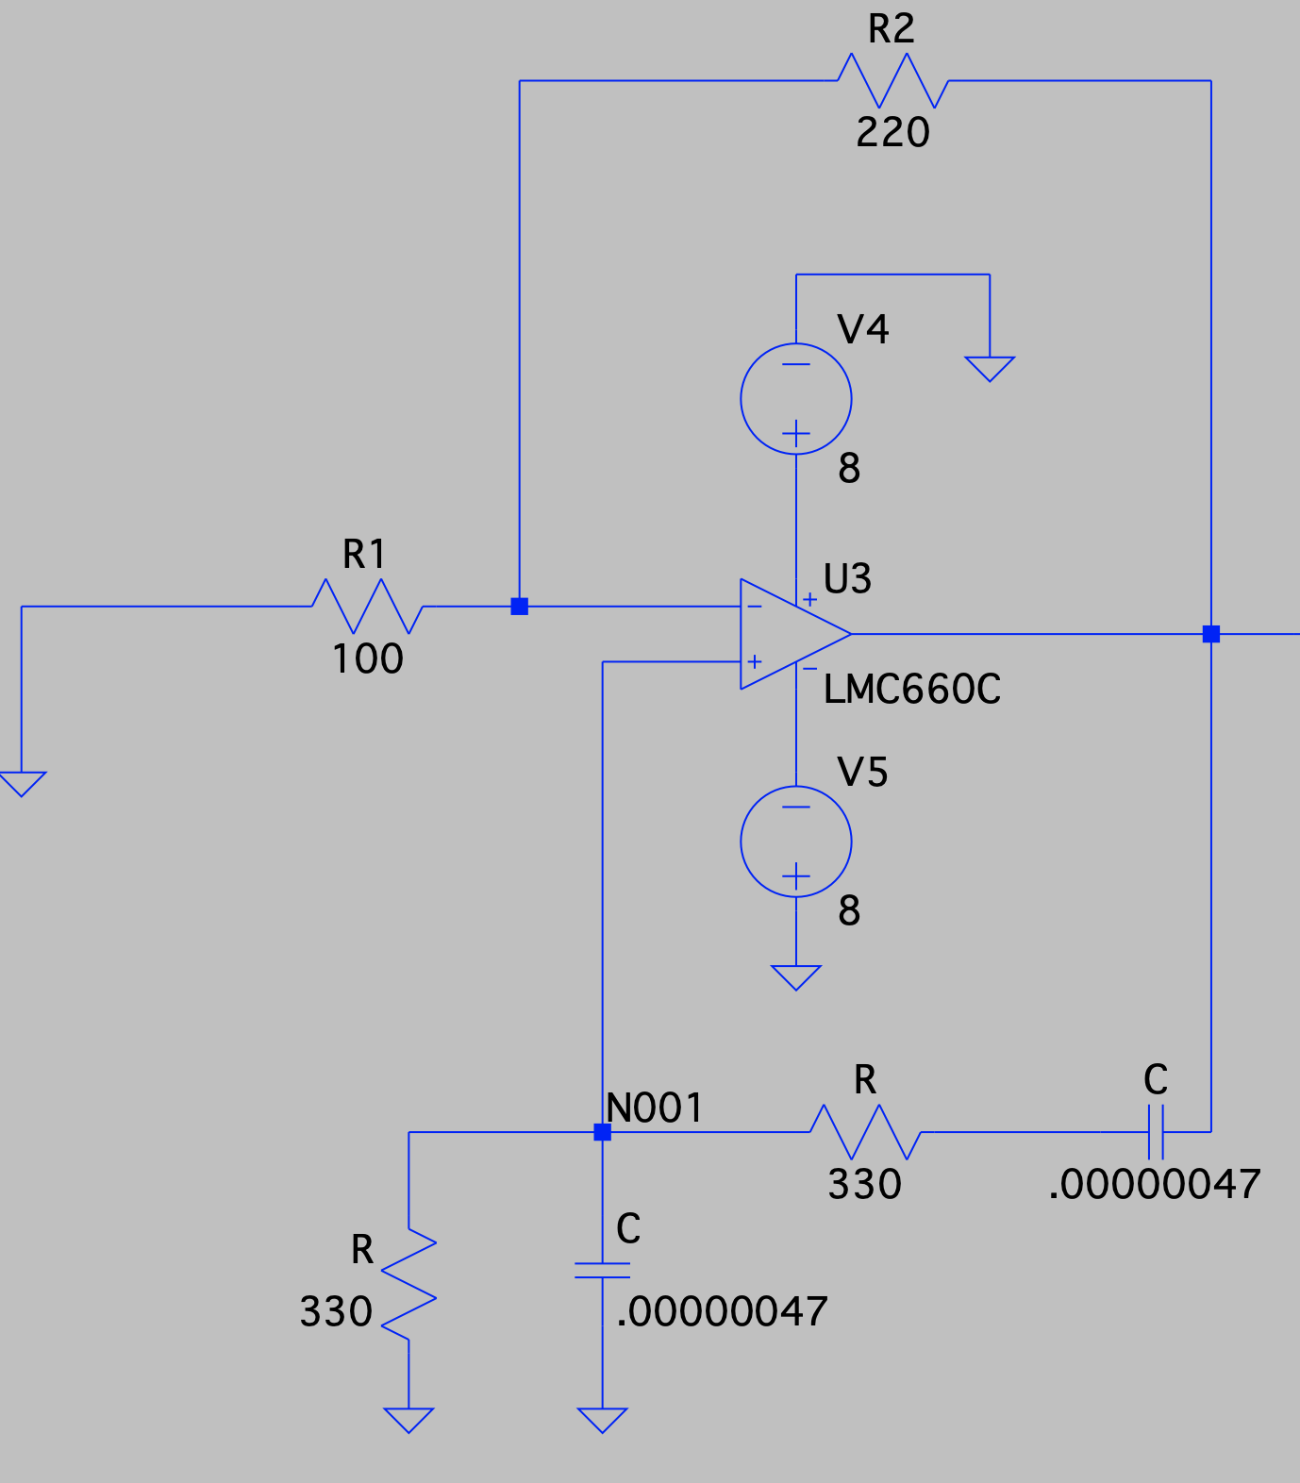
Figure 1: 1 kHz Wein-Bridge oscillator for the transmitter circuit.

10 kHz oscillator:
$62831.9=\frac{1}{R(.047*{10}^{-6})}$ $\frac{220}{R_{1}}=2$
$R=338.6Ω$ $R_{1}=110$
Chosen values for 10 kHz oscillator:
$C=.047μF, R=330Ω, R_{1}=100Ω, R_{2}=220Ω$
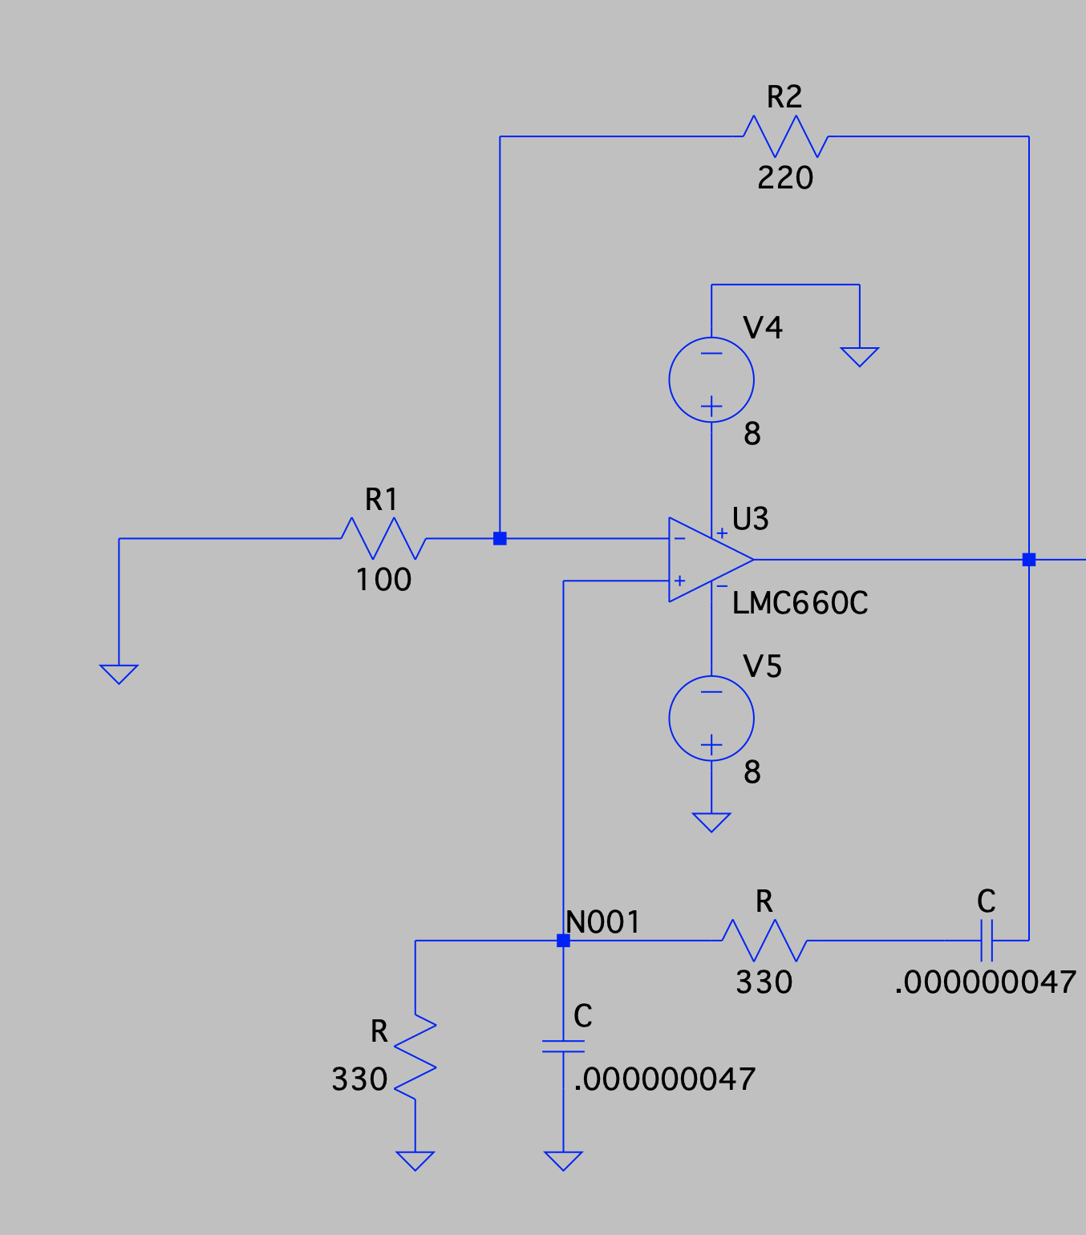
Figure 2: 10 kHz Wein-Bridge oscillator for the transmitter circuit.

The next step on the transmitter side was to add some DC offset to the sine wave so that the wave was always a positive voltage. This was completed using a summing amplifier with the output directly powering the infrared LED. The outputs of each wein-bridge oscillator were connected to the summing amplifier through a push button
Note: In the actual circuit, each op-amp was powered using plus and minus eight-volt supplies that were simply jumpered from one to the other. The DC power supply for the summing amplifier was taken from the negative terminal of the op-amp. The gain of the summing amplifier was tuned through experimentation to insure there wasn’t any clipping of the output.

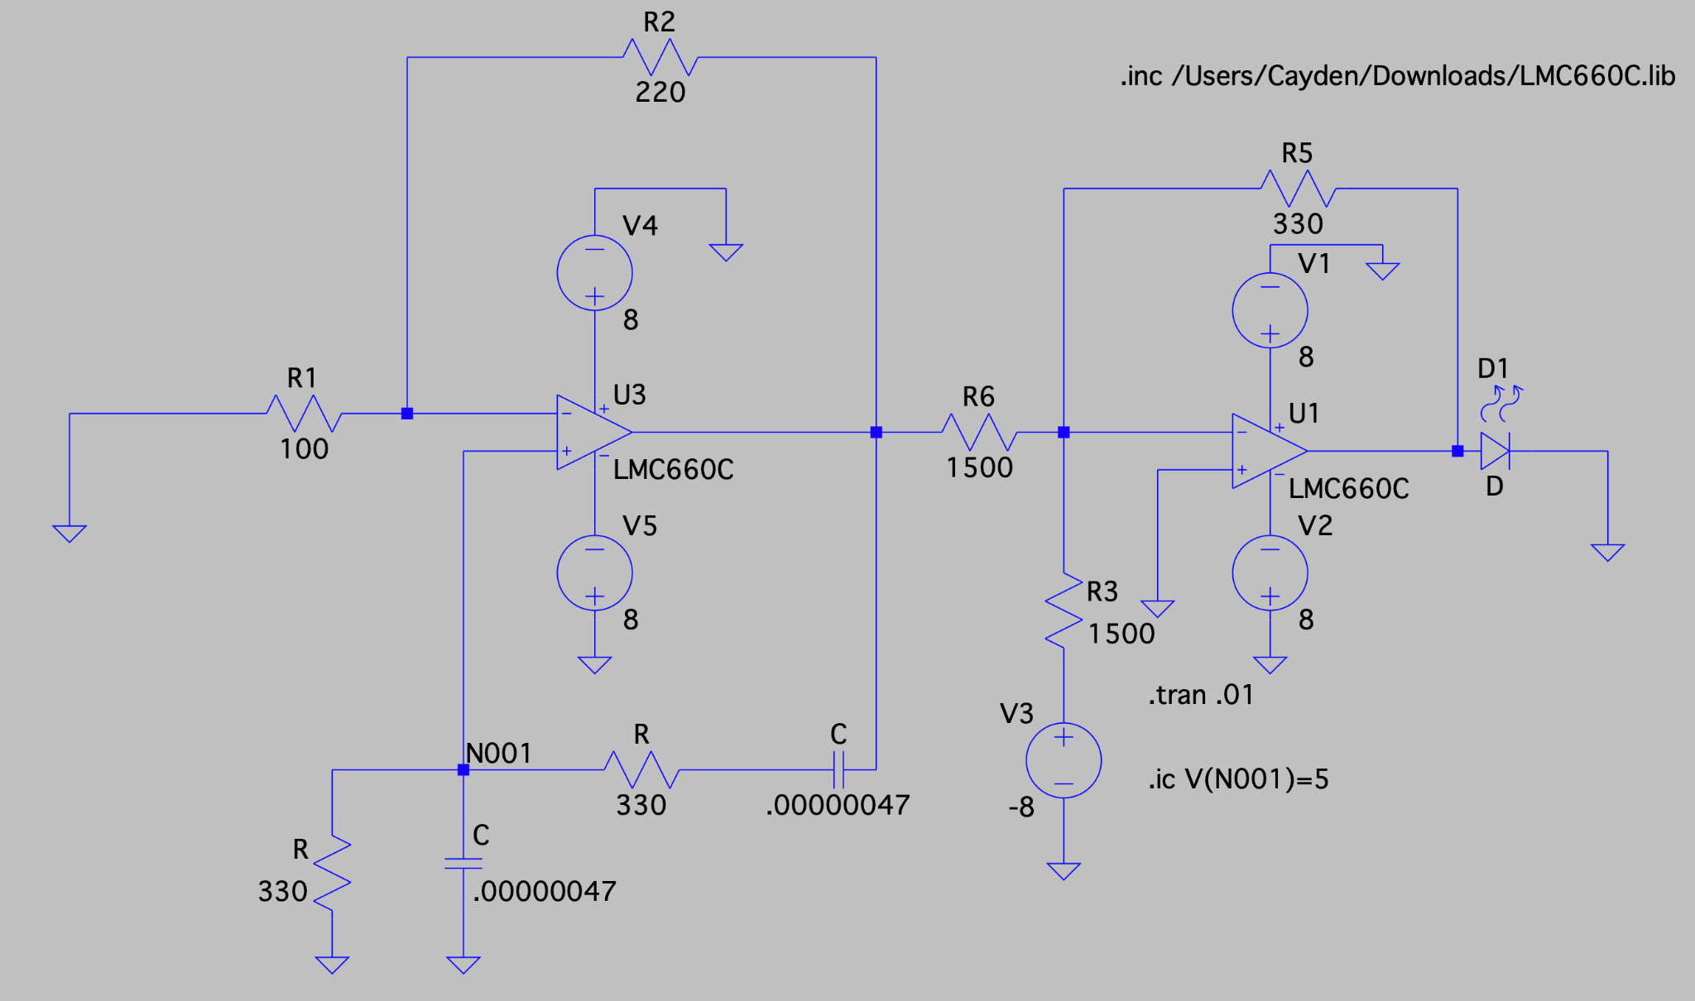
Figure 3: 1 kHz Wein-Bridge oscillator and summing amplifier for the transmitter circuit.

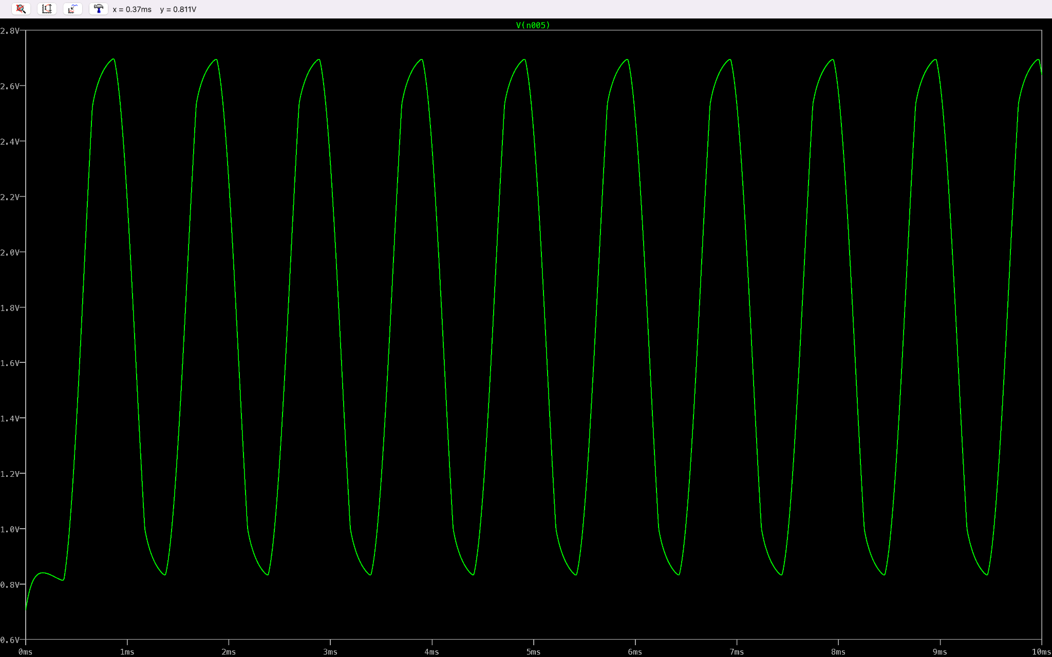
Figure 4: 1 kHz Wein-Bridge oscillator and summing amplifier output for the transmitter circuit. The gain of the summing amplifier had been tuned to output an unclipped wave that never went below 0.7V.

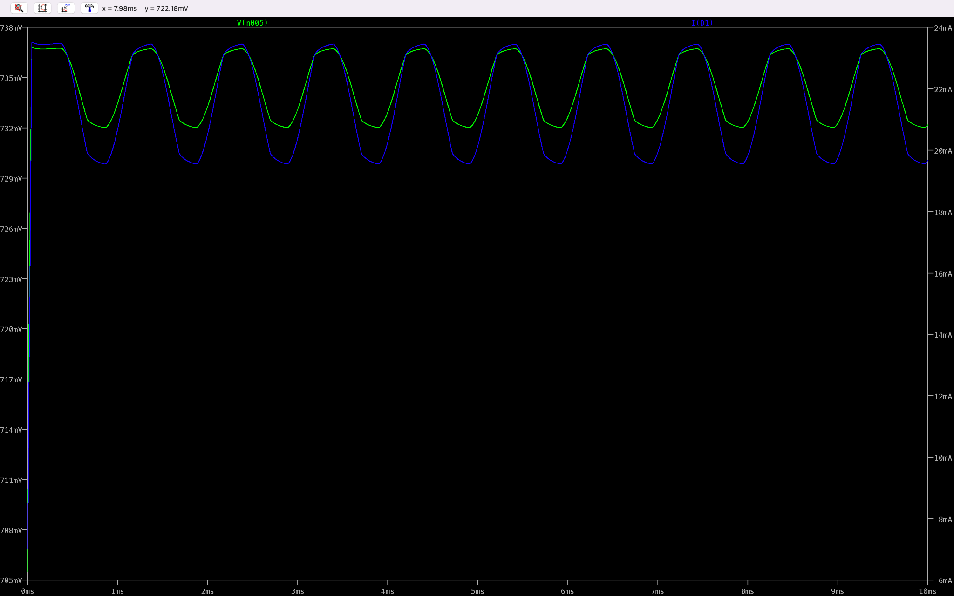
Figure 5: 1 kHz Wein-Bridge oscillator and summing amplifier output for the transmitter circuit with LED attached.
The voltage is pictured in green, and the current flowing through the diode is in blue. The current through the diode ranged from 19 to 23 mA

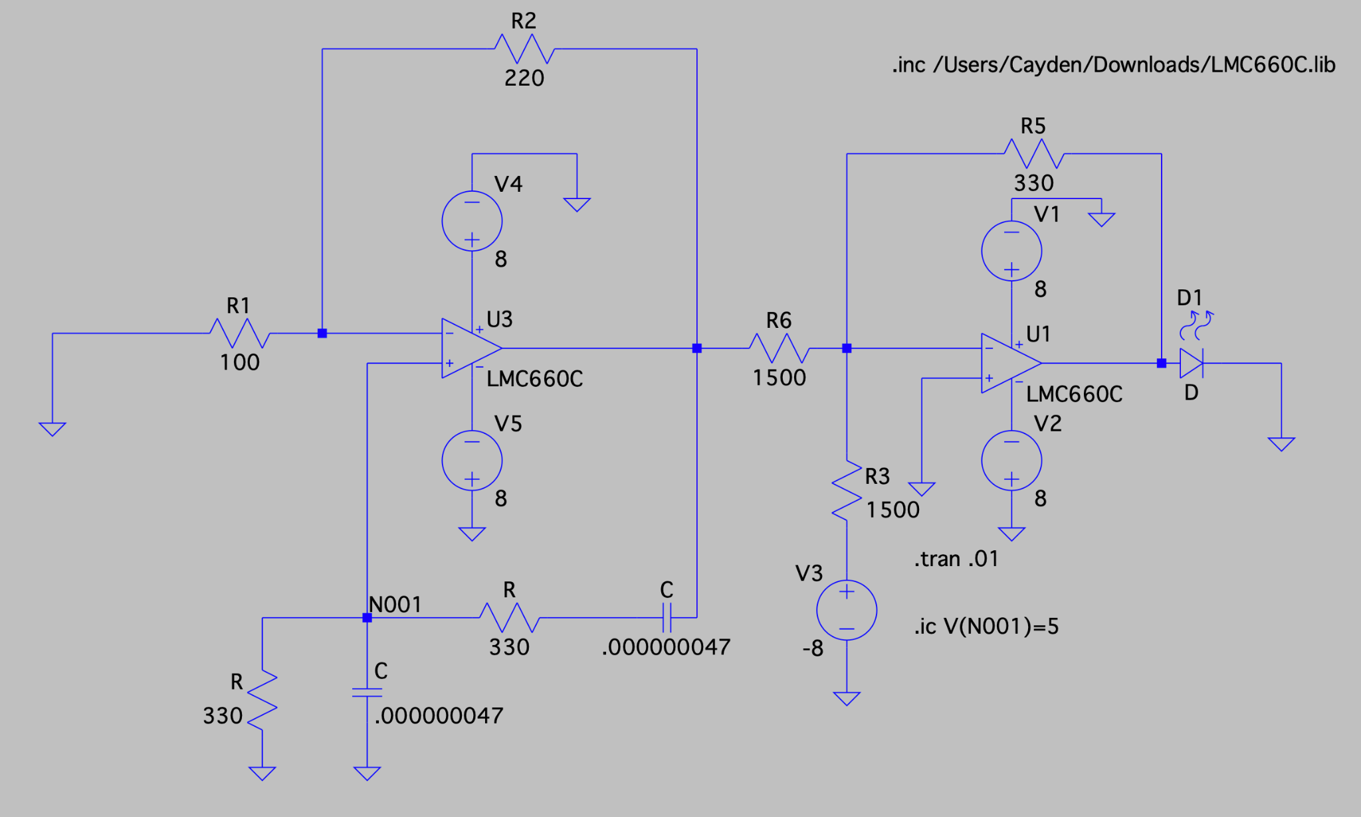
Figure 6: 10 kHz Wein-Bridge oscillator and summing amplifier for the transmitter circuit.

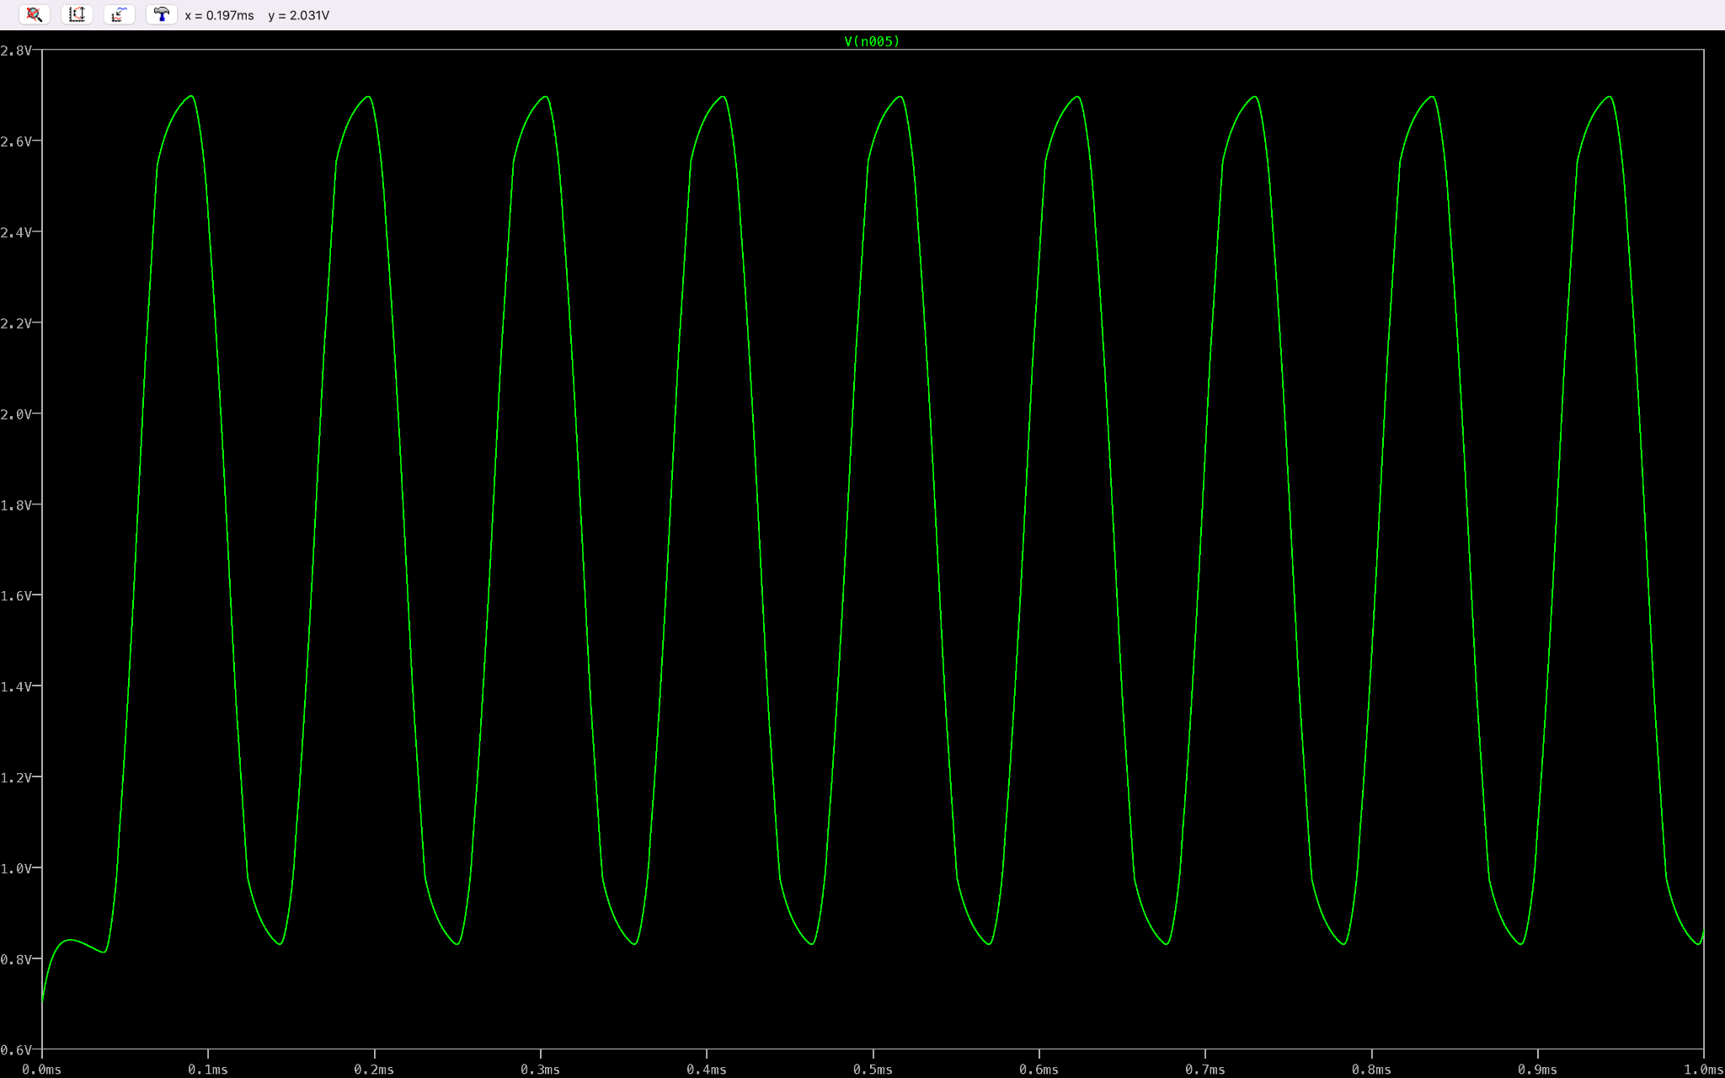
Figure 7: 10 kHz Wein-Bridge oscillator and summing amplifier output for the transmitter circuit. The gain of the summing amplifier had been tuned to output an unclipped wave that never went below 0.7V.

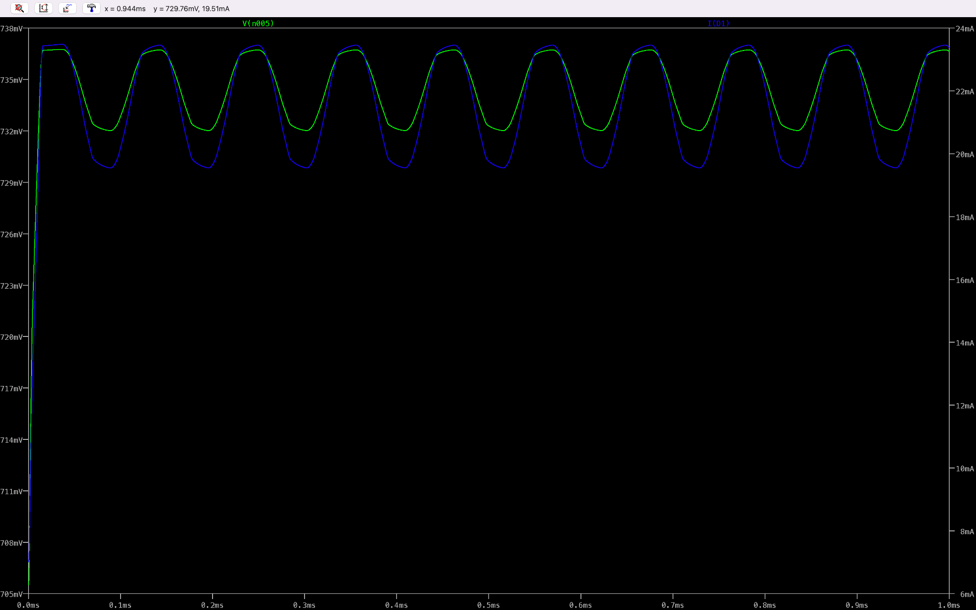
Figure 8: 10 kHz Wein-Bridge oscillator and summing amplifier output for the transmitter circuit with LED attached. The voltage is pictured in green, and the current flowing through the diode is in blue. The current through the diode ranged from 19 to 23 mA
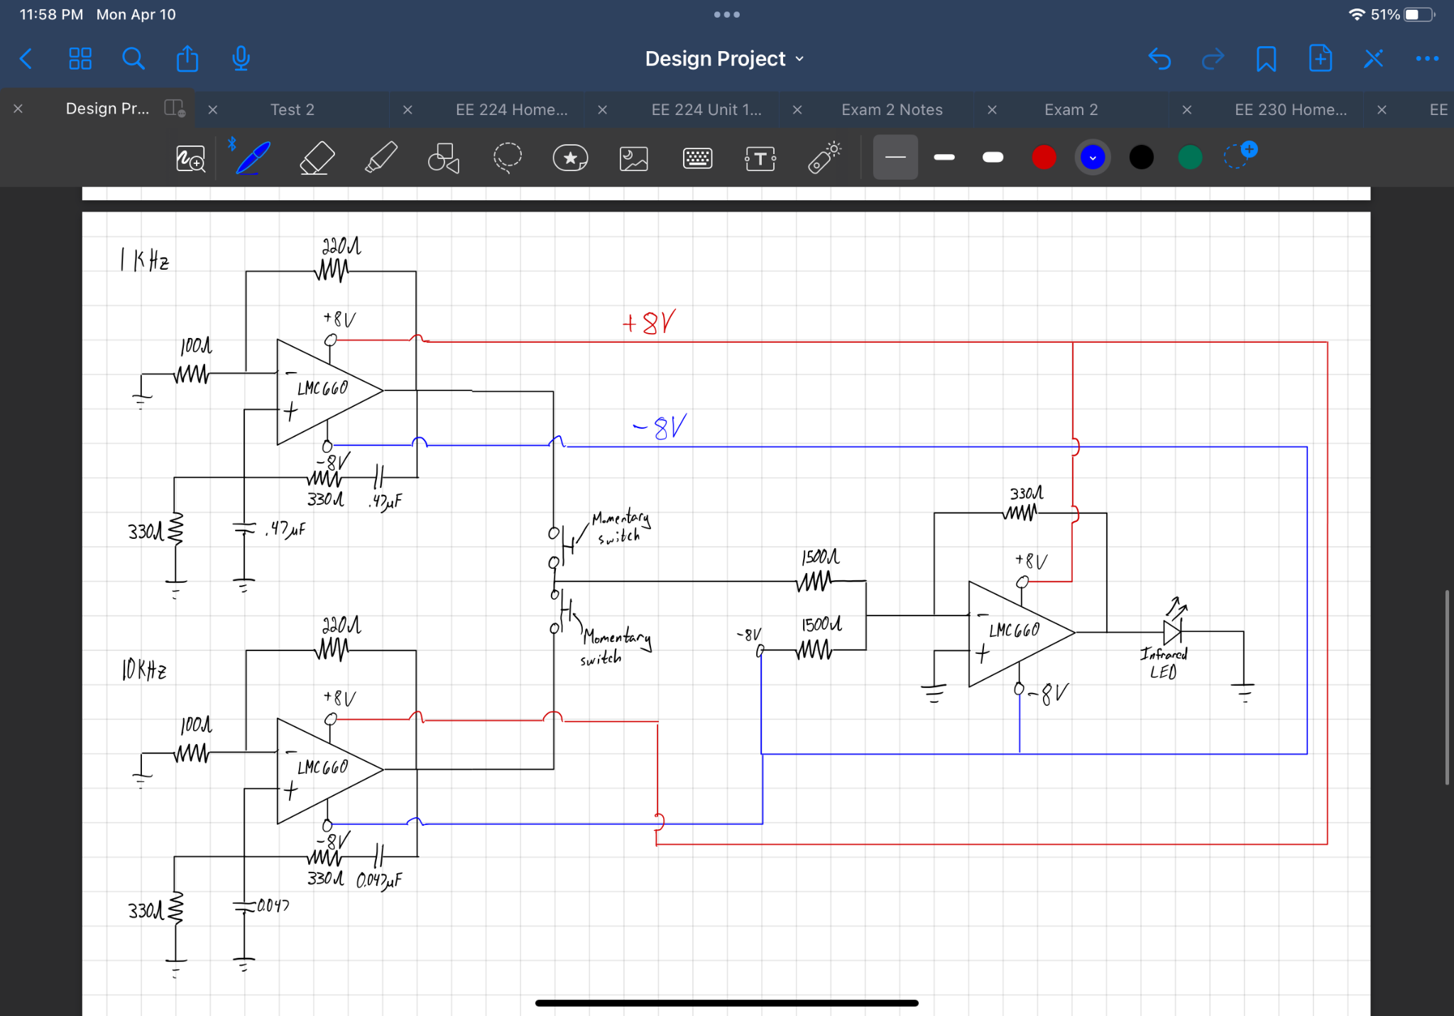
Figure 9: Schematic of the entire transmitter circuit, including how the rail voltages are distributed and the placement of the momentary switches.

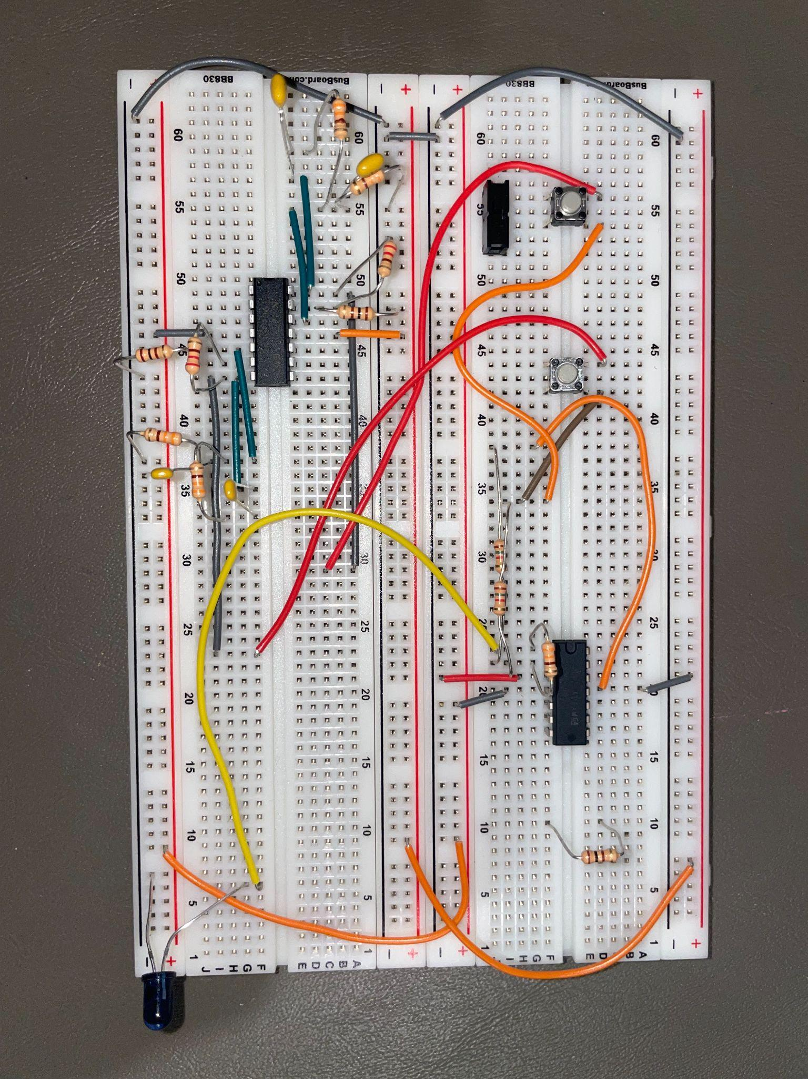
Figure 9: Actual image of transmitter circuit.

Design Process - Receiver
The second portion of the project was the receiver. This part would take the oscillating signal transmitted from the IR led and determine the signal's frequency. It did this using one band-pass filter and one second-order high-pass filter. The band-pass filter was able to filter high frequencies along with the DC offset. The component that was able to receive the signal was an SFH235FA photodiode.

Band-pass Filter:
$f{(low)}_{}=\frac{1}{2πRC} = \frac{1}{2π(3520)(.047E-6)} = 950Hz$
$f(high)=\frac{1}{2πRC} = \frac{1}{2π(15000)(.01E-6)} = 1050Hz$

High-pass filter:
$f=\frac{1}{2π\sqrt{(RC)(RC)}} = \frac{1}{2π\sqrt{(1000)(1500)(.01E-6)(.01E-6)}} = 12994 Hz$

This value is higher than expected because we found it prevent turning the LED on when the 1kHz button was pressed.

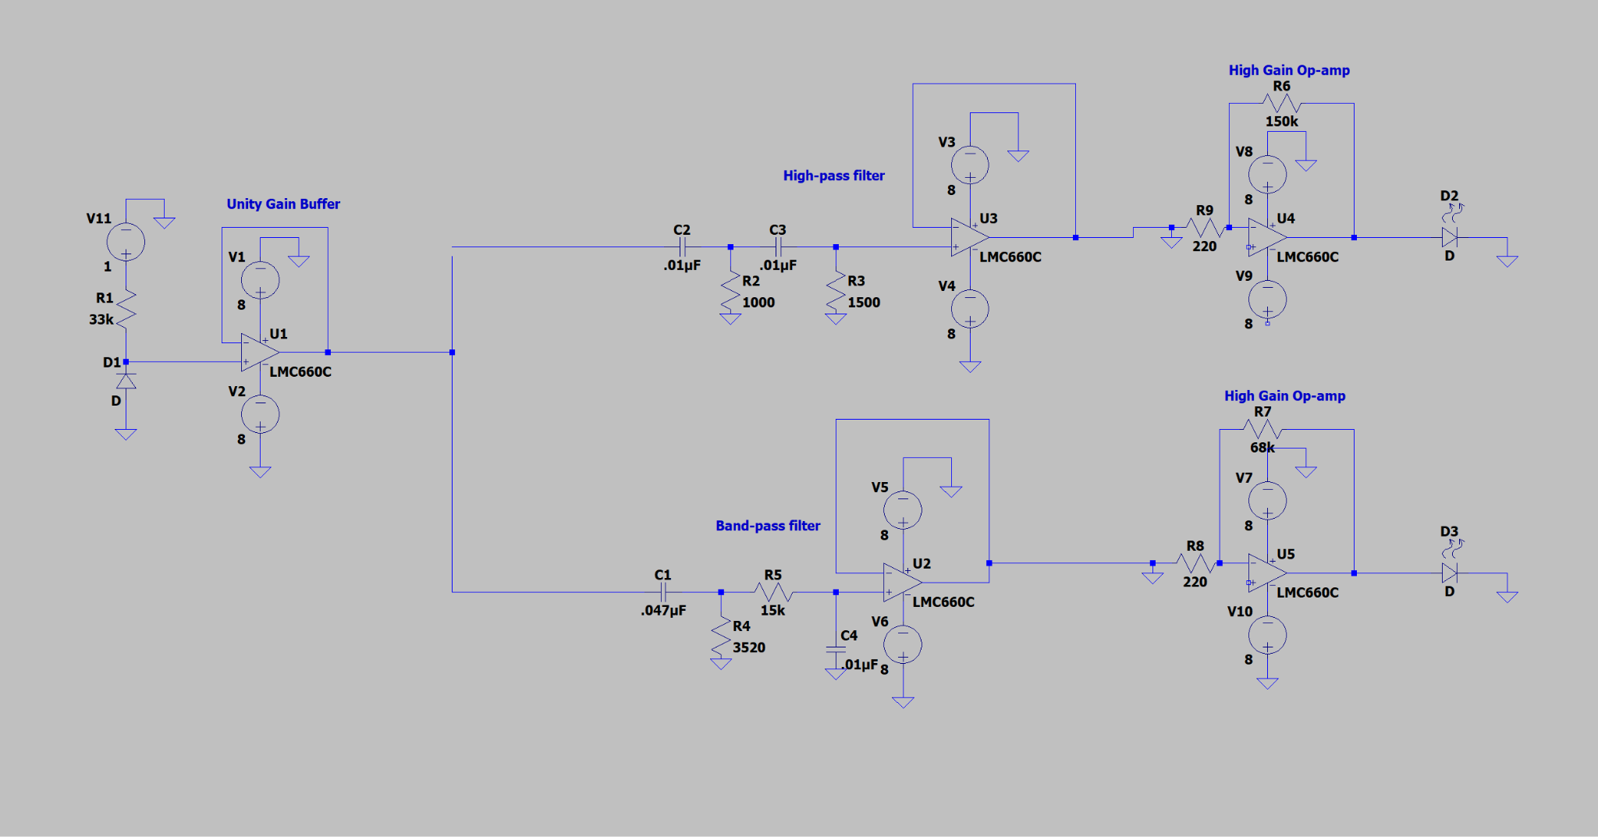
Figure 9: Receiver Circuit

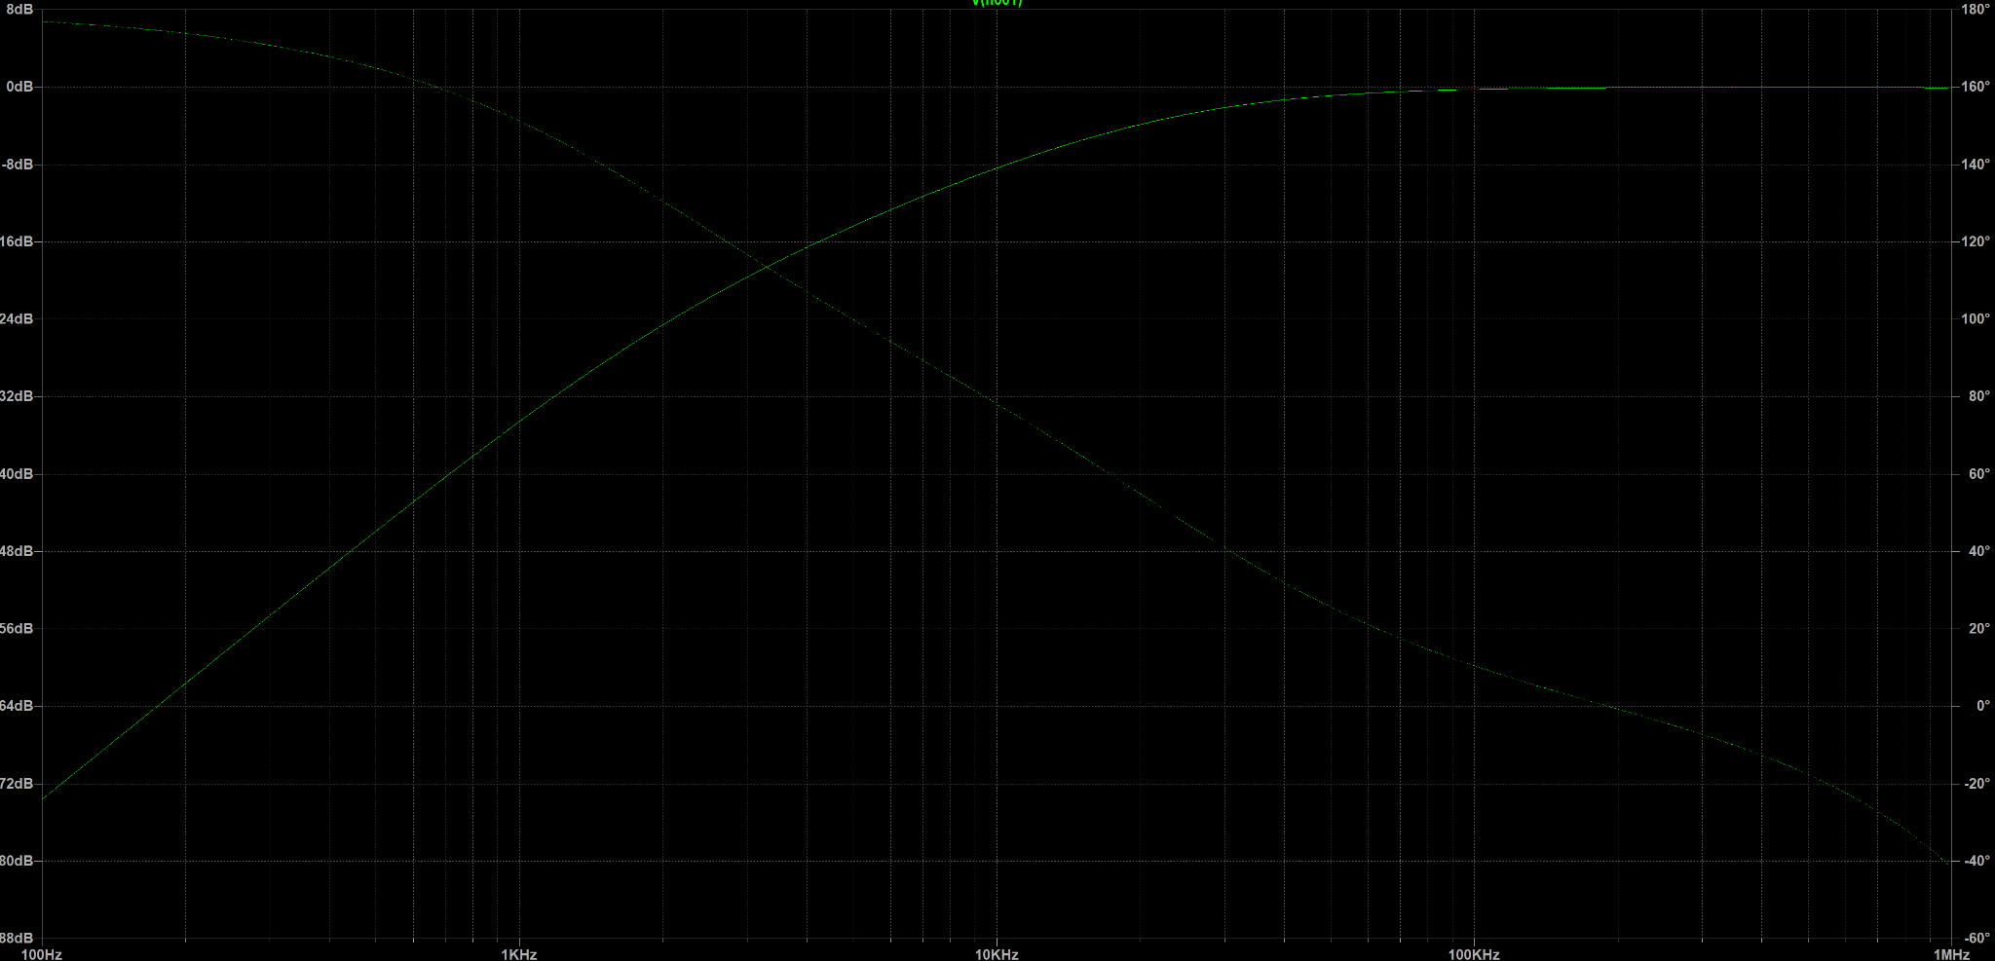
Figure 10: High-pass filter magnitude and phase. The cutoff frequency is higher than we expected it to be. After some tests we found that this made our circuit significantly less lightly to have a false LED flash.
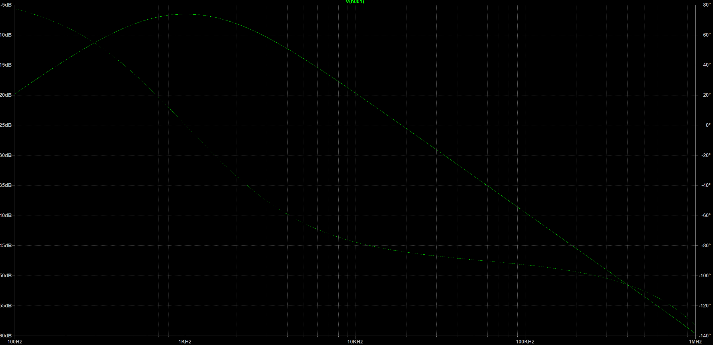
Figure 11: Band-pass filter magnitude and phase.

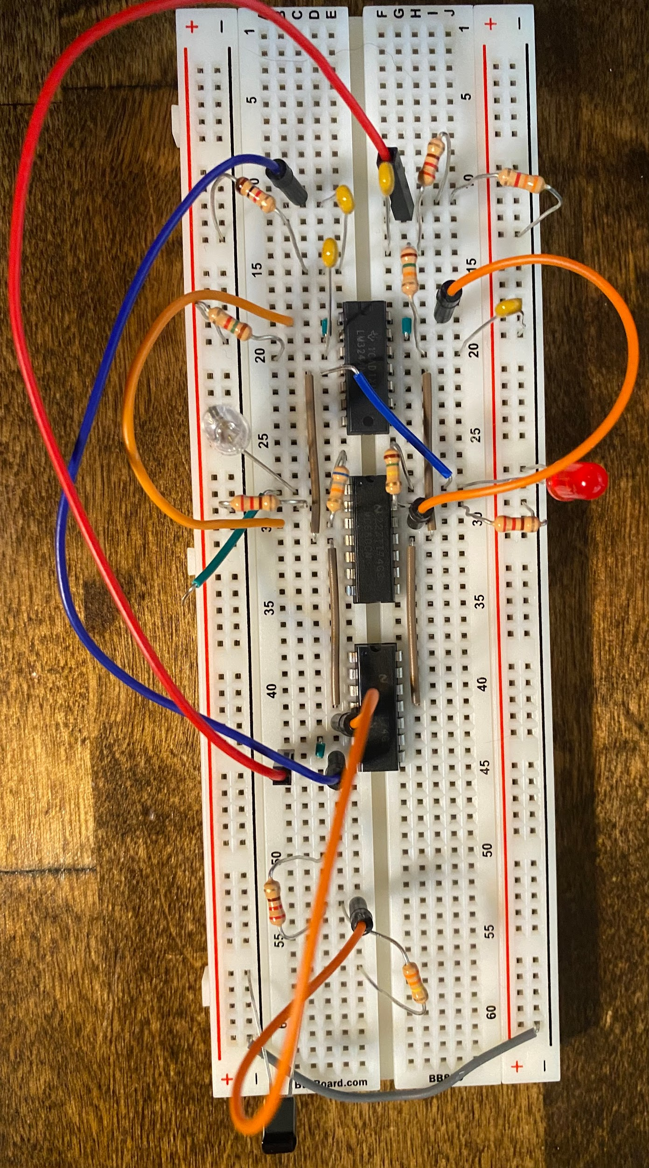
Figure 12: Actual image of the receiver circuit

Conclusion

This project had many challenges we had to overcome to finish with a working prototype. Our first issue had to do with an oscillator that would only work some of the time. We fixed this problem by simply designing a new oscillator circuit; we never did figure out why the original circuits were so troublesome. Our next issue, and by far our biggest problem, had to do with filtering the signals after they had been received by the photodiode. We started with a simple high and low pass filter with cutoff frequencies of 5000 Hz, but they would often still pass the signal when they weren’t supposed to. We settled on using a bandpass filter and a second-order high-pass filter to better differentiate between the two input frequencies. We also discovered the importance of unity gain buffers when dealing with very small amplitude signals. These buffers allow the other aspects of the circuit to use the signal without loading the circuit in a way that distorts the signal. One final thing we learned was the importance of the oscilloscope. Although we don’t show any traces in this report (since no traces were called for in the design document), we did use the oscilloscope to check the output of our oscillators, photodiode, and filters. This helped us to ensure everything was working as it was supposed to and even helped us to line up the infrared LED with the photodiode. Our circuit had a range of over 30 inches (we could have gone further, but we burned up an op-amp when we were plugging in extension cables), and we could have maximized the output of the infrared LED by using a transistor to add current to the circuit beyond the capabilities of the op-amp. We also made the discovery that we could trigger the receiver circuit with the infrared lights in our phone that aid in face id and the LIDAR detector on the back of the phone.

Works Cited

“LM324.” LM324 Data Sheet, Product Information and Support | TI.com, Texas Instruments, Oct. 2022, https://www.ti.com/product/LM324.
“LMC660.” LMC660 Data Sheet, Product Information and Support | TI.com, Texas Instruments, Mar. 2013, https://www.ti.com/product/LMC660.
“SFH 235 FA AMS Osram: Mouser.” Mouser Electronics, Osram, 9 Aug. 2022, https://www.mouser.com/ProductDetail/ams-OSRAM/SFH-235-FA?qs=K5ta8V%252BWhtYEHWvO6%252B357Q%3D%3D.
Storr, Wayne. “Active Band Pass Filter - Op-Amp Band Pass Filter.” Basic Electronics Tutorials, Electronics Tutorials, 6 Aug. 2022, https://www.electronics-tutorials.ws/filter/filter_7.html.
Storr, Wayne. “Band Pass Filter - Passive RC Filter Tutorial.” Basic Electronics Tutorials, Electronics Tutorials, 6 Aug. 2022, https://www.electronics-tutorials.ws/filter/filter_4.html.
Storr, Wayne. “High Pass Filter - Passive RC Filter Tutorial.” Basic Electronics Tutorials, Electronics Tutorials, 6 Aug. 2022, https://www.electronics-tutorials.ws/filter/filter_3.html.
“TL082.” TL082 Data Sheet, Product Information and Support | TI.com, Texas Instruments, Dec. 2021, https://www.ti.com/product/TL082.
“Tsal6100 Vishay - Datasheet PDF, Footprint, Symbol & Technical Specs.” All About Circuits, 18 July 2008, https://www.allaboutcircuits.com/electronic-components/datasheet/TSAL6100--Vishay/.

