[**Weekly Progress Report 1**](https://sit.instructure.com/courses/56947/modules/items/1379052)

In the first week, we implemented the design of 5 panel pages.

1. Main Panel

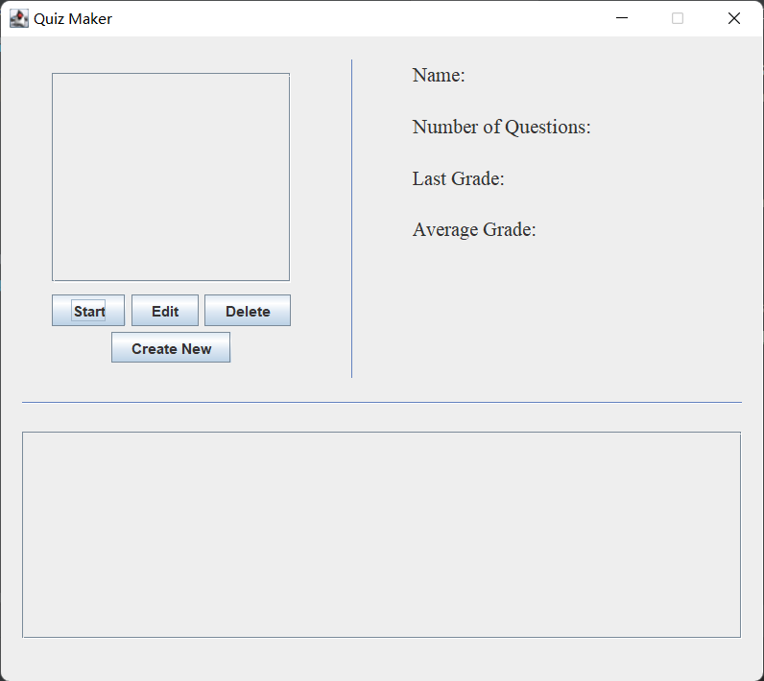

2. Edit Panel

3. New Question Panel

4. Quiz Panel

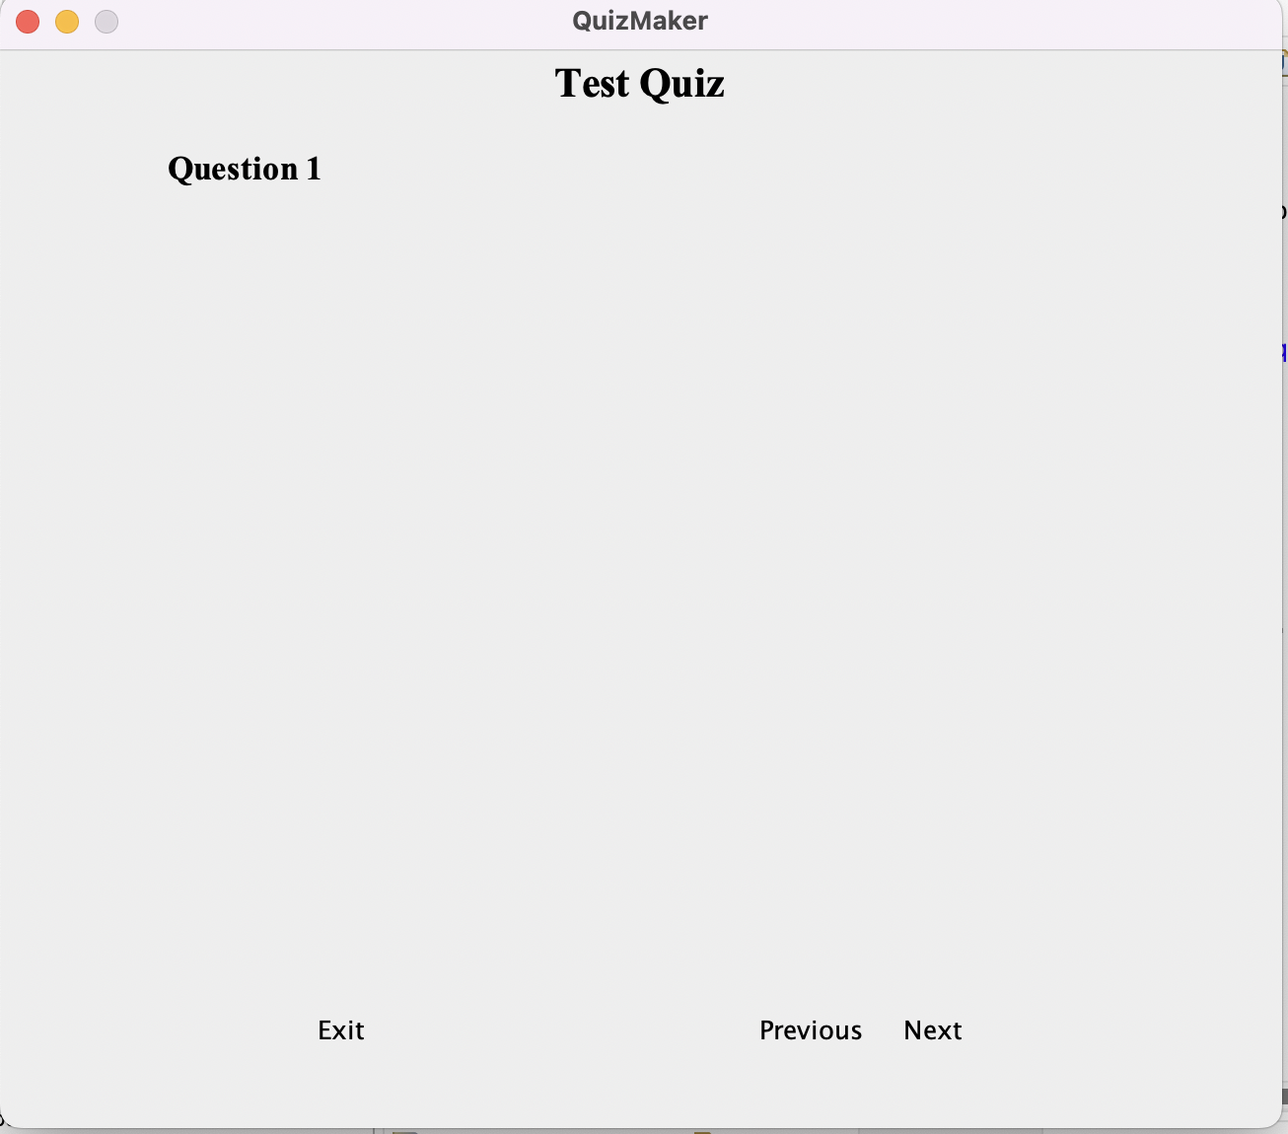

5. Quiz Result