**MINISTRY OF EDUCATION OF THE REPUBLIC OF MOLDOVA**

**THE TECHNICAL UNIVERSITY OF MOLDOVA**

**FACULTY OF COMPUTERS, INFORMATICS AND MICROELECTRONICS**

**DEPARTMENT OF SOFTWARE ENGINEERING AND AUTOMATICS**

**Report**

**WEB Technologies and Applications**

**The topic: Simple JavaScript Quiz**

**Done by: st. gr. TI-171M Cebotari Daria**

**Checked by: sup. lect. Poddukin Vladimir**

**Chișinău 2018**

**Task**

Create simple JavaScript quiz.

**List of Specifications**

* group files by type;
* add basic index.html file with standard elements;
* add dynamic questions with radio buttons to let user choose right answer;
* at the bottom of page add 2 buttons, first for switch to next question and second for show previous question;
* add simple CSS file for page styling;
* create .json file that contains questions and right answer;
* add score counter.

**Realization**

jQuery is used to load JSON-encoded data from the server using a GET HTTP request.

$.getJSON('scripts/questions.json', function(data) {

/…

}

Bootstrap is used to build web page grid that contains main elements.

<div class="container-fluid">

<div class="row">

<div class="col-xs-12">

<h1 style="color:white;" class="display-4">JavaScript Quiz</h1>

<div id="quiz" class="card" style="margin-top:100px;"></div>

<div class="card-block text-center">

<button class="btn btn-w-md btn-primary btn-squared" id="previous">Previous Question</button>

<button class="btn btn-w-md btn-primary btn-squared" id="next">Next Question</button>

<button class="btn btn-w-md btn-success btn-squared" id="submit">Submit Quiz</button>

</div>

</div>

</div>

<div id="results"></div>

</div>

</section>

</div>

Initially at web page loading, is necessary to load .json, for that we call function buildQuiz(questionsJson, quizContainer); where we send 2 parameters json from internet and container where are shown questions. Questions are build dynamically in next function buildQuiz(myQuestions, quizContainer).

function buildQuiz(myQuestions, quizContainer) {

const output = [];

myQuestions.forEach((currentQuestion, questionNumber) => {

var answers = [];

for (var letter in currentQuestion.answers) {

answers.push(

`<li class="list-group-item">

<div class="form-check">

<label class="form-check-label">

<input type="radio" name="question${questionNumber}" value="${letter}">

${letter} : ${currentQuestion.answers[letter]}

</label>

</div>

</li>`

);

}

output.push(

`<div class="slide">

<div class="card-block">

<h4 class="card-title">${currentQuestion.question}</h4>

</div>

<ul class="list-group list-group-flush answers">${answers.join("")}</ul>

</div>`

);

});

quizContainer.innerHTML = output.join("");

}

Also in main file index.js are implemented pagination, to show questions in different pages. For that, are called function showSlide(n) where n is number of page.

function showSlide(n) {

slides[currentSlide].classList.remove("active-slide");

slides[n].classList.add("active-slide");

currentSlide = n;

if (currentSlide === 0) {

previousButton.style.display = "none";

} else {

previousButton.style.display = "inline-block";

}

if (currentSlide === slides.length - 1) {

nextButton.style.display = "none";

submitButton.style.display = "inline-block";

} else {

nextButton.style.display = "inline-block";

submitButton.style.display = "none";

}

}

**Results**

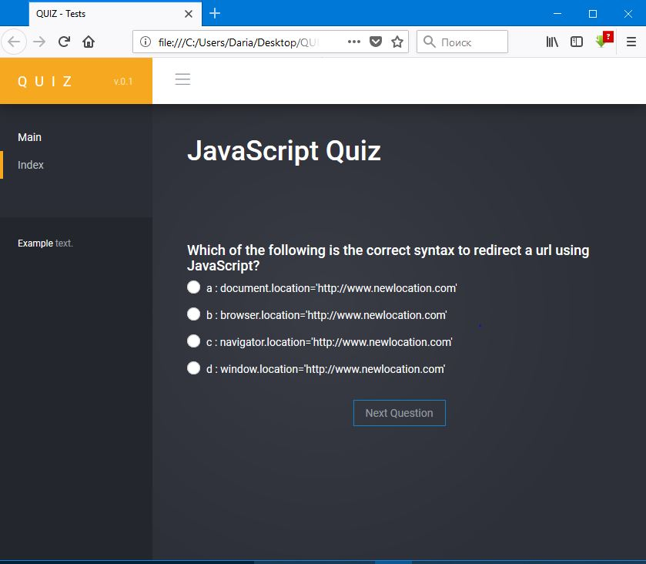

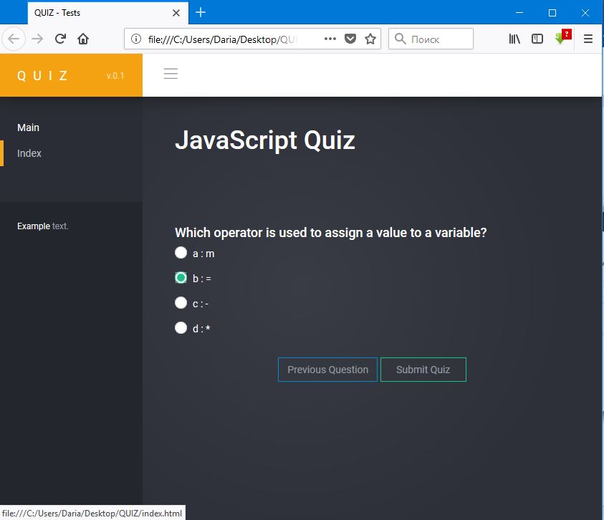

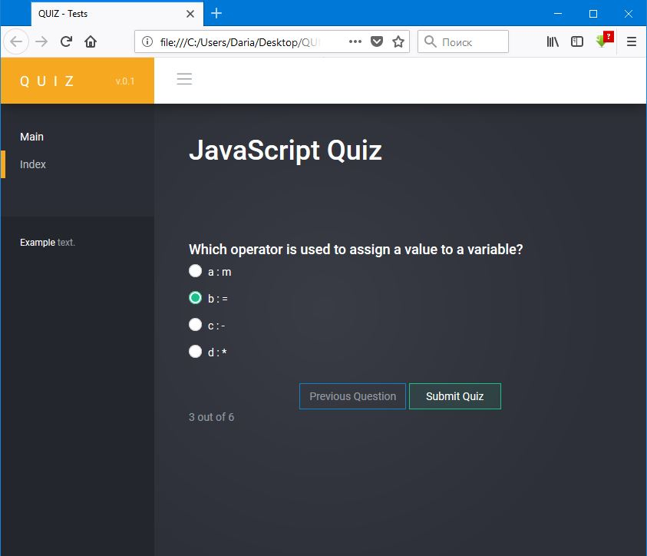

**Source Code**

**index.html**

<!DOCTYPE html>

<html>

<head>

<meta charset="utf-8">

<meta http-equiv="X-UA-Compatible" content="IE=edge">

<meta name="viewport" content="width=device-width, initial-scale=1.0">

<link href='http://fonts.googleapis.com/css?family=Roboto:300,400,500,700,900' rel='stylesheet' type='text/css'>

<!-- Page title -->

<title>QUIZ - Tests</title>

<!-- Vendor styles -->

<link rel="stylesheet" href="vendor/fontawesome/css/font-awesome.css"/>

<link rel="stylesheet" href="vendor/animate.css/animate.css"/>

<link rel="stylesheet" href="vendor/bootstrap/css/bootstrap.css"/>

<!-- App styles -->

<link rel="stylesheet" href="styles/pe-icons/pe-icon-7-stroke.css"/>

<link rel="stylesheet" href="styles/pe-icons/helper.css"/>

<link rel="stylesheet" href="styles/stroke-icons/style.css"/>

<link rel="stylesheet" href="styles/style.css">

</head>

<body>

<!-- Wrapper-->

<div class="wrapper">

<!-- Header-->

<nav class="navbar navbar-default navbar-fixed-top">

<div class="container-fluid">

<div class="navbar-header">

<div id="mobile-menu">

<div class="left-nav-toggle">

<a href="#">

<i class="stroke-hamburgermenu"></i>

</a>

</div>

</div>

<a class="navbar-brand" href="index.html">

QUIZ

<span>v.0.1</span>

</a>

</div>

<div id="navbar" class="navbar-collapse collapse">

<div class="left-nav-toggle">

<a href="">

<i class="stroke-hamburgermenu"></i>

</a>

</div>

</div>

</div>

</nav>

<!-- End header-->

<!-- Navigation-->

<aside class="navigation">

<nav>

<ul class="nav luna-nav">

<li class="nav-category">

Main

</li>

<li class="active">

<a href="index.html">Index</a>

</li>

<li class="nav-info">

<div class="m-t-xs">

<span class="c-white">Example</span> text.

<br/>

</div>

</li>

</ul>

</nav>

</aside>

<!-- End navigation-->

<!-- Main content-->

<section class="content">

<div class="container-fluid">

<div class="row">

<div class="col-xs-12">

<h1 style="color:white;" class="display-4">JavaScript Quiz</h1>

<div id="quiz" class="card" style="margin-top:100px;"></div>

<div class="card-block text-center">

<button class="btn btn-w-md btn-primary btn-squared" id="previous">Previous Question</button>

<button class="btn btn-w-md btn-primary btn-squared" id="next">Next Question</button>

<button class="btn btn-w-md btn-success btn-squared" id="submit">Submit Quiz</button>

</div>

</div>

</div>

<div id="results"></div>

</div>

</section>

</div>

<!-- End wrapper-->

<!-- Vendor scripts -->

<script src="vendor/pacejs/pace.min.js"></script>

<script src="vendor/jquery/dist/jquery.min.js"></script>

<script src="vendor/bootstrap/js/bootstrap.min.js"></script>

<!-- App scripts -->

<script src="scripts/luna.js"></script>

<script src="scripts/index.js"></script>

</body>

</html>

**index.js**

//JSON hosting service http://myjson.com

(function () {

var questionsJson = [];

$.getJSON('scripts/questions.json', function(data) {

questionsJson = data;

function buildQuiz(myQuestions, quizContainer) {

const output = [];

myQuestions.forEach((currentQuestion, questionNumber) => {

var answers = [];

for (var letter in currentQuestion.answers) {

answers.push(

`

<div class="radio radio-success">

<input type="radio" name="question${questionNumber}" value="${letter}" >

<label>

${letter} : ${currentQuestion.answers[letter]}

</label>

</div>

`

);

}

output.push(

`<div class="slide">

<div class="card-block">

<h4 class="card-title">${currentQuestion.question}</h4>

</div>

<ul class="list-group list-group-flush answers">${answers.join("")}</ul>

</div>`

);

});

quizContainer.innerHTML = output.join("");

}

function showResults() {

const answerContainers = quizContainer.querySelectorAll(".answers");

let numCorrect = 0;

questionsJson.forEach((currentQuestion, questionNumber) => {

const answerContainer = answerContainers[questionNumber];

const selector = `input[name=question${questionNumber}]:checked`;

const userAnswer = (answerContainer.querySelector(selector) || {}).value;

if (userAnswer === currentQuestion.correctAnswer) {

numCorrect++;

answerContainers[questionNumber].style.color = "lightgreen";

} else {

answerContainers[questionNumber].style.color = "red";

}

});

resultsContainer.innerHTML = `${numCorrect} out of ${questionsJson.length}`;

}

function showSlide(n) {

slides[currentSlide].classList.remove("active-slide");

slides[n].classList.add("active-slide");

currentSlide = n;

if (currentSlide === 0) {

previousButton.style.display = "none";

} else {

previousButton.style.display = "inline-block";

}

if (currentSlide === slides.length - 1) {

nextButton.style.display = "none";

submitButton.style.display = "inline-block";

} else {

nextButton.style.display = "inline-block";

submitButton.style.display = "none";

}

}

function showNextSlide() {

showSlide(currentSlide + 1);

}

function showPreviousSlide() {

showSlide(currentSlide - 1);

}

var currentSlide = 0;

const previousButton = document.getElementById("previous");

const nextButton = document.getElementById("next");

const submitButton = document.getElementById("submit");

const quizContainer = document.getElementById("quiz");

const resultsContainer = document.getElementById("results");

buildQuiz(questionsJson, quizContainer);

const slides = document.querySelectorAll(".slide");

showSlide(0);

submitButton.addEventListener("click", showResults);

previousButton.addEventListener("click", showPreviousSlide);

nextButton.addEventListener("click", showNextSlide);

});

})();

**questions.json**

[

{

"question": "Which of the following is the correct syntax to redirect a url using JavaScript?",

"answers": {

"a": "document.location='http://www.newlocation.com'",

"b": "browser.location='http://www.newlocation.com'",

"c": "navigator.location='http://www.newlocation.com'",

"d": "window.location='http://www.newlocation.com'"

},

"correctAnswer": "d"

},

{

"question": "Which of the following is correct about features of JavaScript??",

"answers": {

"a": "JavaScript is is complementary to and integrated with HTML",

"b": "JavaScript is open and cross-platform",

"c": "Both of the above",

"d": "All of the above"

},

"correctAnswer": "c"

},

{

"question": "Which of the following type of variable takes precedence over other if names are same?",

"answers": {

"a": "global variable",

"b": "local variable",

"c": "Both of the above",

"d": "None of the above"

},

"correctAnswer": "b"

},

{

"question": "Which of the following is not a software language?",

"answers": {

"a": "C",

"b": "C++",

"c": "Visual Basic",

"d": "HTML"

},

"correctAnswer": "d"

},

{

"question": "JavaScript is the same as Java?",

"answers": {

"a": "True",

"b": "False"

},

"correctAnswer": "b"

},

{

"question": "Which operator is used to assign a value to a variable?",

"answers": {

"a": "m",

"b": "=",

"c": "-",

"d": "*"

},

"correctAnswer": "b"

}

]

**Conclusion**

[JavaScript](https://developer.mozilla.org/en-US/docs/Glossary/JavaScript) ("JS" for short) is a full-fledged [dynamic programming language](https://developer.mozilla.org/en-US/docs/Glossary/Dynamic_programming_language) that, when applied to an [HTML](https://developer.mozilla.org/en-US/docs/Glossary/HTML) document, can provide dynamic interactivity on websites. JavaScript is incredibly versatile. JavaScript itself is fairly compact yet very flexible. Developers have written a large variety of tools on top of the core JavaScript language, unlocking a vast amount of extra functionality with minimum effort. These include:

* Browser Application Programming Interfaces ([APIs](https://developer.mozilla.org/en-US/docs/Glossary/API)) — APIs built into web browsers, providing functionality like dynamically creating HTML and setting CSS styles, collecting and manipulating a video stream from the user's webcam, or generating 3D graphics and audio samples.
* Third-party APIs to allow developers to incorporate functionality in their sites from other content providers, such as Twitter or Facebook.
* Third-party frameworks and libraries you can apply to your HTML to allow you to rapidly build up sites and applications.

All a developer needs is a text editor and a browser to run JavaScript code. Website users do not need special software and downloads to view JavaScript; every user gets the same experience.