Cebrin Billings  
Challenge Proposal

03/07/2020

# Overview

## Purpose

|  |  |
| --- | --- |
|  | Design and build a SPA that allows horse breeders to anticipate what color a foal may be by selecting the coat color of the parent horses. |

## Audience

|  |  |
| --- | --- |
|  | This SPA will provide pertinent information for anyone who breeds horses, and anyone who wants to know the reason for their horse’s coat color. This app will also be used by my instructor to evaluate my learning in this course. |

## Data Sources

|  |  |
| --- | --- |
|  | * External API – used to pull horse breeds, coat colors, and example pictures. * localStorage – used to store the user’s current horses, user uploaded pictures, and potential breeding crosses. |
|  |  |

## Deliverables

1. Initial Module List
   1. Main.js
   2. Horse class
2. Wireframes

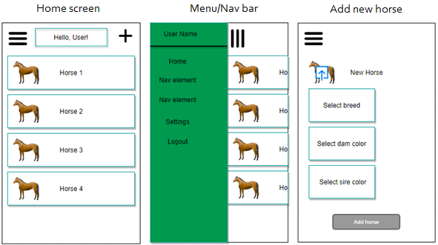

1. Colors/Typography/specific Element styling
   1. Color sample:



* 1. Typography: Bodoni Classic Cyrillic from Google Fonts API
  2. Specific styling:
     1. Green gradiated background
     2. Light teal font, and pink font
     3. Lighter teal borders and shading
     4. Darkest green, pink, and gold accents
     5. Nav menu slides in from side

## Schedule

|  |  |
| --- | --- |
|  | This project comprises my main efforts in CIT261 weeks 10-14 and will require approximately 30 hours of work.  -10 hours will be spent on JavaScript including interfacing APIs  -5 hours on HTML  -15 hours on CSS styling  Milestones  Week 10 – Build Horse API with breeds, colors, and pictures. Build HTML outline.  Week 11 – Stub JS functions, build Horse class  Week 12 – Code JS functions, begin styling  Week 13 – CSS styling  Week 14 – Finish polishing and submit, Celebrate! |