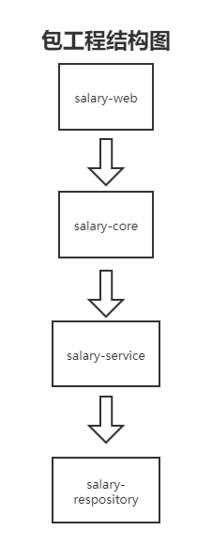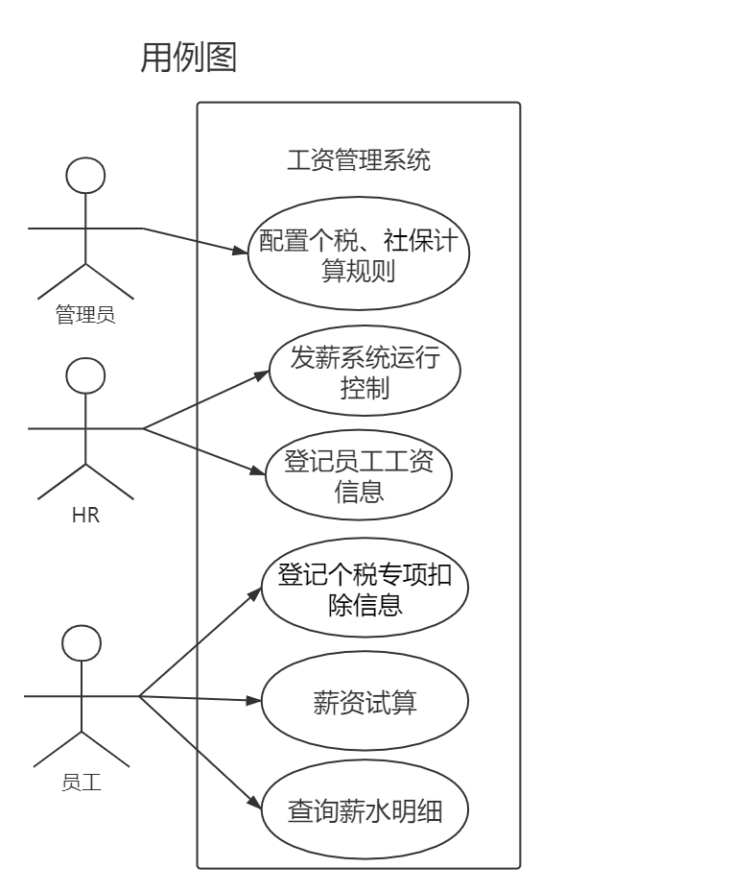工资管理系统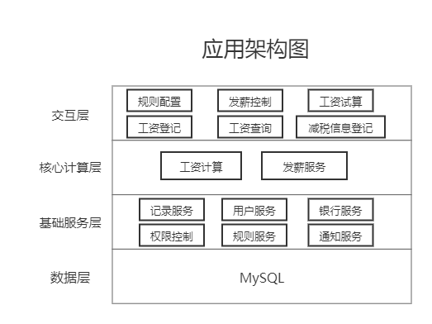

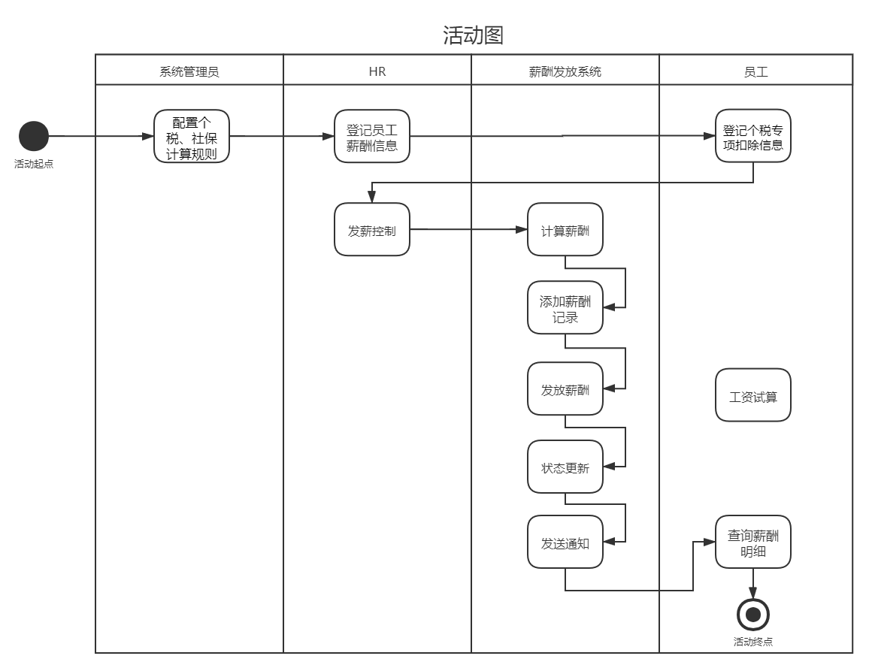

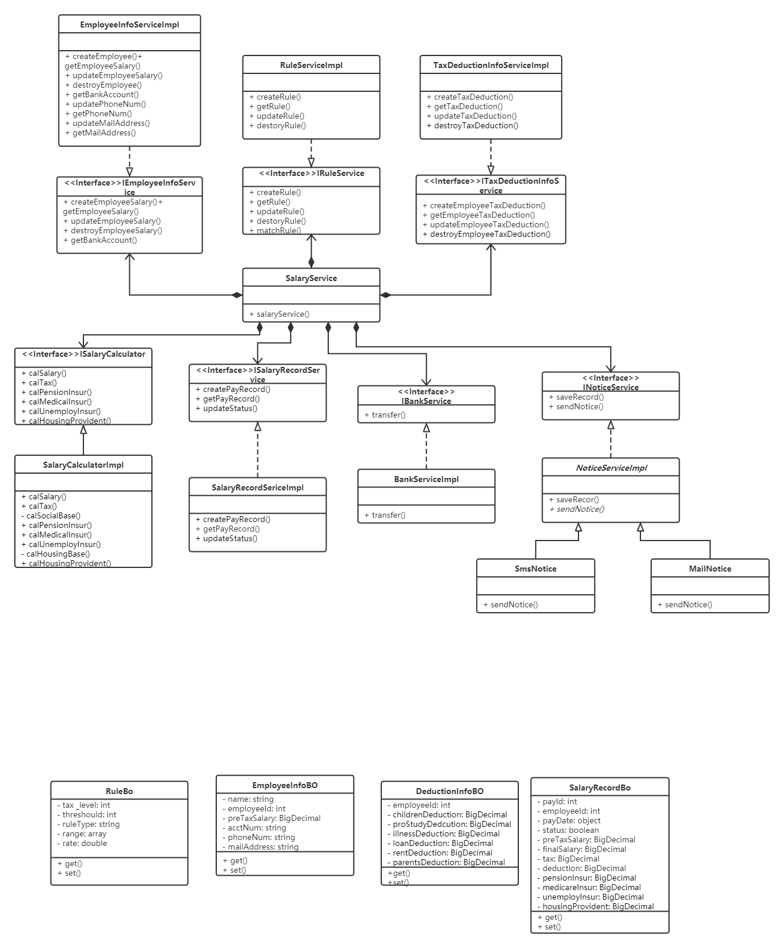类图

* **RuleService 规则服务**

创建规则

|  |  |
| --- | --- |
| 方法 | createRule |
| 入参 | RuleBo |
| 出参 | boolean |
| 异常 | sqlException |

获取规则

|  |  |
| --- | --- |
| 方法 | getRule |
| 入参 | string |
| 出参 | RuleBo |
| 异常 | sqlException |

匹配工资计算对应的规则

|  |  |
| --- | --- |
| 方法 | matchRule |
| 入参 | BigDecimal |
| 出参 | RuleBo |
| 异常 | sqlException |

修改规则

|  |  |
| --- | --- |
| 方法 | updateRule |
| 入参 | int, RuleBo |
| 出参 | boolean |
| 异常 | sqlException |

删除规则

|  |  |
| --- | --- |
| 方法 | destroyRule |
| 入参 | int |
| 出参 | boolean |
| 异常 | sqlException |

* **EmployeeInfoService 员工信息服务**

创建员工

|  |  |
| --- | --- |
| 方法 | createEmployee |
| 入参 | EmployeeInfoBO |
| 出参 | boolean |
| 异常 | sqlException |

获取员工工资

|  |  |
| --- | --- |
| 方法 | getSalary |
| 入参 | int |
| 出参 | BigDecimal |
| 异常 | sqlException |

修改员工工资

|  |  |
| --- | --- |
| 方法 | updateSalary |
| 入参 | int, BigDecimal |
| 出参 | boolean |
| 异常 | sqlException |

删除员工

|  |  |
| --- | --- |
| 方法 | destroyEmployee |
| 入参 | int |
| 出参 | boolean |
| 异常 | sqlException |

获取员工银行账号

|  |  |
| --- | --- |
| 方法 | getBankAccount |
| 入参 | int |
| 出参 | string |
| 异常 | sqlException |

获取员工手机号

|  |  |
| --- | --- |
| 方法 | getPhoneNum |
| 入参 | int |
| 出参 | string |
| 异常 | sqlException |

更新员工手机号

|  |  |
| --- | --- |
| 方法 | updatePhoneNum |
| 入参 | int, string |
| 出参 | boolean |
| 异常 | sqlException |

获取员工邮箱地址

|  |  |
| --- | --- |
| 方法 | getMailAddress |
| 入参 | int |
| 出参 | string |
| 异常 | sqlException |

更新员工手机号

|  |  |
| --- | --- |
| 方法 | updateMailAddress |
| 入参 | int, string |
| 出参 | boolean |
| 异常 | sqlException |

* **TaxDeductionInfoService 个税专项扣除信息服务**

创建员工个税专项扣除信息

|  |  |
| --- | --- |
| 方法 | createTaxDeduction |
| 入参 | DeductionInfoBO |
| 出参 | boolean |
| 异常 | sqlException |

获取员工个税专项扣除信息

|  |  |
| --- | --- |
| 方法 | getTaxDeduction |
| 入参 | int |
| 出参 | DeductionInfoBO |
| 异常 | sqlException |

修改员工个税专项扣除信息

|  |  |
| --- | --- |
| 方法 | updateSalary |
| 入参 | int, string, BigDecimal |
| 出参 | boolean |
| 异常 | sqlException |

删除员工个税专项扣除信息

|  |  |
| --- | --- |
| 方法 | destroyEmployee |
| 入参 | int |
| 出参 | boolean |
| 异常 | sqlException |

* **SalaryCalculator 工资计算服务**

计算工资

|  |  |
| --- | --- |
| 方法 | calSalary |
| 入参 | int |
| 出参 | BigDecimal |
| 异常 |  |

计算个税

|  |  |
| --- | --- |
| 方法 | calTax |
| 入参 | int |
| 出参 | BigDecimal |
| 异常 |  |

计算三险

|  |  |
| --- | --- |
| 方法 | calPensionInsur()  calMedicalInsur()  calUnemployInsur() |
| 入参 | int |
| 出参 | BigDecimal |
| 异常 |  |

计算社保基数

|  |  |
| --- | --- |
| 方法 | calSocialBase |
| 入参 | int |
| 出参 | BigDecimal |
| 异常 |  |

计算公积金

|  |  |
| --- | --- |
| 方法 | calHousingProvident |
| 入参 | int |
| 出参 | BigDecimal |
| 异常 |  |

计算公积金基数

|  |  |
| --- | --- |
| 方法 | calHousingBase |
| 入参 | int |
| 出参 | BigDecimal |
| 异常 |  |

* **SalaryRecordSerice 工资记录服务**

增加一条工资发放记录

|  |  |
| --- | --- |
| 方法 | createPayRecord |
| 入参 | SalaryRecordBo |
| 出参 | boolean |
| 异常 | sqlException |

查询工资发放记录

|  |  |
| --- | --- |
| 方法 | getPayRecord |
| 入参 | int |
| 出参 | boolean |
| 异常 | sqlException |

更新工资发放状态

|  |  |
| --- | --- |
| 方法 | updateStatus |
| 入参 | int |
| 出参 | boolean |
| 异常 | sqlException |

* BankService转账服务

转账

|  |  |
| --- | --- |
| 方法 | transfer |
| 入参 | int |
| 出参 | boolean |
| 异常 |  |

* NoticeService消息提醒服务

消息记录

|  |  |
| --- | --- |
| 方法 | saveRecord |
| 入参 | int |
| 出参 | boolean |
| 异常 |  |

发消息

|  |  |
| --- | --- |
| 方法 | sendNotice |
| 入参 | int |
| 出参 | boolean |
| 异常 |  |

Slry clculte process

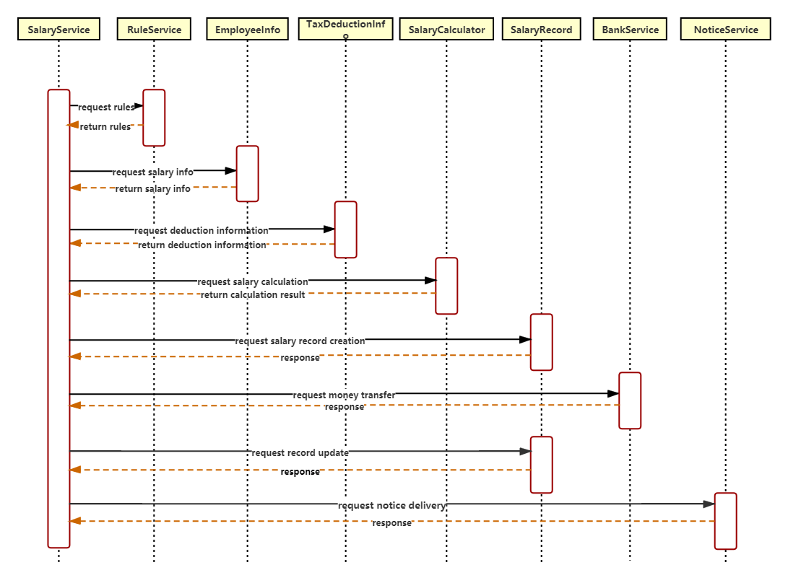类协作图

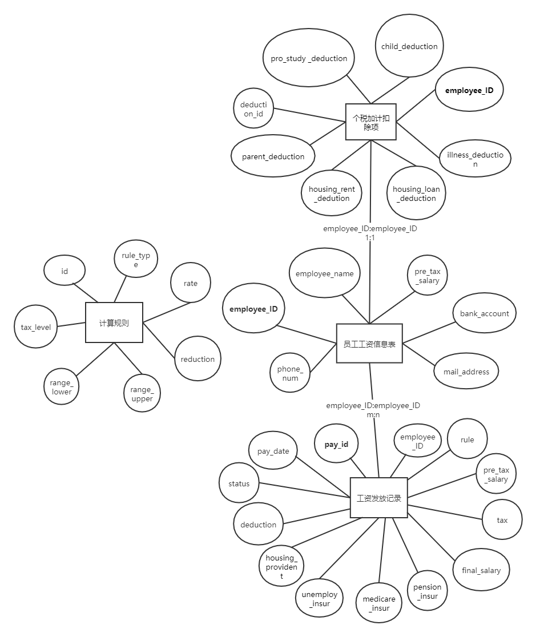数据库ER图

数据库表设计：

计算规则表

/******************************************/

/* DatabaseName = salary_payment_system */

/* TableName = rule */

/******************************************/

CREATE TABLE ` rule` (

`rule_id` int unsigned NOT NULL AUTO_INCREMENT COMMENT '主键',

`tax _level` int(2) unsigned DEFAULT NULL COMMENT '个税等级',

`rule_type` varchar(8) NOT NULL COMMENT '规则种类(个税、社保、公积金)',

`range_upper` decimal(8,2) unsigned DEFAULT NULL COMMENT '收入上限',

`range_lower` decimal(8,2) unsigned NOT NULL COMMENT '收入下限',

`rate` decimal(4,3) unsigned NOT NULL COMMENT '缴纳比例',

`reduction` int unsigned DEFAULT NULL COMMENT '速算扣除数'

PRIMARY KEY (`rule_id`),

)ENGINE=InnoDB DEFAULT CHARSET=utf8mb4 COMMENT='规则表'

;

员工工资信息表

/******************************************/

/* DatabaseName = salary_payment_system */

/* TableName = employee _info */

/******************************************/

CREATE TABLE ` employee _info ` (

`employee_id` int unsigned NOT NULL AUTO_INCREMENT COMMENT "工号",

`employee_name` varchar(64) DEFAULT NULL COMMENT '员工姓名',

`bank_account` char(19) NOT NULL COMMENT '银行卡号',

`pre_tax_salary` decimal(10,2) unsigned NOT NULL COMMENT '税前工资',

`phone_num` char(11) NOT NULL COMMENT '手机号码',

`mail_address` varchar(255) NOT NULL COMMENT '邮箱地址',

PRIMARY KEY (`employee_id`),

)ENGINE=InnoDB DEFAULT CHARSET=utf8mb4 COMMENT='员工信息表'

;

员工个税专项扣除信息表

/******************************************/

/* DatabaseName = salary_payment_system */

/* TableName = deduction _info */

/******************************************/

CREATE TABLE ` deduction _info ` (

`deduction_id` int UNSIGNED NOT NULL AUTO_INCREMENT COMMENT '主键',

`employee_id` int NOT NULL COMMENT '工号',

`child_deduction` int UNSIGNED ZEROFILL NOT NULL COMMENT '子女教育',

`pro_study_deduction` int UNSIGNED ZEROFILL NOT NULL COMMENT '继续教育',

`illness_deduction` decimal(7, 2) UNSIGNED ZEROFILL NOT NULL COMMENT '大病医疗',

`housing_loan_deduction` int UNSIGNED ZEROFILL NOT NULL COMMENT '住房贷款利息',

`housing_rent_deduction` int UNSIGNED ZEROFILL NOT NULL COMMENT '住房租金',

`parent_deduction` int UNSIGNED ZEROFILL NOT NULL COMMENT '赡养老人',

PRIMARY KEY (`deduction_id`)

)ENGINE=InnoDB DEFAULT CHARSET=utf8mb4 COMMENT='员工个税专项扣除信息表'

;

工资发放记录表

/******************************************/

/* DatabaseName = salary_payment_system */

/* TableName = salary_payment_record */

/******************************************/

CREATE TABLE ` salary_payment_record ` (

`pay_id` int unsigned NOT NULL AUTO_INCREMENT COMMENT "主键",

`employee_id` int unsigned NOT NULL COMMENT "工号",

`pay_date` datetime DEFAULT NULL COMMENT '工资发放时间 ',

`status` tinyint(2) unsigned NOT NULL DEFAULT ‘0’ COMMENT '工资发放状态',

`pre_tax_salary` decimal(8,2) unsigned DEFAULT NULL COMMENT '税前工资',

`final_salary` decimal(8,2) unsigned DEFAULT NULL COMMENT '实发工资',

`tax` decimal(6,2) unsigned DEFAULT NULL COMMENT '缴税额',

`deduction` decimal(8,2) unsigned DEFAULT NULL COMMENT '个税专项扣除额',

`pension_insur` decimal(8,2) unsigned DEFAULT NULL COMMENT '养老保险扣缴额',

`unemploy_insur` decimal(8,2) unsigned DEFAULT NULL COMMENT '失业保险扣缴额',

`medicare_insur` decimal(8,2) unsigned DEFAULT NULL COMMENT '医疗保险扣缴额',

`housing_provident` decimal(8,2) unsigned DEFAULT NULL COMMENT '公积金',

`rule` varchar(512) DEFAULT NULL COMMENT '计算规则'

PRIMARY KEY (`pay_id`),

)ENGINE=InnoDB DEFAULT CHARSET=utf8mb4 COMMENT='工资发放记录表'

;

CREATE TABLE tb_rule (

rule_id int unsigned NOT NULL AUTO_INCREMENT,

tax_level int(2) unsigned DEFAULT NULL,

rule_type varchar NOT NULL,

range_upper int unsigned NOT NULL,

range_lower int unsigned NOT NULL,

rate decimal(4,2) unsigned NOT NULL,

reduction int unsigned DEFAULT NULL,

PRIMARY KEY (rule_id),

)ENGINE=InnoDB DEFAULT CHARSET=utf8mb4

;