Yixin Zhang

yzh223

Perceptron Training Report

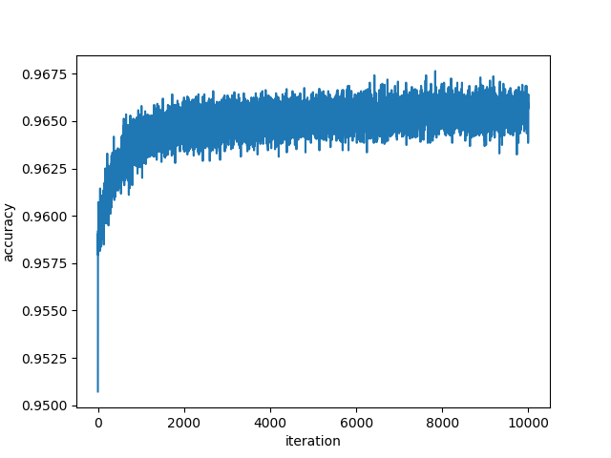**Challenge 0**

Non-separable.

Maximum number of iterations: 10,000

Highest accuracy: 0.9675

The data has been oscillating around 0.964 to 0.966 since the 4000 epoch. No significant improvement of accuracy is shown as iterations increases. Also, 0.966 is far away from 1, thus there might be 17898 * 3.25% ≈ 580 points that are not separable.

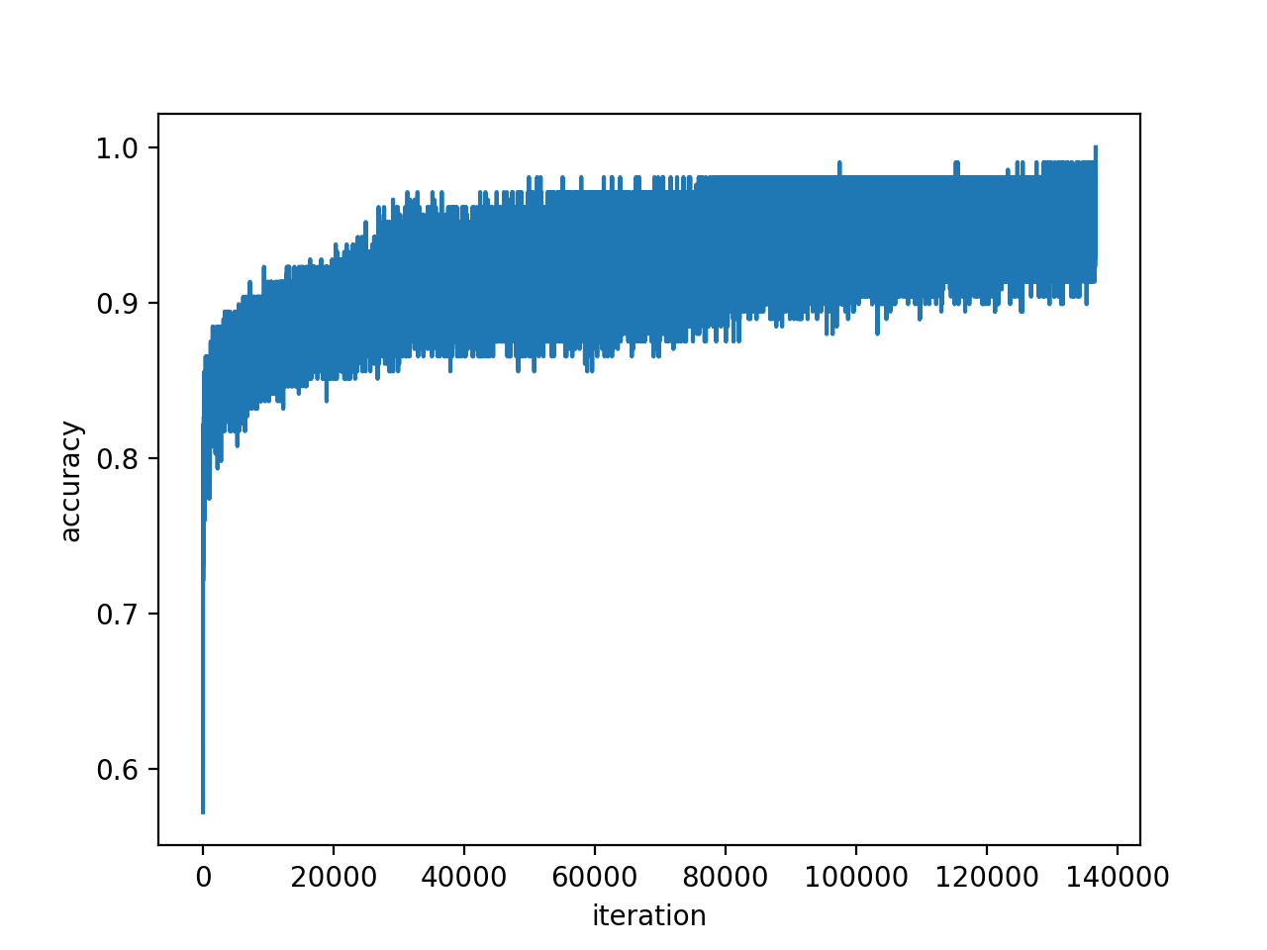**Challenge 1**

Separable.

Converged iteration: 4155

Maximum vector norm (R): 2.896098539414707

Upper bound for delta - sqrt(R^2/k): 0.00783318905

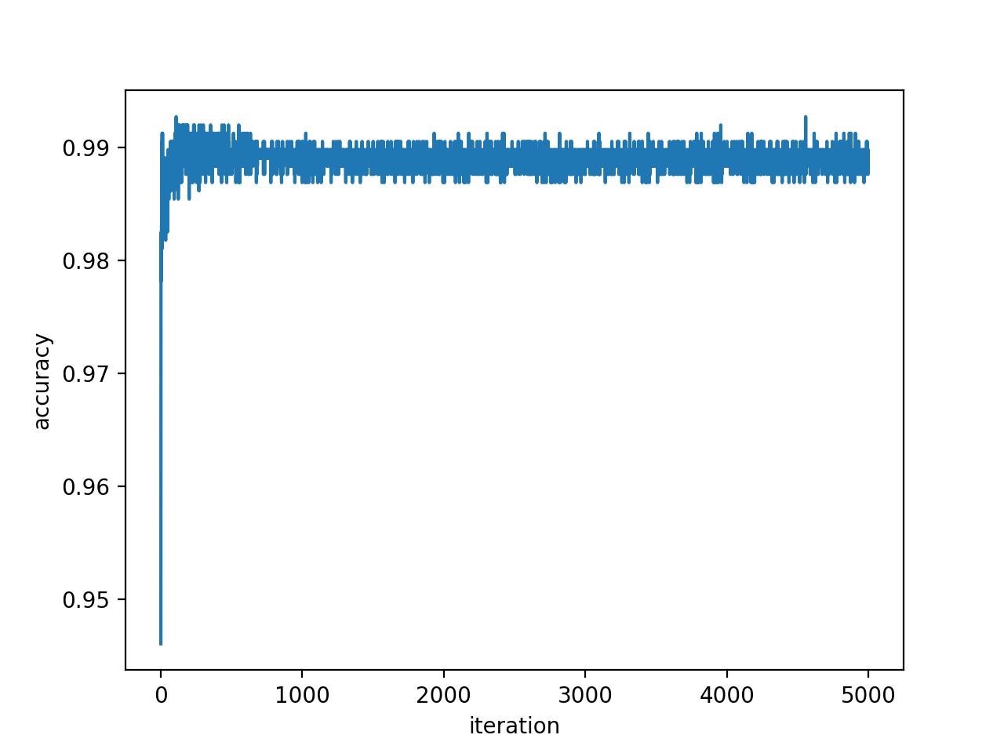**Challenge 2**

Non-separable.

Maximum number of iterations: 5000

Highest accuracy: 0.9925

The data has been oscillating around 0.9875 to 0.9915 since the 1000 epoch. Sometimes reaching 0.9925 at two spots. But the oscillation band is flat. Thus it’s not separable.

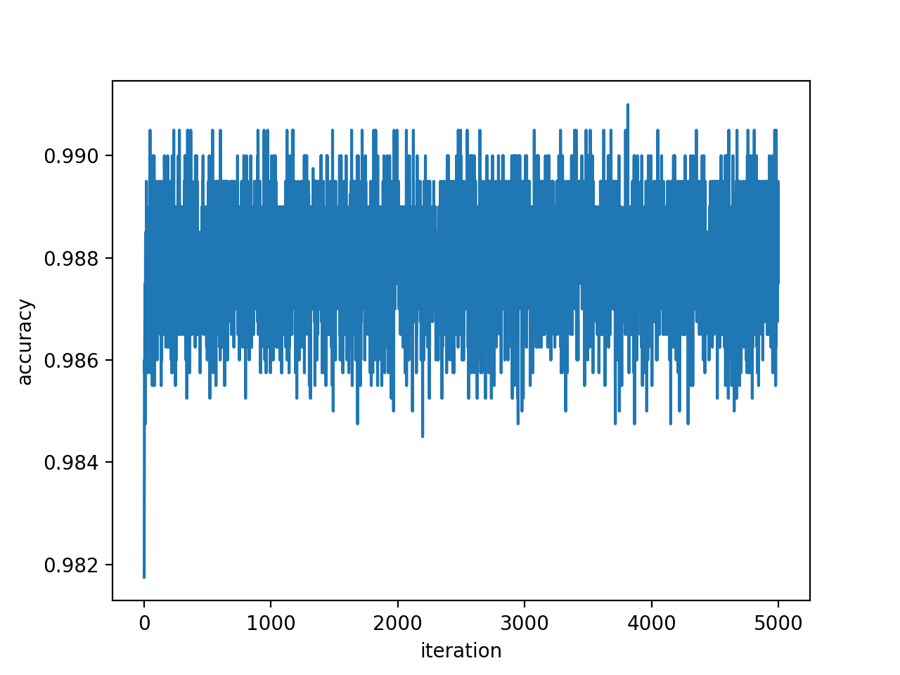**Challenge 3**

Non-separable.

Maximum number of iterations: 500

Highest accuracy: 0.9952

The data has been oscillating around 0.985 to 0.992 since the 500 epoch. The oscillation band is flat, and no significant improvement is detected. Also, the oscillation band is very wide, meaning every update creates significant shift that mis-classify other points . Thus the data is non separable.

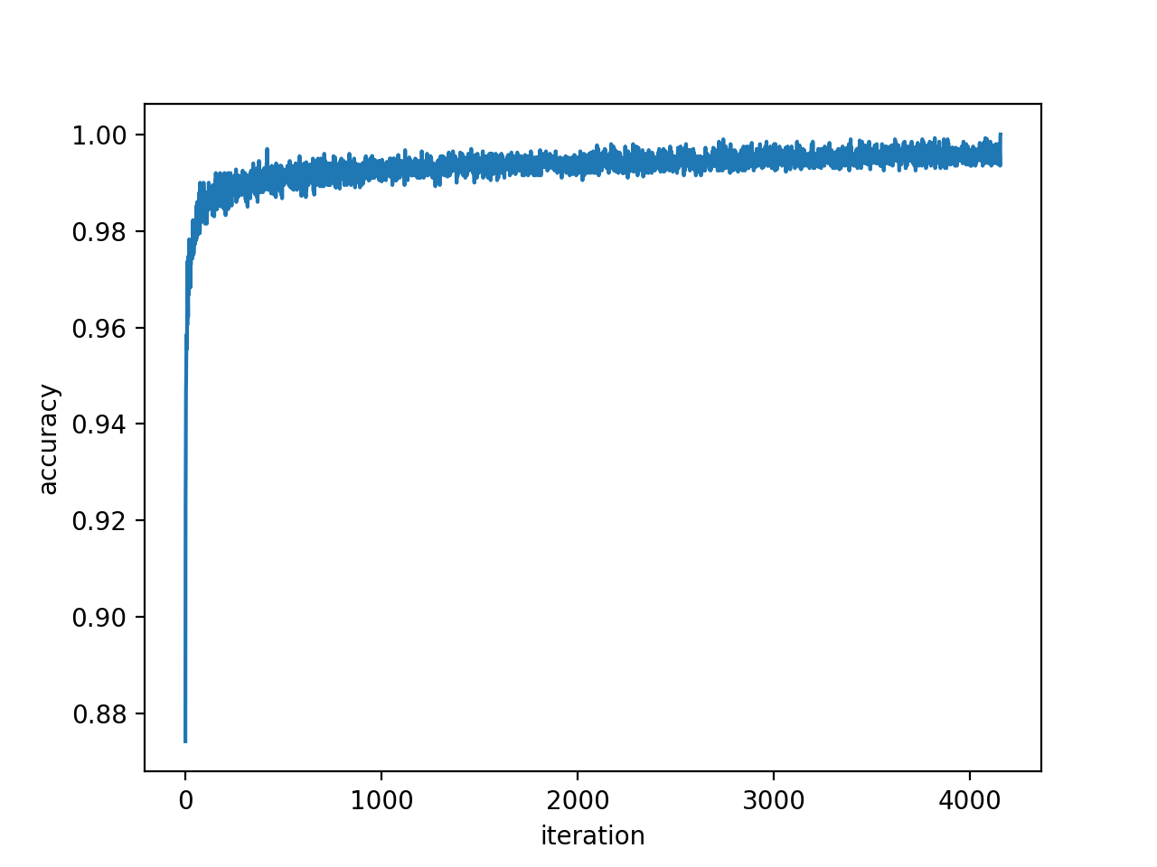**Challenge 4**

Separable.

Converged iteration: 136694

Maximum vector norm (R): 3.4301797073279428

Upper bound for delta - sqrt(R^2/k): 0.05321466809