.316347904:34a53eda4223221a4eeeb8dca70274c5_6a464af6f5d6edef387578ea.6a47ab7178cc4f68a0d64d07.6a47ab6faa34821f786329c3:Trae CN.T(2026/7/3 20:30:41)
session 1
.316347904:947fde9d0ed24f4736583370fbdec56b_6a464af6f5d6edef387578ea.6a47b06978cc4f68a0d64de4.6a47b068aa34821f786329c4:Trae CN.T(2026/7/3 20:51:53)
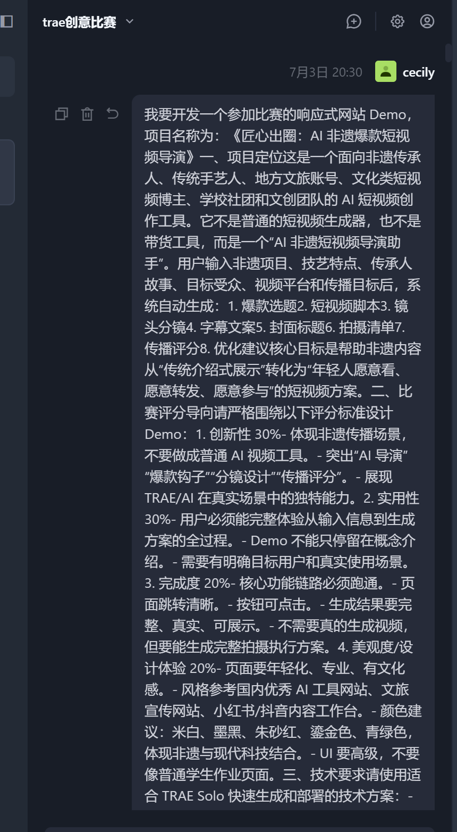
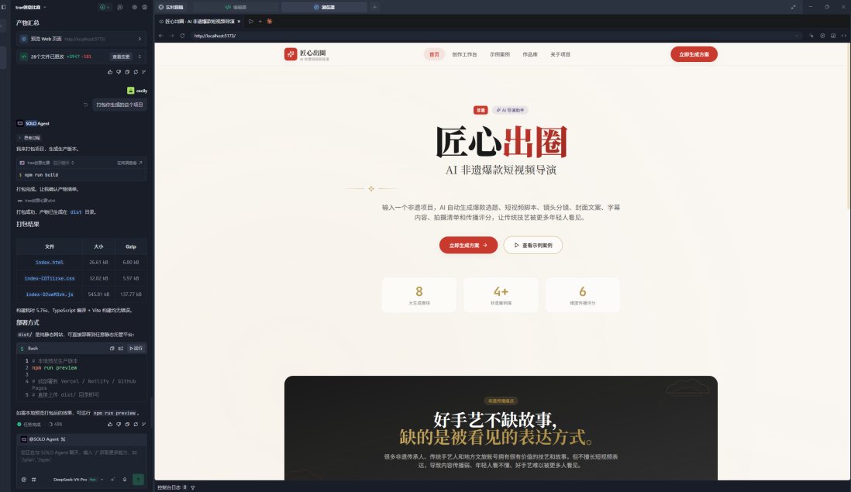
.316347904:0dcc8d82e9387467efcd45d675106f38_6a464af6f5d6edef387578ea.6a4b688078cc4f68a0d64e11.6a4b687faa34821f786329c6:Trae CN.T(2026/7/6 16:34:08)
.316347904:ea597ac4a29fbc460fc34ef4c957adcc_6a464af6f5d6edef387578ea.6a4b7e1d78cc4f68a0d64f44.6a4b7e1daa34821f786329c8:Trae CN.T(2026/7/6 18:06:21)
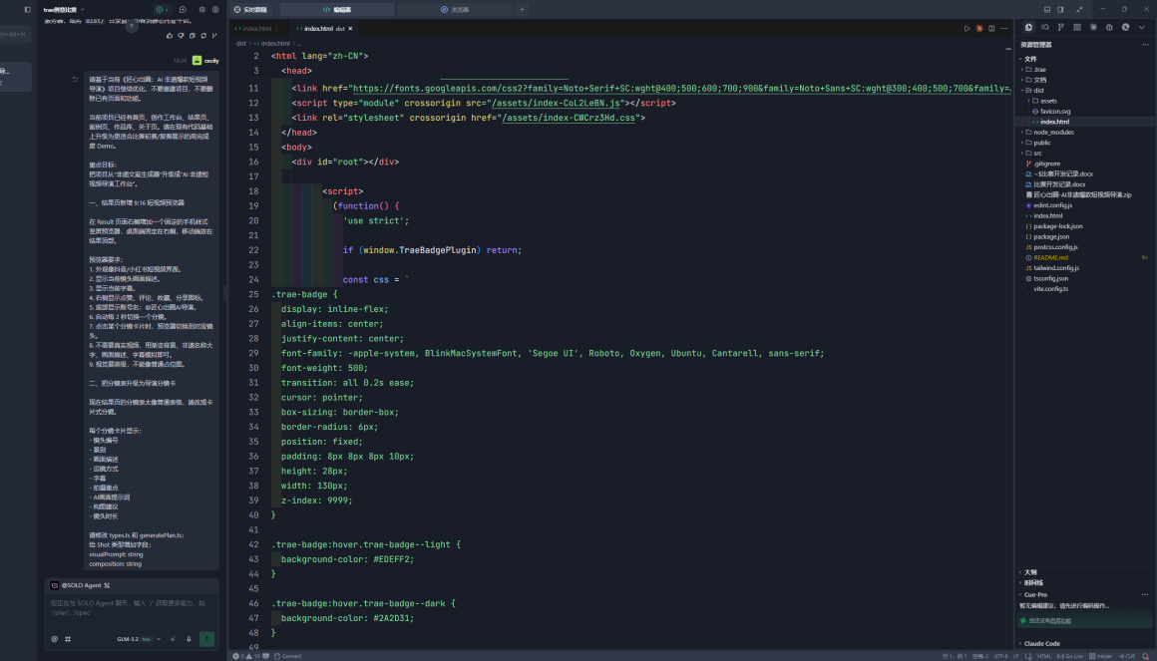
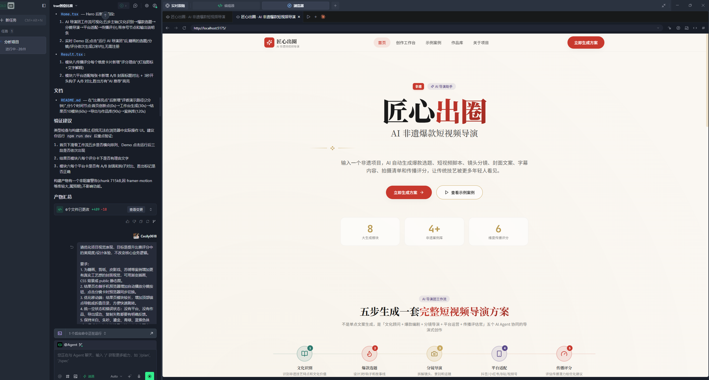
.2338020768353514:2c5194bf68e14fe88f231c451296300f_6a4649ecf5d6edef387578e8.6a52871a89673401540acfaf.6a528719d69e42553fd462d6:Trae CN.T(2026/7/12 02:10:34)
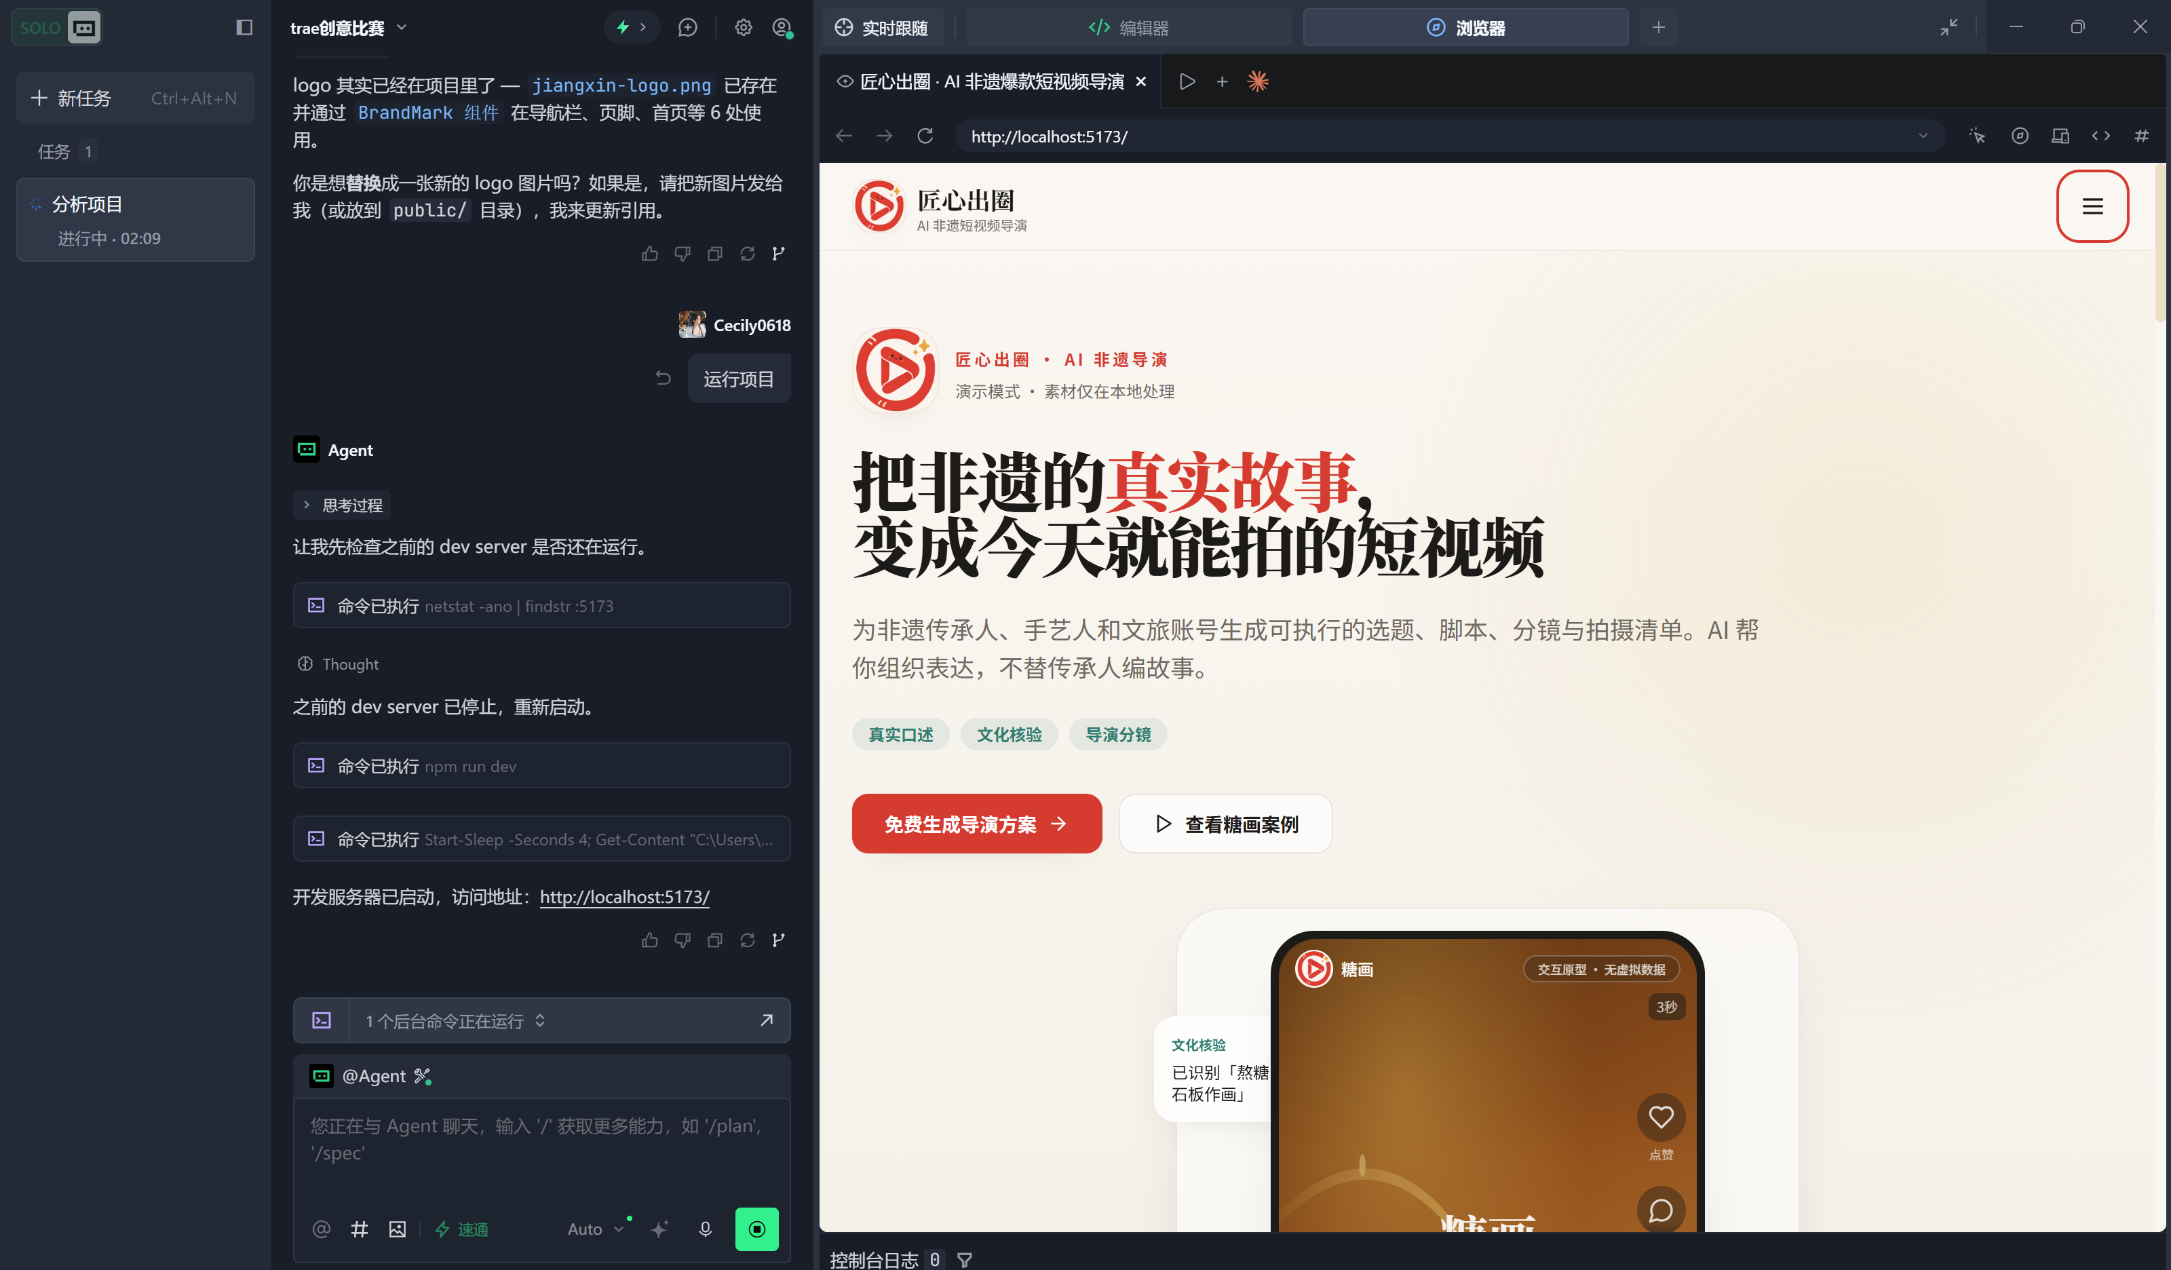
.2338020768353514:315484da3acf060d30b70ed529c95b83_6a4649ecf5d6edef387578e8.6a5288dc89673401540acfc5.6a5288dcd69e42553fd462d7:Trae CN.T(2026/7/12 02:18:04)

