Instructions

British Condition instruction

“The following task will examine your ability to coordinate your intuitive judgements with other people from all around the UK. You will see a series of simple instructions to name an everyday thing, and you should consider the best example that you think most other participants in this study will select. The other participants from around the UK will also be trying to coordinate their judgements with yours. You should enter only one answer for each of these questions. Once you have given an answer, press the arrow button to move on to the next item.”

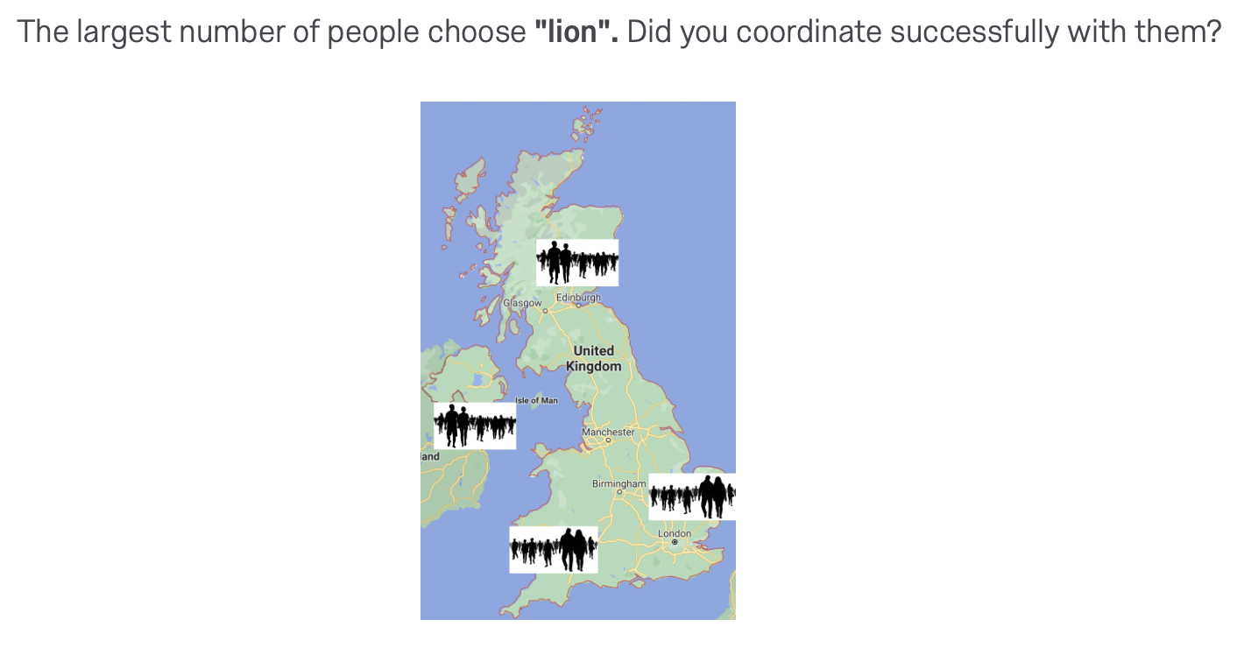
After each alignment trial, participants read a feedback message and looked at map of the UK with silhouettes on it in order to increase their engagement with the task. Feedback responses were based on the pilot study answers. See below an example for the item 1 “name a wild animal”.

After completing 10 alignment items, participants read the following message:

“REMINDER.

Remember, you are trying to pick the same answers as other people - and they are trying to do the same. Participants are from all around the UK.”

Global Condition instruction

The following task will examine your ability to coordinate your intuitive judgements with other people from all around the world. You will see a series of simple instructions to name an everyday thing, and you should consider the best example that you think most other participants in this study will select. The other participants from around the world will also be trying to coordinate their judgements with yours. You should enter only one answer for each of these questions. Once you have given an answer, press the arrow button to move on to the next item.

After responding each item, participants in the global condition were shown a similar feedback message as the British participants. See below for details.

Feedback for the alignment item 3: “name a popular dance”
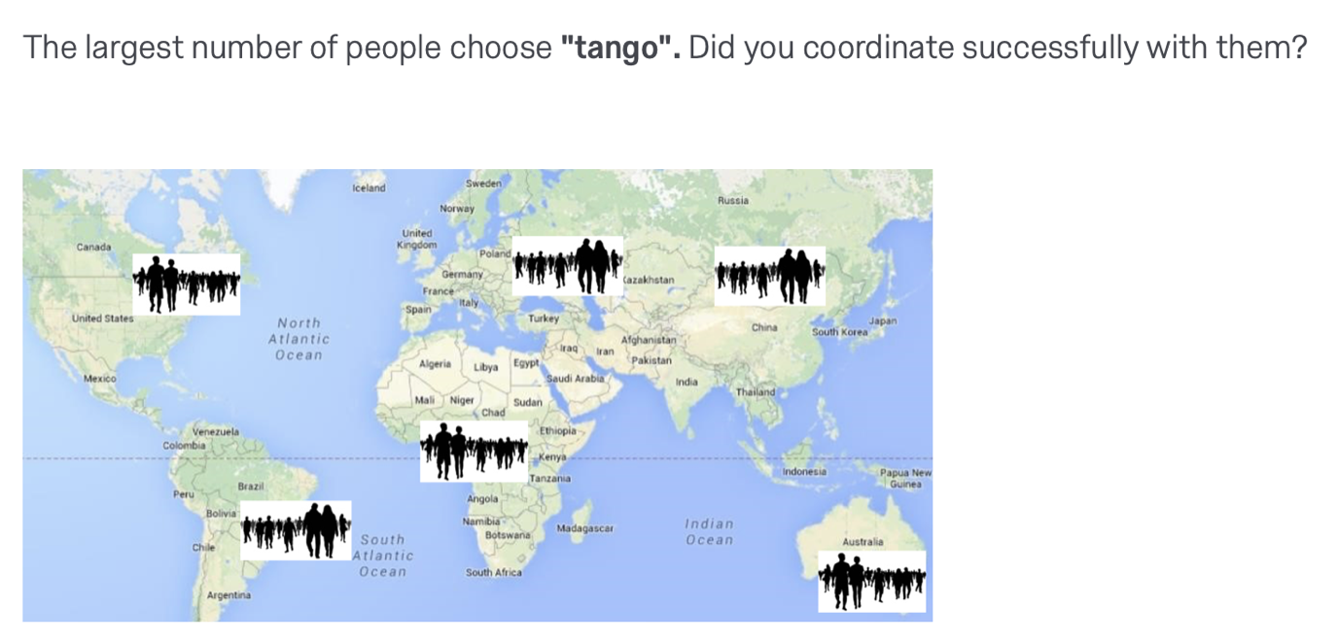
After completing 10 alignment items, participants read the following message:

“REMINDER.

Remember, you are trying to pick the same answers as other people - and they are trying to do the same. Participants are from all around the UK.”

Once answered all the alignment items, participants were asked the following control question: “Name the current president of the United States”. Answer: Joe Biden.

