DIGIBOK: WEB-BASED BOOKKEEPING MANAGEMENT SYSTEM IN THE MUNICIPALITY OF SIPOCOT

A Capstone Project
Presented to the Faculty of the
COLLEGE OF INFORMATION TECHNOLOGY
CENTRAL BICOL STATE UNIVERSITY OF AGRICULTURE- SIPOCOT

In Partial Fulfillment of the Requirements
for the Degree of
BACHELOR OF SCIENCE IN INFORMATION TECHNOLOGY

ELIJAH P. URSUA
JOHN CEDRICK M. MENDEZ
KIMBERLY SHANE C. CUYA

May 18, 2026
CHAPTER I
THE PROJECT AND ITS BACKGROUND

Introduction
In today’s fast-paced business environment, efficient financial management is critical for organizational stability and growth. Azman said bookkeeping plays a vital role in dealing with records of day-to-day transactions from invoices to payment. It is also a method of documenting all company transactions in order to create a collection of accounting documents, Azman et.al (2021). The industry is currently undergoing a significant technological information, moving rapidly from traditional manual methods to highly automated and digital solutions. Artificial Intelligence (AI) revolutionized every field by automating routine tasks, it also extends supports, accurate forecasting, risk management and fraud detection. In bookkeeping software, such as QuickBooks Online, further streamline operations by offering real-time access to financial data from any location, fostering collaboration, and automating numerous tasks. This digital transformation, combined with increasing adaptation of technologies means bookkeepers are transitioning data entry roles to becoming financial advisors, focusing on data interpretation and providing valuable insights for business growth.
Mrs. Arni - Adoracion M. Perido, residing at PNR Compound, North Centro, Sipocot Camarines Sur. Started in bookkeeping since 2005, she’s now a bookkeeper for 21 years and is responsible for handling numerous processes and files. This includes the primary tasks such as securing permits, filing taxes, and maintaining core financial books. Monitoring every deadline, taxes, files and sales outside the office should always be on track. It is a must that the office shall refrain from making errors, balance sheets and so as to maximize their time and resources for the other important transactions.
As bookkeeping plays a vital role in businesses, most enterprises still rely on manual bookkeeping processes and disjoined systems to track compliance requirements, manage financial records, and fulfill regulatory obligations. Fulfilling the processes in the current file system that they are using are somewhat laborious and prone to errors. Monitoring records, file and transactions takes so much time and effort on the part of the bookkeeper. Securing permits such as Mayor’s Permits, Fire Safety Certificates and Business Permits. Filing taxes like Quarterly Percentage Tax, Quarterly Income Tax and Annual Income Tax. Maintaining core financial books in sales, purchases, journals and ledgers including the separate record of VAT and Non-VAT transactions, as well as subsidiary accounts. This manual bookkeeping approach are managed through handwritten schedules and unintegrated workflows, the file system that they are using are somewhat prone to errors, missed deadlines, redundant data entry, and difficulty in consolidating financial information across different components of operations.
This project aims to take the weight off our client shoulders by bringing all their financial and compliance needs into one easy-to-use system. The system will send timely reminders for permits and taxes, automate repetitive data entry, and pull all their records together so they can see exactly where their business stands at a glance. This solution that we want to create feels like a reliable partner, one that handles the details so they can get back to what matters most: running their business even if it means juggling countless responsibilities. This system addresses these challenges by systematic compliance tracking, automotive repetitive tasks and integrating all bookkeeping functions into a single digital platform. This capstone project seeks to develop an adaptable, client-focused solution that aligns with the client’s operational needs and modernization of their financial management practices, by streamlining permit renewal schedules, tax filing reminders, and record-keeping processes. The system aims to reduce administrative burden, minimize risks, and provide real-time visibility into an organizations financial health.

Objectives
The main objectives of this study are to develop a web-based digital bookkeeping management system that streamlines financial record-keeping, monitoring and tracking management for businesses in Sipocot, Camarines Sur. Specifically, this study aims to;
- Manage Registration and profiling of bookkeeper and clients
- Develop a real-time monitoring of dues on permits and tax obligations
- Automatically post transactions from journal to the ledger
- Develop financial data management system in balancing transactions.

Conceptual Framework
INPUT
- Registration and Profiling of Bookkeeper and Clients
- Real-time Monitoring of dues on permits and tax obligation
- Post transactions automatically to the ledger
- Financial data management system balancing to ensure portability and liquidity.
OUTPUT
- Managed database of verified user and client profiles
- Timely compliance and payment record histories
- A current, accurate, and balanced general ledger
- Optimized financial data for portability and liquid reporting
PROCESS
- Validate user credentials and create profile accounts
- Synchronize real-time system data and generate alert triggers
- Match automated transactions and reconcile with ledger entries
- Perform data normalization and balancing across systems

FEEDBACK

Figure 1.1
Conceptual Framework for “Digibok: Web-based Bookkeeping Management System in the Municipality of Sipocot
Figure 1.1 shows the conceptual framework of “Digibok: Web-based Bookkeeping Management System in the Municipality of Sipocot”
The Input-Process-Output (IPO) paradigm shows system analysis and software engineering, structure of information processing program, and feedback that gives significant insights to further improve the system. The input includes information from the office. These inputs are processed through data gathering and series of interviews. After collecting the important information, these data are classified and was used in finalizing the design and features of the system. Lastly, feedback serves as a control element, allowing the processes and inputs to be modified when the intended result comes under user expectations.

Scope and Delimitation
This study aims to develop a web-based system to help bookkeepers register their information and their clients. Monitoring deadline permits needed and taxes filing of their client’s businesses. This system monitors their schedule to help their clients provide the needed files issued to the bookkeeper of the Sipocot, Camarines Sur. Likewise, the system can show the status of the client’s balance if needed to be filed as soon as possible. Then, the bookkeeper can monitor whether the balance is being paid or not. It focuses on real-time reminders helping the bookkeepers and the client to avoid missing deadlines and penalties.
Additionally, this system will also help them keep track of their files, deadlines and their taxes. Moreover, the system can also provide files for clients when they need to see their overall financial statements. Furthermore, the system will generate reports or the transaction records made by the client and the bookkeeper necessary to the company, such as: Quarterly income percentage, Quarterly income tax and Annual income tax for their yearly income and expenses made by the client. The system automatically posts the transactions made to the ledger using the trial-balance.
The bookkeeper can only modify the file or the report to help them keep on track and balanced. Other non-related processes in bookkeeping are not covered by Bureau of Internal Revenue. This study will not cover VAT (Value Added Tax) end-users. The system can only accommodate the bookkeeper and the client. However, the study will not cover industry specific modules like advanced inventory or payroll, nor will it include predictive analytics or compliance with specific national tax laws.

Significance of the Study
This study, which covers the development of Web-based Integration Bookkeeping Management and Automation System will be significant to the following:
Small-Medium Enterprises – helps to provide a computerized record of their day-to-day transactions.
Accountants and Bookkeepers – frees them from repetitive data-entry tasks, allowing them to focus on higher-value advisory services.
Academic Community – helps free access, analyze, and verify the same dataset in real-time, share standardized data across institutions, and use it without the limits of local files or manual records.
Future Researchers – helps in providing accessible, clean, and real-time financial data with built-in audit trails that simplify data collection, verification and analysis.
Definition of Terms
The following definitions establish the intended meaning of key terminologies used in this chapter.
Application Programming Interface (API) – making transactions easier from the clients to the bookkeeper. According to Merriam-Webster, API is a set of rules that allows programmers to develop software for a particular operating system without having to be completely familiar with that operating system.
Automation. Automatically post transactions from the journal to the ledger without manual typing. According to Kanade V., Automation is a set of rules that allows programmers to develop software for a particular operating system without having to be completely familiar with that operating system.
Bookkeeping Management System. A web-based system that reduces manual effort, data accuracy and real-time financial intelligence.
Cloud Computing. Used for file storage intended to financial reports or statements of the clients. According to Susnjara et.al, Cloud Computing is on-demand access to computing resources, physical or virtual servers, data storage, networking capabilities, application development tools, software, AI-powered analytic platforms and more over the internet with pay-per-use pricing.
DigiBok. Stands for Digital Bookkeeping. In our title, we used it as unique name that stands for Digital Bookkeeping.
Ledger. Post all transactions from the journal to create a financial statement automatically. According to AccountingTools, Ledger is a record in which is recorded a specific type of transaction. These transactions can relate to assets, liabilities, equity, sales, expenses, gains, or losses - in essence, all of the transactions that are aggregated into the balance sheet and income statement. The ending balances in these accounts are then aggregated and reported in the balance sheet and income statement.
Role-based Access Control. The bookkeeper only can modify the file. According to Male V.R. RBAC is a security framework that restricts system access based on a person's role within the organization. In this system, it ensures that only authorized users, such as the bookkeeper, have the permissions required to modify specific financial files.
Web-based System. An online system used in this study. Based on TechTarget, Web-based System is a collection of interconnected web pages that provide users with information and content.

NOTES
Accounting Tools. (2024). Bookkeeping Definition. Retrieved March 6, 2026, from https://www.accountingtools.com/articles/what-is-bookkeeping.html

Accounting Tools. (2023, December 18). General Ledger Definition and Usage. AccountingTools. https://www.accountingtools.com/articles/what-is-a-general-ledger.html

Azman, M. Z., et al. (2021). The Impact of Automated Bookkeeping on Small Business Efficiency. Journal of Financial Reporting and Accounting. https://www.researchgate.net/

IBM Education. (2024, May 15). What is Cloud Computing? IBM. https://www.ibm.com/topics/cloud-computing

Kanade, V. (2024, February 26). What Is Automation? Definition, Types, Benefits, and Importance. Spiceworks. https://www.spiceworks.com/it-innovations/it-automation/articles/what-is-automation/

Merriam-Webster. Retrieved March 5, 2026, Application programming interface. In Merriam-Webster.com dictionary. From https://www.merriam-webster.com/dictionary/application%20programming%20interface

Male, V. R. (2025, February 8). Decoding Role-Based Access Control (RBAC). ResearchGate. https://www.researchgate.net/publication/388983776_Decoding_RoleBased_Access_Control_RBAC

TechTarget. (2023). Web Application (Web App). SearchSoftwareQuality. https://www.techtarget.com/searchsoftwarequality/definition/Web-application-Web-app
CHAPTER II
REVIEW OF RELATED LITERATURE AND STUDIES

User Registration and Profiling of Bookkeepers and Clients
One of the main objectives of the BIR's Digital Transformation Plan for 2022– 2023 is to make registration easy, accessible, and quick for all taxpayers. In order to facilitate online registration-related operations, the BIR has introduced the Online Registration and Update System (ORUS), which enables taxpayers to register, update, and transact with the BIR. (Palanog, J. et al, 2025)
Micro, small, and medium enterprises (MSMEs) are widely recognized as key drivers of economic development, social inclusion, and sustainability. They promote job creation, stimulate innovation, and strengthen local communities, thereby contributing to overall economic resilience. In the Philippine context, MSMEs are integral to national growth, fostering innovation and wealth creation while maintaining the country's competitive advantage within the ASEAN integration and global market. (Ibieza D., et al, 2025)
Business owners usually venture into enterprises that they feel would harness their skills or something that they really love to do. The business will continue to operate for as long as the owner still possesses the enthusiasm or the owner thinks that the venture is worthwhile, that is, if the owner believes that the business is able to increase his net worth or the venture is indeed profitable. (Santos J. et al, 2024)
The digital landscape streamlines the accounting process, manages costs effectively, and enhances overall business performance. The Computerized Accounting System (CAS) automates financial transactions and accounting functions, minimizes the risk of human error, ensures regulatory compliance, and provides reliable financial information, thereby improving decision- making. (Dimaano D. M, et al, 2024)
The digital landscape streamlines the accounting process, manages cost effectively, and improves overall business performance, paving the way for a horizon of vast opportunities for growth and development. However, despite the rapid advancement of technology, many small and medium enterprises (SMEs) in the Philippines still rely on manual recording or basic spreadsheet applications like Microsoft Excel for their financial transactions. (Magtibay, G. C. et al, 2020)
Real-Time Monitoring on Dues of Permits and Tax Obligations
To address bureaucratic red tape in the Philippines, local government units (LGUs) have aggressively pushed for real-time compliance monitoring. Navarro et al. (2019) documented the development of the Electronic Business Permit and Licensing System (eBPLS), which successfully reduced the processing time for new and renewed business applications to a single day.
The Department of Information and Communications Technology [DICT] (2016) mandated these unified systems to eliminate the tedious, paper-based tracking of expiring permits.
In local implementations, Garcia (2021) detailed how the Municipality of Palanan institutionalized an automated one-stop-shop to monitor business fees and prevent late penalties in real-time.
The City Government of San Fernando (2021) implemented a portal allowing taxpayers to monitor their application statuses and tax obligations remotely.
The Municipality of Solsona (2021) enacted an ordinance proving that simplifying and automating the monitoring of business permits directly enhances local revenue generation while helping business owners avoid compliance violations.

Automatic Posting of Transactions to the Ledger

Most enterprises rely on manual bookkeeping approach and disjoined systems to track compliance requirements, manage financial records, and fulfill regulatory obligations.

Automating the general ledger is a primary focus of financial reform in the Philippine government and private sector. The Commission on Audit [COA] (2018) spearheaded the Electronic New Government Accounting System (eNGAS) to guarantee the accuracy and timeliness of recording financial transactions by eliminating manual journal entries.

Navarro et al. (2023) explored the lived experiences of finance personnel in Surigao del Norte using eNGAS, concluding that automated ledger posting eradicated the errors inherent in manual tracking and enabled immediate, informed decision-making.

At the national level, the Department of Budget and Management [DBM] (2016) introduced the Integrated Public Financial Management System (IFMIS), which utilizes a Unified Accounts Code Structure to instantly harmonize budgetary and accounting processes across agencies.

Abcede (2020) further emphasized in the DepEd PFM Reform Roadmap that shifting to digital general ledgers ends the ineffective practice of "catch-up" accounting by generating real-time execution reports.

Rilwan and Usman (2021) assert that replacing labor-intensive, manual-based ledger systems in local cooperatives with automatic transaction posting guarantees uniformity and audit readiness.

Financial Data Management for Portability and Liquidity

Organizes financial information to enable easy access across platforms and systems, while tracking assets to ensure they can be quickly converted to cash when needed. This dual focus supports flexible, informed decision-making and maintains control over financial resources.

In the Philippines, the economic disruptions of the past few years severely impacted Micro, Small, and Medium Enterprises (MSMEs), which comprise over 99% of the country's registered businesses. This crisis highlighted the urgent need for portable and highly liquid financial data management. According to Matias and Hernandez (2021), while cloud computing drastically improves how financial services are deployed, its adoption was previously sluggish among local MSMEs. However, the sudden need for remote business continuity forced many local enterprises to adopt cloud-based accounting to survive.

Dulce (2021) noted that the Philippine government actively updated its "cloud-first" policies to pave the way for MSMEs to take the digital leap, making them more competitive and financially resilient.

Macaraeg (2020) highlighted that modernizing financial management systems through cloud integration provides the real-time reporting necessary to track liquid assets and manage contingent liabilities. Recent local studies prove the direct benefit of this technological shift on business liquidity.

In a 2024 study of medium-sized enterprises in Calamba, Laguna, researchers found that transitioning to cloud-based accounting platforms grants business owners immediate, on-the-go access to real-time cash flow data, which heightens transparency and precision in financial reporting (Manalo et al., 2024).

In a study of Laguna-based food industries, Brila-Catapang (2022) found that small businesses utilizing integrated Point of Sales (POS) and portable accounting tools were significantly more successful at forecasting cash flow and avoiding liquidity shortages.

Synthesis of the Related Literature and Studies
Micro, small, and medium enterprises (MSMEs) are recognized as key drivers of economic development and are integral to the national growth of the Philippines. Despite their importance and the rapid advancement of technology, many small businesses still rely on manual recording or basic spreadsheets for their financial transactions. However, transitioning to a Computerized Accounting System (CAS) streamlines the accounting process, minimizes human error, and ensures regulatory compliance. To facilitate this shift and address bureaucratic red tape, national and local government units have introduced digital systems like the Bureau of Internal Revenue's Online Registration and Update System (ORUS) and the Electronic Business Permit and Licensing System (eBPLS).
These platforms make taxpayer registration accessible and enable real-time compliance monitoring, directly enhancing local revenue generation. .A primary focus of financial reform in both the public and private sectors is the automation of the general ledger to replace labor-intensive, manual bookkeeping approaches. Systems such as the Electronic New Government Accounting System (eNGAS) and the Integrated Public Financial Management System (IFMIS) have been implemented to guarantee the accuracy of financial records by eliminating manual journal entries and harmonizing budgetary processes. By shifting to digital general ledgers, organizations can guarantee audit readiness and end the ineffective practice of "catch-up" accounting by generating real-time execution reports and enabling immediate, informed decision-making.
Furthermore, recent economic disruptions have highlighted an urgent need for portable and highly liquid financial data management among MSMEs. While the adoption of cloud computing was previously sluggish, the necessity for remote business continuity has forced many local enterprises to take the digital leap, a move supported by updated government "cloud-first" policies. Modernizing financial management systems through cloud integration and portable accounting tools provides business owners with immediate, on-the-go access to real-time cash flow data. Ultimately, this technological shift allows enterprises to successfully forecast cash flow, heighten transparency in financial reporting, and proactively avoid liquidity shortages.

NOTES
Abcede, R. F. (2020). DepEd public financial management reform roadmap 2020 and beyond. Department of Education Philippines. https://deped.gov.ph/wp content/uploads/2020/pfm_reform_roadmap_2020.pdf

Brila-Catapang, C. (2022). Utilization of accounting information system in small medium enterprises in line with food industry in San Pablo, Laguna. LPU Laguna Journal of Business, 4(2), 15-30. https://lpulaguna.edu.ph/wp-content/uploads/2022/01/3.-Brila-Catapang_AIS-in-Small-Medium-Enterprises.pdf

City Government of San Fernando. (2021). Electronic business permits and licensing system (eBPLS) user manual. Local Government of La Union. https://sanfernandocity.gov.ph/downloads/ebpls-user-manual-2021.pdf

Commission on Audit [COA]. (2018). Implementation of the electronic new government accounting system (eNGAS). Republic of the Philippines. https://www.dbm.gov.ph/wp-content/uploads/Issuances/2013/Joint%20Circular/JC2013-1_UACS_d.pdf

Department of Budget and Management [DBM]. (2016). Integrated public financial management system and unified accounts code structure. Republic of the Philippines.https://www.dbm.gov.ph/wp-content/uploads/Issuances/2013/Joint%20Circular/JC2013-1_UACS_d.pdf

Department of Information and Communications Technology [DICT]. (2016). Joint memorandum circular no. 01: Revised standards in processing business permits and licenses. Republic of the Philippines. https://dict.gov.ph/wp-content/uploads/2016/09/JMC-No.-01-s.-2016.pdf
Dimaano, D.M. et al. (2024) Computerized Accounting System Implementation among Small and Mid- Sized Service Enterprises, Asia Pacific Journal of Management and Sustainable Development, https://ejournals.ph/function/reader1/read2/web/reader.php?id=uploads%2Farchive%2FAPJMSD%2FVol.+12+No.+3+Part+2+%282024%29%2FArticles%2Fa12_105-114.pdf&di=26172

Dulce, C. (2021). The digital leap: Cloud-first policies and MSME resilience in the Philippines. Journal of Southeast Asian Economic Studies, 18(4), 112-128. https://jsaes.org/archive/2021/dulce_cloud_first_policies.pdf

Garcia, T. A. (2021). Municipal ordinance no. 2021-75: Institutionalizing the business permit and licensing system (BPLS). Municipality of Palanan, Isabela. https://palanan-isabela.gov.ph/ordinances/2021-75-bpls.pdf

Ibieza, D. et al, (2025) Micro Business Owners Bookkeeping Knowledge and Practices, Psych Educ, 2025, 48(4): 476-486, Document ID:2025PEMJ4667, doi:10.70838/pemj.480401, ISSN 2822-4353

Macaraeg, A. (2020). Public financial management in the Philippine government: Towards improved accountability and transparency. Global Scientific Journal,8(12),45-60. https://globalscientificjournal.com/researchpaper/macaraeg_pfm_philippines.pdf

Magtibay, G. C. (2020). Computerized Accounting System Implementation among Small and Mid-Sized Service Enterprises. International Journal of Computing Sciences Research, 4(1). Retrieved from https://ejournals.ph/article.php?id=26172

Manalo, E., Santos, P., & Garcia, R. (2024). Accounting technology and the financial reporting process of medium-sized enterprises in Calamba, Laguna. Philippine Journal of Accountancy and Business Research, 9(1), 77-92. https://pjabr.edu.ph/issues/2024/manalo-accounting-tech.pdf

Matias, J. B., & Hernandez, A. A. (2021). Cloud computing adoption intention by MSMEs in the Philippines. Global Business Review, 22(3), 612-633. https://doi.org/10.1177/0972150918818262

Municipality of Solsona. (2021). Municipal ordinance adopting a simplified business permit and licensing system. Province of Ilocos Norte. https://solsona.gov.ph/downloads/ordinance-simplified-bpls-2021.pdf

Navarro, M., Farida, L., & Singh, P. (2023). Ebudget system and eNGAS: Lived experiences of finance services personnel in DPWH Surigao del Norte Province, Philippines. International Journal of Financial Management Research, 5(3), 101-115. https://www.ijfmr.com/papers/2024/3/23157.pdf

Navarro, R. et al. (2019). Development of electronic business permit and licensing system (eBPLS). IEEE Xplore Digital Library, 1-6. https://ieeexplore.ieee.org/document/8666319

Palanog, J. et al (2025). Awareness and Satisfaction of the Registered Bookkeepers on the Online Registration and Update System (ORUS) of the Bureau of Internal Revenue, Psych Educ, 2025, 33(2): 243-251, Document ID:2025PEMJ3155, doi:10.70838/pemj.330209, ISSN 2822-4353

Rilwan, O., et al. (2021). Overcoming labor-intensive manual-based accounting systems in local cooperatives. Journal of Financial Automation, 14(2), 34-49. https://doi.org/10.1016/j.jfa.2021.34.49
Santos, J. et al. (2025). Business Sustainability Driven by Accounting Practices: The Case of MSMEs in the Philippines, College of Business and Accountancy Manuel S. Enverga University Foundation https://ejournals.ph/function/reader1/read2/web/reader.php?id=uploads%2Farchive%2FMSEUFRS%2FVol.+21+No.+1+%282024%29%2FArticles%2F32-42_a6.pdf&di=2
CHAPTERT III
METHODOLOGY
This chapter presents the methodology and procedures employed in the development of the proposed system, DIGIBOK: A Web-Based Bookkeeping Management System in the Municipality of Sipocot. It focuses on the analysis of existing bookkeeping practices, particularly the manual processes used in managing financial records, tracking permits and tax obligations, and handling client information. The chapter highlights how these traditional methods are often time-consuming, error-prone, and inefficient, thereby emphasizing the need for a more streamlined and automated approach to financial management.
Moreover, this chapter discusses the system design and development, including the use of system models such as the Data Flow Diagram (DFD) and Entity Relationship Diagram (ERD), which illustrate the flow of financial data and the structure of the database within the system. It also presents the system requirements, detailing the necessary hardware and software components to ensure the effective implementation and operation of the proposed system.
Furthermore, this chapter outlines the development methodology adopted by the researchers, along with the specific procedures and activities undertaken throughout the system development life cycle. These include planning, analysis, design, development, testing, and evaluation phases, all of which are essential in ensuring the successful creation of a reliable, efficient, and user-friendly bookkeeping management system that addresses the needs of bookkeepers and their clients.
Research Design
The study utilizes a combination of Descriptive Research and Developmental Research designs. Descriptive Research is employed in the initial phase to gather information concerning the current status of the bookkeeping processes in the Municipality of Sipocot. This design allows the researchers to describe the existing procedures, identify the problems encountered in the manual system, and determine the specific needs and requirements of the end-users. The data collected through this method serves as the foundation for establishing the system’s specifications. Following this, Developmental Research is used to design, develop, and implement the proposed web-based system. This design follows a systematic approach to software creation, ensuring that the output is functional, reliable, and directly addresses the specific problems identified in the descriptive phase. It also encompasses the evaluation phase, which measures the systems acceptability and effectiveness in a real-world context.
Research Methodology
To have systematic approach in developing the system, the Agile Software Development Methodology was used. Agile is an iterative approach that emphasizes flexibility, collaboration, and rapid delivery, making it highly suitable for software development projects.
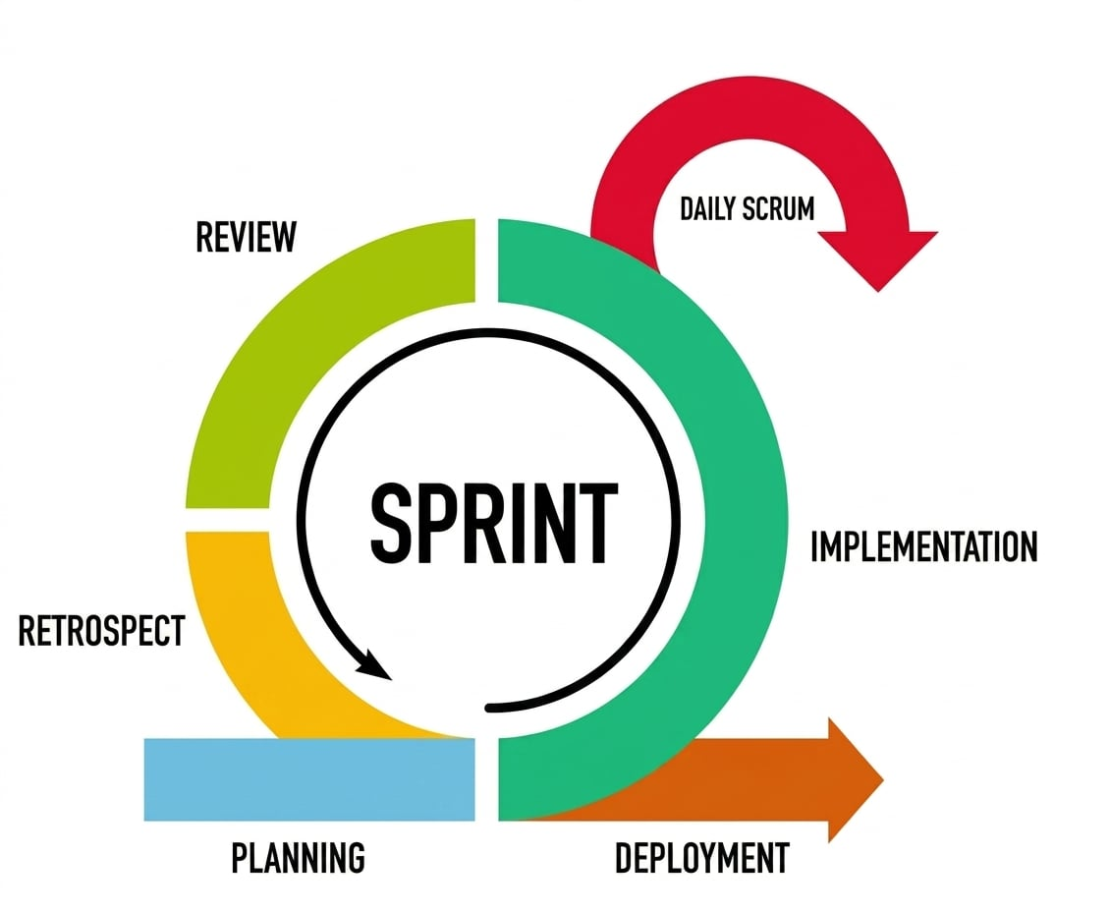
Figure 1
Agile Methodology (Scrum Framework)
Phase 1: Requirement Analysis/ Planning
This phase involves outlining the project goal, gathering information and expectations, and identifying potential issues that must be addressed during development. This phase defines the system, subsystem, and unit requirements.
The researchers gathered the information and take note of the client’s problems, solutions, how this project would address them, and the specific tools for development. Data for the study was gathered through interviews and observations to define the functional and non-functional requirements of the system. For this project, the researchers interviewed the Bookkeeper about their business processes and problems. The information gathered was compiled and then assessed for the problems of the Bookkeepers in the Municipality of Sipocot.
The researchers then used all the gathered data to identify the tools, software and hardware requirements presented in the table below. The requirements are based on the specifications of the identified software needed to develop the system.
Table 1.1
Software Requirements
Software | Minimum | Recommended
Browser | Any browser
Operating System | Any operating system that supports online browsing
Web hosting | Any compatible hosting provider
Text Editor | Visual Studio Code
Database Management System (DBMS) | PostgreSQL
Programming Language | JavaScript, ReactJS, NodeJS
Table 1.2
Hardware Requirements
Hardware | Minimum | Recommended
RAM | At least 4GB | 8GB and above
Disk Space | 256 HDD | 500 HDD and above
Processor | At least Quad Core | Octa Core and above
Network Connectivity | Internet connection with 4G connectivity | Fiber optic connection with 100Mbps and above
The tables present the software and hardware requirements necessary for the effective development and implementation of the proposed system. Table 1.1 outlines the software requirements, which include essential tools and platforms needed to build and run the system. A web browser is required to access the system, while any operating system that supports online browsing ensures compatibility across different devices. Web hosting is necessary to deploy the system online, making it accessible to users. For development purposes, a text editor such as Visual Studio Code is utilized to write and manage the source code. The system also requires a Database Management System (DBMS), specifically PostgreSQL, to store and manage data efficiently. Additionally, programming languages such as JavaScript, ReactJS and NodeJs are used to develop the system’s functionality and user interface.
On the other hand, Table 1.2 presents the hardware requirements, which specify the minimum and recommended specifications for optimal system performance. The system requires at least 4GB of RAM, although 8GB or higher is recommended for smoother operation. In terms of storage, a minimum of 256GB HDD is needed, while 500GB or more is preferred to accommodate larger data and system files. The processor should be at least a quad-core to handle system processes efficiently, with an octa-core processor recommended for better performance. Lastly, stable network connectivity is essential, with a minimum requirement of an internet connection with 4G capability, while a fiber optic connection with at least 100 Mbps is recommended to ensure faster data access and reliable system usage.
In addition, the researchers created a Gantt chart, shown in Figure 3.2, to help with project development. The timelines established critical milestones in the system’s development and kept tasks on track until the researcher’s deadline.

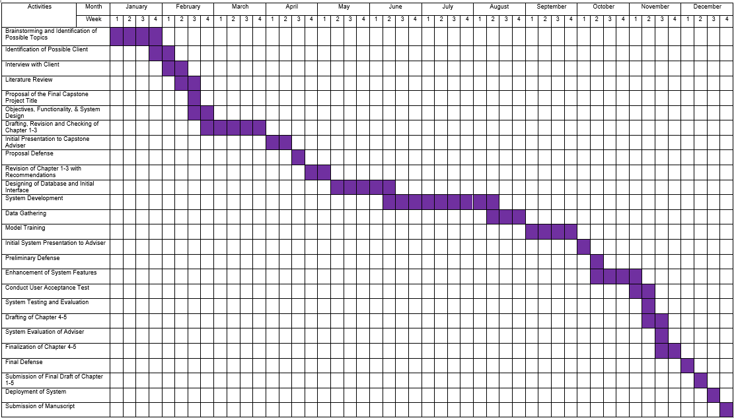

Figure 3.2
Gantt Chart of “Digibok: Web-based Bookkeeping Management System in the Municipality of Sipocot”

Phase 2: Implementation
This phase focuses on user design, creating models and diagrams to visualize the system’s process and architecture, and demonstrating how the system works. The design phase assesses and analyzes the system’s requirements and architecture. After carefully reviewing the collected data, the researchers were required to create the project’s system architectures and models. The required information is converted into a design, which then is used to create the system interface.
The design of the system architecture, as shown in Figure 3.3 was formulated after the researchers had acquired knowledge on the business process being under taken by the Bookkeeper, the individuals involved in the process, and the gadgets utilized. The given architectural model is a blueprint that guides data flow and interactions among the system elements. It will make sure that every operation on the proposed system is customized to the requirements of the users and the office process.

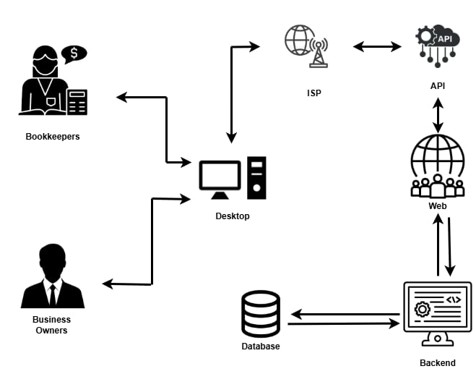
System Architecture

Figure 3.3
System Architecture of Digibok: Web-based Bookkeeping Management System in the Municipality of Sipocot
The figure presents how the system’s follows a client-server, web-based structure designed to efficiently manage financial data and user interactions. The system is primarily used by two types of users: bookkeepers and business owners. Bookkeepers are responsible for recording and managing financial transactions, while business owners access the system to monitor reports and overall business performance. Both users interact with the system through a desktop-based interface, which serves as the client layer where data is entered and displayed.
The communication between the users and the system is facilitated through an Internet Service Provider (ISP), which acts as the medium for transmitting data over the internet. Once a request is made from the desktop interface, it is sent to the web layer, which functions as the hosting environment or web server. This layer receives and directs the requests to the appropriate application components. The system uses an Application Programming Interface (API) as an intermediary that ensures secure and structured communication between the web interface and the backend. The API handles requests such as data retrieval, submission, and validation.
At the core of the system is the backend or application layer, which processes all user requests and implements the business logic of the application. This includes tasks such as recording transactions, generating financial reports, and managing user accounts. The backend communicates directly with the database layer, where all relevant data—such as financial records, user information, and transaction histories—is stored and managed. The database ensures centralized and organized data storage, allowing efficient retrieval and updates. After processing, the results are sent back through the same layers—from the database to the backend, through the API and web server, and finally back to the user interface—providing users with accurate and real-time information. This layered architecture enhances the system’s scalability, security, and accessibility, making it a reliable solution for bookkeeping management in the Municipality of Sipocot.

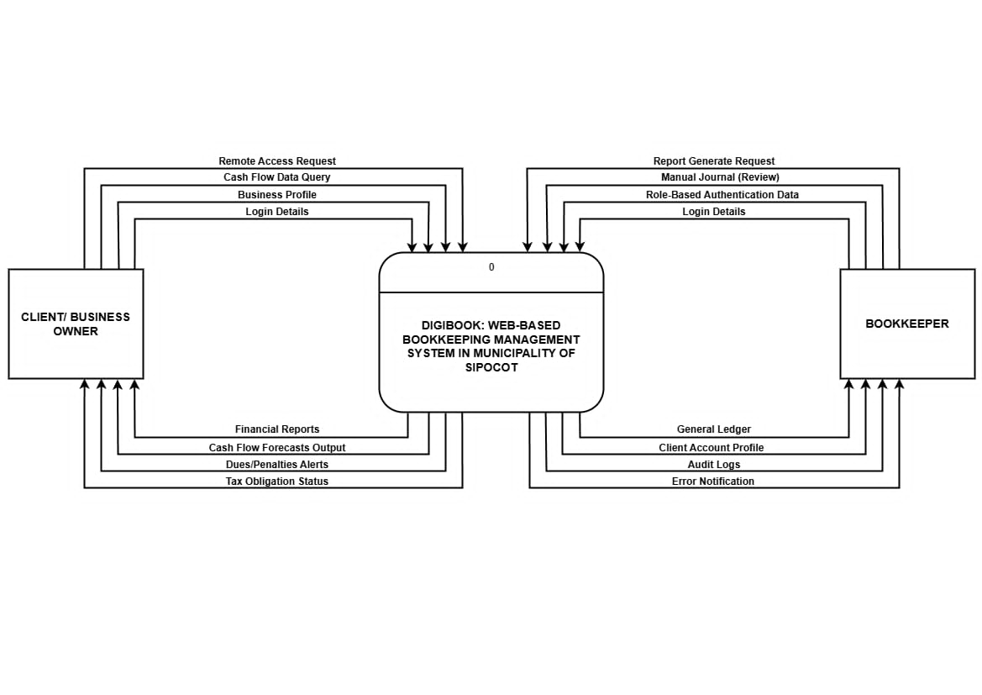

Figure 3.4
Level 0 or Context Diagram of Digibok: Web-based Bookkeeping Management System in the Municipality of Sipocot
Digibook is a web-based bookkeeping management system designed for the Municipality of Sipocot that seamlessly bridges the gap between local business owners and their bookkeepers. Clients can securely log into the platform to set up their business profiles, request remote access, and easily query their cash flow data. In return, the system empowers these business owners by providing them with clear financial reports, cash flow forecasts, timely alerts for dues or penalties, and updates on their tax obligation status.
Meanwhile, bookkeepers securely access the platform using role-based authentication to review manual journals and request the generation of official reports. To support their daily administrative tasks, Digibook equips the bookkeepers with comprehensive general ledgers, detailed client account profiles, audit logs for tracking activity, and instant error notifications. Ultimately, this digital ecosystem streamlines financial management by ensuring both parties have exactly the real-time data they need to stay organized and compliant.

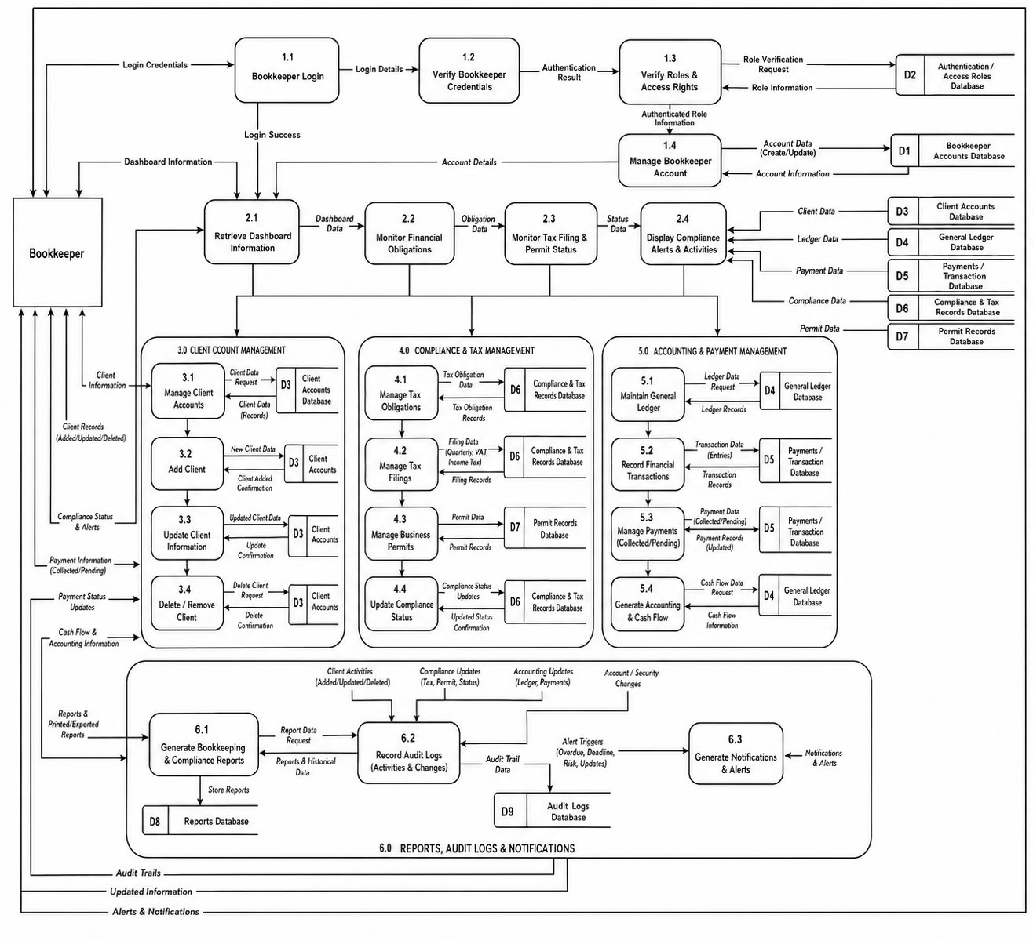

Figure 3.4.1
Part 1 of Level 1 DFD of Digibok: Web-based Bookkeeping Management System in the Municipality of Sipocot
The Data Flow Diagram (DFD) illustrates how data moves within the Digibok: Web-based Bookkeeping Management System, focusing on the interactions between the bookkeeper, system processes, and databases.
The process begins with user registration, where the bookkeeper submits an application by filling out the application form (Process 1.0). The system then verifies the submitted details (Process 1.1), and once validated, creates a bookkeeper account (Process 1.2). The account information and application status are stored in the Bookkeeper Accounts database (D1). After registration, the bookkeeper can log in to the system (Process 2.0) by providing login credentials, which are verified. The system then checks the user’s access permissions through role verification (Process 2.1), retrieving role data from the Access Roles database (D3) to ensure proper authorization.
Once authenticated, the bookkeeper can perform core bookkeeping functions. One of the main processes is maintaining the general ledger (Process 3.0), where financial transactions are recorded and stored in the General Ledger database (D4). The bookkeeper can also manage client accounts (Process 3.1), which involves adding new clients (Process 3.2), updating existing client information (Process 3.3), and deleting client records (Process 3.4). All client-related data is stored and managed in the Client Account database (D5).
In addition, the system supports report generation (Process 4.0), where bookkeeping reports and cash flow forecasts are created based on stored financial data. These reports are then linked to audit logging and notification management (Process 4.1), ensuring that all activities are tracked and recorded in the Audit Logs database (D7). This helps maintain transparency, accountability, and system monitoring.
Overall, the DFD demonstrates a structured flow of data from user input to system processing and storage, highlighting how Digibok ensures secure account management, efficient bookkeeping operations, and reliable reporting through interconnected processes and databases.

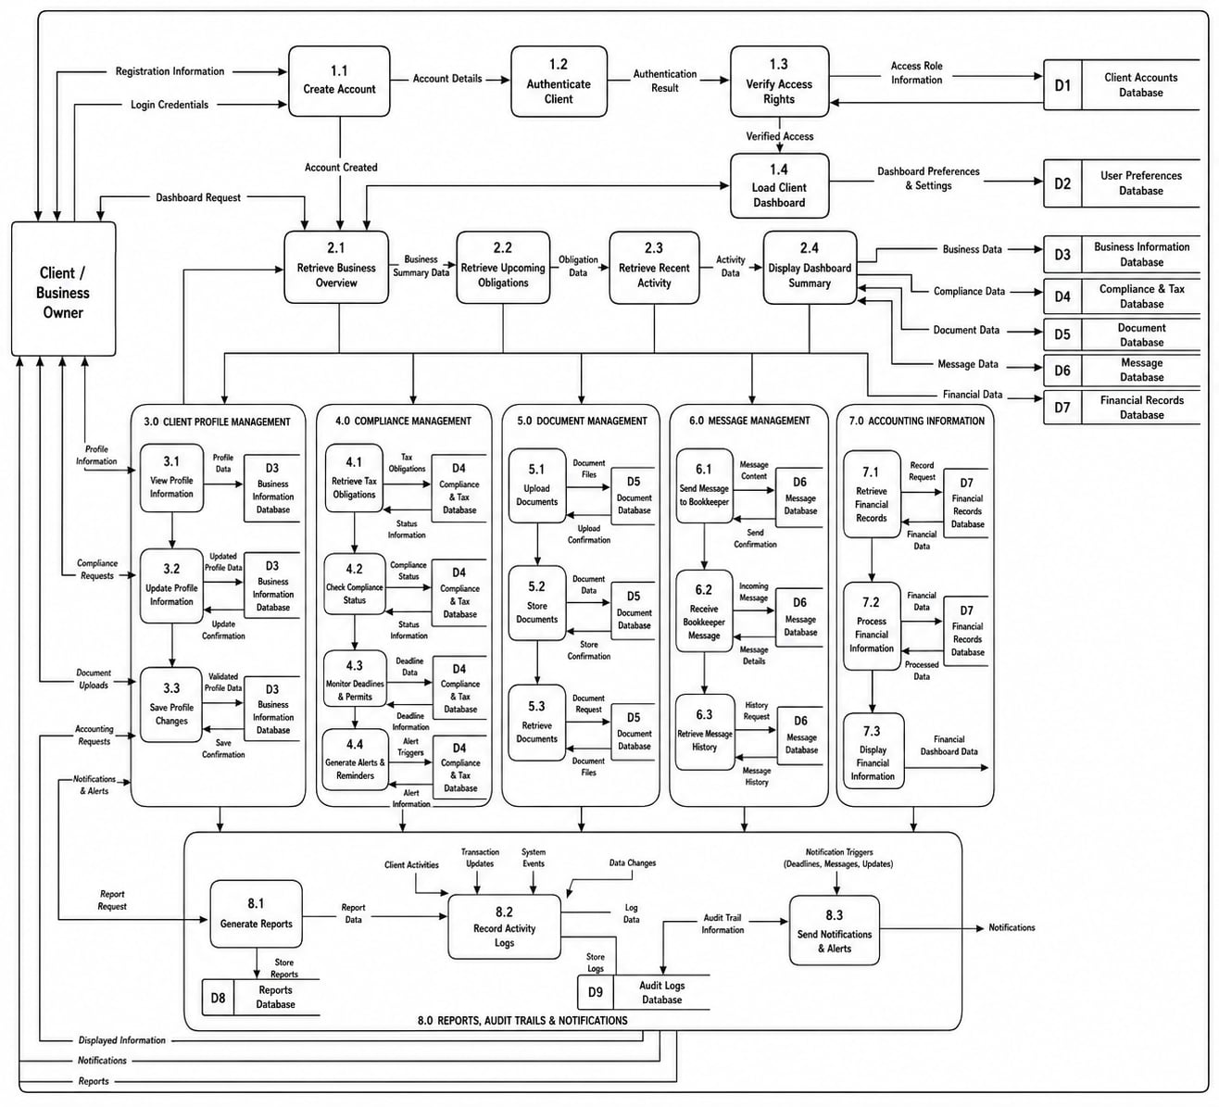

Figure 3.4.2
Part 2 of Level 1 DFD of Digibok: Web-based Bookkeeping Management System in the Municipality of Sipocot
This Data Flow Diagram (DFD) represents the interaction between the client/business owner, system processes, and databases in the Digibok system, focusing on financial monitoring, tax compliance, and notification services.
The process begins with account creation and authentication. The client or business owner registers by providing business profile information through the “Create Account” process (1.0), and this data is stored in the Client Database (D1). After registration, the user logs in through the “Authenticate Client” process (1.1), where login details are verified. A verification request is processed, and the verification status is sent back to the user, often through the Email Notification Database (D2), ensuring secure access to the system.
Once authenticated, the client can access financial reporting features. Through the “Financial Reports” process (2.0), users can view different types of financial data. This includes viewing cash flow dashboards (2.1), financial reports (2.2), and cash flow forecasts (2.3). These processes retrieve and analyze financial data stored in the Financial Records Database (D3), allowing users to monitor real-time financial performance and make informed decisions.
The system also provides tax compliance and obligation tracking. The client can check their tax status through the “View Obligation Status” process (3.0), which retrieves and records tax-related data in the Tax Compliance Records Database (D4). For more detailed needs, users can request tax or permit-related data through the “Process Tax/Permit Data Requests” process (3.1). These requests are logged in the Compliance Request Log (D5) and may also involve retrieving information from the Permit Records Database (D6).
Additionally, the system includes a notification and alert mechanism. The “Send Dues Alerts” process (3.2) monitors compliance and generates alerts for dues, penalties, or deadlines. Notifications are stored and managed in the Email Notification Database (D2) and sent to the client to ensure they remain updated on their obligations.
Overall, this DFD shows how the system integrates user authentication, financial data processing, tax compliance monitoring, and automated notifications. It highlights a structured and efficient data flow where information is securely stored, processed, and delivered to support business owners in managing their finances and meeting regulatory requirements.

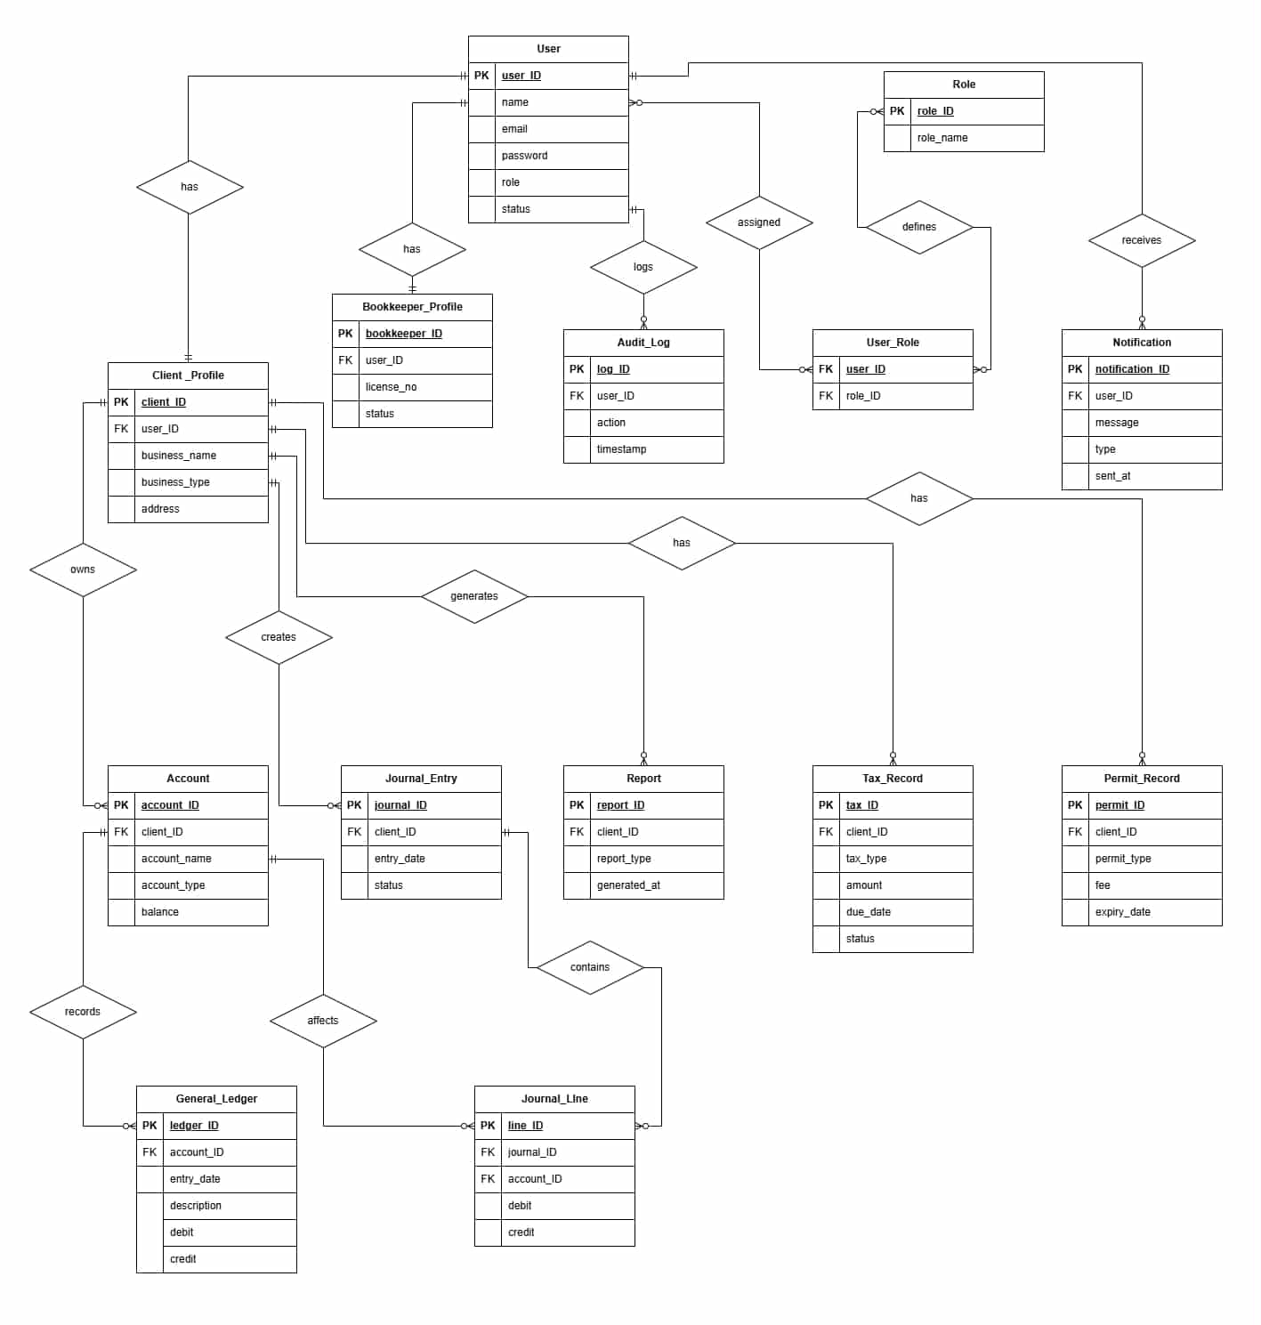

Figure 3.5
Entity Relationship Diagram of Digibok: Web-based Bookkeeping Management System in the Municipality of Sipocot
The Entity Relationship Diagram (ERD) illustrates the structure of the Digibok system database, showing how different entities (tables) are related to support bookkeeping, user management, and compliance tracking.
At the center of the system is the User entity, which stores general user information such as user ID, name, email, password, role, and status. A user can either be a client (business owner) or a bookkeeper, and this distinction is represented through two related entities: Client_Profile and Bookkeeper_Profile. Each profile is linked to the User table through a foreign key (user_ID). The Client_Profile contains business-related details such as business name, type, and address, while the Bookkeeper_Profile includes professional information like license number and status.
Users are also associated with roles through the User_Role entity, which connects users to the Role table. The Role entity defines different system roles (e.g., bookkeeper, client), enabling role-based access control. Additionally, user activities are tracked in the Audit_Log, which records actions performed by users along with timestamps, ensuring accountability and system monitoring.
For communication, the Notification entity stores messages sent to users, including the message content, type, and timestamp. Each notification is linked to a specific user, allowing the system to send alerts such as reminders or updates.
The system’s core bookkeeping functionality revolves around financial data. A client owns multiple Accounts, which store account details like account name, type, and balance. These accounts are used in recording transactions. The Journal_Entry entity represents individual transaction records created by the client, while the Journal_Line entity breaks down each journal entry into detailed debit and credit lines linked to specific accounts. These entries affect the General_Ledger, where all financial transactions are recorded for long-term tracking and reporting.
The system also generates Reports, which are linked to clients and contain summarized financial information such as financial statements or performance reports. These reports are derived from the recorded financial data.
In addition to bookkeeping, the system manages compliance-related data. The Tax_Record entity stores tax-related information such as tax type, amount, due date, and status, while the Permit_Record entity keeps track of business permits, including permit type, fees, and expiration dates. Both are associated with the client, ensuring that business owners can monitor their legal and regulatory obligations.
Overall, the ERD shows a well-structured relational database where users, financial transactions, reports, and compliance records are interconnected. This design supports efficient data management, accurate bookkeeping, secure user access, and comprehensive monitoring of business and regulatory activities within the Digibok system.

NOTES
Coronel, C., & Morris, S. (2018). Database systems: Design, implementation, and management (13th ed.). Cengage Learning. https://drive.google.com/file/your-link-to-erd/view

Digibook Development Team. (2026). Context level diagram of the Digibook system [System diagram]. Bicol State College of Applied Sciences and Technology. https://drive.google.com/file/your-link-to-context-diagram/view

Digibook Development Team. (2026). Bookkeeper workflow process diagram [System diagram]. Bicol State College of Applied Sciences and Technology. https://drive.google.com/file/your-link-to-bookkeeper-workflow/view

Digibook Development Team. (2026). Client and business owner workflow process diagram [System diagram]. Bicol State College of Applied Sciences and Technology. https://drive.google.com/file/your-link-to-client-workflow/view

Ferraiolo, D. F., Kuhn, D. R., & Chandramouli, R. (2003). Role-based access control (2nd ed.). Artech House. https://doi.org/10.5296/ijafr.v10i2.17052

Kendall, K. E., & Kendall, J. E. (2019). Systems analysis and design (10th ed.). Pearson. https://drive.google.com/file/your-link-to-context-diagram/view

