Response of Stream Macroinvertebrate Community to Canopy-opening Manipulations

Cedar Mackaness

June 15, 2019

Stream light availability is an important factor influencing aquatic food webs. In forested headwaters, stream algal production is highly light-limited, and an increase in light often enhances benthic algal growth, which in turn increases food availability for primary consumers in the stream. In forested headwater streams, light availability is almost entirely mediated by the canopy structure of stream-side vegetation. Over the last century, many streamside forests in the Pacific Northwest were heavily harvested, leaving dense regenerating stands for the time being. Under current conditions, the dense closed canopies, allow for limited primary production, and a low abundance of invertebrates that feed on stream algae. We investigated the response of benthic periphyton, stream macroinvertebrates, and prey consumption by trout to a release from light limitation in a paired-reach study design. We hypothesized that increased light availability promotes elevated algal production which causes the invertebrate community to shift toward scraper dominance, and predicted that this change in community structure is detectable in the diets of trout. We found that the presence of a canopy gap had little influence on the invertebrate community, and this lack of change was not being masked by increased consumption of grazing invertebrates in summer trout diets.

# Introduction

In forested systems, streams and their biota are intrinsically linked to riparian vegetation (Vannote, Minshall, Cummins, Sedell, & Cushing (1980)). Stream food webs depend on direct carbon subsidies from the terrestrial environment in the form of both leaf litter and terrestrial invertebrates (Wipfli (1997)), but riparian controls on stream systems aren’t limited to organic inputs. Riparian canopy cover also has an indirect effect on stream food webs by limiting light available for benthic primary production. In the Pacific Northwest (PNW) region of North America, riparian forests have changed substantially in the past half century. In response to a legacy of heavy harvesting (Pan et al. (2011)), riparian forest protections have created dense regenerating vegetation along streams in contrast with structurally complex old-growth forests containing multiple canopy gaps (D. R. Warren et al. (2016)). The dense vegetation in these regenerating forests decreases light availability and limits benthic primary production (M. J. Kaylor, Warren, & Kiffney (2017)). As forest stand development continues natural disturbances and individual tree mortalities will increase canopy heterogeneity through the introduction of gaps. To understand how aquatic food webs respond to an increase in light associated with canopy gaps, we investigate the response of macroinvertebrates and fish feeding to canopy-opening manipulations.

Light, and its impact on primary productivity in streams is of particular interest because autochthonous carbon can be disproportionately represented in consumer biomass relative to its availability in aquatic systems (Lau, Leung, & Dudgeon (2009), McCutchan & Lewis (2002)). In forested headwaters specifically, basal carbon availability is dominated by leaf litter (McCutchan & Lewis (2002)); however, energetically, algae is a higher quality food source and is preferentially assimilated into higher trophic levels (Macarelli & others (2011)). Primary consumers mediate basal carbon availability for higher trophic levels and, in streams, primary consumers are dominated by macroinvertebrates, a major food resource for insectivorous fish. Because macroinvertebrates play a crucial role in mediating food web interactions, understanding their community dynamics and functional diveristy can provide key insights into broader ecosystem functioning. Invertebrates in the scraper functional feeding group in particular have evolved specialized mouthparts for consuming benthic algal biofilms (periphyton), and increases in algal production in high light areas can elicit a positive response among these scraping taxa (Liess, Le Gros, Wagenhoff, Townsend, & Matthaei (2012)).

Macroinvertebrate community data have historically been used to evaluate stream health. Indicies such as the B-IBI (benthic index of biological integrity) rely on total taxa richness and taxa richness of key families, such as Ephemeroptera, Plecoptera and Trichoptera (EPT taxa) to evaluate the biological condition of streams. Other indicies such as the EPT index focus on proportional abundance of taxa known to be sensitive to environmental disturbances. More broadly, an assesement of the whole community can be used to evaluate overall food web and ecosystem responses to a multitude of variables. For example, studies using nonmetric multidimensional scaling (NMS) have assessed community responses along a variety of environmental gradients (M. B. Cole, Russell, & Mabee (2003), Purcell et al. (2009)).

In headwater streams, the benthic invertebrate community represents the primary food source for trout, although this may vary seasonally (Syrjänen, Korsu, Louhi, Paavola, & Muotka (2011)). Interspecific interactions between trout and invertebrates can alter the benthic community as trout foraging (Dahl (1998)), or presence selects against invertebrates vulnerable to trout predation (Peckarsky & McIntosh (1998)). Depending on the taxa present, top-down pressures on the invertebrate community may relieve algae from invertebrate grazing. In headwater streams trout are oportunistic foragers, and consumption tends to be biased against large invertebrates. Additionally, cutthroat trout, the dominant fish species in Cascade headwaters, are visual predators typically feeding from the water column. Because salmonids are visual predators, their feeding efficiency can be influenced by light conditions and visibility (Wilzbach, Cummins, & Hall (1986)), therefore gaps have the potential to affect fish feeding not only though potential increases in scraper invertebrate food resources, but also by increasing foraging capture rates of all taxa and functional feeding groups.

Clear-cut harvests without buffers and the resultant reach-level increase in stream light can increase stream primary and secondary productivity, but increases in light also lead to increases in temperature, and cutting to the stream edge can increase sediment loads. Given these negative impacts, clear-cutting adjacent to streams is no longer a common practice in the Pacific Northwest. In unmanaged forests, and in recently implemented riparian buffers, stands are recovering from past land clearing, and are currently in the early to mid-seral stage of development with dense homogenous canopy cover and low stream light (M. J. Kaylor et al. (2017)). Canopy gaps will begin developing naturally along streams as stands mature, and restoration efforts focused on emulating natural disturbance may expedite forest shifts toward late-succession and old-growth structural conditions (Kreutzweiser, Sibley, Richardson, & Gordon (2012)). While studies on reach-scale forest clearing demonstrate a clear response in benthic primary producers, invertebrates, and trout to release from light limitation (Murphy & Hall (1981)), this does not reflect future riparian conditions in most forested landscapes. Rather, as stands progress toward late succesional forest structure, localized light patches (as opposed to large openings) will become increasingly prevelant. The more moderate influence of these small canopy gaps on stream ecosystems has not been widely investigated, especially in an experimental context.

We implemented a two-year long before-after, control-impact study designed to detect and accurately capture the effect of canopy gaps on aquatic ecosystems. In this work, we hypothesized that primary production would increase when canopy gaps were created, and this would cause the invertebrate community to shift toward more scraping taxa. However, we expect the response to be dampened in comparison to observed responses in large scale riparian clearing studies. In addition to evaluating the macroinvertebrate community, we quantified trout diets with the expectation that shifts in the invertebrate community would be reflected proportionally in the diet of opportunistic foraging of trout, but also to ensure that a potential signal in invertebrate scraper taxa was not being masked by increased foraging of apex consumers.

# Methods

## Study location

The study consisted of five reach pairs on five replicate streams in the western Cascade Mountains of Oregon. Each reach pair consisted of one treatment reach and one reference reach. Two of the reach pairs (W-100, W-113) were located on private Weyerhaeuser Co. land, and three (LOON, CHUCK, MCTE) are located on U.S. Forest Service land, one of which (MCTE) was situated in the HJ Andrews Experimental Forest. Stream reaches were 90 meters in length and treatment gaps were 20 to 40 meters in diameter and situated approximately around meter thirty of treatment reaches. Sites had a buffer between stream reach pairs to limit any effects of the upstream reach on downstream conditions.

All of the streams are wadeable, fish-bearing streams with bankfull widths of 1-6 meters. Fish-bearing streams were purposefully selected to provide management-relevant results for key species such as salmonids. Additionally, streams of this size comprise roughly 70% of total stream length in forested catchments. The streams run through 40-60-year-old riparian forests regenerating from previous harvest. These early to mid seral stage forests have a homogenous canopy structure with heavy understory shading. Small streams also provide ease of sampling and maximize the effect of a canopy opening manipulation since small streams may be completely shaded by overhead vegetation due to their high edge to area ratio.

## Study Design

The before-after, control-impact (BACI) study design lends itself to experimental field studies by accounting for natural variations between sites. By taking the difference of a given variable between the paired reaches and comparing the change in the difference from pre to post-treatment years, we account for both spatial and temporal variation. For the BACI analyses, a sample unit refers to a whole stream including both treatment and reference reaches because the metric of interest for BACI is the difference between the two reaches. Therefore, we have five sample units with two repeated measures, pre and post-treatment. To test for effects of the gap treatment, we quantify and assess changes in the reach differences between the two years. Pre-treatment data were collected during summer 2017 and post-treatment data were collected during summer 2018. Canopy gaps were cut in the treatment reach during the winter of 2017-18 to permit adequate time for response to the canopy manipulation at all sites besides MCTE. At MCTE gaps were cut at the end of summer 2017 after data collection.

## Data Collection

### Light

Daily, photosynthetically active radiation (PAR) was estimated from fluorescein decay rate over a twenty-four hour period following methods in D. R. Warren, Keeton, Bechtold, & Rosi-Marshall (2013). fluorescein dyes were prepared by diluting to 400 g L-1 with DI water and buffering with 40 g L-1 of aquarium salt. Once the dye was prepared, we filled 3.7mL glass vials and stored them in the dark until deployment. At each study reach hree replicate vials were deployed every five meters on the streambed, and retrieved twenty-four hours later. Because fluorescence of fluorescein changes with temperature (Bechtold, Rosi-Marshall, Warren, & Cole (2012)), vials were left in the dark until they reached room temperature. fluoresence was then measured using a fluorometer (Turner Designs, San Jose, California), and the twenty-four hour decay rate was converted to daily photosynthetically active radiation (PAR) using the relationship in (D. R. Warren, Collins, Purvis, Kaylor, & Bechtold (2017)).

### Chlorophyll *a*

In each study reach, three ceramic tiles (15 cm x 15cm) were placed every 10 meters and left for 4 weeks before they were collected to allow periphyton communities to establish. Tiles were placed in riffle sections at a depth of 10-25 cm to keep them from silting over. All tiles were deployed in mid-July, and the tiles were deployed at the control and treatment reaches of each stream at the same time to keep within unit measures consistent. After collection, tiles were kept in the dark, submerged in water for two hours to avoid potential photosaturation issues with the *in situ* chlorophyll *a* measurements Chlorophyll *a* (abbreviated as Chla for the remainder of this text) concentrations were then quantified using a BenthoTorchTM (BBE Moldaenke GmbH), a portable field instrument used for the quantification of chlorophyll *a* fluorescence.

### Benthic Invertebrate Sampling

Three benthic invertebrate samples were taken at each stream reach at meters 15, 45 and 75, or the closest area with non-boulder substrate. Samples were collected once per year over the course of one week using a Surber sampler with a .09 m2 sampling area. Substrate was disturbed to a depth of approximately four inches for one minute. The sample was then preserved in 95% ethanol for identification and enumeration in the lab.

In the lab, the three benthic samples per reach were combined into a single pooled sample for each reach. The pooled sample was then subsampled using a Caton tray. Squares $\frac{1}{30}$ the area of the Caton tray were randomly sampled until the cutoff of 300 individuals or greater was reached. Benthic invertebrates were then identified down to genus or the lowest taxonomic unit (LTU) for cryptic taxa such as Chironomidae primarily using Merritt, Cummins, & Berg (2008). Counts from subsamples were then converted to densities using the following formula:

$$\frac{1}{3*s*0.09}$$

where $s$ is the fraction subsampled, 0.09 is the area of the Surber sampler in square meters, and the result is divided by three because three samples from meters fifteen, forty-five and seventy-five were pooled.

For community analyses, singleton taxa (taxa occurring in only one reach) were removed from the original matrix and density values were log transformed to reduce the effect of abundant taxa (Chironomidae, *Baetis*, *Micrasema*) on community relationships by applying the formula:

$$\log_{10}(n+1)$$

where $n$ is the density value per square meter for a given taxon. The resulting matrix of benthic invertebrates at the LTU level of identification (20 reaches by 64 taxa) was then used for analysis. Functional feeding groups (FFG) were assigned using the feeding habits of each taxon as identified in Merritt et al. (2008), and raw density values were used for FFG analyses because sparse or hyper abundant groups were less of a concern with aggregate functional groups.

During Chla tile collection at the two streams with snails as the dominant scraper, the number of snails (Juga) and cased caddisfly (observed taxa being primarily Uenoidae and Glossosomatidae) on each tile were recorded and then removed before taking chlorophyll readings with a BenthoTorchTM.

### Trout Diets

Trout diets were collected during the post-treatment year. Trout diets were collected during three-pass depletion for fish population estimates and were only taken from a subset of fish greater than 80 mm in length. Fish were anesthetized and gastric lavaged. Stomach contents were evacuated by injecting water into the fish stomach using a piece of small plastic tubing attached to a syringe. Diet samples were collected in filter paper and preserved in 95% ethanol for lab processing.

All trout diets were processed (9 to 13 diets per reach) with aquatic invertebrates identified down to the family level and terrestrial invertebrates identified to order. Because the number of fish dieted in each reach varied, the average of all fish diets was used. The resulting matrix was then filtered for aquatic species and appended to a matrix of 2018 stream benthic invertebrate families (10 reaches by 38 families), producing a matrix of 20 sample units (SU’s) by 40 families consisting of both fish diets and benthic samples. Singleton taxa were then removed to create a matrix of combined diet and benthic families of 20 SU’s by 36 families. At this point, the combined matrix was relativized by row maxima to compensate for the difference between benthic sampling—measured in density per m2—and fish diets.

## Data Analysis

### BACI Analysis

The BACI analysis was performed in R (R Core Team (2018)), and consisted of calculating reach-pair differences by subtracting the control reach value from the treatment reach value. Reach differences were calculated for light, Chla, Ephemeroptera, Plecoptera, Trichoptera, (EPT) index (Wallace, Grubaugh, & Whiles (1996)), total invertebrate density and invertebrate densities by functional feeding group. A paired t-test with 4 degrees of freedom was then performed for each metric by subtracting the reach difference from the pre-treatment year from the reach difference in the post-treatment year for each stream assuming the difference between the two reach differences should be zero if the treatment had no effect.

### Community Analysis

Community analyses were performed in PC-ORD (McCune & Mefford (2016)) and R (R Core Team (2018)) using the Vegan package (Oksanen et al. (2018)). Blocked multi-response permutation procedure (MRBP) was used to assess differences between treatment and control reaches in the pre and post treatment years. MRBP was followed up with blocked indicator species analysis (ISA) to determine underlying taxa driving any grouping detected by MRBP. The combined benthic and diet community matrix was subsequently tested for any differences between treatment and control reaches and benthic versus diet taxa representation using the same MRBP and ISA methods.

To test for any pre-treatment reach differences in 2017, MRBP was run on 2017 data only with treatment and reference as the two *a priori* groups and blocked by stream. The 2018 post-treatment data were then assessed using the same MRBP grouping and blocking. MRBP is a nonparametric method used to test for differences between groups. This method accommodates paired or blocked study designs by accounting for variation related to study design variables that have little bearing on the question being addressed. In this case, MRBP accounts for any between-stream variation. MRBP outputs a p-value for the observed within-group distance (smaller distances constituting stronger grouping) by shuffling SU’s between groups to generate a distribution of possible within-group distances (McCune, Grace, & Urban (2002)).

The follow-up ISA calculates an indicator value (IV) for each species. The IV is a composite of a taxon’s fidelity and exclusivity to a group. A taxon consistently abundant in one group and never present in any other, would receive a high IV. Conversely, a taxon rarely abundant in SU’s of one group and present in other groups would receive a low IV (McCune et al. (2002)). A Monte Carlo test of 1,000 permutations of the taxa matrix was used to generate a p-value for each taxon’s IV.

Nonmetric multidimensional scaling (Kruskal (1964)) was used to assess residual variation in the treatment and control reach communities, and quantify the relationship between the synthetic community variables extracted from the ordination axes and environmental variables such as Chla. Sorensen distance was used for both ordinations to reduce the impact of outliers. The ordination was rotated to maximize the environmental variable Chla along axis 1. A random start was used and the real data were run 250 times to ensure an absolute stress minima was reached. A Monte Carlo test with 100 permutations was used to generate a p-value for the the final ordination having a lower than expected stress value based on chance alone.

### Analysis of Trout Diets

Trout diets were collected in the post-treatment year, which limits analysis to a comparison of reference versus treatment reaches without the control on inherent reach differences. We performed paired t-tests for the abundance of each functional feeding group represented in the diets of trout in the reference and the treatment reach, and on the modified Ivlev’s selectivity index (D) (as defined in Jacobs (1974)) for each FFG. The selection index D measures preferential consumption or avoidance using the formula:

$$\frac{(r−p}{r+p−2rp}$$

where a zero represents neutral selection (ie the prey is consumed in equal proportion to its availability).

# Results

## Light and Chlorophyll

In 2017, before treatment, the average daily PAR reaching the stream benthos among the five streams was consistently low (between 0.9 and 1 $mol/m^{2}$ on average) with an average difference between the treatment and reference reach of -0.16 mol m-2 day-1. In 2018, after gaps were cut, light went up by 2.60 mol m-2 day-1 on average in the treatment reach compared to the reference reach (Figure 1) resulting in a final yearly difference between reach differences of 2.77 mol m-2 day-1 (p-value = 0.019, t-value = -3.83).

Again, for Chla, values across all sites in the pre-treatment year were low (mean = 0.095 ug cm-2), and there was little difference between reaches. After gaps were cut in the post-treatment year, Chla values went up by 0.44 ug cm-2 in the gap reach, and only 0.175 ug cm-2 in the reference reach (final BACI difference = 0.265 ug cm-2, p-value = 0.002).

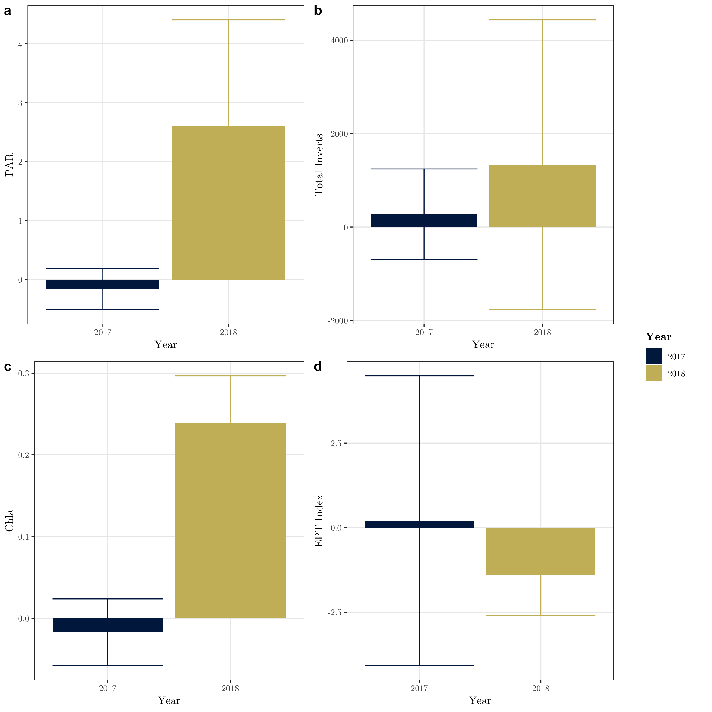

Figure 1: Light, Chla, total invertebrate abundance, and EPT index reach differences in the pre and post-treament years

## *Juga* on Tiles

In the pre-treatment year, the average density of *Juga* on tiles among the two streams with *Juga* present was 24.44 snails per m2 with little difference between the control and treatment reaches. In the post treatment year the average snail density in the treatment reach increased by 204.44 snails per m2, whereas snail density in the control reach only increased by 88.89 snails per m2. Snail abundance at these two streams was moderately associated with Chla (r2 = 0.3204, p = 0.00547), but saw the largest BACI response in meters ten and twenty, slightly upstream of the gap treatment.

## Benthic Invertebrate Community

The EPT index did not change appreciably between years, and there was little difference between benthic invertebrate communities in the treatment and reference reaches in the pre-treatment year (MRBP: A = 0.041, p = 0.071), or the post-treatment year (A = -0.022, p = 0.838). The indicator species analysis confirmed the lack of grouping from MRBP by not identifying any taxa with significant changes in fidelity or exclusivity in response to the treatment. The results from the NMS ordinations support the results of the MRBP and ISA (Figure 2).

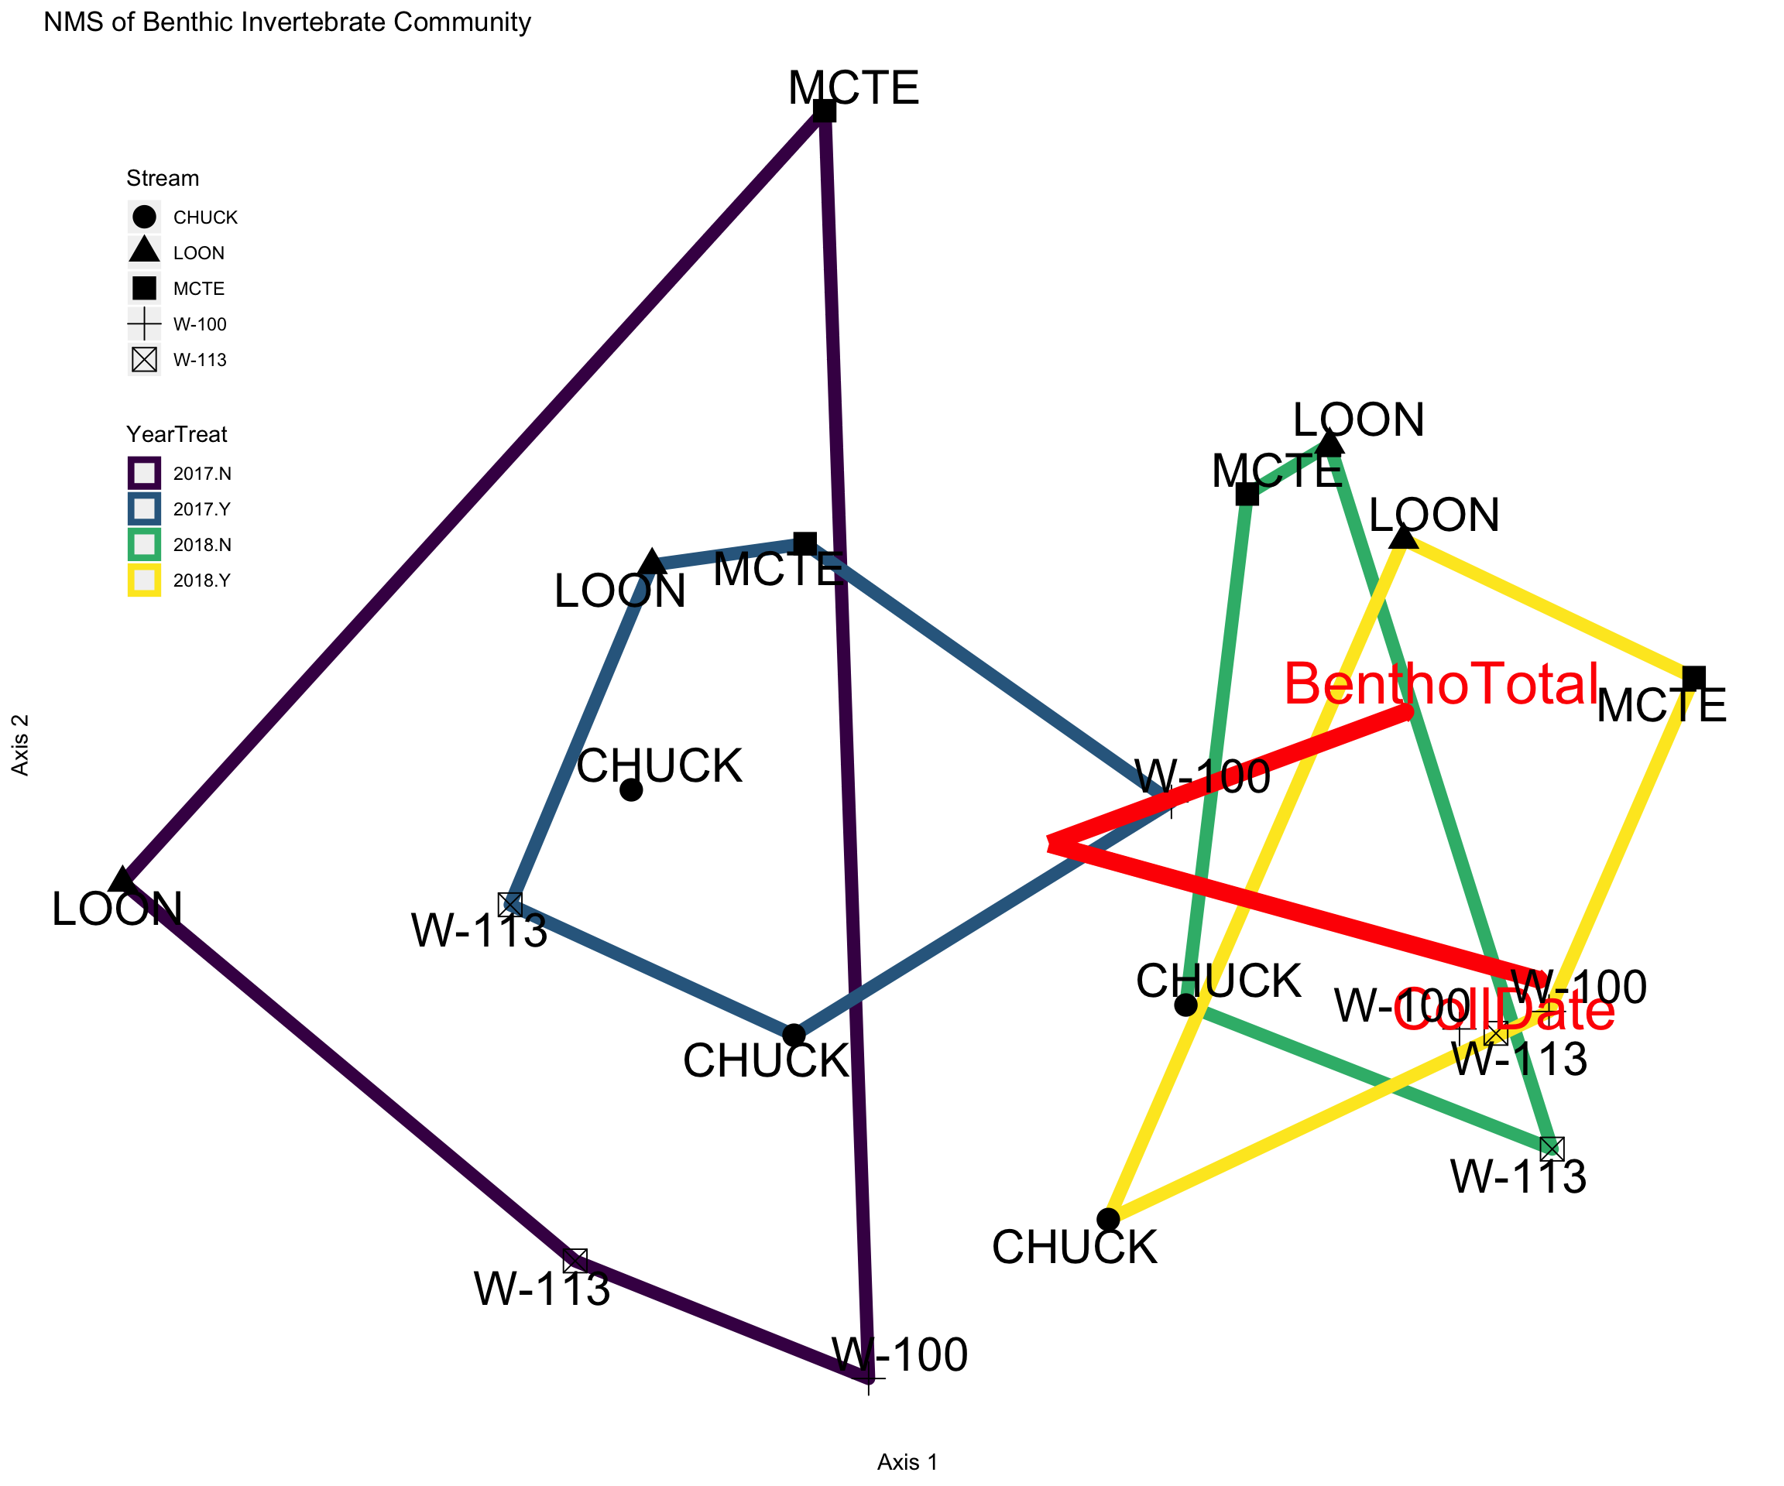

Figure 2: NMS of each reach in invertebrate community space. Each point represents a single stream reach, shapes identify stream, and color identifies treament and year.

The NMS ordination of benthic invertebrates converged on a 2D solution with a final stress of 12.031. BenthoTotal (total chlorophyll values from the BenthoTorch) and CollDate (a binary variable coded with 1’s for 2018 and 0 for 2017) both had positive r2 values with axis 1 (CollDate r2 = 0.83, BenthoTotal r2 = 0.34). An additional explanatory variable, YearTreatQ, was regressed against the ordination axes. YearTreatQ was coded similarly to CollDate, but only 2018 treatment reaches were coded as a 1, all other reaches were assigned 0. YearTreatQ had a weaker relationship than CollDate with both axis 1 and axis 2 (r2 = 0.51 and -0.22 respectively). The main taxa driving the ordination are summarized in table 2. Chironomidae are a significant contributor to axis 1 (r = 0.83), while Heptageniidae have the strongest relationship with axis 2 (r = 0.73).

## Invertebrate Functional Feeding Groups

Collector gatherers were by far the most abundant functional feeding group in the post-treatment year for both reaches at all sites. This does not appear to be due to the treatment of the gaps since we see heightened collector gatherer response in the reference reach as well. Collector-filterers were typically the least abundant FFG in any stream or year. No FFG had a significant response across all streams. Scraping invertebrates only showed a positive response to the gap in MCTE with all other streams having a moderately negative BACI response. When we treat streams as independent replicates and perform a t-test of total invertebrate density response and the density response of each FGG individually, we find that only collector filterers had a statistically significant response (Table 3).

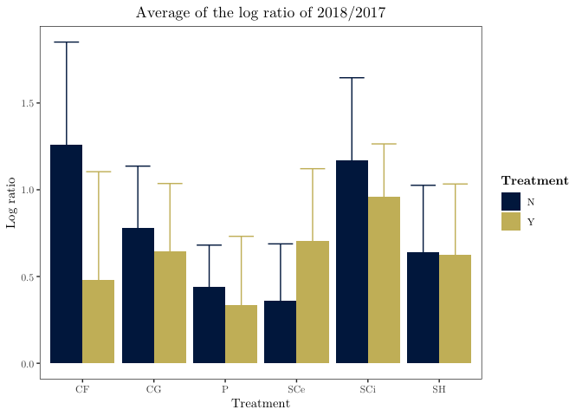

Figure 3: Log ratio of treatment reach divided by control reach for each FFG. CF = Collector-filterer, CG = Collector-gatherer, SH = Shredder, SC = Scrapers, SCe = Edible Scrapers, SCi = Inedible Scrapers, P = Predators, and All Bugs is the total macroinvertebrate density

## Trout Diet

Trout diets in the post treatment year did not vary significantly between reaches, but there were large stream to stream variations (Table 1.4). The functional feeding group with the largest difference between reaches in the difference selection index was predatory invertebrates (t-value = 1.043, p-value = 0.33) such as caddisfly of the family Rhyacophilidae. Table 4 summarizes the other functional feeding groups; however, none showed significant differences in consumption between the control and treatment reaches.

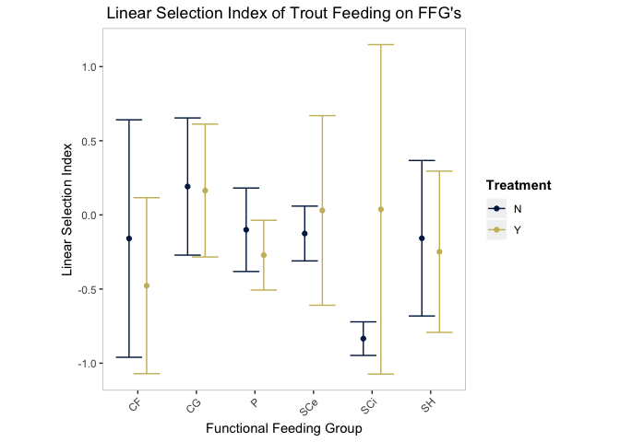

At the family level, trout diets remained variable in composition. The family with the greatest variability in trout diets was *Juga* snails with two trout in MCTE showing strong selection

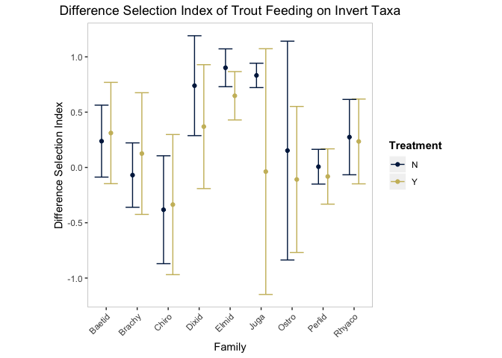

# Discussion

Gaps are, by definition, open canopy patches in a larger forested system. While localized responses beneath a gap may occur, we were particularly interested in whether the effect of an individual canopy gap could be detected at the stream reach scale. Studies have found that large gaps (Wootton (2012)), or patches of high shade (Heaston, Kaylor, & Warren (2018)), had an effect on the overall invertebrate community. Yet, significant localized responses within a single gap may not translate to significant system-wide responses at the stream or even the reach level. Our study design emphasizes the effects of gaps that only comprise a fraction of a stream reach, so the focus is on the integrated effect of small gaps embedded in a larger forested environment.

While light and Chla responded as expected to an opening of the riparian canopy, our reach-scale metrics for the invertebrate community did not respond to increases in primary production. This does not match our original hypothesis that increases in high quality algae would lead to an increased abundance of scraping invertebrate taxa. Instead, we found the magnitude of the invertebrate response was not large enough to manifest at the reach scale and that fish consumption was not masking potential changes in community compisiton or functional feeding group relative abundance. In *Juga* snails, the one taxa group for which we evaluated local responses, we saw a strong BACI response to the treatment in meters adjacent to the gap, but our reach-scale metrics for other invertebrate community members showed little BACI response.

## light and Chla

While the canopy-opening treatment increased PAR by $400\%$, they were not outside the realm of what could occur naturally in these heavily shaded systems. While these small-scale distrubances significantly increase abiotic factors such as light, the localized impact of light increases on stream biota did not manifest at the reach level. Trophic inefficiency may explain the dwindling returns in production from primary producers to consumers, but we also saw muted responses in primary production compared to previous studies on forest shading that indicate a strong linear relationship between light and GPP. Our increases in PAR were concentrated to a relatively small area, and it is possible that algae within the gaps were experiencing photosaturation limitations, or faced nutrient co-limitations.

## Invertebrate Response

When tracing energy flows through an aquatic food chain, stable isotope analysis can reveal the source carbon in higher trophic levels and lend insight into the net autotrophy of the system. However, community studies have the potential to reveal more subtle patterns in energy transfer. For example, snails and other heavily armored scrappers may effectively sequester autocthonous carbon from higher trophic levels.

Overall, our invertebrate communities had greater variability between streams than between treatment reaches, and no taxa have a consistent responses across sites. And while community composition shifted between years at all sites, including the treatment effect actually reduced the strength of the relationship between YearTreatQ and the synthetic community variables of axis 1 and 2 of the NMS ordination.

While we feel confident in the validity of our community results, we wanted to ensure there were no emergent trends across functional feeding groups. There has been some controversy surounding the use of functional feeding groups after studies examining the gut contents of stream invertebrates found a general lack of fidelity of invertebrates to their assumed functional feeding group (Rosi-Marshall, Vallis, Baxter, & Davis (2016)). Within the scope of our hypothesis, and given the varied community response across sites, we felt justified in using functional feeding groups to explore potential energy pathways in an aquatic food chain.

Our functional feeding group results at the reach level seem to be in contradiction with previous studies on stream light (Heaston et al. (2018), Kaylor & Warren (2017), Wootton (2012)), but these studies focused on the immediate, within-treatment response of invertebrates and fish to various alterations to light availability. In that regard, our snails responded as expected, but the relative size of our canopy manipulations, one similar to small scale natural disturbances and individual tree mortality, limited reach-level trophic responses.

## Fish diets

Fish diets were variable with no clear preference or avoidance of any one FFG or taxa group found consistently across streams. A scraper response is most likely not being masked by selective trout foraging because we did not find a significant top-down pressure on scraping invertebrates. However, our trout diets only provide a snapshot of trout foraging from a single day in mid-summer. The differing life histories of benthic invertebrates may expose them to varying top-down pressure throughout the year that are not accurately captured in this study.

# Conclusion

Determining a per-unit-light biotic response is complicated by complex trophic dynamics and limits on primary productivity such as photosaturation and nutrient limitation. Canopy opening manipulations designed to mimic the patchy light environment of old-growth systems and stimulate productivity in heavily shaded systems must account for these inherent, dampening system complexities. Past studies demonstrate clear differences between old-growth and regenerating forest light dynamics and system productivity, but our single-gap study produced little biotic response. More or larger gaps may be necessary to create system-wide change.

Studies on clearing hundreds of meters of riparian vegetation (Wootton (2012), Roon, unpublished data) demonstrated several-fold increases in primary production along with increases in primary consumers such as invertebrates. However, increases in temperature above the threshhold for many salmonids is not uncommon. Creating more dynamic light environments in otherwise dense regenerating stands may allow for increased production while limiting total solar irradiation. Additionally, creating a heterogenous light environment in regenerating forests may reveal other differences between old growth and early to mid seral forest streams.

# References

Bechtold, H. A., Rosi-Marshall, E. J., Warren, D. R., & Cole, J. J. (2012). A practical method for measuring integrated solar radiation reaching streambeds using photodegrading dyes. *Freshwater Science*, *31*(4), 1070–1077.

Cole, M. B., Russell, K. R., & Mabee, T. J. (2003). Relation of headwater macroinvertebrate communities to in-stream and adjacent stand characteristics in managed second-growth forests of the oregon coast range mountains. *Canadian Journal of Forest Research*, *33*(8), 1433–1443.

Dahl, J. (1998). The impact of vertebrate and invertebrate predators on a stream benthic community. *Oecologia*, *117*(1-2), 217–226.

Heaston, E. D., Kaylor, M. J., & Warren, D. R. (2018). Aquatic food web response to patchy shading along forested headwater streams. *Canadian Journal of Fisheries and Aquatic Sciences*, *75*(12), 2211–2220.

Jacobs, J. (1974). Quantitative measurement of food selection. *Oecologia*, *14*(4), 413–417.

Kaylor, M. J., & Warren, D. R. (2017). Linking riparian shade and the legacies of forest management to fish and vertebrate biomass in forested streams. *Ecosphere*, *8*(6), e01845.

Kaylor, M. J., Warren, D. R., & Kiffney, P. M. (2017). Long-term effects of riparian forest harvest on light in pacific northwest (USA) streams. *Freshwater Science*, *36*(1), 1–13.

Kreutzweiser, D. P., Sibley, P. K., Richardson, J. S., & Gordon, A. M. (2012). Introduction and a theoretical basis for using disturbance by forest management activities to sustain aquatic ecosystems. *Freshwater Science*, *31*(1), 224–231.

Kruskal, J. B. (1964). Multidimensional scaling by optimizing goodness of fit to a nonmetric hypothesis. *Psychometrika*, *29*(1), 1–27.

Lau, D. C. P., Leung, K. M. Y., & Dudgeon, D. (2009). What does stable isotope analysis reveal about trophic relationships and the relative importance of allochthonous and autochthonous resources in tropical streams? A synthetic study from hong kong. *Freshwater Biology*, *54*(1), 127–141.

Liess, A., Le Gros, A., Wagenhoff, A., Townsend, C. R., & Matthaei, C. D. (2012). Landuse intensity in stream catchments affects the benthic food web: Consequences for nutrient supply, periphyton c: Nutrient ratios, and invertebrate richness and abundance. *Freshwater Science*, *31*(3), 813–824.

Macarelli, A., & others. (2011). Quantity and quality: Unifying food web and ecosystem perspectives on the role of resource subsidies in freshwater. *Ecology*, *92*, 1215–1225.

McCune, B., & Mefford, M. J. (2016). *PC-ord. multivariate analysis of ecological data. version 7.* Gleneden Beach, Oregon, U.S.A.: MjM Software Design.

McCune, B., Grace, J. B., & Urban, D. L. (2002). *Analysis of ecological communities* (Vol. 28). MjM software design Gleneden Beach, OR.

McCutchan, J. H. J., & Lewis, W. M. J. (2002). Relative importance of carbon sources for macroinvertebrates in a rocky mountain stream. *Limnology and Oceanography*, *47*(3), 742–752.

Merritt, R. W., Cummins, K. W., & Berg, M. B. (2008). *An introduction to the aquatic insects of north america*. Kendall Hunt.

Murphy, M. L., & Hall, J. D. (1981). Vaired effects of clear-cut logging on predators and their habitat in small streams of the cascade mountains, oregon. *Canadian Journal of Fisheries and Aquatic Sciences*, *38*(2), 137–145.

Oksanen, J., Blanchet, F. G., Friendly, M., Kindt, R., Legendre, P., McGlinn, D., … Wagner, H. (2018). *Vegan: Community ecology package*. Retrieved from <https://CRAN.R-project.org/package=vegan>

Pan, Y., Chen, J. M., Birdsey, R., McCullough, K., He, L., & Deng, F. (2011). Age structure and disturbance legacy of north american forests. *Biogeosciences. 8: 715-732.*, *8*, 715–732.

Peckarsky, B. L., & McIntosh, A. R. (1998). Fitness and community consequences of avoiding multiple predators. *Oecologia*, *113*(4), 565–576.

Purcell, A. H., Bressler, D. W., Paul, M. J., Barbour, M. T., Rankin, E. T., Carter, J. L., & Resh, V. H. (2009). Assessment tools for urban catchments: Developing biological indicators based on benthic macroinvertebrates 1. *JAWRA Journal of the American Water Resources Association*, *45*(2), 306–319.

R Core Team. (2018). *R: A language and environment for statistical computing*. Retrieved from <https://www.R-project.org/>

Rosi-Marshall, E. J., Vallis, K. L., Baxter, C. V., & Davis, J. M. (2016). Retesting a prediction of the river continuum concept: Autochthonous versus allochthonous resources in the diets of invertebrates. *Freshwater Science*, *35*(2), 534–543.

Syrjänen, J., Korsu, K., Louhi, P., Paavola, R., & Muotka, T. (2011). Stream salmonids as opportunistic foragers: The importance of terrestrial invertebrates along a stream-size gradient. *Canadian Journal of Fisheries and Aquatic Sciences*, *68*(12), 2146–2156.

Vannote, R. L., Minshall, G. W., Cummins, K. W., Sedell, J. R., & Cushing, C. E. (1980). The river continuum concept. *Canadian Journal of Fisheries and Aquatic Sciences*, *37*(1), 130–137.

Wallace, J. B., Grubaugh, J. W., & Whiles, M. R. (1996). Biotic indices and stream ecosystem processes: Results from an experimental study. *Ecological Applications*, *6*(1), 140–151.

Warren, D. R., Collins, S. M., Purvis, E. M., Kaylor, M. J., & Bechtold, H. A. (2017). Spatial variability in light yields colimitation of primary production by both light and nutrients in a forested stream ecosystem. *Ecosystems*, *20*(1), 198–210.

Warren, D. R., Keeton, W. S., Bechtold, H. A., & Rosi-Marshall, E. J. (2013). Comparing streambed light availability and canopy cover in streams with old-growth versus early-mature riparian forests in western oregon. *Aquatic Sciences*, *75*(4), 547–558.

Warren, D. R., Keeton, W. S., Kiffney, P. M., Kaylor, M. J., Bechtold, H. A., & Magee, J. (2016). Changing forests—changing streams: Riparian forest stand development and ecosystem function in temperate headwaters. *Ecosphere*, *7*(8).

Wilzbach, M. A., Cummins, K. W., & Hall, J. D. (1986). Influence of habitat manipulations on interactions between cutthroat trout and invertebrate drift. *Ecology*, *67*(4), 898–911.

Wipfli, M. S. (1997). Terrestrial invertebrates as salmonid prey and nitrogen sources in streams: Contrasting old-growth and young-growth riparian forests in southeastern alaska, usa. *Canadian Journal of Fisheries and Aquatic Sciences*, *54*(6), 1259–1269.

Wootton, J. T. (2012). River food web response to large-scale riparian zone manipulations. *PLoS One*, *7*(12), e51839.