**STM32 Initial Setup**

The first and second steps should only need completed once per computer or board, respectively. The Last step, board set up, may need to be set up more frequently.

**I. For a new computer:**

Any computer which have not previously programed an STM32 will need to do the following:

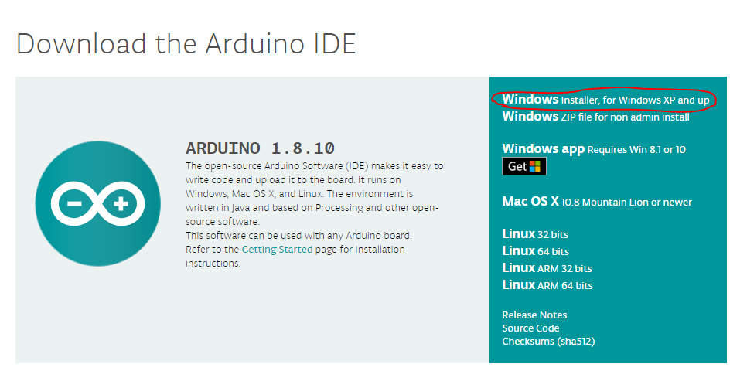

**Install Arduino:**

* Go to <https://www.arduino.cc/en/Main/Software>
* Download the executable for your system (Fig 1)
* Run the executable

Figure 1: Arduino download, assuming Windows OS

**Install the Due libraries in the Arduino Boards Manager:**

* 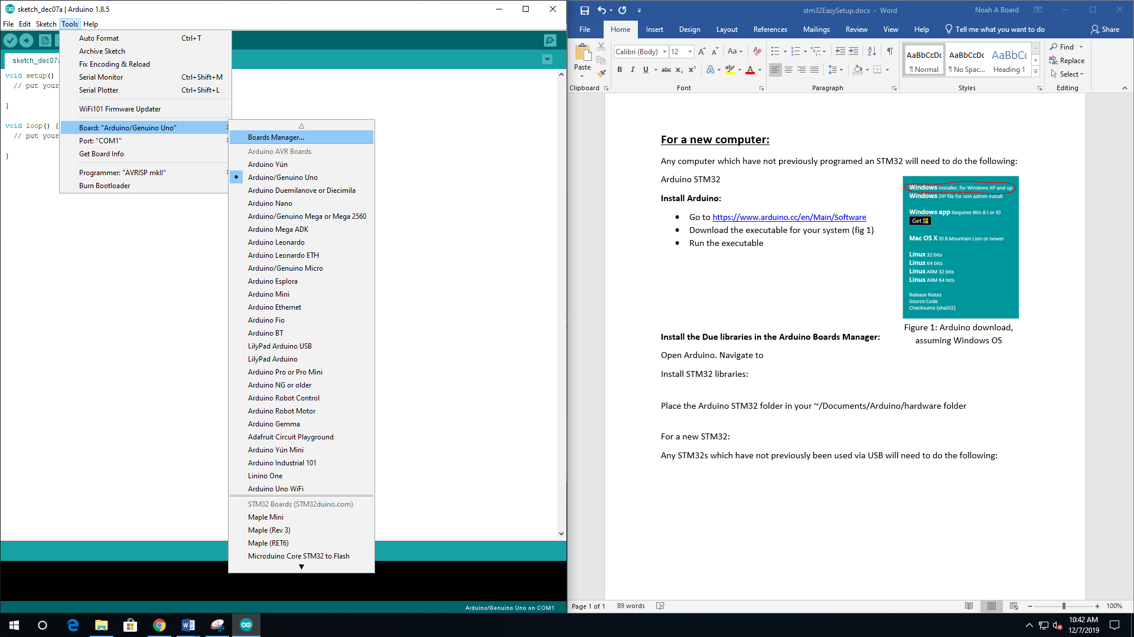Start Arduino
* Navigate to Tools > Board > Boards Manager (Fig. 2)
* In the popup menu, search for DUE and download

the library (Fig 3)

*Figure 2: Arduino Boards Manager*

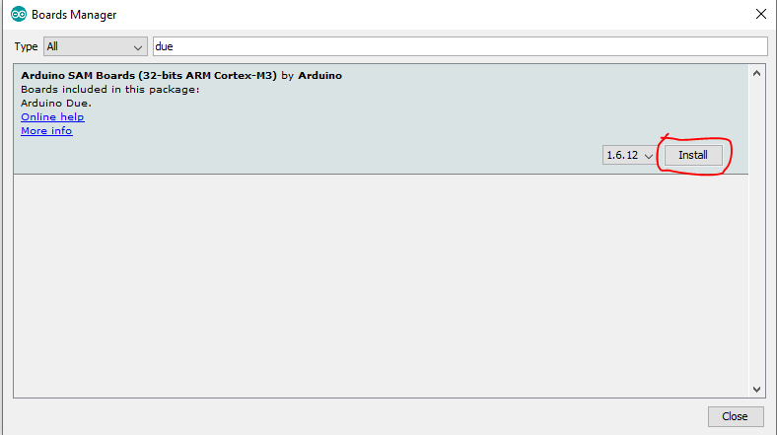

*Figure 3: Install the Due library*

**Install STM32 libraries:**

* Download the STM32 library from [here](https://github.com/rogerclarkmelbourne/Arduino_STM32) (Fig. 4), or locate the library in the T-Drive
  + It should be in a zip file under *T:\Engineering Competitions\ASEE ROBOT\Data Sheets\STM 32 Stuff\Initial Set Up* saved as “Arduino_STM32-master.zip”

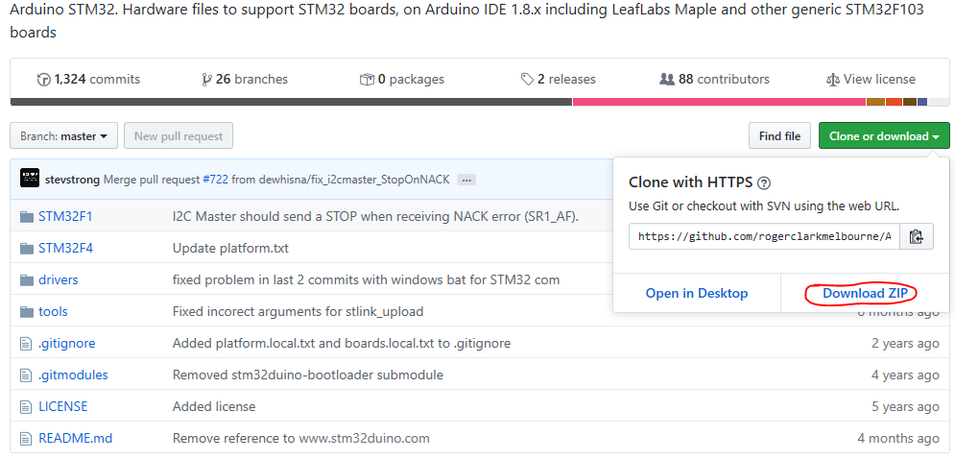

*Figure 4: Install the STM32 Library*

* Unzip the document
* Place the Arduino STM32 folder in your ~/Documents/Arduino/hardware folder
  + You will likely have to create the “hardware” folder

**Install Final library:**

* Open File > Preferences
* Paste the link in the text box marked “Additional Boards Manager URLs”
  + <https://github.com/stm32duino/BoardManagerFiles/raw/master/STM32/package_stm_index.json>
* Press OK
* Re-Open board manager, scroll to the bottom, and download STM32 Cores (version 1.8) (Fig. 5)

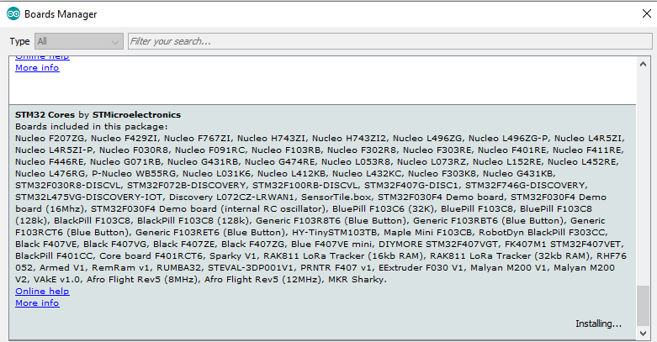

*Figure 5: The last library*

**Your computer should now be ready to compile code for an STM32.**

**II. Arduino Board settings**

Have the following settings in you Arduino editor.

**Open the Board Settings**

* Select Tools in the top bar (Figure 9).
* On the Bar, make sure the settings match
  + Board: “Generic STM32 103C series”
  + Variant: “STM32F103CB (20k RAM, 128 Flash)”
  + Upload method “STM32duino bootloader” (Unless you want to use an alternate method)
  + CPU Speed (MHz): “72Mhz (Normal)”
  + Optimize: “Smallest (default)”
  + Port: You will have to set this after the device is connected. The number will vary, but the option should not appear before you have plugged the device in.

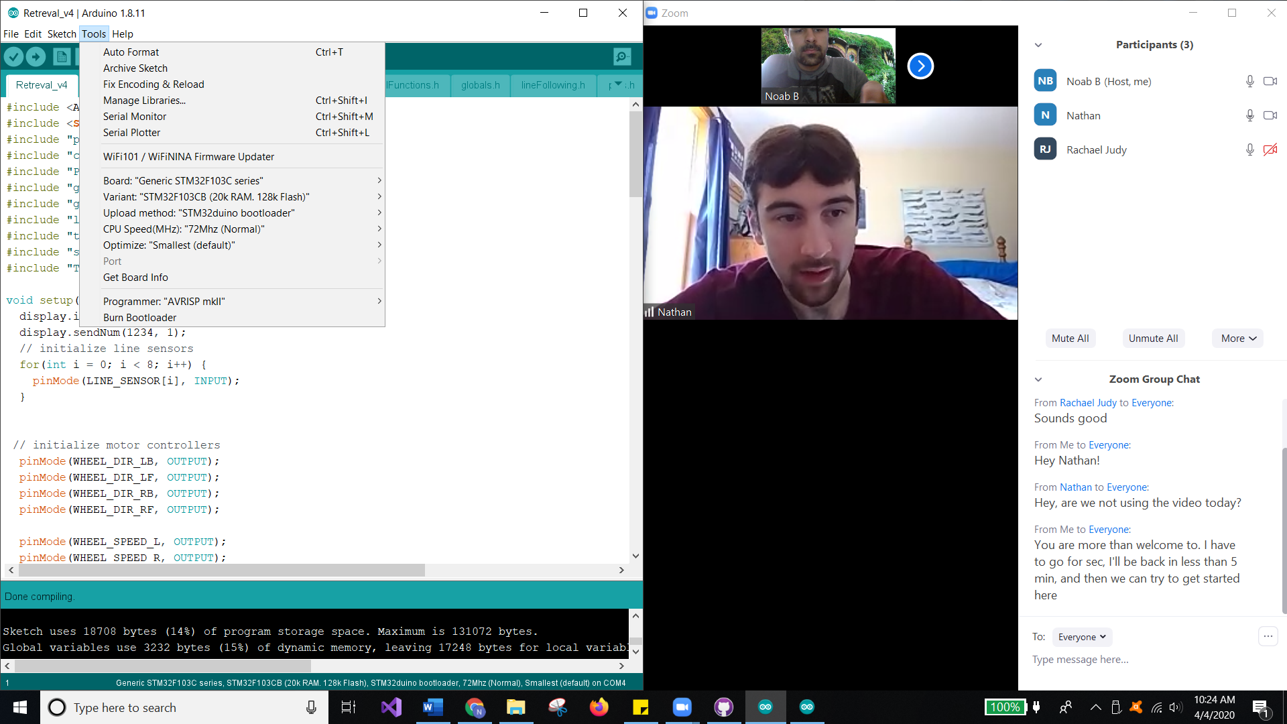

*Figure 9: The Arduino Tools option*

**III. Test Board**

The board should now be ready to use. Test it using the blink program included with Arduino.

You should now be able to program the STM32 via the Bootloader