**Annex B**

Example of an invention disclosure form

**Confidential**

**Disclosure No.: _________________________________________________________**

**Status: _________________________________________________________________**

**Invention Disclosure Form**

**Name: Chelsea Anne M. Permejo**

**Work phone number: 09127588389**

**Email address:permejochelseaanne0@gmail.com**

1. **PROPOSED TITLE: Patani pods Particleboard**
2. **FIELD OF INVENTION: Construction Industry, Civil Engineering**

A. This invention relates primarily to:

Construction materials

**3. BACKGROUND AND RELATED ART**

A. The technical problem addressed by the invention is as follows:

* Now a days construction material are in high cost this is one of the main problem that every construction industry are facing
* Low quality fo structural buiding
* Less supply of particleboard

B. The closest related art is described as follows:

* This particle is like a plywood, solid wood and etc. Due to the in demand of wood this item is high cost construction material.

C. The advantages presented by the invention are as follows:

* This particleboard we can provide a affordable material.
* This invention meet the standard durability and strength.
* Abundant supply alternative materials to prevent increasing price

**4. DRAWING(S)**

Drawings for this invention are available/not available. If available, please attach.

COMMENTS about drawings provided:

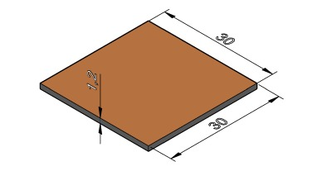

This particleboard are compost of dried patani pods and phenol formaldehyede resin as a binder with the dimension of 30cm in length x 30cm in width 1.2cm thick. We are also have a many size that is costumer need

**5. WRITTEN DESCRIPTION**

The invention is described as follows:

Because they discard the beans from their pods after collecting, patani pods are commonly found in public markets as garbage. As an innovator, I would like to employ patani pods to create particleboard that is less expensive than other types of wood for use in furniture, construction, and other applications. This invention is also has cheaper pnenol formaldehyede used as a binder, making it accessible to everyone. This item is also measured as 30 cm long by 30 cm wide by 1.2 cm thick. We also offer a variety of sizes to meet customer need.

**6. INVENTOR(S) (this section must be completed)**

INVENTOR 1:

Name: Chelsea Anne M. Permejo

Residence address: Zone 3 R. Marco Street Barangay Peñafrancia Gumaca, Quezon

Citizenship: Filipino

**7. DATES OR PRODUCT TESTING AND RELEASE**

Alpha testing: Mechanical and Physical Test

Beta testing: Modulos of Rupture (MOR), Face Srew withdrawal, Internal bond, Thickness Swelling and water Absorption

General release or sale: None

Offers for sale: None

COMMENTS on product testing and release:

This product meet the wood standard that lead my invention to have a better oppurtinities because of the great outcome.

**8. DISCLOSURE OF INVENTION**

Has there been any disclosure to or use of the invention by the public? Any expected future disclosure of the invention? When and to whom? Under a non-disclosure agreement?

Yes , this help to maximize the benefits from research and new invention. Filling a disclosure form is first step to so they can understand what I created and they can clarify a inventorship and ownership of my invetion thatthey can help me for oppurtunities of my invention oustide like some companies.

**9. INTERNAL DISCLOSURE(S)**

First internal disclosure date:May 22, 2022

Name of first person to whom invention was disclosed: Chelsea Anne M. Permejo

COMMENTS about first internal disclosure: Hoping to have more oppurtunities to come.

**10. ARTICLE(S)**

Have any articles been published?

None

DETAILS about publication of articles(s):

None

1. **ADVERTISEMENTS, PRESS RELEASES AND PRODUCT ANNOUNCEMENTS**

Any advertisements, press releases or product announcements?

The advertisement is coming soon after finishing the invention for the better outcome.

**12. OUTSIDE DISCLOSURE(S)**

Have there been any disclosures outside the company?

They been looking for the oppurunities for my invention.

Were all outside disclosures under a nondisclosure agreement?

I am still waiting for the oppurtunities for my invetion

*.*

**13. TRADE SHOWS AND CONFERENCES**

Are there any upcoming trade shows or conferences?

Yes, I am having a show that is showchasing in front of the audeince the durability and strenght of this invention.

DETAILS about upcoming trade shows and/or conferences:

The main materials for this event are patani pods particleboard because we are putting on an exhibition and building things like tables out of them. By placing a weight on the top of the table, we can demonstrate the strength and durability of my particleboard and show visitors that it is more easier to break than other types of wood used to build structures. To have a oppurtunies that many company see my invention.

**ADDITIONAL COMMENTS BY INVENTOR:**

This are all my hardwork and I am hoping that they give me a oppurtunies to showcase more my invention and future idea that I have.

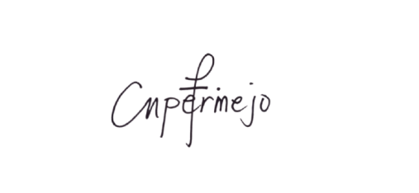Signed: Witnessed and understood by:

CHELSEA ANNE M. PERMEJO MARK jUSTINE V. ANTONIO

Date: July 15, 2022 Date: July 15, 2022