1. Sl-05-Electrophoresis: 10.1002/elps.201000690

Parsing: Good

2. SL-06-Applied Polymer Science: 10.1002/app.24519

Parsing: Good

3. SL-2489-European Journal of organic chemistry: 10.1002/ejoc.200800219

Parsing: Good

4. SL-48-Intl. Journal of energy research: 10.1002/er.3008

Parsing: Good

5. SL-1408-Advanced Materials Interfaces: 10.1002/admi.201400532

Parsing: Good

Query: a) **NO Section Names**

"name": "",

"type": "section_h2"

b) on these very properties.[**1**](https://onlinelibrary.wiley.com/doi/full/10.1002/admi.201400532#admi201400532-bib-0001)-[**3**](https://onlinelibrary.wiley.com/doi/full/10.1002/admi.201400532#admi201400532-bib-0003) **becomes** these very properties.[ ]

6. SL-92-Journal of Heterocyclic Chemistry: 10.1002/jhet.314

Parsing: Good

7. SL-104: Journal of German Chemical Society: 10.1002/anie.201100637

Parsing: Good

Query: a) **NO Section Names**

"name": "",

"type": "section_h2"

8. SL-117: Small: 10.1002/smll.201202697

Parsing: Good

9. SL-118: Advanced Energy Materials: 10.1002/aenm.201200214

Parsing: Good

10. SL-143: Chemistry: 10.1002/chem.201405902

Parsing: Good

11. Sl-162: Advanced Functional Materials: 10.1002/adfm.201501289

Parsing: Good

Query: in so‐called hybrid perovskites.[**1**](https://onlinelibrary.wiley.com/doi/full/10.1002/adfm.201501289#adfm201501289-bib-0001)-[**6**](https://onlinelibrary.wiley.com/doi/full/10.1002/adfm.201501289#adfm201501289-bib-0006) **becomes** resulting in so-called hybrid perovskites.[ ]

12. SL-180-Advanced Synthesis and Catalyst: 10.1002/adsc.201400257

Parsing: Good

Query: Table causes prob:

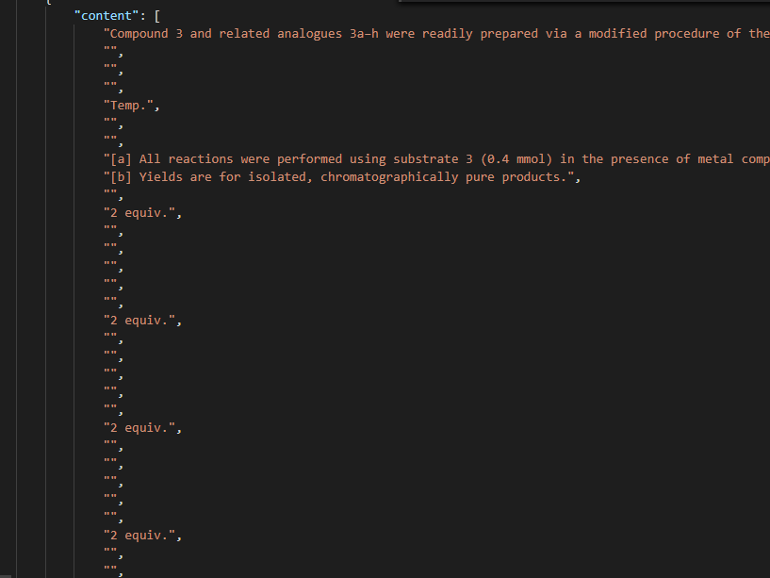

13. SL-185-Advanced Materials: 10.1002/adma.201301627

Parsing: Good

Query: a) **NO Section Names**

"name": "",

"type": "section_h2"

14. SL-224-Advanced Electronic Materials: 10.1002/aelm.201500345

Parsing: Good

"Journal": null,

Query:

a) **NO Section Names**

"name": "",

"type": "section_h2"

b) for wearable devices,[**1**](https://onlinelibrary.wiley.com/doi/full/10.1002/aelm.201500345#aelm201500345-bib-0001) sensors,[**2**](https://onlinelibrary.wiley.com/doi/full/10.1002/aelm.201500345#aelm201500345-bib-0002) and actuators,[**3**](https://onlinelibrary.wiley.com/doi/full/10.1002/aelm.201500345#aelm201500345-bib-0003) **becomes** for wearable devices,[ ] sensors,[ ] and actuators,[ ]

15. SL-233--ZAAC: 10.1002/zaac.201400398

Parsing: Good