HOSTEL MANAGEMENT SYSTEM

Name: Cedric Bakali

Reg No: 24311351021

Institution: DMI University

Submission Date: 12 May 2025

# Table of Contents

1. Introduction

2. System Requirements

3. Technologies Used

4. Features

5. System Design

6. Implementation

7. Error Handling

8. Testing

9. Conclusion

10. Future Enhancements

11. References

12. Screenshots

# 1. Introduction

The Hostel Management System is a Python-based desktop application designed to manage hostel operations, including student registration, room allocation, and fee management. The system improves efficiency, accuracy, and transparency in hostel administration.

# 2. System Requirements

• Python 3.x

• Tkinter library

• SQLite3

• Windows or Linux OS

• Basic hardware (2GB RAM, 1GHz CPU)

# 3. Technologies Used

• Programming Language: Python

• GUI Library: Tkinter

• Database: SQLite3

# 4. Features

• Admin login system

• Add, update, view, delete student details

• Room assignment and availability check

• Fee payment tracking

• Error handling and validation

• User-friendly GUI

# 5. System Design

The system uses a modular design with the following components:  
• GUI forms created using Tkinter.  
• Backend logic to handle user interactions and database operations.  
• SQLite database to store student, room, and fee data.

# 6. Implementation

Example Code Snippet: Student Addition

try:  
 if name == "" or room == "":  
 messagebox.showerror("Error", "All fields are required")  
 else:  
 conn.execute("INSERT INTO students (name, room) VALUES (?, ?)", (name, room))  
 conn.commit()  
 messagebox.showinfo("Success", "Student added successfully")  
except sqlite3.IntegrityError:  
 messagebox.showerror("Database Error", "Student already exists")

# 7. Error Handling

The system uses try-except blocks to catch and handle exceptions like input validation errors, database errors, and connection issues. It ensures the application remains stable and user-friendly.

# 8. Testing

The system was tested for input validation, login security, database integrity, and overall performance. Common bugs were fixed, and the app behaves as expected under normal conditions.

# 9. Conclusion

The Hostel Management System offers a reliable and efficient solution for managing hostel activities. It automates key operations, reduces human error, and improves data accessibility for administrators.

# 10. Future Enhancements

• Add student photo upload feature.

• Generate PDF receipts for payments.

• Create reports for room usage and payment history.

• Online access via web-based extension.

# 11. References

• Python documentation - https://docs.python.org/3/

• Tkinter documentation - https://docs.python.org/3/library/tkinter.html

• SQLite documentation - https://www.sqlite.org/docs.html

# 12. Screenshots

• Login Page Screenshot

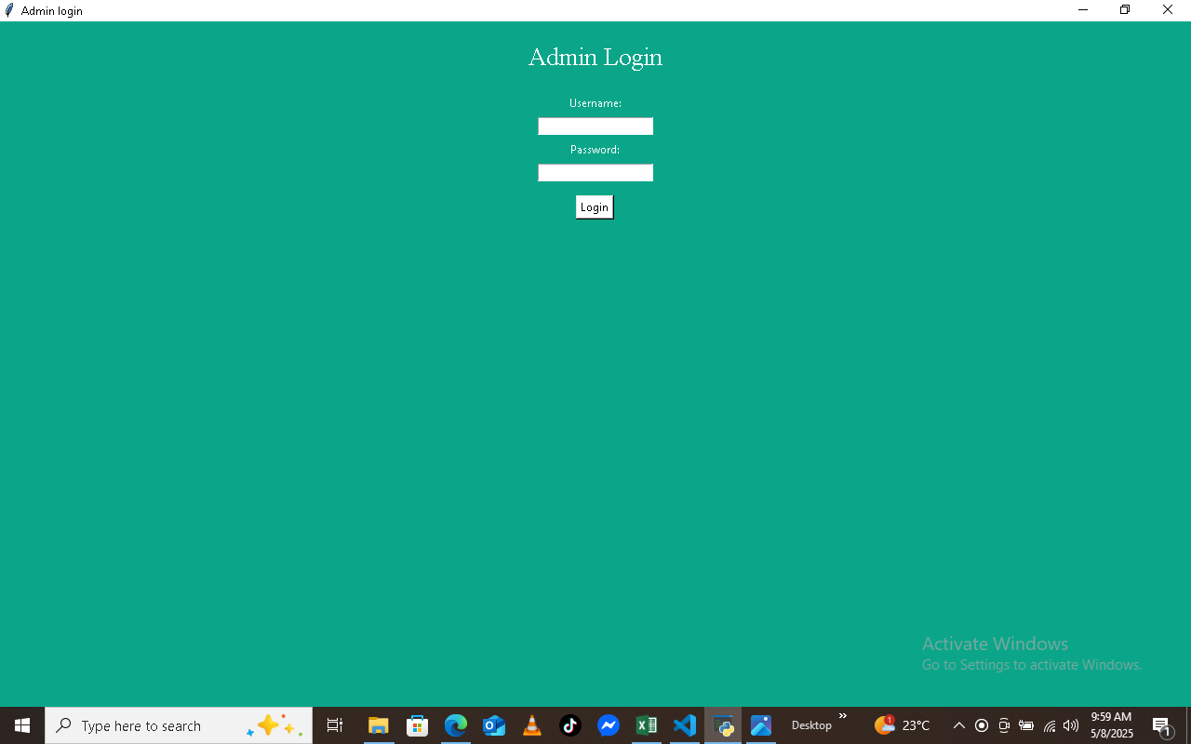

• Add Student Form Screenshot

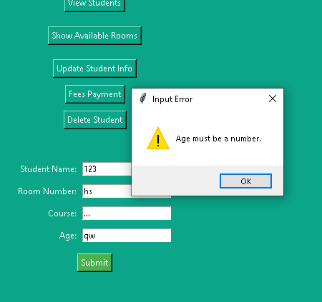

• View Students Window Screenshot

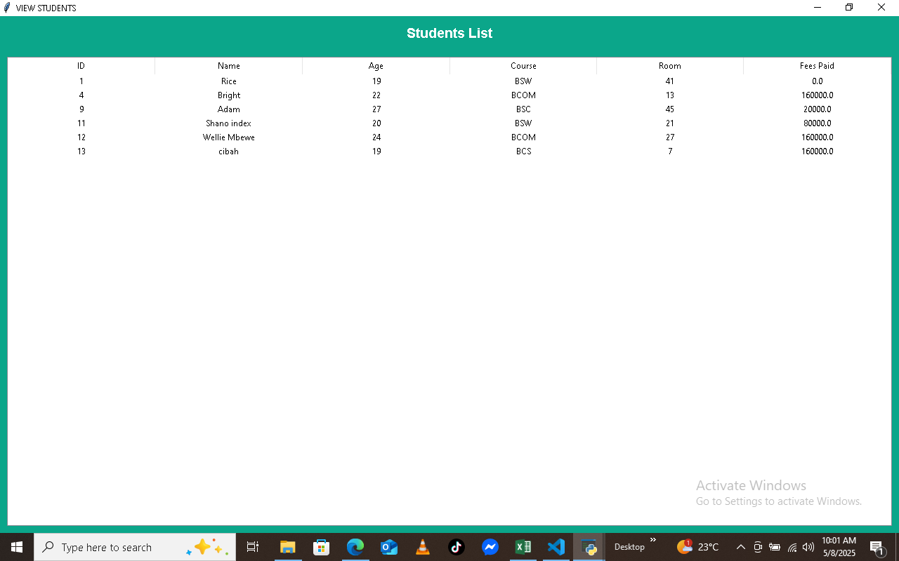

• Fee Payment Screenshot

