Exercise No. 2:

Fuzzy Expert System

# CSci 141 | G027

## Vaughn Cedric L. Araneta

## BSCS-3

## Instructor:

## Prof. Jonah Flor O. Maaghop

# Links:

## GitHub Repository

* + https://github.com/CedricDeVon/Fuzzy-Eval

# Input Linguistic Variables:

## Time Remaining (In Seconds)

|  |  |
| --- | --- |
| **Linguistic Terms** | **Universe of Discourse** |
| low_time_remaining | [0, 0, 10, 15] |
| moderate_time_remaining | [10, 15, 25, 30] |
| high_time_remaining | [25, 30, 60, 60] |

## Board Evaluation

|  |  |
| --- | --- |
| **Linguistic Terms** | **Universe of Discourse** |
| black_advantage | [-10, -10, -2, -1] |
| draw | [-2, 0, 0, 2] |
| white_advantage | [1, 2, 10, 10] |

# Output Linguistic Variables:

## Classification

|  |  |
| --- | --- |
| **Linguistic Terms** | **Universe of Discourse** |
| black_winning | [0, 5, 10] |
| draw | [8, 10, 12] |
| white_winning | [10, 15, 20] |

# Membership Functions:

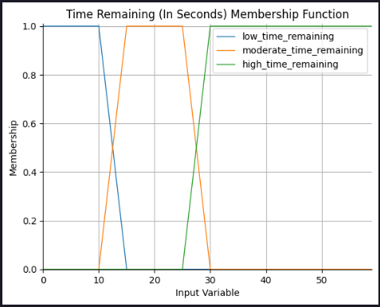

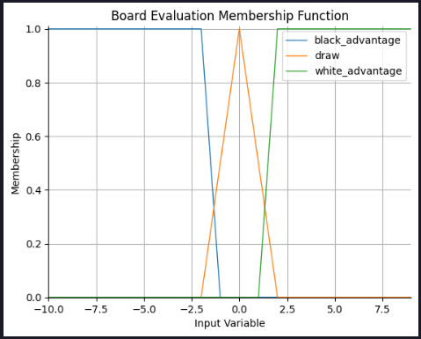

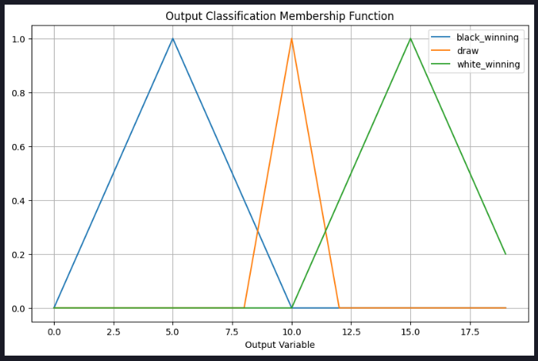

# Fuzzy Set Rules:

## If (time_remaining is moderate) and (evaluation is black_advantage) Then (classification is black_winning).

## If (time_remaining is moderate) and (evaluation is draw) Then (classification is draw).

## If (time_remaining is moderate) and (evaluation is white_advantage) Then (classification is black_winning).

