Kapsul3D Technical Design Document
Kapsul3d – Game Development System
Draft
Author: Kenneth L. Hurley
Scheduled Release: 1.0

Revision History
The following revisions have been made to this document:
Date | Revision | Developer | Summary of Changes
2002-04-30 | .1 | KLH | Started Document
2002-05-10 | .2 | KLH | Updated with Coding Standards

Contents
1 Executive Summary 1
2 Owners of Key Product Areas 1
3 Design Overview 1
4 Architectural Design 3
5 Design Criteria and Constraints 3
6 Components 3
6.1 KapsulApp.h 3
6.2 Extension DLLS 4
6.3 CFileManager 5
6.4 CResourceManager 5
6.5 CObject 6
6.6 CRenderer 7
6.7 CMesh 8
6.8 CHardwareStream 9
6.9 CCamera 10
6.10 CLight 11
6.11 CConfig 12
6.12 CVector3 13
6.13 CVector4 14
6.14 CMatrix3 15
6.15 CMatrix4 16
6.16 CTexture 17
7 Data Structures 17
8 Error and Exception Handling 17
9 Application Programming Interface (API) 18
9.1 Extension DLL resource conventions 18
10 Tools 18
11 Feature Operation 18
12 Internationalization 19
13 Other Considerations 19
14 Performance/Resources Impact 19
15 Portability 19
16 Consistency 19
17 Compatibility 19
18 Important Issues 19
19 Coding Standards 19
19.1 Standard Template Libraries 19
19.2 For/Next Loops 19
19.3 Indentation 20
19.4 Defines and Enumerations Definitions 20
19.5 Variables 20
19.6 Prototypes, Variables, Definitions 21
19.7 Subroutines 21
19.8 Constants and References 22
19.9 If Statements 22
19.10 Braces/Switch Statements 23
19.11 Comments 23
19.12 Parenthesis 24
19.13 Classes 24
19.14 Include Files 25
19.15 Commas 25
19.16 Miscellaneous 26
20 Related Documentation 27

Executive Summary

Owners of Key Product Areas
<Identify owners in the key product areas.>
Product Area | Owners
Marketing | <name(s)>
Development | Cédric Guillemet, Kenneth L. Hurley
Development Leader | Cédric Guillemet
Supporting Developers | N/A
Supporting Development Leaders | <name(s) or none>
Quality Assurance | <name(s)>
Documentation | <name(s)>
Online Help | <name(s)>

Design Overview
Kapsul3d Application
CMainFrame
CResourceBar
CResourcePages
CResourceDLL
CDLLInterface
CDLLInterface
CBaseDLL
Plugin Directory
COpenGLRender
CDX8Render
CHierarchy
CTextureDLL
CSoundDLL
CBSPMap
CWorldEditor
Message Direction
Derived From
Searches
CRender
The design of Kapsul3D is such that there is minimal passing of direct pointers. For instance, when the Crender class wants to get a pointer to the resource manager, it sends a message of “GetResourceManager”. This way the system can be a completely distributed system. In the diagram above, the CMainFrame class has the resource manager. It responds to messages that include “GetResourceManager”, “GetStatusBar” and “GetOptionsBar”. The “GetStatusBar” returns the status bar of the mainframe window. The ”GetOptionsBar” message returns a pointer to a property page where the plug in can add a property sheet for itself.
The “CmainFrame” class above searches through the plug in directory for plugins. Each DLL has a priority. The DLLs will get initialized starting from priority 1 to priority MAXINT. It then calls the initialize function for each of the DLLS.

Architectural Design

Design Criteria and Constraints

Components

KapsulApp.h
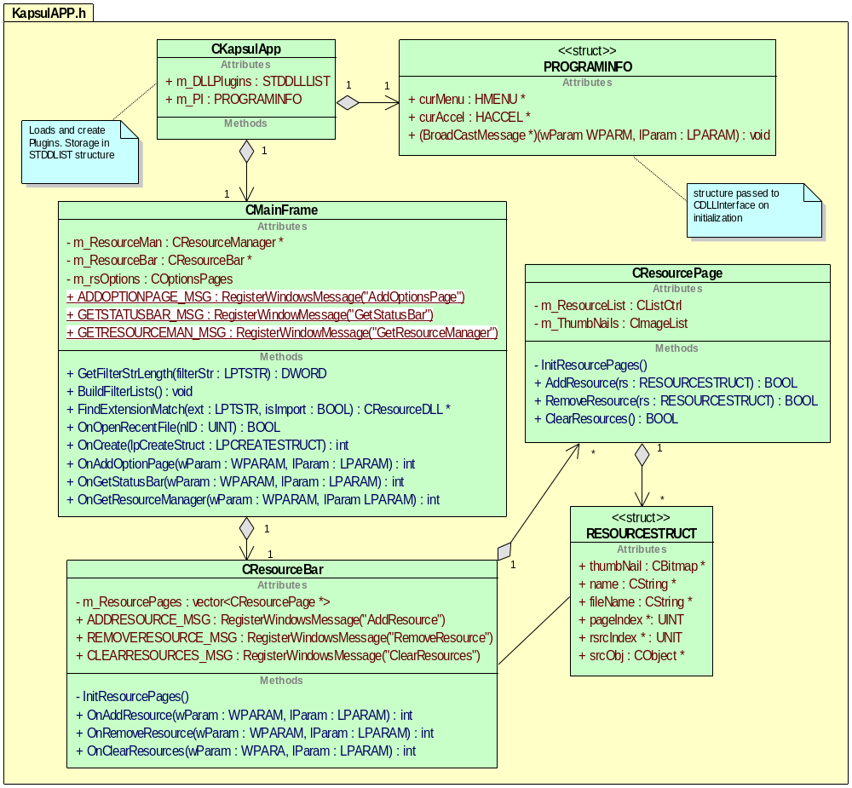
The key design philosophy of Kapsul3d is to keep the API as simple as possible and to document the major functions with a header and description. The description also includes input parameters and output parameters. Additional design philosophies for Kapsul3D include using comments that will automatically generate documentation through the program doxygen. Kapsul3D is plugin based. This means that Kapsul3D should have plugins that are interchangeable with other programs. In order to facilitate this, Kapsul3D was designed to pass messages between plugins and the main application. The plugins should treat themselves as a stand-alone application with no interaction to other plugins or the Kapsul3D application with pointers. Instead of pointers to other plugins, the plugin should broadcast a message on an event. For example, when the texture plugin loads a texture, it should broadcast a message to add a resource. The resource manager will process the message and add the object to its list. After that, the resource page manager will also get the message and add the thumbnail to the resource page. This is also beneficial in that a plugin that is using MFC can have a “CView” or “Cdocument” class get a message that was broadcast.

Extension DLLS
Extension DLLS use the MFC Extension DLL interface. This interface allows a DLL to have access to the main applications MFC controls and data. The extension DLLS are designed in such a way that they shouldn’t know which application they are running in. Program info is passed into the DLL upon initialization, which gives pointers to the main applications elements that need to be passed back and forth. The UML Diagram is as follows:
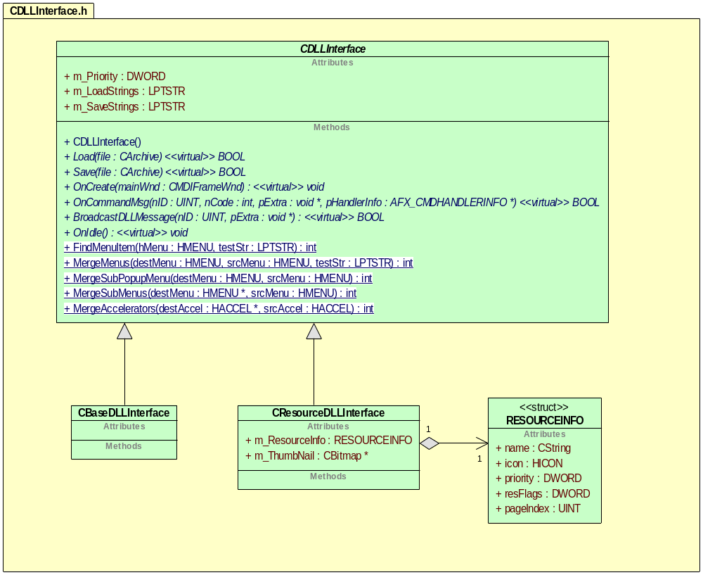
Extension DLLS should be one of two types, CBaseDLLInterface or CResourceDLLInterface. The CBaseDLLInterface class is used for DLLS that are essential to the operation of Kapsul. For example, the hierarchy window is defined in CBaseSceneDLL, which is derived from CDLLInterface. In addition, the rendering window DLLs should be derived form CBaseDLLInterface.

CFileManager
The File Manager will be responsible for calling the Load and Save functions for a resource. The resource .dll file will be responsible for processing two calls.

BOOL Load(CArchive &file) - Loads the resource into memory - for example of resource see CMesh in document
BOOL Save(CArchive &file) - Saves the resouce from memory.
Resource .dlls are responsible for getting windows messages, except Load/Save.

CResourceManager
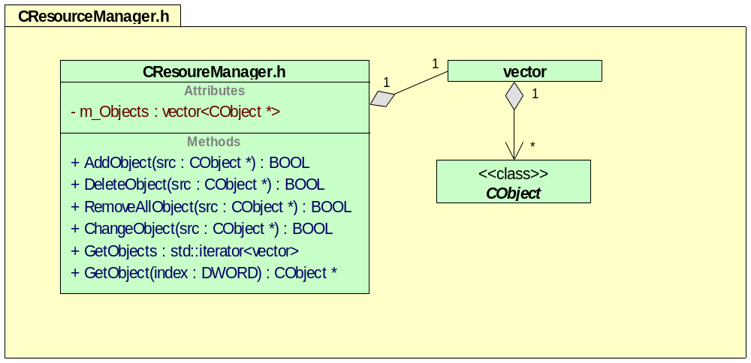
The resource manager is responsible for holding all the resources that are loaded. When a DLL loads in a resource, it calls the ResourceManager that was passed in the PROGRAMINFO structure when the DLL was initialized. When a resource DLL file changes an object, it calls the resource manager with the changes for the object. The m_Objects is the variable that holds a “vector map” of all the objects in the system that are currently loaded.

CObject
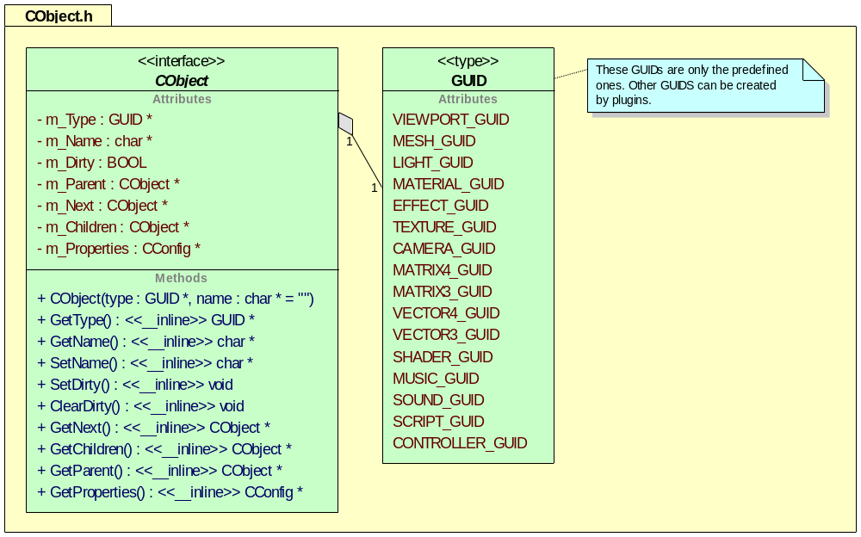
The CObject class is a general class that is used by the resource manager. The resource manager doesn’t know or care what types of objects are being managed. The m_Type is a GUID that allows for communicating the type between plugins. The name field is the textual representation of the object. The m_Dirty flag gets set when the object has been modified and cleared when all plugins have had a chance to see the change. The m_Parent is a pointer to the parent object in the hierarchy. The m_Next pointer is a pointer to the next sibling object. The m_Children is a pointer to any child objects in the hierarchy. The m_Properties attribute is a pointer to the Cconfig class. An example of a configuration for this object is the “Visible” flag. If the configuration has the “Visible” flag set then the render would render the object. All attributes are private and are accessed through inline functions. This is to protect the object and for error checking.

CRenderer
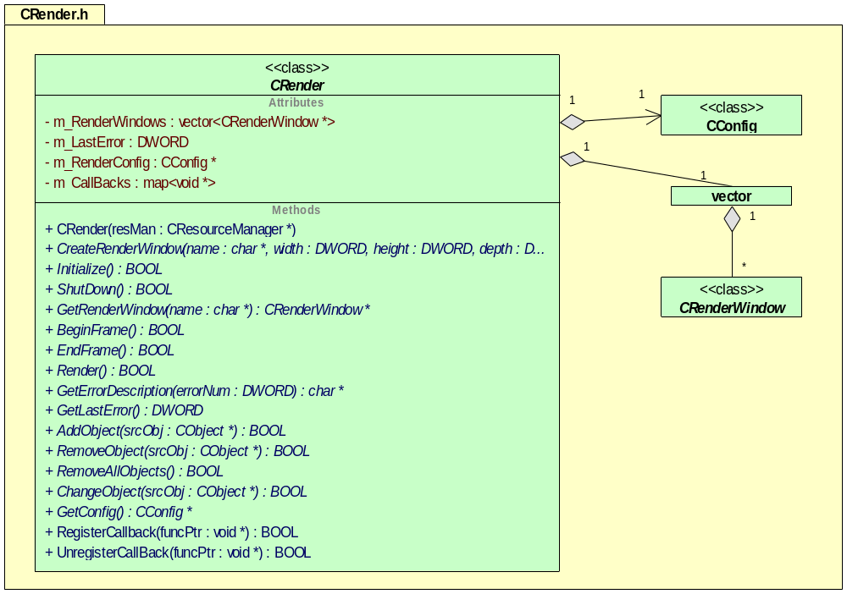
All renders are derived from the CRender class. This is so that the any number of renders may be developed as plug-ins. A CRender class must be capable of creating multiple windows. The rendering class has functions to add, remove and change Cobjects. The derived render class is responsible for determining if it understands the object type. The GetConfig function allows the application to set configuration parameters for the render class. One example would be “RenderMode” and the enumerant MODE_WIRE_FRAME. The RegisterCallback functions are there so that a plugin knows when a frame is about to be rendered. This is useful for controllers that want to animate a mesh or for a plugin that generates procedural textures.

CMesh
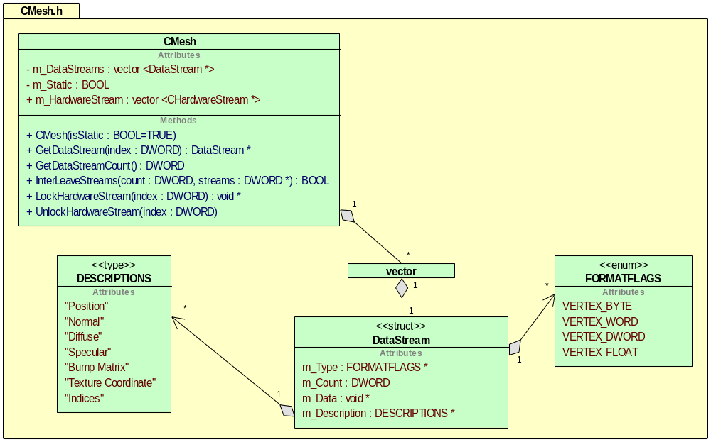
The CMesh class is a generic class that holds mesh data. The data can include any sort of data. The data that the mesh does include is specified by the DataStream structures. Each structure holds the description of the stream and the format of the data in the stream. This data is located in system memory and may not be hardware friendly. There is also a link to a hardware stream class. This stream is more hardware friendly. There are several functions for interleaving the data so that it can be packed into one stream. This may be useful for hardware. The m_Static flag is used to specify if this mesh is static or may have to be updated. Updated mesh examples would be DX7 or CPU bone animated meshes, or a dynamic LOD terrain system like ROAM.

CHardwareStream
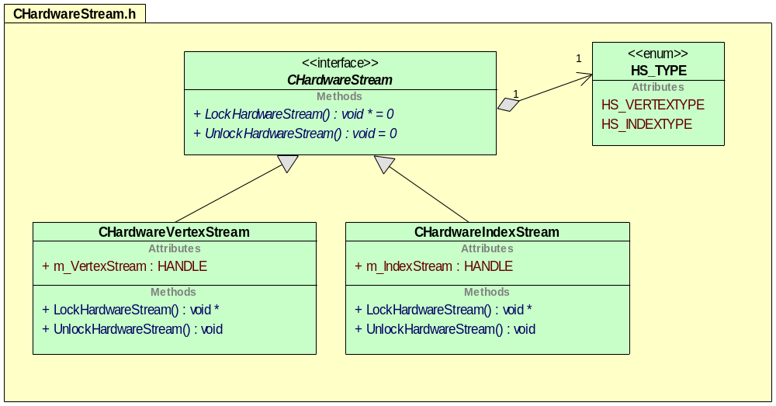

CCamera
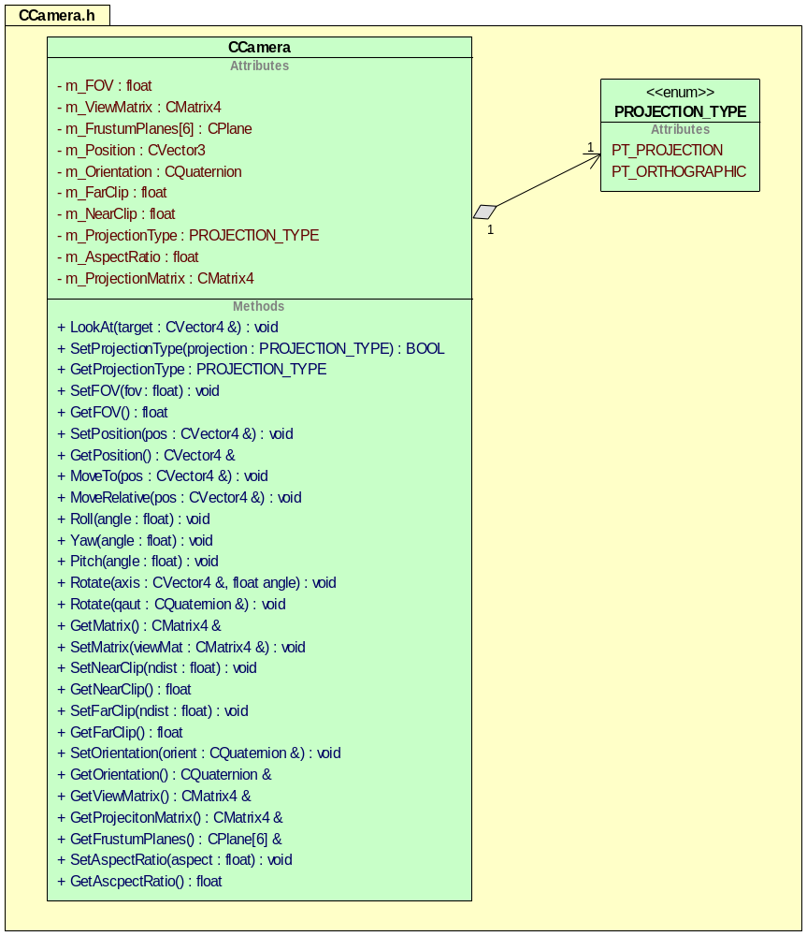

CLight
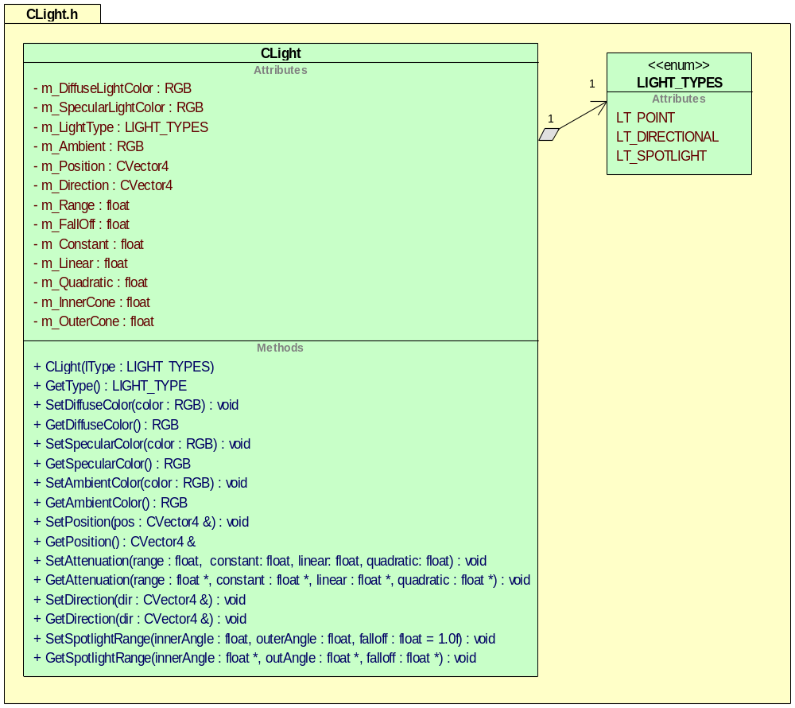

CConfig
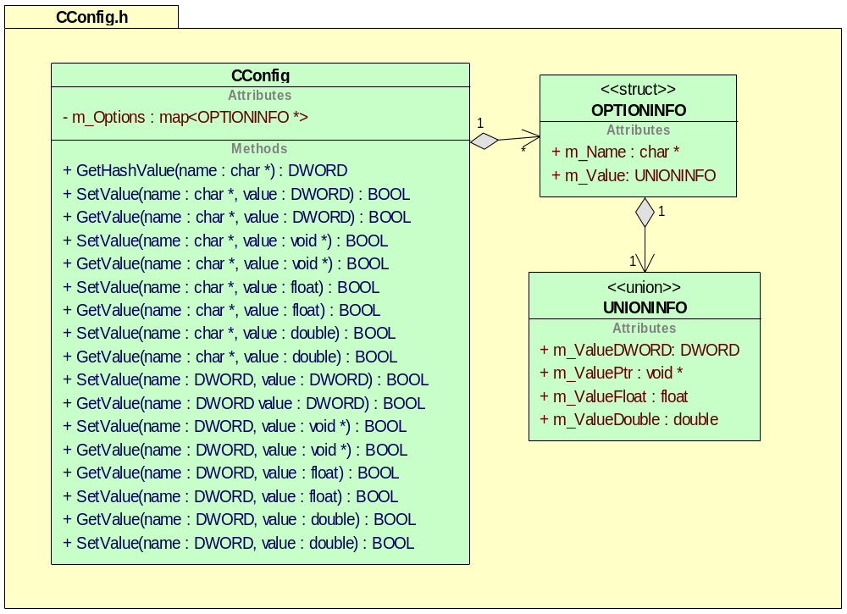

CVector3
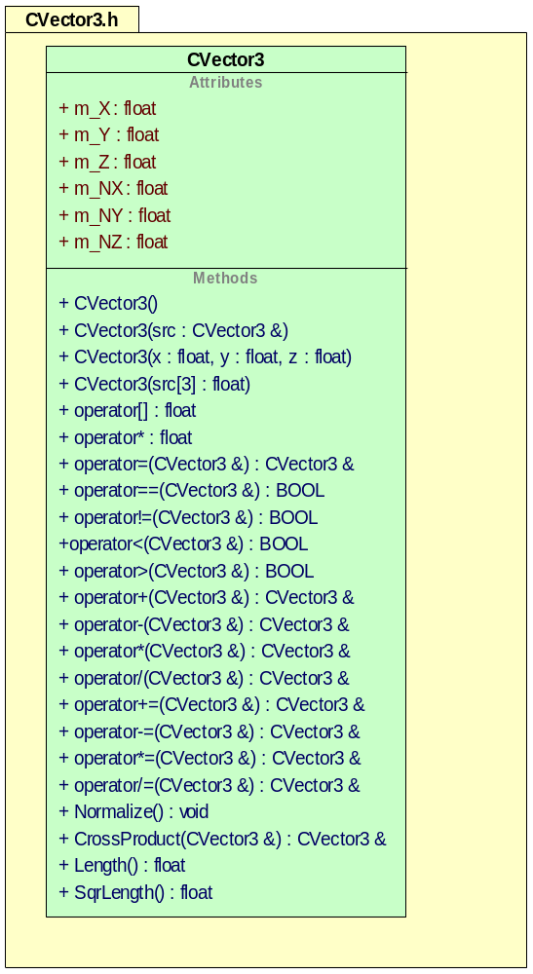

CVector4
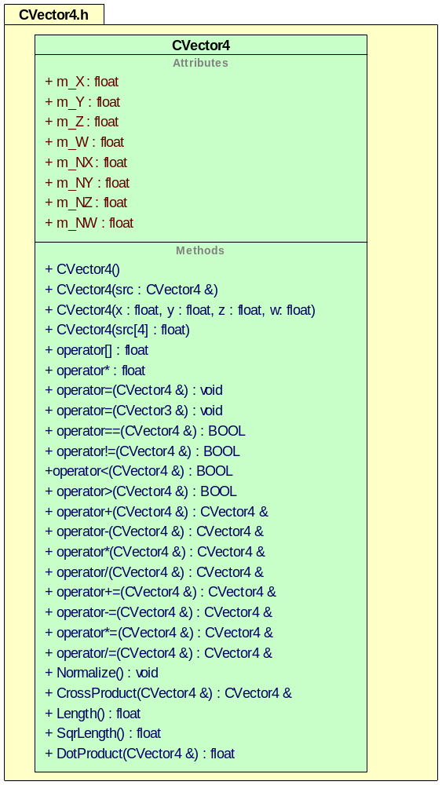

CMatrix3
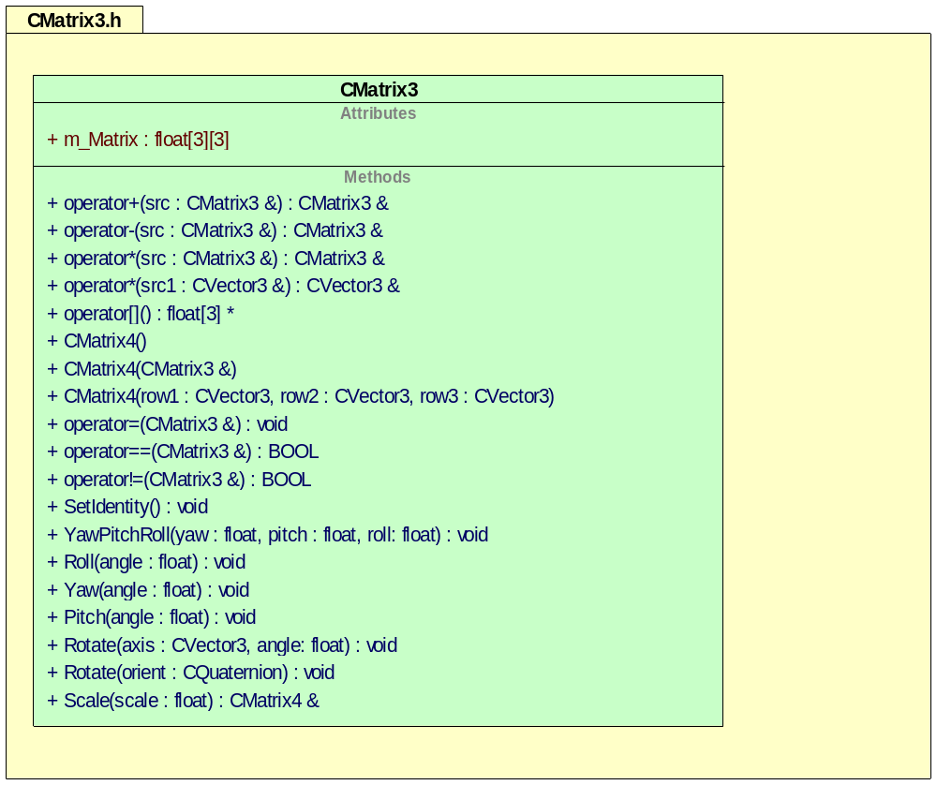

CMatrix4
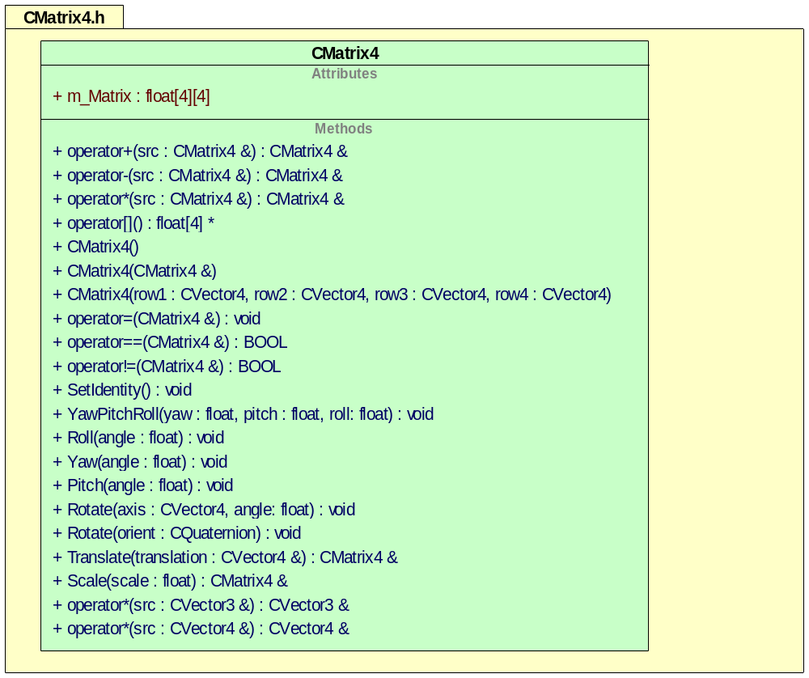

CTexture
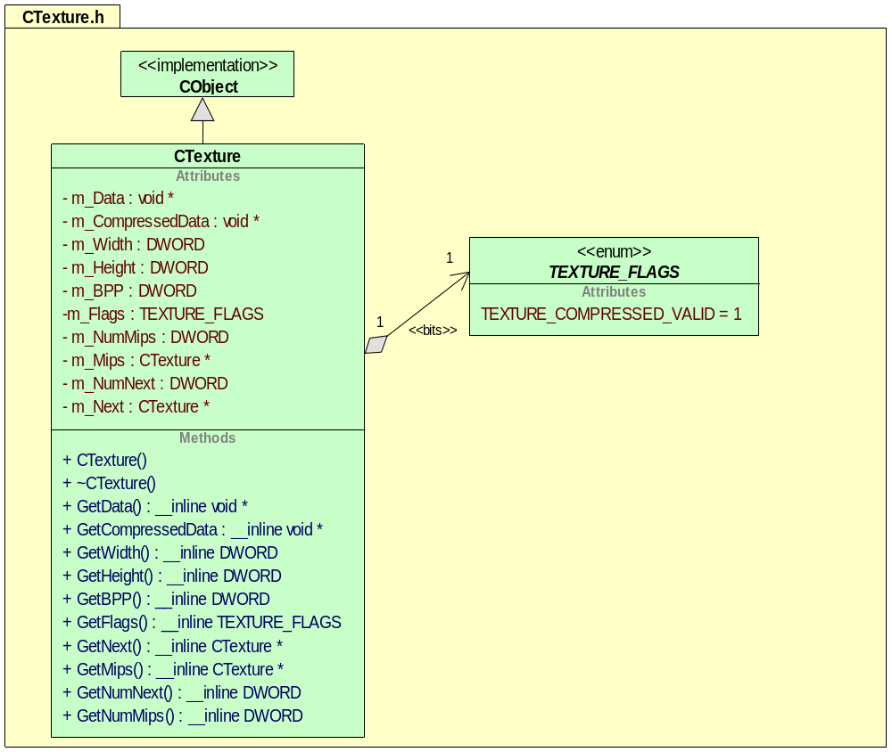

Data Structures
<Identify and describe the data structures used by this feature.>

Error and Exception Handling
<Describe the error and exception handling for this feature.>

Application Programming Interface (API)

Extension DLL resource conventions
Microsoft’s DLL extension mechanism is a great idea, but there are still issues with resource IDS. If you want to use IDS in the resource DLL, they will have to be unique. With this in mind the follow, conventions for IDS are proposed. Each extension DLL must modify the resource.h file to setup the unique IDS for that DLL. The modification only has to be done once when the project is created.
Extension DLLS are loaded by priority when passed back to the application that has loaded them. There is usually a menu, an icon and an ID associated with the document/view architecture. This is the starting point for the ID specification. Change this number to a number between 1000 and 20000. Then for controls, start the IDS at this number + 100. For IDS for menu items and buttons, add 40,000 to this number. Finally, for symed values, add 200. At the end of a resource file there are four values that need to be modified, APS_NEXT_RESOURCE_SYMBOL, APS_NEXT_COMMAND_SYMBOL, APS_NEXT_CONTROL_VALUE and APS_NEXT_SYMED_VALUE. These should be set to the last symbol defined for these types + 1. Here is an example implementation

//{{NO_DEPENDENCIES}}
// Microsoft Developer Studio generated include file.
// Used by ResourceShader.rc
//
#define IDR_SHADER_TYPE 2000 // Second Highest Priority loaded DLL
#define IDR_SHADER_TOOL_PALETTE 2000
#define IDS_SHADER 2000
#define IDS_RESOURCE_NAME 2001
#define IDD_SHADER_TOOL_PALETTE 2002
#define IDB_SHADER_TOOL_PAL 2005
#define IDB_SHADER_TOOL_PAL_DISABLE 2006

#define IDC_COMBO1 2100
#define IDC_SEARCHBUTTON 2101
#define IDC_EDIT_WATCH_VAR 2102
#define ID_TOOLBAR_COMPILE 2103

#define ID_SHADER_CHECK_SYNTAX 42001

// Next default values for new objects
//
#ifdef APSTUDIO_INVOKED
#ifndef APSTUDIO_READONLY_SYMBOLS
#define _APS_NEXT_RESOURCE_VALUE 20007
#define _APS_NEXT_COMMAND_VALUE 42002
#define _APS_NEXT_CONTROL_VALUE 2104
#define _APS_NEXT_SYMED_VALUE 2200
#endif
#endif

Tools
UML Diagrams were generated with UML Sculptor (http://umlsculptor.sourceforge.net)

Feature Operation
<Describe the feature in action. That is, describe how the pieces function together.>

Internationalization
<Identify and describe any internationalization requirements for this feature.>

Other Considerations
<Identify and describe any functional aspects of this feature not covered elsewhere in this document.>

Performance/Resources Impact
<Describe this feature's impact on system performance and resources.>

Portability
<Identify and describe any portability requirements for this feature.>

Consistency
<Identify and describe any consistency aspects of this feature relative to the tool. That is, consider how the feature conforms to the overall design of the tool in architecture, user interface characteristics, functionality, and so on.>

Compatibility
<Describe how this feature fits into the overall product.>

Important Issues

Coding Standards

Standard Template Libraries

Requirement: Use typedefs for your STL sets

Example:
typedef set<string> SoundFiles;
SoundFiles sound_files;

Optionally:
typedef SoundFiles::iterator SoundFilesIterator;

For/Next Loops

Optional: Try and not do the following.

for (SoundFilesIterator i = sound_files.begin(); i != sound_files.end(); i++)
{

/* whatever */
}

Justification: Debugging this becomes a lot harder, because you cannot set a breakpoint on initialization/iteration steps. Instead try to adhere to the following:

SoundFilesIterator SIterator;

Siterator = SoundFilesBegin();
while (i != SoundFilesEnd())
{
i++;
}

Requirement: Do not break up your statements, unless it is very long and only break it up at the semicolons

Justification: Readability

Indentation

Requirement: 4 space indentation do be used

Justification: Printing files line up this way. This is also the default for Visual C++.

Defines and Enumerations Definitions

Requirement: All defines and enumeration defines should be in all capital letters.

Justification: When reading code you can easily discern between definitions and variables

Examples:
#define DEFINES_ARE_ALL_CAPS 1

enum
{
ENUM_A,
ENUM_B,
};

#if DEFINES_ARE_ALL_CAPS
// code here
#else

#endif

Variables

Requirement: Variables can use underscores or use mixed case, but stick to one or the other for consistency.

Justification: When reading code you can easily discern between definitions and variables

Examples:
int variable_use_underscores;

bool bIsReady; // mixed case variable
int tooSexyForMyCode; // this is ok

Prototypes, Variables, Definitions

Optional: Keep prototypes, variables and definitions in separate groups.
Justification: Easier to find in code.

Example:

//
// Prototypes
//
void ExternalSub(int a);

//
// Definitions
//
#define TIMER_NUMBER 100

//
// Global Variables
//
int gCounter;
bool gBIsHardware;

Subroutines

Requirement: Use mixed case for subroutine names

Justification: Easily differentiate between routines and variables.

Example:

void SubRoutinesUseMixedCase()
{
}

Requirement: Use headers that describe what the routine does.

Justification: Helps other people understand what the function is good for. Will help in documentation.

Example:
//===============================================================
// Function: FlatLightRenderObject
// Description: To light every vertex with surface normal
// Parameters: vert_data1 = Vertices that are going to be lit
// vert_data2 = Lighting values
// light = light that will be used on the vertices
// Returns: bool = TRUE if any errors
//===============================================================
bool FlatLightRenderObject(const int & vert_data1, const int & vert_data2, CLight & light)
{
}

Constants and References

Optional: Use const and references whenever possible

Justification: It helps avoid initialization bugs

If Statements

Requirement: Do not have statements on the same line as the if statement.

Example:
if (a < b) FlatLightRenderObject();

Justification: You cannot set a breakpoint if the condition is met, which is very useful.

Correct Example:
If (a < b)
{
FlatLightRenderObject();
}

Requirement: Do not put else if statements on separate lines.

Justification: It breaks up the else if statement and isn't very aesthetic.

Correct Example:
if (a < b)
{
}
else if (c < < b)
{

}
else
{

}

// single line if statement are ok, but must next line must never split
if (a)
b = 43;

// NOT, (this is just asking for trouble)
if (a)
CallAReallyLongName(WITH_A_THOUSAND_OPTIONS |
THAT_SPAN_MULTIPLE_LINE);

if (a)
{
CallAReallyLongName(WITH_A_THOUSAND_OPTIONS |
THAT_SPAN_MULTIPLE_LINE);
}

// never do this
if (c) xxx();

Braces/Switch Statements

Requirement: Break switch statements and braces onto new lines.

Justification: It's easier to line up curly braces than to line up and if and a curly brace.

Example:

switch(q)
{
case a:
break;
// add line break here
case b:
break;
}

do // brace is on line below
{
//code here
} while(); // while is on same line

while()
{
// code
}

Comments

Optional: Comments can go in blocks and should be indented for multiple lines

Example:

/*
comments can go in blocks
indented, use this for large block
*/

Other Examples:

// single line comments are good

Parenthesis

Requirement: Liberal use of parenthesis is a good thing:

Justification: Avoids ambiguous statements and prevents bugs.

Examples:

if ( ( a & flagA ) && ( b & flagB )
&& ( c & flagC ) )
{

}

return 0; // no parenthises around return value,

Classes

Requirement: Proceed class name with a capital C

Justification: Allow you to discern that the variable is a class. Visual C, does it this way.

Example:

class CTree
{
public: // public stuff first
void CanIGoHomeNow() { return NO;}
bool IsFishGoodFood(const int & ocean); // const references are strongly recomended
// for all data types, classes, ints, whatever

void GetFish(CFish & fish); // references are preferable over pointers
void GetFish(CFish * fish); // these can be overridden, too

private: // put private members at the bottom

void PrivateClasses1(CFish * fish); // routines first, then vars
void PrivateClasses2(CFish * fish); // routines first, then vars
void PrivateClasses3(CFish * fish); // routines first, then vars

// strongly encourage members to be private or protected.
int m_member; // add m_ to member function or a struct called m
bool m_bIsReadyToRockAndRoll; //b for boolean is optional
bool m_bsReadyToRumble; //b for boolean is optional

// other way to represent class data
typedef struct CTreeData
{
int another_member1;
int another_member2;
} CTreeData;

CTreeData m;
};

Include Files

Examples:

// for include files, this is permitted
CommonInclude.h:
#ifndef _EXTERN
#define _EXTERN extern
#endif
_EXTERN int exportedVariable;

DefiningFile.c
#define _EXTERN
#include "CommonInclude.h"

UsingFile.c
#include "CommonInclude.h"

Requirement: Use #if around .h file

Justification: Because of multiple includes can cause problems

Example:

// add to header, use the name of the file
#ifdef INCLUDE_FILE_H
#define INCLUDE_FILE_H

... // file contents
#endif

Commas

Requirement: Command are always at the end of the line

Justification: Avoids confusion for list

Example:
char array[] =
{
0,
1,
2, // commas are at the end of the line
};

Miscellaneous

Optional coding practices, but these are not encouraged.

- non const references
- non caps for subroutine
- using extern for subroutines
- extern void external_sub(int a);

int flat_line_object(int Vert_data1, int Vert_data2, CLight & light)
{
// caps for variable
int A, VertexVariable;

// operators before or after is up to the coder
if ( ( a & flagA ) &&
( b & flagB ) &&
( c & flagC ) )
}

Do not use the following:

class a_special_class
{
public:
int mMember; // must use m_
};

// operator on line before
int
main (int argc, char * argv[]) {

// braces on same line
if (a < b ? 1: 0) {

}

// NO magic numbers

if (a == 34.5) // make this a define
{
// special case
}

return (0);
}

never chained ?: (e.g. confuseMe = i > n ? j > m ? 0 : 1 : i > m ? 2 : 3;)

Commas are at the beginning of the variables are not permitted

Example:
char array[] =
{
0
,1
,2
}

Related Documentation
<Identify other documents related to this feature.>
Document | Location/Filename
Marketing Requirements Document | <filename or none>
<Feature> Functional Specification | <filename or TBD>
<Feature> Test Plan | <filename or TBD>
Progress User Documentation
Other Documents

