Crossing selection

The crossing is one, every object is selected  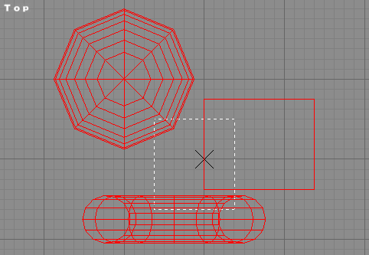 | The crossing toggle permits you to change the selection. If the crossing is on, you’ll only need a vertex in the selection to select the whole entity. When Crossing is off (crossing button upper), You’ll need the entier entity to be in the selection to select it.
Crossing off, only the object entierely in is selected.  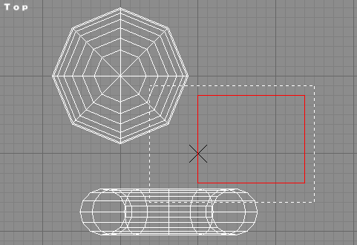 | Crossing works for all primitives.

View navigation

Moving view

We move the iso view  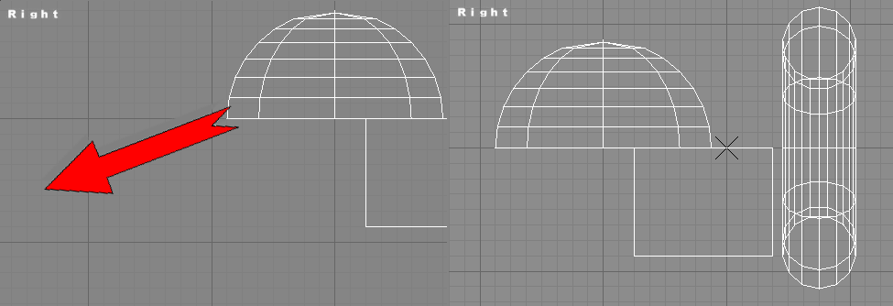 | You have various way to move a view. The first is to click that icon, select your view and dragging in the window. The second is to use the mouse middle button and dragging with. In addition, you can use the arrow keys. The up key move the view to the bottom, the left key to the right and so on.
We move the perspective view  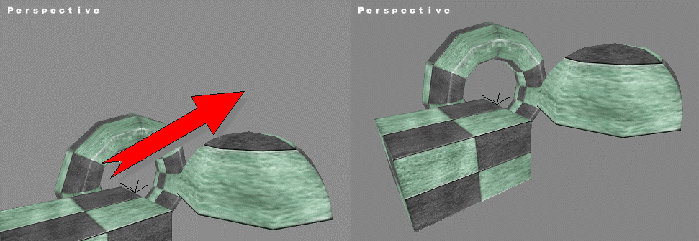 | In the camera/perspective view, that function (by the button or by the mouse middle button), it acts different. That function works more like a tripod camera. It rotate your head around. The arrow keys works different too. The up key make you go forward, the down key to backward, the left key rotate camera to left left and right key to the right.  Red arrow show mouse movement.

Viewing extends

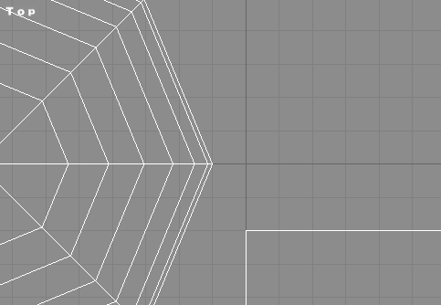  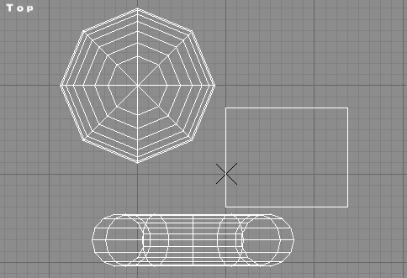 | Click that button if you want to see all the scene in your current view.
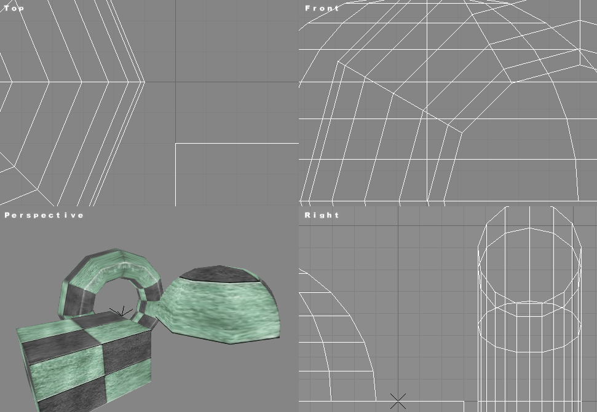  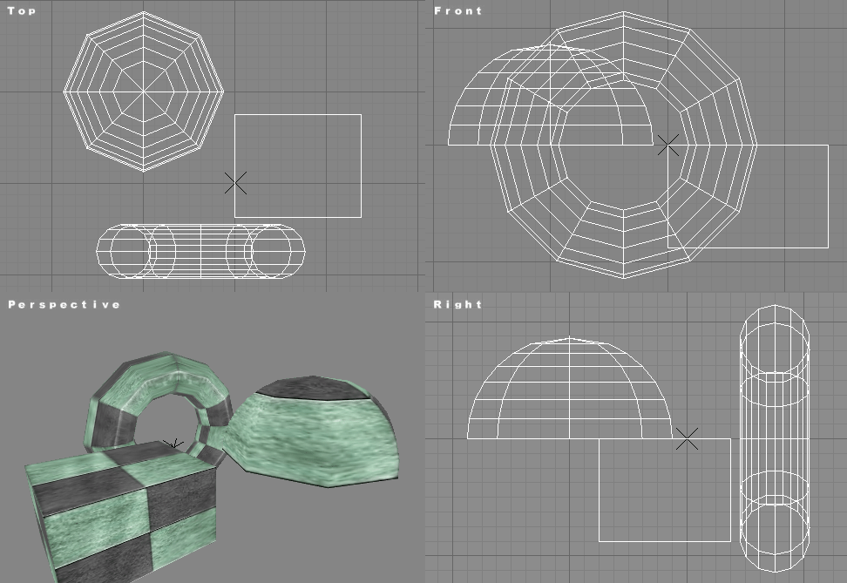 | Click that button if you want to see all the scene in all the views.

Zooming

Before Zooming  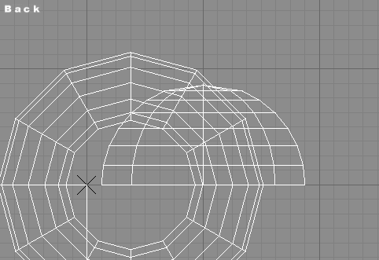  After zooming  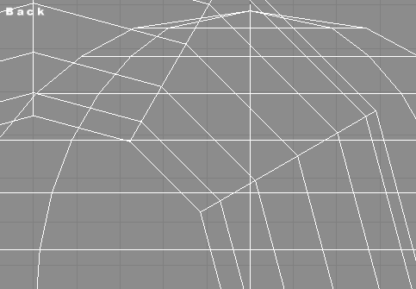 | There are 2 ways for zooming/unzooming. The first is to click that button and drag in a view. The second is to use the mouse wheel. Turn your wheel backward zooms in and wheel forward zoom out.

Zooming region

While dragging the box  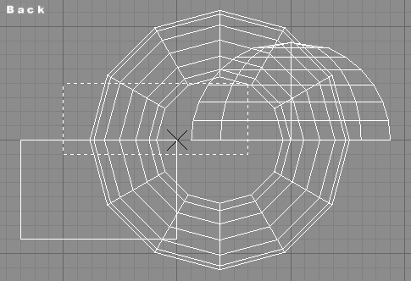 | You can zoom an entiere region by click that icon and draggind a box. The view will coresponds after to the boxed area. That area will keep the same proportion.
The resulting
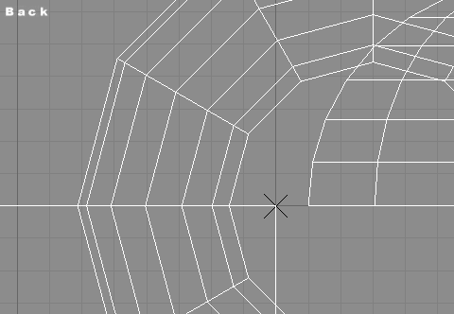

Rotating view

Rotating Iso view  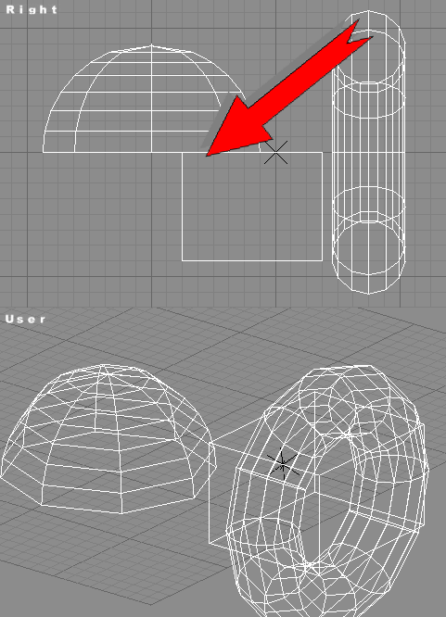 | You can rotate an isometric view (not camera/perspective). Click that button and drag in the selected view. The isometric view name switch to « User ». The read arrow show the mouse drag.

Isometric views/Camera selection/perspective

