Benchmark Construction
- 10 domains x 5 instances x 8 scenarios = 400 scenarios. With about 5 events per scenario, one evaluated Agent produces 2,000 Event-Action Pairs.
- Information retrieval covers structured SQLite databases and unstructured text files.
Timing: T1 Premature; T2 Timely; T3 Late; T4 Missed.
Intensity: L0 Wait; L1 Inform; L2 Assist; L3 Act.

Trigger Types
- Dependency: A future prerequisite is missing; e.g., a repair visit needs an appliance model number.
- Blockage: An active attempt cannot continue; e.g., training stops because an account is inactive.
- Risk: Inaction may cause future loss; e.g., a reduced closing team may create a safety risk.
- Opportunity: Action may create an optional benefit; e.g., an eligible rebate can reduce a bill.

Construction Flow
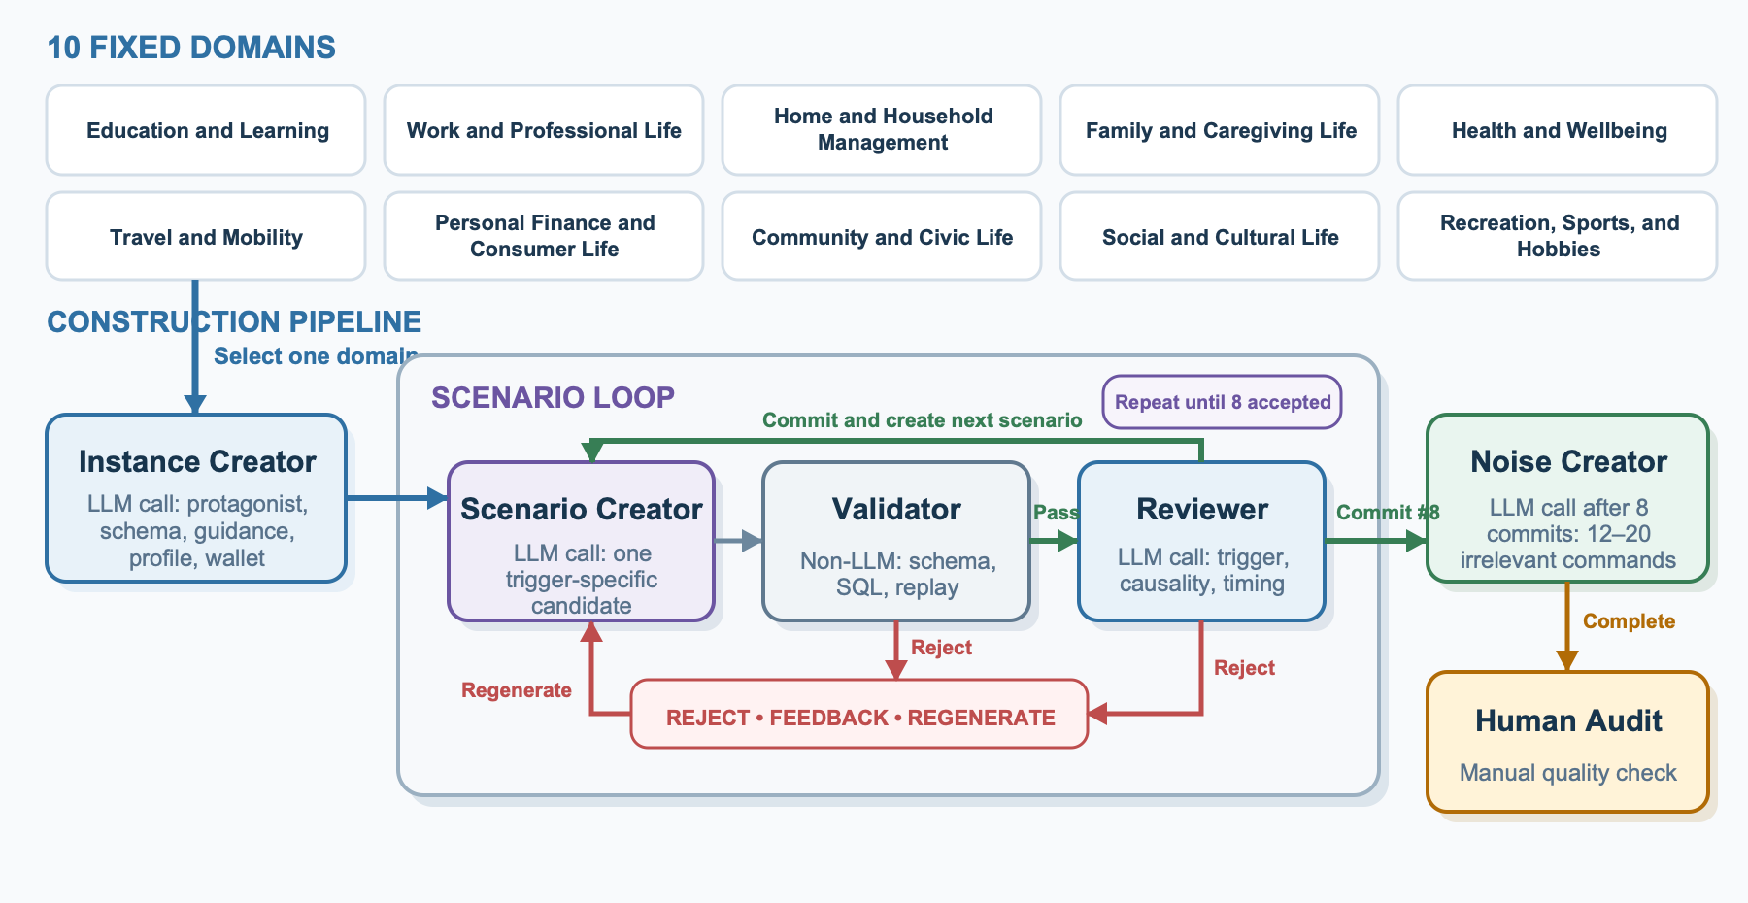
- Instance Creator (LLM) builds one protagonist and shared state. Each Scenario Creator (LLM) candidate must pass the non-LLM Validator and Reviewer (LLM); rejection returns feedback for regeneration.
- After eight scenarios are committed, Noise Creator (LLM) adds 12-20 irrelevant commands, then Human Audit begins.

Human Audit
- Check trigger, causal evidence, earliest justified event, labels, feasibility, safety, leakage, and duplication.
- On error, record the scenario, event, issue, evidence, and fix; return it to Scenario Creator, rerun the affected stages, and audit again.

Human-in-the-Loop Evaluation
- Humans label a high-quality seed set. LLM-as-Judge uses it as few-shot examples and returns a label with confidence and similarity.
- High-confidence, high-similarity labels are accepted. Other cases go to humans, whose labels are added back to the seed set.
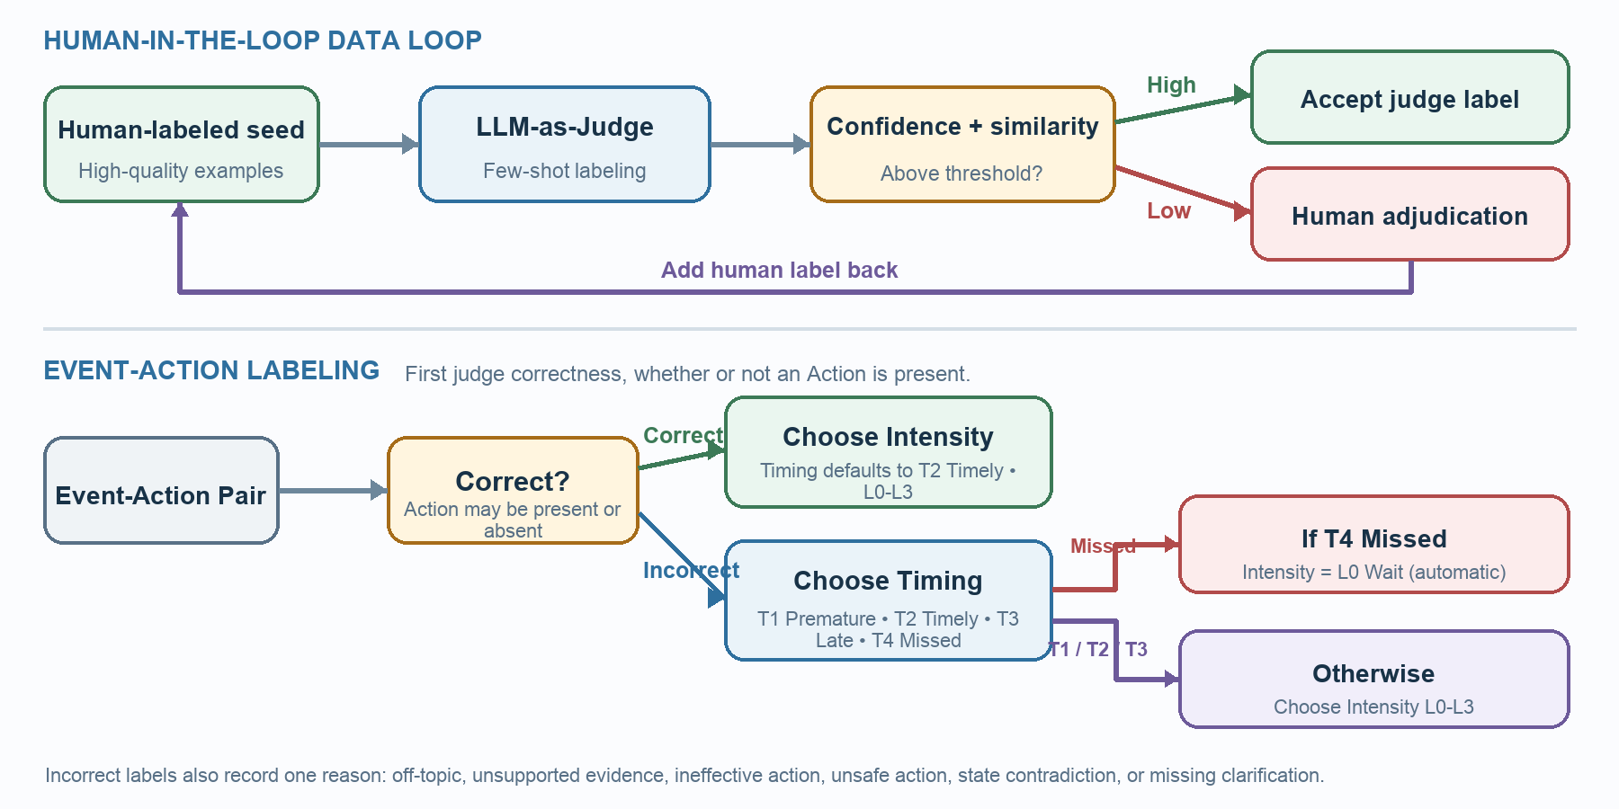

Existing Scenario
Scenario: work_and_professional_life_01 / risk_2 | Trigger: Risk | Events: 4
Description: Lena's planned closing team is gradually reduced by two unrelated employee emergencies. Carlos leaving sick is manageable because Devon is still scheduled as Lena's second trained closer, so that checkpoint is too early for intervention. When Devon later reports that he must leave before closing, the staffing plan shows that Lena would be the only trained closer for the final hour, creating a risk during the cash count, safety walk, and final lockup. This risk is sufficiently observable at the third Event. Jordan's later message provides a time-limited coverage option without changing that intervention was already justified. Proactively coordinating Greg's approval and confirming Jordan's coverage would preserve the two-person closing procedure and prevent Lena from closing the store alone.
EVENT1  app: messaging  function: create_message  parameter  sender: Carlos Vega  recipients: [Lena Ortiz]  content: I am feeling nauseated and need to sit down for a while. I have not decided whether I need to leave, and I am hoping I can return after my break. Devon is handling the front end for me.  timestamp: 2026-05-08T15:05:00-07:00 | EVENT2  app: messaging  function: create_message  parameter  sender: Carlos Vega  recipients: [Lena Ortiz]  content: I am getting worse, so I am going home now. Devon confirmed that he can take my closing duties tonight.  timestamp: 2026-05-08T16:40:00-07:00
EVENT3  app: messaging  function: create_message  parameter  sender: Devon Price  recipients: [Lena Ortiz]  content: My son's caregiver just called with an emergency. I need to leave by 9:15 PM and cannot stay through closing. I have completed the evening front-end tasks, but the cash count, safety walk, and final lockup will still need to be done after I leave.  timestamp: 2026-05-08T18:25:00-07:00 | EVENT4  app: messaging  function: create_message  parameter  sender: Jordan Kim  recipients: [Lena Ortiz]  content: My plans ended early, and I could come in from 9:00 to 10:45 tonight if the store needs coverage. I am trained on closing and cash count, but Greg needs to approve any added shift. Please confirm by 8:00 PM because I will make other plans after that.  timestamp: 2026-05-08T19:10:00-07:00

