
Faculty of Information Sciences and Engineering Management & Science University

INTERNSHIP REPORT
CCLI20112

OG IT FORENSICS SERVICES
By:
UTHAYAKUMAAR A/L KRISHNAN
Bachelor of Computer Forensic (Hons.)

Internal Supervisor:
Dr. Nur Fasihah Binti Mohd Esa

External Supervisor:
Ahmad Luqman Bin Hanafi

Feburary 2026
V

THIS REPORT IS DONE IN PARTIAL FULFILMENT OF THE COURSE EQUIPMENT OF BACHELOUR OF INFORMATION AND COMMUNICATION TECHNOLOGY

Title Page
Acknowledgements ii
ABSTRACT (abstract of practical training and summary of task given within 200 words) iii
Table of contents iv
LIST OF TABLE v
LIST OF FIGURE vi

CHAPTER 1: INTRODUCTION
  - Company Background 1
  - Organizational Chart 2
1.2.1 Chart of ogitfs company 3
1.2.2 Explanation of ogitfs chart 4
1.3 Mission and vision of the company 5
1.4 Objective and Function of Department Involved 5

CHAPTER 2: PROJECT
2.1 Project Involved 1
2.1.1 Tasks description
2.1.2 Methodology
2.1.4 Problems and Solutions
2.15 Duration
- Explain of each project (Gantt chart)
2.2 Project involved 2
2.3 Project involved 3
2.5 Others
CHAPTER 3: Training, Workshop & Seminar (If any)
3.1 Training, Workshop & Seminar
3.1.1 Explanation of each training
3.1.2 Corporate Social Responsibility (CSR)

CHAPTER 4: SUMMARY
4.1 Project Summary
4.2 Suggestions

APPENDIX A (Samples of printed report or any relevant forms etc)
APPENDIX B (Logbook)
Format
Paragraph: 1.5 line spacing
Margin: ( as cover page)
Page number: bottom right
Arial 11 or times roman 12

ACKNOWLEDGMENTS
I would like to express my deepest appreciation and sincere gratitude to all individuals and organizations whose guidance, encouragement, and support contributed to the successful completion of my industrial training.
First and foremost, I wish to extend my heartfelt gratitude to the management and staff of OG IT Forensic Services (M) Sdn. Bhd. for granting me the opportunity to undergo my industrial training within their organization. The experience provided me with invaluable exposure to the professional environment of digital forensics and cybersecurity, allowing me to bridge the gap between academic knowledge and practical industry applications.
My sincere appreciation is extended to my industrial supervisor, Ahmad Luqman Hanafi, whose continuous guidance, patience, and professional mentorship greatly enriched my learning experience. Their willingness to share technical expertise, constructive feedback, and practical insights into digital forensic investigations has significantly enhanced my analytical, technical, and professional competencies.
I would also like to express my gratitude to all members of the Digital Forensics Department and every colleague who generously shared their knowledge, provided technical assistance, and fostered a collaborative working environment throughout my internship. Their professionalism, encouragement, and support made my industrial training both meaningful and rewarding.
Special thanks are extended to my university internship coordinator, academic supervisor, and lecturers from Management and Science University for their continuous guidance, academic support, and valuable advice throughout the internship programme. Their commitment to ensuring the successful integration of academic learning with industrial practice has been instrumental in the completion of this training.
Finally, I would like to convey my deepest appreciation to my beloved parents, family members, and friends for their unwavering encouragement, understanding, and moral support throughout this journey. Their constant belief in my abilities has motivated me to overcome challenges and strive for excellence during my industrial training.
I am sincerely grateful to everyone who, in one way or another, contributed to the successful completion of this internship. The knowledge, skills, and professional values gained during this period will serve as a strong foundation for my future career in the field of digital forensics and cybersecurity.

ABSTRACT
This internship report summarizes the practical training undertaken at a digital forensic company as part of the Bachelor of Digital Forensics programme. The internship aimed to provide practical exposure to digital forensic investigations, cybersecurity operations, evidence handling, and professional workplace practices.
During the internship, various projects and technical tasks were assigned, including digital evidence acquisition, forensic analysis, documentation, report preparation, malware analysis support, incident response assistance, and research related to cybersecurity technologies. The internship also provided opportunities to understand industry-standard forensic methodologies, legal considerations, and the importance of maintaining the integrity of digital evidence.
Besides technical activities, participation in internal meetings, training sessions, and collaborative projects helped improve communication, teamwork, and problem-solving skills. The experience bridged the gap between academic knowledge and industrial practices while strengthening technical competencies in digital forensics.
Overall, the internship successfully enhanced professional knowledge, practical skills, and confidence in handling real-world digital forensic investigations and cybersecurity challenges.

TABLE OF CONTENT
Contents
ACKNOWLEDGMENTS 4
ABSTRACT 5
TABLE OF CONTENT 6
LIST OF TABLES 7
LIST OF FIGURE 8
CHAPTER 1: INTRODUCTION 9
1.1 Company Background 9
1.2 Organizational Chart 11
1.2.1 Chart of OG IT Forensic Services 11
1.2.2 Explanation of OG IT Forensic Service chart 12
1.3 Mission and vision of the company 13
1.4 Objective and Function of Department Involve 13
Chapter 2: Project 15
2.1 Project Involved 1 15
2.1.1 Tasks description 15
2.1.2 Methodology 16
2.1.3 Problems and Solutions 33
2.1.4 Timeline 34
2.2 Project Involved 2 35
2.2.1 Tasks description 35
2.2.2 Methodology 36
2.2.3 Problems and Solutions 36
2.2.4 Duration 41
2.3 Project Involved 3 42
2.3.1 Tasks description 42
2.3.2 Methodology 43
2.3.3 Problems and Solutions 43
2.3.4 Duration 44
3.0 Chapter 3: TRAINING, WORKSHOP & SEMINAR 45
3.1 Training, Workshop & Seminar 45
3.1.1 Explanation of Each Training 45
3.1.2 Corporate Social Responsibility (CSR) 47

LIST OF TABLES

LIST OF FIGURE

CHAPTER 1: INTRODUCTION

1.1 Company Background


OG IT Forensic Services is the Malaysia’s first private digital forensic investigator located in Kuala Lumpur, Malaysia. OG IT Forensic Services started as freelancer in July 2010 and officially registered under SSM in May 2011. In October 2021, OG IT Forensic Services has been registered as private limited company.
OG IT Forensics Services provides several services as shown below:
- Computer Forensics: Forensic analysis on Hard Disk, External Drive, Thumb drives, Email/Chats communications, password-protected files can be recovered, Hacker activity & break in attempts.

- Mobile Phone Forensics: Types of electronic data gathering to gather criminal evidence from trail of digital data for legal evidence purposes, Mobile chip off (Malaysia First Chip Off Service) for deleted data recovery.

- Social Networking Analysis (First SNA provider in Malaysia): Find relationships and flow between individual, groups, organization, computers and more revealing the digital footprint across the internet infrastructure. The teams can find hidden connections between entities proving the entities are linked or not. In the era of cybertroopers and fake identities OG IT Forensic Services can unmask anonymity using their SNA service.

- Email Forensic: Uncovering phishing, spoofed, insider threat to reconstruct the chronological timeline of the event and perform deep packet inspections of email headers.

- Audio & Video Forensic: Validates the authenticity of the audio and video evidence identifying for digital tampering ensures evidence is admissible to the court.

- Live Security Incident Response: The team is expert in handling the volatile data without destroying the data in the compromised devices. OGITFS provides depth security incident investigation such as Identification of Security Incident, Containment of A Security Incident, Eradication of the security incident, Recovery of the security incident, Recommendation for improvement.

OG IT Forensic Services laboratory fully equipped with advance industry standard forensic tools. This specialized infrastructure enables to perform depth investigation ensuring the digital artifacts are extracted and preserved. The forensic tools are Oxygen Forensics, Maltego, GMDSOFT MD-Series, Vound Intella, Adobe Audition, Izotope, Encase Forensic, FAW, Magnet Forensics, Cognitech, Sumuri.

1.2 Organizational Chart

1.2.1 Chart of OG IT Forensic Services
Senior Digital Forensic Investigator

UTHAYAKUMAAR A/L KRISHNAN
(Junior Digital Forensic Investigator)
Digital Forensic Investigator

Diagram 1.2.1.1: Organization Chart of OG IT Forensic Services

1.2.2 Explanation of OG IT Forensic Service chart

Diagram 1.2.1.2: Explanation of the OG IT Forensic Services Company Chart

1.3 Mission and vision of the company

Mission
Bringing “Financial Fraud, Identity Theft & Cyber Crime to Justice with Digital Evidence”.
Vision
Develop OG IT Forensic Services to provide ad-hoc Security Incident Response & Best Digital Forensic Services to our clients in Malaysia.

1.4 Objective and Function of Department Involve

The Digital Forensic Department is that responsible in identifying, acquiring, preserving, analysing and presenting the digital evidence such as computers, smart phones, storage media etc. Every activity in the digital space leaves a digital footprint and the department’s job is to uncover them. Their core objectives are to uncover the evidence in the digital evidence with maintaining integrity of the evidence handled and bring cyber-crime to justice with digital evidence.
Core Objectives of the Digital Forensics Department
- Identifying, acquiring, preserving, analysing and presenting the digital data in an investigation to present them as evidence in the court of law.
- Ensure digital data is handled under International Organization for Standardization (ISO/IEC 27037) to ensure the integrity is maintained throughout the investigation admissible in court.
- Aid in find the motive behind crime and identify main culprit in investigation.
- `Restore cyber incident process and timeline.
- Once gathered and preserved the evidence, detailed report in understandable manner serving as expert witness who provide testimony in criminal and civil cases to present in the evidence to the court.
- cybersecurity training within corporate and legal environments.
- Assists in real-time incident response align with corporate strategy, evaluate weaknesses and offer instruction and practical suggestions to strengthen their clients' defences against digital threats.
The Digital Forensic Department responsible copies and protects digital data from devices to preserve this data's authenticity and demonstrate that it hasn't been altered for legal purposes, they record every stage of managing it. After that, experts look through systems to retrieve erased files, get around encryption, and create distinct histories of user activity. Lastly, they convert these technical discoveries into reports that are easy to read and understand for decision-makers. These reports help law enforcement, settle legal issues, and shield the company from any security risks.

Chapter 2: Project

2.1 Project Involved 1
Video and Audio verification investigation from USB. The task was to determine the authenticity of the audio and video files are genuine and not tampered.

2.1.1 Tasks description
Table 2.1.1: Task description
Case Scope | Audio and Video Verification.
Objective | Identify if the video and audio files were tampered or genuine.
Scope of work | - Perform forensic acquisition of the USB media.  - Analyse the audio stream of the video file & audio file.  - Analyse extracted frames for any sign of tampering.

To ensure forensic integrity and prevent data alteration, the subject USB storage drive was connected to a Windows analysis workstation via a validated hardware write-blocker. This prevented any modification to physical sectors, file content, or system timestamps.
A bit-stream physical acquisition of the media was performed using Exterro FTK Imager. Cryptographic hash verification (MD5/SHA-256) was conducted immediately post-acquisition, matching the source drive to the forensic image and confirming bit-level integrity with zero discrepancies.

Ingestion and Forensic Examination
The verified forensic image was ingested into Oxygen Forensic Detective to parse the underlying file system, index directory structures, and render file contents for structured analysis.
Target digital video files within multimedia containers (such as MP4 and MOV) were segregated into their constituent components metadata, video stream, and audio stream for specialized tampering analysis:

- File and Container Metadata Analysis:
Evaluated container headers and system-level timestamps using ExifTool and Oxygen Forensic Detective.
Compared internal embedded container dates (CreateDate, ModifyDate) against external file system timestamps ($MFT/FAT timestamps) to detect chronological anomalies, re-encoding signatures, or discrepancies.

- Video Stream & Frame-by-Frame Authentication:
Extracted raw video frames sequentially to inspect inter-frame visual continuity.
Evaluated motion vectors and object inertia across adjacent frames to identify frame drops, splicing, ghosting, or frame substitution indicative of manipulation.
- Audio Stream & Spectrographic Authentication:
Audited the continuous timeline of the audio track from start to finish to confirm an absence of unexplained pauses or hard cut-offs.
Analyzed the ambient background noise floor across the entire duration for consistency.
Performed waveform and spectrographic analyses to ensure uninterrupted acoustic flow and detect frequency-domain anomalies characteristic of edits, inserts, or deletions.
- Hexadecimal Verification:
Conducted hex-level reviews of the file structure to identify non-standard atom/box layouts, incomplete moov atoms, appended data, or proprietary metadata tags introduced by third-party editing software.

All forensic procedures, hardware configurations, software tool versions, and chain-of-custody verifications were methodically documented in a contemporaneous case log.
The finalized forensic examination report outlines the methodology, technical findings, and objective conclusions in clear, structured language suitable for both technical and non-technical stakeholders. Following an internal peer review with the forensic supervisor, necessary revisions were applied, and the final forensic report was formally submitted.

2.1.2 Methodology
Table 2.1.2 shows the tools used for this project.
Table 2.1.2: Tool used in this task
Tools Used
Exterro FTK Imager – Forensic imaging software
Oxygen Forensic Detective – Mobile forensic software
Exiftool – Metadata extractor tool
iZotope FX10 – Audio analysis software
Adobe Audition - Audio analysis software
Ffmpeg – Video Frame Extraction tool

- Evidence Collection and Imaging
The first step was to seize the USB drive and create a forensic copy for analysis.
- The USB drive was connected to an analysis laptop through a write-blocker to make sure no files, timestamps, or system data were changed.
- Using Exterro FTK Imager, a physical copy of the drive was created. This process makes an exact bit-by-bit clone of the USB, including deleted files and unallocated space.

- Verification and Analysis
- Once imaging was finished, FTK Imager automatically generated and compared the hash values of both the original USB and the forensic image. The matching hashes confirmed the copy was identical to the original and had not been changed, keeping it legally valid for court.
- The verified image was then loaded into Oxygen Forensic Detective to be examined.

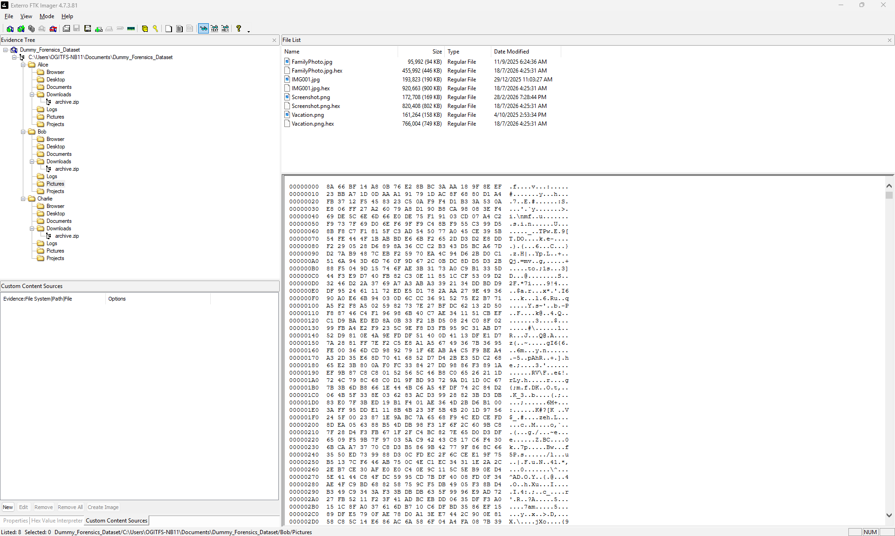
File List Panel
Hex value viewer Panel
Evidence tree Panel
Figure 2.1.1.1: The view of Exterro FTK Imager (To perform physical acquisition)
Digital video and audio evidence play a critical role in modern investigations, but their evidentiary value depends entirely on proving their integrity and authenticity. Because digital multimedia can be easily altered, cut, or re-encoded without obvious visual or audible flaws, forensic examination must rely on systematic acquisition and multi-layered technical analysis.

This investigation began with the secure collection and preservation of the subject USB media. Using a hardware write-blocker alongside Exterro FTK Imager, a forensically sound physical acquisition was performed to capture an exact bit-by-bit duplicate of the device, including unallocated clusters and deleted data. The forensic image was authenticated via cryptographic hashing to ensure the evidence remained unchanged and legally admissible for court proceedings.

Following acquisition, the image was ingested into Oxygen Forensic Detective and further inspected using ExifTool. The examination focused on verifying the authenticity of container-based media files (such as MP4 and MOV) by analyzing their underlying hex structure, headers, footers, and internal container timestamps such as Track and Media Create and Modify dates. Identifying discrepancies across these technical layers allows investigators to distinguish an unedited, original recording from a file that has been re-saved, tampered with, or processed through secondary editing software.

Audio and Video Metadata Verification
Metadata analysis was conducted using Oxygen Forensic Detective and ExifTool to evaluate the authenticity of the media files.

- Key container timestamp fields were checked and compared across the streams:
- Track Create Date
- Track Modify Date
- Media Create Date
- Media Modify Date

In an unedited original file, these internal timestamps generally match. If the modification date is newer than the creation date, it indicates that the file was likely re-saved, edited, or re-encoded by secondary software rather than preserved in its original recorded state.

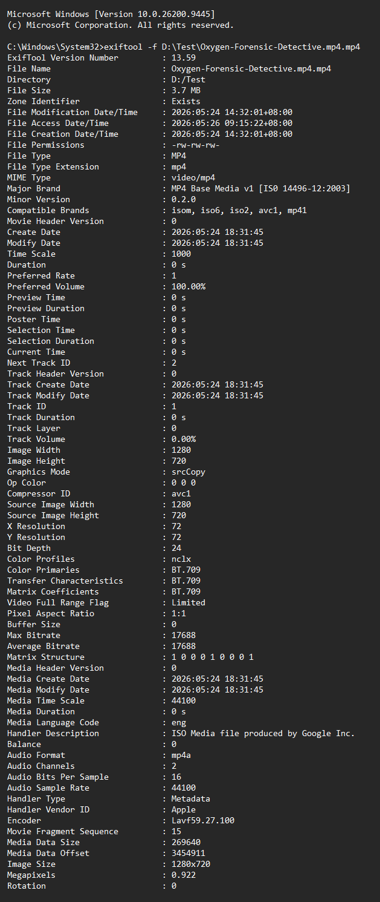
Video Metadata information
File Creation Date, Modification date and Access Date may change whenever new copy of the video are made accordingly
Audio Track & Video Created date and Modified date is the same, which indicates the video is Genuine
Video Track Metadata information
Audio Track Metadata information
File System Metadata information
Figure 2.1.1.2a: Example of genuine metadata
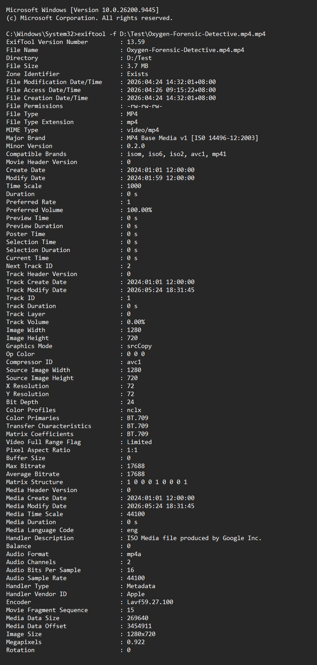
Video Metadata information
File Creation Date, Modification date and Access Date may change whenever new copy of the video are made accordingly
Audio Track Metadata information information
Video Track Metadata information
Audio Track & Video Created date and Modified date is changed, which indicates the video is Tampered
File System Metadata information
Figure 2.1.1.2b: Example of tampered metadata
- Metadata and Hexadecimal Analysis

The next step was examining the video files' metadata and hex values using Oxygen Forensic Detective.
Metadata reveals key details about a file, including when it was created, when it was last modified, the software used to make it, and its source device.

- File Header Analysis: The header is at the very beginning of the file. It tells the computer how to read the file format. By checking the hex values in the header, we can confirm the true file type regardless of its extension. For example, the hex sequence 66 74 79 70 69 73 6F 6D (ASCII: ftypisom) identifies the file as an MP4 "ISO Base Media" container.
- File Footer Analysis: The footer is at the end of the file, marking where the data stops. Footers often store trailing data from editing tools. For instance, if a video was modified using Adobe Premiere Pro, the footer may contain software version details, project timestamps, and edit history (such as save actions).

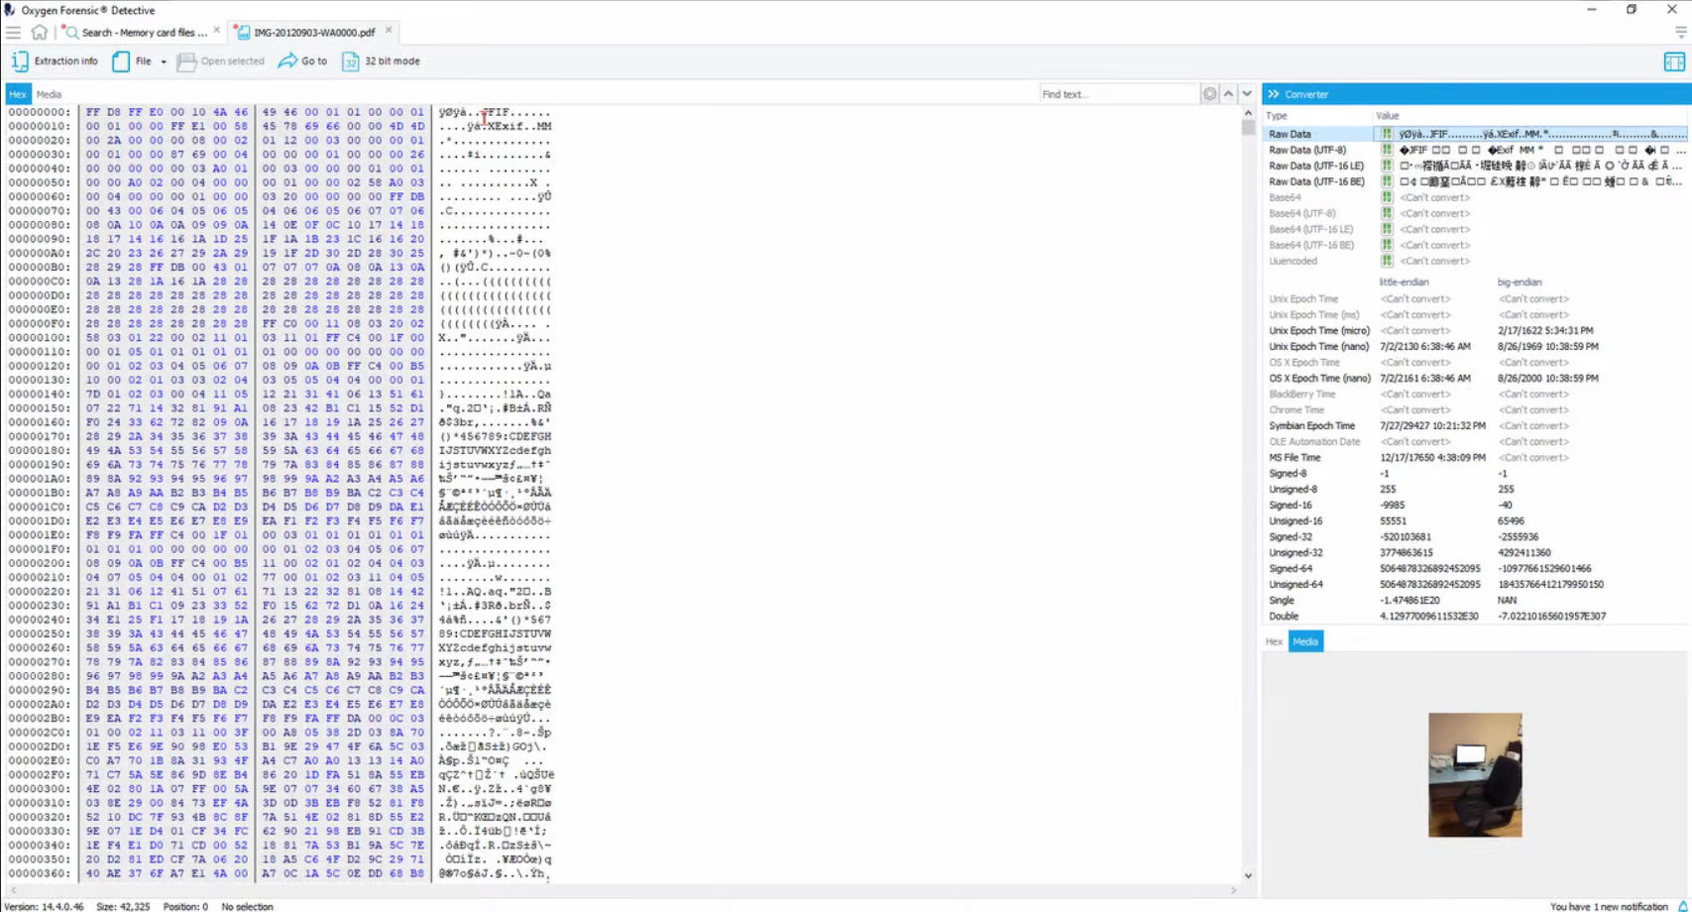
Figure 2.1.1.3: Hex view of the Oxygen Forensic Detective

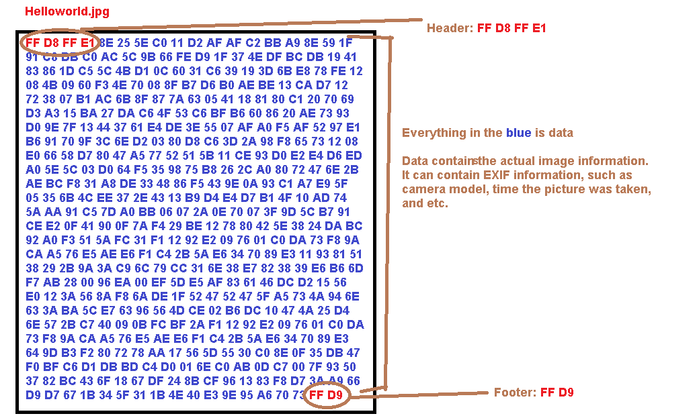
Figure 2.1.1.4: Header and Footer of the hex view of a file

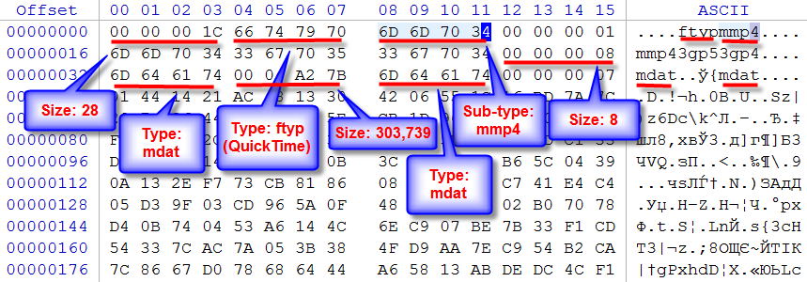
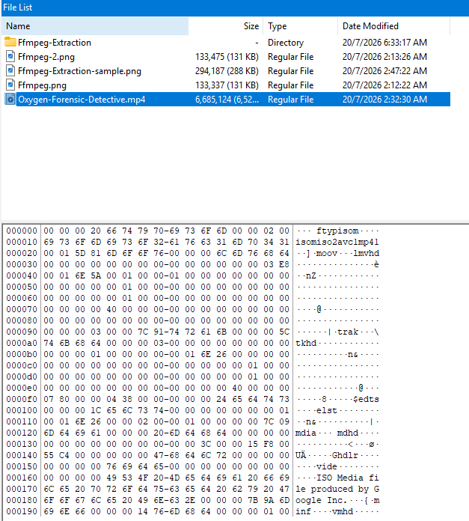
Figure 2.1.1.5: Header of the file showing it is a MP4 file

- Video Stream and Frame Analysis

The next phase involved analyzing the video stream to detect tampering, cut frames, or splicing. A video recorded at 60 fps consists of 60 individual still images played per second. The examination followed these steps:

- Frame Extraction: Using FFmpeg, every frame of the video was extracted sequentially as a separate JPEG image.
- Frame Continuity and Motion Review: The extracted frames were reviewed sequentially to ensure natural motion continuity from one frame to the next. The investigator verified that moving objects followed consistent inertia, checking that no abrupt frame drops, insertions, or unnatural scene breaks occurred. Representative frames displaying motion continuity were documented from the beginning, middle, and end of the footage.

- Image Forensics Verification: Key extracted frames were uploaded to FotoForensics for deeper image integrity analysis. The evaluation reviewed:

  - Error Level Analysis (ELA) to detect resaved or spliced regions
  - Metadata and source image structure
  - Hidden content and ICC profile data
  - Histogram equalization and estimated JPEG compression quality

Reporting: The analytical findings and charts were exported from FotoForensics as a PDF report to serve as technical supporting evidence.

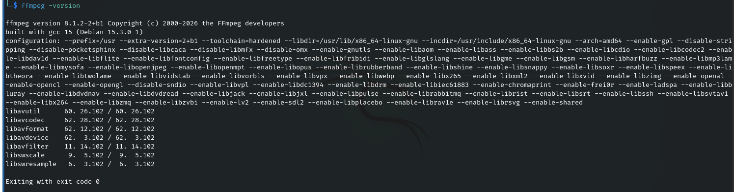
Figure 2.1.1.6: FFmpeg Version Information Displayed in the Linux Terminal, The command was executed to verify the installed version of FFmpeg and the associated multimedia libraries available within the Linux environment. This verification ensured that FFmpeg had been correctly installed and properly configured before proceeding with the implementation and subsequent development tasks.
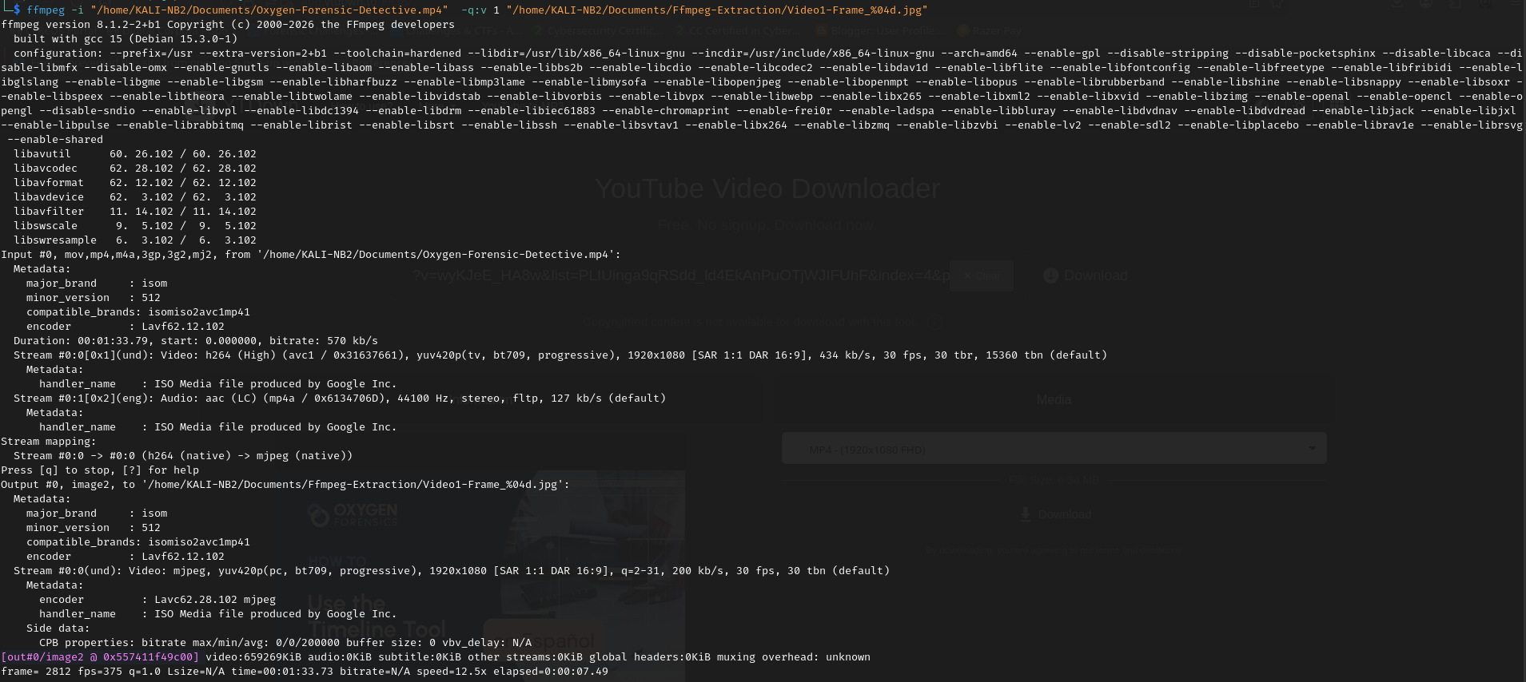
Figure 2.1.1.7: Extraction of an MP4 File Using FFmpeg
Ffmpeg extraction Destination path
Ffmpeg primary command
Quality control command of the jpeg extraction
MP4 video Source path
Figure 2.1.1.8 Ffmpeg command explanation

Figure 2.1.1.9 The metadata of the Mp4 video extracted shows the Frames-per-second, encoder, Duration, handler_name

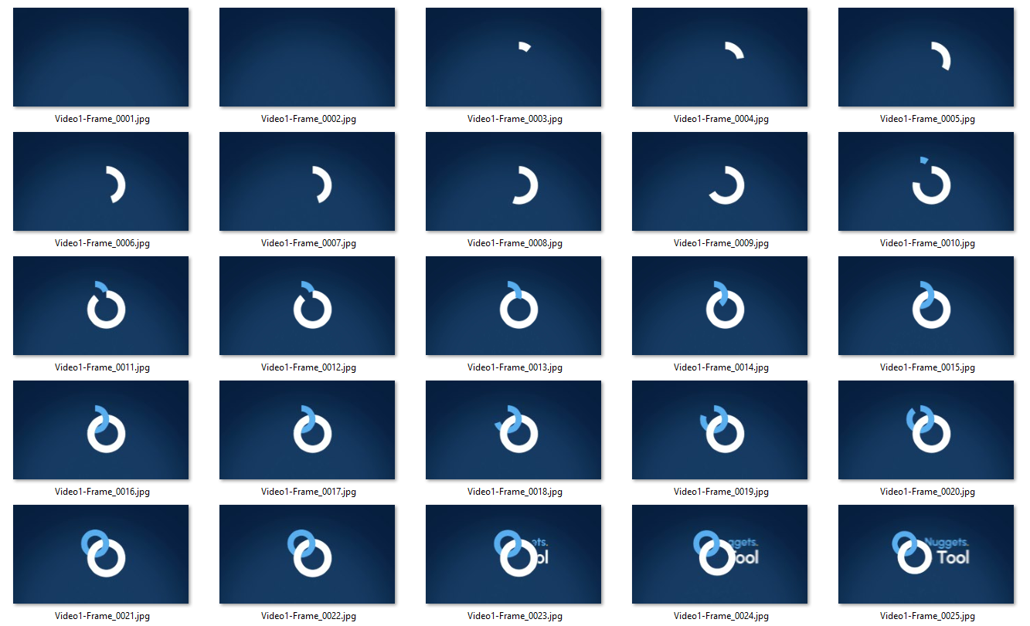
Extracted frames
Figure 2.1.1.10: Extracted frames of the video file using Ffmpeg

For example, consider a video depicting a ball moving from Point A to Point B. When the extracted frames are examined sequentially, the ball should exhibit smooth and continuous motion throughout its trajectory. If there is an abrupt displacement, discontinuity, or unexpected transition in the ball's position between consecutive frames, it may indicate that the video has been edited or otherwise tampered with. Therefore, reviewing the extracted frames enables the analyst to assess the continuity of the object's motion and determine whether its movement follows a natural and uninterrupted path, providing evidence to support the authenticity or identify potential signs of manipulation.
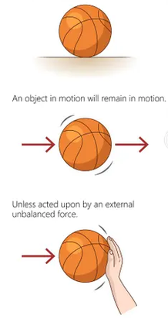
Figure 2.1.1.11: Showing inertia of a ball moving from point A to Point B

Adobe Audition or iZotope RX10 was used to examine the audio stream by analysing its waveform, spectrogram, and noise floor for indications of potential manipulation. During the analysis, the noise floor was assessed to ensure it remained consistent throughout the recording, with no unexplained interruptions, gaps, or abrupt changes in the background noise profile. The audio was also reviewed for sudden sound transitions, discontinuities, or pauses that could indicate sections had been cut, inserted, or replaced. In an authentic recording, the audio should exhibit continuous playback from beginning to end without unnatural breaks or noticeable transitions. The absence of these anomalies supports the conclusion that the audio stream is consistent with an original recording and shows no apparent signs of tampering.

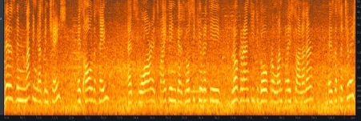
The constant noise floor shows no sign of cut/gap
Figure 2.1.1.12a: Shows constant noise floor with no break which indicates no sign of tampering
(Audio is genuine)

There no constant noise floor shows sign of cut/gap
The constant noise floor shows no sign of cut or editing
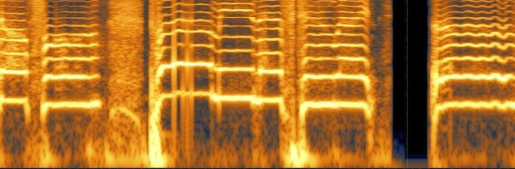
Figure 2.1.1.12b: Irregular noise floor which has cut/gaps indicates sign of tampering
(Audio is modified)

2.1.3 Problems and Solutions
Problem | Solution
Logical forensic image unsuccessful to be processed in the Oxygen Forensic Detective | Physical acquisition is performed using Exterro FTK Imager and the physical forensic image is used to process in the Oxygen Forensic Detective.

2.1.4 Timeline

18th MAY 2026 & 19th MAY 2026
- Audio verification analysis (Extract video frames and review frame inertia).
- Reporting

14th MAY 2026
- Physical acquisition of the USB device.
- Processed & metadata analysis.

14th March 2026
18th March 2026
15th MAY 2026 & 16th MAY 2026
- Audio verification analysis (Review audio spectrogram).
- Reporting

2.2 Project Involved 2
The email and attachment analysis on the provided .eml file and the associated ZIP file (containing 20 snapshots) to prove if the email sent is spoofed, compromised, or contains manipulated evidence by analyzing email headers and performing comprehensive image forensics.

2.2.1 Tasks description
Table 2.2.1: Task description
Case Scope | Email and Attachment Forensic Analysis
Objective | Identify any signs of email spoofing, structural routing anomalies, or malicious/tampered image artifacts hidden within the email attachments.
Scope of work | - Forensically collect, acquire, verify, and perform detailed forensic analysis on the .eml file using Vound Intella.  - Review the raw email headers to trace routing paths, verify sender authenticity, and identify potential spoofing indicators.  - Extract the ZIP container, isolate the 20 image snapshots, and extract their underlying metadata (EXIF data) to check for device signatures and modification timelines.  - Perform comprehensive image forensic analysis using Lab.FotoForensics to evaluate Error Level Analysis (ELA), pixel-level adjustments, original versus resaved signatures, and histogram patterns to detect any digital tampering or manipulation.

Email header is the metadata that is attached to every email containing information such as sender, receiver, route, timestamp etc. Email headers are used to authenticate the email senders. The email headers are identified as field and value such as “From: Adam” where “From” field and “Adam” is the value. The header is crucial place to investigate as it contains various details such as return-path, reply-to and so on however the header also give out valuable information on the route of the email servers.

Furthermore, image forensics play a critical role in cases where visual evidence is attached. File structures, compression artifacts, and pixel arrangements can reveal whether a screenshot has been edited or artificially altered. The raw email headers and .eml files, along with the associated attachment ZIP files containing the 20 snapshots, were thoroughly processed using Vound Intella for advanced email parsing, search indexing, and deep attachment extraction. The isolated image files and their corresponding EXIF metadata were then subjected to rigorous visual verification via Lab.FotoForensics covering Error Level Analysis (ELA) for compression discrepancies, pixel integrity checks, original versus resaved signatures, and histogram analysis to definitively test for any malicious or intentional image tampering. To maintain strict digital forensic standards, all collected evidence items were forensically acquired, hashed, and verified using Exterro FTK Imager to ensure the evidence is properly preserved.

2.2.2 Methodology
Table 2.2.2 shows the tool used for this project.
Table 2.2.2: Tool used in this task
Tools Used
Vound Intella – eDiscovery and email parsing platform
ExifTool – Metadata extraction utility
Lab.FotoForensics – Web-based digital image forensics tool

The .eml files, associated attachment ZIP files containing the 20 snapshots, and raw email headers were collected, processed, and verified within Vound Intella. Extracted image files and their underlying metadata were isolated to ensure data integrity, structural preservation, and precise forensic analysis.

2.2.3 Problems and Solutions
No | Problem | Solution
1 | I had limited experience with Vound Intella and specialized image analysis workflows via Lab.FotoForensics, hence my progress was slow initially. | I conducted independent research using online documentation and technical guides, along with holding discussions and seeking guidance from my supervisor. Soon I was able to catch up the pace.
2 | The raw email headers contained complex routing anomalies and unstructured text fields, making it challenging to manually trace the authentic transmission path. | I utilized Vound Intella's built-in header parsing capabilities to systematically break down the fields and cross-referenced the hop-by-hop delivery details to reconstruct an accurate transmission timeline.

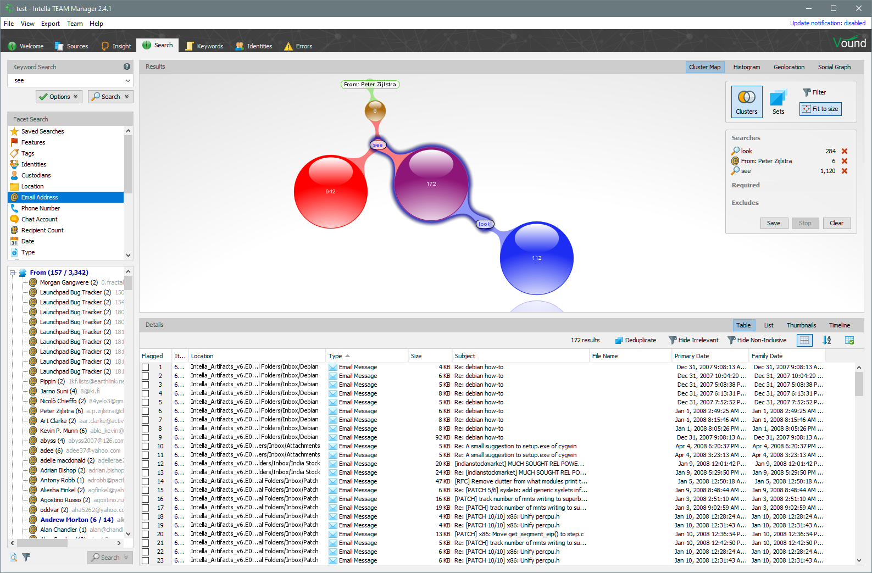
Figure 2.2.2.1 The Vound Intella Email analysis interface

Firstly, the interface and workspace layout analysis was conducted using Intella 3.0 to evaluate how Electronically Stored Information (ESI) and digital evidence are indexed, categorized, and presented for examination. As depicted in the figure, the Intella workspace is structured into distinct functional panels including the facet navigation sidebar, the primary result/content pane, and the real-time item previewer which collectively streamline data organization and evidence discovery.

The facet panel on the left aggregates critical metadata attributes (such as file type, date ranges, custodians, and keyword hits), allowing investigators to efficiently filter through large volumes of data. Meanwhile, the central content pane displays item lists alongside corresponding metadata columns, enabling analysts to verify file properties, search queries, and communication flows at a glance. Utilizing this standardized interface layout ensures systematic tracking of evidence items and maintains transparency throughout the digital forensic examination process.
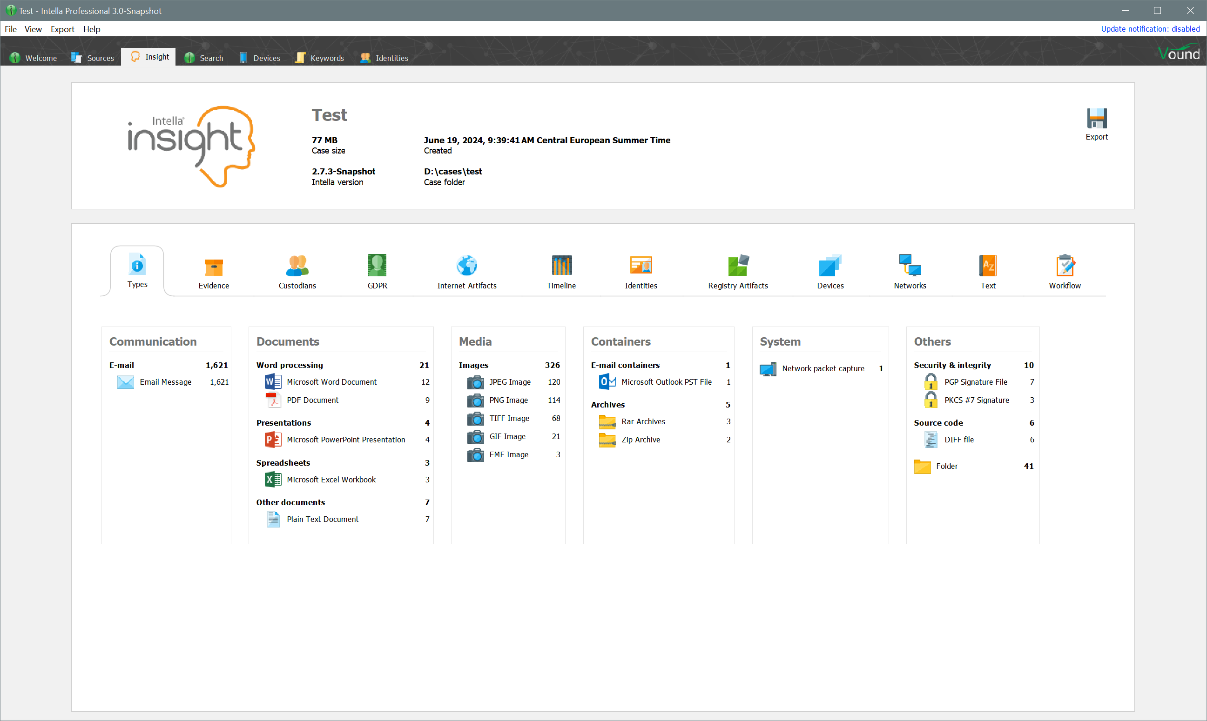
Figure 2.2.2.2 The Vound Intella Insight section

Insight interface in Intella, which provides an overview of the indexed digital evidence after processing. The dashboard summarizes important case information, including the total number of indexed items, deduplicated files, encrypted files, recovered items, and unsupported files. It also categorizes evidence into different types such as communications (emails, contacts, chats), user activities (web browsing history and registry artifacts), documents (Word, PDF, Excel, PowerPoint), and media files (images and videos). This feature allows investigators to quickly understand the contents of a case, identify significant evidence, and determine the next steps for further analysis, thereby improving the efficiency of the digital forensic investigation.

Figure 2.1.2.3a: FFmpeg Version Information Displayed in the Linux Terminal, The command was executed to verify the installed version of FFmpeg and the associated multimedia libraries available within the Linux environment. This verification ensured that FFmpeg had been correctly installed and properly configured before proceeding with the implementation and subsequent development task
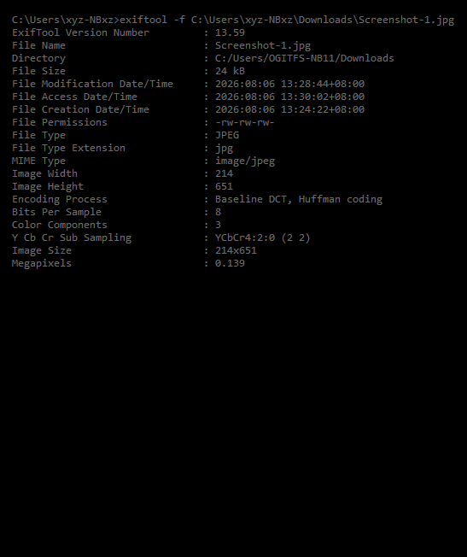
Figure 2.1.2.3b: Metadata Analysis using Exiftool

2.2.4 Duration

15th APRIL 2026 & 19th MAY 2026
- Extracted audit log of mailboxes and Azure.
- Email header analysis (cont).
- Reporting.

9th APRIL 2026
- Identify, tag and export the emails to be investigated within the time frame.

16th APRIL 2026
- Review IP addresses for potential malicious or genuine.
- Reporting.

10th APRIL 2026, 11th APRIL 2026 & 13th APRIL 2026
- Email header analysis.
9th April 2026

2.3 Project Involved 3

- Social Network Analysis (SNA)
Social Network Analysis (SNA) is an analytical technique used to map and examine relationships among individuals, organizations, digital identities, and physical assets. By visualizing these connections as structured networks, investigators can uncover patterns of association that are not immediately evident through standard linear review.
In this phase, link analysis was performed using Maltego
  - Entity and Relationship Mapping
Critical data points (such as suspects, email addresses, phone numbers, domain names, and IP addresses) were populated as nodes, with their interactions and associations represented as directional or non-directional links (edges).
- Automated Data Correlation
Using Maltego transforms, related digital footprints were automatically queried and pulled from multiple open-source intelligence (OSINT) repositories to expand the graph.
- Key Node and Sub-network Identification

Network centrality analysis was applied to isolate primary targets, including central communication hubs (high degree centrality) and critical intermediaries or bridges that route information across clusters (betweenness centrality).

This graph-based methodology contextualized the isolated digital evidence, establishing clear associations between entities and exposing covert pathways across the operational network.

2.3.1 Tasks description

Table 2.3.1.1: Task Description
Case Scope | Social Network Analysis.
Objective | Conduct social network analysis on targeted companies to find relationship between companies and actors using Open-Source Intelligence (OSINT).
Scope of work | - Review and cross examine every result given by Maltego.  - Conduct OSINT to find information that Maltego did not provide.

- Corporate Social Network Analysis (SNA) and OSINT Methodology
I was tasked with conducting Social Network Analysis (SNA) across targeted corporate entities and associated threat actors utilizing Open-Source Intelligence (OSINT) methodologies. The objective of the assessment was to identify relevant corporate entities, map organizational structures, and uncover covert or non-obvious relationships using publicly accessible data sources.

- Tool Execution and Verification Workflow
- Link Analysis via Maltego: Initial data collection and relationship visualization were executed using Maltego. While automated transforms mined large volumes of entity data, the output required active analyst triage to eliminate false positives—such as shared name collisions, unrelated third-party registrar data, and generic corporate registry matches.

- Secondary OSINT Cross-Verification: To validate transform results, secondary open-source searches were performed via search engines (Google dorking/advanced syntax) and corporate verification sources. Extracted leads—including executive names, registered domains, physical addresses, and corporate filings—were manually cross-referenced against the target entities to verify organizational context before confirmation.
- Documentation and Evidence Handling
All queried entities and raw results were systematically logged in the investigative case notes to preserve an audit trail.

- Data points confirmed as genuine were categorized as relevant and integrated into the primary network graph.
- Erroneous, unverified, or out-of-scope connections were documented separately as excluded false positives, ensuring that no potential leads were lost while keeping the analytical findings accurate and defensible.
The finalized findings, entity correlation charts, and supporting intelligence were compiled into a comprehensive report.

2.3.2 Methodology
Table 2.1.2 shows the tool used for this project.
Table 2.1.2: Tool used in this task
Tools Used
Maltego - An interactive data mining tool for connection analysis that creates directed graphs

PUT THE FLOW

2.3.3 Problems and Solutions

Table 2.3.3: Problems & Solutions
No | Problem | Solution
1 | In the process of social network analysis, Maltego results provided information that are false positive. This occurs due to similar keywords or names of other organization or individuals. For example, our target search is “ABC XYZ Sdn Bhd” but Maltego might provide “QWE XYZ Sdn Bhd” because it has keyword XYZ | - I did manual google search in browser of every result that Maltego provided to validate and identify if the actual information we are looking for aligned with Maltego result.  - I conducted my searches using advance Google search which uses keywords to narrow my searches. For example, I want only excel files for the keyword “XYZ Sdn Bhd”, so my search would be `”XYZ Sdn Bhd” filetype:xlsx.
2 | The challenging part in SNA is to verify the information obtained from our search and it can be very time consuming. | I use some open-source tools that automates the keyword search to save time.


Figure 2.3.3.1: Shows the Entities of Company A, B, C to be enter the company names to run transforms

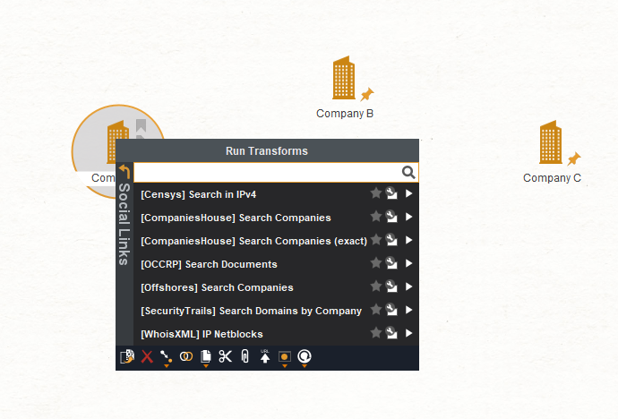
Figure 2.3.3.2: Show the transform interface to select and run for results.

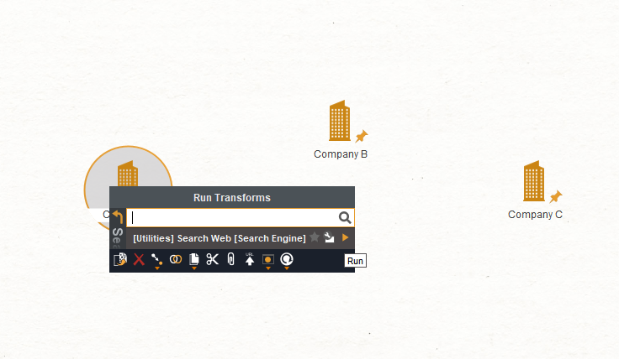
Figure 2.3.3.3: Shows the “Search web” transform from social link

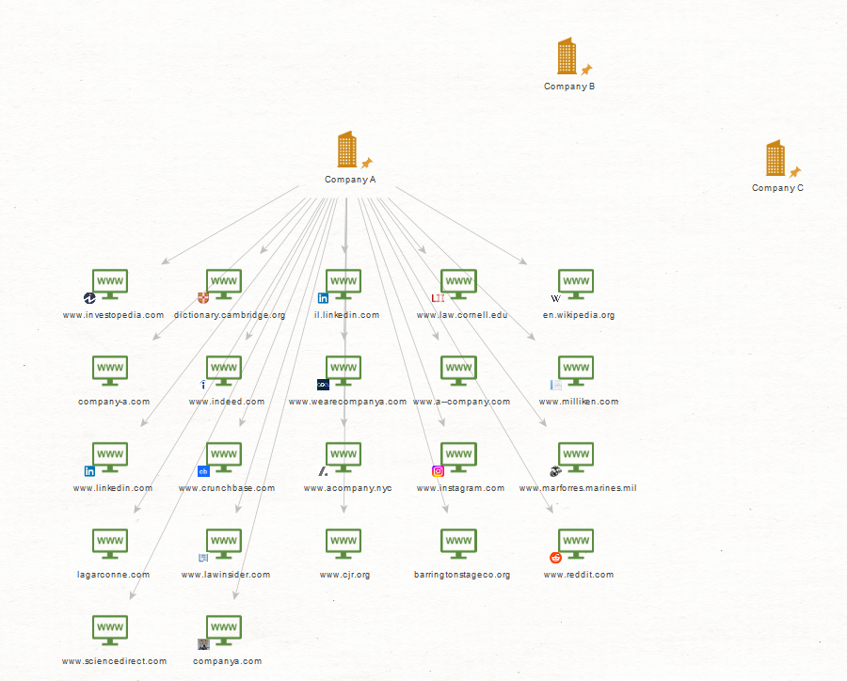
Figure 2.3.3.4: Once the search web transform runs, the publicly available information of the company a will be displayed.

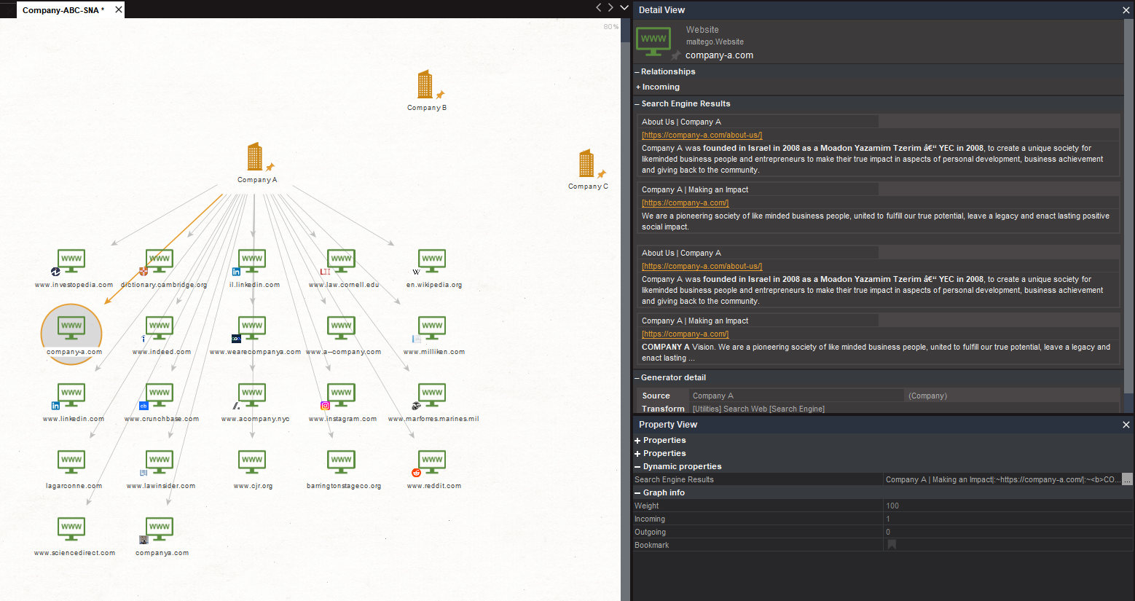
Figure 2.3.3.5: The result from “Company A” search web information derived with source link and properties

2.3.4 Duration
10th June 2026
- Reviewed 1st company results by Maltego and analyse those results.
10th June 2026
11th June 2026
- 1st company analysis (const).

3.0 Chapter 3: TRAINING, WORKSHOP & SEMINAR

3.1 Training, Workshop & Seminar
During the internship period, the training received was primarily practical and work-based rather than through formal workshops or seminars. The main training and exposure involved participating in multiple on-site digital forensic acquisition activities under the supervision and guidance of experienced digital forensic analysts.

The on-site acquisition activities provided practical exposure to the procedures involved in handling and acquiring digital evidence. Through repeated participation in these activities, I was able to develop a better understanding of real-world digital forensic procedures, evidence handling, documentation, and the importance of maintaining the integrity of digital evidence throughout the acquisition process.

No formal workshop or seminar was attended during the internship period. However, the practical training gained through on-site acquisition provided valuable experience and allowed me to apply the knowledge gained from my academic studies in an actual professional environment.

3.1.1 Explanation of Each Training

3.1.1.1 On-Site Digital Forensic Acquisition

The main practical training received during the internship was participation in on-site digital forensic acquisition. The purpose of on-site acquisition is to properly identify, preserve, and acquire digital evidence from electronic devices while maintaining the integrity and authenticity of the evidence.
Before each acquisition, preparation was carried out to ensure that the necessary forensic equipment and storage media were available and ready for use. The devices present at the location were then identified and documented according to the requirements of the investigation. Proper handling procedures were followed to minimise the possibility of accidentally altering, damaging, or contaminating the digital evidence.
During the acquisition process, I was exposed to the procedures used to obtain forensic copies or images of digital storage devices. I also gained an understanding of the importance of using appropriate forensic acquisition equipment and procedures to ensure that the original evidence was preserved as much as possible.
Another important aspect of the training was evidence documentation. Relevant information regarding the devices and acquisition activities had to be recorded accurately. This helped me understand the importance of maintaining proper documentation throughout a forensic investigation.
I was also introduced to the importance of hash values in digital forensics. Hashing can be used to verify the integrity of acquired forensic images by providing a unique value that can be compared to confirm that the acquired data has not been altered.
In addition, the on-site acquisition activities provided practical exposure to the concept of chain of custody. I learned that digital evidence must be properly documented whenever it is handled, transferred, or stored. Maintaining an accurate chain of custody is important to demonstrate that the evidence has been handled appropriately throughout the investigation.
Participating in multiple on-site acquisitions also improved my familiarity with the overall forensic workflow. By observing and assisting experienced digital forensic analysts, I gained a better understanding of how forensic procedures are carried out in real-world situations. The repeated exposure helped improve my confidence, attention to detail, communication, and ability to follow established forensic procedures.
Overall, the on-site acquisition training allowed me to apply theoretical knowledge obtained during my studies to practical digital forensic work. It provided valuable experience in evidence handling, acquisition, documentation, evidence integrity, and professional conduct within a digital forensic investigation.

3.1.2 Corporate Social Responsibility (CSR)
During the internship period, no formal Corporate Social Responsibility (CSR) programme or activity was conducted or assigned to me. Therefore, there was no specific CSR activity to report under this section.
Nevertheless, the professional practices observed during the internship highlighted the importance of responsibility, confidentiality, integrity, and ethical conduct when handling digital evidence. As digital forensic evidence may contain sensitive and confidential information, maintaining professionalism and protecting the confidentiality of information are important responsibilities within the field of digital forensics.

