|  |
| --- |
| HCC2, HCCE2, BSHC2, BSHCE2, BSHBIS2, BSHBISE2 |
| Requirements Specification (RS) |
| Project: AAA (Acoustic Audio Assistant) |

|  |
| --- |
|  |

Colin Allen,

Keith Feeney,

Patrick Lawlor,

Fearghal McMorrow,

Cedric Vecchionacce

(Group 14)

17 February 2017

Requirements Specification (RS)

Document Control

Revision History

|  |  |  |  |  |  |
| --- | --- | --- | --- | --- | --- |
| **Date** | **Version** | **Scope of Activity** | **Prepared** | **Reviewed** | **Approved** |
| 14/10/2005 | 1 | Create | AB | X | X |
| 21/10/05 | 2 | Update | CD |  |  |

Distribution List

|  |  |  |
| --- | --- | --- |
| **Name** | **Title** | **Version** |
| Arghir Moldovan | Lecturer |  |
| Eamon Nolan | Lecturer |  |
|  |  |  |
|  |  |  |
|  |  |  |

Related Documents

|  |  |
| --- | --- |
| **Title** | **Comments** |
| Title of Use Case Model |  |
| Title of Use Case Description |  |

**Table of Contents**

1 Introduction 4

1.1 Purpose 4

1.2 Project Scope 4

1.3 Definitions, Acronyms, and Abbreviations 4

2 User Requirements Definition 4

3 Requirements Specification 4

3.1 Functional requirements 4

3.1.1 Use Case Diagram 5

3.1.2 Requirement 1 <name of requirement in a few words> 5

3.1.3 Requirement 2 <name of requirement in a few words> 6

3.2 Non-Functional Requirements 7

3.2.1 Performance/Response time requirement 8

3.2.2 Availability requirement 8

3.2.3 Recover requirement 8

3.2.4 Robustness requirement 8

3.2.5 Security requirement 8

3.2.6 Reliability requirement 8

3.2.7 Maintainability requirement 8

3.2.8 Portability requirement 8

3.2.9 Extendibility requirement 8

3.2.10 Reusability requirement 8

3.2.11 Resource utilization requirement 8

4 GUI 8

5 System Architecture 8

6 System evolution 8

# Introduction

## Purpose

The purpose of this document is to specify the requirements for the development of an audio acoustic app that we are creating. The intended customers will be YouTubers, voice actors, musicians, music producers and event organisers (for concerts and presentations). There is currently no popular app that can help in this area of expertise.

## Project Scope

The scope of the project is for the likes of YouTubers and home producers and for novice people in media production, specifically dealing with sound, to speed up the process of performing sound acoustic treatments. It is not necessary for the user to have prior knowledge. Sound engineering in itself is rather complicated and can require expensive equipment to get the acoustics of a room just right.

We aim to simplify this process by providing an Android app. The database within the app will contain an extensive amount of default figures and calculations, allowing the user to simply clap their hands to see how their current acoustics of their room is. Then they will be able to input the size of the room, and get the required measurements, RT60, size of materials in their room, such as their carpet or walls. Steps for this will be included.

The user will then clap their hands again to see how their room measures up. If it is OK, the user can produce their media. If not, they can restart the steps.

This app itself will be completed in Android Studio and will run on Android version 4.1 (Jelly Bean) to 6.0.1 (Marshmallow). 97.2% of Android users use these versions (Google, n.d.), hence why we will release the app in these versions.

Our idea stemmed from Cedric. Early 2016, Cedric saw there was a niche in the market for such an app. He tried to create something, but was lacking the knowledge, technology and funds of how to create such an app.

In late 2016, Cedric and Keith created a web page/application for an Audio Acoustic Assistant for their Web Application Development project. This project is the next step in this process.

### Acronyms and Abbreviations

AAA - Audio Acoustic Assistant

RT60 - Reverberation time, 60 (decibels)

AF - Absorption factor

### Definitions

RT60 - An RT60 of a room or area is the time in seconds it takes a sound or noise to become inaudible, for example, one clap. (Hagelskjaer, n.d.)

Room - For the purpose of this document, “room” is defined as the likes of a bedroom, area (such as a studio) or an arena.

# User Requirements Definition

This section describes the set of objectives and requirements for the system from the customer’s perspective. What are the clients saying they want?

# Requirements Specification

All requirements should be verifiable. For example, experienced controllers shall be able to use all the system functions after a total of two hours training. After this training, the average number of errors made by experienced users shall not exceed two per day.

## Functional requirements

This section lists the functional requirements in **ranked order**. Functional requirements describe the possible effects of a software system, in other words, what the system must accomplish. Other kinds of requirements (such as interface requirements, performance requirements, or reliability requirements) describe how the system accomplishes its functional requirements. Each functional requirement should be specified in a format similar to the following:

Short, imperative sentence stating highest ranked functional requirement.

### Use Case Diagram

Each requirement should be uniquely identified with a sequence number or a meaningful tag of some kind.

The Use Case Diagram provides an overview of all functional requirements.

### Requirement 1 <name of requirement in a few words>

The heading of this section should read, e.g., “Requirement 1: User registration” or “Requirements 1: Participant takes test”

#### Description & Priority

A description of the requirement and its priority. Describes how essential this requirement is to the overall system.

#### Use Case

Each requirement should be uniquely identified with a sequence number or a meaningful tag of some kind.

**Scope**

The scope of this use case is to …….

**Description**

This use case describes the ………..

**Flow Description**

**Precondition**

The system is in initialisation mode……..

**Activation**

This use case starts when an <Actor>…………

**Main flow**

1. The system identifies the ………….
2. The <Actor> …………...(See A1)
3. The system …………..(See E1)
4. The <Actor> ………….

**Alternate flow**

A1 : <title of A1>

1. The system …………..
2. The <Actor> ………….
3. The use case continues at position 3 of the main flow

**Exceptional flow**

E1 : <title of E1>

1. The system …………..
2. The <Actor> ………….
3. The use case continues at position 4 of the main flow

**Termination**

The system presents the next ……….

**Post condition**

The system goes into a wait state

### Requirement 2 <name of requirement in a few words>

#### Description & Priority

A description of the requirement and its priority. Describes how essential this requirement is to the overall system.

#### Use Case

Each requirement should be uniquely identified with a sequence number or a meaningful tag of some kind.

**Scope**

The scope of this use case is to …….

**Description**

This use case describes the ………..

**Flow Description**

**Precondition**

The system is in initialisation mode……..

**Activation**

This use case starts when an <Actor>…………

**Main flow**

1. The system identifies the ………….
2. The <Actor> …………...(See A1)
3. The system …………..(See E1)
4. The <Actor> ………….

**Alternate flow**

A1 : <title of A1>

1. The system …………..
2. The <Actor> ………….
3. The use case continues at position 3 of the main flow

**Exceptional flow**

E1 : <title of E1>

1. The system …………..
2. The <Actor> ………….
3. The use case continues at position 4 of the main flow

**Termination**

The system presents the next ……….

**Post condition**

The system goes into a wait state

**List further functional requirements here, using the same structure as for Requirements 1 & 2. Most systems would have at least five main requirements.**

## Non-Functional Requirements

Specifies any other particular non-functional attributes required by the system. Examples are provided below. **Remove the requirement headings that are not appropriate to your project.**

### Performance/Response time requirement

### Availability requirement

### Recover requirement

### Robustness requirement

### Security requirement

### Reliability requirement

### Maintainability requirement

### Portability requirement

### Extendibility requirement

### Reusability requirement

### Resource utilization requirement

# GUI

Include mock-ups of the key pages or stages of the system. Explain how they are linked. Explain how you addressed above requirements in the design. It is important that the mock-ups are in line with the functional requirements above, e.g., if one of your requirements is “user registration” then one of the screens listed in this section should show a registration page.

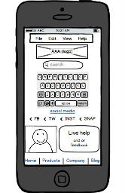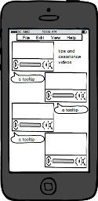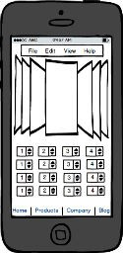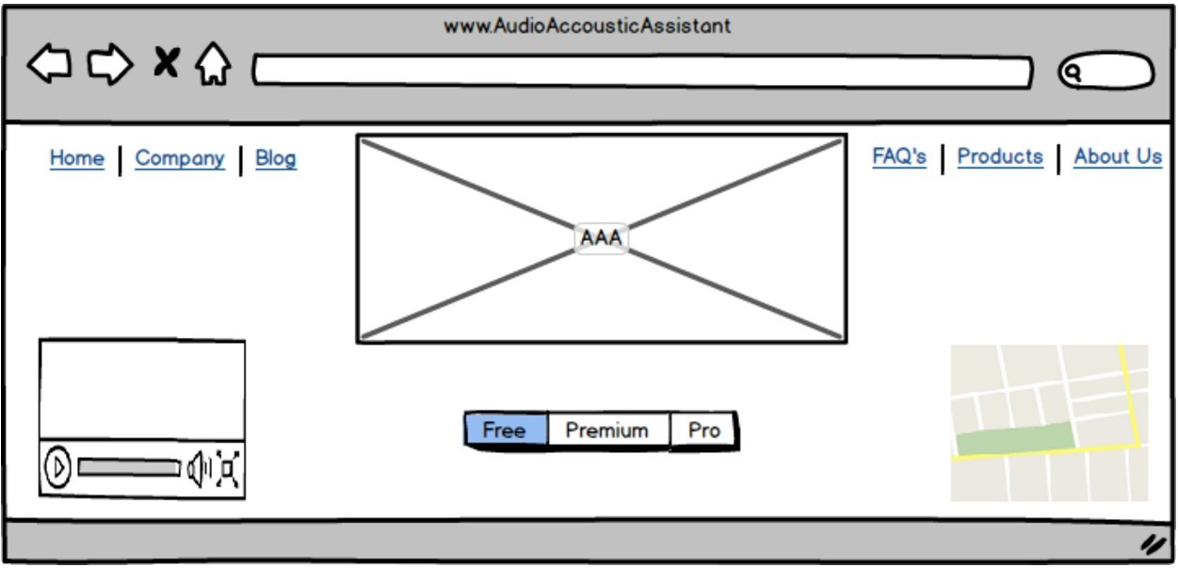

# System Architecture

Use a class diagram to outline the structure of the system. Explain briefly why you have chosen this architecture. You might want to use Visio or Rational Rose to create these.

# System Evolution

This section describes how the system could evolve over time.