|  |
| --- |
| HCC2, HCCE2, BSHC2, BSHCE2, BSHBIS2, BSHBISE2 |
| Requirements Specification (RS) |
| [Type the document subtitle] |

|  |
| --- |
| insert all student names  [Pick the date] |

Requirements Specification (RS)

Document Control

Revision History

|  |  |  |  |  |  |
| --- | --- | --- | --- | --- | --- |
| **Date** | **Version** | **Scope of Activity** | **Prepared** | **Reviewed** | **Approved** |
| 14/10/2005 | 1 | Create | AB | X | X |
| 21/10/05 | 2 | Update | CD |  |  |

Distribution List

|  |  |  |
| --- | --- | --- |
| **Name** | **Title** | **Version** |
| Arghir Moldovan | Lecturer |  |
| Eamon Nolan | Lecturer |  |
|  |  |  |
|  |  |  |
|  |  |  |

Related Documents

|  |  |
| --- | --- |
| **Title** | **Comments** |
| Title of Use Case Model |  |
| Title of Use Case Description |  |

**Table of Contents**

1 Introduction 4

1.1 Purpose 4

1.2 Project Scope 4

1.3 Definitions, Acronyms, and Abbreviations 4

2 User Requirements Definition 4

3 Requirements Specification 4

3.1 Functional requirements 4

3.1.1 Use Case Diagram 5

3.1.2 Requirement 1 <name of requirement in a few words> 5

3.1.3 Requirement 2 <name of requirement in a few words> 6

3.2 Non-Functional Requirements 7

3.2.1 Performance/Response time requirement 8

3.2.2 Availability requirement 8

3.2.3 Recover requirement 8

3.2.4 Robustness requirement 8

3.2.5 Security requirement 8

3.2.6 Reliability requirement 8

3.2.7 Maintainability requirement 8

3.2.8 Portability requirement 8

3.2.9 Extendibility requirement 8

3.2.10 Reusability requirement 8

3.2.11 Resource utilization requirement 8

4 GUI 8

5 System Architecture 8

6 System evolution 8

# Introduction

## Purpose

The purpose of this document is to set out the requirements for the development of ……………

The intended customers are ……….

## Project Scope

The scope of the project is to develop a …………….The system shall have a ……………

John Smyth was involved in discussions with John Ryan from AN Company Ltd. To elicit the following requirements

This section also details any constraints that were placed upon the requirements elicitation process, such as schedules, costs, or the software engineering environment used to develop requirements.

## Definitions, Acronyms, and Abbreviations

AD Another Definition

……..

# User Requirements Definition

This section describes the set of objectives and requirements for the system from the customer’s perspective. What are the clients saying they want?

# Requirements Specification

All requirements should be verifiable. For example, experienced controllers shall be able to use all the system functions after a total of two hours training. After this training, the average number of errors made by experienced users shall not exceed two per day.

## Functional requirements

This section lists the functional requirements in **ranked order**. Functional requirements describe the possible effects of a software system, in other words, what the system must accomplish. Other kinds of requirements (such as interface requirements, performance requirements, or reliability requirements) describe how the system accomplishes its functional requirements. Each functional requirement should be specified in a format similar to the following:

Short, imperative sentence stating highest ranked functional requirement.

### Use Case Diagram

Each requirement should be uniquely identified with a sequence number or a meaningful tag of some kind.

The Use Case Diagram provides an overview of all functional requirements.

### Requirement 1 <name of requirement in a few words>

The heading of this section should read, e.g., “Requirement 1: User registration” or “Requirements 1: Participant takes test”

#### Description & Priority

A description of the requirement and its priority. Describes how essential this requirement is to the overall system.

#### Use Case

Each requirement should be uniquely identified with a sequence number or a meaningful tag of some kind.

**Scope**

The scope of this use case is to …….

**Description**

This use case describes the ………..

**Flow Description**

**Precondition**

The system is in initialisation mode……..

**Activation**

This use case starts when an <Actor>…………

**Main flow**

1. The system identifies the ………….
2. The <Actor> …………...(See A1)
3. The system …………..(See E1)
4. The <Actor> ………….

**Alternate flow**

A1 : <title of A1>

1. The system …………..
2. The <Actor> ………….
3. The use case continues at position 3 of the main flow

**Exceptional flow**

E1 : <title of E1>

1. The system …………..
2. The <Actor> ………….
3. The use case continues at position 4 of the main flow

**Termination**

The system presents the next ……….

**Post condition**

The system goes into a wait state

### Requirement 2 <name of requirement in a few words>

#### Description & Priority

A description of the requirement and its priority. Describes how essential this requirement is to the overall system.

#### Use Case

Each requirement should be uniquely identified with a sequence number or a meaningful tag of some kind.

**Scope**

The scope of this use case is to …….

**Description**

This use case describes the ………..

**Flow Description**

**Precondition**

The system is in initialisation mode……..

**Activation**

This use case starts when an <Actor>…………

**Main flow**

1. The system identifies the ………….
2. The <Actor> …………...(See A1)
3. The system …………..(See E1)
4. The <Actor> ………….

**Alternate flow**

A1 : <title of A1>

1. The system …………..
2. The <Actor> ………….
3. The use case continues at position 3 of the main flow

**Exceptional flow**

E1 : <title of E1>

1. The system …………..
2. The <Actor> ………….
3. The use case continues at position 4 of the main flow

**Termination**

The system presents the next ……….

**Post condition**

The system goes into a wait state

**List further functional requirements here, using the same structure as for Requirements 1 & 2. Most systems would have at least five main requirements.**

## Non-Functional Requirements

Specifies any other particular non-functional attributes required by the system. Examples are provided below. **Remove the requirement headings that are not appropriate to your project.**

### Performance/Response time requirement

### Availability requirement

### Recover requirement

### Robustness requirement

### Security requirement

### Reliability requirement

### Maintainability requirement

### Portability requirement

### Extendibility requirement

### Reusability requirement

### Resource utilization requirement

# GUI

Include mock-ups of the key pages or stages of the system. Explain how they are linked. Explain how you addressed above requirements in the design. It is important that the mock-ups are in line with the functional requirements above, e.g., if one of your requirements is “user registration” then one of the screens listed in this section should show a registration page.

# System Architecture

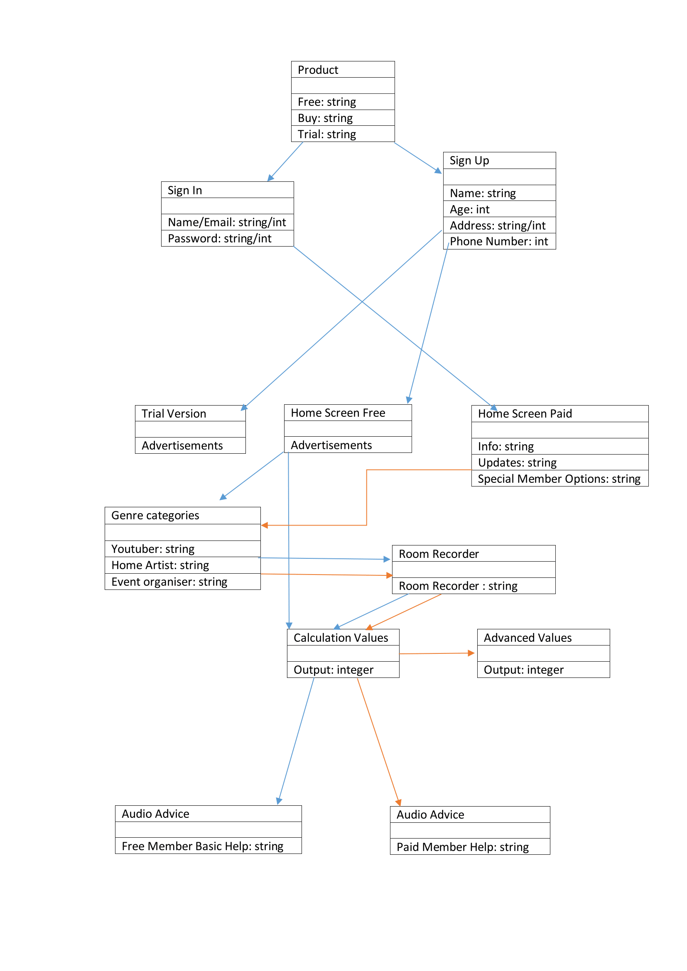

The main focus on why we chose this architecture is because they are essential to our apps creation, development and success. Every successful application needs a simple and effective home screen with a logo that grabs the user’s attention.

From there we need to create a user interface experience that satisfies the user and encourages them to learn how to use our application.

There will be two versions of the application, a free version with ads, And a paid version without ads, Both will be separate uploads on the google play store.

The premium version has all the content and is kept up to date with software improvements and changes as they happen. The free version will not have these options and is mainly for testing our product. The free version has mandatory advertisements that will help keep our application monetized. On the home page you can choose your own specific user role, from YouTuber, amateur musician or any event regarding audio enhancements.

Moving forward will bring the user to the room recorder with all the calculators. The free version is limited, naturally, and only offers basic calculations and very few options. The premium version allows the user to access tips, tricks, help and a full range of calculators needed to pinpoint the perfect sound. When all the values have been added up the perfect formula is displayed to the user to help them improve their sound quality. More help and specifications are on offer with the premium version but the free version will offer hints and very little full-on support.

# System Evolution

This section describes how the system could evolve over time.