# Tokyo in the Heart of New York

# Introduction

## Background

Have anyone ever wondered how big the risks of a restaurant investor are when entering a new marketplace? Have anyone though about the repercussions that the owner have to withstand if he/she made the wrong strategic decision on where to locate the restaurant? What should the owner think of when deciding what type of cuisine should he/she implement?

## Problem

These are some of the many questions a restaurant investor must as him/herself think of preceding any action taken. Whenever opening a new business, no matter of what kind, the first thing to think about and find is the targeted audience and the market to spread one's product or service.

## Interest

This project basically introduces an entrepreneur to the variety of the marketsS and the availability or possibility for an investment so that one can decide on what basis to invest.

# Data acquisition and cleaning

## Data Source

Having a powerful tool such as the Foursquare API, one can benefit from the data provided to find needed aspects such as location of similar cuisines, available neighborhood aspects and competitors, as well as ideas and ratings of Foursquare users within the region. I will also be using the New York Database provided online alongside getting calls from the Foursquare database in order to get my hands on data needed for me to be able to submit a report to the restaurant investor of the optimal location and cuisine type that satisfies the demand available in this specific region in NY where the restaurant is to be located.

## Data acquisition

The data will be formulated by a ‘json’ file which will be then transformed into a data frame using the pandas library in order to be able to wrangle the data for extraction of valuable information. This data frame includes a variety of New York Boroughs and Neighborhoods and their corresponding latitudes and longitudes pinpointing their exact locations.

## Feature Selection

I will first start by a sample list of our borough and neighborhoods’ data available of the City of New York. Below is a data frame showing a five-row sample of every borough with its various neighborhoods and the corresponding latitude and longitude.

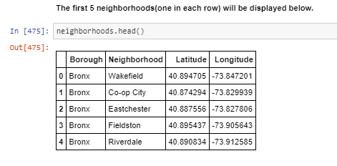

# Methodology

## Calculation of Targeted Variable

My method of analysis was mainly composed of two main components. The first was getting location data and clustering of similar businesses dispersed within our desired location of analysis and the second component is analyzing their frequency of occurrence and popularity as motive to make the appropriate investment decision. My analysis will be based on determining the best location choice of investing in a Sushi Restaurant in the Heart of New York. My choice of cuisine type will be discussed later in the results section.

## Steps Followed

We will breakdown these steps mostly using tables of our available data and then visualize them on a New York map showing our obtained results.

Next, a geolocator library can be used to find the location (Latitude and Longitude) of any required address all around the world. Saying that, we find that the geographical coordinates of New York City are 40.7128 degrees N, 74.0060 degrees W.

After getting the data frame shown above, and in order to better understand the results and what we are dealing with, a map of New York will best describe the situation.

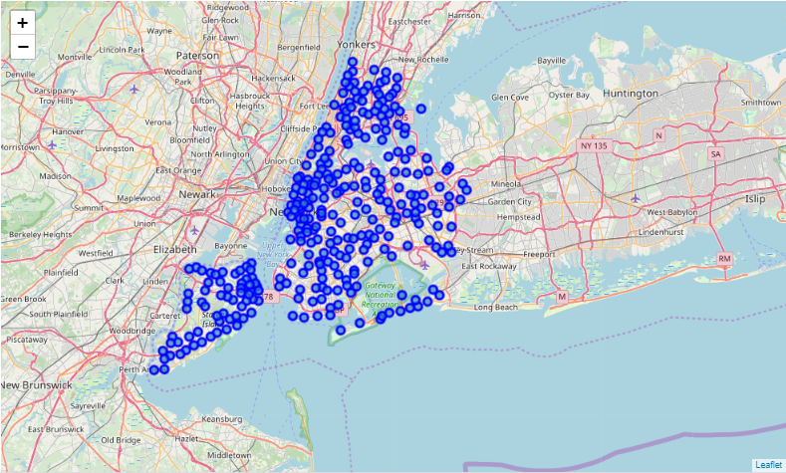

This figure shows every neighborhood location within the vicinity of New York shown as a blue circle marker on the above map. These neighborhoods represent the basis of our analysis by which I will guide the interested investor to the optimal location of the intended Sushi place in New York.

## API Foursquare Tool

After singing up for a foursquare account, the user can perform calls to the API to get geographical or demographic data from a desired location of venue. This tool manages to give off data about venues, whether restaurants or stores or any other product or service business, for the purpose of venue locations, foursquare users’ ratings and other interrelated data.

To perform certain calls and gather data, one should enter the account’s credentials in order to link the foursquare account to the python notebook being used to execute the analysis. With a specified radius and a limit to the required venues, alongside the account credentials, I generated another data frame adding to the previous one the venue category, its name, and location (Longitude and Latitude). The table below displays the data called from the Foursquare API along the previous data of neighborhoods.

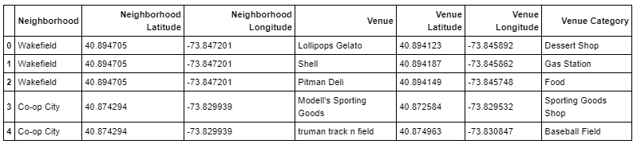

## Top Three Common Venues

A valuable way to determine the popularity of different venues is using its frequency of visiting these venues by foursquare users. The illustration below shows the top three venue categories in each of the neighborhoods extracted from our database of New York City.

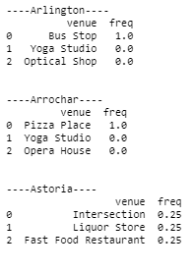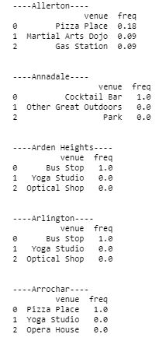

## Filtering Data

Now to be able to draw conclusions about the popularity and frequency of visiting certain venues, I managed to filter all Japanese and Sushi Restaurants to a specified radius and store them in a new data frame. The table below represents all sushi and Japanese restaurants to a specified radius of given neighborhoods.

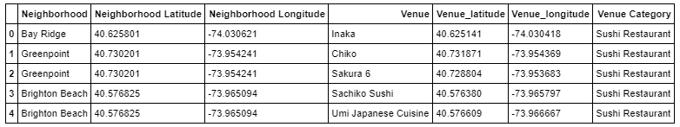

Visualizing these results, a new map of New York City is presented highlighting these venues as blue circle markers.

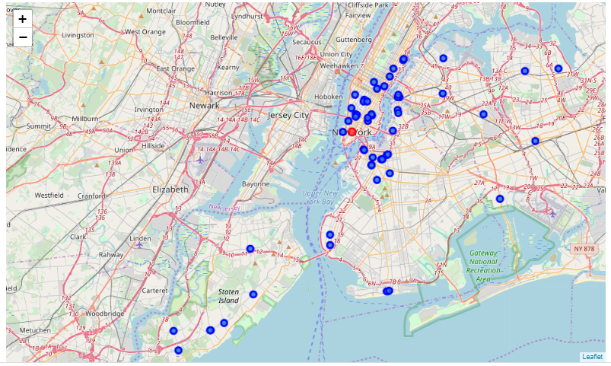

This map will give the investor an incentive about how well known and popular are those types of cuisines in New York and the possibility of a new successful Sushi Restaurant chain being able to maintain its business and grow within a specified area in New York.

Results

This study is mainly to help the investor study the feasibility of entering the Sushi business in New York, its popularity and demand in the US market and most importantly its demographics. My final outcome of this analysis is presenting every neighborhood with its top venues categories showing where every category is most likely to have higher demand and by that has a bigger probability of success. Magnifying the previous sentence, a table below represents a sample of the neighborhoods of New York and their top venue categories where each row represents one neighborhood.

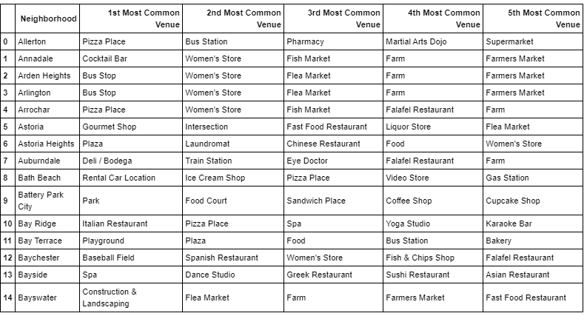

## Filtering Results

Our main objective is to find one of multiple optimal location to open a Sushi Restaurant while being a successful and profitable investment. I managed to display all neighborhoods having one of their top three most common venues as sushi places or Japanese restaurants. By that, I would have created a series of clusters having numerous neighborhoods and of which we can locate a suitable neighborhood within these cluster to be our target investment location.

The table below shows the chosen neighborhoods where either one of the top three most common venues are either a sushi restaurant or Japanese restaurant. I chose both these venue types since most of the times when a restaurant is labeled as Japanese, they would most probably also serve sushi too. As one can see, some of the total 12 neighborhoods chosen are duplicated within the table. This shows that within this particular neighborhood both a sushi and a Japanese restaurant are within the top three most common venues in this neighborhood. This shows that Japanese cuisine and especially sushi is particularly popular and has high demand within this neighborhood. This gives an additional indication to the investor about what to expect in this neighborhood and to what extent people are used to having high competition when it comes to Japanese cuisine.

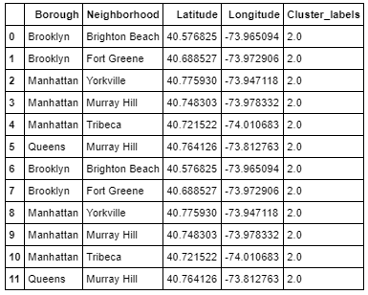

# Discussion

Based on all the data combined we can draw many conclusions. This map is a final illustration of the results where I will discuss its meanings and what can we conclude from just looking at it.

First I will start by stating what each circular mark represents.

1. The big red mark in the center represents the heart of New York and the location of City Hall
2. The small sized marks represent 5 different neighborhood cluster
3. The large yellow marks with a black entourage are the target locations for our Sushi Restaurant

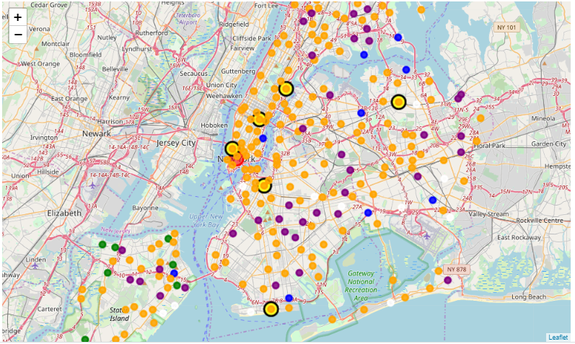

Discussing these results, and based on the previous table, I can say that after this analysis six different locations are suitable for opening a “Sushi Restaurant” in New York. Having based my analysis on venue locations and visitation frequency using the foursquare API, a set of neighborhood locations are readily available for further discussion complying with every investor and what would be his/her personal strategies that concerns them.

One example has to do with the intensity of competition. For instance an investor might say I would probably select the location that has multiple restaurants whether they were Japanese cuisines or just Sushi due to the fact that these venues has majorly impacted their neighborhoods and the demand on a Sushi place is quite high relative to neighborhoods with less exposure to this type of cuisine. Others might say that they would prefer to choose a neighborhood with a relatively good exposure but with less competition that other neighborhoods with higher variety of restaurant chains.

This poses a question that every investor must ask before diving into this particular project.

*“Do I want to enter a highly competitive neighborhood and learn from this experience, or would I rather start slow and climb up the ladder step by step?*

Experience and business risk play a major role in taking this kind of decision. Each investor has his/her own way of handling this situation and my task is to shed light on these issues where they will probably have some deep thinking to do and what choices to take.

Another aspect affecting an investor’s decision of which neighborhood to choose is demographics and resident density within a specified radius of the city. An investor might target a highly dense neighborhood to increase the chances of people wanting to try out this new Sushi restaurant chain while others target other specific aspects in a neighborhood.

Conclusion

My project will represent the ability and feasibility of opening a sushi restaurant in the heart of New York while specifying the optimal location for the restaurant. I based my analysis on similar venues’ demographics and frequency of visiting specific venues. I also briefly discussed other aspects and questions a restaurant investor has to take into consideration when making this strategic decision about where to invest and on what basis.

The final map of New York shows the best choice of locations for opening a Sushi Restaurant based on the aspects discussed previously. This analysis is open for further research and discussion for a better estimation of most feasible location based on further aspects than the ones discussed.

But rather than that, this analysis gives the investor a wide overview on what to expect and from where to start his/her feasibility study in order to select the best strategic path for an optimal and profitable investment in a Sushi Restaurant which would represent …

***Tokyo in the Heart of New York City.***