ETF Rotation Strategy

Rotation universe
Dividend ETF (510880.SH)
ChiNext ETF (519915.SH)
CSI 300 ETF (510300.SH)
Gold ETF (518880.SH)

Scoring factors
trend_score：
trend_score = (e^(252 * slope) - 1) * R^2, where slope is the fitted linear regression slope of closing prices over multiple days.
slope: trend strength; R^2: trend stability.

momentum_close (close price) and momentum_open (open price)
Momentum factor:
(P_t - P_(t-win_length)) / win_length

trend_score_riskoff：
Trend strength (trend_score) + volatility + stability of trading turnover

sharpe_momentum：
Momentum + volatility

Trading logic
- After each daily close, score the ETFs using end-of-day price and volume data. Generate a signal to allocate fully to the highest-scoring ETF.
- At the next day's open, execute using the opening price and the signal stored the previous day.
- Mark the position's net asset value to market at the daily closing price.

Parameter settings
ETF trading commission: 0.005%
Slippage: 0.5%
Initial capital: CNY 1,000,000

Backtest results
Factor | CAGR | Volatility | Sharpe | MDD | Calmar
trend_score | 33.31% | 26.09% | 1.275 | -30.72% | 1.084
trend_score_riskoff | 29.30% | 25.37% | 1.180 | -35.50% | 0.825
sharpe_momentum | 27.41% | 24.70% | 1.141 | -27.45% | 0.998
momentum_close | 32.12% | 26.41% | 1.227 | -27.77% | 1.157
momentum_open | 29.61% | 27.02% | 1.131 | -28.50% | 1.039

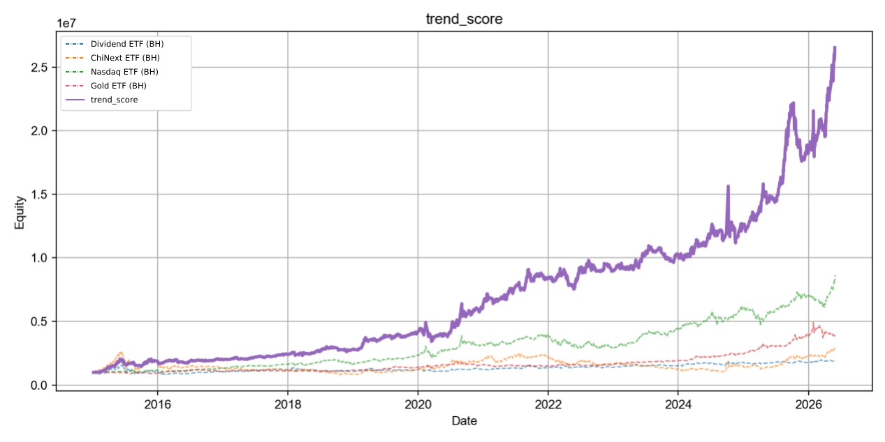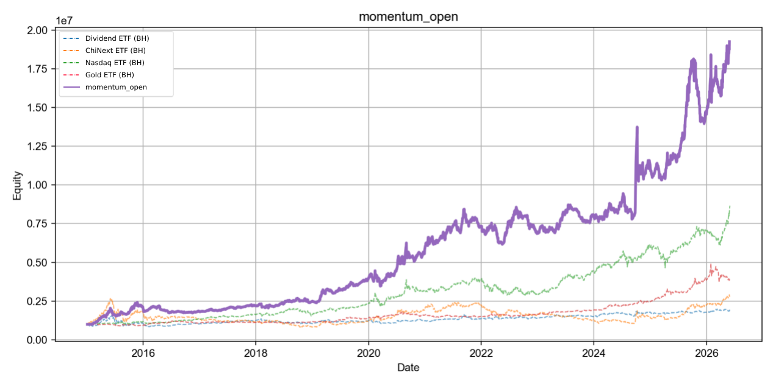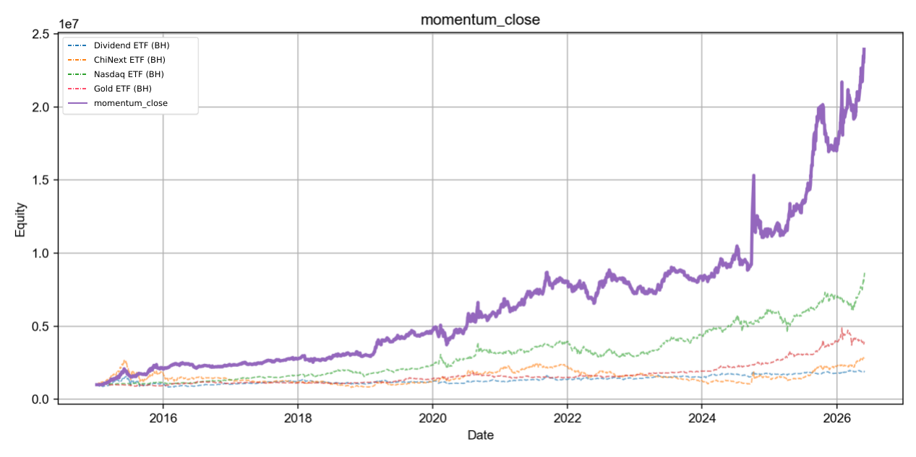

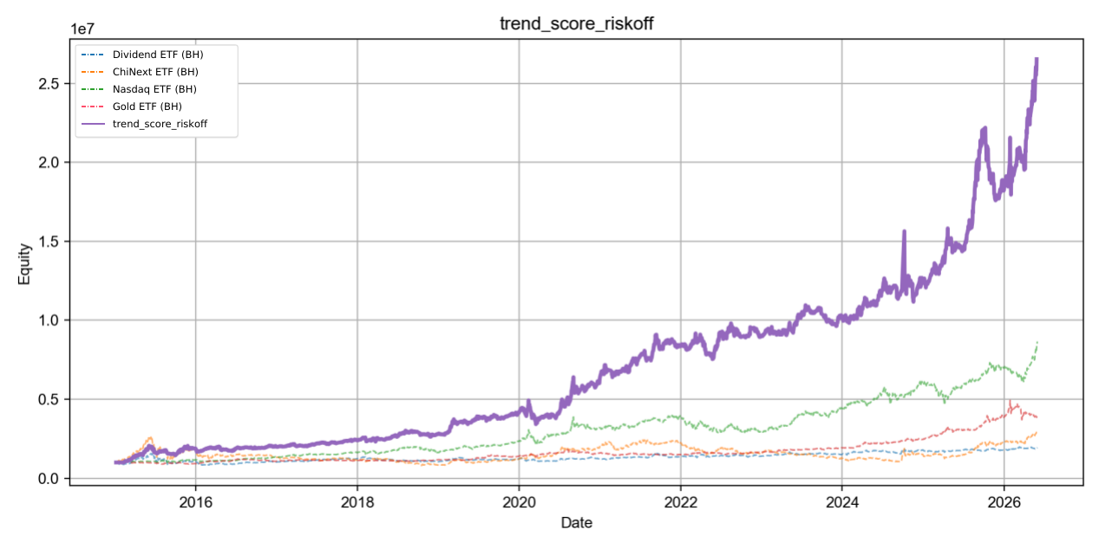
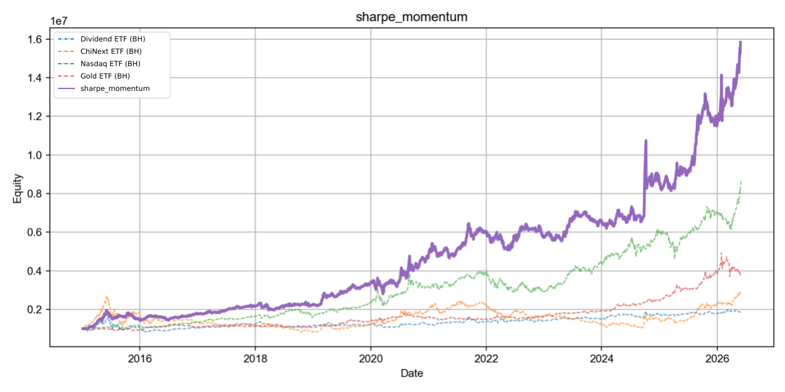

Optimization attempt
Record a drawdown series from the position NAV history, adding a record whenever a drawdown occurs that day.
If drawdown exceeds the series' 95th percentile for three consecutive days, force close at the next open and wait three cooldown days before opening again based on the factor.

Backtest results after optimization
Factor | CAGR | Volatility | Sharpe | MDD | Calmar
trend_score | 34.21% | 25.39% | 1.33 | -23.71% | 1.44
trend_score_riskoff | 27.70% | 24.81% | 1.15 | -31.60% | 0.88
sharpe_momentum | 24.29% | 24.09% | 1.06 | -25.20% | 0.96
momentum_close | 21.57% | 24.78% | 0.94 | -49.54% | 0.44
momentum_open | 28.43% | 26.58% | 1.11 | -27.06% | 1.05

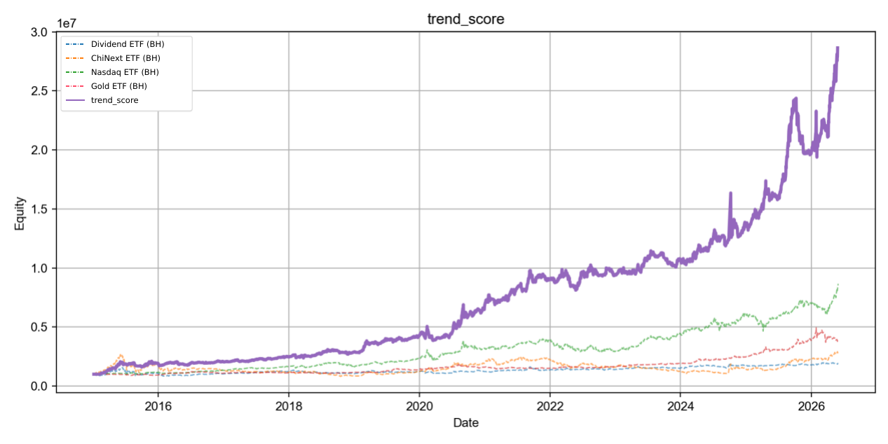
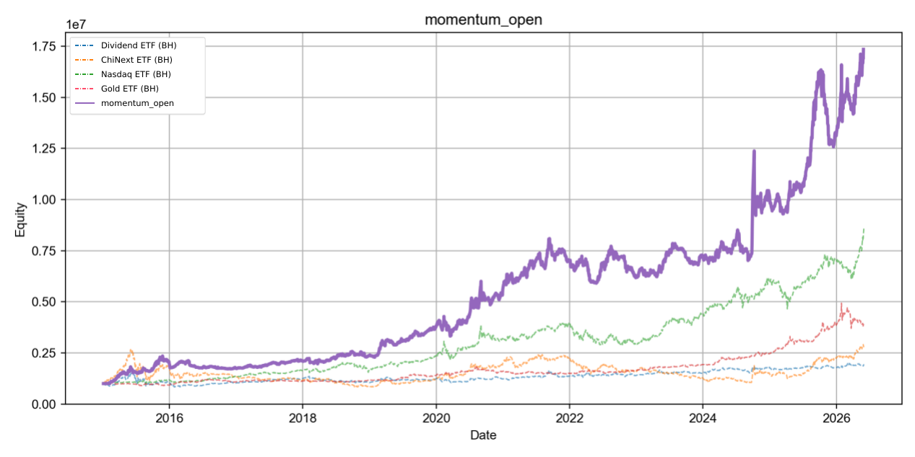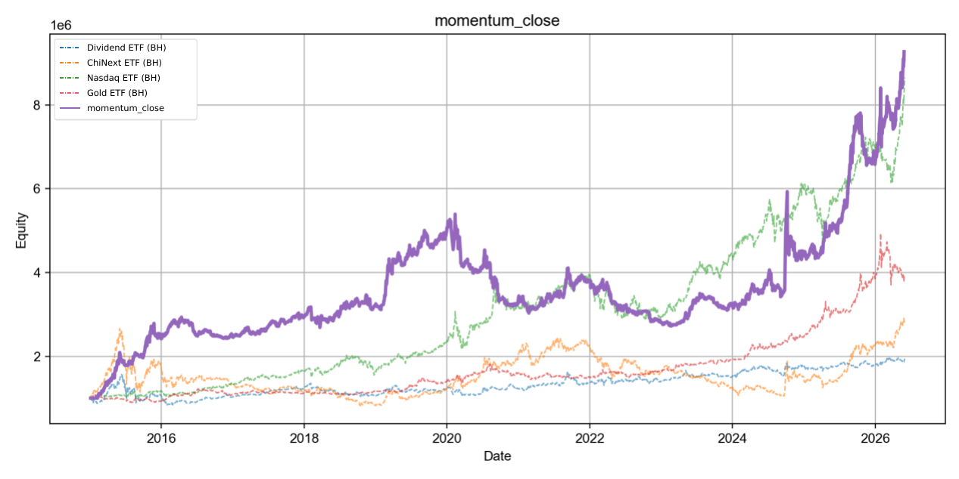
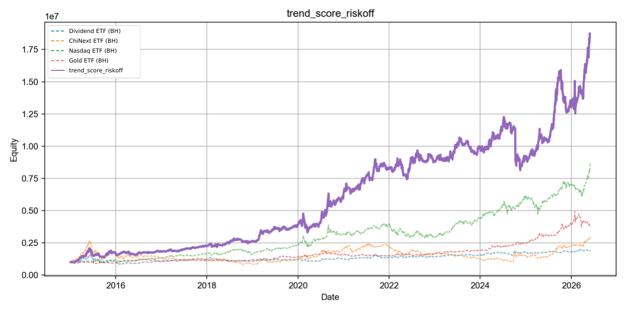
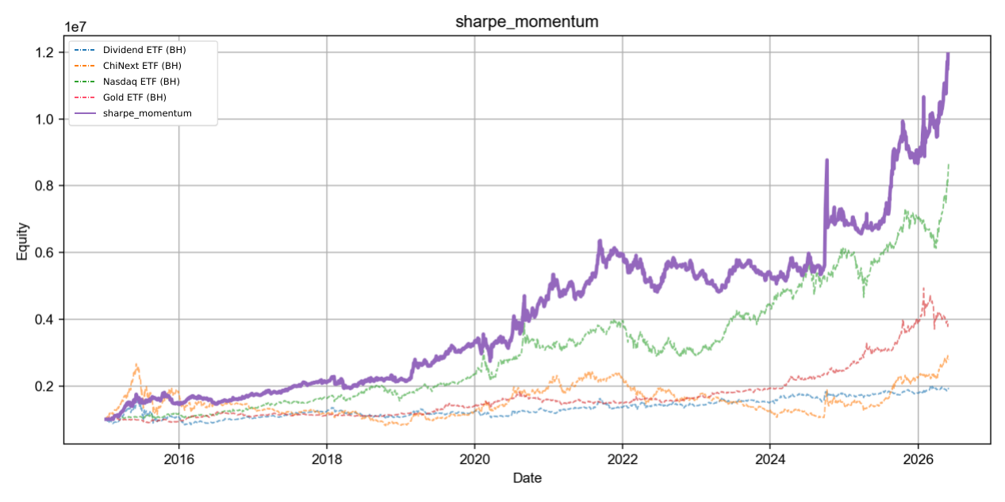

Comparison
Before optimization
Factor | CAGR | Volatility | Sharpe | MDD | Calmar
trend_score | 33.31% | 26.09% | 1.275 | -30.72% | 1.084
trend_score_riskoff | 29.30% | 25.37% | 1.180 | -35.50% | 0.825
sharpe_momentum | 27.41% | 24.70% | 1.141 | -27.45% | 0.998
momentum_close | 32.12% | 26.41% | 1.227 | -27.77% | 1.157
momentum_open | 29.61% | 27.02% | 1.131 | -28.50% | 1.039

After optimization
Factor | CAGR | Volatility | Sharpe | MDD | Calmar
trend_score | 34.21% | 25.39% | 1.33 | -23.71% | 1.44
trend_score_riskoff | 27.70% | 24.81% | 1.15 | -31.60% | 0.88
sharpe_momentum | 24.29% | 24.09% | 1.06 | -25.20% | 0.96
momentum_close | 21.57% | 24.78% | 0.94 | -49.54% | 0.44
momentum_open | 28.43% | 26.58% | 1.11 | -27.06% | 1.05

Conclusion
In the reported backtest, trend_score and momentum_close both performed strongly. Overall, trend_score compared favorably with the other factors in return, Sharpe ratio, and stability. Introducing dynamic risk controls based on the 95th percentile of drawdowns produced different effects across factors. For trend_score, annualized return rose from 33.31% to 34.21%, maximum drawdown fell from 30.72% to 23.71%, and the Calmar ratio increased from 1.08 to 1.44, improving the reported risk-return profile. By contrast, factors such as momentum_close lost return because of frequent market exits. Across return, drawdown, and risk-adjusted performance, trend_score with dynamic drawdown controls achieved the best overall performance and robustness in this ETF style-rotation study.

Additional data
Record drawdown and Sharpe ratio for each year
Translation note: This document translates the original research report. Historical figures, draft research questions, and original assumptions are retained; they are not newly verified performance claims. The implemented strategy and current reproduction limits are described in the English README and docs/IMPLEMENTATION_NOTES.md.

