Shikhar Giri

DIGM-1350-15777

Infographic Research

References:

1. Aslam, S. (2018, September 18). Snapchat by the Numbers: Stats, Demographics & Fun Facts. Retrieved from <https://www.omnicoreagency.com/snapchat-statistics/>
2. U.S. mobile app hours by device and age 2016 | Statistic. (n.d.). Retrieved from <https://www.statista.com/statistics/323522/us-user-mobile-app-engagement-age/>
3. Jeremiah Owyang. (n.d.). Retrieved from <http://www.web-strategist.com/blog/2013/01/09/social-network-stats-facebook-myspace-reunion-jan-2013/>
4. Digital, M. (2016, March 08). A History of Mobile Application Development. Retrieved from <https://manifesto.co.uk/history-mobile-application-development/>
5. Mitesh Patel. (2018, June 23). Retrieved from <http://customerthink.com/mobile-app-development-trends-today-and-tomorrow/>
6. The Mission. (2018, August 29). App Development Trends – The Mission – Medium. Retrieved from <https://medium.com/the-mission/app-development-trends-b4989e488664>
7. Roy, S. (2016, May 9). Why App Development is Important to know? Retrieved from <https://www.linkedin.com/pulse/why-mobile-application-development-service-important-today-samuel-roy/>
8. Haselmayr, M. (2014, November 12). 7 Reasons Why Your Business Needs a Mobile App. Retrieved from <https://www.allbusiness.com/7-reasons-business-needs-mobile-app-19179-1.html>

**Sketch:**

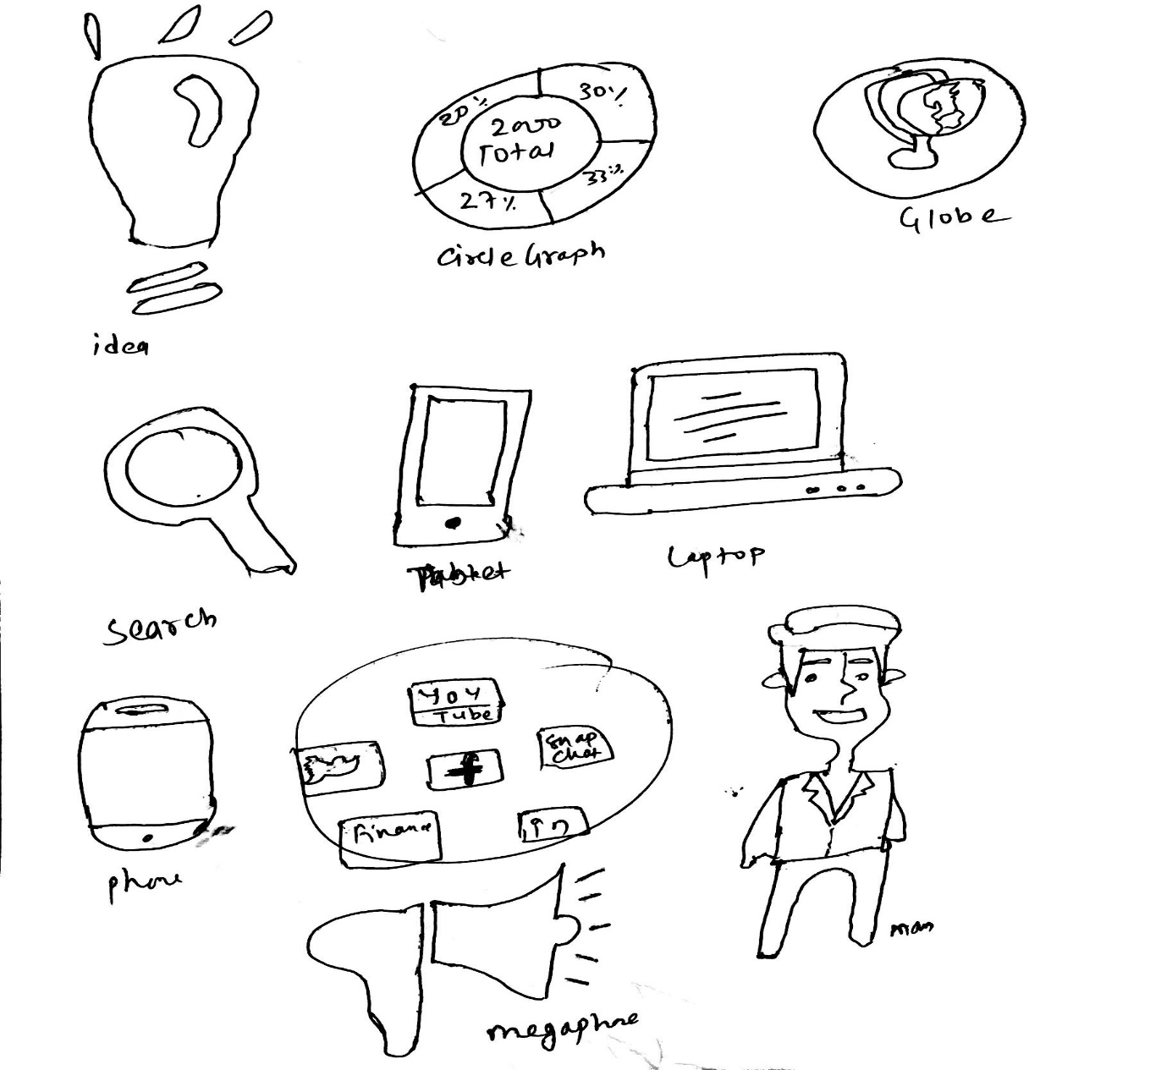

In this infographic, the story and central idea I am trying to communicate is that about the importance of mobile apps and its influence in our daily lifestyle. My audience are all people who uses mobile devices ranging from teens to upper age. The invention and the theory of app development has been very useful tool as of today. We cannot even imagine a day without a phone and a app itself.

I am trying to convey my audience with that information which I believe are important for them to know as a user. I will post my final infographic in the social media, magazine and websites so that the user will be able to interact with it and understand what I am trying to convey them as a message.