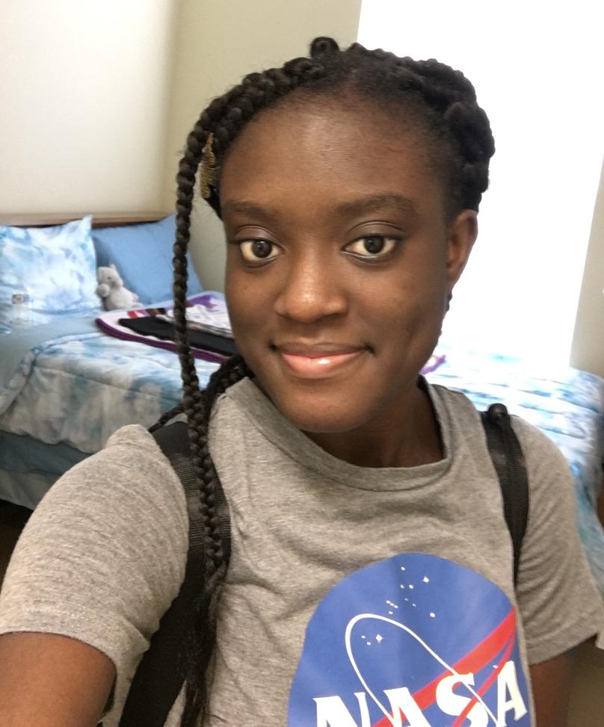

This is me, Priscillla Saarah. I am a rising senior at Dillard University with a major in biology and a minor in chemistry and computer science. This summer, I am working with Dr. Nancy Amato and Dr. Marco Aguiree on a computational biology project. (See my project description and my blogs to learn more).

People usually get curious about why I decided to learn computer science especially after they know I want to be a neurosurgeon. Well, I was fortunate to be born during the time technology and its devices were becoming popular in Ghana - and yes, I am a Ghanaian. And I was fortunate once more to have a dad who had lived in Canada so was more open to technology and computers compared to others his age back then - the 2000’s - as well as brothers who were open to anything computer. The result? My family became the first to own a personal computer in my neighbourhood which of course was put to good use, mainly by my brothers. I loved to watch but I guess watching for years instilled in me the desire to learn about computers, a little more than just what we see but also how it works. The road to the study of computer science was created right at that moment.

There is more to this story and just me as a person but we’ll leave that for whoever gets the chance to meet me or finds me online.