ResInsight Advanced User Course
Q4 2026

Table of Contents
Table of Contents 2
Support and Resources 4
Preparations 5
a) Grid Cross Plot with formations 7
b) Grid Cross Plot with filtering 8
c) Sector model export 9
d) Ensemble Grid Case Statistics 10
e) Grid Property Calculator 11
f) Well Log Extraction 14
g) Well Log Data 15
h) Well Measurements in 3D 16
i) Well Measurements in plots 17
j) Well Picks 19
k) Well Path Creation 20
l) Well Path Completions 21
m) Export LGR for Completions 22
n) Valve Modeling and Export 23
o) Project file manipulations 24
p) Seismic Data 25
q) Seismic Data along a well path 26
r) Correlation analysis 27
s) Analysis Plot 30
t) Python scripting 31
u) Summary Data from SUMO 32
v) Well Paths from OSDU 33
w) Description of Flow Diagnostics 34
x) Performance Hints 35
y) Latest releases 36

Support and Resources
Main help page
https://resinsight.org/
Yammer
Internal Equinor Yammer channel “ResInsight users”
https://web.yammer.com/main/threads/eyJfdHlwZSI6IlRocmVhZCIsImlkIjoiNzM3MzA5MDI1MjgwMDAwIn0
Tutorials – introduction
There are a few tutorials available, and we also have recorded videos for some of them.
https://github.com/CeetronSolutions/resinsight-tutorials
https://www.youtube.com/channel/UCEJoH_ti1YZXz4hPMeAKMgw
Overview of the interface for 3D visualization
https://github.com/CeetronSolutions/resinsight-tutorials/blob/main/tutorials/graphical-user-interface/graphical-user-interface.md

Preparations
Test models used in tutorials are available from https://github.com/CeetronSolutions/resinsight-tutorials
The data to be used in tutorials is in the folder model-data.
Either clone the GitHub repository, or select “Download ZIP” from the Code menu
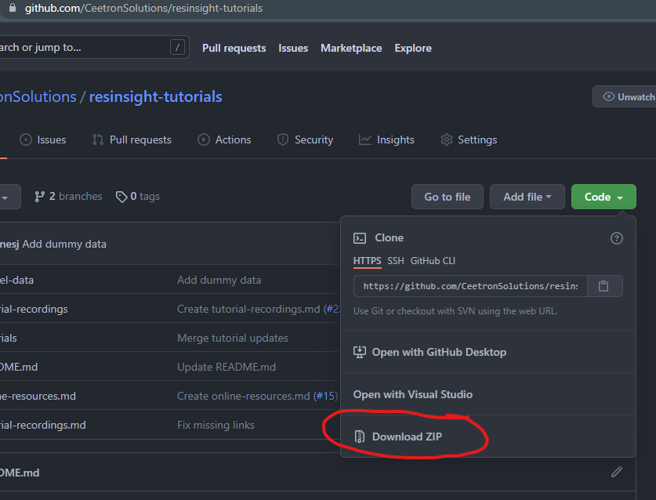

Conventions
In this document, bold text indicates an object in the property tree. Menu item text is “written in quotes”.
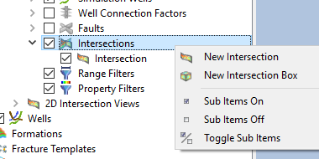
Example
Select “New Intersection” from Intersections.

Tips and tricks
Please close the existing project (“File->Close Project”) before starting a new tutorial. This will help you to avoid confusion caused by data from previous tutorials.

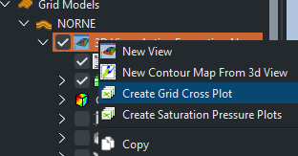
Grid Cross Plot with formations

Objective: Create grid cross plot with automated categories based on formations
- Import grid data using “Import Eclipse Case” from folder “model-data/norne”
- Import formations from folder “model-data/norne/Norne_subZones.lyr”
- In Cell Result, select Static->PORO
- In the Project Tree, open the right-click menu of the view, Select “Create Grid Cross Plot”. The default X-Axis Property is defined by the Cell Result in the 3D view, and default Y-Axis Property is Depth with the Y-axis inverted with increasing values at the bottom of the plot
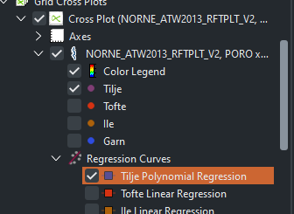
- Select PERMX as the Y-Axis Property
- Click on a sample in the plot to highlight all samples for a group
- Regression curves
  - Disable all other cross plot curves except one from Tilje formation
  - In the Plots Tree, scroll down to the regression curves enable
the regression curve for the curve in a.
  - Select the regression curve and adjust properties in the Property Editor
https://resinsight.org/plot-window/gridcrossplots/
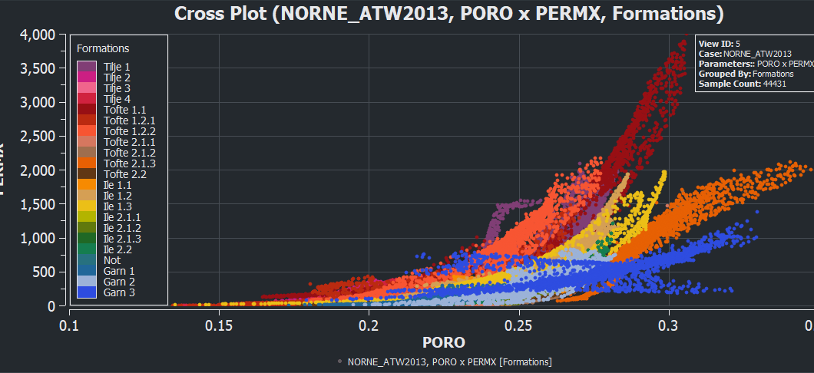

Grid Cross Plot with filtering

Objective: Create grid cross plot with filtering
- Import grid data using “Import Eclipse Case” from folder “model-data/norne”
- Import formations from folder “model-data/norne/Norne_subZones.lyr”
- In the 3D view, set Cell Result to Static -> FIPNUM
- In the Project Tree, open the right-click menu of the view
- Select “Create Grid Cross Plot”
- Set Static PORO as x-axis
- Set Static SWATINIT as y-axis
- Set Group Data by “Result Property”, select Static -> PERMX
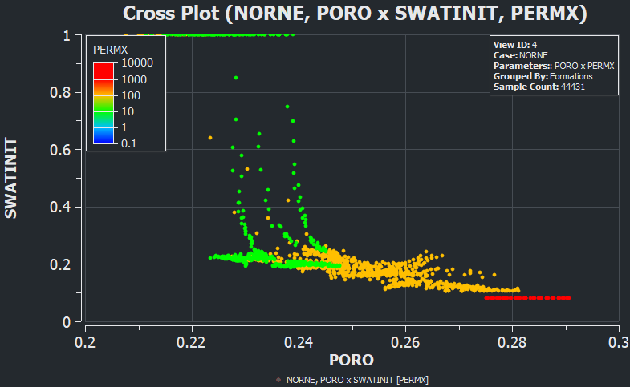
- Select color legend in Project three
  - See how manipulation of “Number of intervals” affects the plot
- In the grid cross plot, select Filter by 3D view
- Go back to the 3D view, and create a property filter based on FIPNUM
  - Select FIPNUM value 6 the category selection (multiple selection is supported)
  - Hide faults to see the filtered grid cells
- Make sure both the 3D view and the plot window are open at the same time. Modify the selected FIPNUM values in the property filter and see how the plot is updated as visible cells in the 3D view changes.
- Right-click the Cross Plot in the Plots tree view and select “Show Plot Data” to see the plot values.
- Optional: The 3D view can be docked inside the plot window from the right-click menu of the 3D view “Dock in Plot Window”. This enables side-by-side display of a 2D plot and a related 3D view.

Sector model export

Objective: Export a subset of the grid based on visible cells
- Make sure the “Model Reader” in Preferences->Grid is set to resdata
- Import grid data using “Import Eclipse Case” from folder “model-data/norne”
- Move to the last timestep as there is no flow at the first timestep
- In the 3D view, set Cell Result to Flow Diagnostics
- Select “By Selection”
- Select injector C-2H and producer B-2H
- Select Injector Producer Communication
- Create a property filter on communication between C-2H and B-2H
- Hide the faults to see the cells
- In the right-click menu in the 3D view, select “Export Eclipse Sector Model”
- Select Export Folder and additional settings, and click Export button
- Import the exported data
  - Select “Import Eclipse Input Case”
  - Select all files exported in the previous step (use multiselect in file dialog)
- Compare the imported data with the original binary case
  - Select PERMX in both views
  - In the right-click menu in the 3D view, activate Compare to
https://resinsight.org/export/sectormodel/
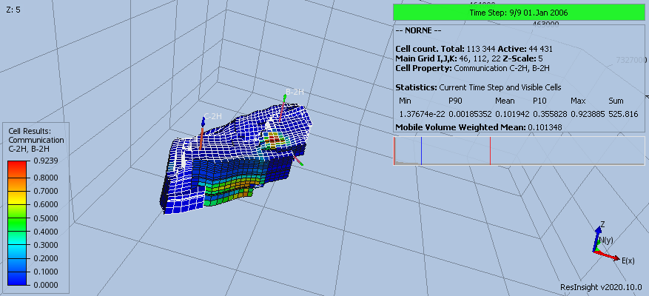

Ensemble Grid Case Statistics

Objective: Import an ensemble of grid cases and compute statistics cell by cell
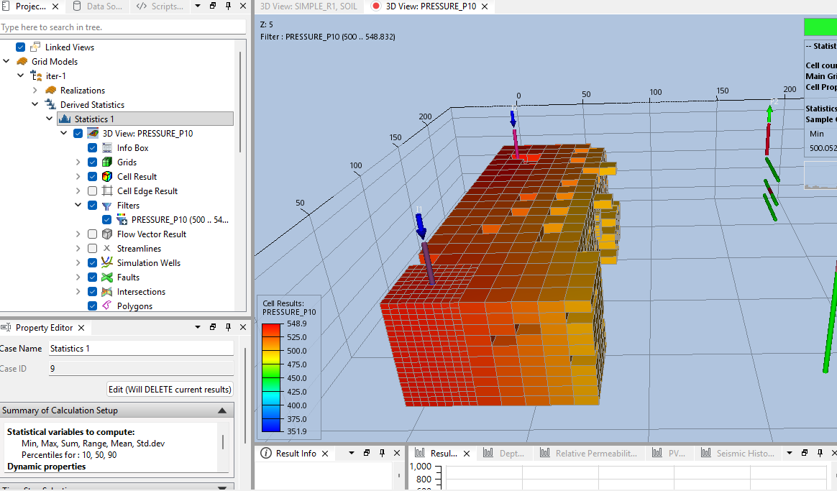
- Start import using Import Grid and Summary Ensemble, either from the File menu or toolbar button. Import grid ensemble from folder
“model-data/grid_ensemble”
- From the right-click menu of Derived Statistics, select New Statistics Case
- In the property panel, click the button “Compute” to compute default statistics
- Select dynamic property PRESSURE_P10, move to last time step
Create a new view and create a property filter showing PRESSURE_P10 larger than 500
- [Optional] Select Statistics 1. In the Property Editor, click the button “Edit(Will DELETE current result)”
Add PORV to the list of static variables.
- [Optional] Handling of inactive cells (Use Zero as Inactive Cell Value)
  - When computing statistics on PRESSURE, it is usually required to leave this option off (total cell count is active)
  - When computing statistics on PORO/PERM, it is usually required to enable this option (total cell count is active + inactive)
https://resinsight.org/calculated-data/gridensemble/

Grid Property Calculator

Objective: Compute mobile oil using a grid property calculator
- Import grid data using “Import Eclipse Case” from folder “model-data/norne”
- Open the grid property calculator
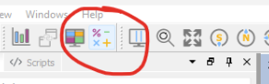
- Add the expression text and click Parse Expression
MOBILE_OIL := if(((SOIL-SOWCR) < 0.00), 0.00, PORV*(SOIL-SOWCR))
- Assign corresponding properties to the variables using the Edit button
- Select the Cell Result “Generated ->MOBILE_OIL”
- Create a contour map, and set Map Projection, “Result Aggregation->Sum”
Please note that there are options in a contour map to compute mobile directly without creating the calculated expression shown in this example.
- In the 3D view, create a polygon cell filter for a section of the grid where there is a lot of mobile oil. Activate the right click menu, and select “Polygon Filter”
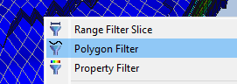
- Open the Grid Property Calculator, and create a new expression
SUM_MOBILE_OIL := sum(MOBILE_OIL)
- Expand the Cell Filter group, and for Filter by 3d View Visibility, select “3D View: MOBILE_OIL”
- Click Parse Expression, an assign the Generated variable MOBILE_OIL
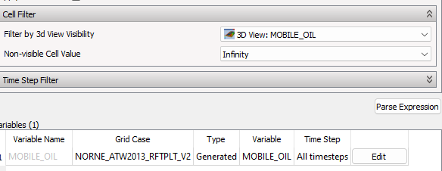
- Click on calculate and create a view of the grid property SUM_MOBILE_OIL
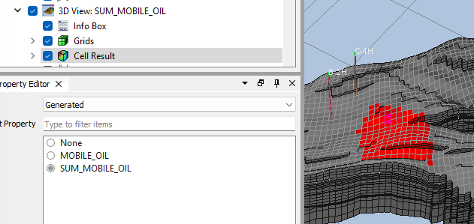
The aggregated sum is assigned to all cells participating in the calculation. The value can be seen in Result Info by clicking on a cell.
Note that expressions can be stored to a text file for reuse in other projects. This is available from button operations in the Grid Property Calculator.

References
https://resinsight.org/calculated-data/gridpropertycalculator/
https://resinsight.org/calculated-data/calculatorexpressions/
See the following description on how to calculate this on an ensemble of grids.
https://github.com/OPM/ResInsight/discussions/10913
Calculation of mobile oil directly in a contour map
https://resinsight.org/3d-main-window/contourmaps/index.html#map-projection-properties

Well Log Extraction

Objective: Plot well log extraction curve in 2D plot window

- In 3D main window
  - Import grid case from “norne” and import formations from “norne/Norne_Fm.lyr”
  - Import well path "model-data/norne-well-logdata/dummy-B-3H.dev"
  - Select cell result Dynamic -> SOIL
  - Select well path DUMMY-B-3H, and from the right click menu select “Well Plots->New Well Log Extraction Curve”
  - Activate the plot main window
- In plot main window
  - In the project tree, activate right-click menu of the plot and select “New Track”
  - Select the new track in the Project tree
  - In the Regions/Annotations group, set Region Annotation to Formations
  - Make sure Formation Case is set to Norne and Well Path is set to DUMMY-B-3H
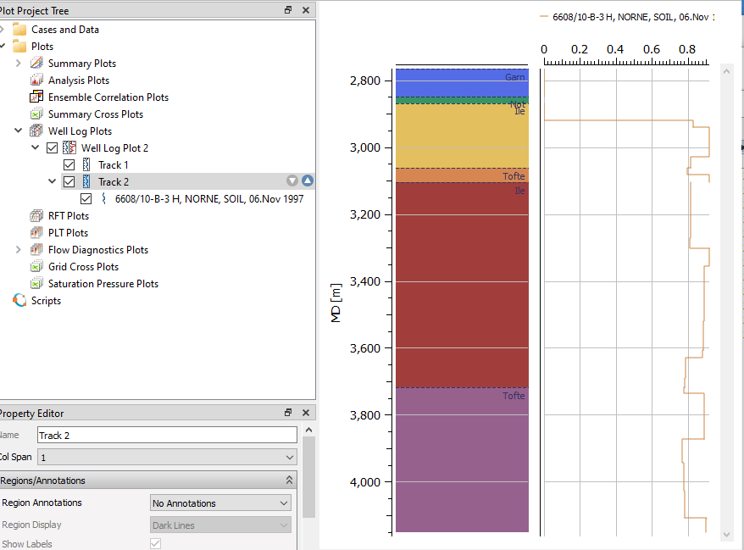
https://resinsight.org/plot-window/welllogsandplots/

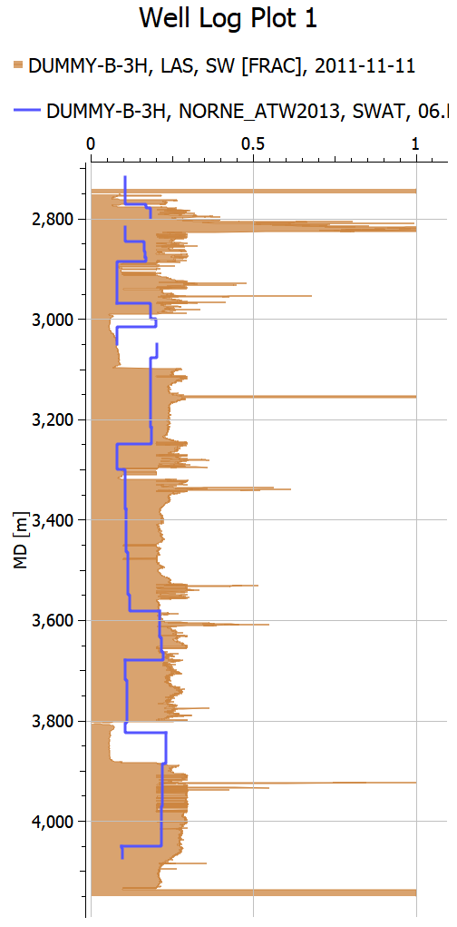
Well Log Data

Objective: Plot well log extraction curve in 2D plot window
- Import grid case from “norne”
- Import well path "model-data/norne-well-logdata/dummy-B-3H.dev"
- From the right-click menu of well DUMMY-B-3H, select “Import Well Logs from File” and select "model-data/norne-well-logdata/dummy-B-3_H.LAS "
- From the right-click menu of SW, select “Add to New Plot”
- From the right-click menu of the track, select “New Well Log Extraction Curve”
- Select Dynamic -> SWAT
- Select the SW curve object and enable Area fill. Drag and drop curves to make sure the LAS curve is located at the top of the list and will be drawn behind other curves. You can also toggle the curve visibility to control the drawing order.
- Compare data from the two data sources. They do not have a good match, as the data set contains dummy data

https://resinsight.org/plot-window/welllogsandplots/

Well Measurements in 3D

Objective: Import well measurements, display in 3D view
- Import norne
- Import formations for norne
- Set Cell Result to Static -> PORO
- Import well paths C-3H and E-3H from folder “model-data/norne-well-measurements”. Use multi-select in the file import dialog to import both in one operation.
- From the right-click menu of Wells, select “Import Measurements”
- Show measurements in the view
  - Create a new view
  - Select Wells in the Project Tree, and disable clipping of wells to be able to see the well path all the way up to the sea surface
  - Uncheck Grid Cells and Faults. Optionally uncheck Simulation Wells to make the view cleaner.
  - Make sure the checkbox in front of Well Measurements is enabled (Located above Simulation Wells)
  - Manipulate the filtering options for each measurement type in the property editor
- Continue to next tutorial without closing the project
https://resinsight.org/wells-and-completions/wellmeasurements/
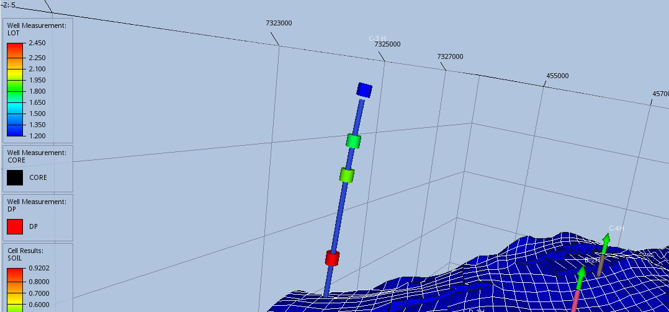

Well Measurements in plots

Objective: Import well measurements, display in plots
- Import data (see import in previous tutorial or continue with same project)
- Well log extraction curve for well C-3H
  - Create a Well Log Extraction curve for C-3H, open the plot window
  - Show data for Static -> PORO
  - In Curve -> Appearance, set Area Fill Style to Solid Fill
- Create measurement track
  - Create a new track
  - From the right-click menu of the track, select “New Well Measurement Curve”
  - Select well C-3H and XLOT
  - Use the zoom all button to make sure all measurements are visible, or toggle visibility of curve to make the well measurements visible
  - Make the measurement symbols larger
  - The measurements are outside the grid, and the depth axis min/max values can be defined in the Depth Axis section of the plot or by zoom using CTRL+mouse wheel
- Create formation track
    - Create a new track
    - From the property editor of the track, in group Region/Annotation, set the Region Annotation to Formations
    - Select case and well path, the formations appear as colors in the track
    - Change the color legend to the same as the formations, usually “Category”
- Use the up/down arrow to the right of a track to modify the ordering of tracks
- Add formations as lines to the PORO track
- Change the track width distribution
  - Set col span to 2 for XLOT
  - Set col span to 5 for PORO track
- See next page for an example plot

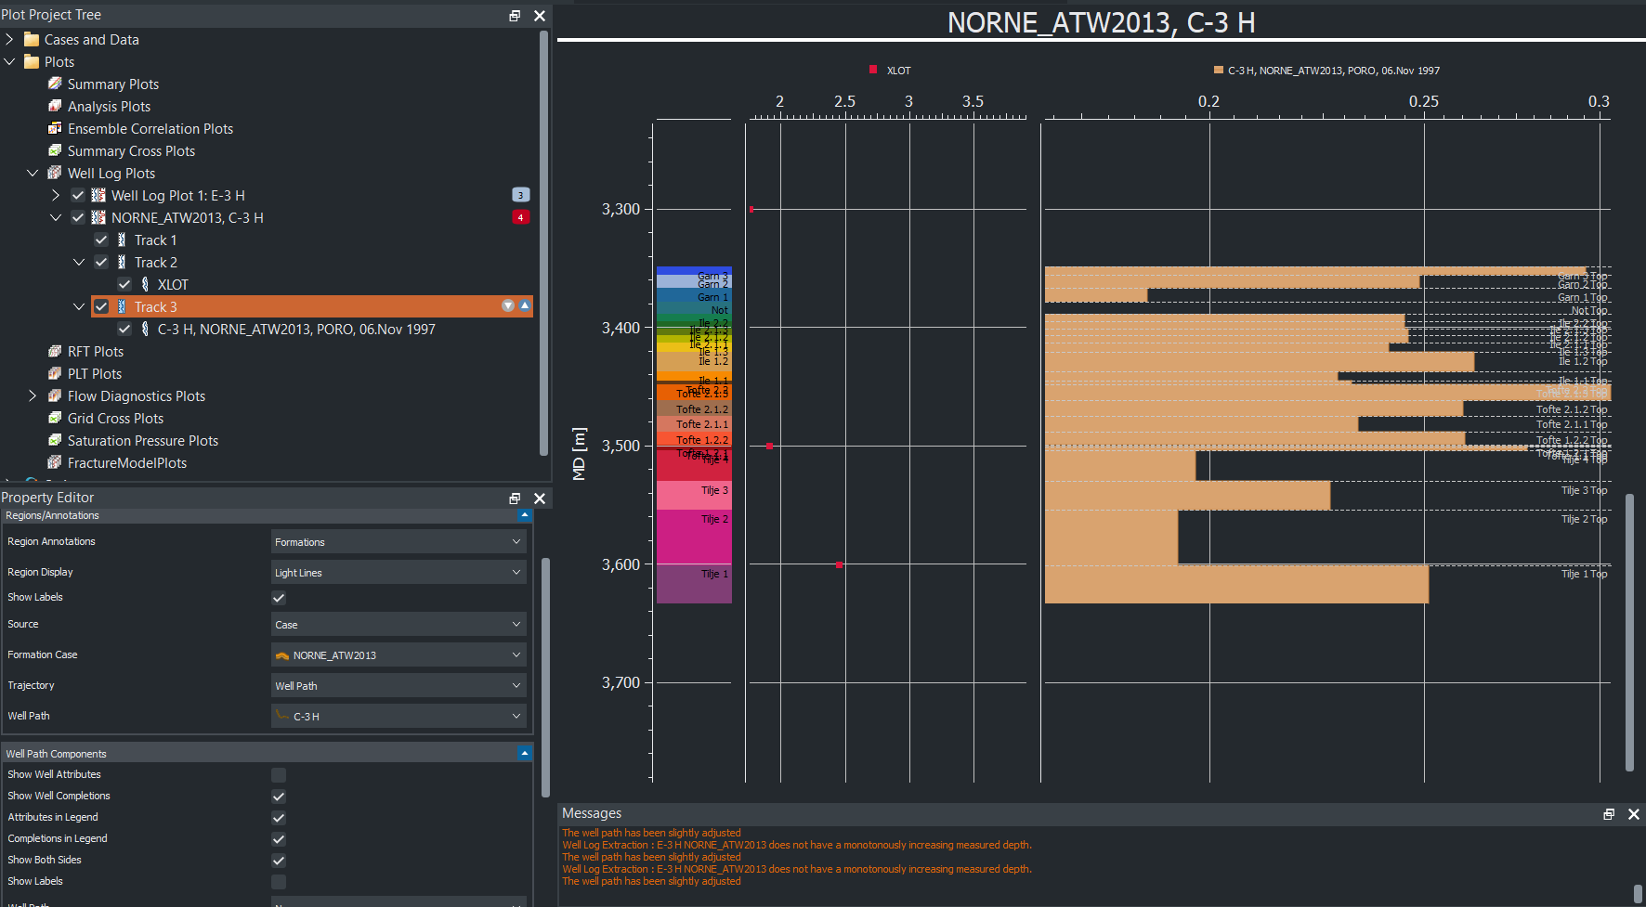

Well Picks

Objective: Import well picks, display in plots
- Import norne case
- From folder “model-data/norne-well-picks”, import well path dummy-B-3H
- Open the file “report.csv” in a text editor to see how the well picks are defined
- From the right-click menu of Wells, select “Import well picks” and select “model-data/norne-well-picks/report.csv”
- Create a well log extraction curve, use PORO
- Use area fill for PORO
- Add a new track for formations
- In Region/Annotations, in dropdown Region Annotations, select Formations
- In dropdown Source, select Well Picks for Well Path
- Select DUMMY-B-3H
- The well picks are displayed as horizontal lines

https://resinsight.org/3d-main-window/formations/#well-picks

Well Path Creation

Objective: Create a new well path using well targets
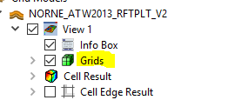
- Import grid data using “Import Eclipse Case” from “model-data/norne”
- Create intersection
  - From the right click menu in 3D view, select “Intersections->Polyline Intersection”
  - Add points to intersection, and click button “Stop picking points” when you have added all points
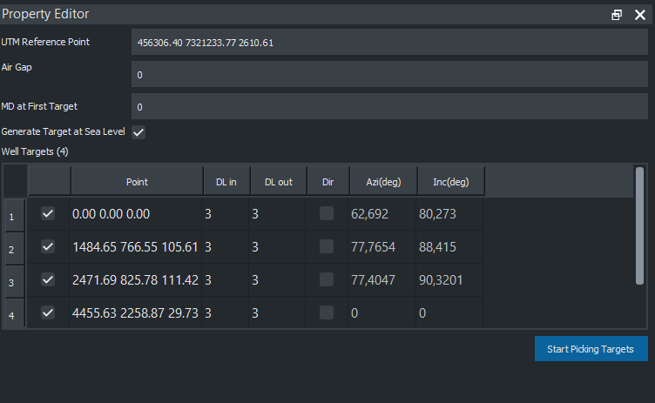
  - Disable Grids and Faults to see the intersection in the 3D view
- Select “Create Editable Well Path” from right-click menu of Wells
  - Click on several locations on the intersection to create target points
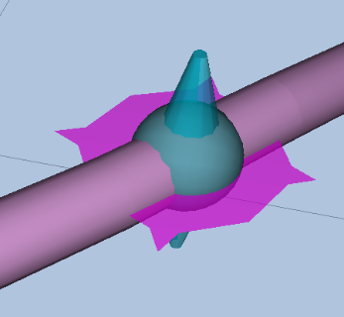
  - Manipulate the location by using dragger items in 3D
- Investigate data when selecting “Show well plan” from the right-click menu of Well-1
- Export the well path to a text file from Well-1, “Export Visible well path”. Investigate the exported text file.
- Import the exported well path using “Import Well Path”, investigate the potential geometry differences as the exported file is discretized
- Save project, as the created well path is intended to be used in other tutorials
Well target move operations
https://resinsight.org/wells-and-completions/createnewwellpaths/#well-target-interaction-operations

Well Path Completions

Objective: Export computed transmissibility factors based on completion along a well path
Continue with the user defined well path from previous tutorial.
- Find a location along the well path inside the grid, and from right click menu when clicking on the well path in 3D view select “Completions->New Perforation Interval”
- From Well Targets, select “Export Completions for Visible Well Paths”. Create a new folder as destination for the export operation. Open the Messages window to see the location of the exported file.
Inspect the exported file in a text editor and try to match the exported data with the perforation intervals in the 3D view.
- Add one more perforation interval
- Export completions, and investigate exported text file
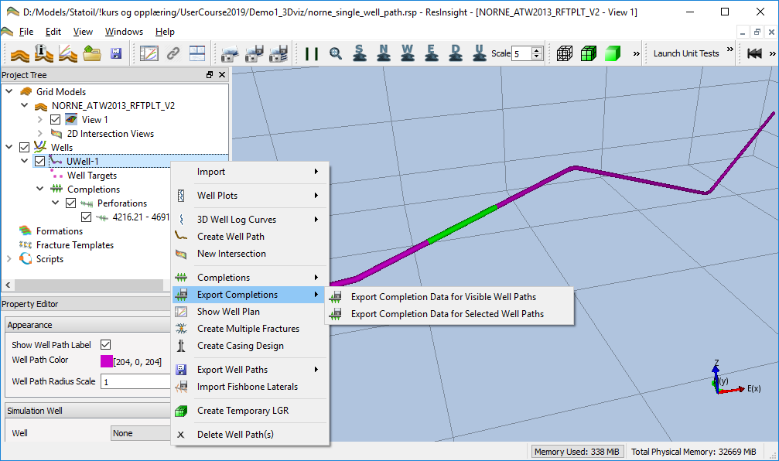
- Combined export
  - Create fracture template
    - Select “New Stim Plan Fracture Template” from the right click menu of Fracture Templates
    - Import template from "/model-data/norne-well-hydrfrac/StimPlan_HydrFrac.XML"
    - Find a location for the template, and launch the right click menu in the 3D view when clicking on the well path geometry
    - Select “Completions->New Fracture”
    - Select “3D View”->Fractures”
Toggle the view if “Fractures” object is missing.
Select “Result Color->Conductivity [md-ft]”
  - Add a fishbones section “Completions->New Fishbones”
  - Export completions, and select File Split “Split on Well and Completion Type”
  - Investigate the exported files in export folder
https://resinsight.org/wells-and-completions/completions/

Export LGR for Completions

Objective: Create and export local grid refinement (LGR) based on completions
Continue with the user defined well path from previous tutorial.
- Add two perforation intervals and one fracture to the well path
- In the Wells folder in the Project Tree, select the well you are working on. From right click menu of this well, select “Create Completions->Create Temporary LGRs”
- Export completion data into an empty folder
- Investigate CARFIN section in generated file LGR_Well-1.dat
- Untick all filters, and untick Main Grid in the Grids folder
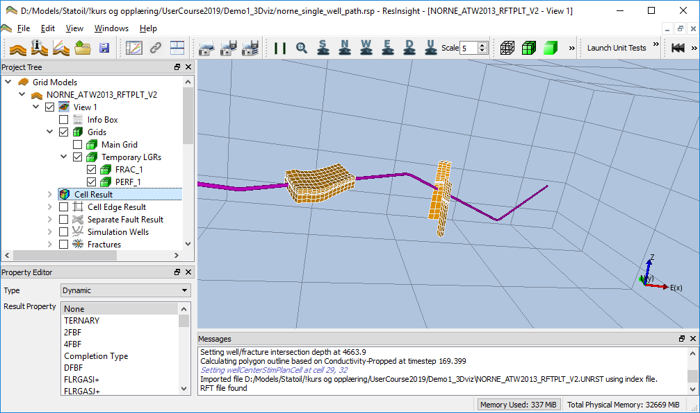
- From right click menu of the well, select “Create Completions->Create Temporary LGRs” and set number of cells in K direction to 5
- Export and Investigate CARFIN section in generated file LGR_Well-1.dat
- Add fishbones
- Optional: Possible to create multiple fractures using Stim Plan fracture
  - From the right click menu of Well-1, select “Create Multiple Fracture”
  - Select “Replace Fractures” and close the dialog
- Use the checkboxes in Grids to investigate the generated LGR grids

NB! Please note that the temporary LGRs will not be restored if you save the project and open the project again.
https://resinsight.org/wells-and-completions/completionslgr/

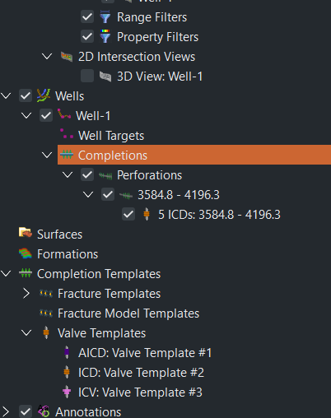
Valve Modeling and Export

Objective: Create valves and export completion
- Create a well or import modeled well path from previous tutorial
- Create a perforation of length 500m
- Add a valve from the right-click menu of a perforation interval
- ICD Export
  - Select an ICD template, and click Edit for easy navigation to the valve templates
  - Set Number of Valves to 5
  - Select “Export Completions“ from the context menu of the well
  - Investigate the exported text files
- Export AICD
  - Change valve to AICD template
  - Set the following values in the AICD template
    - Strength of AICD: 1e-5
    - Calibration Fluid Density: 1000
    - Calibration Fluid Viscosity: 1
    - Volume Flow Rate Exponent: 2
    - Viscosity Function Exponent: 0.7
  - Select “Export Completions“ from the context menu of the well
  - Investigate the exported text files
Import of templates from text files is supported using the right-click menu of Valve Templates and select “Import Valve Templates”. Valves can be imported from Completor or Eclipse text files.
https://resinsight.org/wells-and-completions/completions/#perforation-interval-valves
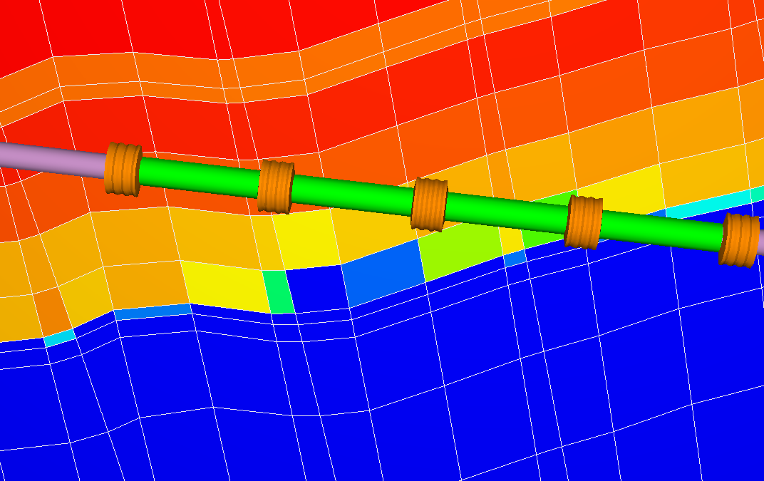

Project file manipulations

Objective: Know how to manipulate selected parts of the project file
- Show path section <ReferencedExternalFiles>
  - Discuss how these can be changed by external scripts
- Show well path targets <WellPathTargets>
  - Discuss how these can be changed by external scripts
  - Create a copy of the well path target project file
  - Move one target 50 meter in x-direction
  - Save project as copy with new name
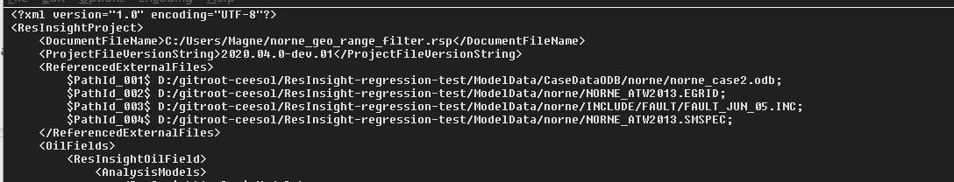
  - Open copy, and investigate the modified location of the well path target
  - Discuss how to manipulate model from scripting

Seismic Data

Objective: Import and visualize seismic data. Compare with reservoir data.
- Import the Drogon grid model from "model-data/drogon/DROGON-0.EGRID”
- Import seismic data from "model-data/drogon/seismic/seismic--amplitude_depth--20180701_20180101.vds”
- In the Project Tree, toggle off Grids to be able to see seismic data to be created in the next step
- From the right-click menu of Seismic Sections, select “New Inline Section” and investigate seismic data in the view
  - Activate the Seismic Histogram dialog to see the value distribution
  - Click on red and blue parts of the seismic slice to see the associated seismic value in the Result Info dialog, see how the reported values corresponds to the seismic color legend
  - Select the Inline object, and manipulate the Inline value in the Property Editor
- Select the seismic data source, and adjust the mute and clip values to filter seismic data
  - Set Clip Value to 0.003
  - Set Mute Value to 0.001
  - Select the Inline object, expand the Experimental group and activate Transparent
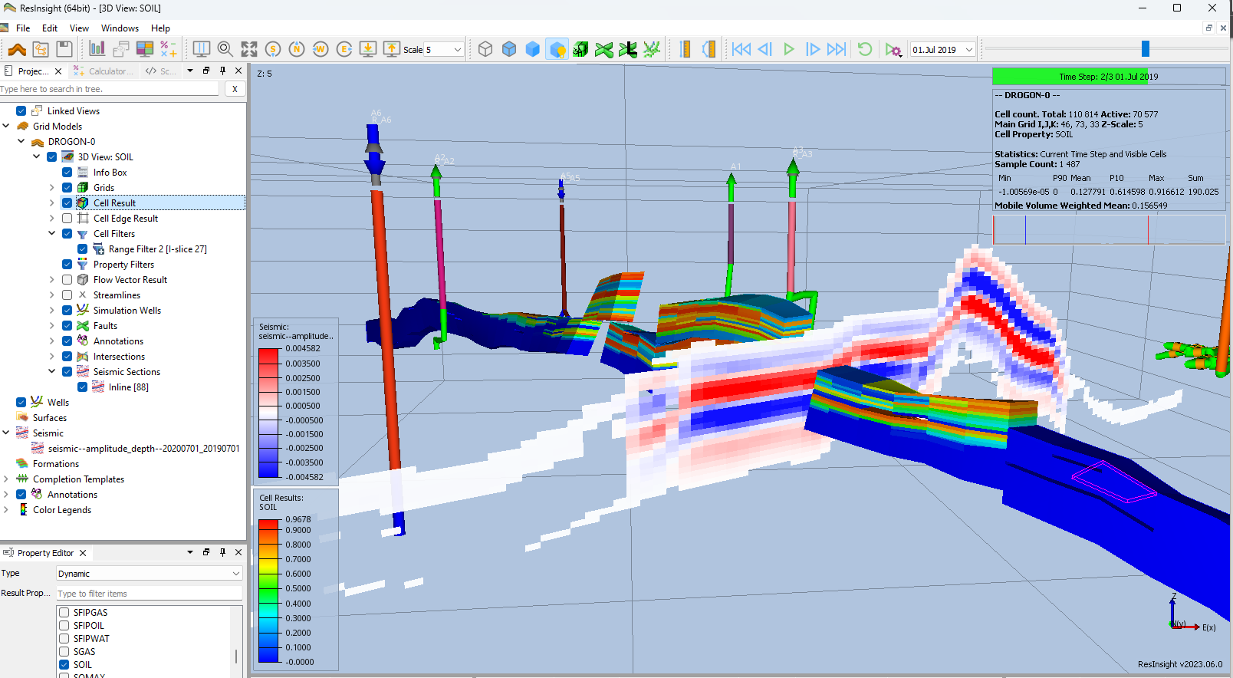
  - Move the inline to see how seismic data correlates to grid model geometry

Seismic Data along a well path

Objective: See seismic data along a well path
- Import the Drogon grid model from " model-data/drogon/DROGON-0.EGRID”
- Import seismic data from " model-data/drogon/seismic/seismic--amplitude_depth--20180701_20180101.vds”
- Create a user defined well path
- From the right-click menu of Intersections, select “New Intersection”. Change intersection type to Well Path, and select the well path
- From the right-click menu of the generated intersection, select “Create as Seismic Section”
- Select the Seismic section, and set it transparent
- Tile the windows to be able to see both views at the same time
- Show only seismic data in one view and grid model data in the other
- Manipulate the well path targets, and see grid is updated
- Advanced manipulation:
  - Press and hold CTRL to move the target and all downstream well targets
  - From the right-click menu in a view, select Compare to

A seismic view can be created independently of the reservoir view. To create this type of view, select New View from the right-click menu of Seicmic Views.

Correlation analysis

Objective: Create and configure a Correlation Plot
- Basic use
  - Import a Summary Ensemble, and use import path "model-data/reek_ensemble/3_r001_reek_50/realization-*/iter-1”
  - From the right-click of a curve, select “Create Correlation Plot from Curve Point ->New Report Plot”
  - Click on individual cells in the Correlation Matrix, and see how the cross plot is updated
Currently selected cell is indicated by a border in green
  - Show Pearson calculation
  - Change data source to WOPT for all wells OP_1 to OP_5
  - Click on individual cells in the Correlation Matrix, and see how the cross plot is updated
  - Right-click in plot, and select Show Plot Data
  - Expand the Filter group, and activate “Use Parameter Filter”
  - Adjust the sliders
  - A subset of realizations is inside the filter seen in the cross plot between summary response and input parameter. A new ensemble based on these filtered realizations can be created from the right-click menu “Create Ensemble from Filtered Cases”

https://resinsight.org/plot-window/correlationplots/

Definition of how the Pearson correlation coefficient is computed
https://en.wikipedia.org/wiki/Pearson_correlation_coefficient#For_a_sample
X is input parameter value, Y is simulated value
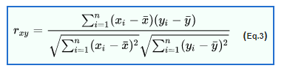

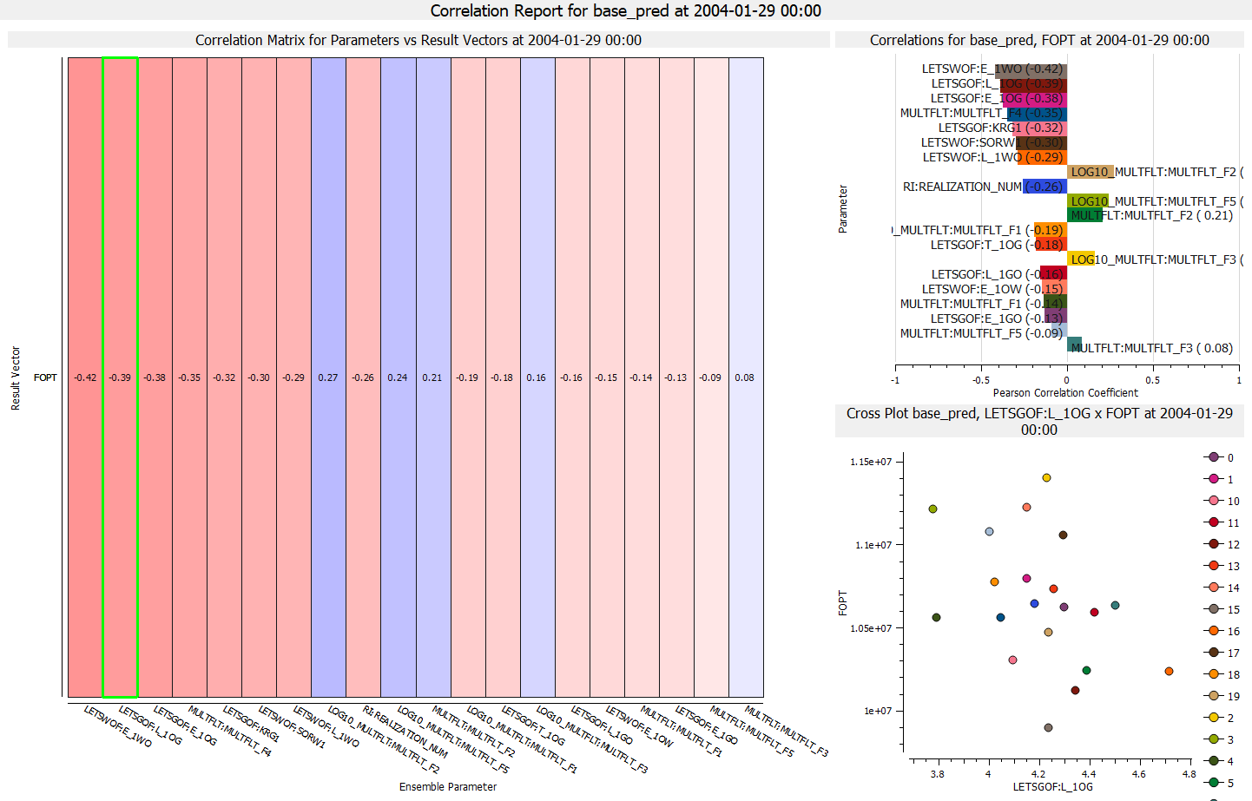

Analysis Plot

Objective: Create and configure an Analysis Plot
- Import a Summary Ensemble, and use import path "model-data/reek_ensemble/3_r001_reek_50/realization-0/base_pred”
- Import a Summary Ensemble, and use import path "model-data/reek_ensemble/3_r001_reek_50/realization-0/pred_op6”
- Select New Delta Ensemble from right-click on Summary Cases
Create a Delta Ensemble as the difference between the two cases (pred_op6 - base_pred)
- Toggle off checkbox “Discard Missing or Incomplete Realizations” (see screenshot)
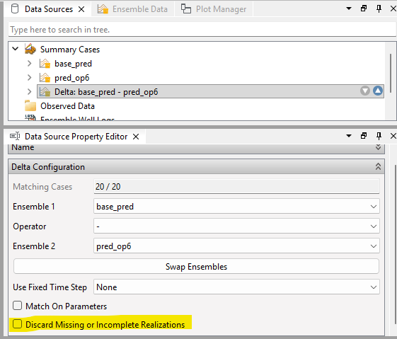
- Select new Analysis Plot
- In Property Editor, in group Selected Vectors, click on the button with three dots “…”
  - Set source Delta ensemble
  - Select all OP_* wells
  - Select Summary Vector WOPT
- Bar Orientation: Horizontal
- Select major grouping Summary Item
- Select sort by abs(Value)
- Optionally
  - Show legend
  - Bar labels
- Right-click in plot, and select Show Plot Data
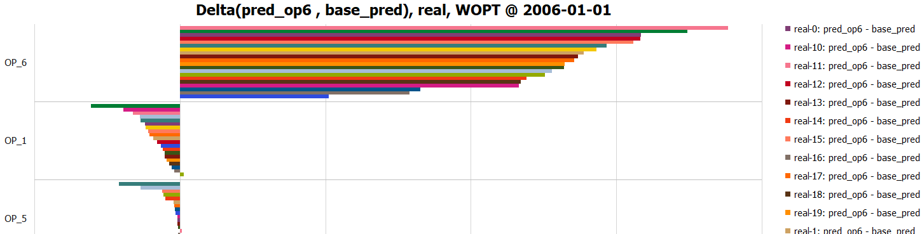
https://resinsight.org/plot-window/analysisplots/

Python scripting

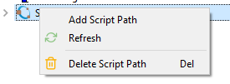
Objective: Learn how to execute a Python script from ResInsight UI
- Configuration of Equinor internal scripts is described in
“ResInsight user Course Preparations 2022.pdf”
- [Optional] Add a folder containing existing scripts
  - Right-click on Scripts item, and select “Add Script Path”
  - Select script folder
  - To edit the text content of a Script, select “Edit” from the right-click menu
- Use the right-click menu to execute a script
- Investigate the output from the Python script in Process Monitor
- It is also possible to execute a Python script directly from a terminal

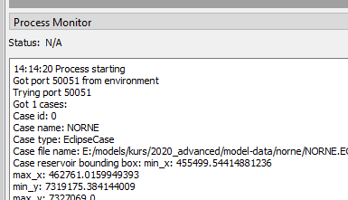
https://api.resinsight.org
https://api.resinsight.org/en/stable/PythonExamples.html

Summary Data from SUMO

Objective: Learn how access and use summary data from SUMO
SUMO is a cloud storage solution for reservoir data. ResInsight support access and visualization of summary data.
- Activate the Cloud Data object in the Cloud tab. If required, a authorization dialog is diplayed in a web browser window. When authorization is completed, an access token is stored for future connections to this service.
- The data you have access to is displayed in Field, Case and Ensemble displays
- Select ensembles for visualization
- Click button Add Ensembles
Data is retrieved from cloud and visualized in a plot. The ensemble can be visualized similar to ensemble imported from file.

The connection to SUMO stores an access token in the form of a text file in your home folder. If you experience connection issues, you can close down ResInsight, delete the file “your home folder/.resinsight/sumo_token.json”

https://resinsight.org/import/cloudservicesauthorization/
https://resinsight.org/import/cloudservices/

Well Paths from OSDU

Objective: Learn how import well paths from OSDU
OSDU is a cloud storage solution for reservoir data. ResInsight support import of well path trajectories from OSDU.
- Import grid data using “Import Eclipse Case” from “model-data/norne”
- From the right-click menu of Wells, select Import Well Paths from OSDU [BETA]
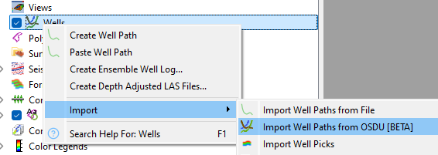
- Use the wizard to select some well paths from Norne
- In the 3D view, untick display of simulation wells to make it easy to see only the imported well paths
- Investigate the imported well paths

The connection to OSDU stores an access token in the form of a text file in your home folder. If you experience connection issues, you can close down ResInsight, delete the file “your home folder/.resinsight/osdu_token.json”

https://resinsight.org/import/cloudservicesauthorization/
https://resinsight.org/import/cloudservices/

Description of Flow Diagnostics
A Flow Diagnostics simulator developed by SINTEF based on MRST(MATLAB Reservoir Simulation Toolbox) is included in ResInsight. The flow diagnostics simulator as described by SINTEF:
“Flow diagnostics are simple and controlled numerical flow experiments run to probe a reservoir model, establish connections and basic volume estimates, and measure dynamic heterogeneity. Flow diagnostic quantities are quick to compute and can thus be used interactively to explore fluid communication in a geological model before or after more comprehensive multiphase flow simulations.”
The following table displays the short name used by ResInsight and the more detailed description taken from the SINTEF documentation.
ResInsight naming | Flow Diagnostics description (SINTEF)
Forward time of flight (injectors)  Reverse time of flight (producers) | Travel time for mass-less particles that passively follow the flow field from an injector into the reservoir and from a point in the reservoir to the nearest producer
Drainage/flooding regions | Delineate regions drained by given producers or swept (flooded) by given injectors
Injector Producer communication | Determine whether pairs of injectors and producers communicate or not and measure the relative strength of their connection
Tracer Cell Fraction | Determine how flux is allocated between different injectors and producers

Flow diagnostics use the flux field (flow rates) defined per grid cell (FLROIL/FLRGAS/FLRWAT). These cell properties can be exported from a reservoir simulator by adding the keyword FLORES to RPTRST in both SOLUTION section and SCHEDULE section. If no flow rate data is available, ResInsight will estimate the flow field. Users are encouraged to export flow rates from the simulator for best precision.

https://www.sintef.no/projectweb/mrst/modules/diagnostics/

Performance Hints
Some workflows create huge amounts of data. Performance related to transfer of data can in some cases be limited by infrastructure (network disk access, cloud data access, organization of data causing extra delays, ..) ResInsight has settings that can improve the performance in some situations.
Summary Data
Summary data is by default stored in SMSPEC and UNSMRY files. The organization of data in these files can give bad performance form large files. ResInsight has support for an improved file format called ESMRY. This format can be used by selecting opm-common summary reader in Preferences. ResInsight is also able to convert from UNSMRY to ESMRY. This is a heavy operation that includes read/transform/write of all summary data, but can give significant improvements for post-processing of summary ensembles.
Grid Data
Grid data can be imported using resdata and opm-common.
- resdata
  - Maintained over many years, many special cases of import files covered
- opm-common
  - Modern and fast codebase
  - Support for skipping inactive cell geometry
  - Support for flow diagnostics coming in next release

https://resinsight.org/best-practices/performancehints/

Latest releases

https://resinsight.org/releases/release-notes/index.html

