ResInsight User Course
May 2025

- Welcome, course layout and introductory remarks
- ResInsight Introduction and Overview
a) Well Target Mapping 2
b) Ensemble Contour Map 3
c) Ensemble Parameter Histogram 4

Well Target Mapping

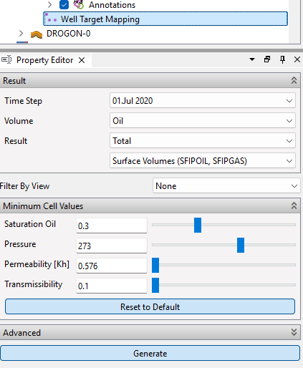
Objective: Identify new well target candidates
- Import grid data using “Import Eclipse Case” from folder “/model-data/drogon-varying-grid-geometry/realization-0/iter-0/eclipse/model/DROGON-0.EGRID”
- From the right-click menu of the grid model select “New Well Target Mapping”
- In the Property Editor, click Generate at the bottom of the properties
The first available view will be updated with the well target candidates
- Adjust the following threshold values
  - Saturation Oil: 0.4
  - Transmissibility: 10
- Click Generate, and see change in region identification
- Select Cell Result, and select Result Property TOTAL_SFIPOIL
https://resinsight.org/workflows/welltargetmapping

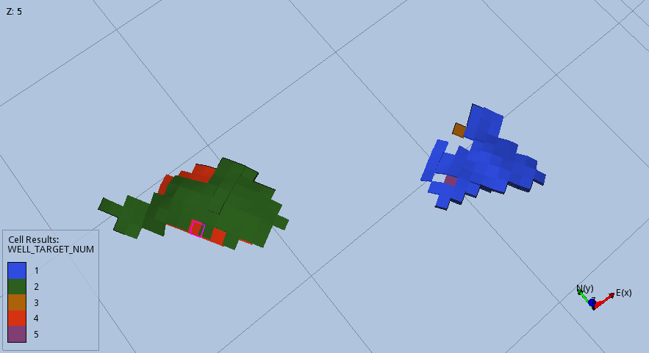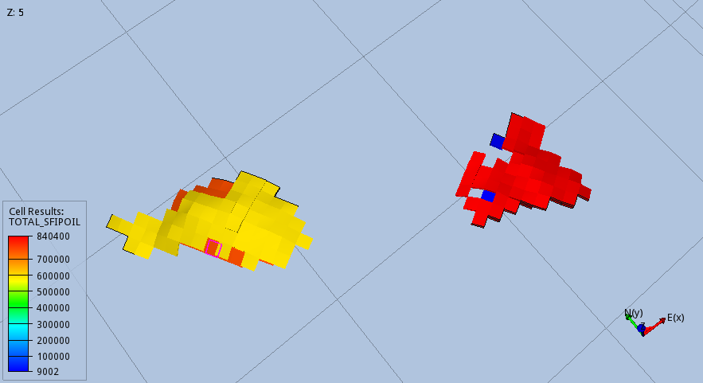

Ensemble Contour Map

Objective: Import grid models and create statistics contour map
- Import ensemble of grid models
  - Select “File->Import->Eclipse Cases->Create Grid Case Ensemble”.
  - Select folder “model-data/drogon-varying-grid-geometry”, and press Search and Ok
- Expand the Realizations folder to verify the import of realizations
- From the right-click menu of the ensemble “iter-0” select “New Ensemble Contour Map”
- In the Result Aggregation dropdown, select “Mobile Oil Column” and click Compute
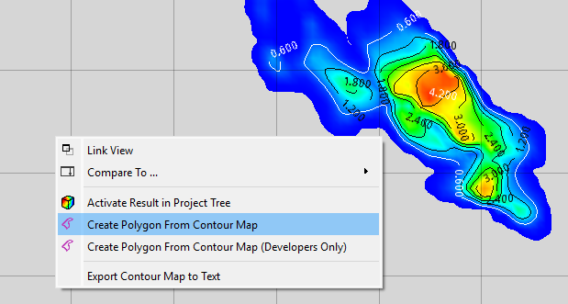
- In the generated contour map, select the Map Projection object. Set Statistics Type to P90
- Set value filter to Above set the value to 3.7. This will remove contour map values below the threshold
- Inside the plot are of the contour map, select “Create Polygon From Contour Map”
- Activate the 3D view. Right-click on Cell Filters and select one of the generated polygons.
The cells outside the polygon will be hidden.
- In the top level Polygons object, increase Line Thickness to improve polygon visibility

https://resinsight.org/3d-main-window/ensemblecontourmap/

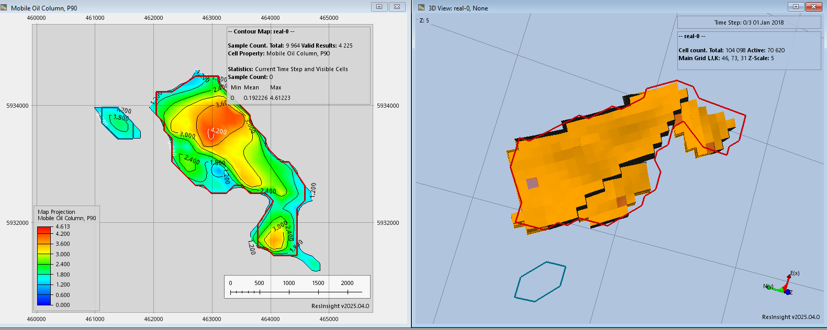

Ensemble Parameter Histogram

Objective: Investigate and compare histograms for ensemble parameters
- Import a Summary Ensemble, and use import path "model-data/reek_ensemble/3_r001_reek_50/realization-*/iter-1”
- From the right-click menu of Histogram Plots, select “New Histogram Plot->Ensemble Parameter”
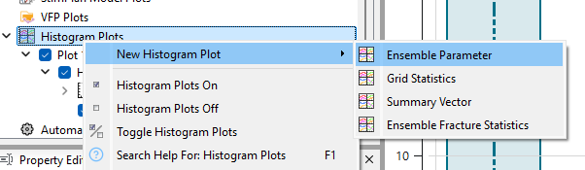
- Add more histograms from the right-click menu of the Plot
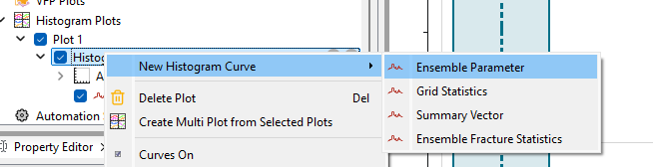
- Drag and drop is supported from the Data Sources tree view
