ResInsight User Course
November 2025

a) 3D Grid Visualization 5
b) 3D Grid Inspection Features – Intersections 6
c) Polygons 7
d) 3D Grid Inspection Features – Fault Analysis 8
e) 2D Contour Map 10
f) Description of Flow Diagnostics 11
g) Flow Diagnostics – 3D view 12
h) Flow Diagnostics – plots 14
i) Summary Plots 15
j) Summary Cross Plot Curves 16
k) Summary Plots – calculated curves 17
l) Summary Data in Table 19
m) Summary Decline Curves 20
n) Summary Regression Curves 21
o) Observed Data Plots 22
p) Ensemble Plots (1 of 2) 23
q) Ensemble Plots (2 of 2) 24
r) Plot Templates 25
s) RFT Plots 26
t) Ensemble RFT Plots 27
u) Correlation Analysis 28
v) Analysis Plot 31
w) Well Path Import from OSDU 32

Support and Resources

Main help page
https://resinsight.org/

Tutorials and recordings
Tutorial site for ResInsight
https://github.com/CeetronSolutions/resinsight-tutorials
Video recording of selected tutorials
https://www.youtube.com/channel/UCEJoH_ti1YZXz4hPMeAKMgw

Overview of the interface for 3D visualization
https://github.com/CeetronSolutions/resinsight-tutorials/blob/main/tutorials/graphical-user-interface/graphical-user-interface.md

Preparations
Test models used in tutorials are available from https://github.com/CeetronSolutions/resinsight-tutorials
Either clone the GitHub repository, or select “Download ZIP” from the Code menu
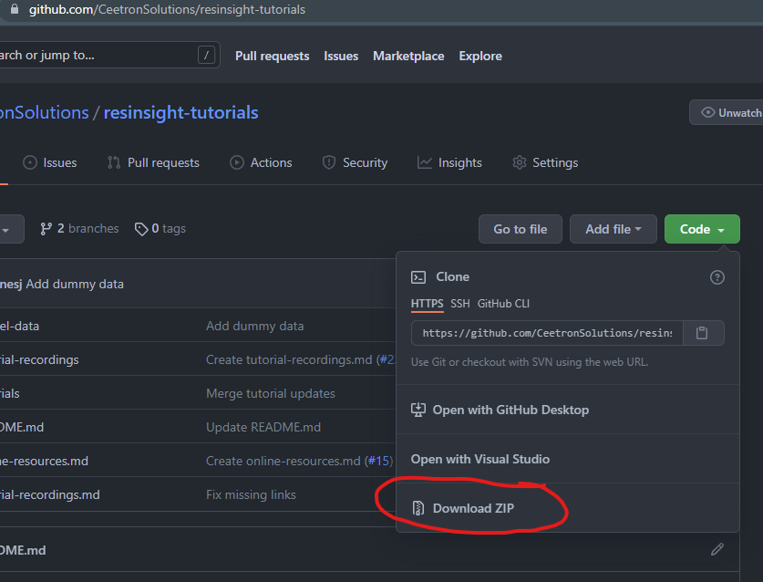

Conventions
In this document, bold text indicates an object in the property tree. Menu item text is “written in quotes”.
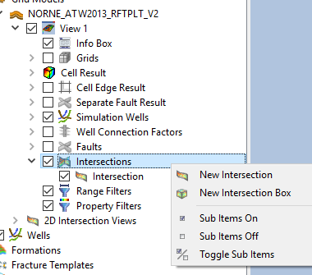
Example
Select “New Intersection” from Intersections.
Tips and tricks
Please close the existing project (“File->Close Project”) before starting a new tutorial. This will help you to avoid confusion caused by data from previous tutorials.

3D Grid Visualization

Objective: Get familiar with basic visualization concepts
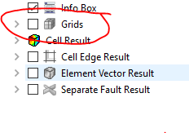
- Import grid data using “Import Eclipse Case” from folder “model-data/norne”
- In Project Tree, select Cell Result
- In Property Editor, change “Result Property” to “PRESSURE”
- Move to the last time step using the play toolbar button
- Click on different cells, and investigate the plots for Relative Permeability Plot, PVT Plot and Result Plot
- To see the simulation wells, turn off Grids (see snapshot hint to the right)
- Open main application plot window and select “Import Summary Case” from “norne”. This data source is required to be able to see well disks
- Select Simulation Wells in the Property Editor
- Enable Disks in the Visibility group. Data source for the disks can be changed in the Disks group at the bottom of the Property Editor for Simulation Wells
- Expand Simulation Wells and enable Well Connection Factors. Click on the well connection factors star symbol and investigate the values in the Result Info panel.
You may change mouse interaction mode in “Edit->Preferences->Navigation Mode”, c.f. https://resinsight.org/getting-started/modelnavigation/
Online tutorial
https://github.com/CeetronSolutions/resinsight-tutorials/blob/main/tutorials/grid-visualization/grid-visualization.md
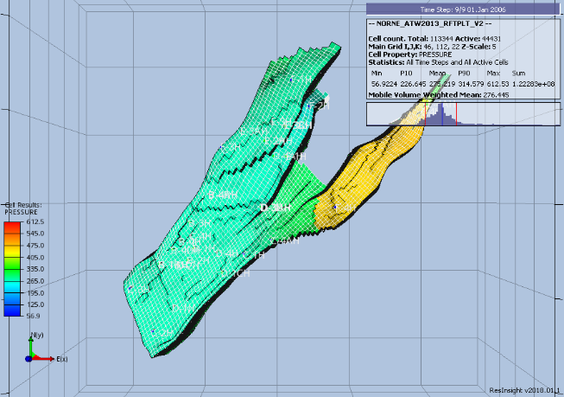

3D Grid Inspection Features – Intersections
Objective: Able to show and manage intersections
- Import grid data using “Import Eclipse Case” from folder “model-data/norne”
- Right-click on the surface of the grid model, and select “Intersections->Polyline Intersection”
- Select a few points on the surface to define an intersection, and click “Stop picking points” in the Property editor
- Turn off Grids and Faults in the Project Tree to see the intersection geometry
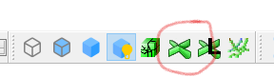
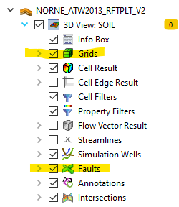
- Mark the checkbox in front of the intersection object in the folder “2D Intersection Views”
A flat 2D intersection view is displayed
- Right-click on a simulation well and select New Intersection. Activate the corresponding 2D intersection view
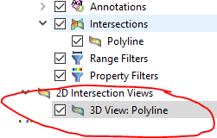
When many intersections are visible, they might obscure other interesting geometry in the model. Visibility of parts of the intersection geometry can be controlled from the Depth Filter group in Property Editor.
https://resinsight.org/3d-main-window/derivedresults/
https://resinsight.org/3d-main-window/gridpropertycalculator/

Polygons
Objective: Create and manage polygons and use polygons in filtering operations
- Import grid data using “Import Eclipse Case” from folder “model-data/norne”
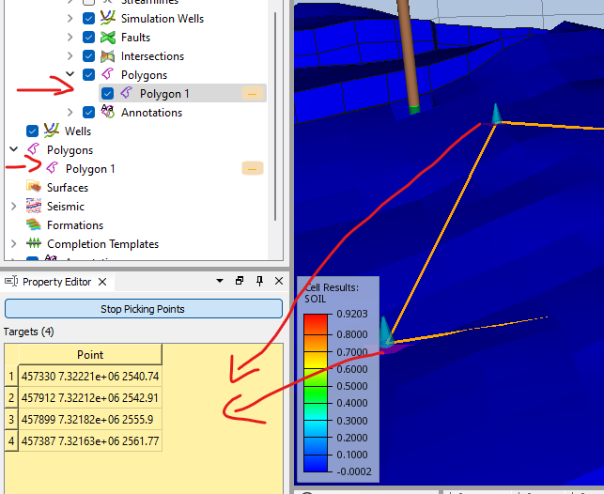
- From the right-click menu, select Polygon
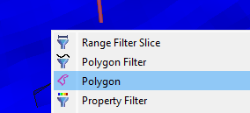
- Add point to the polygon by clicking on locations on the grid model. Coordinates will be displayed in the yellow input field in the Property Editor.
The polygon object is created in the Polygons Project folder, and the visibility of the polygon is controlled in the Polygons folder inside a view.
- Click Stop Picking Points to end the coordinate input mode.
- From the right-click menu of the Polygon, select Create Polygon Filter
- Manipulate the polygon by dragging in 3D, and investigate the filtered cells. Number of cells including statistics is displayed in the info box 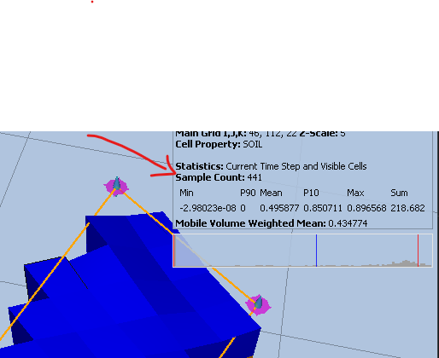
Polygons can be imported from text files.
https://resinsight.org/3d-main-window/polygons/

3D Grid Inspection Features – Fault Analysis
Objective: Able to show and manage cell edge results, formations, Allan diagrams
- Import grid data using “Import Eclipse Case” from folder “model-data/norne”
- Move to the last time step using the play toolbar button
- Turn off grid visualization to see faults
- Open folder Faults in Project Tree, right-click fault “GH”, and select “On – Others off”
- Activate Fault Result, and select this object
- In the Property Editor, select Type “Static”, and select result “TRANXYZ”. Now you can see transmissibility for all NNCs across the fault.
- Create a new view
- Import formations using “File->Import->Import Formation Names”, select file “norne/Norne_Fm.lyr”
- Turn off grid visualization to see faults
- In Project Tree, open folder Faults, right-click fault “GH”, and select “On – Others off”
- Activate Fault Result, and select this object
- In the Property Editor, select Type “Allan Diagrams” and select Result Property “Formation Allan” in Result
- Click on fault “GH”, and investigate the text output in the Result Info dialog
- Make sure there are at least two views in your project
- Right-click in the 3D scene (outside the grid model), and select “Compare To: -> Name of other view”
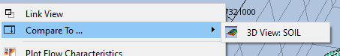
- Manipulate the slider to see data from the two results

- Create a new view
- Turn on Cell Edge Result. By default, the MULT values are mapped onto the edges of the cells. Click on cells defining close to a fault, and investigate the text output in the Result Info dialog

https://resinsight.org/3d-main-window/3dviews/
https://resinsight.org/3d-main-window/allandiagrams/

2D Contour Map

Objective: Create and configure a 2D contour map

- Open the main 3D plot window
- Import grid data using “Import Eclipse Case” from “model-data/norne”
- Import formation file (see previous tutorial) “Norne_subZones.lyr”
- Contour Map of SWAT
  - In the right click menu of the view, select “New Contour Map from 3d view”
  - Select SWAT as Cell Result
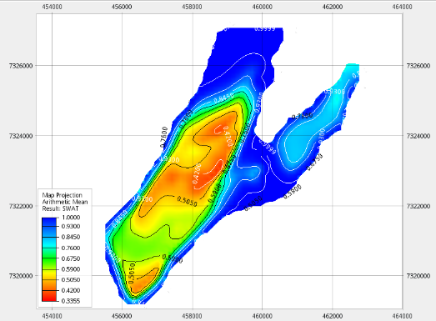
- Contour Map of Oil Column
  - From the right click menu of the Contour Map, select “Duplicate Contour Map”
  - Select object Map Projection
  - Select “Oil Column” from Result Aggregation
  - Compute oil column for a selection of formations
    - Create property filter based on “Formation Names”
    - In property filter, select formations “Garn 2” and “Garn 3
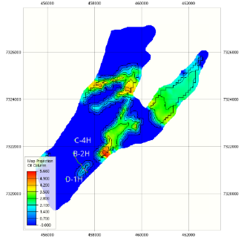
- In the “Windows” menu, select “Tile Windows” to see both plots next to each other

https://resinsight.org/3d-main-window/contourmaps/

Description of Flow Diagnostics
A Flow Diagnostics simulator developed by SINTEF based on MRST(MATLAB Reservoir Simulation Toolbox) is included in ResInsight. The flow diagnostics simulator as described by SINTEF:
“Flow diagnostics are simple and controlled numerical flow experiments run to probe a reservoir model, establish connections and basic volume estimates, and measure dynamic heterogeneity. Flow diagnostic quantities are quick to compute and can thus be used interactively to explore fluid communication in a geological model before or after more comprehensive multiphase flow simulations.”
The following table displays the short name used by ResInsight and the more detailed description taken from the SINTEF documentation.
ResInsight naming | Flow Diagnostics description (SINTEF)
Forward time of flight (injectors)  Reverse time of flight (producers) | Travel time for mass-less particles that passively follow the flow field from an injector into the reservoir and from a point in the reservoir to the nearest producer
Drainage/flooding regions | Delineate regions drained by given producers or swept (flooded) by given injectors
Injector Producer communication | Determine whether pairs of injectors and producers communicate or not and measure the relative strength of their connection
Tracer Cell Fraction | Determine how flux is allocated between different injectors and producers

Flow diagnostics use the flux field (flow rates) defined per grid cell (FLROIL/FLRGAS/FLRWAT). These cell properties can be exported from a reservoir simulator by adding the keyword FLORES to RPTRST in both SOLUTION section and SCHEDULE section. If no flow rate data is available, ResInsight will estimate the flow field. Users are encouraged to export flow rates from the simulator for best precision.

https://www.sintef.no/projectweb/mrst/modules/diagnostics/

Flow Diagnostics – 3D view

Objective: Get an overview of how Flow Diagnostics data is accessed and visualized
- Import gri data using “Import Eclipse Case” from folder “model-data/norne”
- Go to last time step
- Select Cell Result, and change type to “Flow Diagnostics”
- Change “Tracers” to “By Selection”
- Select single injector C-2H
  - Select Result property “Forward Time of Flight” (unit for time is days)
  - Create a property filter, show cells close to the injector by reducing the max value
- Create new view, set “Tracers” to “By Selection”
  - Select producer B-2H and “Reverse Time of Flight”
  - Create a property filter to see cells communicating with B-2H
  - In right click menu of B-2H, select “Well Plots->Plot Well Allocation”
  - In the plot area of the well allocation plot, open the right click menu and select “Show Contributing Wells”
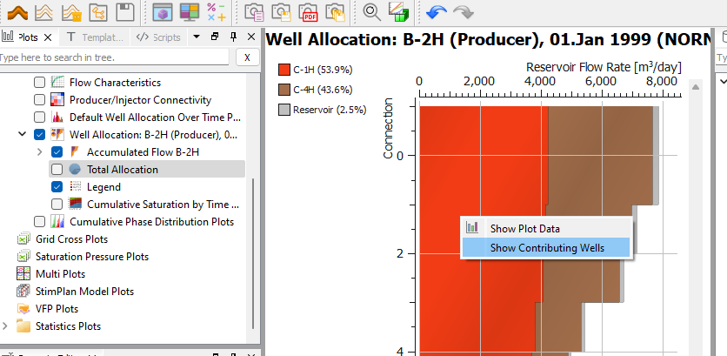
A custom 3D view is created with only data for wells related to the flow in B-2H.
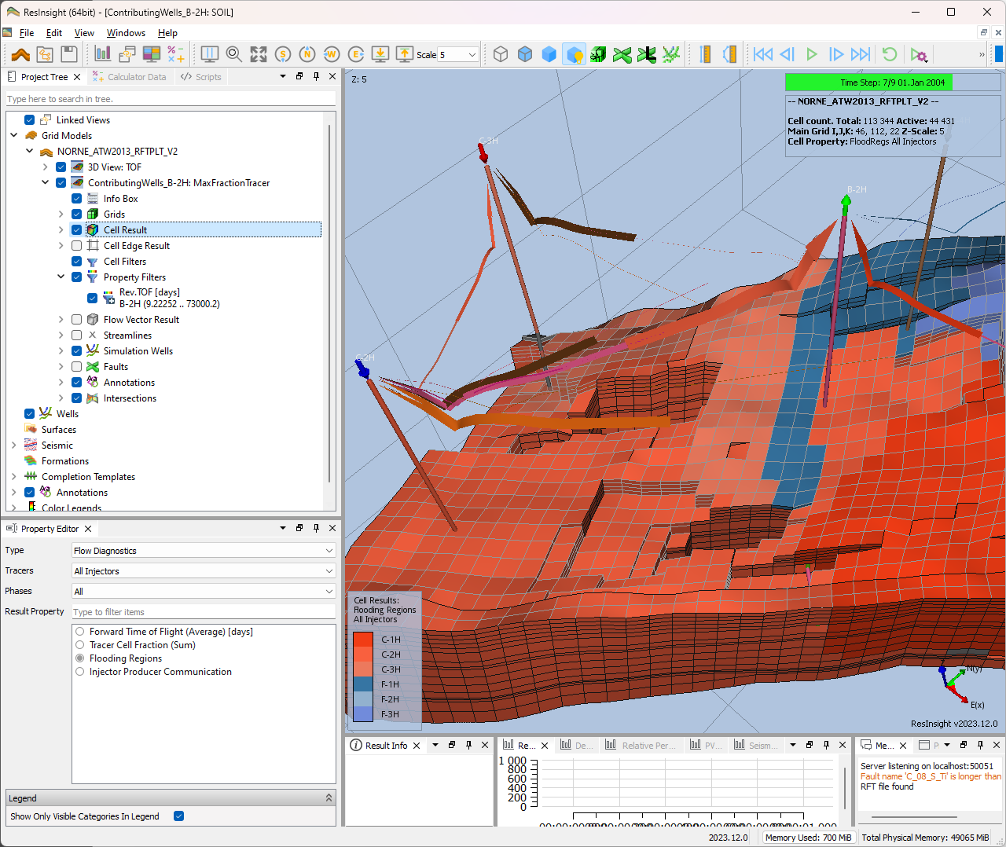
  - In the “3D Project Tree, select “Simulation wells”
In the Property Editor, enable “Communication Lines”
The bands visualize the flow direction/rate between wells

https://resinsight.org/plot-window/flow-diagnostics-plots/
https://resinsight.org/3d-main-window/cellresults/#flow-diagnostic-results

Flow Diagnostics – plots

Objective: Get an overview of how Flow Diagnostics data is accessed and visualized
- Import grid data using “Import Eclipse Case” from folder “model-data/norne”
- Go to last time step
- In the right click menu of B-2H, select “Well Plots->Plot Well Allocation”
  - Investigate the different settings in Property Editor -> Options, adjust Plot Type and Flow Type
- Enable the plot “Well Allocation over time” to see the distribution for all time steps
- In the Plot Project Tree, make sure the checkbox for Producer/Injector Connectivity is enabled
  - Disable Filter by 3D View to see all wells
  - Set the time step to 2002 and see how the communication changes
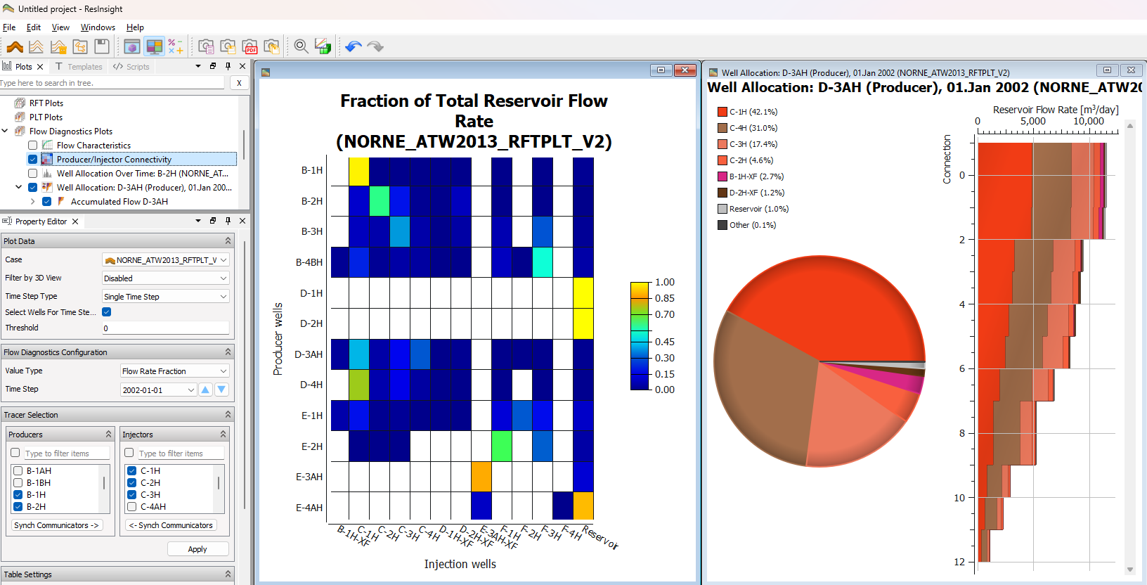
  - Compare the communication for well D-3AH to the well allocation plot for D-3AH at the same time step

Summary Plots

Objective: Able to configure summary plots with curves
- Open main application plot window and select “Import Summary Case” from “model-data/norne”
- Open the Data Sources panel
- Navigate to B-2H WBHP, and select New Summary Plot from the right-click menu
  - Use the toolbar to change data source for the curve
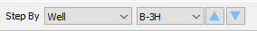
- Select wells C-1H, C-2H and C-3H. Right-click selected wells, and activate Append Plots for Wells
- Adjust the number of columns and rows for each page
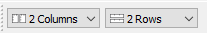

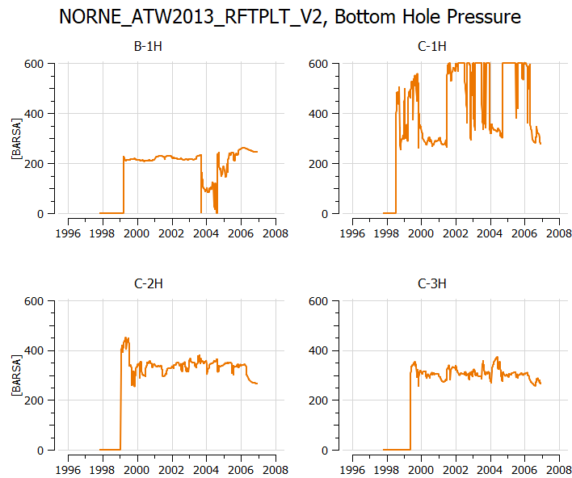
https://github.com/CeetronSolutions/resinsight-tutorials/blob/main/tutorials/summary-plot/summary-plot.md

Summary Cross Plot Curves

Objective: Create and work with summary cross plot curves
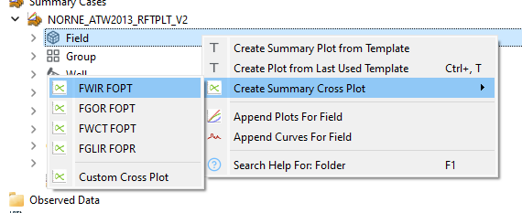
- Open main application plot window and select “Import Summary Case” from “model-data/norne”
- Open the Data Sources panel
- Navigate to Field, and select Create Summary Cross Plot->FWIR FOPT from the right-click menu
- Navigate to a well and select Create Summary Cross Plot from the right-click menu. The list of possible cross plots is adjusted to fit the selected well.
- The combination of vectors can be modified in Preferences->Plotting->Cross Plot Addresses
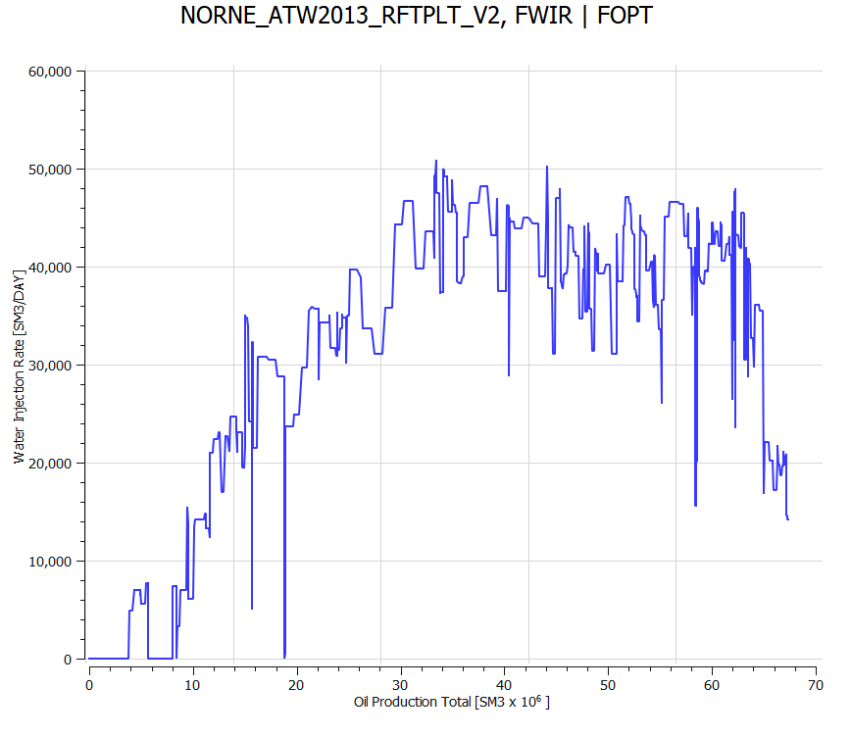
https://resinsight.org/plot-window/summarycrossplots/

Summary Plots – calculated curves

Objective: Able to configure summary plots with curves and calculate a derived curve
- Open main application plot window and select “Import Summary Case” from “model-data/norne”
- From the Data Sources panel, navigate to B-2H WGPR, and select “New Summary Plot” from the right-click menu
- Drag and drop B-2H WOPR into the same plot
- Open the curve calculator by clicking a button in the toolbar
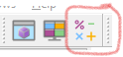
- Calculate gas-oil ratio for B-2H using the formula my_GOR := GasRate/OilRate
- Select and assign the corresponding summary vector for each variable
- Press “Calculate” then close the curve calculator
The new vector is now available at the bottom of the vector list for a well
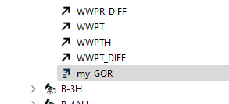
- Drag and drop my_GOR into the plot and investigate the calculated curve.

- A calculation will by default be available for all items of the same type. In the example above, my_GOR will be available for all wells and is calculated on demand.
- If a vector is calculated based on two different types of vectors, the calculation will appear in the same collection as the first variable
- The calculation FOPT+WOPT B-2H will appear in field vectors, and the WOPT B-2H+FOPT will appear in wells
- The user can control if a calculation should be distributed to other items in the same group

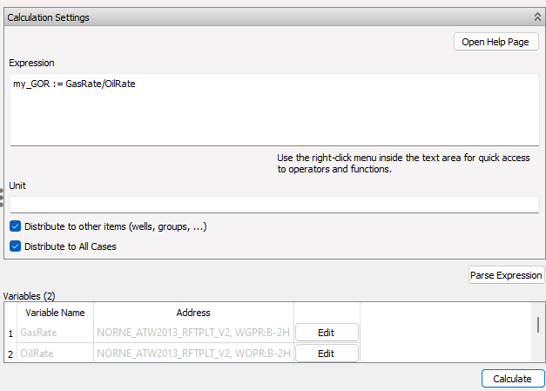

Operations on calculations are available in the button group below calculations.
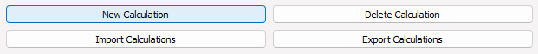

https://resinsight.org/calculated-data/curvecalculator/

Summary Data in Table

Objective: Display summary data in a table to quickly get an overview of reservoir drainage stategy
- Import summary data from "norne/NORNE_ATW2013_RFTPLT_V2.SMSPEC”
- From the right-click menu of Summary Tables, select “New Summary Table”
- For WBHP table, set the threshold value to 150. Wells with value below this threshold are hidden
- Change the Colors to “Blue to Magenta”
- Create a summary table displaying WOPR, WWCT, and WGOR
- To see all tables at the same time, select Windows->Tile Windows
This operation is also available as a tool button on the toolbar
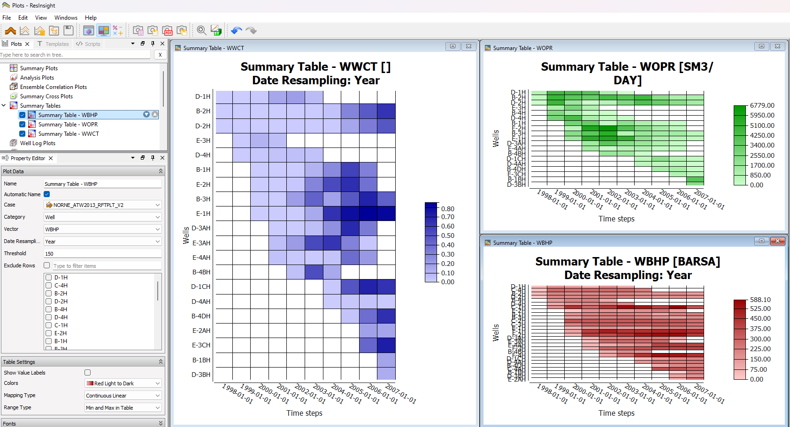

Summary Decline Curves

Objective: Show estimates of future production based on curve analysis
- Import summary data from "norne/NORNE_ATW2013_RFTPLT_V2.SMSPEC”
- Create a plot for WOPR:B-2H
- From the right-click menu of the curve, select “Create Decline Curves”
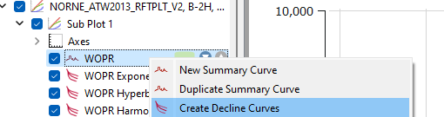
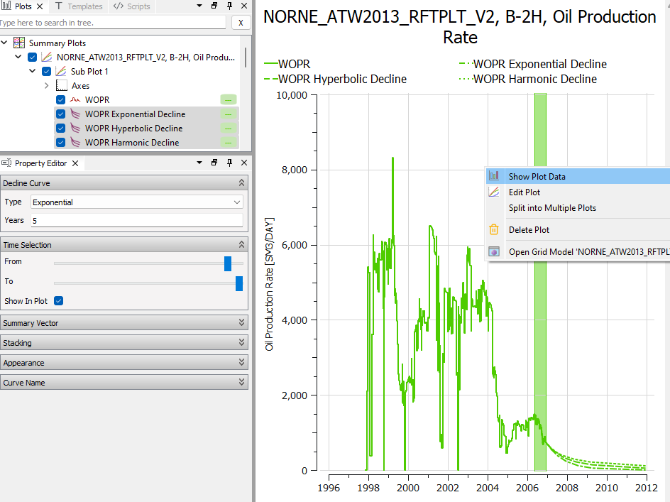
- Select all thre curves and modify the curve values to be estimated
- Inside the plot, right-click and select “Show Plot Data” to see the estimated production

Summary Regression Curves

Objective: Enable and configure regression analysis curves for summary data
- Import summary data from "norne/NORNE_ATW2013_RFTPLT_V2.SMSPEC”
- Create a summary plot of FGOR
- Right-click the line object, and select “Create Regression Analysis Curve”
- Set the Forward Forecast to 5 years
- In the Time Selection group, modify the from date to see how the regression curve changes based on input data
- Select polynomial regression
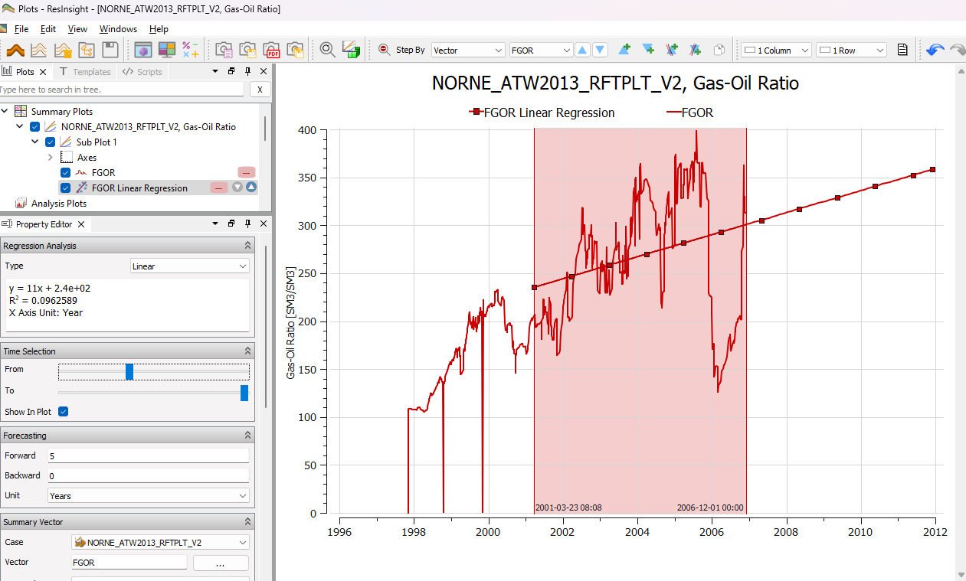

Observed Data Plots

Objective: Import and visualize curves from both simulated and observed data
- Open a text editor and look at the content of “norne_well_data” to see what data we are supposed to import
- Open plot window and select “Import Summary Case” from “norne”
- Import observed data files in folder “model-data/norne_well_data/BHP_B1-H.csv” from menu “Import->Import Observed Data”
- Enable the checkbox “Use Custom Date Time Format” and type the string yyyy-MM in “Custom Date Time Format”.
- Create a new plot with observed and simulated data for WBHP for well B-1H
  - The curves use separate axis by default. Workaround to make sure both curves use same axis:
Select the first curve. In Property Editor, select the first item in the Axis list. Repeat for second curve.
- Import all observed data files in folder “model-data/norne_well_data/BHP_B1-H_error.csv” from menu “Import->Import Observed Data”
- Enable the checkbox “Use Custom Date Time Formant” and type the string yyyy-MM in “Custom Date Time Format”.
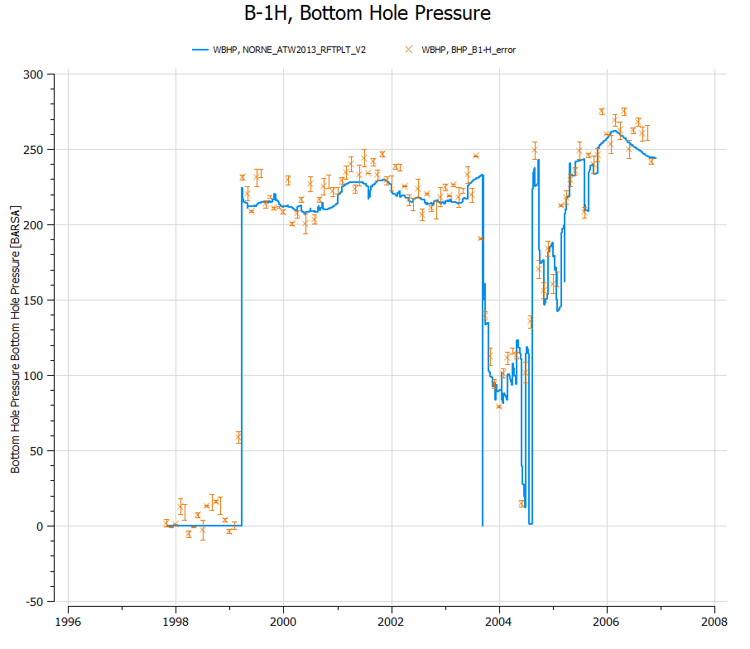
- Create a new plot with observed and simulated data for WBHP for well B-1H, make sure you show curve data including error data
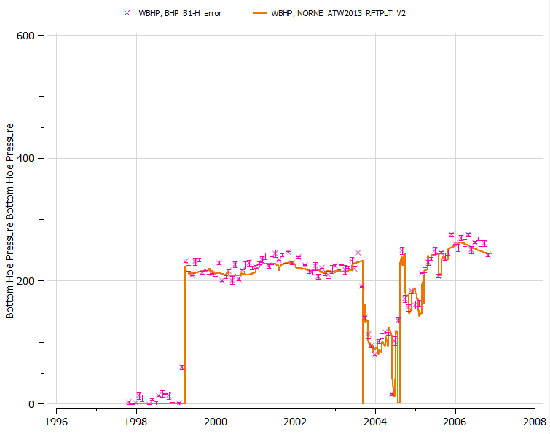

Ensemble Plots (1 of 2)

Objective: Import of ensemble data and plot ensemble curves
- Import base ensemble
  - Import data using “Import Ensemble” toolbar button and use the browse dialog by pushing the … button. The following path pattern should be used:
“model-data/reek_ensemble/3_r001_reek_50/realization-0/iter-0/*"
  - Click Find and OK
- Create a new plot of well oil production total for well OP_5
- Use the data source stepping toolbar to change plot to other wells
- In the property editor for the generated ensemble curve set, change “Coloring Mode” to “By Ensemble Parameter”
- Test with different settings for Statistics curves in the property editor and see the effect in the plot
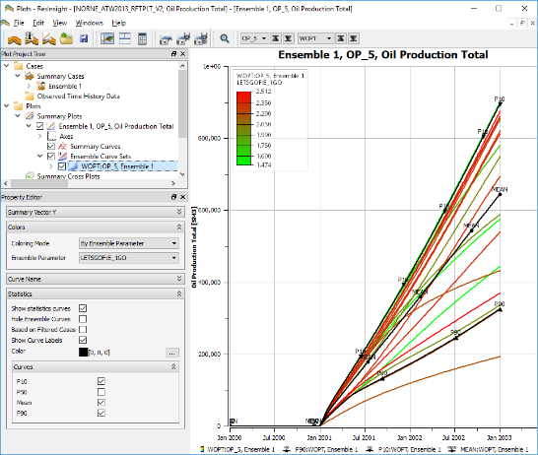

Ensemble Plots (2 of 2)

Objective: Compute and show difference between two ensembles
- Import base ensemble (can be skipped if data was loaded in previous tutorial)
  - Import data using “Import Ensemble” and set the root folder to
“model-data/reek_ensemble/3_r001_reek_50/realization-0/base_pred/eclipse/*"
  - Click Find and OK
- Import prediction ensemble
  - Import data using “Import Ensemble” and set the root folder to
“reek_ensemble/3_r001_reek_50/realization-0/pred_op6/eclipse/*"
  - Click Find and OK
- Create delta ensemble
  - In right click menu of Data Sources, Summary Cases, select “New Delta Ensemble”
  - Select “pred_op6” as Ensemble 1
  - Select “base_pred” as Ensemble 2
  - Create a new plot, select ensemble “Delta(pred_op6, base_pred)” and expand Field to plot FOPT
  - In the “Statistics” group, check item “Hide Ensemble curves”
  - In the right click menu in the plot, select “Show Plot Data” to see curve values including P10 and P90
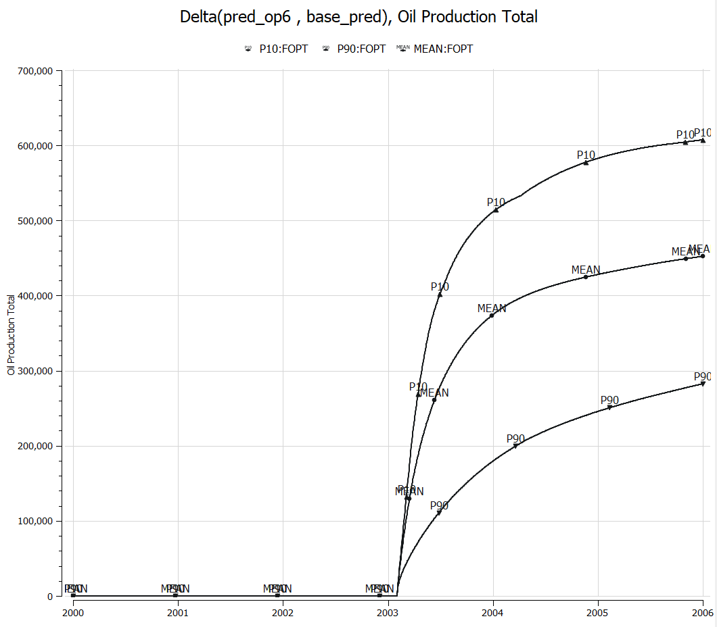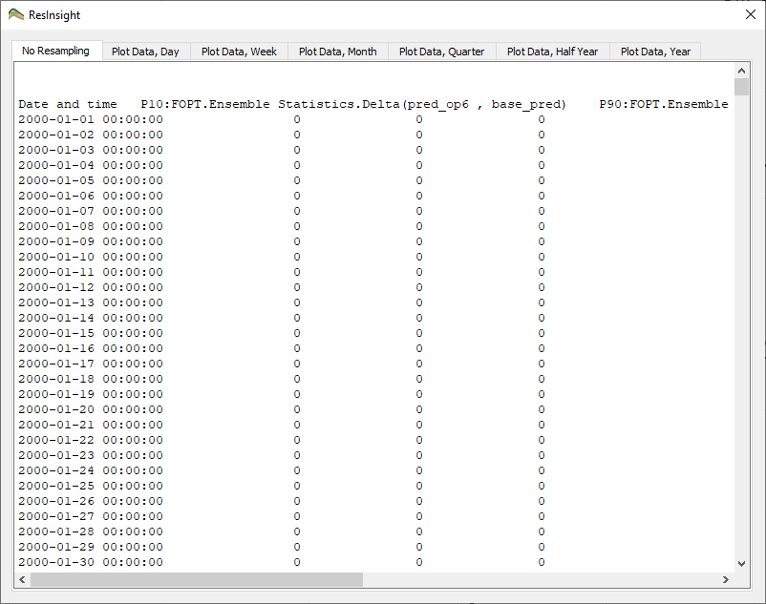

Plot Templates

Objective: Store plot setup with customized curve appearance for reuse on different data
- Import multiple summary cases as standalone cases
  - Import data using “File->Import->Import Summary Cases Recursively” and set Path pattern to
“model-data/reek_ensemble/3_r001_reek_50/realization-0/base_pred/eclipse/*"
  - Click Find and OK
- Create a plot, and from the right-click menu select “Open Summary Plot Editor”
- Select two realizations
- Select well OP_1 and select summary vector WOPR (Well oil production rate)
- Change the curve appearance of the two curves the way you like best
- In the Project Tree, activate the right-click menu of the plot and select “Save As Plot Template”. Create a folder in your user area and store this plot template in this folder using the template name “wopr_two_cases”
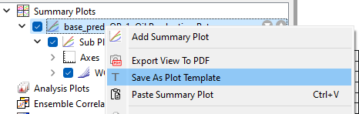

- Apply an existing template
  - In Data Sources, select two other summary cases than the ones used to produce template
  - From the right-click menu, invoke “Create Plot from Template” and select the plot template you created (“wopr_two_cases”)
  - Note that the visual settings you stored in the template are applied to the generated plot
Hint: An existing template can be applied to a selection of summary ensemble cases

https://resinsight.org/plot-window/summaryplottemplate/

RFT Plots
- Import grid data using “Import Eclipse Case” from folder “model-data/norne”
- Untick Simulation Wells to hide simulation wells to easier see imported well paths
- From right click menu of Wells, select “Import Well Paths from File” and select well path “C-1H.dev” in folder “norne_rft”
- From right click menu of well path C-1H, select “Import Well Logs from File”, select “C-1H_RFT_dummy.las” in folder “norne_rft”
- From right click menu of well path C-1H, select “Well Plots->New RFT plot”
Optional: Import formations (right-click Formations in Project Tree and select Import Formations) to see formation names in the plot.
https://resinsight.org/plot-window/rftplot/
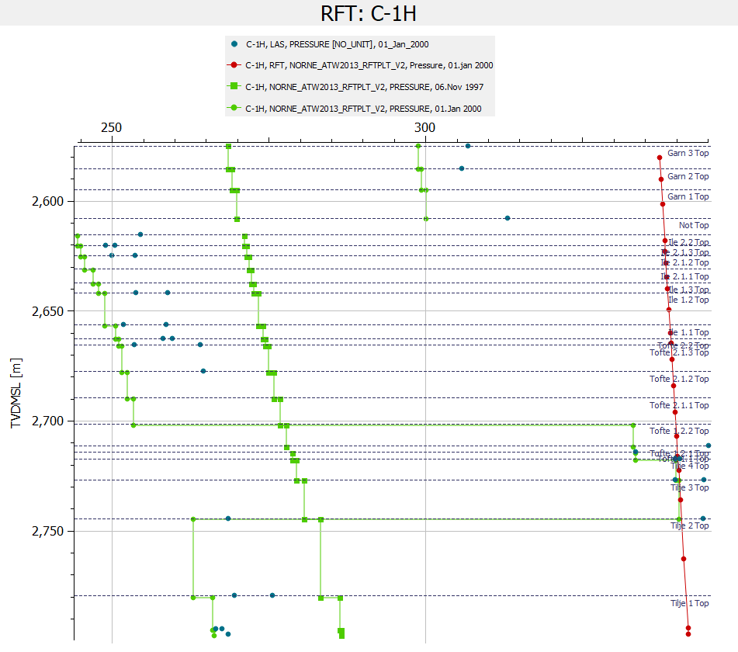

Ensemble RFT Plots
- Import data using “Import Ensemble” from folder “model-data/1_r001_reek_20_rft”
- Import observations using “Import Observed FMU Data” from folder “reek_rft”
- Select Imported FMU RFT Data 1, and look at the information in the property editor
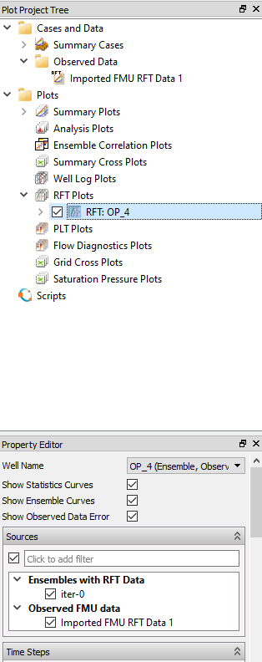
- From the right-click menu of RFT Plots, select “New RFT Plot”
- Change the Well to OP_4
- A well RFT plot can be used as template for other wells. On a RFT plot,
select “Create Multiple RFT Plots” from the menu, and select wells to create plots for.
https://resinsight.org/plot-window/ensemblerftplot/
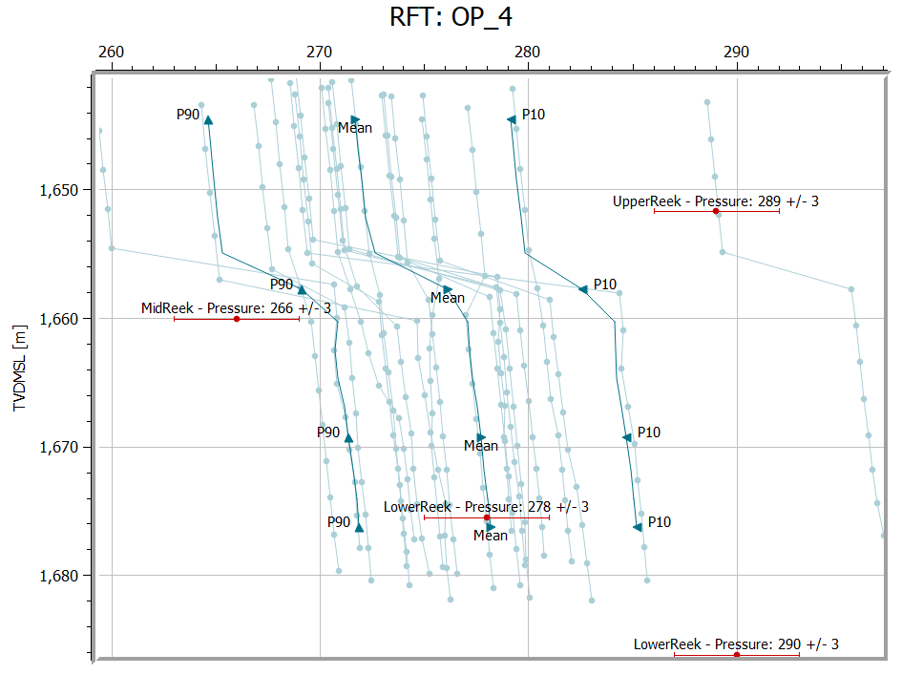

Correlation Analysis

Objective: Create and configure a Correlation Plot
- Basic use
  - Import a Summary Ensemble, and use import path "model-data/reek_ensemble/3_r001_reek_50/realization-*/iter-1”
  - From the right-click of a curve, select “Create Correlation Plot from Curve Point ->New Report Plot”
  - Click on individual cells in the Correlation Matrix, and see how the cross plot is updated
Currently selected cell is indicated by a border in green
  - Show Pearson calculation
  - Change data source to WOPT for all wells OP_1 to OP_5
  - Click on individual cells in the Correlation Matrix, and see how the cross plot is updated
  - Right-click in plot, and select Show Plot Data
- Filtering (available from 2025.09)
  - Expand the Filter group, and activate “Use Parameter Filter”
  - Adjust the sliders
  - A subset of realizations is inside the filter seen in the cross plot between summary response and input parameter. A new ensemble based on these filtered realizations can be created from the right-click menu “Create Ensemble from Filtered Cases”

https://resinsight.org/plot-window/correlationplots/

Definition of how the Pearson correlation coefficient is computed
https://en.wikipedia.org/wiki/Pearson_correlation_coefficient#For_a_sample
X is input parameter value, Y is simulated value
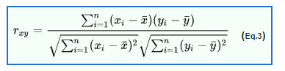

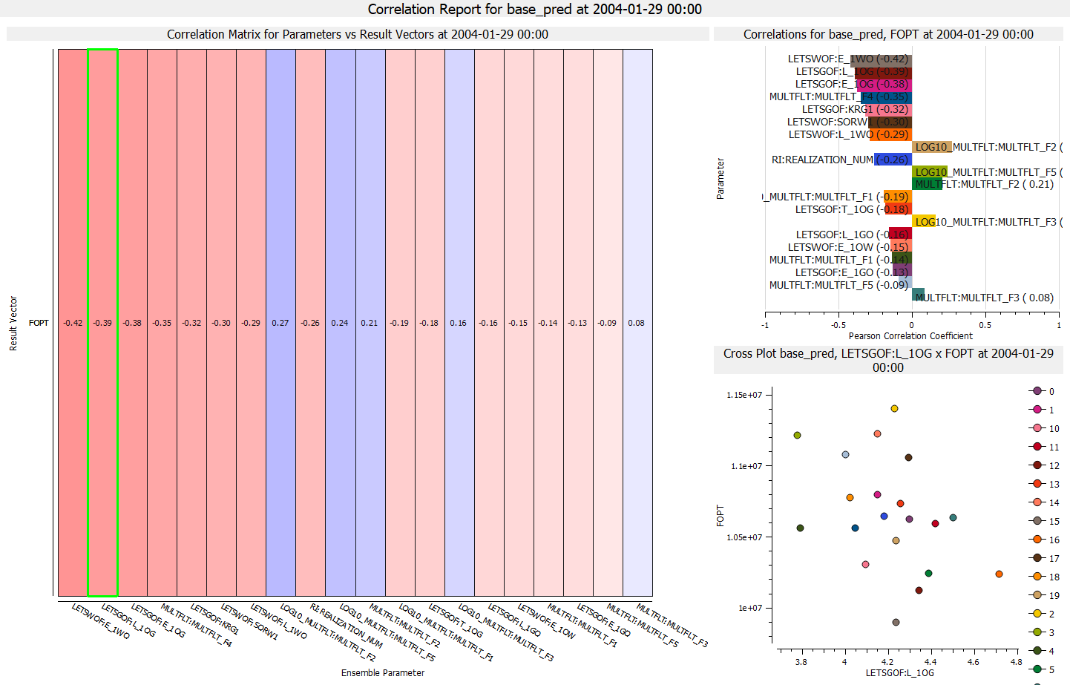

Analysis Plot

Objective: Create and configure an Analysis Plot
- Import a Summary Ensemble, and use import path "model-data/reek_ensemble/3_r001_reek_50/realization-0/base_pred”
- Import a Summary Ensemble, and use import path "model-data/reek_ensemble/3_r001_reek_50/realization-0/pred_op6”
- Select New Delta Ensemble from right-click on Summary Cases
Create a Delta Ensemble as the difference between the two cases (pred_op6 - base_pred)
- Toggle off checkbox “Discard Missing or Incomplete Realizations” (see screenshot)
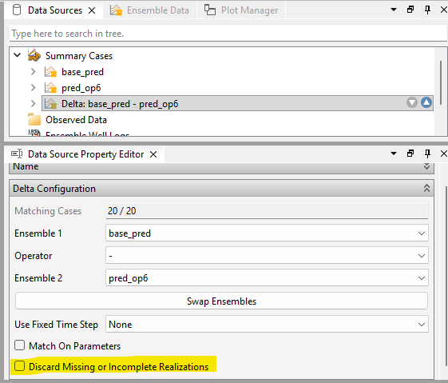
- Select new Analysis Plot
- In Property Editor, in group Selected Vectors, click on the button with three dots “…”
  - Set source Delta ensemble
  - Select all OP_* wells
  - Select Summary Vector WOPT
- Bar Orientation: Horizontal
- Select major grouping Summary Item
- Select sort by abs(Value)
- Optionally
  - Show legend
  - Bar labels
- Right-click in plot, and select Show Plot Data
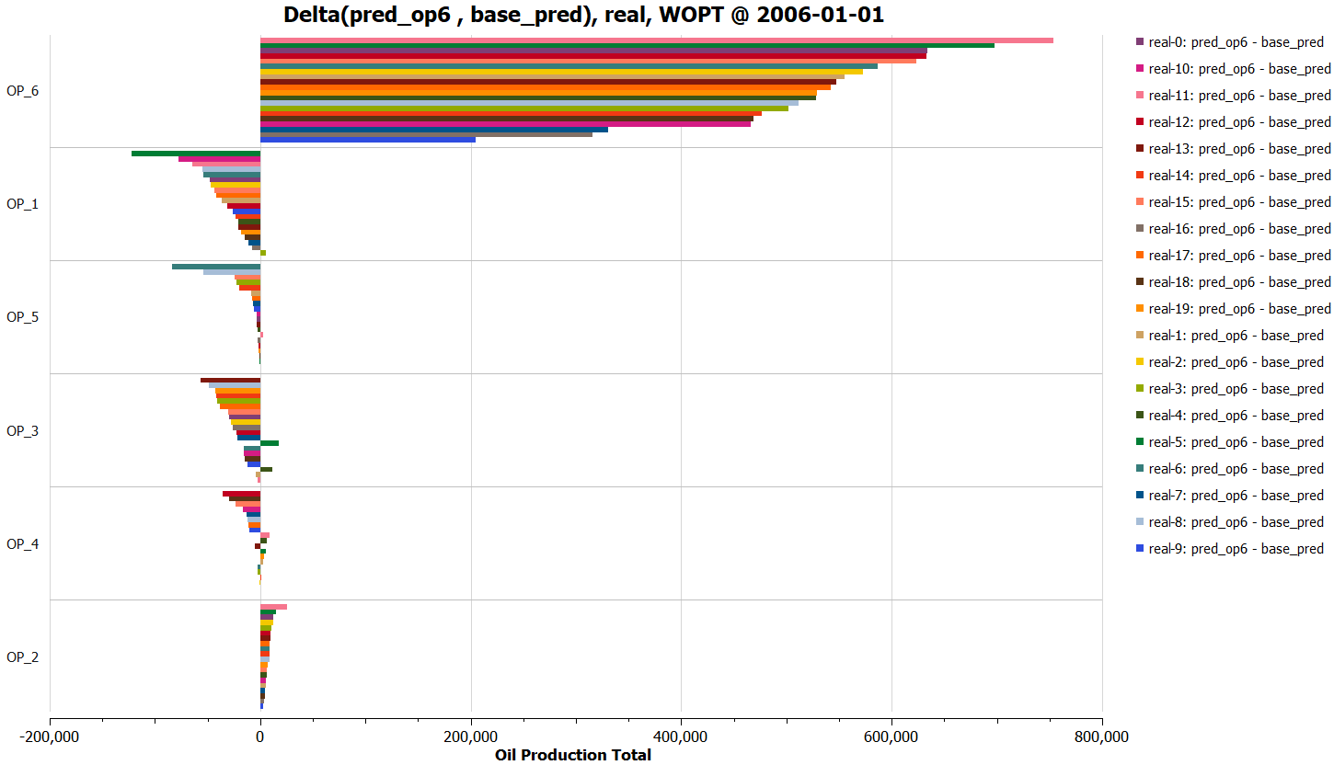
https://resinsight.org/plot-window/analysisplots/

Well Path Import from OSDU

Objective: Import well path geometry from OSDU cloud service
- Make sure you have the sufficient access to the OSDU cloud service
- Import grid data using “Import Eclipse Case” from folder “model-data/norne”
- In the right-click menu of top-level object Wells, select “Import Well Paths from OSDU [BETA]”
This will check for authentication, and a browser login is displayed if required.
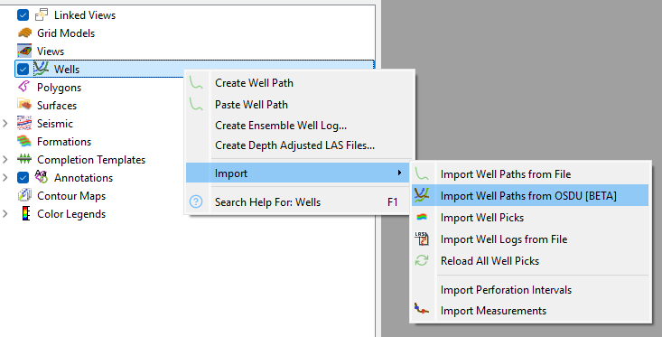
- When a successful authentication is completed, the OSDU login dialog is displayed. The Next button is active if a successful authentication to OSDU is completed.
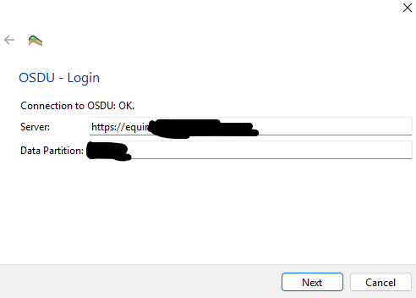
- Use the text filter to find the field, and select the field
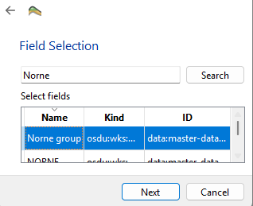
- Select the wells to import from the wells list, and import the well path geometry
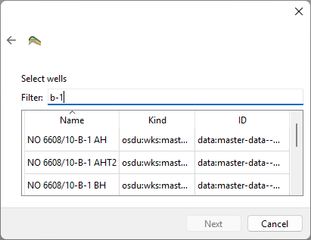
https://resinsight.org/import/cloudservices/index.html#well-paths-from-osdu

