ResInsight Advanced User Course
Q2 2023

Agenda
- Welcome, course layout and introductory remarks
- Hands-on Exercises
- Summary and feedback

Table of Contents
Table of Contents 2
Support and Resources 4
Preparations 5
a) Grid Cross Plot with formations 7
b) Grid Cross Plot with filtering 8
c) Sector model export 9
d) Ensemble Grid Case Statistics 10
e) Well Log Extraction 11
f) Well Log Data 12
g) Well Measurements in 3D 13
h) Well Measurements in plots 14
i) Well Picks 16
j) Well Path Creation 17
k) Well Path Completions 18
l) Export LGR for Completions 19
m) Valve Modeling and Export 20
n) Project file manipulations 21
o) Seismic Data 22
p) Seismic Data along a well path 23
q) Correlation analysis (taken from ResInsight Intro Course) 24
r) Analysis Plot (taken from ResInsight Intro Course) 26
s) Python scripting 27
t) Improvements and new features 2023.10 28
u) Improvements and new features 2023.06 29
v) Improvements and new features 2023.03 30
w) Improvements and new features 2023.01 31

Support and Resources
Main help page
https://resinsight.org/
Yammer
Internal Equinor Yammer channel “ResInsight users”
https://web.yammer.com/main/threads/eyJfdHlwZSI6IlRocmVhZCIsImlkIjoiNzM3MzA5MDI1MjgwMDAwIn0
Tutorials – introduction
We have started building a tutorial site for ResInsight. We will use some of these tutorials in addition to some located only on file system in Equinor.
https://github.com/CeetronSolutions/resinsight-tutorials
https://www.youtube.com/channel/UCEJoH_ti1YZXz4hPMeAKMgw
Overview of the interface for 3D visualization
https://github.com/CeetronSolutions/resinsight-tutorials/blob/main/tutorials/graphical-user-interface/graphical-user-interface.md

Preparations
Test models used in tutorials are available from https://github.com/CeetronSolutions/resinsight-tutorials
The data to be used in tutorials is in the folder model-data.
Either clone the GitHub repository, or select “Download ZIP” from the Code menu
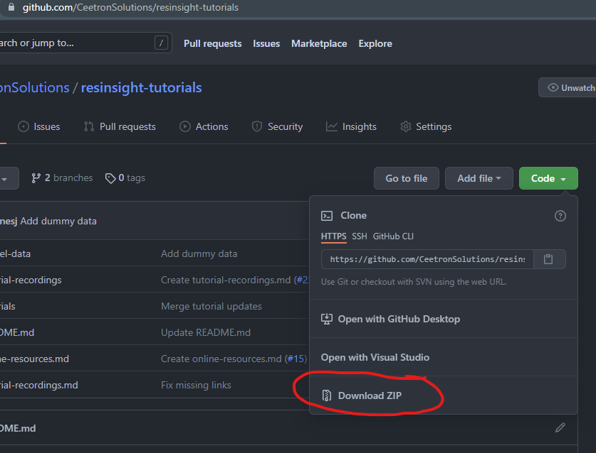

Conventions
In this document, bold text indicates an object in the property tree. Menu item text is “written in quotes”.
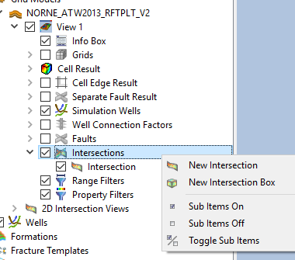
Example
Select “New Intersection” from Intersections.

Tips and tricks
Please close the existing project (“File->Close Project”) before starting a new tutorial. This will help you to avoid confusion caused by data from previous tutorials.

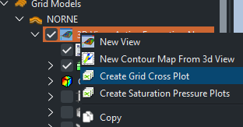
Grid Cross Plot with formations

Objective: Create grid cross plot with automated categories based on formations
- Import grid data using “Import Eclipse Case” from folder “model-data/norne”
- Import formations from folder “model-data/norne/Norne_subZones.lyr”
- In Cell Result, select Static->PORO
- In the Project Tree, open the right-click menu of the view, Select “Create Grid Cross Plot”. The default X-Axis Property is defined by the Cell Result in the 3D view, and default Y-Axis Property is Depth with the Y-axis inverted with increasing values at the bottom of the plot
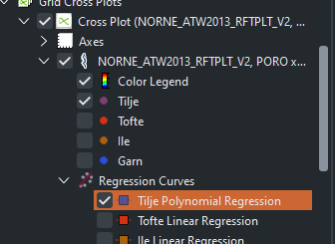
- Select PERMX as the Y-Axis Property
- Click on a sample in the plot to highlight all samples for a group
- Regression curves
  - Disable all other cross plot curves except one from Tilje formation
  - In the Property Editor, enable the regression curve for this formation
  - Adjust the regression curve properties in the Property Editor
https://resinsight.org/plot-window/gridcrossplots/
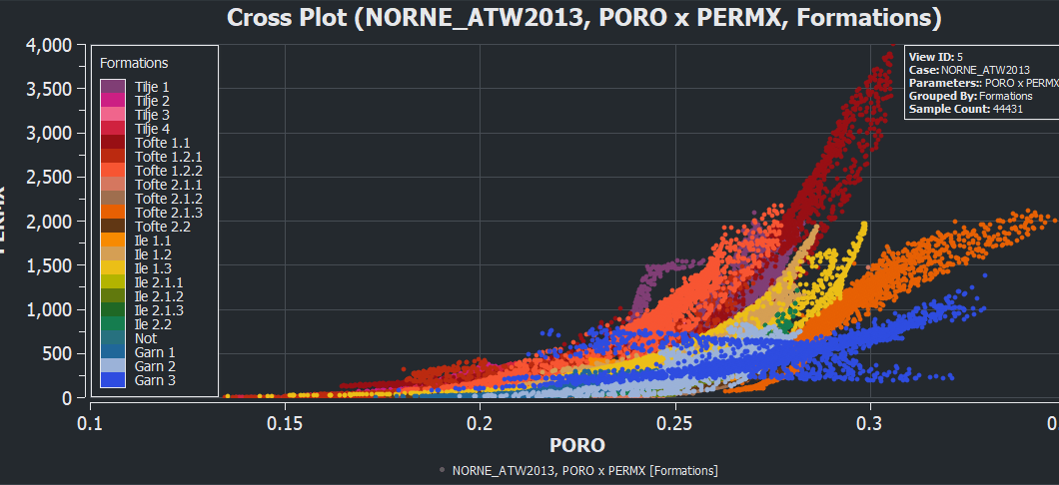

Grid Cross Plot with filtering

Objective: Create grid cross plot with filtering
- Import grid data using “Import Eclipse Case” from folder “model-data/norne”
- Import formations from folder “model-data/norne/Norne_subZones.lyr”
- In the 3D view, set Cell Result to Static -> FIPNUM
- In the Project Tree, open the right-click menu of the view
- Select “Create Grid Cross Plot”
- Set Static PORO as x-axis
- Set Static SWATINIT as y-axis
- Set Group Data by “Result Property”, select Static -> PERMX
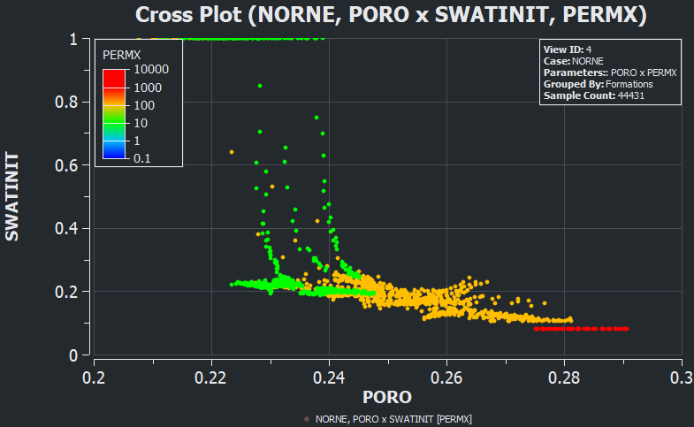
- Select color legend in Project three
  - See how manipulation of “Number of intervals” affects the plot
- In the grid cross plot, select Filter by 3D view
- Go back to the 3D view, and create a property filter based on FIPNUM
  - Select FIPNUM value 6 the category selection (multiple selection is supported)
  - Hide faults to see the filtered grid cells
- Make sure both the 3D view and the plot window are open at the same time. Modify the selected FIPNUM values in the property filter and see how the plot is updated as visible cells in the 3D view changes.
- Right-click the Cross Plot in the Plots tree view and select “Show Plot Data” to see the plot values.

Sector model export

Objective: Export a subset of the grid based on visible cells
- Import grid data using “Import Eclipse Case” from folder “model-data/norne”
- Move to the last time step as there is no flow at the first time step
- In the 3D view, set Cell Result to Flow Diagnostics
- Select “By Selection”
- Select injector C-2H and producer B-2H
- Select Injector Producer Communication
- Create a property filter on communication between C-2H and B-2H
- Hide the faults to see the cells
- In the right-click menu in the 3D view, select “Export Eclipse Sector Model”
- Select Export Folder and additional settings, and click Export button
- Import the exported data
  - Select “Import Eclipse Input Case”
  - Select all files exported in the previous step (use multiselect in file dialog)
- Compare the imported data with the original binary case
  - Select PERMX in both views
  - In the right-click menu in the 3D view, activate Compare to
https://resinsight.org/export/sectormodel/
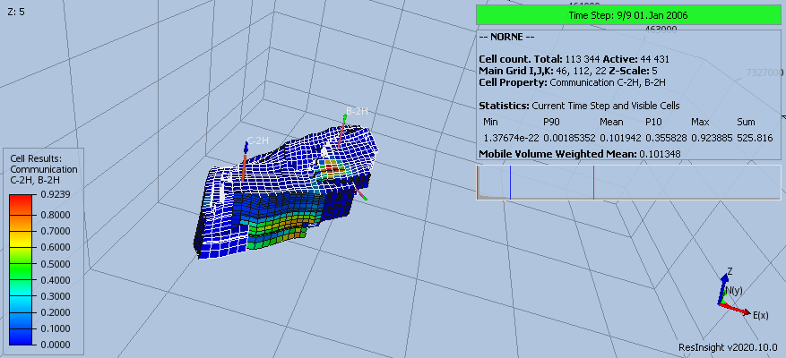

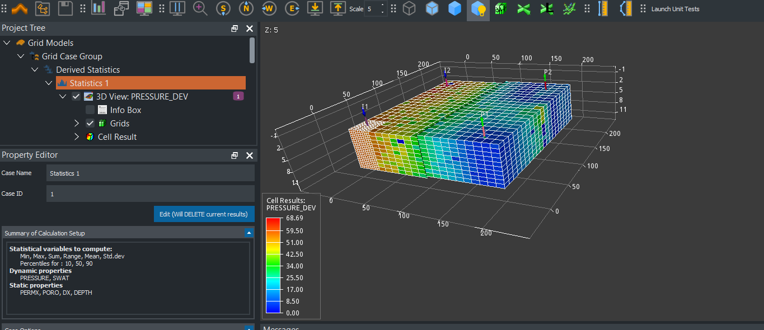
Ensemble Grid Case Statistics

Objective: Import an ensemble of grid cases and compute statistics cell by cell
- Use data located in folder
“model-data/grid_ensemble”
- Import data using “Create Grid Case Group”
Use the Find button to search the folder for files matching the search filter.
The imported cases can be investigated in Source Cases folder in the Project Tree
- In the property panel, click the button “Compute” to compute default statistics
- Select dynamic property PRESSURE_DEV, move to last time step
PRESSURE_DEV represents the standard deviation of pressure based on source cases
- Select Statistics 1, and in the Property Editor in group Case Options, select one of the source cases to use for well data. This will display simulation wells in the view.
- Create a new view and create a property filter
  - Select PRESSURE_DEV (pressure standard deviation) larger than 40
  - If you will set the cell result to match the property filter, open the right-click menu of a property filter and select Apply As Cell Result
- [Optional] Select Statistics 1. In the Property Editor, click the button “Edit(Will DELETE current result)”
Add PORV to the list of static variables. The user interface for selection of properties supports multiselect of items by pressing and holding CTRL key when clicking items in the list.
- [Optional] Handling of inactive cells (Use Zero as Inactive Cell Value)
  - When computing statistics on PRESSURE, it is usually required to leave this option off (total cell count is active)
  - When computing statistics on PORO/PERM, it is usually required to enable this option (total cell count is active + inactive)
https://resinsight.org/3d-main-window/casegroupsandstatistics/
The statistics case can be used as data source for well log extraction of grid cell data as described in the next section.

Well Log Extraction

Objective: Plot well log extraction curve in 2D plot window

- In 3D main window
  - Import grid case from “norne” and import formations from “norne/Norne_Fm.lyr”
  - Import well path "model-data/norne-well-logdata/dummy-B-3H.dev"
  - Select cell result Dynamic -> SOIL
  - Select well path DUMMY-B-3H, and from the right click menu select “Well Plots->New Well Log Extraction Curve”
  - Activate the plot main window
- In plot main window
  - In the project tree, activate right-click menu of the plot and select “New Track”
  - Select the new track in the Project tree
  - In the Regions/Annotations group, set Region Annotation to Formations
  - Make sure Formation Case is set to Norne and Well Path is set to DUMMY-B-3H
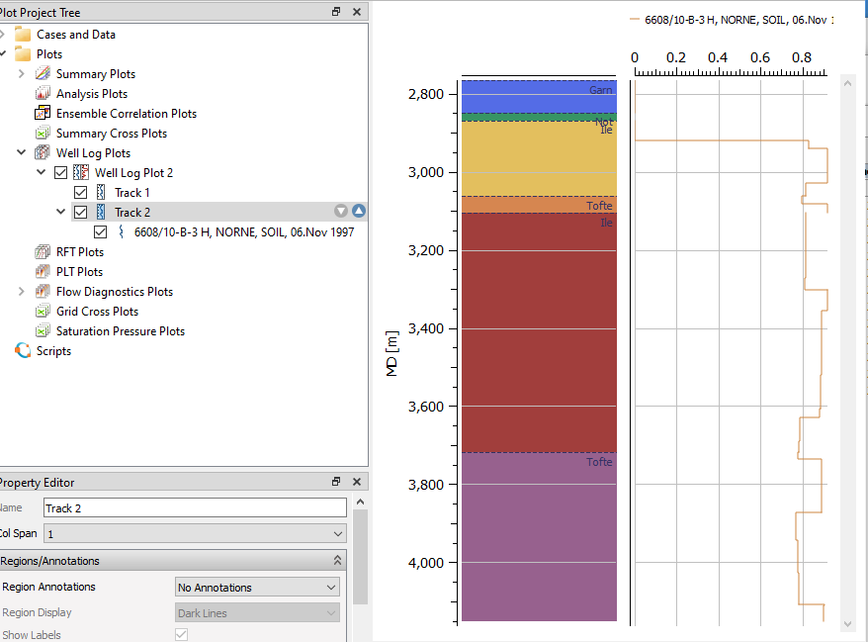
https://resinsight.org/plot-window/welllogsandplots/

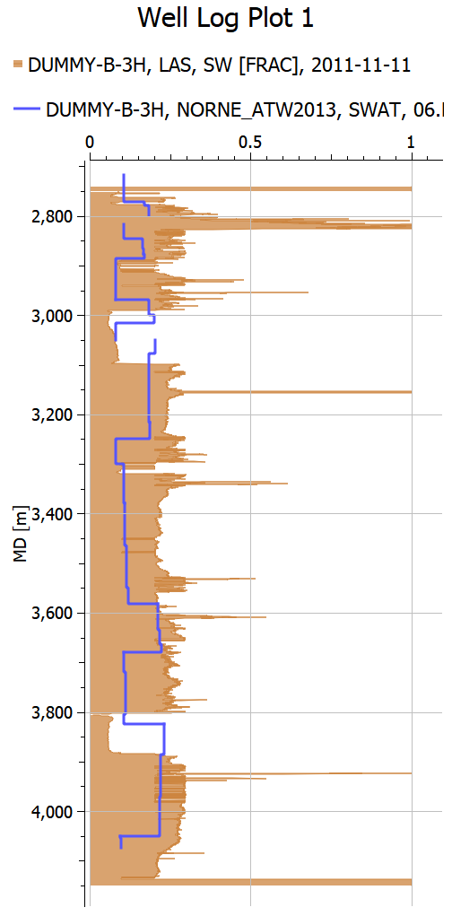
Well Log Data

Objective: Plot well log extraction curve in 2D plot window
- Import grid case from “norne”
- Import well path "model-data/norne-well-logdata/dummy-B-3H.dev"
- From the right-click menu of well DUMMY-B-3H, select “Import Well Logs from File” and select "model-data/norne-well-logdata/dummy-B-3_H.LAS "
- From the right-click menu of SW, select “Add to New Plot”
- From the right-click menu of the track, select “New Well Log Extraction Curve”
- Select Dynamic -> SWAT
- Select the SW curve object and enable Area fill. Drag and drop curves to make sure the LAS curve is located at the top of the list and will be drawn behind other curves. You can also toggle the curve visibility to control the drawing order.
- Compare data from the two data sources. They do not have a good match, as the data set contains dummy data

https://resinsight.org/plot-window/welllogsandplots/

Well Measurements in 3D

Objective: Import well measurements, display in 3D view
- Import norne
- Import formations for norne
- Set Cell Result to Static -> PORO
- Import well paths C-3H and E-3H from folder “model-data/norne-well-measurements”. Use multi-select in the file import dialog to import both in one operation.
- From the right-click menu of Wells, select “Import Measurements”
- Show measurements in the view
  - Create a new view
  - Select Wells in the Project Tree, and disable clipping of wells to be able to see the well path all the way up to the sea surface
  - Uncheck Grid Cells and Faults. Optionally uncheck Simulation Wells to make the view cleaner.
  - Make sure the checkbox in front of Well Measurements is enabled (Located above Simulation Wells)
  - Manipulate the filtering options for each measurement type in the property editor
- Continue to next tutorial without closing the project
https://resinsight.org/wells-and-completions/wellmeasurements/
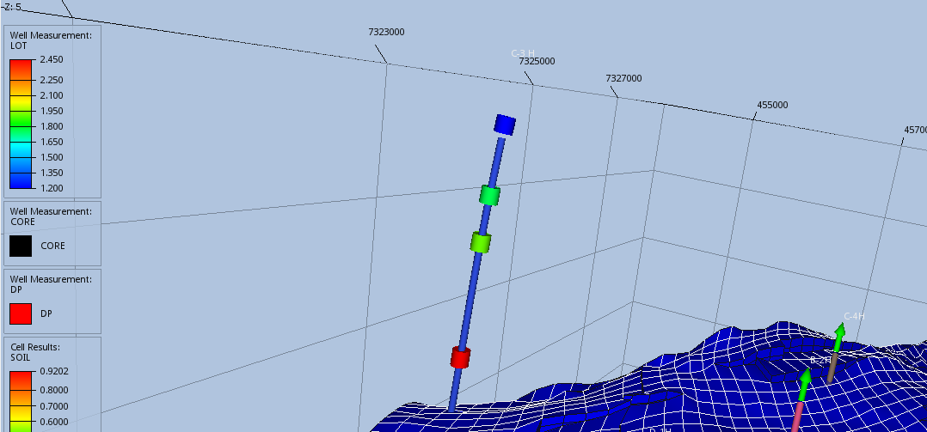

Well Measurements in plots

Objective: Import well measurements, display in plots
- Import data (see import in previous tutorial or continue with same project)
- Well log extraction curve for well C-3H
  - Create a Well Log Extraction curve for C-3H, open the plot window
  - Show data for Static -> PORO
  - In Curve -> Appearance, set Area Fill Style to Solid Fill
- Create measurement track
  - Create a new track
  - From the right-click menu of the track, select “New Well Measurement Curve”
  - Select well C-3H and XLOT
  - Use the zoom all button to make sure all measurements are visible, or toggle visibility of curve to make the well measurements visible
  - Make the measurement symbols larger
  - The measurements are outside the grid, and the depth axis min/max values can be defined in the Depth Axis section of the plot or by zoom using CTRL+mouse wheel
- Create formation track
    - Create a new track
    - From the property editor of the track, in group Region/Annotation, set the Region Annotation to Formations
    - Select case and well path, the formations appear as colors in the track
    - Change the color legend to the same as the formations, usually “Category”
- Use the up/down arrow to the right of a track to modify the ordering of tracks
- Add formations as lines to the PORO track
- Change the track width distribution
  - Set col span to 2 for XLOT
  - Set col span to 5 for PORO track
- See next page for an example plot

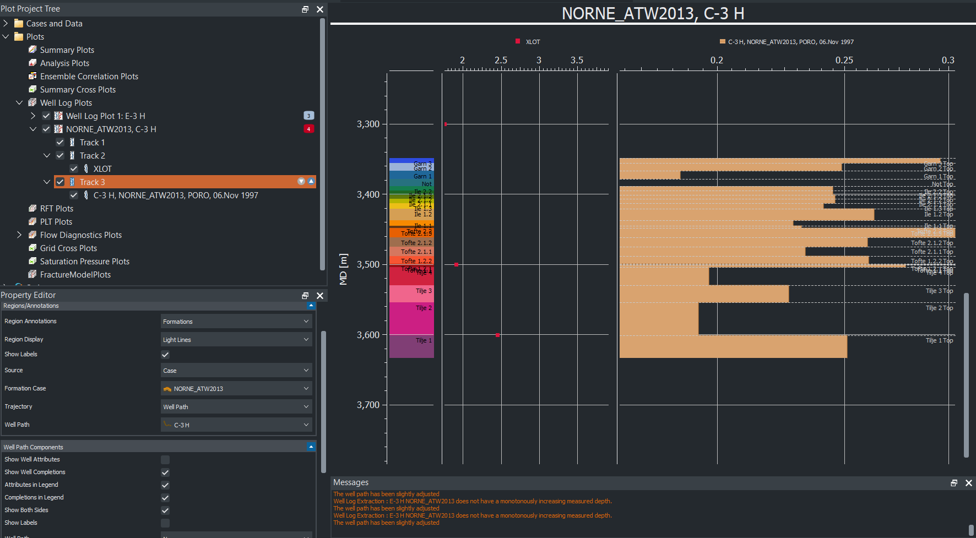

Well Picks

Objective: Import well picks, display in plots
- Import norne case
- From folder “model-data/norne-well-picks”, import well path dummy-B-3H
- Open the file “report.csv” in a text editor to see how the well picks are defined
- From the right-click menu of Wells, select “Import well picks” and select “model-data/norne-well-picks/report.csv”
- Create a well log extraction curve, use PORO
- Use area fill for PORO
- Add a new track for formations
- In Region/Annotations, in dropdown Region Annotations, select Formations
- In dropdown Source, select Well Picks for Well Path
- Select DUMMY-B-3H
- The well picks are displayed as horizontal lines

https://resinsight.org/3d-main-window/formations/#well-picks

Well Path Creation

Objective: Create a new well path using well targets
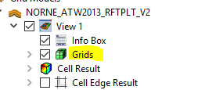
- Import grid data using “Import Eclipse Case” from “model-data/norne”
- Create intersection
  - From the right click menu in 3D view, select “Intersections->Polyline Intersection”
  - Add points to intersection, and click button “Stop picking points” when you have added all points
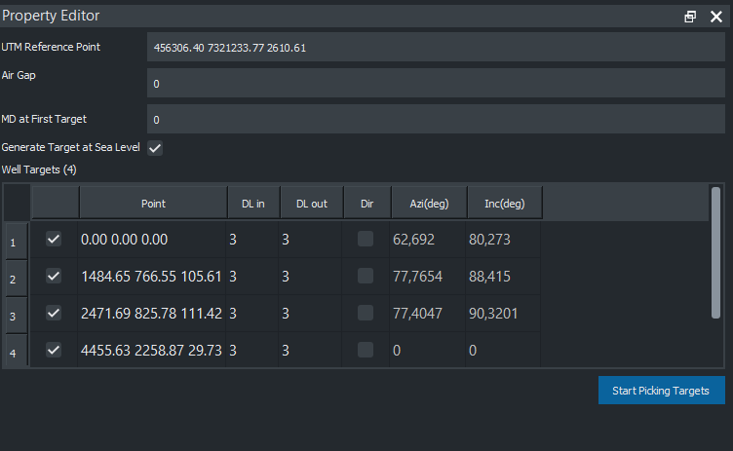
  - Disable Grids and Faults to see the intersection in the 3D view
- Select “Create Well Path” from right-click menu of Wells
  - Click on several locations on the intersection to create target points
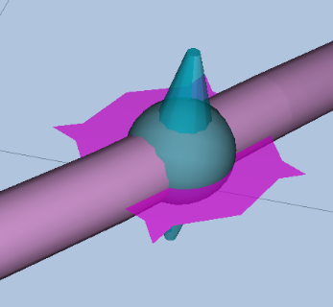
  - Manipulate the location by using dragger items in 3D
- Investigate data when selecting “Show well plan” from the right-click menu of Well-1
- Export the well path to a text file from Well-1, “Export Visible well path”. Investigate the exported text file.
- Import the exported well path using “Import Well Path”, investigate the potential geometry differences as the exported file is discretized
- Save project, as the created well path is intended to be used in other tutorials
Well target move operations
https://resinsight.org/wells-and-completions/createnewwellpaths/#well-target-interaction-operations

Well Path Completions

Objective: Export computed transmissibility factors based on completion along a well path
Continue with the user defined well path from previous tutorial.
- Find a location along the well path inside the grid, and from right click menu when clicking on the well path in 3D view select “Completions->New Perforation Interval”
- From Well Targets, select “Export Completions for Visible Well Paths”. Create a new folder as destination for the export operation. Open the Messages window to see the location of the exported file.
Inspect the exported file in a text editor and try to match the exported data with the perforation intervals in the 3D view.
- Add one more perforation interval
- Export completions, and investigate exported text file
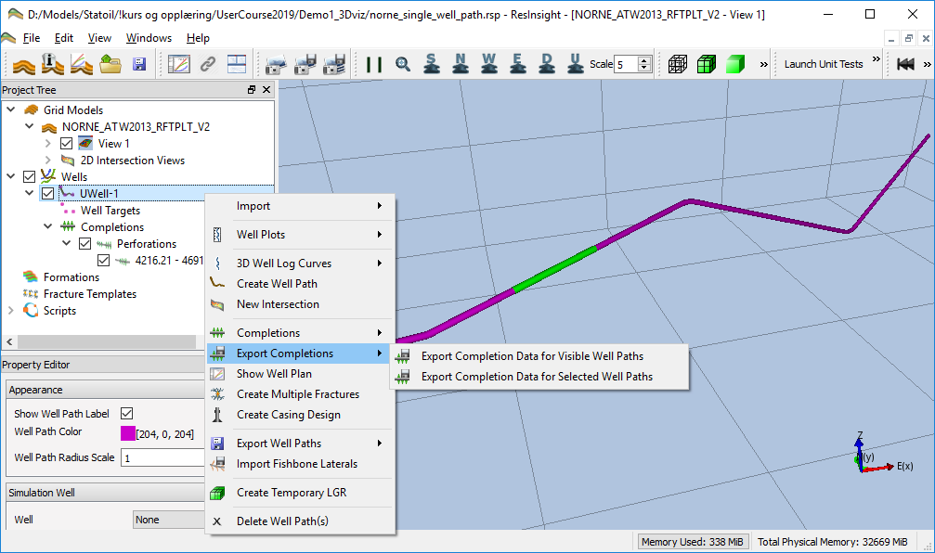
- Combined export
  - Create fracture template
    - Select “New Stim Plan Fracture Template” from the right click menu of Fracture Templates
    - Import template from "/model-data/norne-well-hydrfrac/StimPlan_HydrFrac.XML"
    - Find a location for the template, and launch the right click menu in the 3D view when clicking on the well path geometry
    - Select “Completions->New Fracture”
    - Select “3D View”->Fractures”
Toggle the view if “Fractures” object is missing.
Select “Result Color->Conductivity [md-ft]”
  - Add a fishbones section “Completions->New Fishbones”
  - Export completions, and select File Split “Split on Well and Completion Type”
  - Investigate the exported files in export folder
https://resinsight.org/wells-and-completions/completions/

Export LGR for Completions

Objective: Create and export local grid refinement (LGR) based on completions
Continue with the user defined well path from previous tutorial.
- Add two perforation intervals and one fracture to the well path
- In the Wells folder in the Project Tree, select the well you are working on. From right click menu of this well, select “Create Completions->Create Temporary LGRs”
- Export completion data into an empty folder
- Investigate CARFIN section in generated file LGR_Well-1.dat
- Untick all filters, and untick Main Grid in the Grids folder
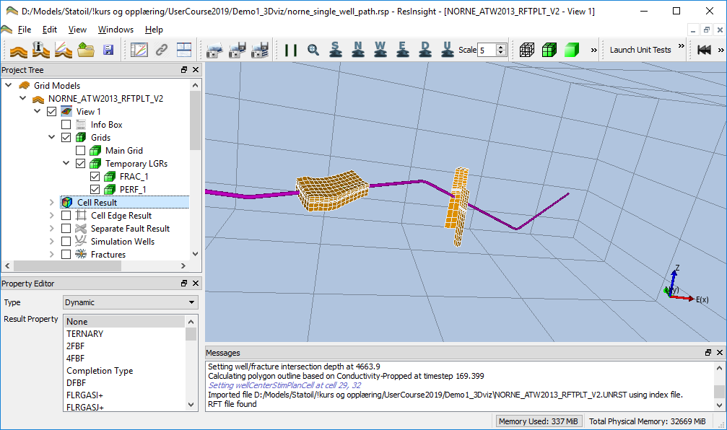
- From right click menu of the well, select “Create Completions->Create Temporary LGRs” and set number of cells in K direction to 5
- Export and Investigate CARFIN section in generated file LGR_Well-1.dat
- Add fishbones
- Optional: Possible to create multiple fractures using Stim Plan fracture
  - From the right click menu of Well-1, select “Create Multiple Fracture”
  - Select “Replace Fractures” and close the dialog
- Use the checkboxes in Grids to investigate the generated LGR grids

NB! Please note that the temporary LGRs will not be restored if you save the project and open the project again.
https://resinsight.org/wells-and-completions/completionslgr/

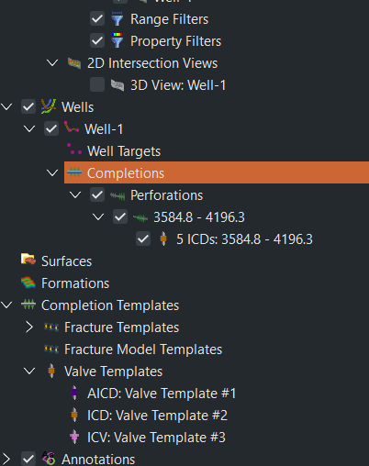
Valve Modeling and Export

Objective: Create valves and export completion
- Create a well or import modeled well path from previous tutorial
- Create a perforation of length 500m
- Add a valve from the right-click menu of a perforation interval
- ICD Export
  - Select an ICD template, and click Edit for easy navigation to the valve templates
  - Set Number of Valves to 5
  - Select “Export Completions“ from the context menu of the well
  - Investigate the exported text files
- Export AICD
  - Change valve to AICD template
  - Set the following values in the AICD template
    - Strength of AICD: 1e-5
    - Calibration Fluid Density: 1000
    - Calibration Fluid Viscosity: 1
    - Volume Flow Rate Exponent: 2
    - Viscosity Function Exponent: 0.7
  - Select “Export Completions“ from the context menu of the well
  - Investigate the exported text files
Import of templates from text files is supported using the right-click menu of Valve Templates and select “Import Valve Templates”. Valves can be imported from Completor or Eclipse text files.
https://resinsight.org/wells-and-completions/completions/#perforation-interval-valves
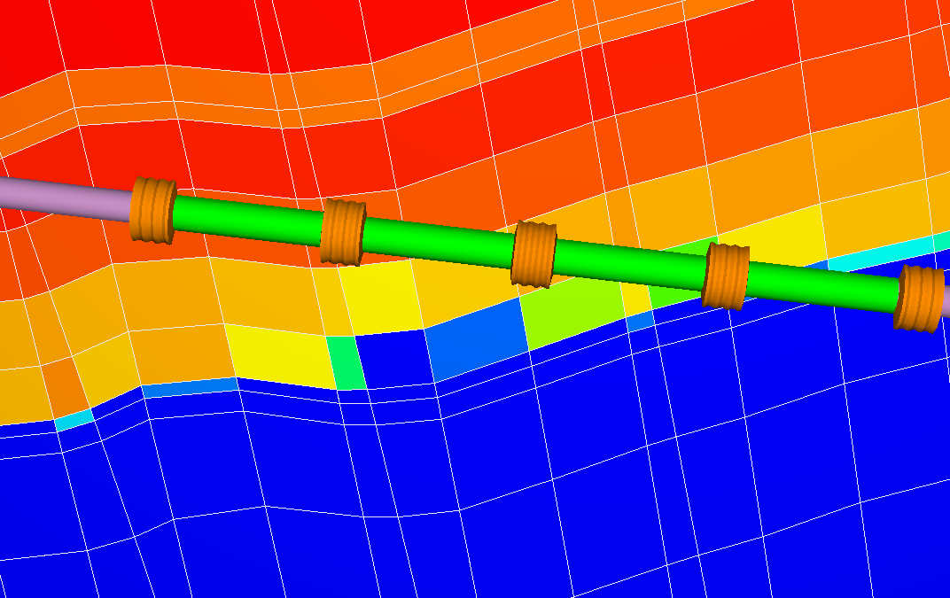

Project file manipulations

Objective: Know how to manipulate selected parts of the project file
- Show path section <ReferencedExternalFiles>
  - Discuss how these can be changed by external scripts
- Show well path targets <WellPathTargets>
  - Discuss how these can be changed by external scripts
  - Create a copy of the well path target project file
  - Move one target 50 meter in x-direction
  - Save project as copy with new name
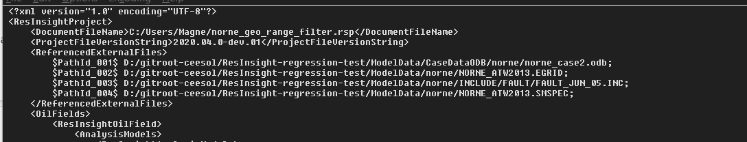
  - Open copy, and investigate the modified location of the well path target
  - Discuss how to manipulate model from scripting

Seismic Data

Objective: Import and visualize seismic data. Compare with reservoir data.
- Import the Drogon grid model from "model-data/drogon/DROGON-0.EGRID”
- Import seismic data from "model-data/drogon/seismic/seismic--amplitude_depth--20180701_20180101.vds”
- In the Project Tree, toggle off Grids to be able to see seismic data (optionally toggle off Faults)
- From the right-click menu of Seismic Sections, select “New Inline Section” and investigate seismic data in the view
  - Activate the Seismic Histogram dialog to see the value distribution
  - Click on red and blue parts of the seismic slice to see the associated seismic value in the Result Info dialog, see how the reported values corresponds to the seismic color legend
  - Select the Inline object, and manipulate the Inline value in the Property Editor
- Select the seismic data source, and adjust the mute and clip values to filter seismic data
  - Set Clip Value to 0.003
  - Set Mute Value to 0.001
  - Select the Inline object, expand the Experimental group and activate Transparent
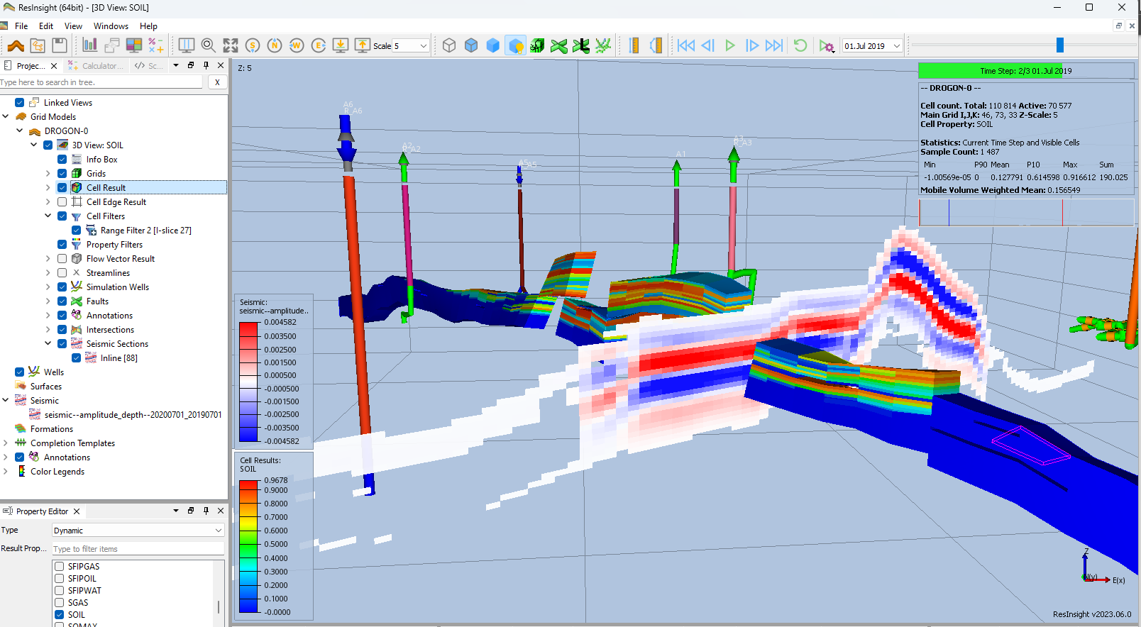
  - Move the inline to see how seismic data correlates to grid model geometry

Seismic Data along a well path

Objective: See seismic data along a well path
- Import the Drogon grid model from " model-data/drogon/DROGON-0.EGRID”
- Import seismic data from " model-data/drogon/seismic/seismic--amplitude_depth--20180701_20180101.vds”
- Create a user defined well path
- From the right-click menu of Intersections, select “New Intersection”. Change intersection type to Well Path, and select the well path
- From the right-click menu of the generated intersection, select “Create as Seismic Section”
- Select the Seismic section, and set it transparent
- Tile the windows to be able to see both views at the same time
- Show only seismic data in one view and grid model data in the other
- Manipulate the well path targets, and see grid is updated
- Advanced manipulation:
  - Press and hold CTRL to move the target and all downstream well targets
  - From the right-click menu in a view, select Compare to

A seismic view can be created independently of the reservoir view. To create this type of view, select New View from the right-click menu of Seicmic Views.

Correlation analysis (taken from ResInsight Intro Course)

Objective: Create and configure a Correlation Plot
- Import a Summary Ensemble, and use import path "model-data/reek_ensemble/3_r001_reek_50/realization-*/iter-1”
- From the right-click of a curve, select “Create Correlation Plot from Curve Point ->New Report Plot”
- Click on individual cells in the Correlation Matrix, and see how the cross plot is updated
Currently selected cell is indicated by a border in green
- Show Pearson calculation
- Change data source to WOPT for all wells OP_1 to OP_5
- Click on individual cells in the Correlation Matrix, and see how the cross plot is updated
- Right-click in plot, and select Show Plot Data

https://resinsight.org/plot-window/correlationplots/

Definition of how the Pearson correlation coefficient is computed
https://en.wikipedia.org/wiki/Pearson_correlation_coefficient#For_a_sample
X is input parameter value, Y is simulated value
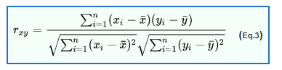

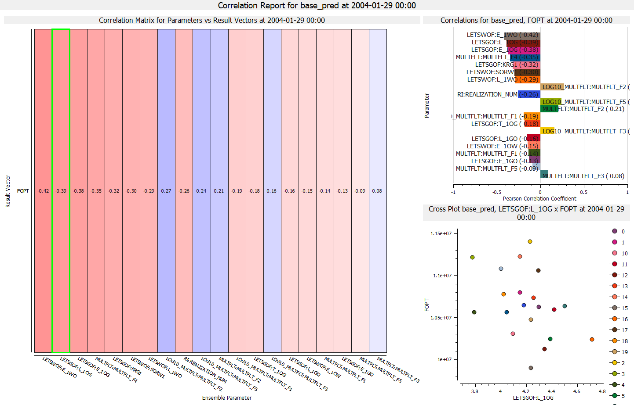

Analysis Plot (taken from ResInsight Intro Course)

Objective: Create and configure an Analysis Plot
- Import a Summary Ensemble, and use import path "model-data/reek_ensemble/3_r001_reek_50/realization-0/base_pred”
- Import a Summary Ensemble, and use import path "model-data/reek_ensemble/3_r001_reek_50/realization-0/pred_op6”
- Select New Delta Ensemble from right-click on Summary Cases
Create a Delta Ensemble as the difference between the two cases (pred_op6 - base_pred)
- Select new Analysis Plot
- In Property Editor, in group Selected Vectors, click on the button with three dots “…”
  - Set source Delta ensemble
  - Select wells OP_1-5
  - Select Summary Vector WOPT
- Bar Orientation: Horizontal
- Select major grouping Summary Item
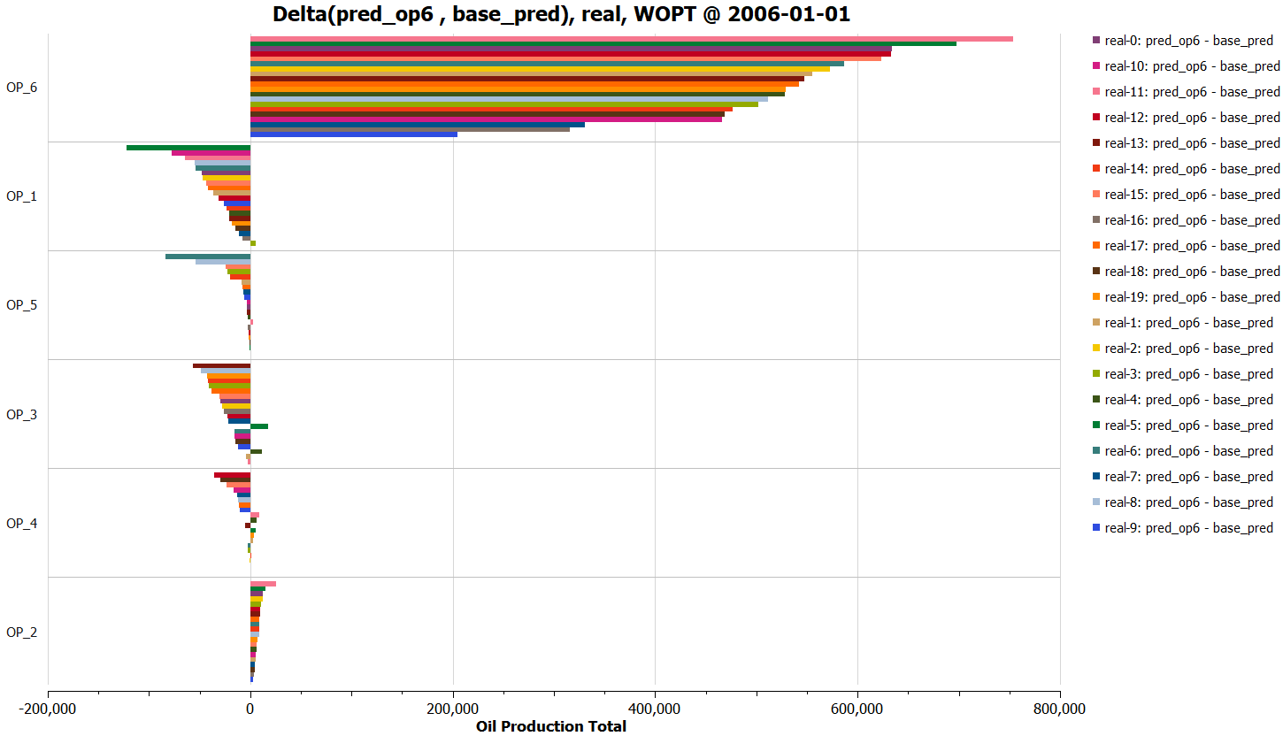
- Select sort by abs(Value)
- Optionally
  - Show legend
  - Bar labels
- Right-click in plot, and select Show Plot Data

https://resinsight.org/plot-window/analysisplots/

Python scripting

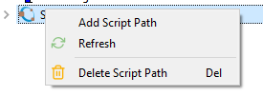
Objective: Learn how to execute a Python script from ResInsight UI
- Configuration of Equinor internal scripts is described in
“ResInsight user Course Preparations 2022.pdf”
- [Optional] Add a folder containing existing scripts
  - Right-click on Scripts item, and select “Add Script Path”
  - Select script folder
  - To edit the text content of a Script, select “Edit” from the right-click menu
- Use the right-click menu to execute a script
- Investigate the output from the Python script in Process Monitor
- It is also possible to execute a Python script directly from a terminal

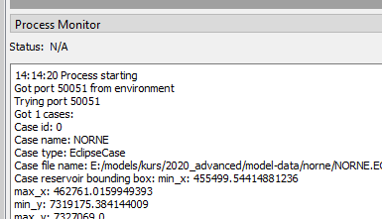
https://api.resinsight.org
https://api.resinsight.org/en/stable/PythonExamples.html

Improvements and new features 2023.10

Seismic Data
Import and display of 3D seismic cubes in a custom seismic view.
Summary Visualization
- Summary Cross Plot curves is now supported and improved
- Regression curve support for cross plot curves
- Regression curve support for Grid Cross Plots
Analysis Plots and Correlation Plots can now display plot values using Show Plot Data.

https://resinsight.org/getting-started/whats-new/releasenotes_2023_10/

Improvements and new features 2023.06

Seismic Data
Import and display of 3D seismic cubes in the same scene as reservoir grid model.
Summary Visualization
- Summary tables used to see summary data for multiple wells in a table view.
- Producer/Injector connectivity table can be used to get an overview of the communication between wells
- Regression and Decline Curves
Improved visualization of Ensemble Curves

https://resinsight.org/getting-started/whats-new/releasenotes_2023_06/

Improvements and new features 2023.03

Calculator improvements
A calculator expression will by default be available for all wells, all cases, and all ensembles
Radial grids
Import of radial grids including local grid refinement (LGR) is now supported. Using I and J range filters will filter the grid case based on angle and radius (Theta and R).
Multi Segment Well
Added optional visualization of valves.
Other
- Use Well Allocation Over Time to see the allocation over multiple restart time steps.
- The Depth Plot can be used to display values for all K-cells for one or multiple selected IJ cells.
- Improved custom time axis tick marks
- Pressure Depth Data can be imported from a custom file format.
- Fixed freeze during import of grid model (Progress bar freezes at 28%)
- GRDECL export: Added option to export NOECHO and ECHO to generated text file
- When clicking on a cell: Show center coordinates and corner coordinates [Result Info]

More details at
https://resinsight.org/getting-started/whats-new/releasenotes_2023_03/

Improvements and new features 2023.01

ROFF Grid Models
- Import of ROFF files exported from RMS
Import->ROFF Grid Models->Import Roff Case
All existing features for Eclipse grid models are also available for ROFF grid models.
- Grid data in text format can be imported into any grid model (Eclipse EGRID, Eclipse GRDECL, Roff). This works if the number of cells matches the destination grid.
Linked Views
- See property value as text from all linked views in Result Info
- Link property filters, works locally on each individual grid model
Other
- See multiple result values in Result Info
- Improved documentation for calculations
- Support for display of RFT segment curves
- Horizontal well log plots
- Improved window tiling

More details at
https://resinsight.org/getting-started/whats-new/releasenotes_2023_01/

