**ResInsight Advanced User Course  
Q3 2022**

Agenda

1. Welcome, course layout and introductory remarks
2. Hands-on Exercises
3. Summary and feedback

# Table of Contents

Table of Contents 2

Support and Resources 3

Preparations 4

a) Grid Cross Plot with formations 6

b) Grid Cross Plot with filtering 7

c) Sector model export 8

d) Ensemble Grid Case Statistics 9

e) Well Log Extraction 10

f) Well Log Data 11

g) Well Measurements in 3D 12

h) Well Measurements in plots 13

i) Well Picks 15

j) Well Path Creation 16

k) Well Path Completions 17

l) Export LGR for Completions 18

m) Valve Modeling and Export 19

n) Project file manipulations 20

o) Correlation analysis (taken from ResInsight Intro Course) 21

p) Analysis Plot (taken from ResInsight Intro Course) 23

q) Python scripting 24

# Support and Resources

**Main help page**<https://resinsight.org/>

**Yammer**

Internal Equinor Yammer channel “*ResInsight users”*<https://web.yammer.com/main/threads/eyJfdHlwZSI6IlRocmVhZCIsImlkIjoiNzM3MzA5MDI1MjgwMDAwIn0>

**Tutorials – introduction**

We have started building a tutorial site for ResInsight. We will use some of these tutorials in addition to some located only on file system in Equinor.

<https://github.com/CeetronSolutions/resinsight-tutorials>  
<https://www.youtube.com/channel/UCEJoH_ti1YZXz4hPMeAKMgw>

**Overview of the interface for 3D visualization**

<https://github.com/CeetronSolutions/resinsight-tutorials/blob/main/tutorials/graphical-user-interface/graphical-user-interface.md>

# Preparations

Test models used in tutorials are available from <https://github.com/CeetronSolutions/resinsight-tutorials>  
The data to be used in tutorials is in the folder **model-data.**

Either clone the GitHub repository, or select “**Download ZIP**” from the **Code** menu

#### Conventions

In this document, **bold text** indicates an object in the property tree. Menu item text is “written in quotes”.

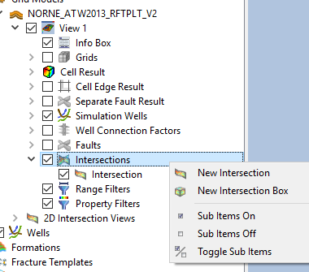Example   
Select “New Intersection” from **Intersections.**

#### Tips and tricks

Please close the existing project (“File->Close Project”) before starting a new tutorial. This will help you to avoid confusion caused by data from previous tutorials.

## Grid Cross Plot with formations

#### Objective: Create grid cross plot with automated categories based on formations

1. Import grid data using “Import Eclipse Case” from folder “model-data/norne”
2. Import formations from folder “model-data/norne/Norne_subZones.lyr”
3. In **Cell Result**, select **Static->PORO**
4. In the **Project Tree**, open the right-click menu of the view, Select “Create Grid Cross Plot”. The default **X-Axis Property** is defined by the **Cell Result** in the 3D view, and default **Y-Axis Property** is **Depth** with the Y-axis inverted with increasing values at the bottom of the plot
5. Select **PERMX** as the **Y-Axis Property**
6. Uncheck **Invert Axis** from the Y-Axis object in **Property Editor**
7. Click in the plot to highlight all samples for a group

<https://resinsight.org/plot-window/gridcrossplots/>

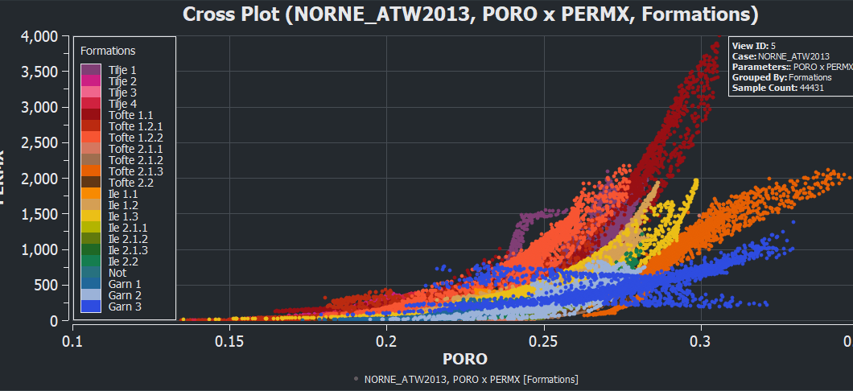

## Grid Cross Plot with filtering

#### Objective: Create grid cross plot with filtering

1. Import grid data using “Import Eclipse Case” from folder “model-data/norne”
2. Import formations from folder “model-data/norne/Norne_subZones.lyr”
3. In the 3D view, set **Cell Result** to **Static -> FIPNUM**
4. In the **Project Tree**, open the right-click menu of the view
5. Select “Create Grid Cross Plot”
6. Set Static **PORO** as x-axis
7. Set Static **SWATINIT** as y-axis
8. Set **Group Data by** “Result Property”, select **Static** -> **PERMX**
9. 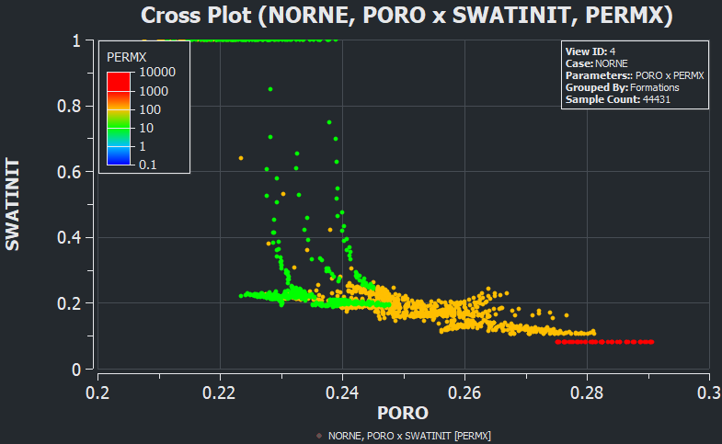Select color legend in Project three
   1. See how manipulation of “*Number of intervals”* affects the plot
10. In the grid cross plot, select **Filter by 3D view**
11. Go back to the 3D view, and create a property filter based on **FIPNUM**
    1. Select FIPNUM value 6 the category selection (multiple selection is supported)
    2. Hide faults to see the filtered grid cells
12. Make sure both the 3D view and the plot window are open at the same time. Modify the selected FIPNUM values in the property filter and see how the plot is updated as visible cells in the 3D view changes.

## Sector model export

#### Objective: Export a subset of the grid based on visible cells

1. Import grid data using “Import Eclipse Case” from folder “model-data/norne”
2. Move to the last time step as there is no flow at the first time step
3. In the 3D view, set **Cell Result** to **Flow Diagnostics**
4. Select “*By Selection*”
5. Select injector **C-2H** and producer **B-2H**
6. Select **Injector Producer Communication**
7. Create a property filter on communication between **C-2H** and **B-2H**
8. In the right-click menu in the 3D view, select “*Export Eclipse Sector Model*”
9. Export data by clicking **Export**
   1. Select grid folder and fault folder
10. Import the exported data
    1. Select “*Import Eclipse Input Case***”**
    2. Select all files exported in the previous step (use multiselect in file dialog)
11. Compare the imported data with the original binary case
    1. Select **PERMX** in both views
    2. In the right-click menu in the 3D view, activate **Compare to**

<https://resinsight.org/export/sectormodel/>

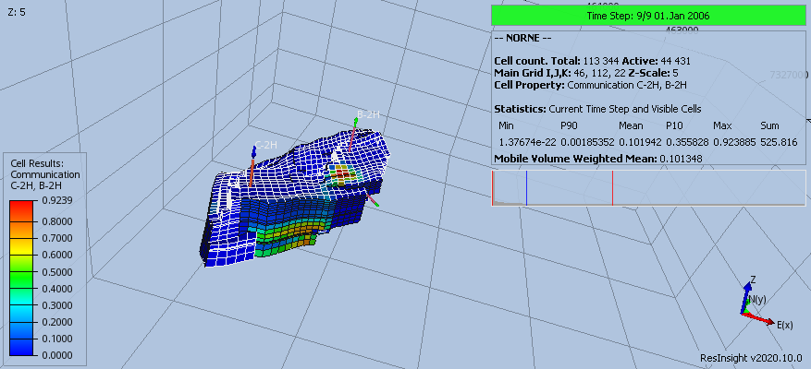

## Ensemble Grid Case Statistics

#### Objective: Import an ensemble of grid cases and compute statistics cell by cell

1. 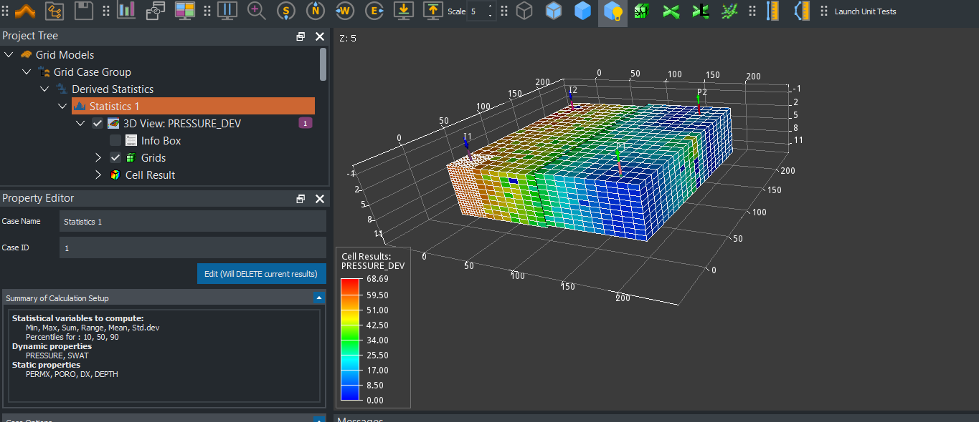Use data located in folder  
   “model-data/grid_ensemble”
2. Import data using “*Create Grid Case Group*”  
   Use the **Find** button to search the folder for files matching the search filter.  
   The imported cases can be investigated in **Source Cases** folder in the **Project Tree**
3. In the property panel, click the button “Compute” to compute default statistics
4. Select dynamic property **PRESSURE_DEV**, move to last time step  
   **PRESSURE_DEV** represents the standard deviation of pressure based on source cases
5. Select **Statistics 1**, and in the **Property Editor in group Case Options**, select one of the source cases to use for well data. This will display simulation wells in the view.
6. Create a new view and create a property filter
   1. Select **PRESSURE_DEV** (pressure standard deviation) larger than 40
   2. If you will set the cell result to match the property filter, open the right-click menu of a property filter and select **Apply As Cell Result**
7. **[Optional]** Select **Statistics 1**. In the **Property Editor**, click the button “Edit(Will DELETE current result)”  
   Add **PORV** to the list of static variables. The user interface for selection of properties supports multiselect of items by pressing and holding **CTRL** key when clicking items in the list.
8. **[Optional]** Handling of inactive cells (Use Zero as Inactive Cell Value)
   1. When computing statistics on **PRESSURE**, it is usually required to leave this option off (total cell count is active)
   2. When computing statistics on **PORP/PERM**, it is usually required to enable this option (total cell count is active + inactive)

<https://resinsight.org/3d-main-window/casegroupsandstatistics/>

## Well Log Extraction

#### Objective: Plot well log extraction curve in 2D plot window

1. In 3D main window
   1. Import grid case from “norne” and import formations from “norne/Norne_Fm.lyr”
   2. Import well path"model-data/norne-well-logdata/dummy-B-3H.dev"
   3. Select cell result **Dynamic -> SOIL**
   4. Select well path **B-3H**, and from the right click menu select “*Well Plots->New Well Log Extraction Curve*”
   5. Activate the plot main window
2. In plot main window
   1. In the project tree, activate right-click menu of the plot and select “New Track”
   2. Select the new track in the Project tree
   3. In the Regions/Annotations group, set **Region Annotation** to **Formations**
   4. Make sure **Formation Case** is set to **Norne** and **Well Path** is set to **B-3H**

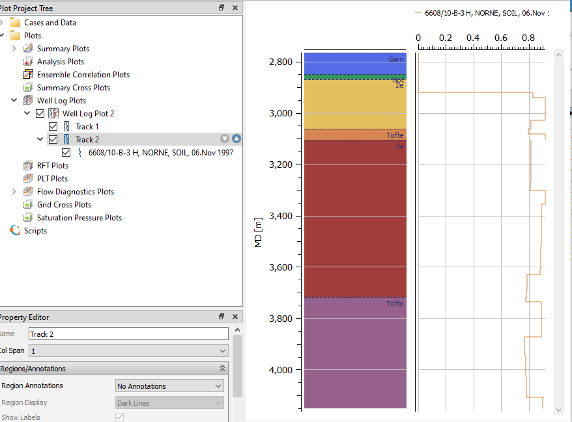<https://resinsight.org/plot-window/welllogsandplots/>

## Timeline Description automatically generatedWell Log Data

#### Objective: Plot well log extraction curve in 2D plot window

1. Import grid case from “norne”
2. Import well path"model-data/norne-well-logdata/dummy-B-3H.dev"
3. From the right-click menu of well **B-3H**, select “*Import Well Logs from File*”
4. From the right-click menu of **SW**, select “*Add to New Plot*”
5. From the right-click menu of the track, select “*New Well Log Extraction Curve*”
6. Select **Dynamic** -> **SWAT**
7. Use Area fill for **SW**, and toggle the **SWAT** curve to make sure it is drawn on top of the filled curve
8. Compare data from the two data sources. They do not have a good match, as the data set contains dummy data

<https://resinsight.org/plot-window/welllogsandplots/>

## Well Measurements in 3D

#### Objective: Import well measurements, display in 3D view

1. Import norne
2. Import formations for norne
3. Set **Cell Result** to **Static -> PORO**
4. Import well paths C-3 H and E-3 H from folder “norne-well-measurements”
5. From the right-click menu of **Wells**, select “Import Measurements”
6. Show measurements in the view
   1. Create a new view
   2. Select **Wells** in the **Project Tree**, and disable clipping of wells to be able to see the well path all the way up to the sea surface
   3. Uncheck **Grid Cells** and **Faults**
   4. Make sure the checkbox in front of **Well Measurements** is enabled
   5. Manipulate the filtering options for each measurement type in the property editor
7. Continue to next tutorial without closing the project

<https://resinsight.org/wells-and-completions/wellmeasurements/>

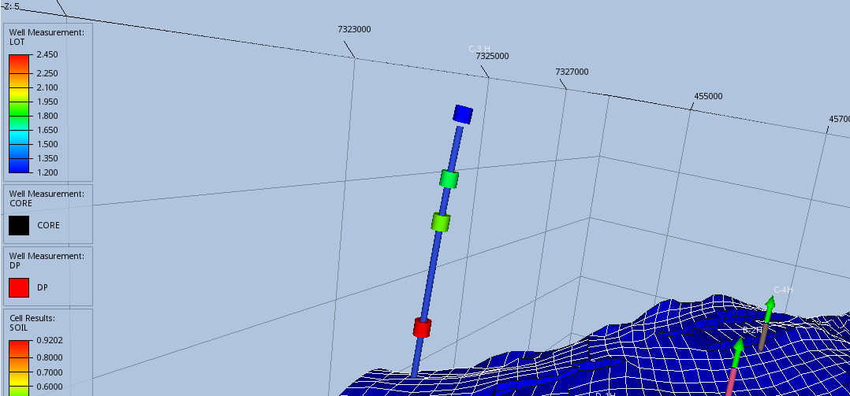

## Well Measurements in plots

#### Objective: Import well measurements, display in plots

1. Import data (see import in previous tutorial or continue with same project)
2. Well log extraction curve for well **C-3 H**
   1. Create a **Well Log Extraction** curve for **C-3 H**, open the plot window
   2. Show data for **Static -> PORO**
   3. In **Curve** -> **Appearance**, set **Area Fill Style** to **Solid Fill**
3. Create measurement track
   1. Create a new track
   2. From the right-click menu of the track, select “New Well Measurement Curve”
   3. Select well **C-3 H** and **XLOT**
   4. Use the zoom all button to make sure all measurements are visible, or toggle visibility of curve to make the well measurements visible
   5. Make the measurement symbols larger
   6. The measurements are outside the grid, and the depth axis min/max values can be defined in the **Depth Axis** section of the plot or by zoom using **CTRL**+mouse wheel
4. Create formation track
   * 1. Create a new track
     2. From the property editor of the track, in group **Region/Annotation**, set the **Region Annotation** to **Formations**
     3. Select case and well path, the formations appear as colors in the track
     4. Change the color legend to the same as the formations, usually “Category”
5. Use the up/down arrow to the right of a track to modify the ordering of tracks
6. Add formations as lines to the **PORO** track
7. Change the track width distribution
   1. Set col span to 2 for **XLOT**
   2. Set col span to 5 for **PORO** track
8. See next page for an example plot

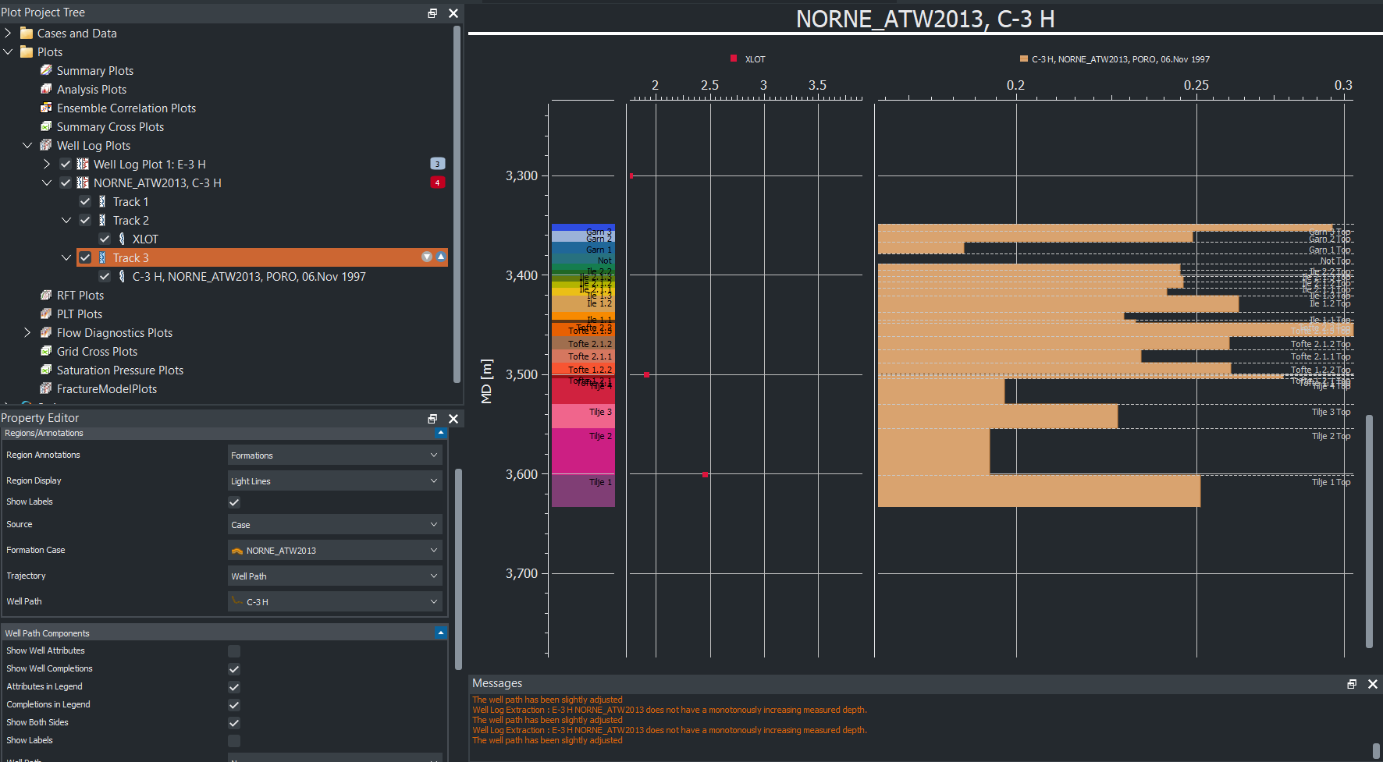

## Well Picks

#### Objective: Import well picks, display in plots

1. Import norne case
2. From folder “model-data/norne-well-picks”, import well path **dummy-B-3H**
3. Open the file “report.csv” in a text editor to see how the well picks are defined
4. From the right-click menu of **Wells**, select “*Import well picks*” and select “/norne-well-picks/report.csv”
5. Create a well log extraction curve, use **PORO**
6. Use area fill for **PORO**
7. Add a new track for formations
8. In Region/Annotations, in dropdown **Region Annotations**, select **Formations**
9. In dropdown **Source**, select **Well Picks for Well Path**
10. Select **DUMMY-B-3H**
11. The well picks are displayed as horizontal lines

<https://resinsight.org/3d-main-window/formations/#well-picks>

## Well Path Creation

#### Objective: Create a new well path using well targets

1. 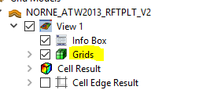Import grid data using “Import Eclipse Case” from “norne”
2. Create intersection
   1. From the right click menu in 3D view, select “Intersections->Polyline Intersection”
   2. Add points to intersection, and click button “Stop picking points” when you have added all points
   3. 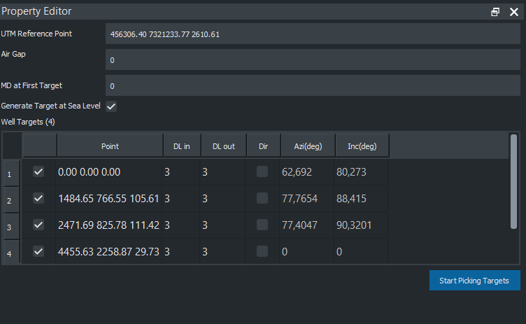Disable **Grids** and **Faults** to see the intersection in the 3D view
3. Select “Create Well Path” from right-click menu of **Wells**
   1. Click on several locations on the intersection to create target points
   2. 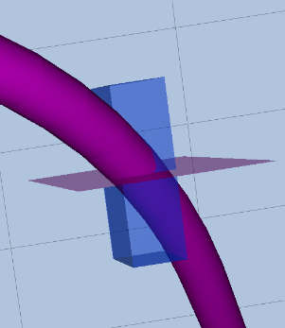Manipulate the location by using dragger items in 3D
4. Investigate data when selecting “Show well plan” from the right-click menu of **Well-1**
5. Export the well path to a text file from **Well-1**, “Export Visible well path”. Investigate the exported text file.
6. Import the exported well path using “Import Well Path”, investigate the potential geometry differences as the exported file is discretized
7. Save project, as the created well path is intended to be used in other tutorials

<https://resinsight.org/wells-and-completions/createnewwellpaths/>

## Well Path Completions

#### Objective: Export computed transmissibility factors based on completion along a well path

Continue with the user defined well path from previous tutorial.

1. Find a location along the well path inside the grid, and from right click menu when clicking on the well path in 3D view select “Completions->New Perforation Interval”
2. From **Well Targets**, select “Export Completions for Visible Well Paths”. Create a new folder as destination for the export operation. Open the **Messages** window to see the location of the exported file.  
   Inspect the exported file in a text editor and try to match the exported data with the perforation intervals in the 3D view.
3. Add one more perforation interval
4. Export completions, and investigate exported text file
5. 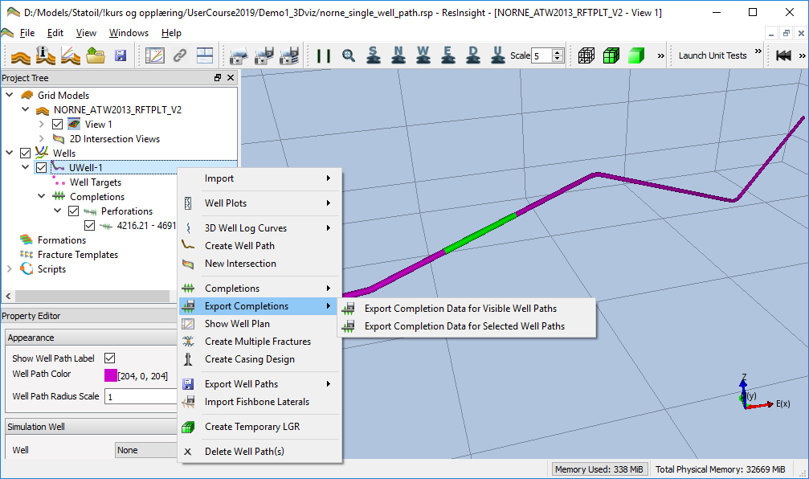Combined export
   1. Create fracture template
      1. Select “New Stim Plan Fracture Template” from the right click menu of **Fracture Templates**
      2. Import template from "/model-data/norne-well-hydrfrac/StimPlan_HydrFrac.XML"
      3. Find a location for the template, and launch the right click menu in the 3D view when clicking on the well path geometry
      4. Select “Completions->New Fracture”
      5. Select “3D View”->”Fractures”  
         Select “Result Color”->”Conductivity [md-ft]
   2. Add a fishbones section “Completions->New Fishbones”
   3. Export completions, and select **File Split** “Split on Well and Completion Type”
   4. Investigate the exported files in export folder

<https://resinsight.org/wells-and-completions/completions/>

## Export LGR for Completions

#### Objective: Create and export local grid refinement (LGR) based on completions

Continue with the user defined well path from previous tutorial.

1. Add two perforation intervals and one fracture to the well path
2. From right click menu of **Completions**, select “Create Temporary LGRs”
3. Export completion data into an empty folder
4. Investigate **CARFIN** section in generated file **LGR_Well-1.dat**
5. Untick all filters, and untick **Main Grid** in the **Grids** folder
6. 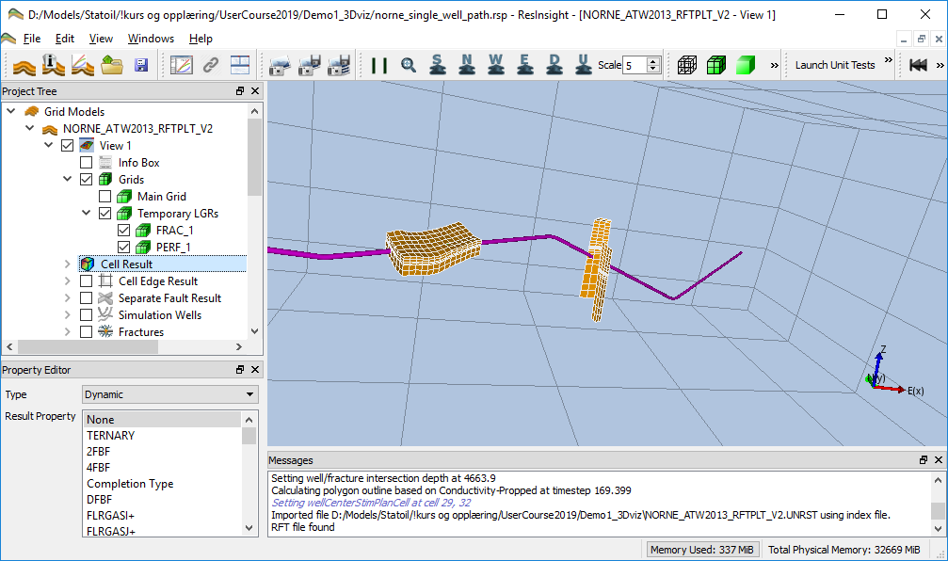From right click menu of **Completions**, select “Create Temporary LGRs” and set number of cells in K direction to 5
7. Export and Investigate **CARFIN** section in generated file **LGR_Well-1.dat**
8. Add fishbones
9. Optional: Possible to create multiple fractures using Stim Plan fracture
   1. From the right click menu of **Well-1, select “Create Multiple Fracture”**
   2. Select “Replace Fractures” and close the dialog
10. Use the checkboxes in **Grids** to investigate the generated LGR grids

NB! Please note that the temporary LGRs will not be restored if you save the project and open the project again. Recreate the LGRs using the operations described above if required.

<https://resinsight.org/wells-and-completions/completionslgr/>

## Valve Modeling and Export

#### Objective: Create and export valves

1. Create a well or import modeled well path from previous tutorial
2. Create a perforation of length 500m
3. Add a valve from the right-click menu of a perforation interval
4. ICD Export
   1. Select an ICD template, and click **Edit** for easy navigation to the valve templates
   2. Set Number of Valves to 5
   3. Select “*Export Completions*“ from the context menu of the well
   4. Investigate the exported text files
5. Export AICD
   1. Change valve to **AICD template**
   2. Set the following values in the **AICD template**
      1. Strength of AICD: 1e-5
      2. Calibration Fluid Density: 1000
      3. Calibration Fluid Viscosity: 1
      4. Volume Flow Rate Exponent: 2
      5. Viscosity Function Exponent: 0.7
   3. Select “Export Completions“ from the context menu of the well
   4. Investigate the exported text files

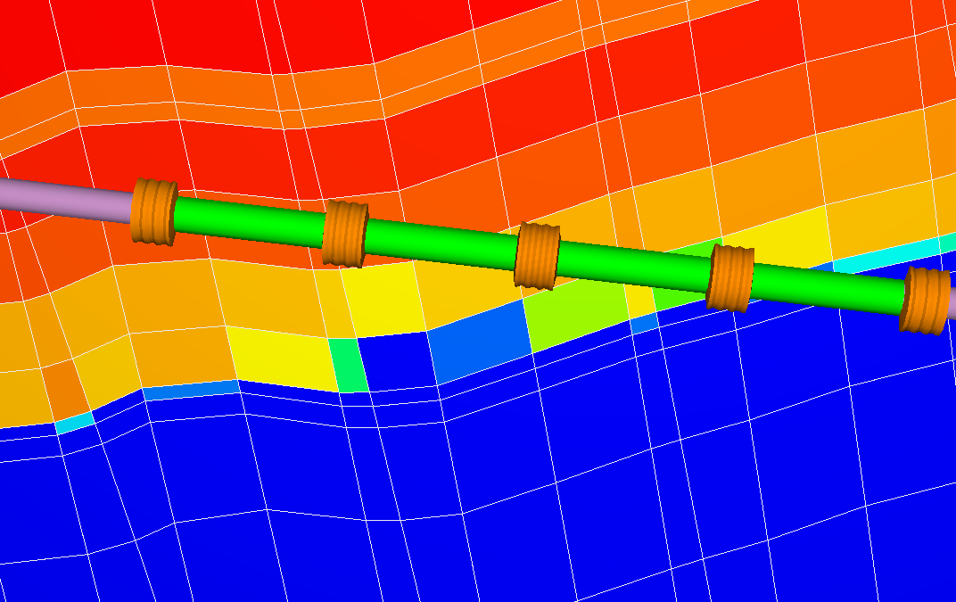<https://resinsight.org/wells-and-completions/completions/#perforation-interval-valves>

## Project file manipulations

#### Objective: Know how to manipulate selected parts of the project file

* Show path section <ReferencedExternalFiles>
  + Discuss how these can be changed by external scripts
* Show well path targets <WellPathTargets>
  + Discuss how these can be changed by external sciprts
  + Create a copy of the well path target project file
  + Move one target 50 meter in x-direction
  + Save project as copy with new name
  + 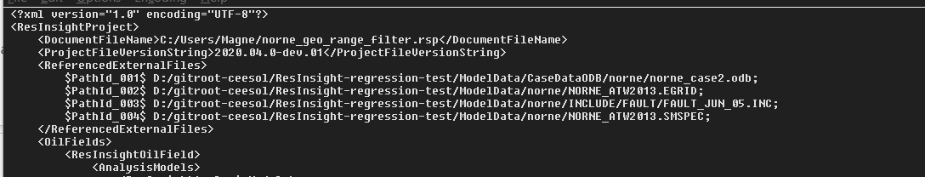Open copy, and investigate the modified location of the well path target
  + Discuss how to manipulate model from scripting

## Correlation analysis (taken from ResInsight Intro Course)

#### Objective: Create and configure a Correlation Plot

* Import a Summary Ensemble, and use import path "2020_intro/model-data/reek_ensemble/3_r001_reek_50/realization-*/iter-1”
* From the right-click of a curve, select “Create Correlation Plot from Curve Point ->New Report Plot”
* Click on individual cells in the **Correlation Matrix**, and see how the cross plot is updated  
  Currently selected cell is indicated by a border in green
* Show Pearson calculation
* Change data source to **WOPT** for all wells **OP_1** to **OP_5**
* Click on individual cells in the **Correlation Matrix**, and see how the cross plot is updated

<https://resinsight.org/plot-window/correlationplots/>

**Definition of how the Pearson correlation coefficient is computed**

<https://en.wikipedia.org/wiki/Pearson_correlation_coefficient#For_a_sample>

X is input parameter value, Y is simulated value

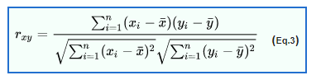

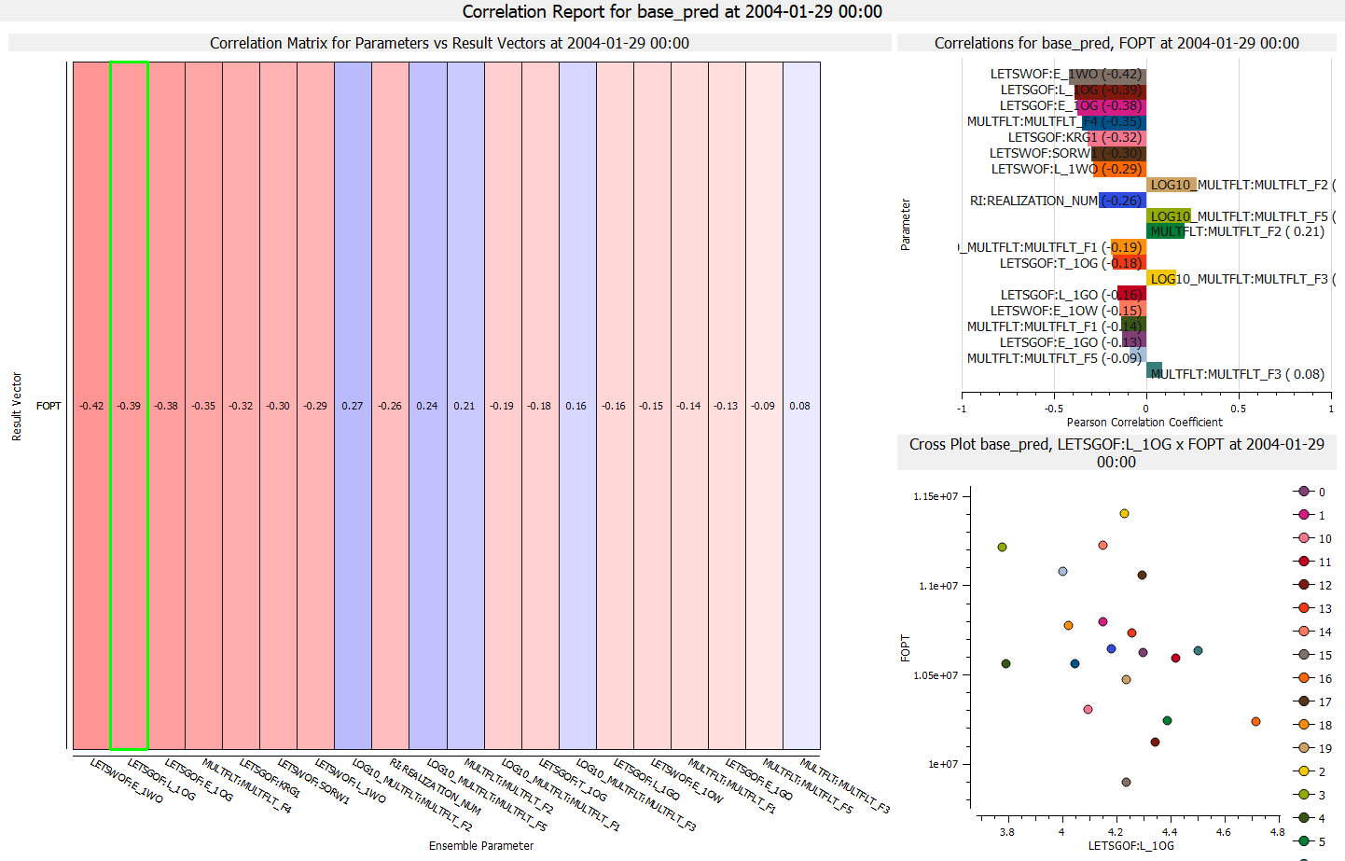

## Analysis Plot (taken from ResInsight Intro Course)

#### Objective: Create and configure an Analysis Plot

* Import a Summary Ensemble, and use import path "2020_intro/model-data/reek_ensemble/3_r001_reek_50/realization-0/base_pred”
* Import a Summary Ensemble, and use import path "2020_intro/model-data/reek_ensemble/3_r001_reek_50/realization-0/pred_op6”
* Select New Delta Ensemble from right-click on **Summary Cases**  
  Create a **Delta Ensemble** as the difference between the two cases (pred_op6 - base_pred)
* Select new **Analysis Plot**
* In Property Editor, in group Selected Vectors, click on the button with three dots “…”
  + Set source **Delta ensemble**
  + Select wells **OP_1-5**
  + Select Summary Vector **WOPT**
* Bar Orientation: **Horizontal**
* Select major grouping **Summary Item**
* 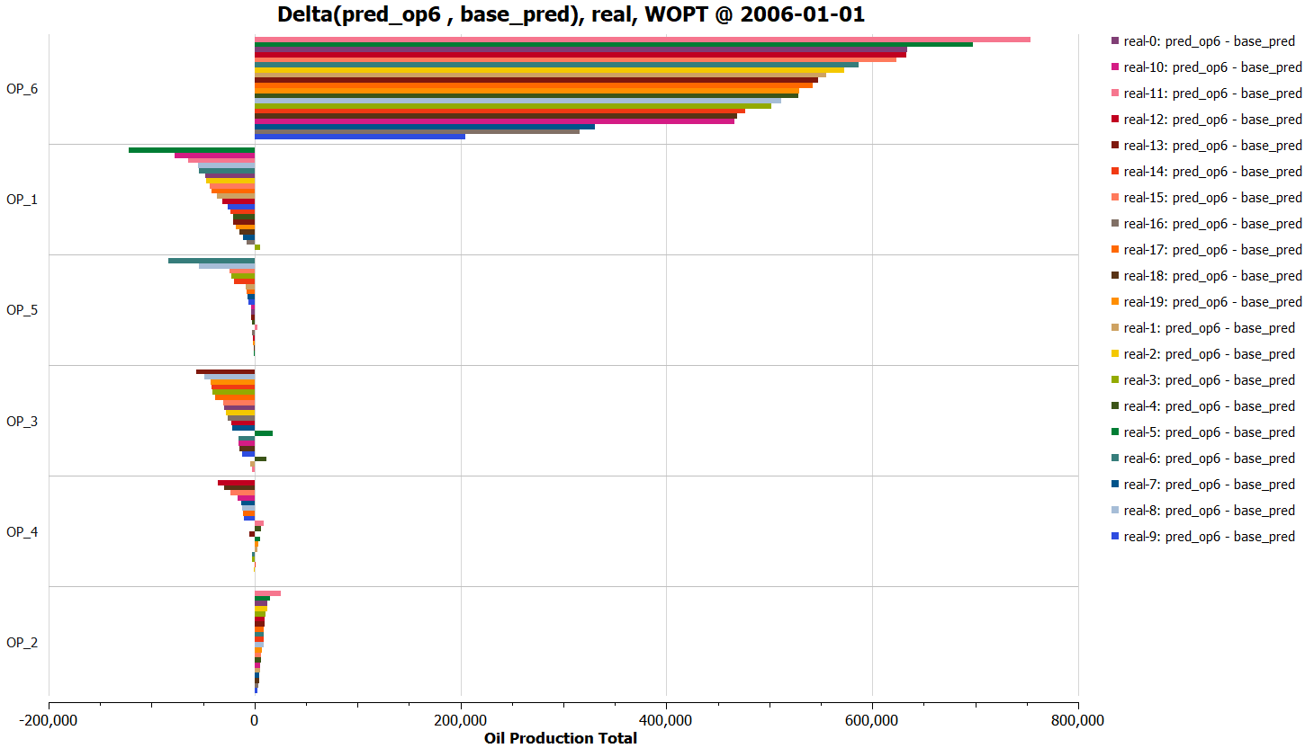Select sort by abs(Value)
* Optionally
  + Show legend
  + Bar labels

<https://resinsight.org/plot-window/analysisplots/>

## Python scripting

#### Objective: Learn how to execute a Python script from ResInsight UI

* Configuration of Equinor internal scripts is described in  
  *“ResInsight user Course Preparations 2022.pdf”*
* [Optional] Add a folder containing existing scripts
  + Right-click on **Scripts** item, and select “Add Script Path”
  + Select script folder
  + To edit the text content of a **Script**, select *“Edit”*from the right-click menu
* Use the right-click menu to execute a script
* Investigate the output from the Python script in **Process Monitor**
* It is also possible to execute a Python script directly from a terminal

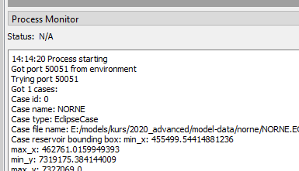<https://api.resinsight.org>

<https://api.resinsight.org/en/stable/PythonExamples.html>