**ResInsight User Course  
2022 Q3**

1. Welcome, course layout and introductory remarks
2. ResInsight Introduction and Overview
3. Hands-on Exercises

a) 3D Grid Visualization

b) 3D Grid Inspection Features – Intersections

d) 2D Contour Map

e) Flow Diagnostics

f) Summary Plots

g) Summary Plots – calculated curves

h) Observed Data Plots

i) Ensemble Plots (1 of 2)

j) Ensemble Plots (2 of 2)

k) Plot Templates

l) RFT Plots

m) Ensemble RFT Plots

n) Correlation Analysis

o) Analysis Plot



# Support and Resources

**Main help page**<https://resinsight.org/>

**Tutorials and recordings**

Tutorial site for ResInsight  
<https://github.com/CeetronSolutions/resinsight-tutorials>

Video recording of selected tutorials  
<https://www.youtube.com/channel/UCEJoH_ti1YZXz4hPMeAKMgw>

**Overview of the interface for 3D visualization**

<https://github.com/CeetronSolutions/resinsight-tutorials/blob/main/tutorials/graphical-user-interface/graphical-user-interface.md>

# Preparations

Test models used in tutorials are available from <https://github.com/CeetronSolutions/resinsight-tutorials>

Either clone the GitHub repository, or select “**Download ZIP**” from the **Code** menu

**Conventions**

In this document, **bold text** indicates an object in the property tree. Menu item text is “written in quotes”.

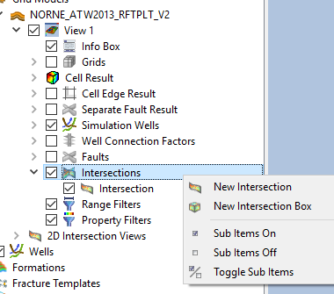Example   
Select “New Intersection” from **Intersections.**

**Tips and tricks**

Please close the existing project (“File->Close Project”) before starting a new tutorial. This will help you to avoid confusion caused by data from previous tutorials.

## 3D Grid Visualization

#### Objective: Get familiar with basic visualization concepts

1. 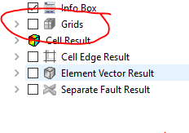Import grid data using “Import Eclipse Case” from folder “norne”
2. In Project Tree, select **Cell Result**
3. In Property Editor, change “Result Property” to “PRESSURE”
4. Move to the last time step using the play toolbar button
5. Click on different cells, and investigate the plots for Relative Permeability Plot, PVT Plot and Result Plot
6. To see the simulation wells, turn off **Grids** (see snapshot hint to the right)
7. Open main application plot window and select “Import Summary Case” from “norne”. This data source is required to be able to see well disks
8. Select **Simulation Wells** in the Property Editor
9. Enable **Disks** in the **Visibility** group. Data source for the disks can be changed in the **Disks** group at the bottom of the **Property Editor** for Simulation Wells
10. Expand Simulation Wells and enable **Well Connection Factors.** Click on the well connection factors star symbol and investigate the values in the **Result Info** panel.

You may change mouse interaction mode in “Edit->Preferences->Navigation Mode”, c.f. <https://resinsight.org/getting-started/modelnavigation/>

**Online tutorial**

<https://github.com/CeetronSolutions/resinsight-tutorials/blob/main/tutorials/grid-visualization/grid-visualization.md>

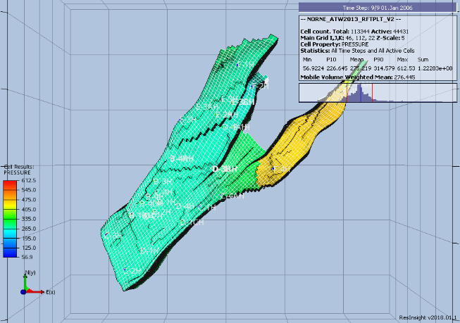

## 3D Grid Inspection Features – Intersections

*Objective: Able to show and manage intersections*

1. Import grid data using “Import Eclipse Case” from folder “norne”
2. Right-click on the surface of the grid model, and select “Intersections->Polyline Intersection”
3. Select a few points on the surface to define an intersection, and click “Stop picking points” in the Property editor
4. Turn off **Grids** and **Faults** in the **Project Tree** to see the intersection geometry

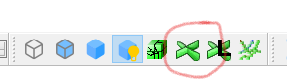 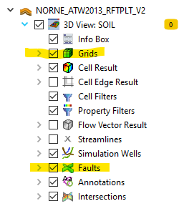

1. Mark the checkbox in front of the intersection object in the folder “2D Intersection Views”   
   A flat 2D intersection view is displayed
2. Right-click on a simulation well and select **New Intersection**. Activate the corresponding 2D intersection view  
   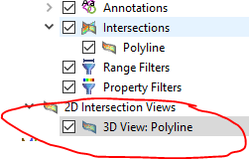

When many intersections are visible, they might obscure other interesting geometry in the model. Visibility of parts of the intersection geometry can be controlled from the **Depth Filter** group in **Property Editor.**

<https://resinsight.org/3d-main-window/derivedresults/>  
<https://resinsight.org/3d-main-window/gridpropertycalculator/>

1. 3D Grid Inspection Features – Fault Analysis

*Objective: Able to show and manage cell edge results, formations, Allan diagrams*

1. Import grid data using “Import Eclipse Case” from folder “norne”
2. Move to the last time step using the play toolbar button
3. Turn off grid visualization to see faults
4. Open folder **Faults** in **Project Tree,** right-click fault “GH”, and select “On – Others off”
5. Activate **Fault Result**, and select this object
6. In the **Property Editor**, select Type “Static”, and select result “TRANXYZ”. Now you can see transmissibility for all **NNCs** across the fault.
7. Create a new view
8. Import formations using “File->Import->Import Formation Names”, select file “norne/Norne_Fm.lyr”
9. Turn off grid visualization to see faults
10. In **Project Tree**, open folder **Faults,** right-click fault “GH”, and select “On – Others off”
11. Activate **Fault Result**, and select this object
12. In the **Property Editor,** select Type “Allan Diagrams” and select Result Property “Formation Allan” in **Result**
13. Click on fault “GH”, and investigate the text output in the **Result Info** dialog
14. Make sure there are at least two views in your project
15. Right-click in the 3D scene (outside the grid model), and select “Compare To: -> Name of other view”
16. 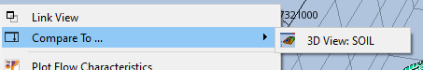Manipulate the slider to see data from the two results
17. Create a new view
18. Turn on **Cell Edge Result**. By default, the MULT values are mapped onto the edges of the cells. Click on cells defining close to a fault, and investigate the text output in the **Result Info** dialog

<https://resinsight.org/3d-main-window/3dviews/>  
<https://resinsight.org/3d-main-window/allandiagrams/>

## 2D Contour Map

#### Objective: Create and configure a 2D contour map

1. Open the main 3D plot window
2. Import grid data using “Import Eclipse Case” from “norne”
3. Import formation file (see previous tutorial) “Norne_subZones.lyr”
4. Contour Map of SWAT
   1. In the right click menu of the view, select “New Contour Map from 3d view”
   2. Select **SWAT** as Cell Result  
        
      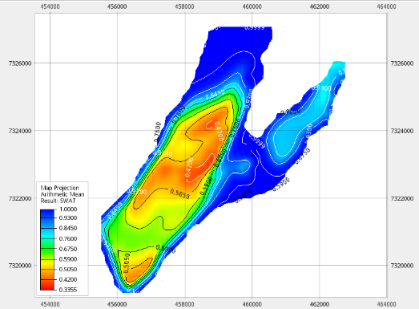
5. Contour Map of Oil Column
   1. From the right click menu of the **Contour Map**, select “Duplicate Contour Map”
   2. Select object **Map Projection**
   3. Select “Oil Column” from **Result Aggregation**
   4. Compute oil column for a selection of formations
      1. Create property filter based on “Formation Names”
      2. In property filter, select formations “Garn 2” and “Garn 3
6. 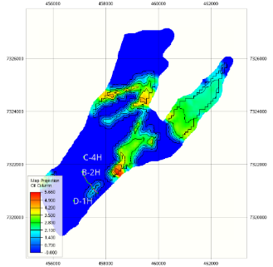In the “Windows” menu, select “Tile Windows” to see both plots next to each other

<https://resinsight.org/3d-main-window/contourmaps/>

## Flow Diagnostics

#### Objective: Get an overview of how Flow Diagnostics data is accessed and visualized

1. Import grid data using “Import Eclipse Case” from folder “norne”
2. Go to last time step
3. Select **Cell Result**, and change type to “Flow Diagnostics”
4. Change “Tracers” to “By Selection”
5. Select single injector **C-2H**
   1. Select Result property “Forward Time of Flight” (unit for time is years)
   2. Create a property filter, show cells close to the injector by reducing the max value
6. Create new view, select producer **B-2H** and “Reverse Time of Flight”
   1. Create property filter
   2. Select “Well Plots->Plot Well Allocation” in right click menu of **B-2H**
   3. Select “Show Contributing Wells” for **B-2H** in right click menu of **B-2H**A custom 3D view is created with only data for wells related to the flow in B-2H.
   4. Enable “Communication Lines” on “Simulation wells”  
      The bands visualize the flow direction/rate between wells

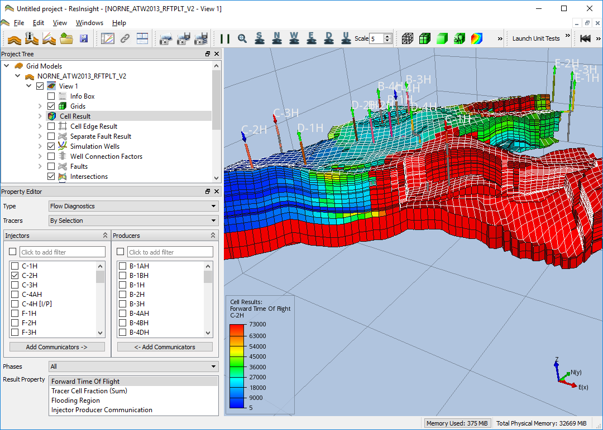

<https://resinsight.org/plot-window/flowdiagnosticsplots/>

<https://resinsight.org/3d-main-window/cellresults/#flow-diagnostic-results>

## Summary Plots

#### Objective: Able to configure summary plots with curves

1. Open main application plot window and select “Import Summary Case” from “norne”
2. Open the Data Sources panel
3. Navigate to B-2H WBHP, and select **New Summary Plot** from the right-click menu
   1. Use the toolbar to change data source for the curve  
      
4. Select wells C-1H, C-2H and C-3H. Right-click selected wells, and activate **Append Plots for Wells**
5. Adjust the number of columns and rows for each page   
   

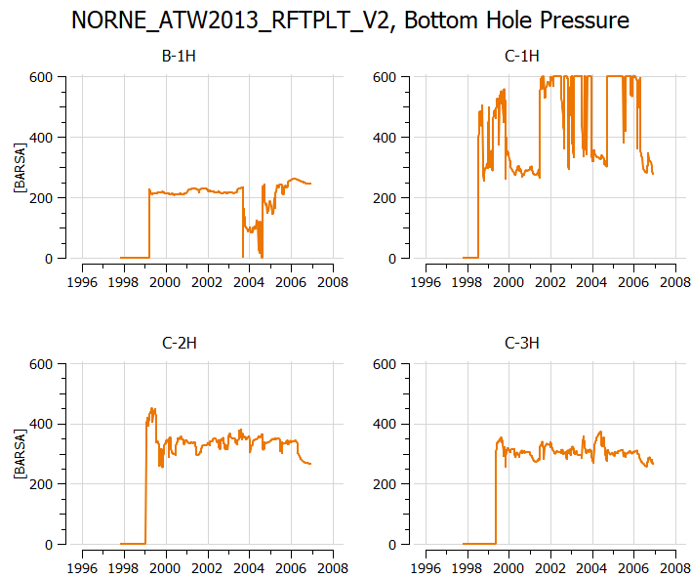

<https://github.com/CeetronSolutions/resinsight-tutorials/blob/main/tutorials/summary-plot/summary-plot.md>

## Summary Plots – calculated curves

#### Objective: Able to configure summary plots with curves and calculate a derived curve

1. Open main application plot window and select “Import Summary Case” from “norne”
2. From the **Data Sources** panel, navigate to B-2H WBHP, and select “New Summary Plot” from the right-click menu
3. Drag and drop B-4H into the same plot
4. Open the curve calculator by clicking a button in the toolbar  
   
5. Calculate the sum of WOPT for B-2H and B-4H, select “Calculate” then close the curve calculator
6. Open the plot editor from the right-click menu of “Sub Plot 1”
7. Add the calculated curve from the “Calculated” Summary Types, and close the dialog by clicking **OK** button

## Observed Data Plots

#### Objective: Import and visualize curves from both simulated and observed data

1. Open a text editor and look at the content of “norne_well_data” to see what data we are supposed to import
2. Open plot window and select “Import Summary Case” from “norne”
3. Import observed data files in folder “norne_well_data/BHP_B1-H.csv” from menu “Import->Import Observed Data”
4. Enable the checkbox “Use Custom Date Time Format” and type the string **yyyy-MM** in “Custom Date Time Format”.
5. Create a new plot with observed and simulated data for **WBHP** for well **B-1H**
   1. The curves use separate axis by default. Workaround to make sure both curves use same axis:  
      Select the first curve. In **Property Editor**, select the first item in the **Axis** list. Repeat for second curve.
6. Import all observed data files in folder “norne_well_data/BHP_B1-H_error.csv” from menu “Import->Import Observed Data”
7. Enable the checkbox “Use Custom Date Time Formant” and type the string yyyy-MM in “Custom Date Time Format”.
8. Create a new plot with observed and simulated data for **WBHP** for well **B-1H,** make sure you show curve data including error data

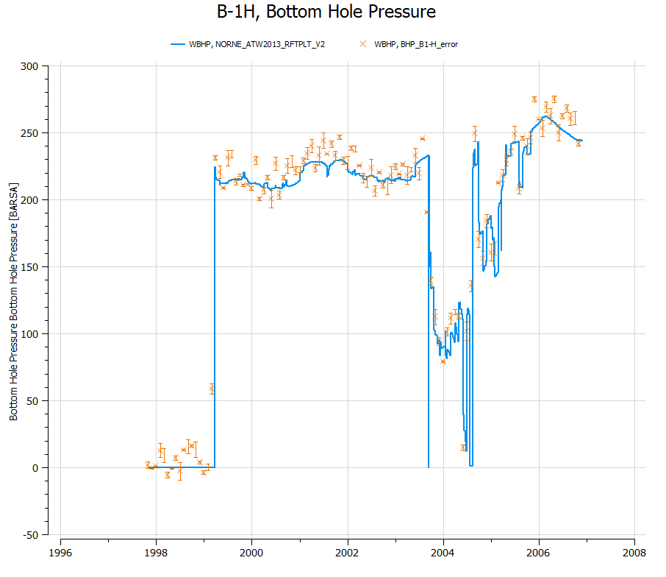 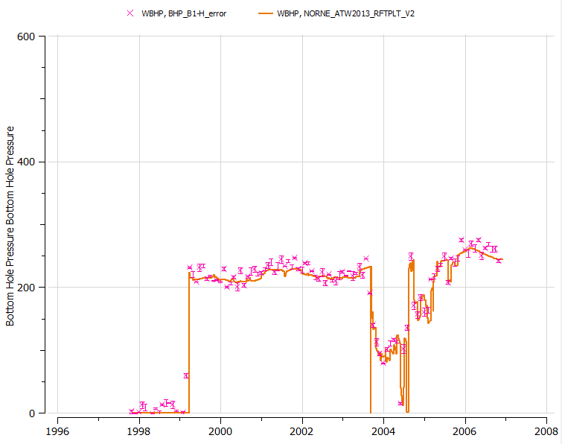  
 **Figure 1: B-1H WBHP from step 3-5 above Figure 1: B-1H WBHP from step 6-8 above**

## Ensemble Plots (1 of 2)

#### Objective: Import of ensemble data and plot ensemble curves

1. Import base ensemble
   1. Import data using “Import Ensemble” toolbar button and use the browse dialog by pushing the … button. The following path pattern should be used:  
      “reek_ensemble\3_r001_reek_50\realization-0\iter-0\*"
   2. Click **Find** and **OK**
2. Create a new plot of well oil production total for well **OP_5**
3. Use the data source stepping toolbar to change plot to other wells
4. In the property editor for the generated ensemble curve set, change “Coloring Mode” to “By Ensemble Parameter”
5. Test with different settings for Statistics curves in the property editor and see the effect in the plot

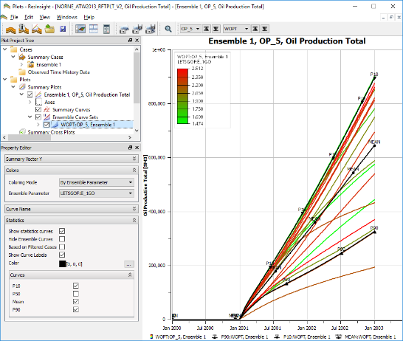

#### 

## Ensemble Plots (2 of 2)

#### Objective: Compute and show difference between two ensembles

1. Import base ensemble (can be skipped if data was loaded in previous tutorial)
   1. Import data using “Import Ensemble” and set the root folder to   
      “reek_ensemble\3_r001_reek_50\realization-0\base_pred\eclipse\*"
   2. Click **Find** and **OK**
2. Import prediction ensemble
   1. Import data using “Import Ensemble” and set the root folder to   
      “reek_ensemble\3_r001_reek_50\realization-0\pred_op6\eclipse\*"
   2. Click **Find** and **OK**
3. Create delta ensemble
   1. In right click menu of **Data Sources**, **Summary Cases**, select “New Delta Ensemble”
   2. Select “pred_op6” as **Ensemble 1**
   3. Select “base_pred” as **Ensemble 2**
   4. Create a new plot, select ensemble “Delta(pred_op6, base_pred)” and expand Field to plot **FOPT**
   5. In the “Statistics” group, check item “Hide Ensemble curves”
   6. In the right click menu in the plot, select “Show Plot Data” to see curve values including P10 and P90

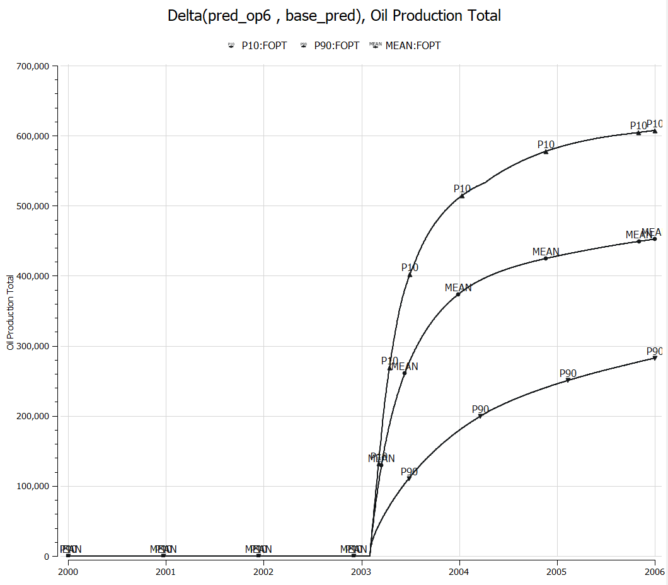 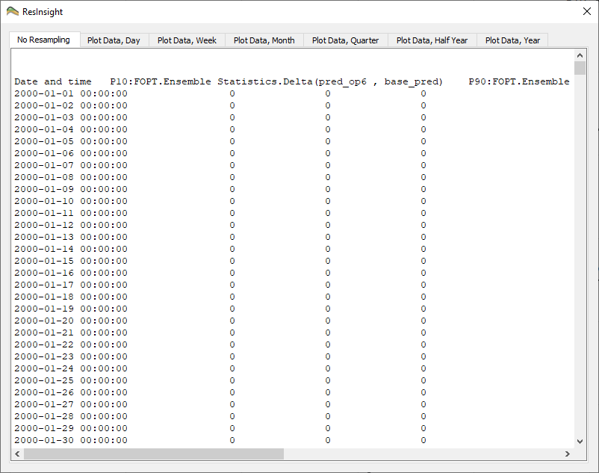

## Plot Templates

#### Objective: Store plot setup with customized curve appearance for reuse on different data

1. Import multiple summary cases as standalone cases
   1. Import data using “File->Import->Import Summary Cases Recursively” and set Path pattern to  
      “reek_ensemble\3_r001_reek_50\realization-0\base_pred\eclipse\*"
   2. Click **Find** and **OK**
2. Create a plot, and from the right-click menu select “Open Summary Plot Editor”
3. Select two realizations
4. Select well **OP_1** and select summary vector WOPR (Well oil production rate)
5. Change the curve appearance of the two curves the way you like best
6. In the plot area, activate the right-click menu and select “Save As Plot Template”. Create a folder in your user area and store this plot template in this folder using the template name “wopr_two_cases”
7. Apply an existing template
   1. In **Data Sources**, select two other summary cases than the ones used to produce template
   2. From the right-click menu, invoke “Create Plot from Template” and select the plot template you created (“wopr_two_cases”)
   3. Note that the visual settings you stored in the template are applied to the generated plot

**Hint:** An existing template can be applied to a selection of summary ensemble cases

<https://resinsight.org/plot-window/summaryplottemplate/>

## RFT Plots

1. Import grid data using “Import Eclipse Case” from folder “norne”
2. Untick **Simulation Wells** to hide simulation wells to easier see imported well paths
3. From right click menu of **Wells**, select “Import Well Paths from File” and select well path “C-1H.dev” in folder “norne_rft”
4. From right click menu of well path **C-1H**, select “Import Well Logs from File”, select “C-1H_RFT_dummy.las” in folder “norne_rft”
5. From right click menu of well path **C-1H**, select “Well Plots->New RFT plot”

*Optional: Import formations (right-click* ***Formations*** *in* ***Project Tree*** *and select Import Formations) to see formation names in the plot.*  
<https://resinsight.org/plot-window/rftplot/>

## Ensemble RFT Plots

1. Import data using “Import Ensemble” from folder “1_r001_reek_20_rft”
2. Import observations using “Import Observed FMU Data” from folder “reek_rft”
3. Select Imported FMU RFT Data 1, and look at the information in the property editor
4. 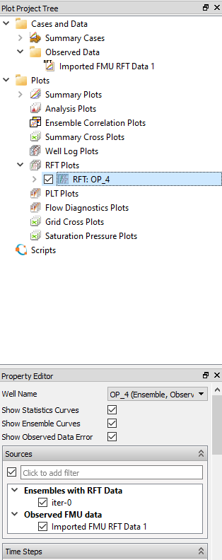From the right-click menu of **RFT Plots**, select “New RFT Plot”
5. Change the Well to OP_4  
     
   <https://resinsight.org/plot-window/ensemblerftplot/>

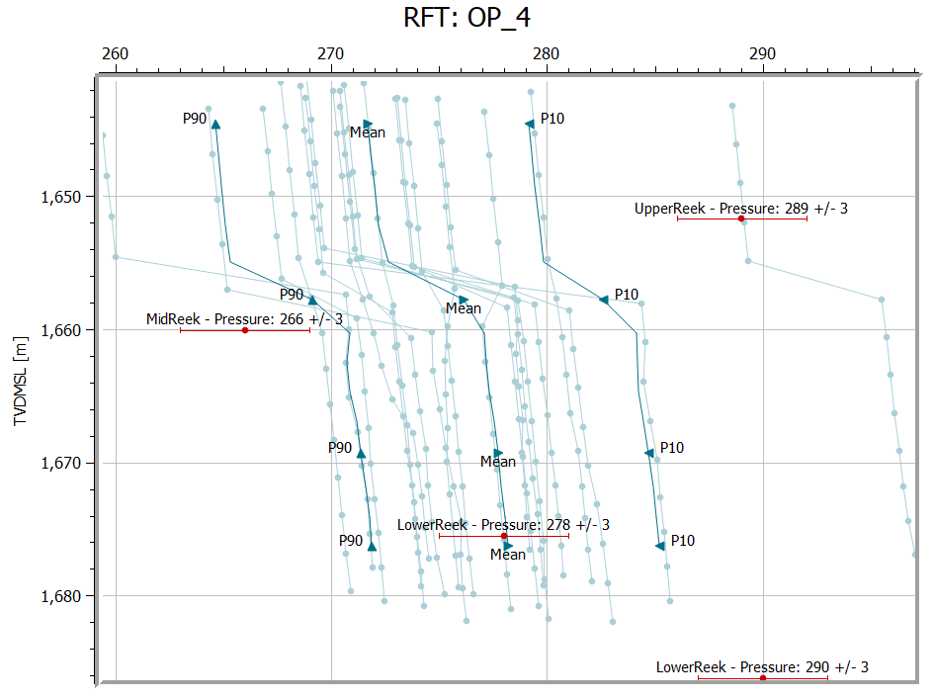

## Correlation Analysis

*Objective: Create and configure a Correlation Plot*

* Import a Summary Ensemble, and use import path "reek_ensemble/3_r001_reek_50/realization-*/iter-1”
* From the right-click of a curve, select “Create Correlation Plot from Curve Point ->New Report Plot”
* Click on individual cells in the **Correlation Matrix**, and see how the cross plot is updated  
  Currently selected cell is indicated by a border in green
* Show Pearson calculation
* Change data source to **WOPT** for all wells **OP_1** to **OP_5**
* Click on individual cells in the **Correlation Matrix**, and see how the cross plot is updated

<https://resinsight.org/plot-window/correlationplots/>

**Definition of how the Pearson correlation coefficient is computed**

<https://en.wikipedia.org/wiki/Pearson_correlation_coefficient#For_a_sample>

X is input parameter value, Y is simulated value

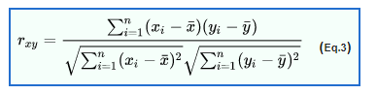

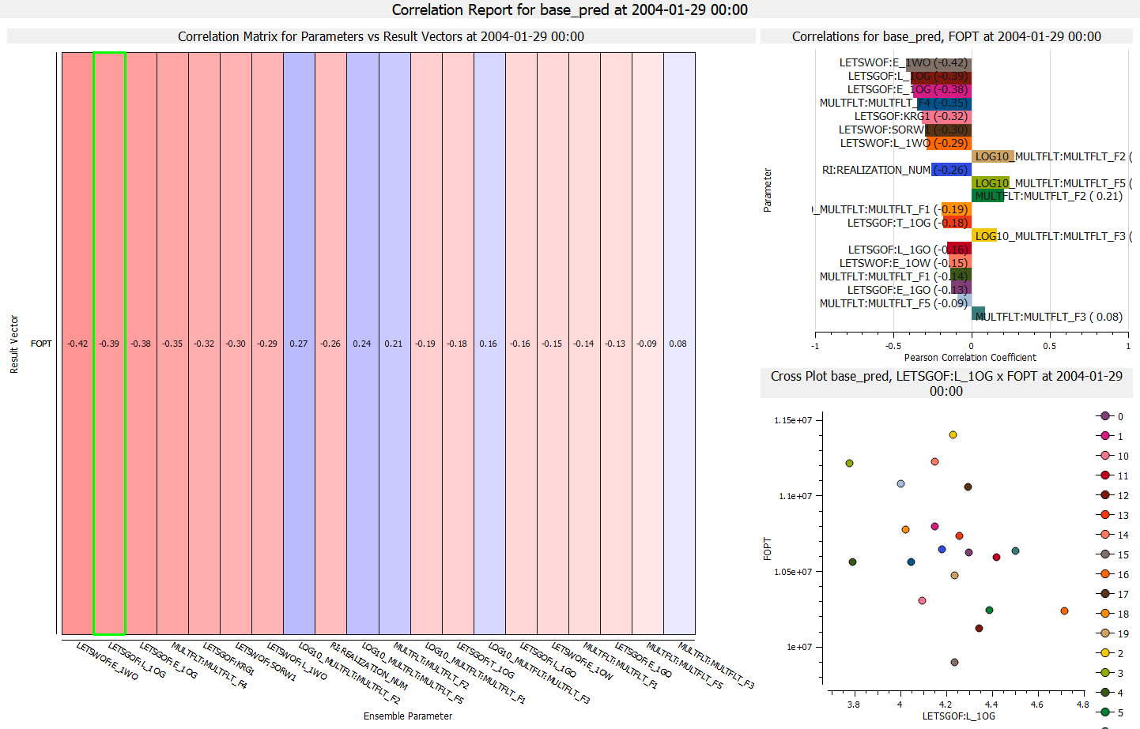

## Analysis Plot

*Objective: Create and configure an Analysis Plot*

* Import a Summary Ensemble, and use import path "reek_ensemble/3_r001_reek_50/realization-0/base_pred”
* Import a Summary Ensemble, and use import path "reek_ensemble/3_r001_reek_50/realization-0/pred_op6”
* Select **New Delta Ensemble** from right-click on **Summary Cases**  
  Create a **Delta Ensemble** as the difference between the two cases (pred_op6 - base_pred)
* Select new **Analysis Plot**
* In Property Editor, in group Selected Vectors, click on the button with three dots “…”
  + Set source **Delta ensemble**
  + Select wells **OP_1-5**
  + Select Summary Vector **WOPT**
* Bar Orientation: **Horizontal**
* Select major grouping **Summary Item**
* Select sort by abs(Value)
* Optionally
  + Show legend
  + Bar labels  
    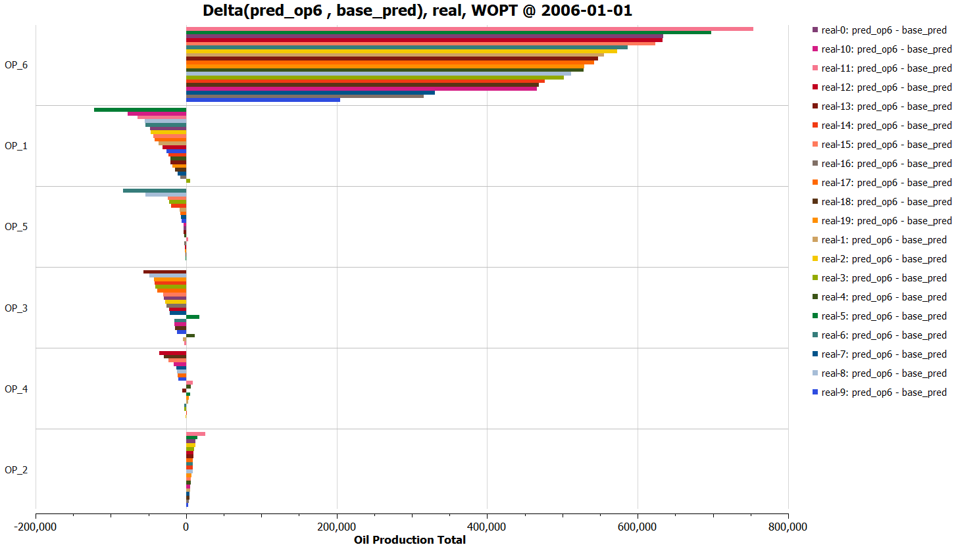

<https://resinsight.org/plot-window/analysisplots/>