**ResInsight User Course  
April 2024**

1. Welcome, course layout and introductory remarks
2. ResInsight Introduction and Overview

a) 3D Grid Visualization 5

b) 3D Grid Inspection Features – Intersections 6

c) Polygons 7

d) 3D Grid Inspection Features – Fault Analysis 8

e) 2D Contour Map 10

f) Description of Flow Diagnostics 11

g) Flow Diagnostics – 3D view 12

h) Flow Diagnostics – plots 14

i) Summary Plots 15

j) Summary Cross Plot Curves 16

k) Summary Plots – calculated curves 17

l) Summary Data in Table 19

m) Summary Decline Curves 20

n) Summary Regression Curves 21

o) Observed Data Plots 22

p) Ensemble Plots (1 of 2) 23

q) Ensemble Plots (2 of 2) 24

r) Plot Templates 25

s) RFT Plots 26

t) Ensemble RFT Plots 27

u) Correlation Analysis 28

v) Analysis Plot 30

**Support and Resources**

**Main help page**<https://resinsight.org/>

**Tutorials and recordings**

Tutorial site for ResInsight  
<https://github.com/CeetronSolutions/resinsight-tutorials>

Video recording of selected tutorials  
<https://www.youtube.com/channel/UCEJoH_ti1YZXz4hPMeAKMgw>

**Overview of the interface for 3D visualization**

<https://github.com/CeetronSolutions/resinsight-tutorials/blob/main/tutorials/graphical-user-interface/graphical-user-interface.md>

**Preparations**

Test models used in tutorials are available from <https://github.com/CeetronSolutions/resinsight-tutorials>

Either clone the GitHub repository, or select “**Download ZIP**” from the **Code** menu

**Conventions**

In this document, **bold text** indicates an object in the property tree. Menu item text is “written in quotes”.

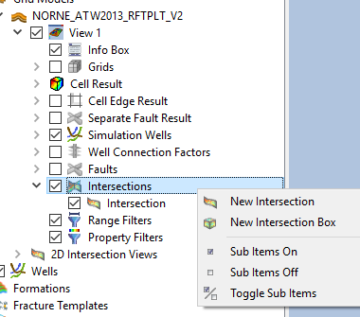Example   
Select “New Intersection” from **Intersections.**

**Tips and tricks**

Please close the existing project (“File->Close Project”) before starting a new tutorial. This will help you to avoid confusion caused by data from previous tutorials.

## 3D Grid Visualization

#### Objective: Get familiar with basic visualization concepts

1. 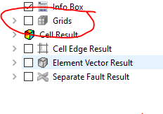Import grid data using “Import Eclipse Case” from folder “model-data/norne”
2. In Project Tree, select **Cell Result**
3. In Property Editor, change “Result Property” to “PRESSURE”
4. Move to the last time step using the play toolbar button
5. Click on different cells, and investigate the plots for Relative Permeability Plot, PVT Plot and Result Plot
6. To see the simulation wells, turn off **Grids** (see snapshot hint to the right)
7. Open main application plot window and select “Import Summary Case” from “norne”. This data source is required to be able to see well disks
8. Select **Simulation Wells** in the Property Editor
9. Enable **Disks** in the **Visibility** group. Data source for the disks can be changed in the **Disks** group at the bottom of the **Property Editor** for Simulation Wells
10. Expand Simulation Wells and enable **Well Connection Factors.** Click on the well connection factors star symbol and investigate the values in the **Result Info** panel.

You may change mouse interaction mode in “Edit->Preferences->Navigation Mode”, c.f. <https://resinsight.org/getting-started/modelnavigation/>

**Online tutorial**

<https://github.com/CeetronSolutions/resinsight-tutorials/blob/main/tutorials/grid-visualization/grid-visualization.md>

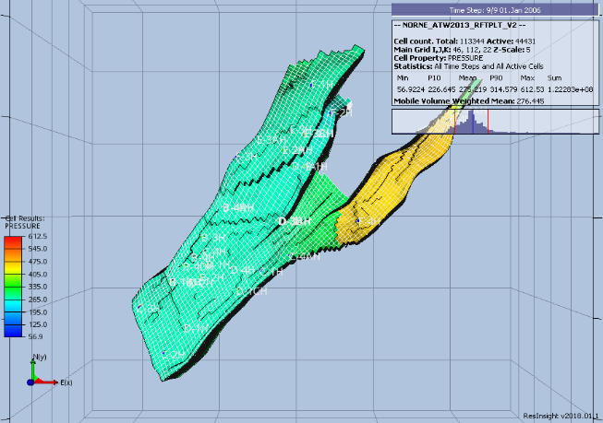

## 3D Grid Inspection Features – Intersections

*Objective: Able to show and manage intersections*

1. Import grid data using “Import Eclipse Case” from folder “model-data/norne”
2. Right-click on the surface of the grid model, and select “Intersections->Polyline Intersection”
3. Select a few points on the surface to define an intersection, and click “Stop picking points” in the Property editor
4. Turn off **Grids** and **Faults** in the **Project Tree** to see the intersection geometry

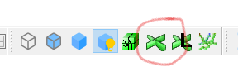 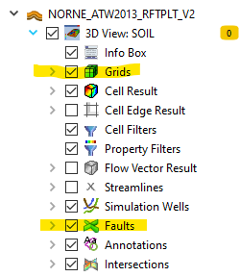

1. Mark the checkbox in front of the intersection object in the folder “2D Intersection Views”   
   A flat 2D intersection view is displayed
2. Right-click on a simulation well and select **New Intersection**. Activate the corresponding 2D intersection view  
   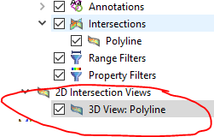

When many intersections are visible, they might obscure other interesting geometry in the model. Visibility of parts of the intersection geometry can be controlled from the **Depth Filter** group in **Property Editor.**

<https://resinsight.org/3d-main-window/derivedresults/>  
<https://resinsight.org/3d-main-window/gridpropertycalculator/>

## Polygons

*Objective: Create and manage polygons and use polygons in filtering operations*

1. Import grid data using “Import Eclipse Case” from folder “model-data/norne”
2. A screenshot of a computer

   Description automatically generatedFrom the right-click menu, select **Polygon**A screenshot of a computer

   Description automatically generated
3. Add point to the polygon by clicking on locations on the grid model. Coordinates will be displayed in the yellow input field in the **Property Editor**.  
   The polygon object is created in the **Polygons Project** folder, and the visibility of the polygon is controlled in the **Polygons** folder inside a view.
4. Click **Stop Picking Points** to end the coordinate input mode.
5. From the right-click menu of the **Polygon**, select **Create Polygon Filter**
6. Manipulate the polygon by dragging in 3D, and investigate the filtered cells. Number of cells including statistics is displayed in the info box A screenshot of a computer

   Description automatically generated  
     
   Polygons can be imported from text files.  
   <https://resinsight.org/3d-main-window/polygons/>

## 3D Grid Inspection Features – Fault Analysis

*Objective: Able to show and manage cell edge results, formations, Allan diagrams*

1. Import grid data using “Import Eclipse Case” from folder “model-data/norne”
2. Move to the last time step using the play toolbar button
3. Turn off grid visualization to see faults
4. Open folder **Faults** in **Project Tree,** right-click fault “GH”, and select “On – Others off”
5. Activate **Fault Result**, and select this object
6. In the **Property Editor**, select Type “Static”, and select result “TRANXYZ”. Now you can see transmissibility for all **NNCs** across the fault.
7. Create a new view
8. Import formations using “File->Import->Import Formation Names”, select file “norne/Norne_Fm.lyr”
9. Turn off grid visualization to see faults
10. In **Project Tree**, open folder **Faults,** right-click fault “GH”, and select “On – Others off”
11. Activate **Fault Result**, and select this object
12. In the **Property Editor,** select Type “Allan Diagrams” and select Result Property “Formation Allan” in **Result**
13. Click on fault “GH”, and investigate the text output in the **Result Info** dialog
14. Make sure there are at least two views in your project
15. Right-click in the 3D scene (outside the grid model), and select “Compare To: -> Name of other view”
16. 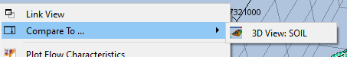Manipulate the slider to see data from the two results
17. Create a new view
18. Turn on **Cell Edge Result**. By default, the MULT values are mapped onto the edges of the cells. Click on cells defining close to a fault, and investigate the text output in the **Result Info** dialog

<https://resinsight.org/3d-main-window/3dviews/>  
<https://resinsight.org/3d-main-window/allandiagrams/>

## 2D Contour Map

#### Objective: Create and configure a 2D contour map

1. Open the main 3D plot window
2. Import grid data using “Import Eclipse Case” from “model-data/norne”
3. Import formation file (see previous tutorial) “Norne_subZones.lyr”
4. Contour Map of SWAT
   1. In the right click menu of the view, select “New Contour Map from 3d view”
   2. Select **SWAT** as Cell Result  
        
      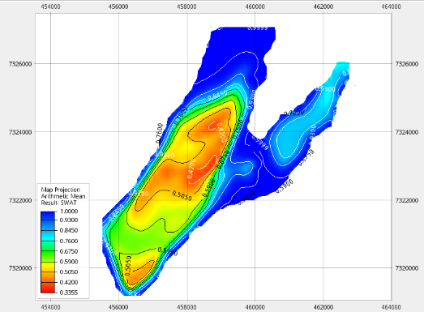
5. Contour Map of Oil Column
   1. From the right click menu of the **Contour Map**, select “Duplicate Contour Map”
   2. Select object **Map Projection**
   3. Select “Oil Column” from **Result Aggregation**
   4. Compute oil column for a selection of formations
      1. Create property filter based on “Formation Names”
      2. In property filter, select formations “Garn 2” and “Garn 3
6. 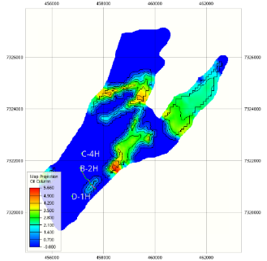In the “Windows” menu, select “Tile Windows” to see both plots next to each other

<https://resinsight.org/3d-main-window/contourmaps/>

## Description of Flow Diagnostics

A **Flow Diagnostics** simulator developed by **SINTEF** based on **MRST(MATLAB Reservoir Simulation Toolbox)** is included in **ResInsight**. The flow diagnostics simulator as described by **SINTEF**:

*“Flow diagnostics are simple and controlled numerical flow experiments run to probe a reservoir model, establish connections and basic volume estimates, and measure dynamic heterogeneity. Flow diagnostic quantities are quick to compute and can thus be used interactively to explore fluid communication in a geological model before or after more comprehensive multiphase flow simulations.”*

The following table displays the short name used by **ResInsight** and the more detailed description taken from the **SINTEF** documentation.

|  |  |
| --- | --- |
| ResInsight naming | Flow Diagnostics description (SINTEF) |
| Forward time of flight (injectors)  Reverse time of flight (producers) | Travel time for mass-less particles that passively follow the flow field from an injector into the reservoir and from a point in the reservoir to the nearest producer |
| Drainage/flooding regions | Delineate regions drained by given producers or swept (flooded) by given injectors |
| Injector Producer communication | Determine whether pairs of injectors and producers communicate or not and measure the relative strength of their connection |
| Tracer Cell Fraction | Determine how flux is allocated between different injectors and producers |

Flow diagnostics use the flux field (flow rates) defined per grid cell (FLROIL/FLRGAS/FLRWAT). These cell properties can be exported from a reservoir simulator by adding the keyword **FLORES** to **RPTRST** in both **SOLUTION** section and **SCHEDULE** section. If no flow rate data is available, **ResInsight** will estimate the flow field. Users are encouraged to export flow rates from the simulator for best precision.

<https://www.sintef.no/projectweb/mrst/modules/diagnostics/>

## Flow Diagnostics – 3D view

#### Objective: Get an overview of how Flow Diagnostics data is accessed and visualized

1. Import gri data using “Import Eclipse Case” from folder “model-data/norne”
2. Go to last time step
3. Select **Cell Result**, and change type to “Flow Diagnostics”
4. Change “Tracers” to “By Selection”
5. Select single injector **C-2H**
   1. Select Result property “Forward Time of Flight” (unit for time is days)
   2. Create a property filter, show cells close to the injector by reducing the max value
6. Create new view, set “Tracers” to “By Selection”
   1. Select producer **B-2H** and “Reverse Time of Flight”
   2. Create a property filter to see cells communicating with **B-2H**
   3. In right click menu of **B-2H,** select “Well Plots->Plot Well Allocation”
   4. In the plot area of the well allocation plot, open the right click menu and select “Show Contributing Wells”  
        
      **A screenshot of a computer

      Description automatically generated**  
      A custom 3D view is created with only data for wells related to the flow in **B-2H**.
   5. A screenshot of a computer

      Description automatically generatedIn the “3D Project Tree, select “Simulation wells”  
      In the **Property Editor**, enable “Communication Lines”   
      The bands visualize the flow direction/rate between wells

<https://resinsight.org/plot-window/flowdiagnosticsplots/>

<https://resinsight.org/3d-main-window/cellresults/#flow-diagnostic-results>

## Flow Diagnostics – plots

#### Objective: Get an overview of how Flow Diagnostics data is accessed and visualized

1. Import grid data using “Import Eclipse Case” from folder “model-data/norne”
2. Go to last time step
3. In the right click menu of **B-2H**, select “Well Plots->Plot Well Allocation”
   1. Investigate the different settings in Property Editor -> Options, adjust **Plot Type** and **Flow Type**
4. Enable the plot “Well Allocation over time” to see the distribution for all time steps
5. In the **Plot Project Tree**, make sure the checkbox for **Producer/Injector Connectivity** is enabled
   1. Disable Filter by 3D View to see all wells
   2. Set the time step to 2002 and see how the communication changes
   3. A screenshot of a computer

      Description automatically generatedCompare the communication for well **D-3AH** to the well allocation plot for **D-3AH** at the same time step

## Summary Plots

#### Objective: Able to configure summary plots with curves

1. Open main application plot window and select “Import Summary Case” from “model-data/norne”
2. Open the Data Sources panel
3. Navigate to B-2H WBHP, and select **New Summary Plot** from the right-click menu
   1. Use the toolbar to change data source for the curve  
      
4. Select wells C-1H, C-2H and C-3H. Right-click selected wells, and activate **Append Plots for Wells**
5. Adjust the number of columns and rows for each page   
   

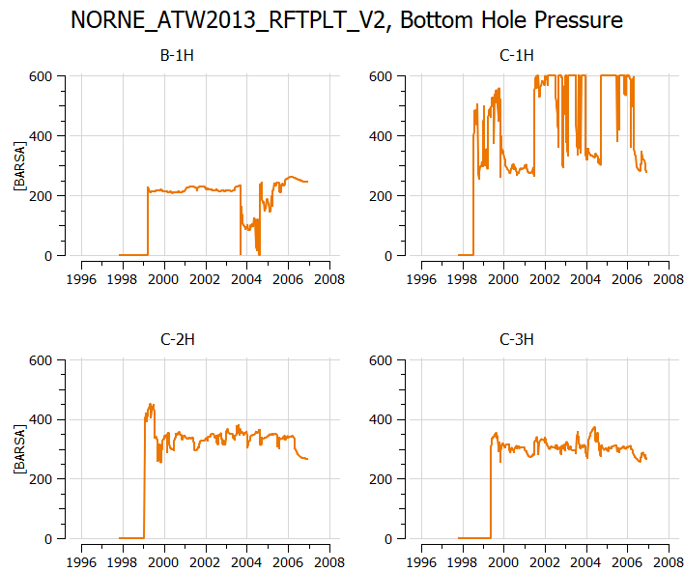

<https://github.com/CeetronSolutions/resinsight-tutorials/blob/main/tutorials/summary-plot/summary-plot.md>

## Summary Cross Plot Curves

#### Objective: Create and work with summary cross plot curves

1. A screenshot of a computer

   Description automatically generatedOpen main application plot window and select “Import Summary Case” from “model-data/norne”
2. Open the Data Sources panel
3. Navigate to **Field**, and select **Create Summary Cross Plot->FWIR FOPT** from the right-click menu
4. Navigate to a well and select **Create Summary Cross Plot** from the right-click menu. The list of possible cross plots is adjusted to fit the selected well.
5. The combination of vectors can be modified in **Preferences->Plotting->Cross Plot Addresses**  
     
   A graph with blue lines

   Description automatically generated

<https://resinsight.org/plot-window/summarycrossplots/>

## Summary Plots – calculated curves

#### Objective: Able to configure summary plots with curves and calculate a derived curve

1. Open main application plot window and select “Import Summary Case” from “model-data/norne”
2. From the **Data Sources** panel, navigate to **B-2H WGPR**, and select “New Summary Plot” from the right-click menu
3. Drag and drop **B-2H WOPR** into the same plot
4. Open the curve calculator by clicking a button in the toolbar  
   
5. Calculate gas-oil ratio for **B-2H** using the formula ***my_GOR := GasRate/OilRate***
6. Select and assign the corresponding summary vector for each variable
7. Press “Calculate” then close the curve calculator  
   The new vector is now available at the bottom of the vector list for a well  
   Text, table

   Description automatically generated with medium confidence
8. Drag and drop **my_GOR** into the plot and investigate the calculated curve.

* A calculation will by default be available for all items of the same type. In the example above, **my_GOR** will be available for all wells and is calculated on demand.
* If a vector is calculated based on two different types of vectors, the calculation will appear in the same collection as the first variable
* The calculation **FOPT+WOPT B-2H** will appear in field vectors, and the **WOPT B-2H+FOPT** will appear in wells
* The user can control if a calculation should be distributed to other items in the same group

Operations on calculations are available in the button group below calculations.

<https://resinsight.org/calculated-data/curvecalculator/>

## Summary Data in Table

*Objective: Display summary data in a table to quickly get an overview of reservoir drainage stategy*

* Import summary data from "norne/NORNE_ATW2013_RFTPLT_V2.SMSPEC”
* From the right-click menu of **Summary Tables**, select “New Summary Table”
* For **WBHP** table, set the threshold value to 150. Wells with value below this threshold are hidden
* Change the **Colors** to “Blue to Magenta”
* Create a summary table displaying **WOPR, WWCT,** and **WGOR**
* To see all tables at the same time, select **Windows->Tile Windows**  
  This operation is also available as a tool button on the toolbar

## Summary Decline Curves

*Objective: Show estimates of future production based on curve analysis*

* Import summary data from "norne/NORNE_ATW2013_RFTPLT_V2.SMSPEC”
* Create a plot for **WOPR:B-2H**
* From the right-click menu of the curve, select “Create Decline Curves”  
    
  A screenshot of a computer

  Description automatically generated

* Select all thre curves and modify the curve values to be estimated
* Inside the plot, right-click and select “Show Plot Data” to see the estimated production

## Summary Regression Curves

*Objective: Enable and configure regression analysis curves for summary data*

* Import summary data from "norne/NORNE_ATW2013_RFTPLT_V2.SMSPEC”
* Create a summary plot of **FGOR**
* Right-click the line object, and select “Create Regression Analysis Curve”
* Set the **Forward Forecast** to 5 years
* In the **Time Selection** group, modify the from date to see how the regression curve changes based on input data
* Select polynomial regression

## Observed Data Plots

#### Objective: Import and visualize curves from both simulated and observed data

1. Open a text editor and look at the content of “norne_well_data” to see what data we are supposed to import
2. Open plot window and select “Import Summary Case” from “norne”
3. Import observed data files in folder “model-data/norne_well_data/BHP_B1-H.csv” from menu “Import->Import Observed Data”
4. Enable the checkbox “Use Custom Date Time Format” and type the string **yyyy-MM** in “Custom Date Time Format”.
5. Create a new plot with observed and simulated data for **WBHP** for well **B-1H**
   1. The curves use separate axis by default. Workaround to make sure both curves use same axis:  
      Select the first curve. In **Property Editor**, select the first item in the **Axis** list. Repeat for second curve.
6. Import all observed data files in folder “model-data/norne_well_data/BHP_B1-H_error.csv” from menu “Import->Import Observed Data”
7. Enable the checkbox “Use Custom Date Time Formant” and type the string yyyy-MM in “Custom Date Time Format”.
8. A graph of a graph showing the growth of a stock market

   Description automatically generated with medium confidenceCreate a new plot with observed and simulated data for **WBHP** for well **B-1H,** make sure you show curve data including error data

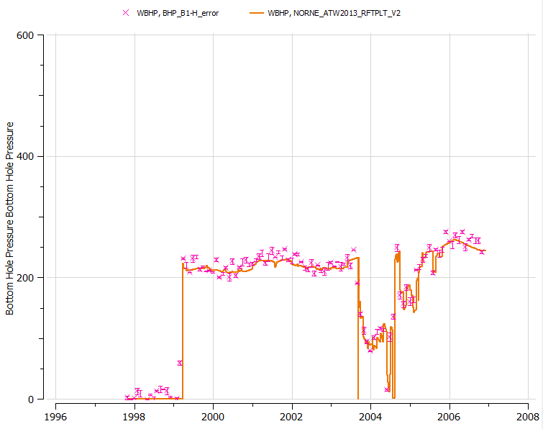

## Ensemble Plots (1 of 2)

#### Objective: Import of ensemble data and plot ensemble curves

1. Import base ensemble
   1. Import data using “Import Ensemble” toolbar button and use the browse dialog by pushing the … button. The following path pattern should be used:  
      “model-data/reek_ensemble/3_r001_reek_50/realization-0/iter-0/*"
   2. Click **Find** and **OK**
2. Create a new plot of well oil production total for well **OP_5**
3. Use the data source stepping toolbar to change plot to other wells
4. In the property editor for the generated ensemble curve set, change “Coloring Mode” to “By Ensemble Parameter”
5. Test with different settings for Statistics curves in the property editor and see the effect in the plot

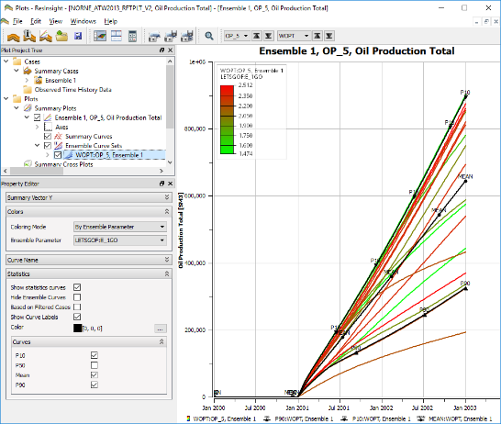

#### 

## Ensemble Plots (2 of 2)

#### Objective: Compute and show difference between two ensembles

1. Import base ensemble (can be skipped if data was loaded in previous tutorial)
   1. Import data using “Import Ensemble” and set the root folder to   
      “model-data/reek_ensemble/3_r001_reek_50/realization-0/base_pred/eclipse/*"
   2. Click **Find** and **OK**
2. Import prediction ensemble
   1. Import data using “Import Ensemble” and set the root folder to   
      “reek_ensemble/3_r001_reek_50/realization-0/pred_op6/eclipse/*"
   2. Click **Find** and **OK**
3. Create delta ensemble
   1. In right click menu of **Data Sources**, **Summary Cases**, select “New Delta Ensemble”
   2. Select “pred_op6” as **Ensemble 1**
   3. Select “base_pred” as **Ensemble 2**
   4. Create a new plot, select ensemble “Delta(pred_op6, base_pred)” and expand Field to plot **FOPT**
   5. In the “Statistics” group, check item “Hide Ensemble curves”
   6. In the right click menu in the plot, select “Show Plot Data” to see curve values including P10 and P90

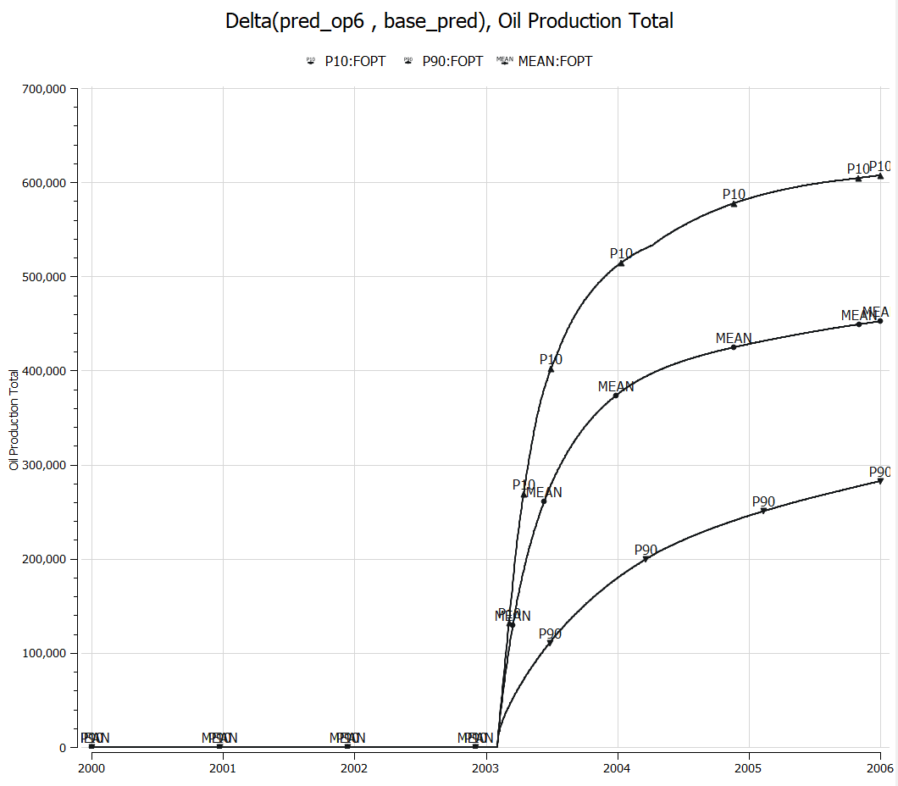 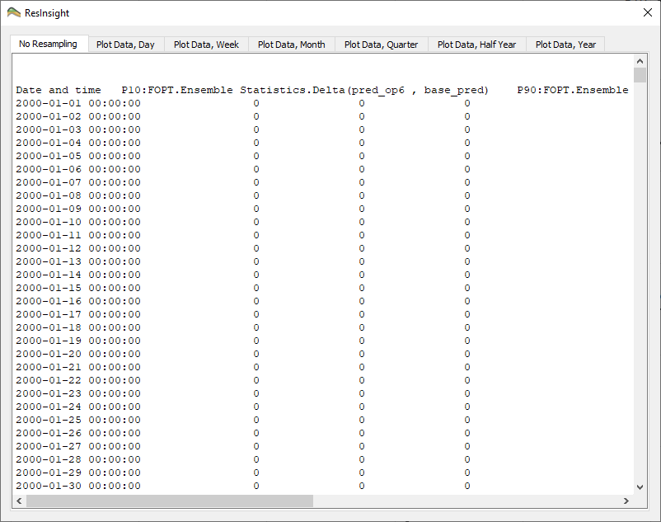

## Plot Templates

#### Objective: Store plot setup with customized curve appearance for reuse on different data

1. Import multiple summary cases as standalone cases
   1. Import data using “File->Import->Import Summary Cases Recursively” and set Path pattern to  
      “model-data/reek_ensemble/3_r001_reek_50/realization-0/base_pred/eclipse/*"
   2. Click **Find** and **OK**
2. Create a plot, and from the right-click menu select “Open Summary Plot Editor”
3. Select two realizations
4. Select well **OP_1** and select summary vector **WOPR** (Well oil production rate)
5. Change the curve appearance of the two curves the way you like best
6. In the **Project Tree**, activate the right-click menu of the plot and select “Save As Plot Template”. Create a folder in your user area and store this plot template in this folder using the template name “wopr_two_cases”  
   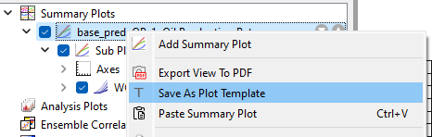
7. Apply an existing template
   1. In **Data Sources**, select two other summary cases than the ones used to produce template
   2. From the right-click menu, invoke “Create Plot from Template” and select the plot template you created (“wopr_two_cases”)
   3. Note that the visual settings you stored in the template are applied to the generated plot

**Hint:** An existing template can be applied to a selection of summary ensemble cases

<https://resinsight.org/plot-window/summaryplottemplate/>

## RFT Plots

1. Import grid data using “Import Eclipse Case” from folder “model-data/norne”
2. Untick **Simulation Wells** to hide simulation wells to easier see imported well paths
3. From right click menu of **Wells**, select “Import Well Paths from File” and select well path “C-1H.dev” in folder “norne_rft”
4. From right click menu of well path **C-1H**, select “Import Well Logs from File”, select “C-1H_RFT_dummy.las” in folder “norne_rft”
5. From right click menu of well path **C-1H**, select “Well Plots->New RFT plot”

*Optional: Import formations (right-click* ***Formations*** *in* ***Project Tree*** *and select Import Formations) to see formation names in the plot.*  
<https://resinsight.org/plot-window/rftplot/>

## Ensemble RFT Plots

1. Import data using “Import Ensemble” from folder “model-data/1_r001_reek_20_rft”
2. Import observations using “Import Observed FMU Data” from folder “reek_rft”
3. Select Imported FMU RFT Data 1, and look at the information in the property editor
4. 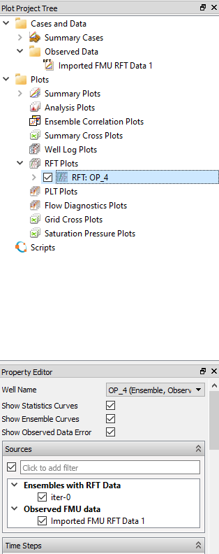From the right-click menu of **RFT Plots**, select “New RFT Plot”
5. Change the Well to OP_4
6. A well RFT plot can be used as template for other wells. On a RFT plot,   
   select “Create Multiple RFT Plots” from the menu, and select wells to create plots for.  
   <https://resinsight.org/plot-window/ensemblerftplot/>

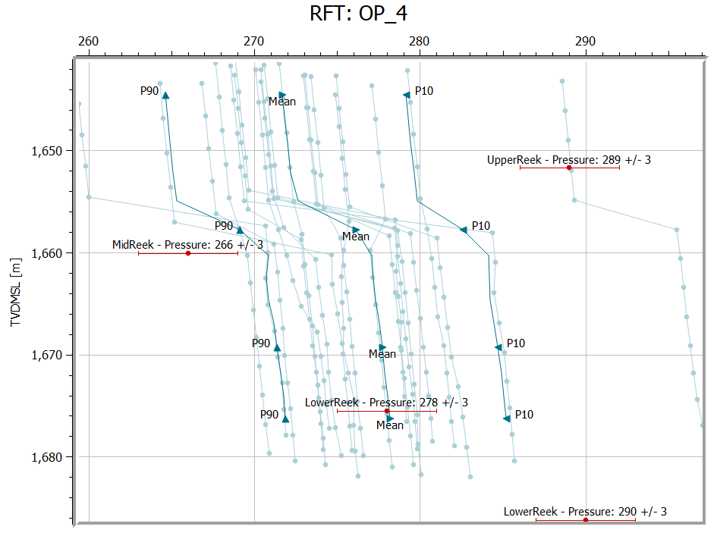

## Correlation Analysis

*Objective: Create and configure a Correlation Plot*

* Import a Summary Ensemble, and use import path "model-data/reek_ensemble/3_r001_reek_50/realization-*/iter-1”
* From the right-click of a curve, select “Create Correlation Plot from Curve Point ->New Report Plot”
* Click on individual cells in the **Correlation Matrix**, and see how the cross plot is updated  
  Currently selected cell is indicated by a border in green
* Show Pearson calculation
* Change data source to **WOPT** for all wells **OP_1** to **OP_5**
* Click on individual cells in the **Correlation Matrix**, and see how the cross plot is updated
* Right-click in plot, and select **Show Plot Data**

<https://resinsight.org/plot-window/correlationplots/>

**Definition of how the Pearson correlation coefficient is computed**

<https://en.wikipedia.org/wiki/Pearson_correlation_coefficient#For_a_sample>

X is input parameter value, Y is simulated value

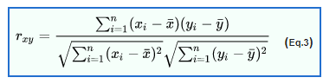

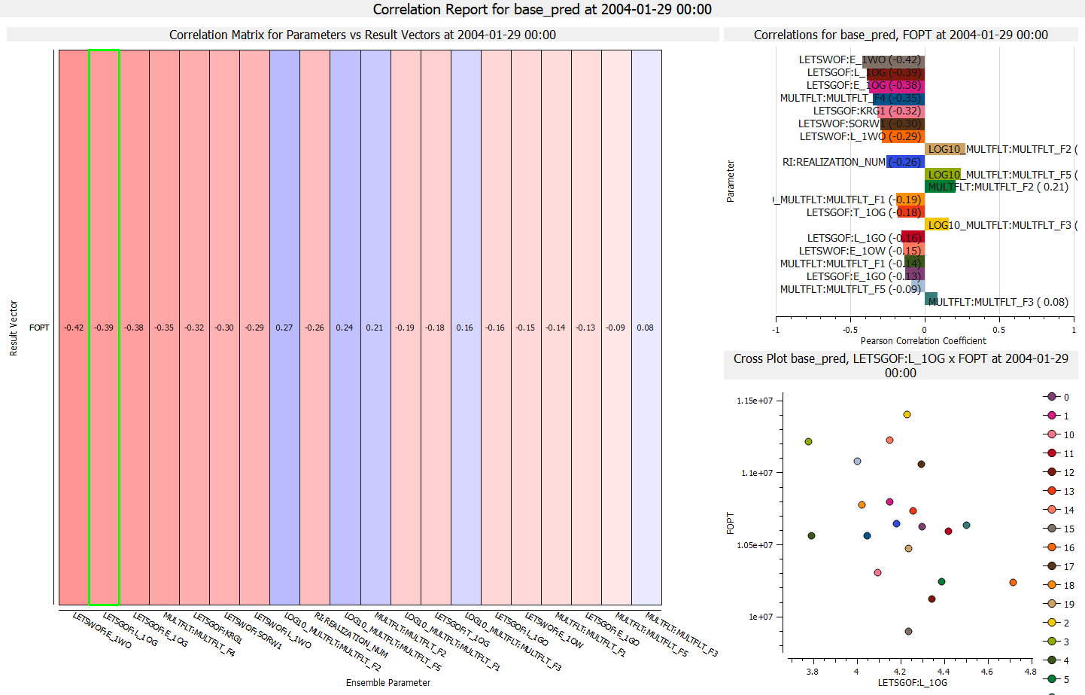

## Analysis Plot

*Objective: Create and configure an Analysis Plot*

* Import a Summary Ensemble, and use import path "model-data/reek_ensemble/3_r001_reek_50/realization-0/base_pred”
* Import a Summary Ensemble, and use import path "model-data/reek_ensemble/3_r001_reek_50/realization-0/pred_op6”
* Select **New Delta Ensemble** from right-click on **Summary Cases**  
  Create a **Delta Ensemble** as the difference between the two cases (pred_op6 - base_pred)
* Select new **Analysis Plot**
* In Property Editor, in group Selected Vectors, click on the button with three dots “…”
  + Set source **Delta ensemble**
  + Select wells **OP_1-5**
  + Select Summary Vector **WOPT**
* Bar Orientation: **Horizontal**
* Select major grouping **Summary Item**
* Select sort by abs(Value)
* Optionally
  + Show legend
  + Bar labels
* Right-click in plot, and select **Show Plot Data**  
  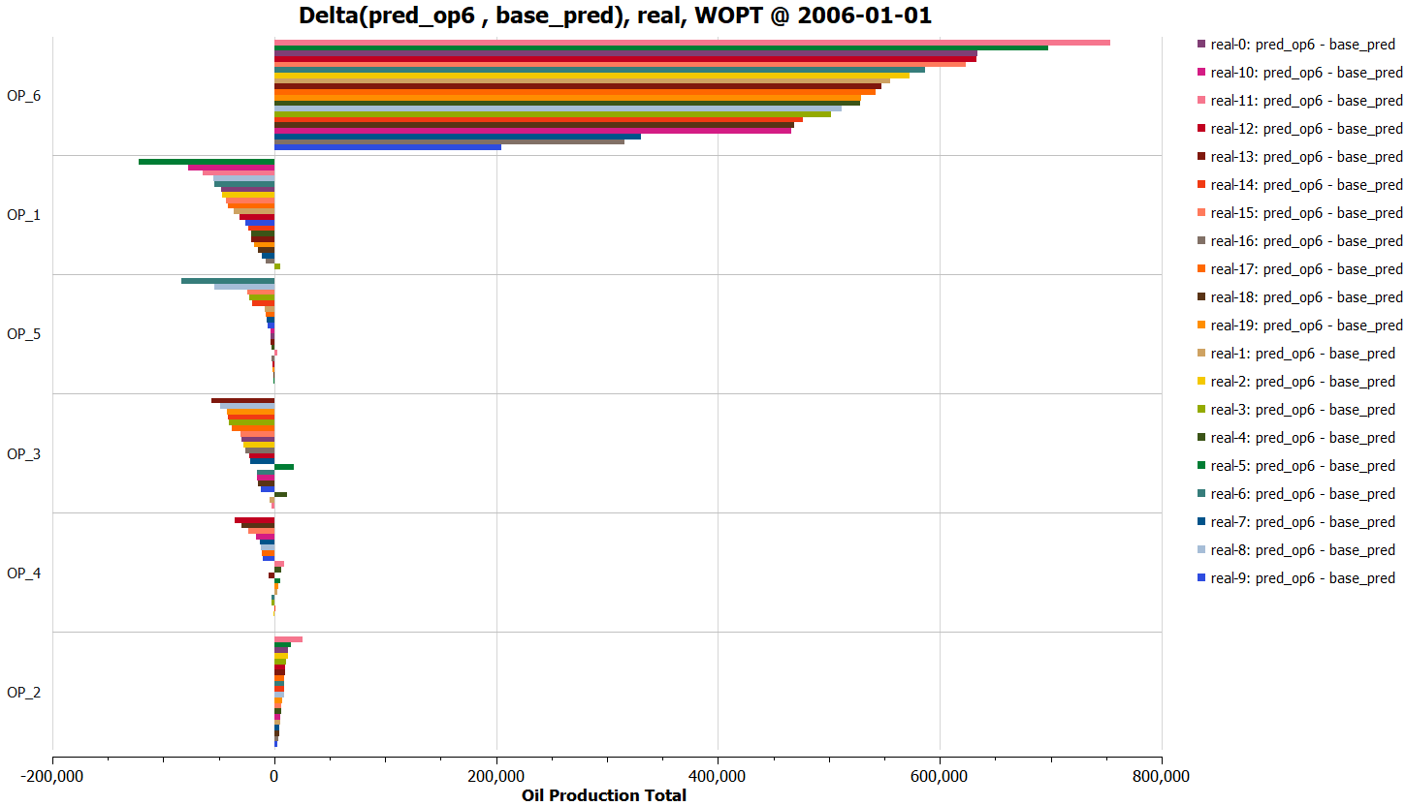

<https://resinsight.org/plot-window/analysisplots/>