# **CI - CD**

* Continuous Integration - CI
* Continuous Deployment - CD
* **DevOps is a set of practices** that works to automate and integrate the processes between software development and IT teams, **so they can build, test, and release software faster and more reliably**.
* **CI/CD** bridges the gaps between development and operation activities and teams by **enforcing automation in building, testing and deployment of applications**.

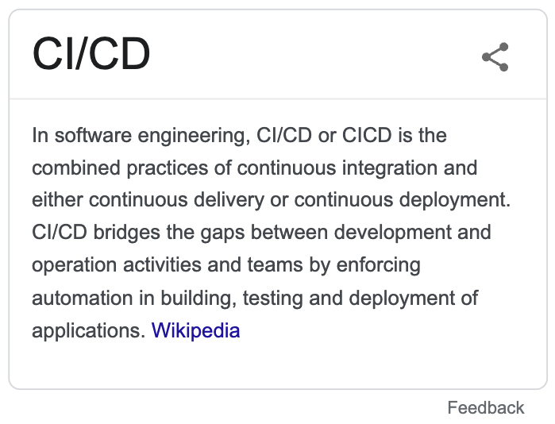

**JENKINS**

* **Jenkins** is an open source automation server. It helps **automate the parts of software development related to building, testing, and deploying**, facilitating continuous integration and continuous delivery.
* The CI/CD practice, or **CI/CD pipeline**, forms the **backbone of modern day DevOps** operations.
* If your tasks are repeatable i.e done in the same way over a time period, then **JENKINS can simply automate the repeatable process**.

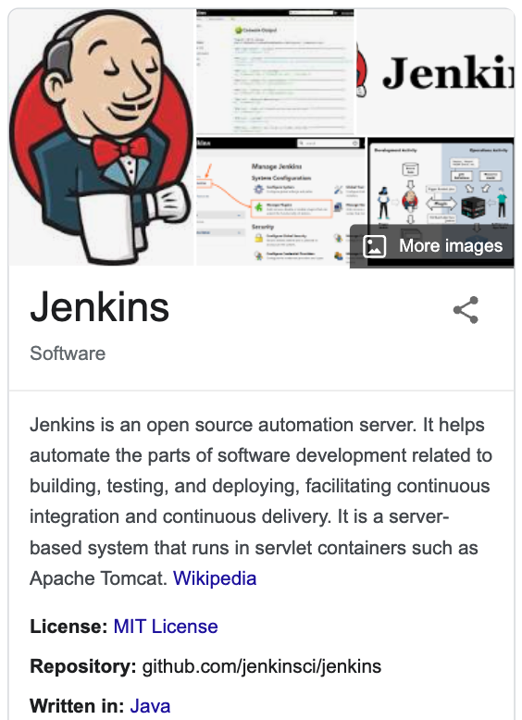

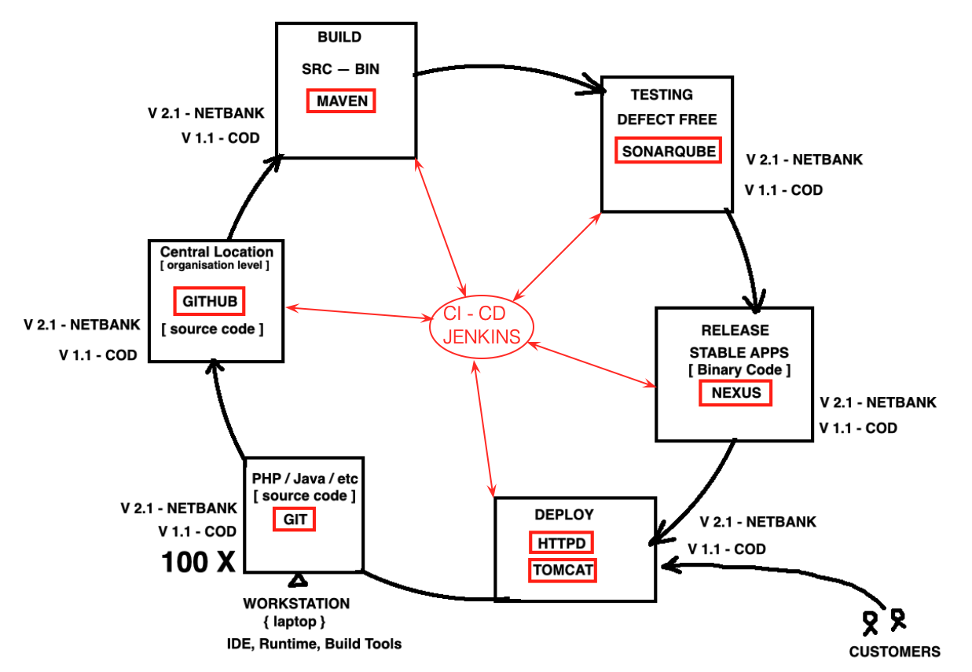

**Traditional Way**

* Traditionally, the development team makes software available in a source code repository, then they give a call to operations and then operations starts building and deploys that software to the dev environment. Once this is done, there is usually a QA team which loads and executes tests on that build and makes it ready for production.

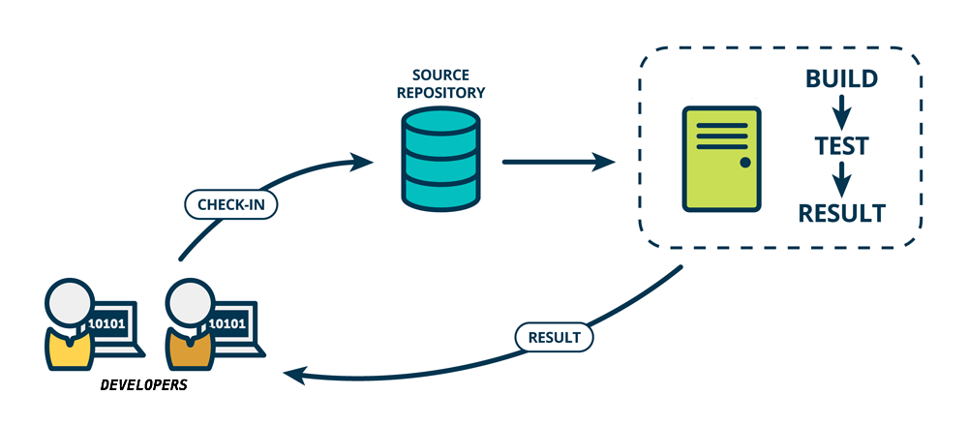

**Continuous Integration - CI**

* Continuous Integration is a DevOps practice where developers regularly merge their code changes into a central repository(GitHub), after which automated builds and tests are run.
* In Continuous Integration each check-in is then verified by an automated build, allowing everyone to detect and be notified of problems with the build immediately

**Continuous Deployment - CD**

* Continuous Deployment is an extension to Continuous Integration
* Continuous Deployment is a DevOps practice where code changes are automatically prepared for a release to Production.

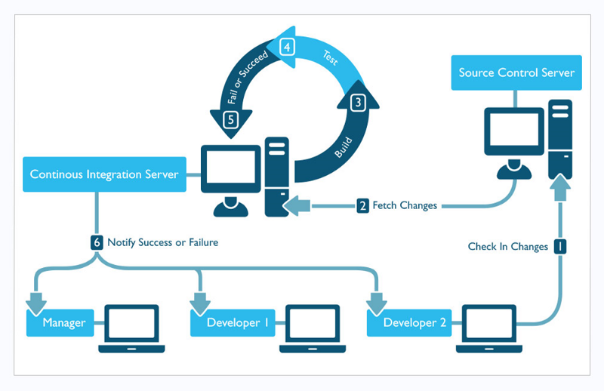

### **Jenkins Setup**

* Follow the below link to setup Jenkins

<https://www.jenkins.io/doc/book/installing/linux/#long-term-support-release-3>

* Jenkins runs on **port 8080**
  + Add **Security Group with port 8080**
  + sudo netstat -ntpl | grep 8080

> sudo yum install wget -y

* Jenkins runs on port 8080
  + sudo netstat -ntpl | grep 8080
  + sudo systemctl status jenkins

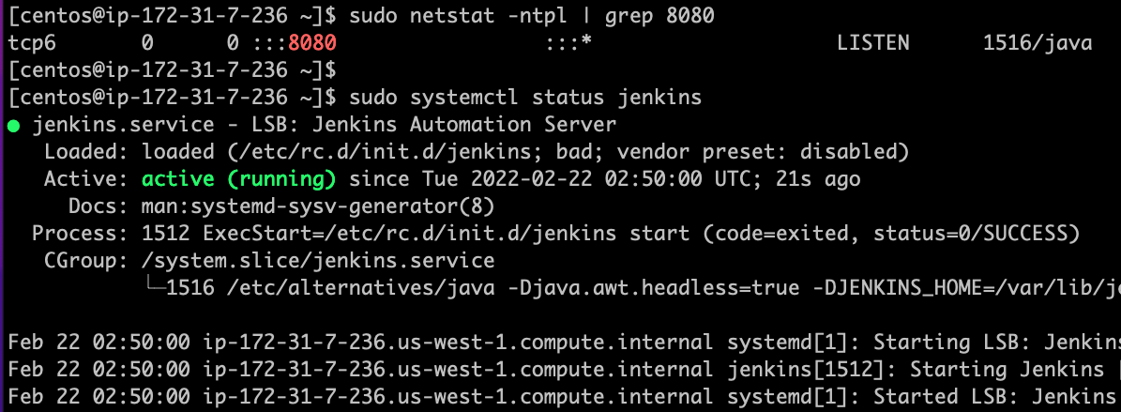

* Access jenkins on http://ip-address:8080
* To unlock “Jenkins”, you will need the administrator password, using the below code on “Terminal” to figure it.
  + sudo cat /var/lib/jenkins/secrets/initialAdminPassword
  + Copy the password that's shown in CLI and paste it to move to next step

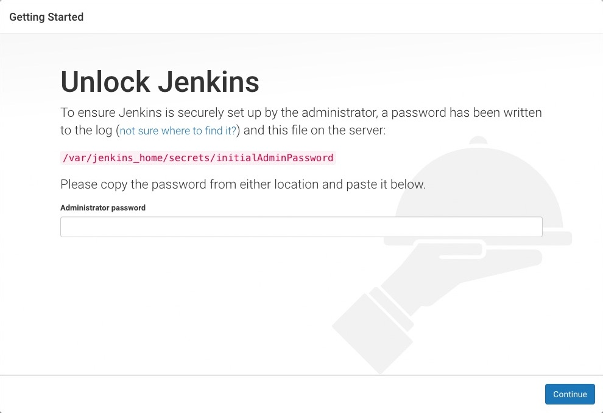

* Click on “Select plugins to install”, > Don't install any plugins select NONE > Now click INSTALL

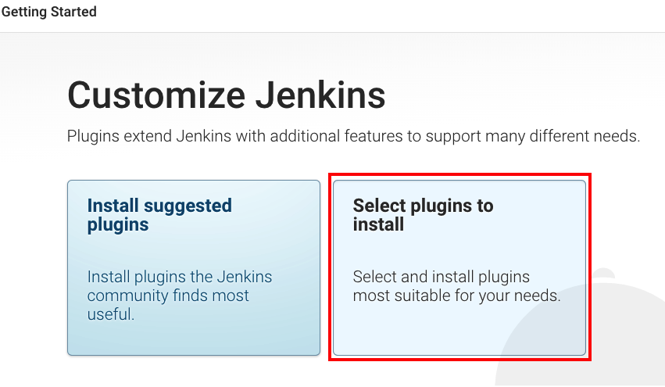

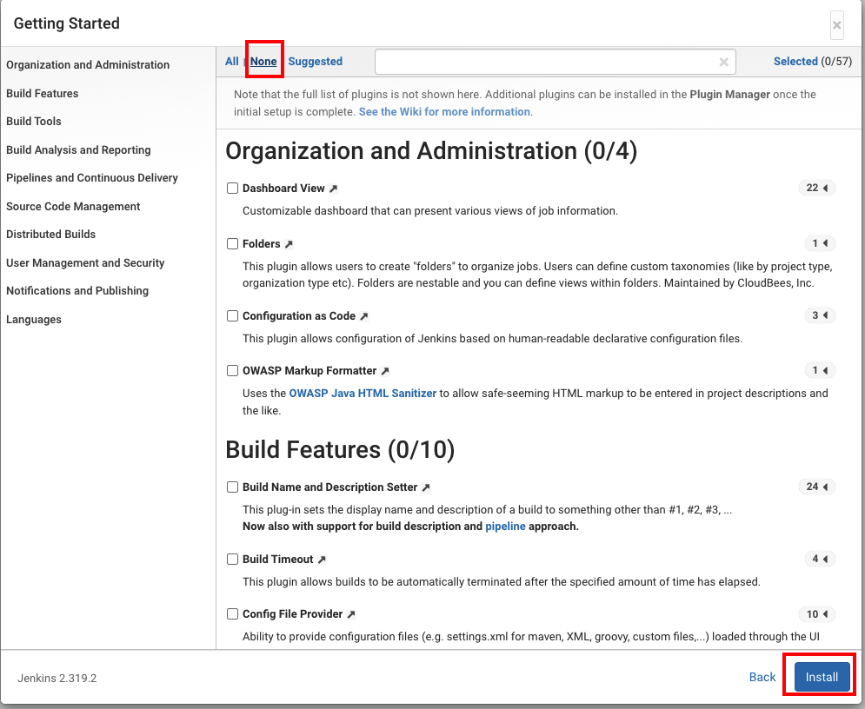

* Now, it will prompt to create the first Admin user

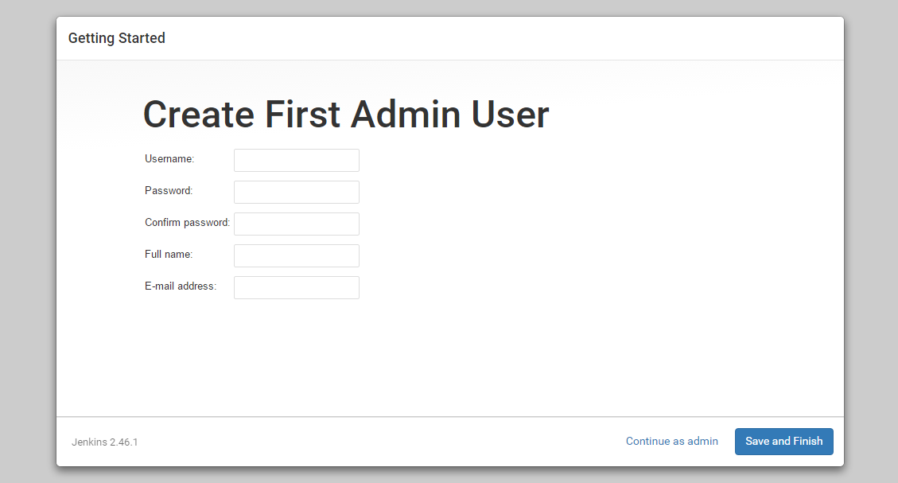

* Once you create the “Admin” user, you will be able to see “Jenkins is ready”, you are almost done, click “Start using Jenkins”.

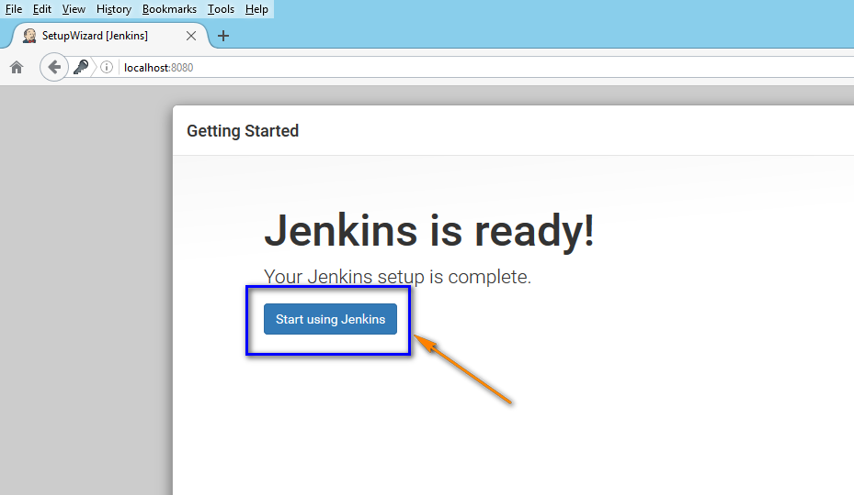

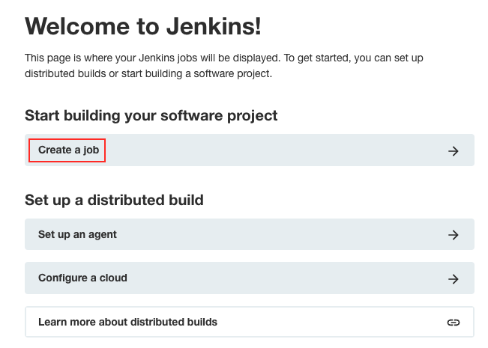

# 

# **Jobs**

* Simply put, you can think of **Jenkins Jobs** as a **particular task or step** in your project.
* A **JOB** can be as simple as
  + compiling your source code or
  + performing a unit test or
  + package an application or
  + deploy an application etc
* Jobs are heart of jenkins

OS - JOB

* Using Jenkins Display the OS Info

* Let say we need to modify the job behavior, we can configure the job at any given point of time

