Tidyverse
Teresa Vaz Martins
2024-01-08
#This is the tidyverse session for the R course 2025. It was based on the original #tidyverse session by Teresa Vas Martins (2024) but Kate Dewally has made a few #minor edits

Learning objectives:
In this session:
- what is the tidyverse and why you should use it
- install the tidyverse
- very brief overview of core functionality and a few available tools
In the following sessions, you will have the opportunity to use the tidyverse in practice

The Data Science Life Cycle
Scientists use data to answer a question, with a number of steps in-between: need to identify relevant data, import it, transform into a format that is easy to work with, explore, possibly visualise, analyse, and communicate their findings.
A typical data science life cycle consists of the following stages:
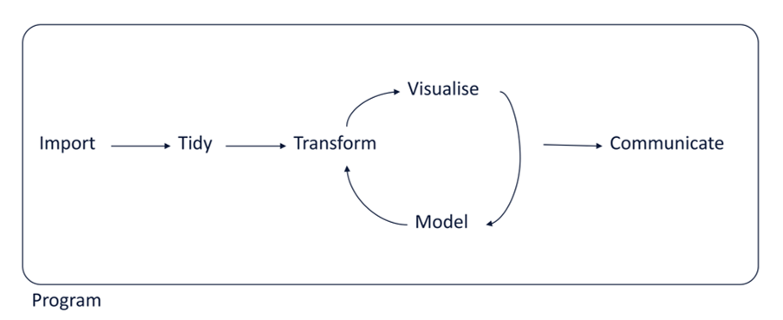
Source: R for Data Science (2e) (hadley.nz), Hadley Wickham.

What is the tidyverse
The tidyverse is “an opinionated collection of R packages designed for data science. All packages share an underlying design philosophy, grammar, and data structures.” Specifically, it is:

- a metadata package: if you install the tidyverse (install.packages('tidyverse'), you will automatically install a set of core packages that provide consistent solutions to various steps of the data life cycle
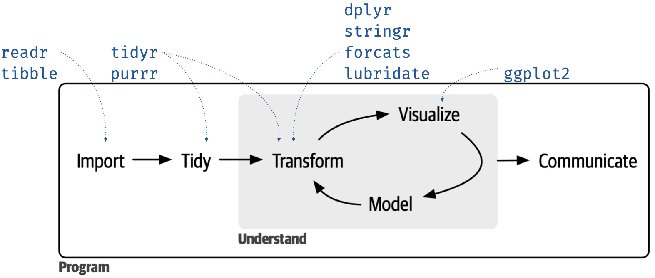
Source: https://www.tidyverse.org/blog/2023/08/teach-tidyverse-23/#improved-and-expanded-_join-functionality

- a R dialect: alongside the core packages, there is a growing number of tidyverse-adjacent packages built on the same principles, designed to integrate consistently with the tidyverse. The below is just a small sample (some are official but non-core tidyverse, like and others, like for instance Shiny and rmarkdown are not yet part of the official tidyverse)
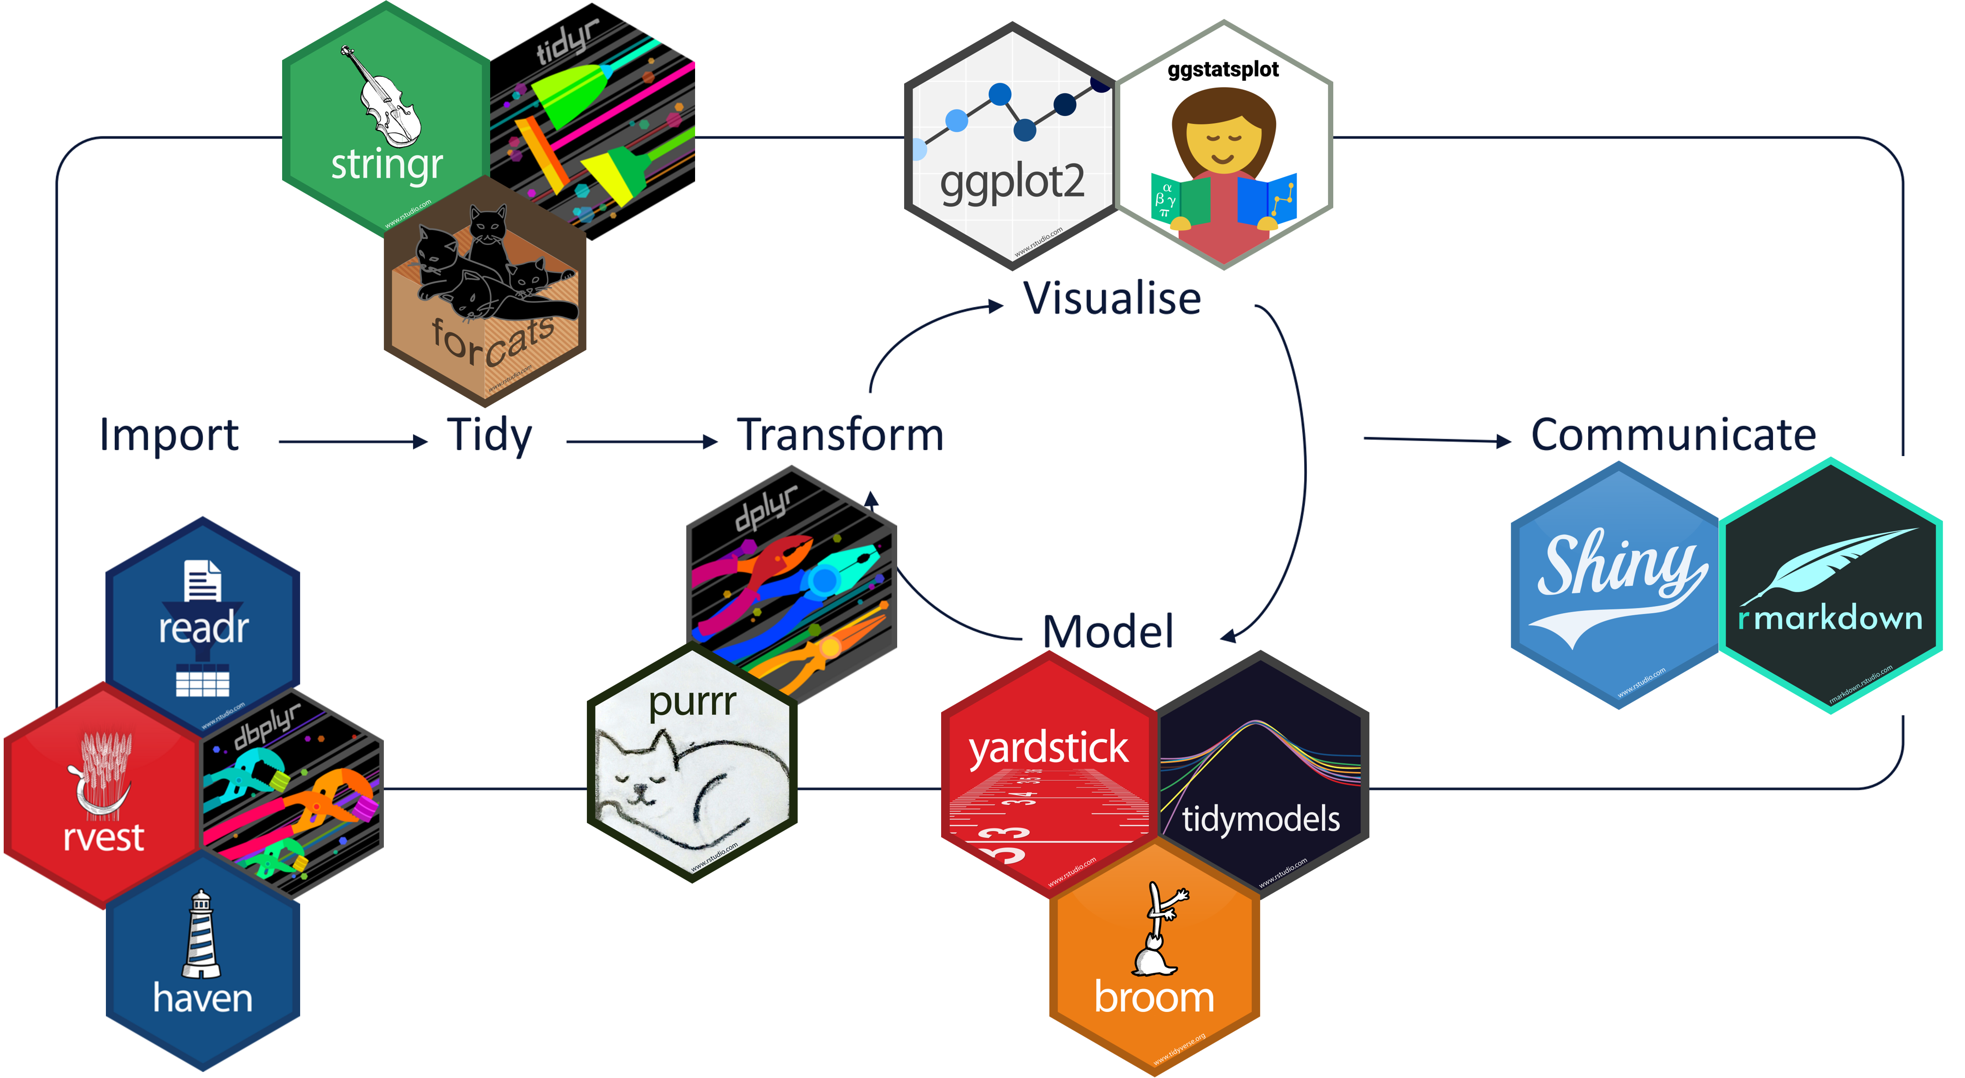

- maybe a R subcommunity? There is a very large number of guidelines and resources to promote, teach and provide support for this “opinionated collection of R packages”. For instance, see:
understand the principles (including code of conduct!)
https://design.tidyverse.org/unifying.html (“inclusive, because the tidyverse is not just the collection of packages, but it is also the community of people who use them.”)

What the tidyverse is not
- not a replacement of base R (base R is the default R installation).
  - the tidyverse is built on top of base R, not meant to replace it
- not something that demands exclusivity
  - There are other useful dialects (the faster data.table, for instance) and you don’t need to stick with one exclusively. A typical script may combine different dialects
- not something that you need to keep up with anxiously
  - the tidyverse has a very fast update rate.
  - during the time scale of a research project of about 2 or 3 years, you may find that the tidyverse syntax has changed. It doesn’t mean that your code has become obsolete. If you have doubts about a particular function, you can consult its state (write ?gather in the console)): by default, functions are in a stable state, but:
  - https://lifecycle.r-lib.org/articles/stages.html#superseded
  - Superseded functions will not receive new features, but will receive any critical bug fixes needed to keep it working. In some ways a superseded function is actually safer than a stable function because it's guaranteed never to change (for better or for worse).

How to install the tidyverse
# Package names
packages <- c('tidyverse', 'palmerpenguins', 'ViewPipeSteps')
# Install packages not yet installed
installed_packages <- packages %in% rownames(installed.packages())
if (any(installed_packages == FALSE)) {
install.packages(packages[!installed_packages], repos = "http://cran.us.r-project.org")
}
# Packages loading
invisible(lapply(packages, library, character.only = TRUE))
- you can also install each package separately using the command install.packages(“NAME OF PACKAGE”)

Two essential tools: pipes and tidy data

Pipes
The maigrittr magrittr::%>% allows us to chain several chunks of code together
Avoid using the pipe when:
- You need to manipulate more than one object at a time. Reserve pipes for a sequence of steps applied to one primary object.
- There are meaningful intermediate objects that could be given informative names.

Why use the pipe in other cases?
Piping is used to emphasise a sequence of actions and avoid nested operations. Let’s see the alternatives:

Multiple lines of code
penguins <- palmerpenguins::penguins
# load data
data <- palmerpenguins::penguins_raw
#Visualise the data
glimpse(data) # switches rows and columns on display to allow you to see every column of data
## Rows: 344
## Columns: 17
## $ studyName <chr> "PAL0708", "PAL0708", "PAL0708", "PAL0708", "PAL…
## $ `Sample Number` <dbl> 1, 2, 3, 4, 5, 6, 7, 8, 9, 10, 11, 12, 13, 14, 1…
## $ Species <chr> "Adelie Penguin (Pygoscelis adeliae)", "Adelie P…
## $ Region <chr> "Anvers", "Anvers", "Anvers", "Anvers", "Anvers"…
## $ Island <chr> "Torgersen", "Torgersen", "Torgersen", "Torgerse…
## $ Stage <chr> "Adult, 1 Egg Stage", "Adult, 1 Egg Stage", "Adu…
## $ `Individual ID` <chr> "N1A1", "N1A2", "N2A1", "N2A2", "N3A1", "N3A2", …
## $ `Clutch Completion` <chr> "Yes", "Yes", "Yes", "Yes", "Yes", "Yes", "No", …
## $ `Date Egg` <date> 2007-11-11, 2007-11-11, 2007-11-16, 2007-11-16,…
## $ `Culmen Length (mm)` <dbl> 39.1, 39.5, 40.3, NA, 36.7, 39.3, 38.9, 39.2, 34…
## $ `Culmen Depth (mm)` <dbl> 18.7, 17.4, 18.0, NA, 19.3, 20.6, 17.8, 19.6, 18…
## $ `Flipper Length (mm)` <dbl> 181, 186, 195, NA, 193, 190, 181, 195, 193, 190,…
## $ `Body Mass (g)` <dbl> 3750, 3800, 3250, NA, 3450, 3650, 3625, 4675, 34…
## $ Sex <chr> "MALE", "FEMALE", "FEMALE", NA, "FEMALE", "MALE"…
## $ `Delta 15 N (o/oo)` <dbl> NA, 8.94956, 8.36821, NA, 8.76651, 8.66496, 9.18…
## $ `Delta 13 C (o/oo)` <dbl> NA, -24.69454, -25.33302, NA, -25.32426, -25.298…
## $ Comments <chr> "Not enough blood for isotopes.", NA, NA, "Adult…
head(data, 5) # gives you first few rows of dataframe (in this case 5)
## # A tibble: 5 × 17
## studyName `Sample Number` Species Region Island Stage `Individual ID`
## <chr> <dbl> <chr> <chr> <chr> <chr> <chr>
## 1 PAL0708 1 Adelie Penguin … Anvers Torge… Adul… N1A1
## 2 PAL0708 2 Adelie Penguin … Anvers Torge… Adul… N1A2
## 3 PAL0708 3 Adelie Penguin … Anvers Torge… Adul… N2A1
## 4 PAL0708 4 Adelie Penguin … Anvers Torge… Adul… N2A2
## 5 PAL0708 5 Adelie Penguin … Anvers Torge… Adul… N3A1
## # ℹ 10 more variables: `Clutch Completion` <chr>, `Date Egg` <date>,
## # `Culmen Length (mm)` <dbl>, `Culmen Depth (mm)` <dbl>,
## # `Flipper Length (mm)` <dbl>, `Body Mass (g)` <dbl>, Sex <chr>,
## # `Delta 15 N (o/oo)` <dbl>, `Delta 13 C (o/oo)` <dbl>, Comments <chr>
names(data) #allows you to see the column names in the dataframe
## [1] "studyName" "Sample Number" "Species"
## [4] "Region" "Island" "Stage"
## [7] "Individual ID" "Clutch Completion" "Date Egg"
## [10] "Culmen Length (mm)" "Culmen Depth (mm)" "Flipper Length (mm)"
## [13] "Body Mass (g)" "Sex" "Delta 15 N (o/oo)"
## [16] "Delta 13 C (o/oo)" "Comments"
# select columns we want
data <- select(data, "Species", "Body Mass (g)")
#' rename columns (what was the data about exactly??)
data <- setNames(data, c("species", "body_mass_g"))
#visualise the data
glimpse(data) # switches rows and columns on display to allow you to see every column of data
## Rows: 344
## Columns: 2
## $ species <chr> "Adelie Penguin (Pygoscelis adeliae)", "Adelie Penguin (Py…
## $ body_mass_g <dbl> 3750, 3800, 3250, NA, 3450, 3650, 3625, 4675, 3475, 4250, …
head(data, 5) # gives you first few rows of dataframe (in this case 5)
## # A tibble: 5 × 2
## species body_mass_g
## <chr> <dbl>
## 1 Adelie Penguin (Pygoscelis adeliae) 3750
## 2 Adelie Penguin (Pygoscelis adeliae) 3800
## 3 Adelie Penguin (Pygoscelis adeliae) 3250
## 4 Adelie Penguin (Pygoscelis adeliae) NA
## 5 Adelie Penguin (Pygoscelis adeliae) 3450
Problem is that as your code grows bigger, you may add things in between two logical steps. After some time, you may not even remember what data were you thinking about, and what have you already done with it.

Nested code
#Example of doing the same as above but in nested format
data <- setNames(select(palmerpenguins::penguins_raw, c("Species", "Body Mass (g)")), c("species", "body_mass_g"))
glimpse(data)
## Rows: 344
## Columns: 2
## $ species <chr> "Adelie Penguin (Pygoscelis adeliae)", "Adelie Penguin (Py…
## $ body_mass_g <dbl> 3750, 3800, 3250, NA, 3450, 3650, 3625, 4675, 3475, 4250, …
head(data)
## # A tibble: 6 × 2
## species body_mass_g
## <chr> <dbl>
## 1 Adelie Penguin (Pygoscelis adeliae) 3750
## 2 Adelie Penguin (Pygoscelis adeliae) 3800
## 3 Adelie Penguin (Pygoscelis adeliae) 3250
## 4 Adelie Penguin (Pygoscelis adeliae) NA
## 5 Adelie Penguin (Pygoscelis adeliae) 3450
## 6 Adelie Penguin (Pygoscelis adeliae) 3650
Problem with nesting is that it will eventually become hard to keep track of all the brackets and R won’t help much. For instance, try removing a bracket in the chunk above…

Piping
#This is the same as the two chunks above but with piping
data <- palmerpenguins::penguins_raw %>%
dplyr::select(c("Species", "Body Mass (g)")) %>%
setNames(c("species", "body_mass_g"))
glimpse(data)
## Rows: 344
## Columns: 2
## $ species <chr> "Adelie Penguin (Pygoscelis adeliae)", "Adelie Penguin (Py…
## $ body_mass_g <dbl> 3750, 3800, 3250, NA, 3450, 3650, 3625, 4675, 3475, 4250, …
head(data)
## # A tibble: 6 × 2
## species body_mass_g
## <chr> <dbl>
## 1 Adelie Penguin (Pygoscelis adeliae) 3750
## 2 Adelie Penguin (Pygoscelis adeliae) 3800
## 3 Adelie Penguin (Pygoscelis adeliae) 3250
## 4 Adelie Penguin (Pygoscelis adeliae) NA
## 5 Adelie Penguin (Pygoscelis adeliae) 3450
## 6 Adelie Penguin (Pygoscelis adeliae) 3650

Tidy data
Besides piping, the tidyverse is known for its emphasis on starting analysis by formatting data into a so-called tidy format. Why a tidy format?

The essential: settle on a standard and work with it
Hadley Wickham “tidy datasets are all alike but every messy dataset is messy in its own way.”
Much of the data you come across has personal add-ons: embedded plots, colours, dates recorded in different formats, unclear column names, duplicated values, comments and calculations in the raw data files, etc. This may be helpful for the human brain but not for a programming language.
By using a consistent data format, the remaining steps of your data science pipeline will be easier to do and generalise. You’ll waste less time struggling with the remaining data analysis tools and can focus on analysis.
https://www.tidyverse.org/

The standard that R works best with: Tidy Data Principles
• Each variable has its own column
• Each observation has its own row
• Each value has its own cell
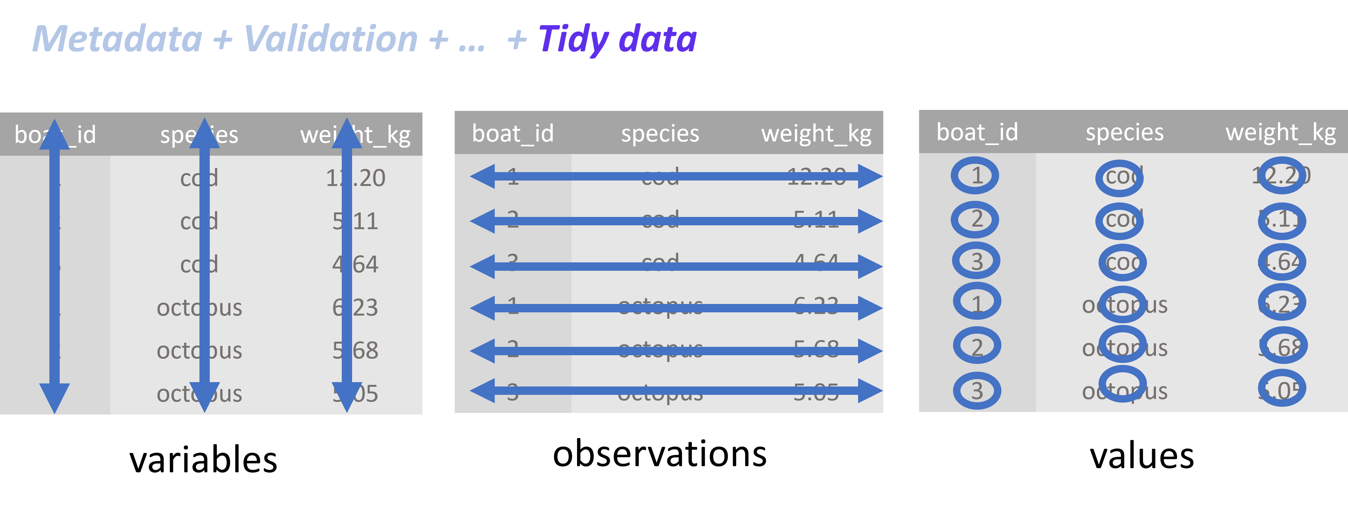

Let’s see a very simple example to show how R prefers tidy data: we will use the (base R) summary function.

📝 Try this:

Tidy data
See the first 10 rows of the penguins dataset. In the case of Palmer penguins, a variable refers to an attribute of all the penguins, and an observation refers to all the attributes of a single penguin.
penguins %>% head(10)
## # A tibble: 10 × 8
## species island bill_length_mm bill_depth_mm flipper_length_mm body_mass_g
## <fct> <fct> <dbl> <dbl> <int> <int>
## 1 Adelie Torgersen 39.1 18.7 181 3750
## 2 Adelie Torgersen 39.5 17.4 186 3800
## 3 Adelie Torgersen 40.3 18 195 3250
## 4 Adelie Torgersen NA NA NA NA
## 5 Adelie Torgersen 36.7 19.3 193 3450
## 6 Adelie Torgersen 39.3 20.6 190 3650
## 7 Adelie Torgersen 38.9 17.8 181 3625
## 8 Adelie Torgersen 39.2 19.6 195 4675
## 9 Adelie Torgersen 34.1 18.1 193 3475
## 10 Adelie Torgersen 42 20.2 190 4250
## # ℹ 2 more variables: sex <fct>, year <int>
Use the built-in function summary() to quickly summarise the data
summary(penguins)
## species island bill_length_mm bill_depth_mm
## Adelie :152 Biscoe :168 Min. :32.10 Min. :13.10
## Chinstrap: 68 Dream :124 1st Qu.:39.23 1st Qu.:15.60
## Gentoo :124 Torgersen: 52 Median :44.45 Median :17.30
## Mean :43.92 Mean :17.15
## 3rd Qu.:48.50 3rd Qu.:18.70
## Max. :59.60 Max. :21.50
## NA's :2 NA's :2
## flipper_length_mm body_mass_g sex year
## Min. :172.0 Min. :2700 female:165 Min. :2007
## 1st Qu.:190.0 1st Qu.:3550 male :168 1st Qu.:2007
## Median :197.0 Median :4050 NA's : 11 Median :2008
## Mean :200.9 Mean :4202 Mean :2008
## 3rd Qu.:213.0 3rd Qu.:4750 3rd Qu.:2009
## Max. :231.0 Max. :6300 Max. :2009
## NA's :2 NA's :2

Untidy data
Transform columns into rows and visualise data in R studio: does it look bad? (Turning into messy from tidy)
(penguins %>% t()) %>% View()
How about this?
summary(penguins%>%t())
## V1 V2 V3 V4
## Length:8 Length:8 Length:8 Length:8
## Class :character Class :character Class :character Class :character
## Mode :character Mode :character Mode :character Mode :character
## V5 V6 V7 V8
## Length:8 Length:8 Length:8 Length:8
## Class :character Class :character Class :character Class :character
## Mode :character Mode :character Mode :character Mode :character
## V9 V10 V11 V12
## Length:8 Length:8 Length:8 Length:8
## Class :character Class :character Class :character Class :character
## Mode :character Mode :character Mode :character Mode :character
## V13 V14 V15 V16
## Length:8 Length:8 Length:8 Length:8
## Class :character Class :character Class :character Class :character
## Mode :character Mode :character Mode :character Mode :character
## V17 V18 V19 V20
## Length:8 Length:8 Length:8 Length:8
## Class :character Class :character Class :character Class :character
## Mode :character Mode :character Mode :character Mode :character
## V21 V22 V23 V24
## Length:8 Length:8 Length:8 Length:8
## Class :character Class :character Class :character Class :character
## Mode :character Mode :character Mode :character Mode :character
## V25 V26 V27 V28
## Length:8 Length:8 Length:8 Length:8
## Class :character Class :character Class :character Class :character
## Mode :character Mode :character Mode :character Mode :character
## V29 V30 V31 V32
## Length:8 Length:8 Length:8 Length:8
## Class :character Class :character Class :character Class :character
## Mode :character Mode :character Mode :character Mode :character
## V33 V34 V35 V36
## Length:8 Length:8 Length:8 Length:8
## Class :character Class :character Class :character Class :character
## Mode :character Mode :character Mode :character Mode :character
## V37 V38 V39 V40
## Length:8 Length:8 Length:8 Length:8
## Class :character Class :character Class :character Class :character
## Mode :character Mode :character Mode :character Mode :character
## V41 V42 V43 V44
## Length:8 Length:8 Length:8 Length:8
## Class :character Class :character Class :character Class :character
## Mode :character Mode :character Mode :character Mode :character
## V45 V46 V47 V48
## Length:8 Length:8 Length:8 Length:8
## Class :character Class :character Class :character Class :character
## Mode :character Mode :character Mode :character Mode :character
## V49 V50 V51 V52
## Length:8 Length:8 Length:8 Length:8
## Class :character Class :character Class :character Class :character
## Mode :character Mode :character Mode :character Mode :character
## V53 V54 V55 V56
## Length:8 Length:8 Length:8 Length:8
## Class :character Class :character Class :character Class :character
## Mode :character Mode :character Mode :character Mode :character
## V57 V58 V59 V60
## Length:8 Length:8 Length:8 Length:8
## Class :character Class :character Class :character Class :character
## Mode :character Mode :character Mode :character Mode :character
## V61 V62 V63 V64
## Length:8 Length:8 Length:8 Length:8
## Class :character Class :character Class :character Class :character
## Mode :character Mode :character Mode :character Mode :character
## V65 V66 V67 V68
## Length:8 Length:8 Length:8 Length:8
## Class :character Class :character Class :character Class :character
## Mode :character Mode :character Mode :character Mode :character
## V69 V70 V71 V72
## Length:8 Length:8 Length:8 Length:8
## Class :character Class :character Class :character Class :character
## Mode :character Mode :character Mode :character Mode :character
## V73 V74 V75 V76
## Length:8 Length:8 Length:8 Length:8
## Class :character Class :character Class :character Class :character
## Mode :character Mode :character Mode :character Mode :character
## V77 V78 V79 V80
## Length:8 Length:8 Length:8 Length:8
## Class :character Class :character Class :character Class :character
## Mode :character Mode :character Mode :character Mode :character
## V81 V82 V83 V84
## Length:8 Length:8 Length:8 Length:8
## Class :character Class :character Class :character Class :character
## Mode :character Mode :character Mode :character Mode :character
## V85 V86 V87 V88
## Length:8 Length:8 Length:8 Length:8
## Class :character Class :character Class :character Class :character
## Mode :character Mode :character Mode :character Mode :character
## V89 V90 V91 V92
## Length:8 Length:8 Length:8 Length:8
## Class :character Class :character Class :character Class :character
## Mode :character Mode :character Mode :character Mode :character
## V93 V94 V95 V96
## Length:8 Length:8 Length:8 Length:8
## Class :character Class :character Class :character Class :character
## Mode :character Mode :character Mode :character Mode :character
## V97 V98 V99 V100
## Length:8 Length:8 Length:8 Length:8
## Class :character Class :character Class :character Class :character
## Mode :character Mode :character Mode :character Mode :character
## V101 V102 V103 V104
## Length:8 Length:8 Length:8 Length:8
## Class :character Class :character Class :character Class :character
## Mode :character Mode :character Mode :character Mode :character
## V105 V106 V107 V108
## Length:8 Length:8 Length:8 Length:8
## Class :character Class :character Class :character Class :character
## Mode :character Mode :character Mode :character Mode :character
## V109 V110 V111 V112
## Length:8 Length:8 Length:8 Length:8
## Class :character Class :character Class :character Class :character
## Mode :character Mode :character Mode :character Mode :character
## V113 V114 V115 V116
## Length:8 Length:8 Length:8 Length:8
## Class :character Class :character Class :character Class :character
## Mode :character Mode :character Mode :character Mode :character
## V117 V118 V119 V120
## Length:8 Length:8 Length:8 Length:8
## Class :character Class :character Class :character Class :character
## Mode :character Mode :character Mode :character Mode :character
## V121 V122 V123 V124
## Length:8 Length:8 Length:8 Length:8
## Class :character Class :character Class :character Class :character
## Mode :character Mode :character Mode :character Mode :character
## V125 V126 V127 V128
## Length:8 Length:8 Length:8 Length:8
## Class :character Class :character Class :character Class :character
## Mode :character Mode :character Mode :character Mode :character
## V129 V130 V131 V132
## Length:8 Length:8 Length:8 Length:8
## Class :character Class :character Class :character Class :character
## Mode :character Mode :character Mode :character Mode :character
## V133 V134 V135 V136
## Length:8 Length:8 Length:8 Length:8
## Class :character Class :character Class :character Class :character
## Mode :character Mode :character Mode :character Mode :character
## V137 V138 V139 V140
## Length:8 Length:8 Length:8 Length:8
## Class :character Class :character Class :character Class :character
## Mode :character Mode :character Mode :character Mode :character
## V141 V142 V143 V144
## Length:8 Length:8 Length:8 Length:8
## Class :character Class :character Class :character Class :character
## Mode :character Mode :character Mode :character Mode :character
## V145 V146 V147 V148
## Length:8 Length:8 Length:8 Length:8
## Class :character Class :character Class :character Class :character
## Mode :character Mode :character Mode :character Mode :character
## V149 V150 V151 V152
## Length:8 Length:8 Length:8 Length:8
## Class :character Class :character Class :character Class :character
## Mode :character Mode :character Mode :character Mode :character
## V153 V154 V155 V156
## Length:8 Length:8 Length:8 Length:8
## Class :character Class :character Class :character Class :character
## Mode :character Mode :character Mode :character Mode :character
## V157 V158 V159 V160
## Length:8 Length:8 Length:8 Length:8
## Class :character Class :character Class :character Class :character
## Mode :character Mode :character Mode :character Mode :character
## V161 V162 V163 V164
## Length:8 Length:8 Length:8 Length:8
## Class :character Class :character Class :character Class :character
## Mode :character Mode :character Mode :character Mode :character
## V165 V166 V167 V168
## Length:8 Length:8 Length:8 Length:8
## Class :character Class :character Class :character Class :character
## Mode :character Mode :character Mode :character Mode :character
## V169 V170 V171 V172
## Length:8 Length:8 Length:8 Length:8
## Class :character Class :character Class :character Class :character
## Mode :character Mode :character Mode :character Mode :character
## V173 V174 V175 V176
## Length:8 Length:8 Length:8 Length:8
## Class :character Class :character Class :character Class :character
## Mode :character Mode :character Mode :character Mode :character
## V177 V178 V179 V180
## Length:8 Length:8 Length:8 Length:8
## Class :character Class :character Class :character Class :character
## Mode :character Mode :character Mode :character Mode :character
## V181 V182 V183 V184
## Length:8 Length:8 Length:8 Length:8
## Class :character Class :character Class :character Class :character
## Mode :character Mode :character Mode :character Mode :character
## V185 V186 V187 V188
## Length:8 Length:8 Length:8 Length:8
## Class :character Class :character Class :character Class :character
## Mode :character Mode :character Mode :character Mode :character
## V189 V190 V191 V192
## Length:8 Length:8 Length:8 Length:8
## Class :character Class :character Class :character Class :character
## Mode :character Mode :character Mode :character Mode :character
## V193 V194 V195 V196
## Length:8 Length:8 Length:8 Length:8
## Class :character Class :character Class :character Class :character
## Mode :character Mode :character Mode :character Mode :character
## V197 V198 V199 V200
## Length:8 Length:8 Length:8 Length:8
## Class :character Class :character Class :character Class :character
## Mode :character Mode :character Mode :character Mode :character
## V201 V202 V203 V204
## Length:8 Length:8 Length:8 Length:8
## Class :character Class :character Class :character Class :character
## Mode :character Mode :character Mode :character Mode :character
## V205 V206 V207 V208
## Length:8 Length:8 Length:8 Length:8
## Class :character Class :character Class :character Class :character
## Mode :character Mode :character Mode :character Mode :character
## V209 V210 V211 V212
## Length:8 Length:8 Length:8 Length:8
## Class :character Class :character Class :character Class :character
## Mode :character Mode :character Mode :character Mode :character
## V213 V214 V215 V216
## Length:8 Length:8 Length:8 Length:8
## Class :character Class :character Class :character Class :character
## Mode :character Mode :character Mode :character Mode :character
## V217 V218 V219 V220
## Length:8 Length:8 Length:8 Length:8
## Class :character Class :character Class :character Class :character
## Mode :character Mode :character Mode :character Mode :character
## V221 V222 V223 V224
## Length:8 Length:8 Length:8 Length:8
## Class :character Class :character Class :character Class :character
## Mode :character Mode :character Mode :character Mode :character
## V225 V226 V227 V228
## Length:8 Length:8 Length:8 Length:8
## Class :character Class :character Class :character Class :character
## Mode :character Mode :character Mode :character Mode :character
## V229 V230 V231 V232
## Length:8 Length:8 Length:8 Length:8
## Class :character Class :character Class :character Class :character
## Mode :character Mode :character Mode :character Mode :character
## V233 V234 V235 V236
## Length:8 Length:8 Length:8 Length:8
## Class :character Class :character Class :character Class :character
## Mode :character Mode :character Mode :character Mode :character
## V237 V238 V239 V240
## Length:8 Length:8 Length:8 Length:8
## Class :character Class :character Class :character Class :character
## Mode :character Mode :character Mode :character Mode :character
## V241 V242 V243 V244
## Length:8 Length:8 Length:8 Length:8
## Class :character Class :character Class :character Class :character
## Mode :character Mode :character Mode :character Mode :character
## V245 V246 V247 V248
## Length:8 Length:8 Length:8 Length:8
## Class :character Class :character Class :character Class :character
## Mode :character Mode :character Mode :character Mode :character
## V249 V250 V251 V252
## Length:8 Length:8 Length:8 Length:8
## Class :character Class :character Class :character Class :character
## Mode :character Mode :character Mode :character Mode :character
## V253 V254 V255 V256
## Length:8 Length:8 Length:8 Length:8
## Class :character Class :character Class :character Class :character
## Mode :character Mode :character Mode :character Mode :character
## V257 V258 V259 V260
## Length:8 Length:8 Length:8 Length:8
## Class :character Class :character Class :character Class :character
## Mode :character Mode :character Mode :character Mode :character
## V261 V262 V263 V264
## Length:8 Length:8 Length:8 Length:8
## Class :character Class :character Class :character Class :character
## Mode :character Mode :character Mode :character Mode :character
## V265 V266 V267 V268
## Length:8 Length:8 Length:8 Length:8
## Class :character Class :character Class :character Class :character
## Mode :character Mode :character Mode :character Mode :character
## V269 V270 V271 V272
## Length:8 Length:8 Length:8 Length:8
## Class :character Class :character Class :character Class :character
## Mode :character Mode :character Mode :character Mode :character
## V273 V274 V275 V276
## Length:8 Length:8 Length:8 Length:8
## Class :character Class :character Class :character Class :character
## Mode :character Mode :character Mode :character Mode :character
## V277 V278 V279 V280
## Length:8 Length:8 Length:8 Length:8
## Class :character Class :character Class :character Class :character
## Mode :character Mode :character Mode :character Mode :character
## V281 V282 V283 V284
## Length:8 Length:8 Length:8 Length:8
## Class :character Class :character Class :character Class :character
## Mode :character Mode :character Mode :character Mode :character
## V285 V286 V287 V288
## Length:8 Length:8 Length:8 Length:8
## Class :character Class :character Class :character Class :character
## Mode :character Mode :character Mode :character Mode :character
## V289 V290 V291 V292
## Length:8 Length:8 Length:8 Length:8
## Class :character Class :character Class :character Class :character
## Mode :character Mode :character Mode :character Mode :character
## V293 V294 V295 V296
## Length:8 Length:8 Length:8 Length:8
## Class :character Class :character Class :character Class :character
## Mode :character Mode :character Mode :character Mode :character
## V297 V298 V299 V300
## Length:8 Length:8 Length:8 Length:8
## Class :character Class :character Class :character Class :character
## Mode :character Mode :character Mode :character Mode :character
## V301 V302 V303 V304
## Length:8 Length:8 Length:8 Length:8
## Class :character Class :character Class :character Class :character
## Mode :character Mode :character Mode :character Mode :character
## V305 V306 V307 V308
## Length:8 Length:8 Length:8 Length:8
## Class :character Class :character Class :character Class :character
## Mode :character Mode :character Mode :character Mode :character
## V309 V310 V311 V312
## Length:8 Length:8 Length:8 Length:8
## Class :character Class :character Class :character Class :character
## Mode :character Mode :character Mode :character Mode :character
## V313 V314 V315 V316
## Length:8 Length:8 Length:8 Length:8
## Class :character Class :character Class :character Class :character
## Mode :character Mode :character Mode :character Mode :character
## V317 V318 V319 V320
## Length:8 Length:8 Length:8 Length:8
## Class :character Class :character Class :character Class :character
## Mode :character Mode :character Mode :character Mode :character
## V321 V322 V323 V324
## Length:8 Length:8 Length:8 Length:8
## Class :character Class :character Class :character Class :character
## Mode :character Mode :character Mode :character Mode :character
## V325 V326 V327 V328
## Length:8 Length:8 Length:8 Length:8
## Class :character Class :character Class :character Class :character
## Mode :character Mode :character Mode :character Mode :character
## V329 V330 V331 V332
## Length:8 Length:8 Length:8 Length:8
## Class :character Class :character Class :character Class :character
## Mode :character Mode :character Mode :character Mode :character
## V333 V334 V335 V336
## Length:8 Length:8 Length:8 Length:8
## Class :character Class :character Class :character Class :character
## Mode :character Mode :character Mode :character Mode :character
## V337 V338 V339 V340
## Length:8 Length:8 Length:8 Length:8
## Class :character Class :character Class :character Class :character
## Mode :character Mode :character Mode :character Mode :character
## V341 V342 V343 V344
## Length:8 Length:8 Length:8 Length:8
## Class :character Class :character Class :character Class :character
## Mode :character Mode :character Mode :character Mode :character

Tidying data with tidyr
tidyr is one of the packages used to get data into a tidy format.
• pivot_longer – convert to tidy
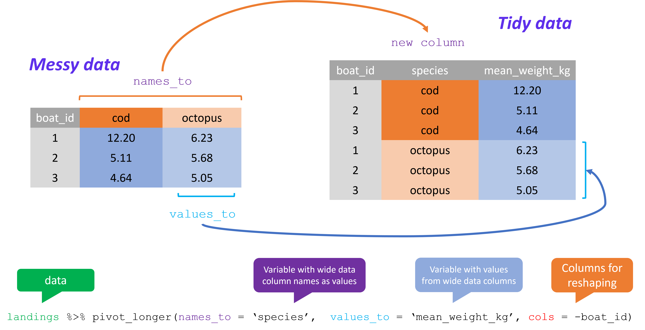
• pivot_wider – convert to untidy (because there is nothing intrinsically wrong with it!)
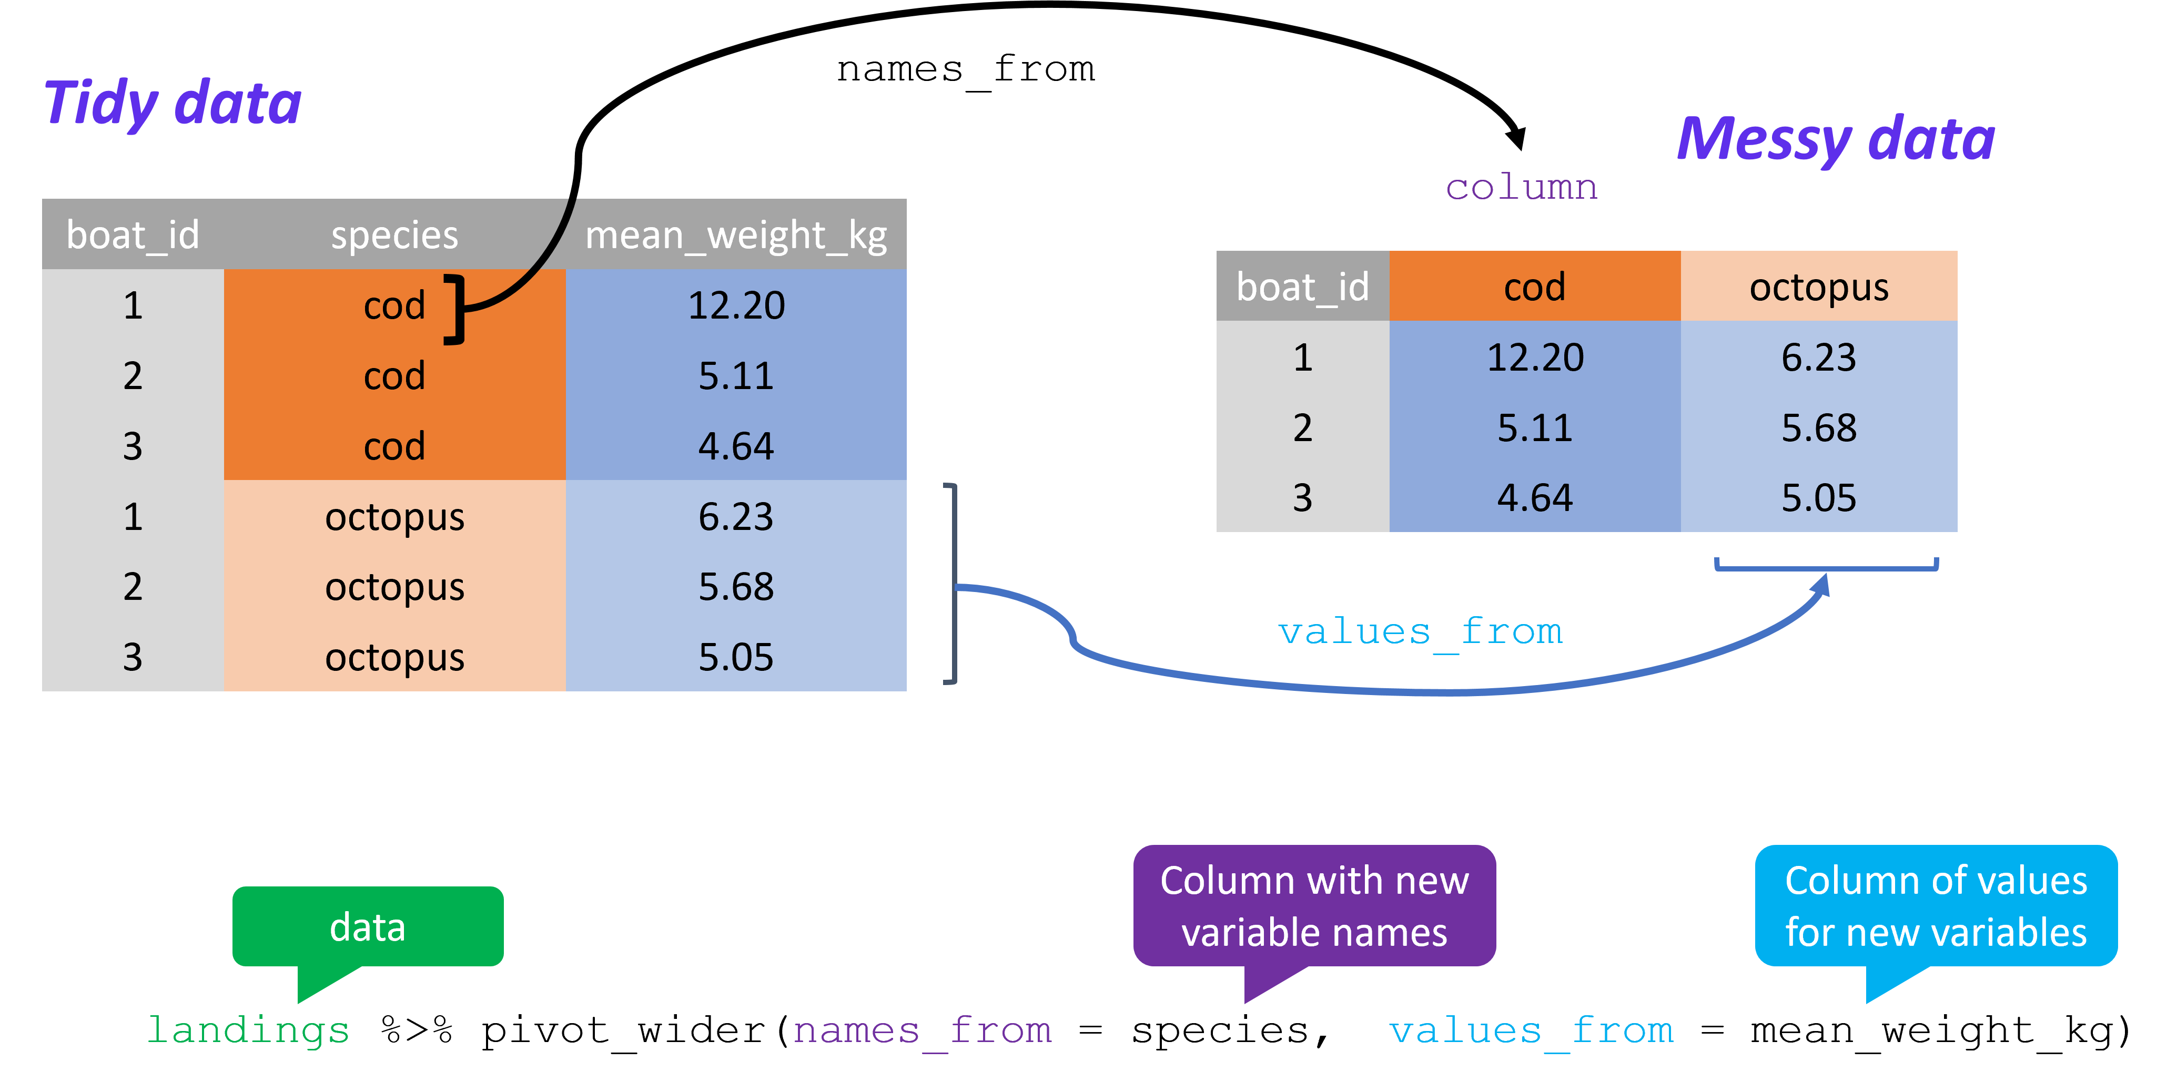

Data Manipulation with dplyr
Besides tidyr, dplyr is probably the most widely used tidyverse package. It is used to manipulate and transform data. The 5 main dplyr verbs that you will come across many times throughout this course:
filter: select a subset of rows/observations
select: choose which columns/variables to work with.
arrange: change order of rows, by default arranging happens in ascending order
mutate: update or create new columns of a data frame.
summarise: turn many observations into a single data point (eg mean, max)
group_by: allows actions to be performed by group (group_by is often followed by summarise)
https://teachingr.com/content/the-5-verbs-of-dplyr

Joining datasets
Another very useful dplyr capability that is essential in research, is to help joining datasets.
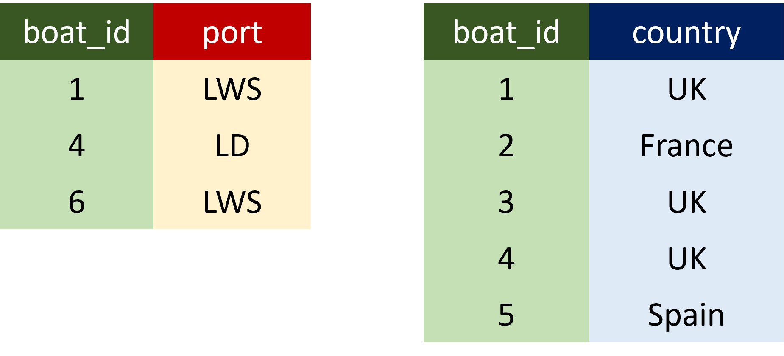
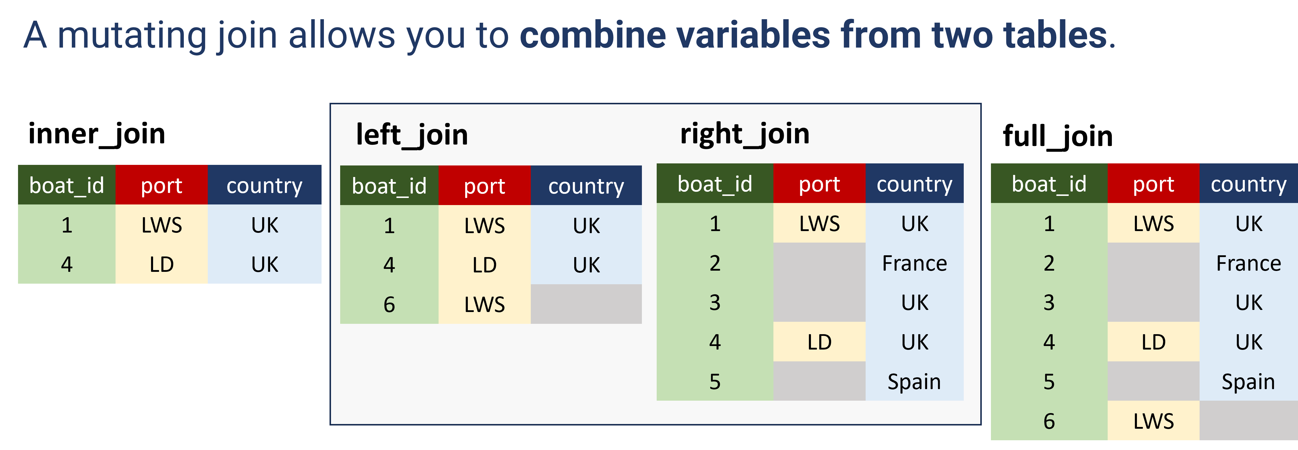
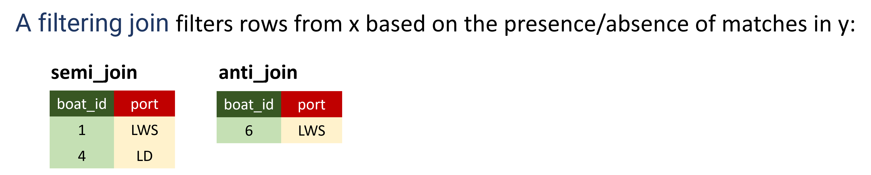

☝️ There is also fuzzyjoin::fuzzy_join (#allows partial and inexact matching)

To summarise:
- using the tidyverse will help to organise and streamline your data analysis workflow in a consistent way
- it is easy to learn and there is help available: there is a huge number of online resources and a very welcoming community organising events, meetups, coding clubs...
- Example: rfordatascience/tidytuesday: Official repo for the #tidytuesday project (github.com)
In the following sessions, you will have the opportunity to use the tidyverse and base R in practice

To finalise, some more resources:
Here you can see animations of the above:
https://tidydatatutor.com/index.html
https://www.garrickadenbuie.com/project/tidyexplain/#pivot-wider-and-longer
Many cheat sheets: Cheatsheets - Posit
learn
https://www.tidyverse.org/learn/
https://r4ds.hadley.nz/
Tidyverse Cheat Sheet For Beginners | DataCamp
https://rstudio-education.github.io/tidyverse-cookbook/transform-tables.html
and practice
https://www.jvcasillas.com/untidydata/

