LAB 1:
Date: 17 de mayo de 2025

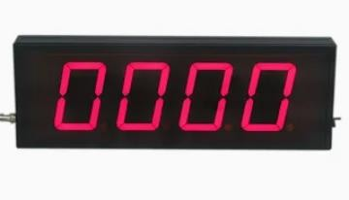

Professor:
Dr. Francisco Javier Rodríguez Navarrete

Students:
Alonso Emmanuel López Macias César Eduardo Inda Ceniceros.
Team: 14

Introduction
In this lab, a sequential digital counter is developed in Verilog, capable of counting from 0 to 9999, both upwards and downwards. This type of circuit is fundamental in digital systems, as it allows controlling
events, measuring time, generating sequences, and addressing memories. The project includes
parameterizing the counter, integrating it with an FPGA, displaying the output on 7-segment displays, and simulating the system's behavior through a testbench.

Requirements
- Design a counter that can reach the decimal value 9999.
- The counter must count up or down based on the up_down signal.
- The initial value can be loaded via the load signal and the input data_in.
- If the loaded value exceeds 9999, the counter resets to 0.
- The output q must be displayed on 4 seven-segment displays.
- When the counter value is 9999, LEDG8 should turn on.
- When the counter value is 8, LEDG8 should turn off.
- The clk is generated by a button (KEY0) and reset is triggered by KEY1.
- The system must be verified using a testbench in simulation.

Development
Parametric Counter: Starting from a 4-bit counter studied in class, the design was expanded to 14 bits to support counting up to 9999. The module includes an up_down signal to determine the counting
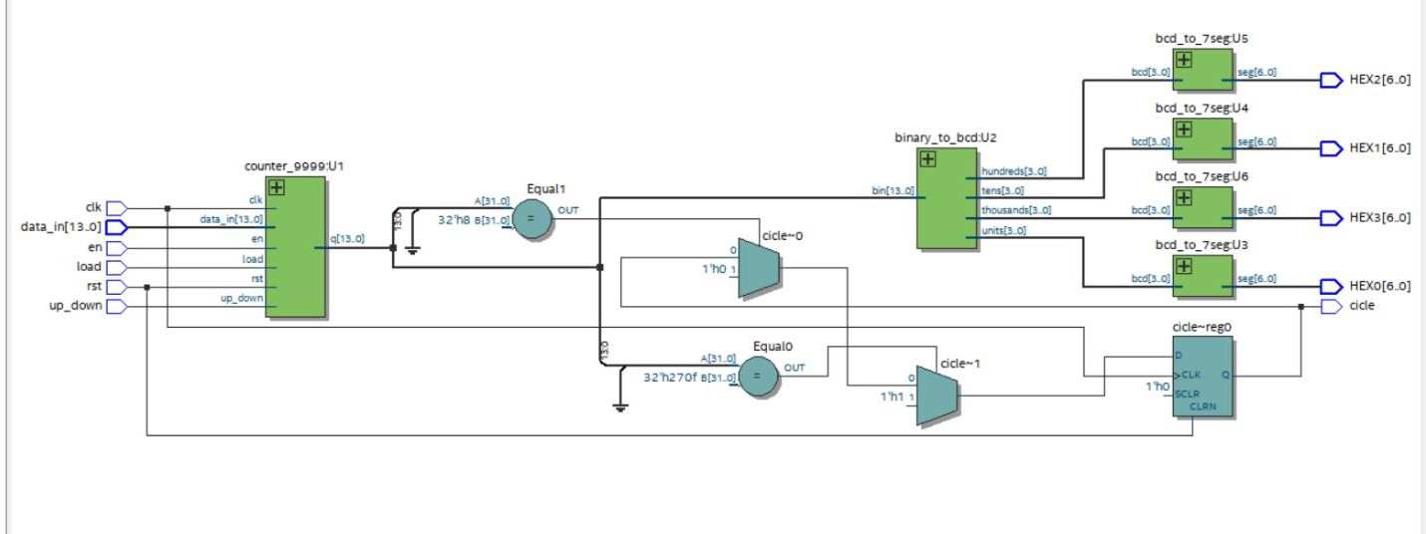
direction, an en signal to enable counting, and a load signal to initialize the counter with an external value (data_in). A conditional structure ensures that if data_in is greater than 9999, the counter resets

to 0. An additional output signal last is used to indicate when the counter reaches its maximum value. This module was written in Verilog using an always block sensitive to the rising edge of clk and rst.
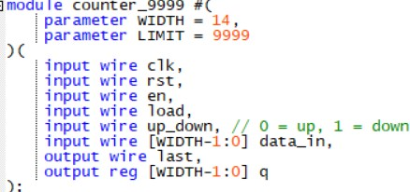
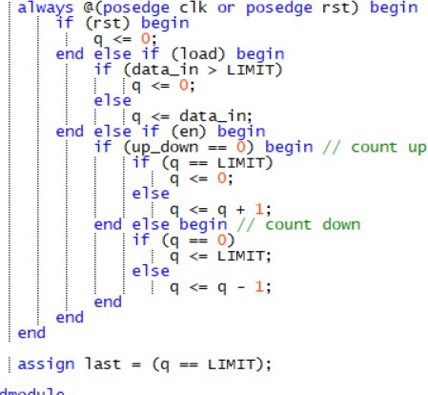

To visualize the counter output on 7-segment displays, a binary-to-BCD conversion module was implemented using the "double dabble" algorithm. This module outputs four 4-bit BCD digits
representing units, tens, hundreds, and thousands. Each BCD digit is then passed to a decoder module
that maps the value to the appropriate segments for a common-anode display. The segments are driven such that a '0' turns on a segment.
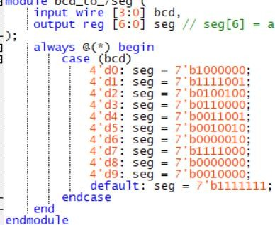

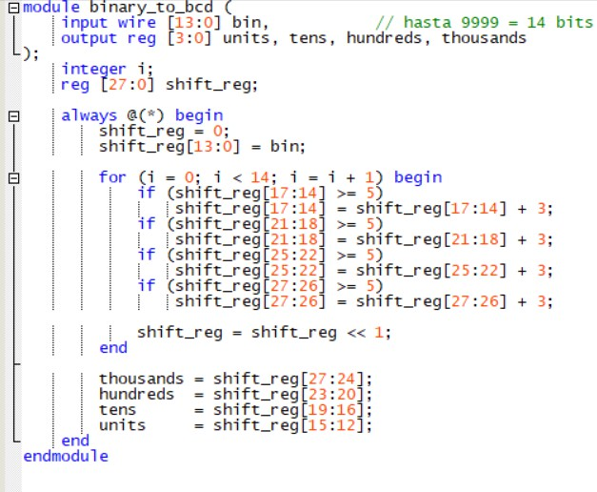
Additionally, the system includes input from toggle switches SW[0–13] for data_in, with SW14 used to
select the counting direction (up_down), SW15 to enable the counter, and SW16 to load data. The clock (clk) and reset (rst) signals are activated through push buttons KEY0 and KEY1 respectively. All modules
were instantiated in the top module, including the 9999 counter, the binary-to-BCD converter, and the 7-segment display drivers.
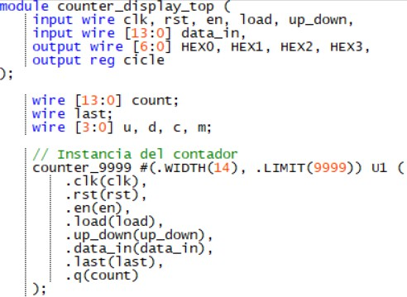
A simple sequential block was added to the top module to monitor the value of the counter. If the counter reaches 9999, the LEDG8 output is set to 1. When the counter reaches 8, LEDG8 is reset to 0. This logic is handled using a separate always block that reacts to the rising edge of the clock and reset signals.

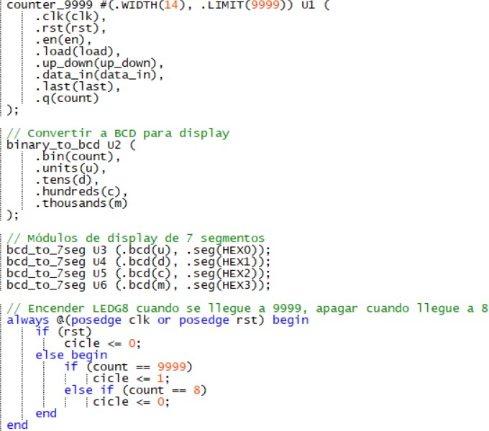

Testbench

The testbench simulates a manual clock pulse (emulating button KEY0) using a task that toggles the clk signal. Several test cases were written: one to load a value close to 9999 and verify the wrap-around, one to test descending count, and one to validate LEDG8 (cicle) logic when reaching 9999 and 8. The
$monitor statement prints simulation data, and $stop halts the simulation. (Insert waveform showing counting, loading, and cicle behavior)

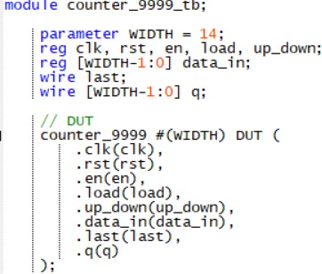
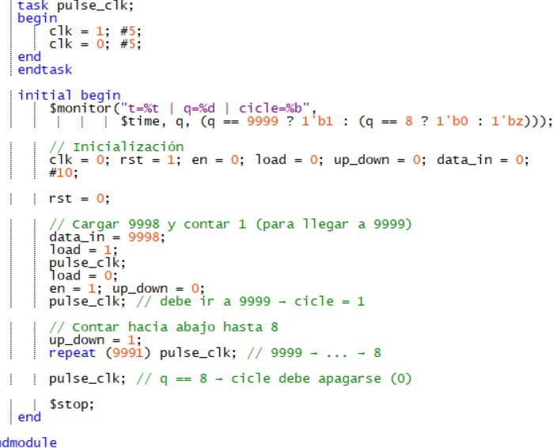

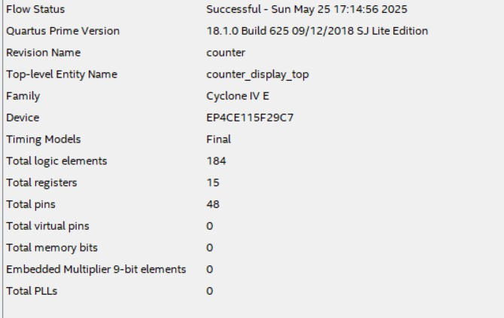
FPGA Implementation

Conclusion/Issues

Cesar Eduardo Inda Ceniceros
Designing a parameterized counter in Verilog allows adapting the circuit to different counting ranges and facilitates reuse in future projects. Moreover, integrating it with displays and output elements
improves visual interpretation of results on an FPGA.

Alonso Emmanuel López Macias.
Simulation through a testbench with controlled pulses allows accurate validation of the circuit's behavior under conditions similar to the physical environment, helping detect logic errors before hardware implementation.

