LAB 1: Traffic Lights
  - Date:4 June of 2025
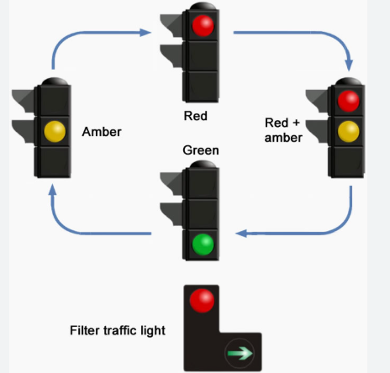

  - Proffesor: Dr. Miguel Angel Rivera Acosta

  - Students: Luis Alberto Castañeda Montaño
José Antonio García Madrigal
  - Cesar Eduardo Inda Ceniceros
Alonso Emmanuel López Macías
  - Team: 9

Introduction
Nowadays, digital systems play a fundamental role in the automation of processes across key sectors such as transportation, industry, and telecommunications. A classic and highly representative example of sequential system applications is traffic light control, where precise and reliable logic is required to manage the cyclic and safe transition of lights (green, yellow, and red). The main objective of this laboratory was to design and implement a digital traffic light control system that responds to specific timing conditions and an external activation signal. For this purpose, the System Verilog language was used a powerful extension of Verilog that allows for more structured and system-oriented modeling, facilitating the development of finite state machines (FSMs) and synchronized structures.
During the project, precise timing cycles were defined for each traffic light state: the green light had to remain active for 10 clock cycles, the yellow light had to blink in a controlled manner (on for 2 cycles, off for 2 cycles, and on again for 2 cycles), and the red light had to stay on for 15 cycles. Additionally, the system was required to start with the green light upon power-up and respond to an input signal to start or stop the cycle. This exercise not only enabled the application of theoretical knowledge about sequential systems and digital controllers but also involved real-world implementation challenges such as clock synchronization, accurate cycle management, and external input handling. Throughout the laboratory, a modular solution was developed and the system’s behavior was validated through simulations, visually confirming the complete light sequence using digital tools.

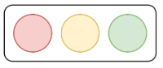

Figure: 1 Semaphore Lights

Requirements
Considering that we are required to design a digital system for traffic control with the following specifications.
- GREEN light must last 10 clock cycles.
- YELLOW light must be on 2 clock cycles then off 2 clock cycles and then on 2 clock cycles.
- RED light must last 15 clock cycles.
- The full cycle must start with the GREEN light at the power up.
- The cycle must start cyclically once an input signal toggles high; the cycle must stop until another input signal toggles high.
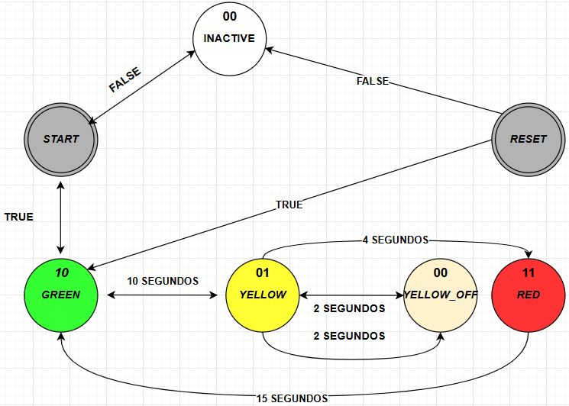

Figure: 2 FMS Traffic Light

For see more details: https://app.diagrams.net/?src=about

Development
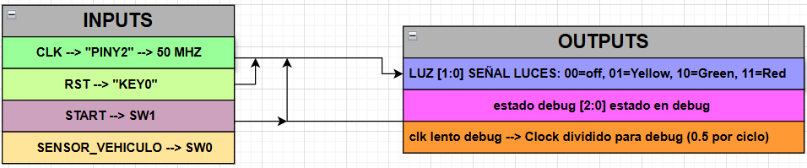
The first part of this laboratory consisted of generating the corresponding documentation for the state machine and the behavior of how the program would operate. For this, the requirements include defining the behavioral block diagram, based on the generation of parameters related to the state machine transition process. Additionally, elements of the program are also taken into account to understand the overall functionality of the program. In this section we can see the “variables data” for values in the input and the output.

Figure: 3 Variables Relations

The main logic in the code was as following:
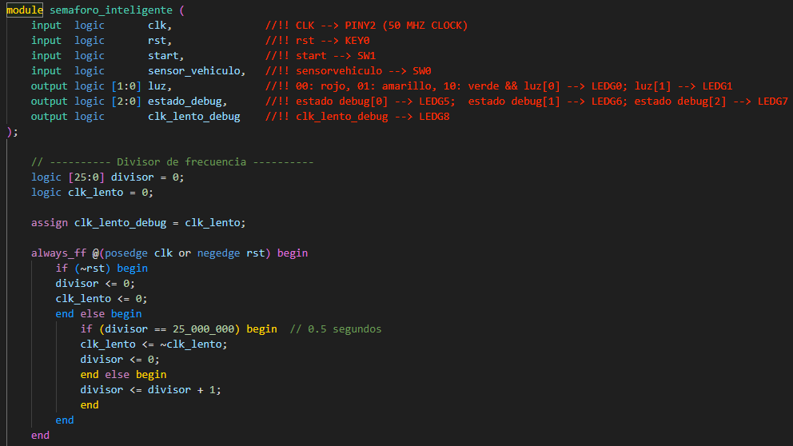

In this other section we define the “enum” states for each one lapsus time representation, the other variables were defined because was a brief representation for see the led status in the board. Also, we integrated the “sequential fsm” section for use here the “always_ff” process.
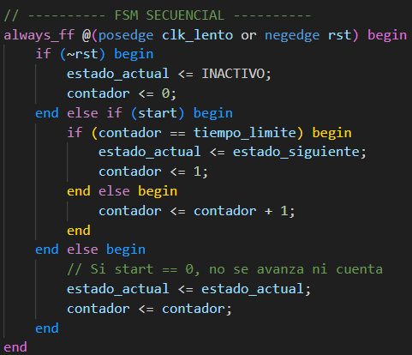
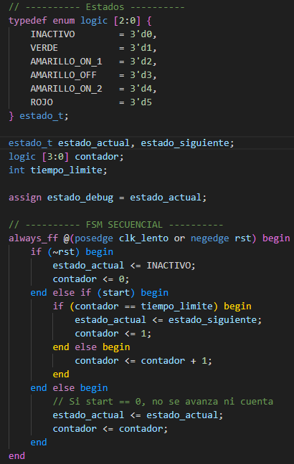

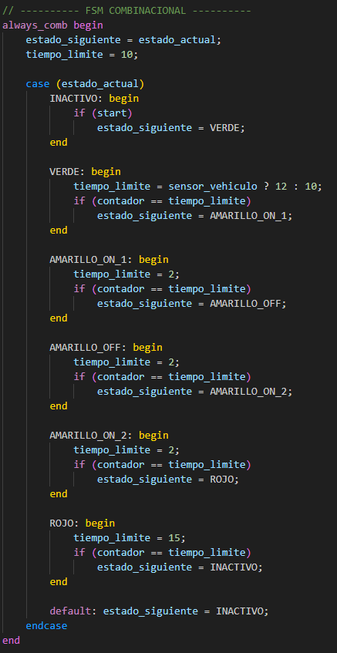
In this section, we define the combinational logic for each of the states in the program, that is, "combinational fsm" in an “always_comb” block along with a structure for the different types of case statements.


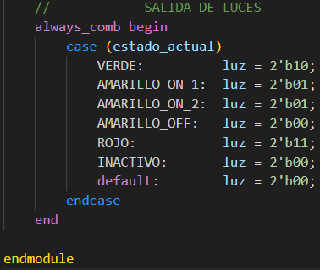
In this part, the output of the behavior for the LED values was defined. That is, in this section, the "estado_actual" will go through each of the conditions in the "case" and will output the value of "luz" at that moment.

Figure: 4 traffic_light.sv

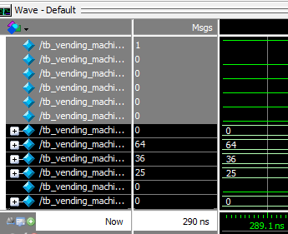
TestBench
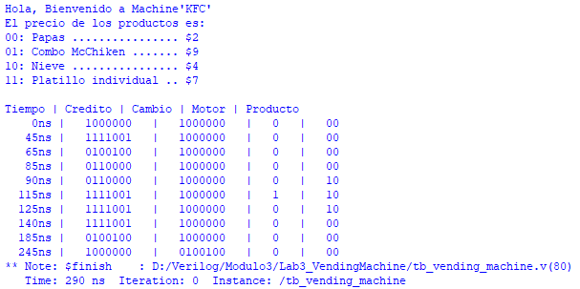

Figure: 7 Testbech_Display

FPGA Implementation
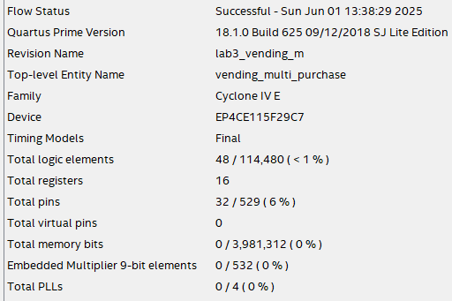
Once the program was completed, the compilation process was carried out in order to generate the pin assignment plan and correctly map the pins according to the program’s requirements.

Figure: 8 Compilation Report

The pins consideration was assigned as following, in this case we add different elements for complete the functionality in the FPGA.
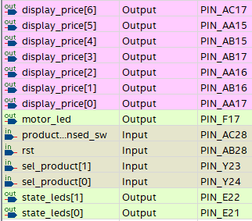
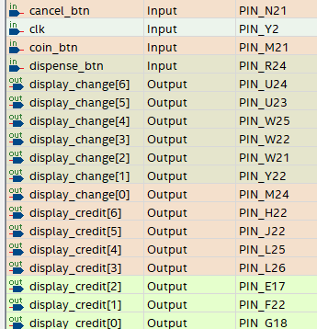

Figure: 9 PinPlanner
The RTL view can be observed as follows.
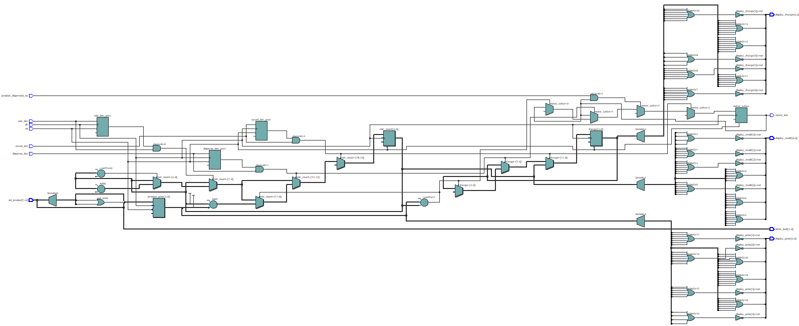

Figure: 10 RTL Viewer

FPGA Results
To perform this FPGA we can simulate a 3 buys in each one we set a $9 credit value and continue shopping the products until we have a credit that is not enough for buy other product, with this we can observe that the functionality is correct the LEDG8 represent the motor in state on because the machine continues dispenser the products and continues with a enough value for other product.
1.- Product = $4 , Credit $9 , Change = $5 Continuation we can continue buy other product
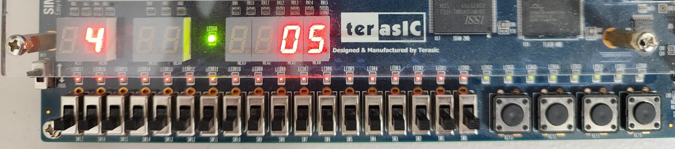

Figure: 11 Test1
2.- Product = $2 , Credit $5 , Change = $3 Continuation we can continue buy other product
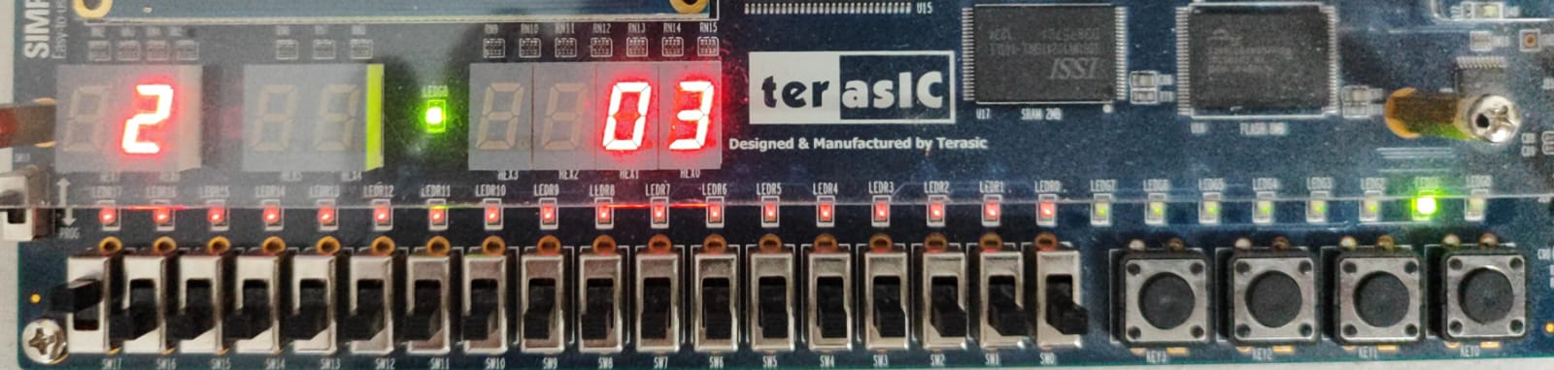

Figure: 12 Test2

3.- Product = $2 , Credit $3 , Change = $1 Continuation we can continue buy other product
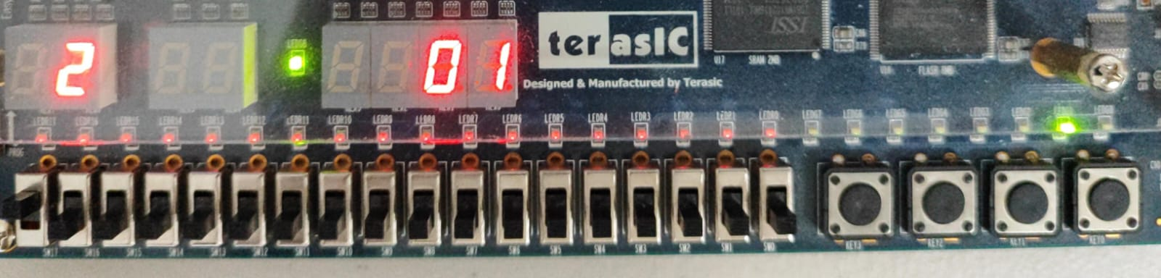

Figure: 13 Test3

GitHub Repository
https://github.com/CeicGitHub/Fundamentals_Of_Digital_Design_FPGA_3/tree/Lab3_VendingMachine

Conclusion / Issues
Cesar Eduado Inda Ceniceros
I believe that in this lab we faced quite a few issues, since in order to implement multiple validations, we had to start separating the logic. First, we made sure that the credit amount worked and that the purchase could be canceled. Then, we added the selector part with the products and made sure they were displayed correctly. Once each functionality was working, we combined the logic to ensure that, when pressing the buttons, the appropriate calculations would be performed by the program. It was challenging to consider certain elements, as the FSM represented a more complex challenge compared to other practices.
Alonso Emmanuel Lopez Macias
We had to segment much of the implementation to ensure it was working correctly. On many occasions, the product purchase would go through, but when trying to buy another product, the value stored in the credit variable would reset to 0. So, we had to start adding many conditions that would allow us to retrieve the remaining credit to continue purchasing. Part of the lab, especially the testbench, also posed difficulties when dealing with the conditions we had created, since some initial considerations triggered errors due to unsupported elements, we had previously been working with in System Verilog. In this case, using Verilog made it significantly more complex. I learned a lot from this lab, but I believe the difficulty level was quite high.

