LAB 2: Subprocesor
  - Date:11 July of 2025

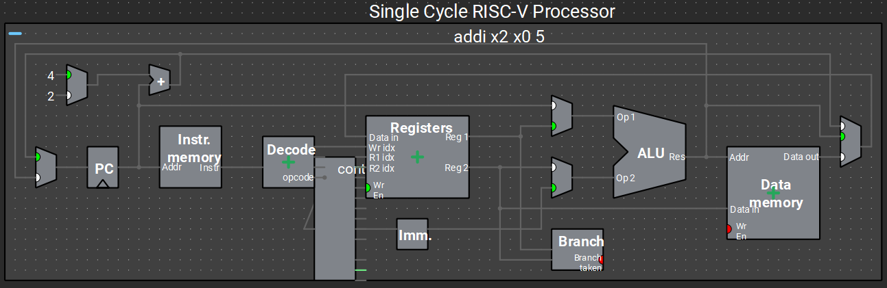

  - Proffesor: Dr. Francisco Javier Rodríguez Navarrete

  - Students: Cesar Eduardo Inda Ceniceros
Alonso Emmanuel López Macías
  - Team: 14

Introduction
Before this laboratory, we had a classroom session where we were introduced to classical blocks, the data path and control path, as well as the integration of these blocks. We covered the importance of the "single-cycle processor," how it works, and some RISC-V instructions, including the types of instructions and their operations. We also explored examples of how programs behave based on these fields or internal preconfigurations of the processor’s microarchitecture, that is, each instruction already defined internally, which the user can utilize. To apply this, we created a project in Vivado focused on implementing this single-cycle concept.
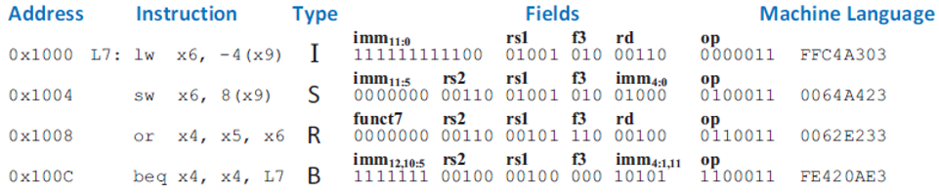
An important part of digital circuit design, especially during its development and verification stages—is ensuring a solid design based on the schematic interpretation of a microarchitecture. This is crucial, particularly when working in multidisciplinary teams, where clear and readable communication of ideas is necessary to avoid design errors in early stages. In this laboratory, we based our work on a given microarchitecture to develop the RTL design logic, also taking into account a RISC-V considerations table.

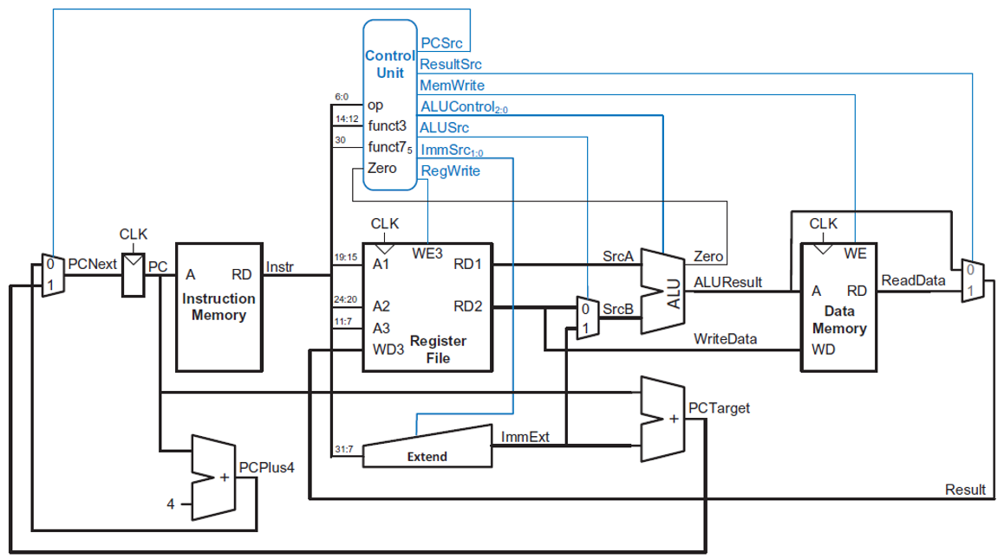

Requirements
- Compile & test the program in “Vivado”.
- Debbug the TestBench “test the console and waveform values”.

Development
We use the microarchitecture interpretation for do the RTL files in this case as following:
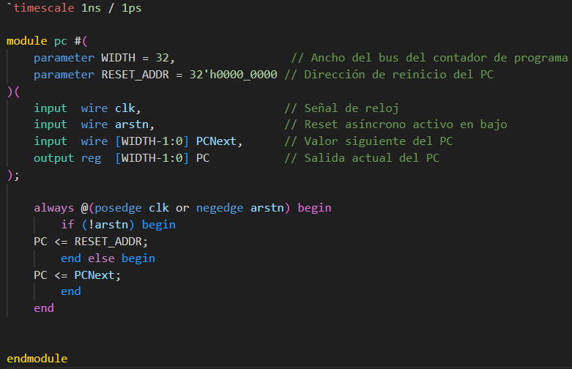
PC.SV

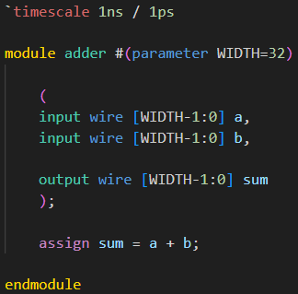
ADDER.SV

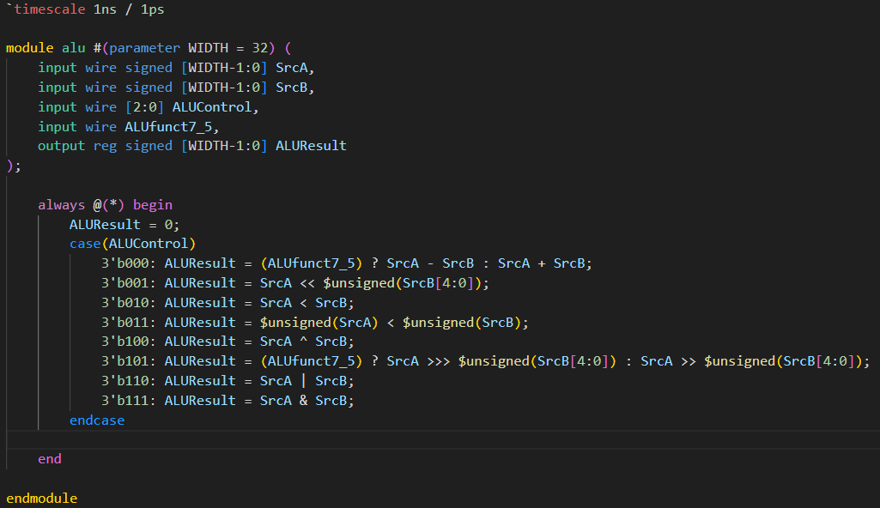
ALU.SV

CONTROL UNIT.SV
In this case we omitted this part because the code represents more than 100 lines of code.

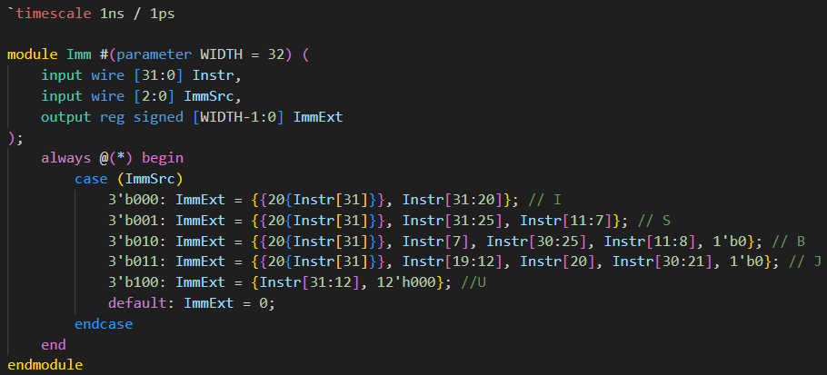
IMM.SV

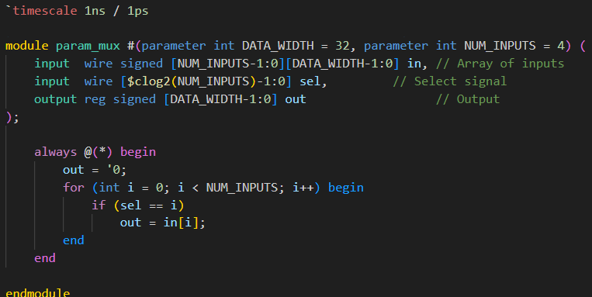
PARAM_MUX.SV

RAM.SV
In this case we omitted this part because the code represents more than 100 lines of code.
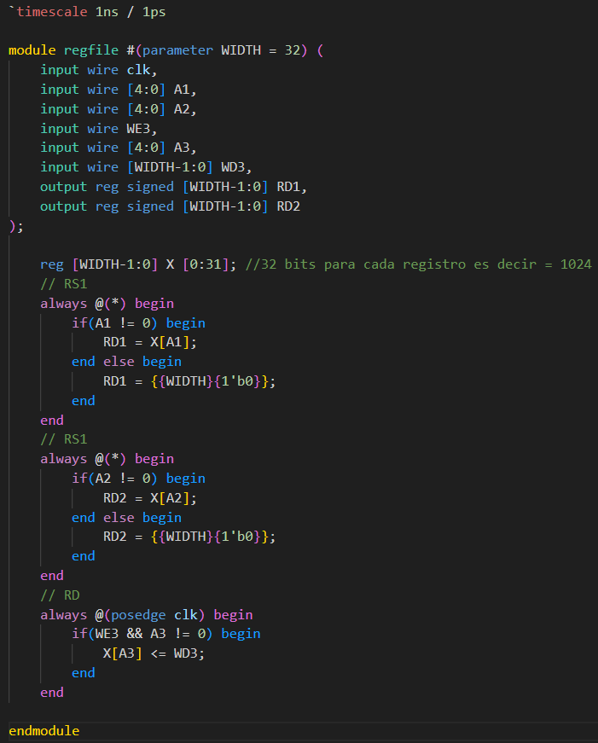
REGFILE.SV

ROM.SV
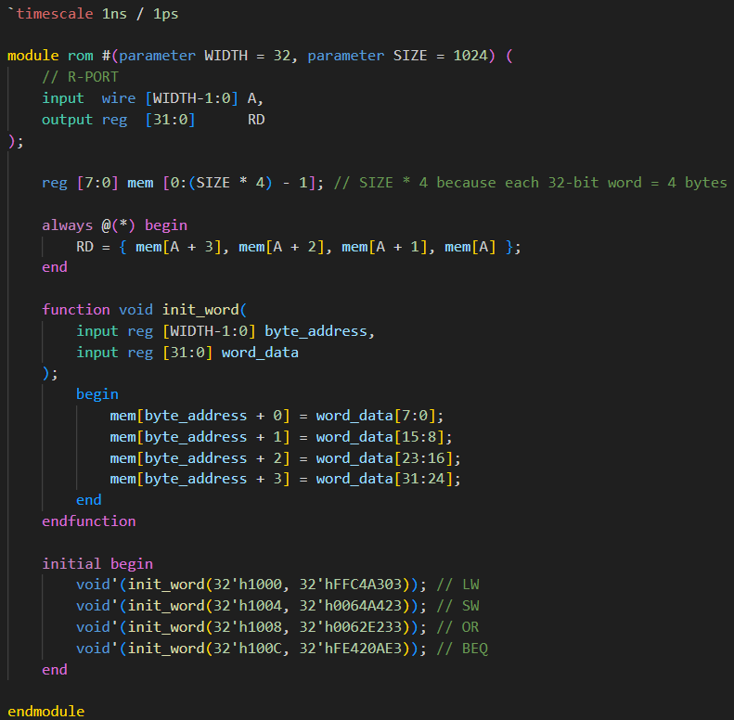

Exist other files considerations for use in the project but some codes are very extensive for reduce the information in the report we simplify with some main files in this recompilation for documentation, but is important to know that exist other files, in this part we reduce some logic for the RISC-V and Testbench sections.

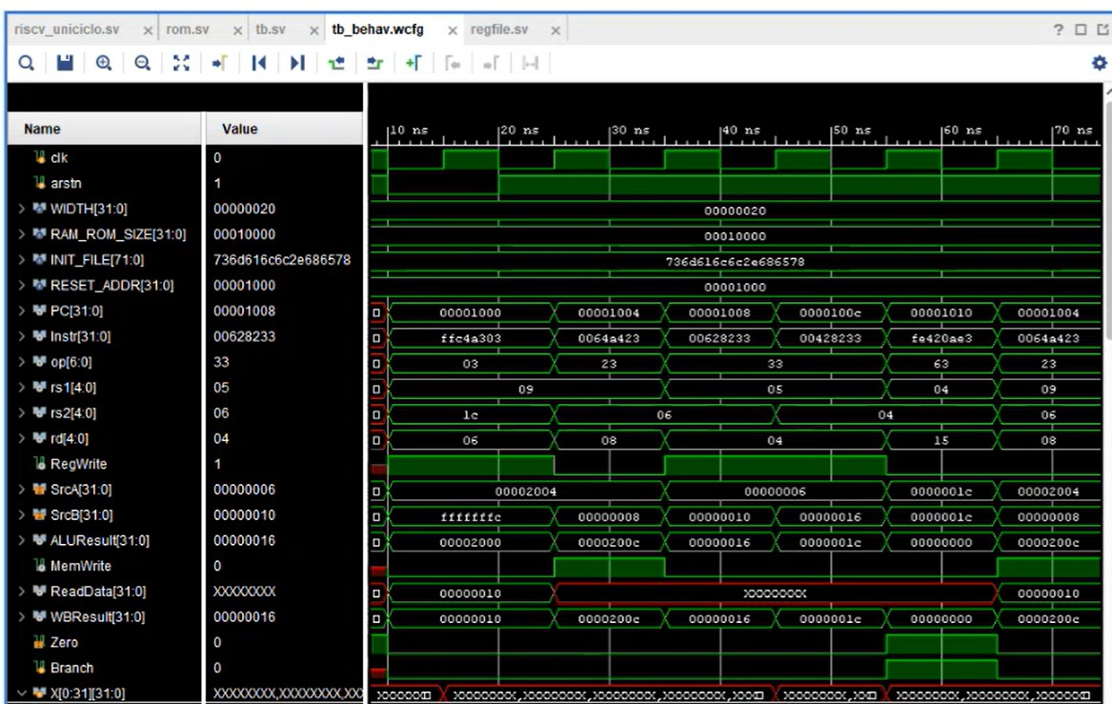
Vivado Simulation (Waveforms)

GitHub Repository
https://github.com/CeicGitHub/Fundamentals_Of_Digital_Design_FPGA_6/tree/Lab2_RiscvSingleCycle

Conclusion / Issues
Alonso Emmanuel Lopez Macias
This was a lengthy lab, but I learned a lot about creating a sub-processor based on the microarchitecture, defining the behavior of each component along with their interactions, individual functionalities, and how they work together according to RISC-V specifications.
Cesar Eduado Inda Ceniceros
I really enjoyed this lab; I learned about the importance of RISC-V and how it influences the microarchitecture of a system, including key considerations for its behavior both at the RTL level and during testing and verification.

