Diseño de SoC con Caravel

Lab 1: SKY130 SRAM Macros

Instructor: MCEE. Emilio Isaac Baungarten Leon

Names: Ricardo Torres López y Cesar Eduardo Inda Ceniceros Date: 15/09/2025

Objective:
The objective of this laboratory practice is to guide students through the RTL to GDSII workflow using OpenLANE for designing a LIFO (Last-In, First-Out) memory. Students will learn to utilize the SKY130 SRAM library and develop the necessary management logic to implement the LIFO functionality.
Additionally, students will gain hands-on experience in hardening the top module, comprising the SRAM and management logic, as a macro.

Description of the laboratory:
- On PDK file search the sky130 sram cell

Delivery:

OpenLane workflow errors and solutions
In this section, students are encouraged to document any error messages encountered during the execution of the workflow. They should explain the error, including its cause and the stage of the flow where it occurred. Additionally, students must provide steps to resolve the error.

Verilog HDL code
For this lab we did a “LIFO” were implemented a file in Verilog where we used different considerations for complete the functionality in the “LIFO” system.
PART1
First, we did a simulation for “memory behavior”.
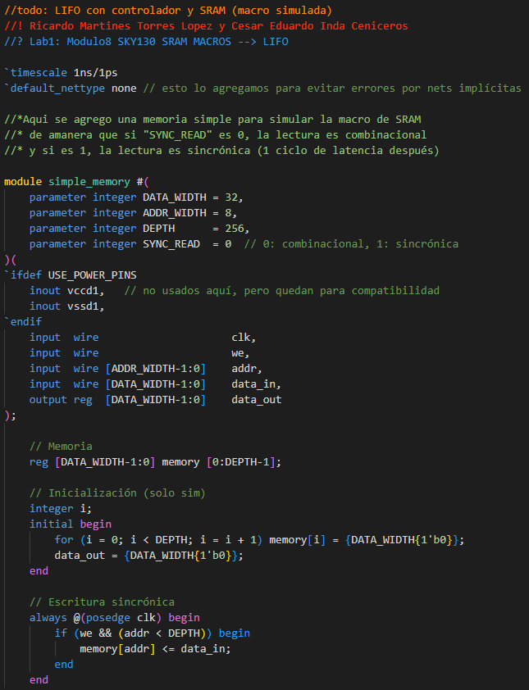

The different “readers” and synthesis for avoid “warnings” in the power pins.
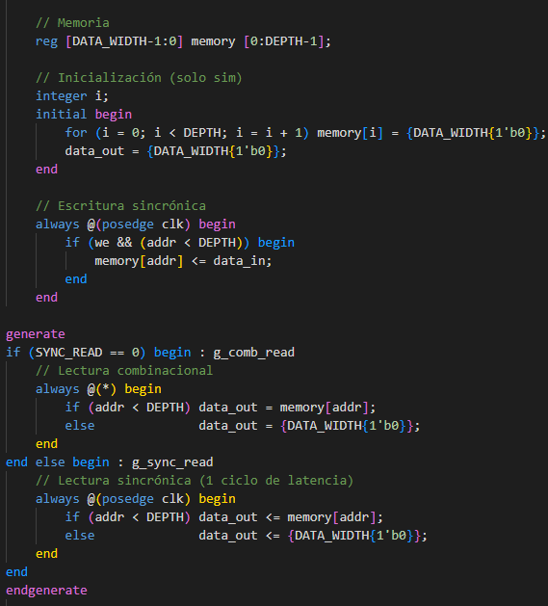

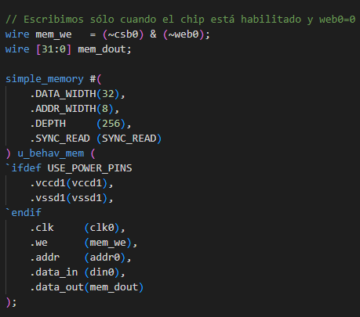
Then we set the consideration for PDK Macro Sky RAM 32x256 propagation to memory.
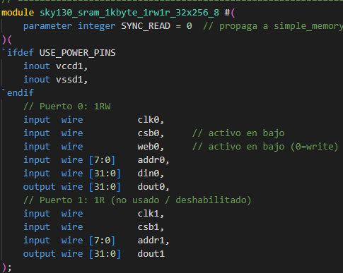

Different considerations for “assigns” in “dout0” and “dout1”.
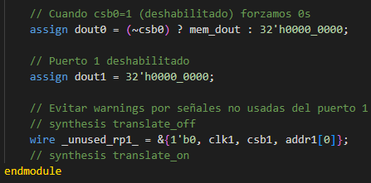

The we did a “lifo controller” for provide a handler in the stack pointer.
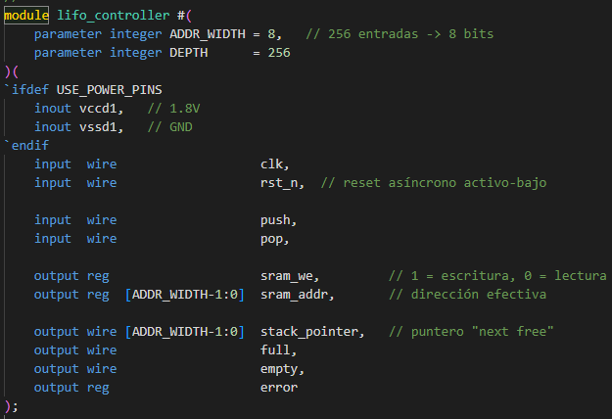

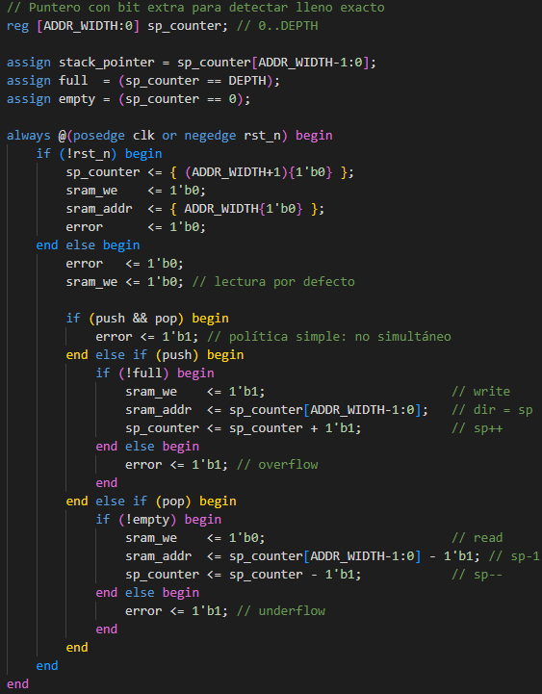

The last consideration was the “top” section for provide a enable in the internal signals for SRAM and the enable chipset when exist some process or operation.
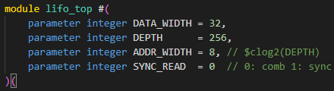

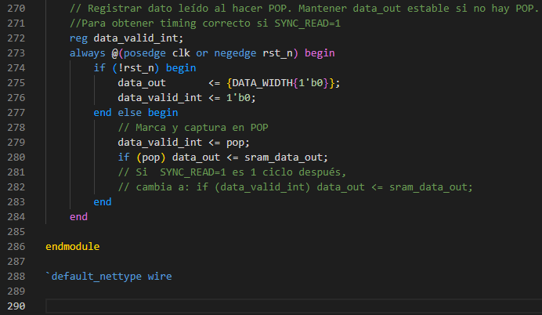
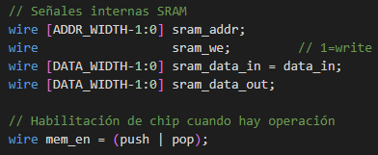

TestBench (DV_ Design Verification)

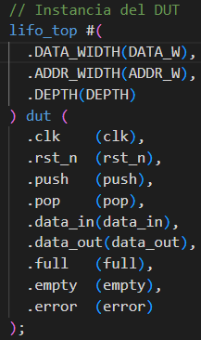
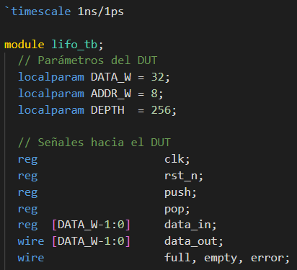
For test the Project in Vivado we did a basic “testbench” were observe the behavior and functionality.

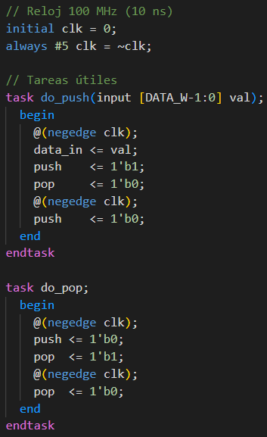

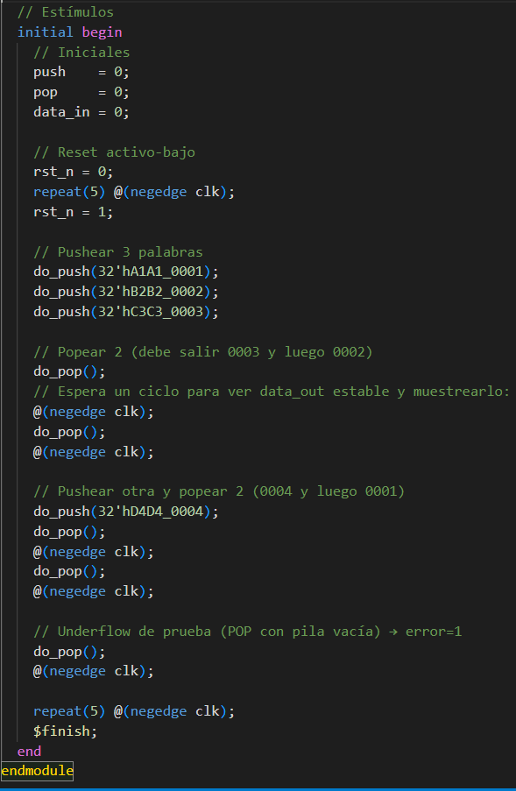
We set a “stimulus” and pop words in some pushes.



RTL (Schematic)
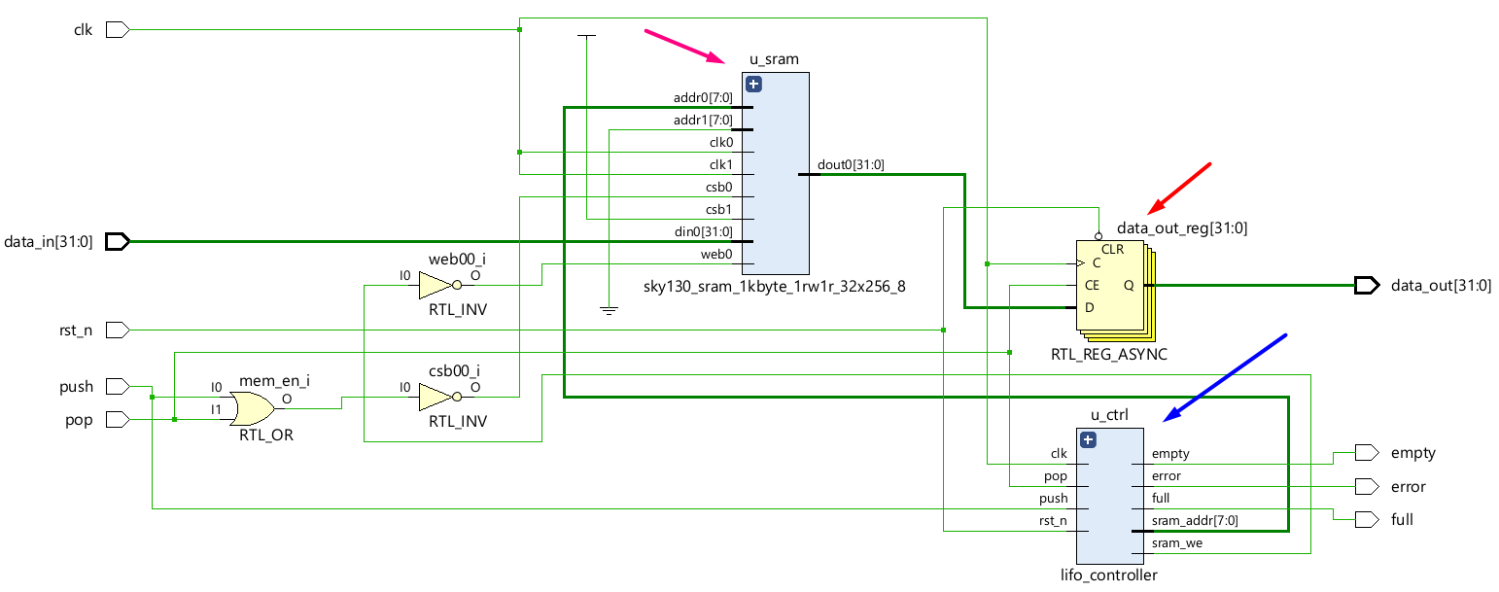

Vivado (Waveform)

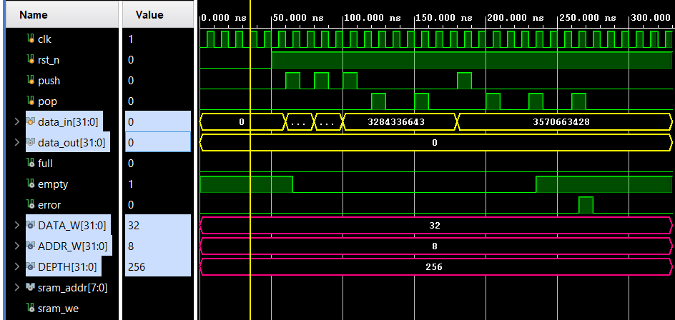
We can observe the next behavior in the waves.

JSON configuration file for the project

Verilog HDL code after OpenLANE workflow

GSII files

Simulation results

Heat Maps

Git-Hub:

We created our own repository:
https://github.com/CeicGitHub/Fundamentals_Of_Digital_Design_FPGA_8

For this lab we use “Caravel” from “Chip Foundry” repository:
https://github.com/chipfoundry/caravel_user_project

