No | The Court Name/ Decision | Year | Name/ Case | Indictment | Punishment
1 | District Court in Muara/ 45/Pid.B/2012/PN.MR | 2012 | Alexander Aan/ promote Atheism in Facebook | Art. 28 (2) and Art. 45 (2) of the IET Law, | Two years and 6 months in prison, fined IDR 100 billions
2. | District Court in Pati/ 10/Pid.Sus/2013/PN.PT | 2013 | Muhamad Rokhisun Bin Ruslan/ posting the prophet Muhammad picture in facebook | Art. 28 (2) and Art. 45 (2) of the IET Law., 156a Criminal Code. | Four years and fined IDR 10 billions
3. | District Court in Jakarta/ 890/Pid. Sus/2022/PN Jk Brt, Desember 28th 2022 | 2016 | Roy Suryo/ defaming the face of President Joko Widodo using meme in Borobudor temple and hare it through twitter | Art. 28 (2) and Art. 45 (2) of the IET Law. | 9 months in prison, fined IDR 150 billions
4. | District Court of Jakarta | 2022 | Muhammad Kece/ share the video content hate speech, stated that the Prophed Muhammad is the follower of JIN. | Art. 28 (2) and Art. 45 (2) of the IET Law. | 10 years in prison
5 | District Court in South Jakarta/ 773/Pid.Sus/2022/PN.Jkt.Slt | 2022 | Yahya Waluni/ defaming the Prophet Muhammad and Islam through social media. | Art. 28 (2) and Art. 45 (2) of the IET Law. | 5 months

Article | The IET Law 2008  (Before Amendment) | The IET Law 2016  (After Amendment) | Comparation
Article 27 (3) | Article 27 Paragraph (3) reads, "Everyone intentionally and without rights distributes and/or transmits and/or makes electronic information and/or electronic documents accessible that contain insults and or defamation. | Article 27 Paragraph (3) reads, "Everyone intentionally attacks a person's honor and reputation by accusing something that is publicly known in the form of electronic information and/or electronic documents carried out through an electronic system. | By removing the phrase "defamation or insult" from Article 27 (3) of the EIT Law of 2016, this article is no longer used to punish blasphemy, as it now focuses on criminal sanctions for defamation of others.  This is merely a transfer of the article, as many blasphemy perpetrators are punished under Article 28 (2), as blasphemy is interpreted similarly to hate speech.
Article 28 (2) | Article 28 Paragraph (2) reads, "Everyone intentionally and without right disseminates information aimed at creating feelings of hatred or hostility towards certain individuals and/or groups of people based on ethnicity, religion, race and inter-group (SARA)."  Revision of the ITE Law | Article 28 Paragraph (2) reads, "Every person intentionally disseminates electronic information and/or electronic documents which are inciting, inviting or influencing other people so as to create a feeling of hatred or hostility towards certain individuals and/or community groups based on ethnicity, religion, race, and/or intergroup (SARA).” | Because a person's "feelings" are highly subjective and difficult to prove in court, the term "feelings of hatred" remains problematic. As a result, this article is frequently used by parties with greater power to exert pressure on those with less.

Proses penegakan hukum penodaan agama

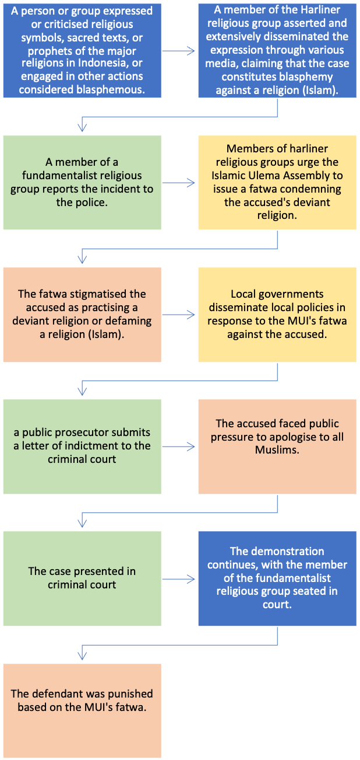
Involve public pressure
Public official Involvement

Criminal justice procedures
Punishment before and after the court’s decision

Undang-Undang a quo sebagi pijakan pemeliharaan kerukunan umat
Beragama. ketiadaan pembatasan yang diwujudkan dalam aturan akan
mengakibatkan pelanggaran etika moral, hilangnya keseimbangan,
timbulnya anarkis, dan terjadinya pelanggaran terhadap pancasila. kerukunan umat beragama di Aceh berpotensi diganggu dan
menimbulkan konflik jika Undang-Undang a quo dicabut. UU a quo ini dalam proses penghantaran umat, karena sudah terbukti bisa
memberikan proteksi, regulasi, dan harmoni pada tataran tertentu, maka
harus tetap dipertahankan

DPR: (Hal. 135) https://www.mkri.id/public/content/persidangan/putusan/putusan_sidang_Putusan%20PUU%20140_Senin%2019%20April%202010.pdf

Dewan
Perwakilan Rakyat telah menyampaikan keterangan tertulis bertanggal 4 Februari
2010 yang diterima Kepaniteraan Mahkamah pada tanggal 8 Februari 2010

Pancasila sila pertama, “Ketuhanan Yang Maha Esa” menjadi landasan filosofis negara dan Bangsa Indonesia dalam menyelenggarakan negara dan pemerintahan […] di berbagai daerah di Indonesia muncul aliran-aliran sesat dan menyesatkan. Atau organisasi-organisasi kepercayaan masyarakat yang bertentangan, atau menyimpang dari pokok-pokok ajaran agama dan hukum agama […] berdampak pada terjadinya perbuatan anarkis yang bertentangan dengan hukum [….] mengganggu ketertiban umum, mengancam kerukunan hidup baik antarpemeluk agama itu sendiri maupun antar umat beragama yang pada
gilirannya dapat mengancam keamanan nasional kita.

Majelis Ulama Indonesia (MUI) bertanggal 4 Februari 2010 yang
diterima Kepaniteraan Mahkamah pada tanggal 8 Februari 2010 (139 -50):

“[…]banyak aliran dan kelompok yang berkembang menyuarakan paham dan kegiatan yang
bertentangan dengan aqidah dan syariah agama Islam…pasti akan menimbulkan keresahan umat di samping akan menimbulkan korban umat yang telah disesatkan dan dirugikan mental spiritualnya dan juga materi jasmaniahnya”

…Ketua Umum Pengurus Besar
Nahdlatul Ulama Kyai Haji Hasyim Muzadi yang dimuat di Harian Republika
menyatakan, “Jangan berbicara tentang kebebasan beragama, jangan berbicara
HAM tentang kasus Ahmadiyah karena Ahmadiyah bukan agama tersendiri.
aliran-aliran atau
organisasi-organisasi kebatinan, kepercayaan masyarakat yang bertentangan
dengan ajaran-ajaran dan hukum agama. Diantara ajaran-ajaran dan perbuatan-
150
perbuatan pada pemeluk aliran-aliran tersebut sudah banyak yang menimbulkan
hal-hal yang melanggar hukum, memecah persatuan nasional, dan menodai
agama. Dari kenyataan itu teranglah bahwa aliran-aliran atau organisasi-organisasi
kebatinan, kepercayaan masyarakat, mempergunakan agama sebagai pokok pada
akhir-akhir ini bertambah banyak dan telah berkembang ke arah yang sangat
membahayakan agama-agama yang ada.

Indonesian Ulema Council (MUI) dated 4 February 2010 which
received by the Registrar of Court on 8 February 2010 (139 -50):
“…many sects and groups have developed to voice their ideas and activities
contrary to the aqidah and sharia of the Islamic religion…it will definitely cause unrest among the people besides causing victims….people who have been misled and harmed mentally, spiritually and materially, physically…

The general chairman of the board of directors Nahdlatul Ulama Kyai Haji Hasyim Muzadi published in Republika Daily stated, “

"Do not discuss religious freedom or human rights in relation to the Ahmadiyya case, as Ahmadiyya is not a separate religion stream or organisation of beliefs, but rather a conflict of societal beliefs with religious teachings and rules among the teachings and deeds."

150
the actions of adherents of these schools have caused many
things that break the law, break national unity, and tarnish
religion. From this fact it is clear that streams or organizations
kebatinan, people's beliefs, using religion as the main subject
recently multiplied and has developed in a very great direction
harm existing religions.

Anggota MUI, Amien Djamaluddin dalam persidangan di Mahkamah Konstitusi menyatakan bahwa yang bersangkutan banyak melaporkan ke Polisi aliran-aliran agama yang kemudian dinyatakan sesat oleh pengadilan, seperti Inkar Sunnah, Teguh Esa, Lia Aminuddin (Salamullah), HMA Bijak Bestari, Nabi Musaddiq, Rasul Sabda Kusumo, Surga Eden, JIL.

The different | Ordinary criminal offences | Blasphemy case’s criminal procedure
Complaint | In general, ordinary offences do not require a complaint in criminal proceedings. | Those who report evidence of blasphemy are extremist groups or members of the MUI, who also determine the criteria for religious deviation in Indonesia.
Involvement of the MUI | In ordinary criminal cases, law enforcement examines suspects, prosecutes and punishes based on evidence for the crime. | In blasphemy cases, the accused is declared heretical based on the MUI fatwa before the tribunal determines the case.
Legal basis of a crime | In ordinary criminal case, a person is deemed culpable and punished in accordance with the law. | In a blasphemy case, the judge bases his decision on the provisions of the MUI fatwa.
Involvement of government through public policies | In ordinary criminal cases the government does not issue public policies regarding cases under consideration by the courts. | Religious fundamentalist groups influence the public to exert pressure on the government and the courts to convict the accused.

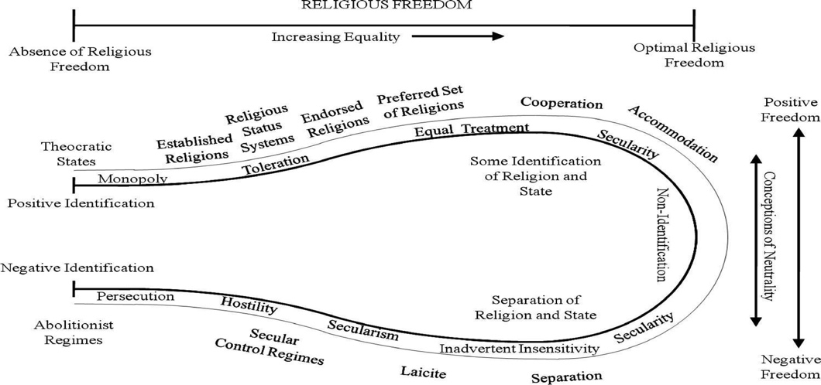
Indonesia’s position

