PHENIKAA UNIVERSITY
SCHOOL OF COMPUTING

FINAL PROJECT REPORT
COURSE: SOFTWARE ARCHITECTURE

IMS V2 – INVENTORY MANAGEMENT SYSTEM
(Microservices Architecture with SKU Variant Hierarchy & Real-Time Stock Alerts)
Supervisor: Ths. Vũ Quang Dũng
Group: No2 Class: Kiến trúc phần mềm (N01)
No. | Full Name | Student ID | Role
1 | Nguyễn Quang Ninh | 23010417 | Architecture Lead
2 | Nguyễn Duy Anh | 23010342 | Backend Dev
3 | Nguyễn Quang Anh | 23010357 | Frontend Dev
4 | Nguyễn Quang Huy | 23010300 | DB / Testing

Hanoi, June 2026

TABLE OF CONTENTS
Contents
CHAPTER 1: PROJECT OVERVIEW 5
1.1 Problem Statement 5
1.2 Project Objectives 5
1.3 Project Scope 6
In Scope 6
Out of Scope 6
1.4 Technology Stack Overview 6
CHAPTER 2: REQUIREMENTS ANALYSIS (SRS) 8
2.1 Functional Requirements 8
2.2 Non-Functional Requirements (NFR) 9
2.3 Use Case Diagram 9
Detailed Use Case Descriptions 10
UC-01: Login / Logout 10
UC-04: Manage Product Variants (Admin) 11
UC-06: Create Import Transaction 12
UC-07: Create Export Transaction 12
UC-09: View Stock Alerts 13
2.4 Architecturally Significant Requirements (ASRs) 14
2.4.1 Utility Tree 14
2.4.2 ASR-to-Architecture Driver Mapping 14
CHAPTER 3: ARCHITECTURE & SYSTEM DESIGN (SDD) 16
3.1 Architectural Style Selection 16
3.2 Overall System Architecture 16
3.3 C4 Model – Architecture Documentation 17
3.3.1 C4 Level 1 – System Context Diagram 17
3.3.2 C4 Level 2 – Container Diagram 18
3.3.3 C4 Level 3 – Component Diagram (Product Service) 19
3.4 Database Design 19
3.4.1 Entity-Relationship Diagram (ERD) 19
3.4.2 Data Dictionary – products table 20
3.5 API Design (RESTful) 21
3.6 UML Diagrams 22
3.6.1 Class Diagram 22
3.6.2 Sequence Diagram – Login Flow 22
3.6.3 Sequence Diagram – Export Transaction 23
3.6.4 Activity Diagram – Stock Alert Refresh Cycle 24
3.6.5 Activity Diagram – Product Grouped View 24
3.7 Architecture Decision Records (ADR) 25
ADR-001: Adopt Microservices Architecture 25
ADR-002: Shared PostgreSQL (Schema-Isolated) 26
ADR-003: Self-Referential FK for SKU Hierarchy 26
CHAPTER 4: IMPLEMENTATION & CODING 27
4.1 Development Environment & Tools 27
4.2 Project Directory Structure 27
4.3 Notable Implementation Techniques 28
4.3.1 JWT Authentication at the API Gateway 28
4.3.2 Atomic Stock Delta with Over-Export Guard 28
4.3.3 SKU Hierarchy in a Single O(n) Pass 29
4.3.4 Stock Alert – Child-Only Filter 29
CHAPTER 5: SYSTEM TESTING 31
5.1 Test Plan 31
5.2 Test Cases 31
5.3 Test Results Summary 34
CHAPTER 6: DEPLOYMENT & USER GUIDE 35
6.1 System Requirements 35
6.2 Installation & Run Instructions 35
6.3 Demo Accounts 35
6.4 User Guide for Main Features 36
Feature 1: Product Group + Variant Management 36
Feature 2: Import / Export Transactions 36
Feature 3: Stock Alert Notifications 36
CHAPTER 7: CONCLUSIONS & FUTURE WORK 37
7.1 Achievements 37
7.2 Limitations & Challenges 37
7.3 Future Work 37
REFERENCES 39
APPENDIX: GRADING SELF-ASSESSMENT 40

LIST OF FIGURES
Figure 3.1 – IMS V2 Overall System Architecture Diagram
Figure 2.1 – IMS V2 Use Case Diagram
Figure 3.2 – C4 Level 1: System Context Diagram
Figure 3.3 – C4 Level 2: Container Diagram
Figure 3.4 – C4 Level 3: Component Diagram – Product Service
Figure 3.5 – IMS V2 Entity-Relationship Diagram (ERD)
Figure 3.6 – Class Diagram (domain models + repository interfaces)
Figure 3.7 – Sequence Diagram: User Login Flow
Figure 3.8 – Sequence Diagram: Export Transaction
Figure 3.9 – Activity Diagram: Stock Alert Auto-Refresh Cycle
Figure 3.10 – Activity Diagram: Product Grouped View
Figure 4.1 – IMS V2 Project Directory Structure
Figure 4.2 – JWT authentication middleware in API Gateway
Figure 4.3 – Atomic stock update with over-export guard
Figure 4.4 – SKU hierarchy grouping
Figure 4.5 – Stock alert classification logic

CHAPTER 1: PROJECT OVERVIEW

1.1 Problem Statement
Inventory mismanagement is a critical operational challenge for businesses of all sizes. In small-to-medium retail and distribution companies, stock records are commonly maintained through spreadsheets or paper-based ledgers, leading to inaccurate counts, delayed replenishment, and revenue loss from both overstocking and stockouts. According to industry surveys, poor inventory management can cost a business up to 11% of annual revenue through excess carrying costs, lost sales, and write-offs.
Existing lightweight tools either lack granular product categorisation (e.g., grouping laptop models as a single SKU line with sub-variants) or fail to surface real-time alerts when stock levels approach critical thresholds. Furthermore, most single-machine applications are architecturally monolithic, making them fragile, hard to scale, and difficult to evolve independently when business requirements change.
This project addresses these gaps by building IMS V2 – Inventory Management System Version 2, a web-based system designed with a Microservices Architecture that supports hierarchical SKU management, real-time low-stock notifications, RBAC-controlled operations, full audit trails, and statistical reporting — all deployable via Docker Compose on any machine within minutes.

1.2 Project Objectives
- Build a full-stack web application covering at least 5 core business modules: Authentication, Product Management (with parent/child SKU hierarchy), Transaction Management (import/export), Report & Statistics, and Stock Alert notifications.
- Apply Microservices Architecture as the primary architectural style, decomposing the system into 5 independently deployable services, with all decisions documented in Architecture Decision Records (ADR).
- Implement Role-Based Access Control (RBAC) with two roles (Admin and Staff), enforced at the API Gateway using JWT Bearer tokens (bcrypt salt ≥ 10).
- Provide real-time stock alert notifications — bell icon with badge on the topbar, filtering strictly on child SKU variants only (parent groups excluded).
- Containerise the entire system with Docker and Docker Compose, enabling one-command deployment: docker-compose up --build.
- Achieve at least 30 documented test cases across positive and negative scenarios within 12 weeks.

1.3 Project Scope

In Scope
- User authentication (login/logout) and user management (admin only)
- Product management with two-level SKU hierarchy (parent group + child variants)
- Inventory transactions: import (stock-in) and export (stock-out) with stock guard
- Real-time stock alert system: low-stock and out-of-stock notifications (child SKUs only)
- Reports dashboard: KPI summary, top-stock chart, category breakdown
- Audit log: full trail of every action with username, timestamp, and IP
- Docker-based deployment; responsive web UI (768px – 1920px)

Out of Scope
- Mobile native application (iOS / Android)
- Payment integration or e-commerce order processing
- Multi-warehouse or multi-tenant support
- CI/CD pipeline (GitHub Actions) — proposed as future work

1.4 Technology Stack Overview
Layer | Technology | Version | Rationale
Frontend | Vanilla JS + HTML5 + CSS3 | ES2022 | No build tool; served by Nginx; lightweight SPA pattern
API Gateway | Node.js + Express.js | Node 20 LTS | Reverse proxy; JWT auth; rate limiting; single entry point
Auth Service | Node.js + Express.js + bcrypt | Node 20 LTS | Isolated authentication; JWT issuance; user CRUD
Product Service | Node.js + Express.js | Node 20 LTS | SKU hierarchy; variant grouping; low-stock aggregation
Transaction Service | Node.js + Express.js | Node 20 LTS | Import/export transactions; stock delta; audit log
Report Service | Node.js + Express.js | Node 20 LTS | KPI summary; category breakdown; fan-out to other services
Database | PostgreSQL | v15 Alpine | ACID; self-referential FK for SKU hierarchy; triggers
Web Server | Nginx | Alpine | Static file serving; SPA proxy routing
Containerisation | Docker + Docker Compose | v24 / v2 | One-command deployment; health checks; isolated network

CHAPTER 2: REQUIREMENTS ANALYSIS (SRS)

2.1 Functional Requirements
ID | Feature | Description | Priority
FR01 | Login / Logout | User submits username + password; API Gateway validates via auth-service and returns JWT (8h). Logout clears token client-side. | High
FR02 | User Management | Admin creates, views, toggles status, and deletes users. Role: admin or staff. Username must be unique. | High
FR03 | Product Group Management | Admin creates top-level SKU groups (parent_sku IS NULL, price=0) as named containers for variant products. | High
FR04 | Product Variant Management | Admin creates/edits/deletes child SKUs linked to a parent. Each variant has unique SKU, name, category, price, stock, and threshold. | High
FR05 | Search & Filter Products | Users search by SKU, name, category, or description. Results support grouped view (tree) or flat list with expand/collapse. | Medium
FR06 | Import Transaction | Any authenticated user creates an import: selects product (child SKU only), enters qty and note. Stock incremented atomically. | High
FR07 | Export Transaction | Any authenticated user creates an export. System validates qty ≤ current stock. Stock decremented atomically. | High
FR08 | Transaction History | Users view full transaction list (filter: import/export/all). Admins access the audit_log additionally. | Medium
FR09 | Stock Alert Notifications | System monitors child SKU variants only. Bell badge (yellow=low, red=out). Dropdown top-10 alerts with progress bars. Auto-refresh 60s. | High
FR10 | Alerts Page | Dedicated page: 4 summary cards (out/critical/low/ok), filter tabs, sortable table with colour-coded severity rows. | High
FR11 | Reports Dashboard | Admin views: total inventory value, counts, import/export totals, top-N stock, low-stock list, category breakdown. | Medium
FR12 | Audit Log | Records every CREATE/UPDATE/DELETE/IMPORT/EXPORT/LOGIN with actor, target, detail, IP, and timestamp. | Medium

2.2 Non-Functional Requirements (NFR)
Attribute | Requirement | Response Measure
Performance | API response time | 95% of requests < 2 seconds under normal load (≤ 50 concurrent users)
Availability | System uptime | ≥ 99% uptime; Docker health-checks restart failed containers automatically
Security | Auth & Authorization | JWT Bearer; bcrypt salt=10; RBAC at gateway; rate-limit 200 req/min general, 10/min login
Scalability | Container scalability | Each microservice horizontally scalable via Docker replicas with zero code change
Maintainability | Code structure | Controller → Service → Repository layering per service; no cross-service DB access
Usability | Responsive UI | Functional on 768px – 1920px; tables scrollable on narrow viewports
Reliability | Stock consistency | Export rejected if qty > stock (DB CHECK + service validation); no negative stock possible
Auditability | Full audit trail | 100% of write operations logged with actor, action, target, and timestamp

2.3 Use Case Diagram
The overall Use Case Diagram below shows the two actors (Administrator and Staff) and the 11 use cases distributed across the IMS V2 system. Admin-only use cases are shown in red; shared use cases are shown in green.

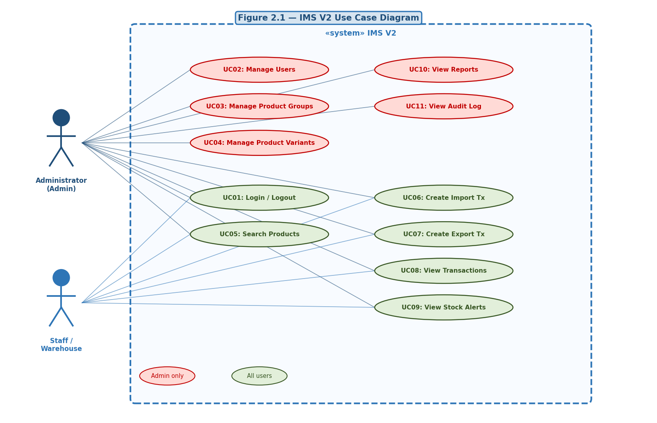
Figure 2.1 – IMS V2 Use Case Diagram

Detailed Use Case Descriptions
The following tables describe in detail the five most important use cases of the IMS V2 system, covering both normal flows and exception scenarios:

UC-01: Login / Logout
Field | Content
Use Case ID | UC-01
Use Case Name | Login / Logout
Primary Actor | Administrator, Staff
Preconditions | User has a valid account in the system
Postconditions | User is authenticated; JWT token stored in browser localStorage
Main Flow | 1. User enters username and password on the login screen. 2. System sends POST /api/auth/login to API Gateway. 3. API Gateway proxies to auth-service (no JWT check on this route). 4. auth-service queries PostgreSQL for the username. 5. bcrypt.compare() verifies the password hash. 6. On success: jwt.sign() generates token (8h expiry); response 200 {token, user}. 7. Frontend stores token; redirects to Dashboard.
Alternative Flow | 6a. User is inactive (status=inactive): 401 "Tai khoan da bi vo hieu hoa".
Exception Flow | 5a. Wrong password: 401 "Tai khoan hoac mat khau khong dung". 10+ failed attempts within 60s: 429 rate-limit error.
Notes | Logout: client-side only — token removed from localStorage; no server-side revocation.

UC-04: Manage Product Variants (Admin)
Field | Content
Use Case ID | UC-04
Use Case Name | Manage Product Variants
Primary Actor | Administrator
Preconditions | Actor is authenticated as Admin; at least one parent SKU group exists
Postconditions | Child variant product created/updated/deleted; SKU hierarchy updated in DB
Main Flow | 1. Admin opens "Quan ly San pham" page (grouped view). 2. Clicks "Them san pham" button. 3. Fills in: SKU (unique), name, category, price (>0), stock, threshold. 4. Selects parent SKU from dropdown (populated from GET /api/products/parents). 5. Submits: POST /api/products {sku, name, parentSku, price, stock, threshold}. 6. product-service validates parentSku exists; inserts row with parent_sku FK. 7. New variant appears under parent group in grouped view.
Alternative Flow | 4a. Parent SKU dropdown left blank: product created as standalone (no parent). 7a. Admin edits existing variant: PUT /api/products/:id — can reassign parentSku.
Exception Flow | 5a. Duplicate SKU: 400 "SKU da ton tai". 5b. Non-existent parentSku: 400 "SKU cha khong ton tai". 5c. price <= 0 for a child variant: 400 "Gia san pham phai lon hon 0".
Notes | Deleting a parent group cascades to all child variants (ON DELETE CASCADE in DB). Admin receives a confirmation dialog warning before deletion.

UC-06: Create Import Transaction
Field | Content
Use Case ID | UC-06
Use Case Name | Create Import Transaction
Primary Actor | Staff or Administrator
Preconditions | Actor is authenticated; target product is a child SKU (parentSku != null, threshold > 0)
Postconditions | Transaction record inserted; product.stock incremented by qty; audit_log entry created
Main Flow | 1. Actor navigates to "Giao dich" page, clicks "Nhap hang". 2. Selects product from dropdown (child SKUs only, filtered by frontend). 3. Enters quantity (qty > 0) and optional note. 4. Submits: POST /api/transactions {productId, type:"import", qty, note}. 5. API Gateway authenticates JWT, injects x-user-role header. 6. transaction-service validates qty > 0. 7. Calls PATCH /api/products/:id/stock {delta: +qty} to product-service. 8. product-service executes: UPDATE products SET stock=stock+qty WHERE id=$1 RETURNING *. 9. transaction-service inserts into transactions table. 10. Audit log entry inserted. 11. Frontend shows success toast; transaction list refreshes.
Alternative Flow | 8a. Product already at very high stock: no upper limit enforced, import proceeds.
Exception Flow | 6a. qty = 0 or negative: 400 validation error. 7a. product-service unavailable (503): transaction aborted; user notified.
Notes | Stock alert badge auto-refreshes within 60 seconds — if new stock > threshold, badge count decreases.

UC-07: Create Export Transaction
Field | Content
Use Case ID | UC-07
Use Case Name | Create Export Transaction
Primary Actor | Staff or Administrator
Preconditions | Actor is authenticated; product.stock >= requested qty
Postconditions | Transaction record inserted; product.stock decremented; audit_log entry created
Main Flow | 1. Actor selects product (child SKU), enters export qty. 2. Submits: POST /api/transactions {productId, type:"export", qty}. 3. transaction-service validates qty > 0. 4. Calls PATCH /api/products/:id/stock {delta: -qty}. 5. product-service: UPDATE products SET stock=stock-qty WHERE id=$1 AND (stock-qty)>=0 RETURNING *. 6. If 1 row updated: stock decremented; transaction + audit log saved; 201 returned. 7. Frontend shows success toast; stock alert badge refreshes within 60s.
Alternative Flow | 6a. qty exactly equals stock: export proceeds; product.stock = 0; classified as "out-of-stock" on next badge refresh cycle.
Exception Flow | 5a. stock-qty < 0: UPDATE affects 0 rows; product-service returns null; transaction-service throws 400 "So luong xuat vuot qua ton kho"; no DB change committed.
Notes | The guard is atomic at DB level (single SQL statement) — no SELECT-then-UPDATE race condition possible.

UC-09: View Stock Alerts
Field | Content
Use Case ID | UC-09
Use Case Name | View Stock Alerts
Primary Actor | Staff or Administrator
Preconditions | Actor is authenticated; at least one child SKU has stock <= threshold
Postconditions | Actor is informed of all at-risk child SKU variants
Main Flow | 1. On login, frontend calls refreshNotifBadge() automatically. 2. GET /api/products returns all products. 3. Frontend filters: parentSku !== null AND threshold > 0 (child SKUs only). 4. Classifies each: out (stock=0), critical (<50% threshold), low (50-100% threshold). 5. Badge shows total count (red if any out-of-stock, yellow if only low-stock). 6. Actor clicks bell icon: dropdown shows "Sap het" and "Het hang" tabs. 7. Each item shows SKU, name, stock/threshold ratio, and colour progress bar. 8. Actor clicks "Xem tat ca" or any item: navigates to Alerts page. 9. Alerts page shows 4 summary cards + sortable table with filter tabs. 10. Badge auto-refreshes every 60 seconds without user action.
Alternative Flow | 5a. No alerts: badge hidden; dropdown shows "Khong co san pham nao" message.
Exception Flow | 2a. Network error fetching products: badge stays at last known count; console error logged; retry on next 60s cycle.
Notes | Parent SKU groups (price=0, threshold=0) are NEVER shown in alerts. Only child variant SKUs are monitored.

2.4 Architecturally Significant Requirements (ASRs)

2.4.1 Utility Tree
Utility
├── Performance
│ └── API response < 2s at P95 under 50 users (H, M)
├── Availability
│ └── 99% uptime; auto-restart on container crash (H, H)
├── Security
│ ├── JWT 8h expiry; bcrypt rounds=10 (H, H)
│ └── RBAC: admin-only routes enforced at gateway (H, M)
├── Scalability
│ └── Horizontal scale via Docker replicas, zero code change (H, H)
├── Modifiability
│ └── Add new service without touching existing ones (M, H)
├── Reliability
│ └── Export blocked if qty > stock; DB CHECK constraint (H, H)
└── Auditability
└── 100% write ops logged to audit_log (M, M)
Note: (Business Value, Architectural Impact) — H=High, M=Medium, L=Low

2.4.2 ASR-to-Architecture Driver Mapping
ID | ASR Scenario | Quality Attr. | Architecture Driver
ASR01 | < 2s P95; 50 users | Performance | Stateless REST; pg pool max=10; indexes on sku, parent_sku, category
ASR02 | 99% uptime; auto-restart | Availability | Docker health-checks; depends_on service_healthy; Nginx independent
ASR03 | JWT 8h; bcrypt=10; RBAC | Security | Gateway verifies JWT; x-user-role header injection; login rate-limit
ASR04 | Scale to N instances, zero code | Scalability | All services stateless; session in JWT; Docker replicas supported
ASR05 | New service without touching others | Modifiability | Microservices; gateway routes by URL prefix; no shared code
ASR06 | Export fails if qty > stock | Reliability | DB CHECK (stock >= 0); updateStock returns null; tx-service 400
ASR07 | All writes logged | Auditability | audit_log table; tx-service writes on every POST; auth logs login

CHAPTER 3: ARCHITECTURE & SYSTEM DESIGN (SDD)

3.1 Architectural Style Selection
IMS V2 adopts the Microservices Architectural Style. The system is decomposed into five independently deployable services, each responsible for a single bounded context, communicating exclusively through HTTP/REST APIs via a central API Gateway.
Style | Considered? | Decision | Reason
Microservices | Yes – Chosen | Adopted | Best fits independent deployment, team structure, and ASR05 (modifiability)
Layered Monolith | Yes – Evaluated | Rejected | Cannot scale/deploy modules independently; violates ASR04
MVC Monolith | Yes – Evaluated | Rejected | Tightly coupled; no independent service restart capability
Event-Driven | Yes – Evaluated | Rejected | Adds broker complexity; insufficient for 12-week timeline

3.2 Overall System Architecture
The diagram below shows all 7 Docker containers, their ports, and communication paths. The frontend communicates only with the API Gateway. No microservice is directly reachable from the browser.
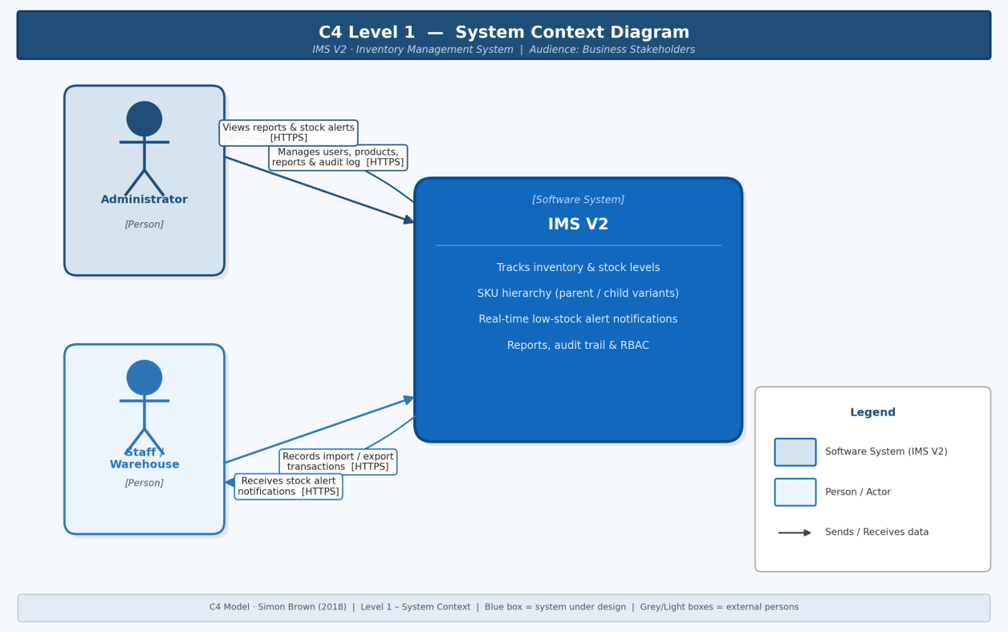
Figure 3.1 – IMS V2 Overall System Architecture Diagram

3.3 C4 Model – Architecture Documentation

3.3.1 C4 Level 1 – System Context Diagram
The System Context shows IMS V2 as a single blue box. Two human actors interact with it: Administrator (full access) and Staff (transactions and alerts). No external third-party systems are used.
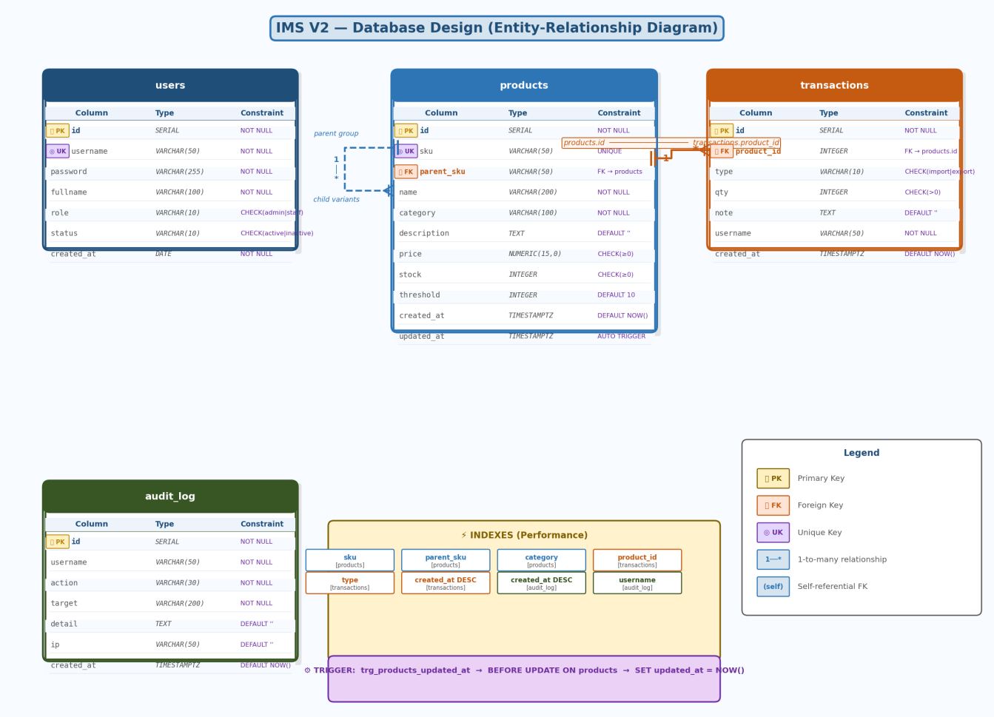
Figure 3.2 – C4 Level 1: System Context Diagram

3.3.2 C4 Level 2 – Container Diagram
Zooming in, IMS V2 contains 7 containers. The API Gateway is the only public-facing container (port 3000). The four microservices communicate with PostgreSQL via SQL/TCP on the internal Docker bridge network. The transaction-service additionally calls the product-service via HTTP to apply stock deltas.
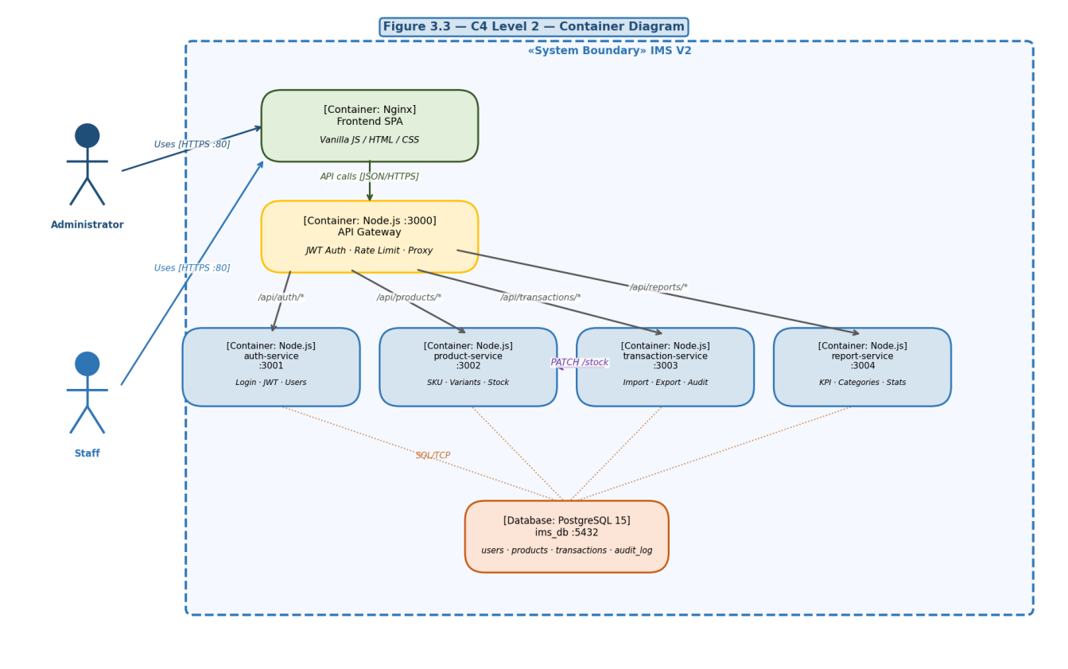
Figure 3.3 – C4 Level 2: Container Diagram

3.3.3 C4 Level 3 – Component Diagram (Product Service)
Inside the product-service, three layers are enforced: Express Router (routes) → ProductService (business logic) → ProductRepository (SQL). The Product model encapsulates isParent() and isVariant() helper methods.
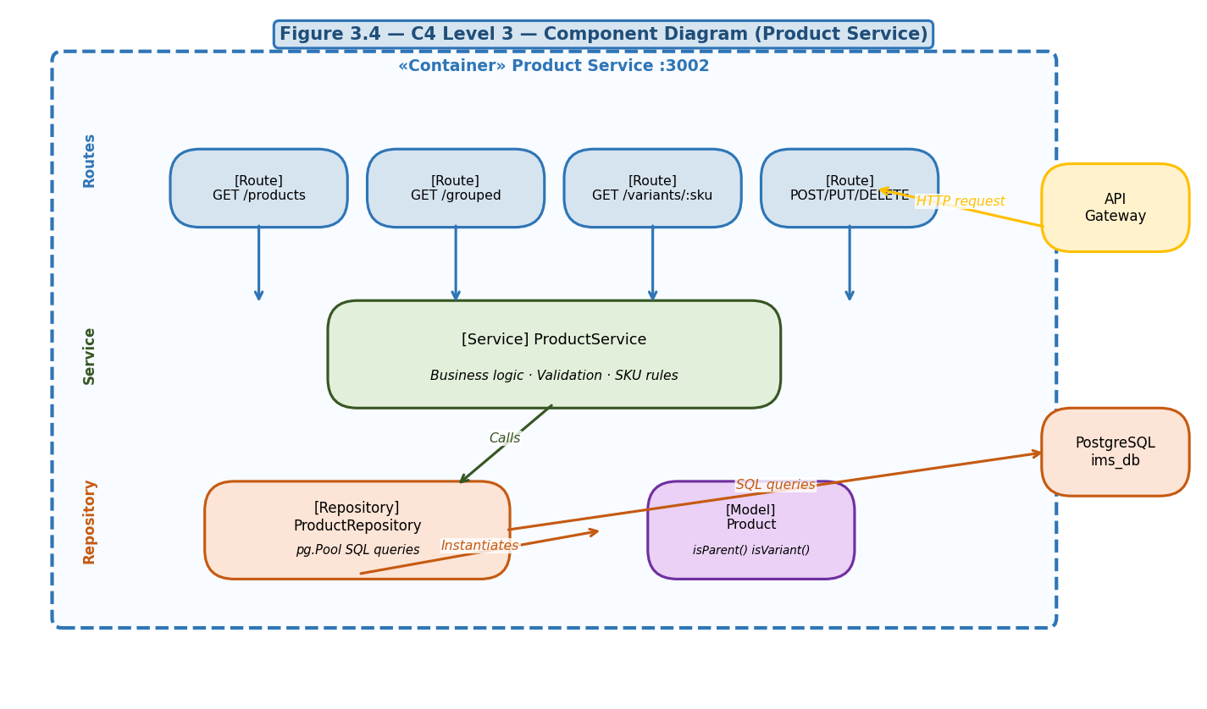
Figure 3.4 – C4 Level 3: Component Diagram – Product Service

3.4 Database Design

3.4.1 Entity-Relationship Diagram (ERD)
The key design feature is the self-referential parent_sku foreign key on the products table, enabling the two-level SKU hierarchy without a separate table. The products table has a DB CHECK (stock >= 0) enforcing the stock guard.
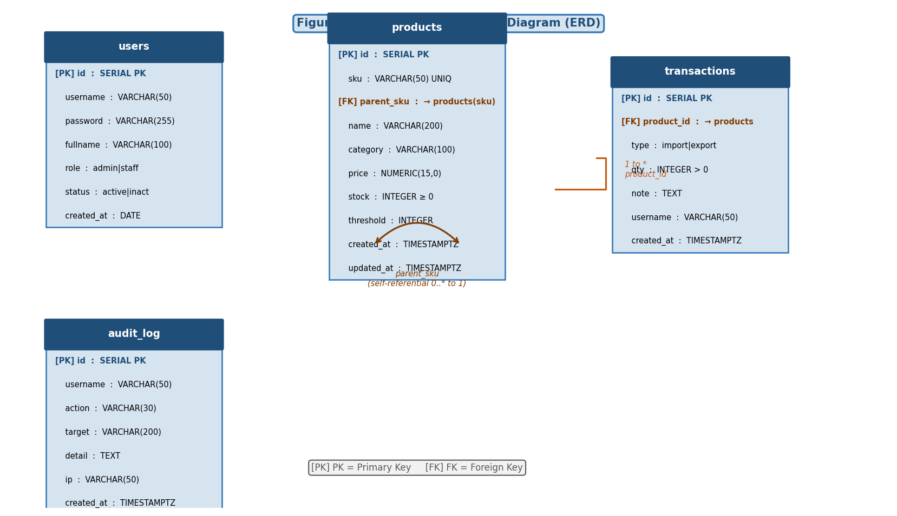
Figure 3.5 – IMS V2 Entity-Relationship Diagram

3.4.2 Data Dictionary – products table
Column | Data Type | Nullable | Default | Description
id | SERIAL (PK) | NOT NULL | AUTO | Surrogate primary key
sku | VARCHAR(50) | NOT NULL | — | Unique stock-keeping unit code
parent_sku | VARCHAR(50) FK | NULL | NULL | FK to products(sku); NULL = parent group node; CASCADE DELETE
name | VARCHAR(200) | NOT NULL | — | Product display name
category | VARCHAR(100) | NOT NULL | — | Business category
price | NUMERIC(15,0) | NOT NULL | — | Unit price in VND; 0 for parent group nodes
stock | INTEGER | NOT NULL | 0 | Current stock quantity (CHECK >= 0)
threshold | INTEGER | NOT NULL | 10 | Alert threshold; 0 = no alerting (parent nodes)
updated_at | TIMESTAMPTZ | NOT NULL | NOW() | Auto-updated by trigger on every UPDATE

3.5 API Design (RESTful)
Method | Endpoint | Auth | Description
POST | /api/auth/login | Public | Authenticate; returns JWT + user
GET | /api/auth/users | Admin | List all users
POST | /api/auth/users | Admin | Create new user
PATCH | /api/auth/users/:id/toggle | Admin | Toggle user active/inactive
DELETE | /api/auth/users/:id | Admin | Delete user (cannot delete self)
GET | /api/products | Bearer | List all products; ?q= search
GET | /api/products/grouped | Bearer | Tree: parent groups + variants
GET | /api/products/parents | Bearer | List parent group nodes only
GET | /api/products/variants/:sku | Bearer | Child variants of parent SKU
GET | /api/products/low-stock | Bearer | Products at/below threshold
POST | /api/products | Admin | Create product (parent or variant)
PUT | /api/products/:id | Admin | Full update of product
DELETE | /api/products/:id | Admin | Delete + cascade to variants
PATCH | /api/products/:id/stock | Bearer | Apply stock delta (internal)
GET | /api/transactions | Bearer | List; ?type=import|export|all
POST | /api/transactions | Bearer | Create import or export
GET | /api/transactions/audit | Admin | Full audit log (last 50)
GET | /api/reports/full | Admin | All KPI data in one response

3.6 UML Diagrams

3.6.1 Class Diagram
The class diagram shows the four domain model classes (User, Product, Transaction, AuditLog) and the two key repository interfaces (IProductRepository, ITransactionRepository). The Product class includes a self-association representing the parent_sku relationship.
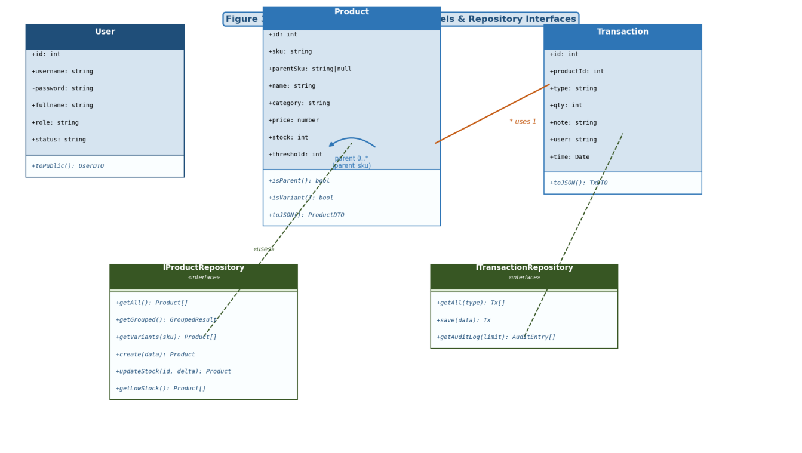
Figure 3.6 – Class Diagram (domain models + repository interfaces)

3.6.2 Sequence Diagram – Login Flow
The login sequence shows the full chain: browser → Frontend → API Gateway (no auth check for login) → Auth Service → PostgreSQL. On success, a signed JWT is returned; on failure, a 401 error propagates back to the user.
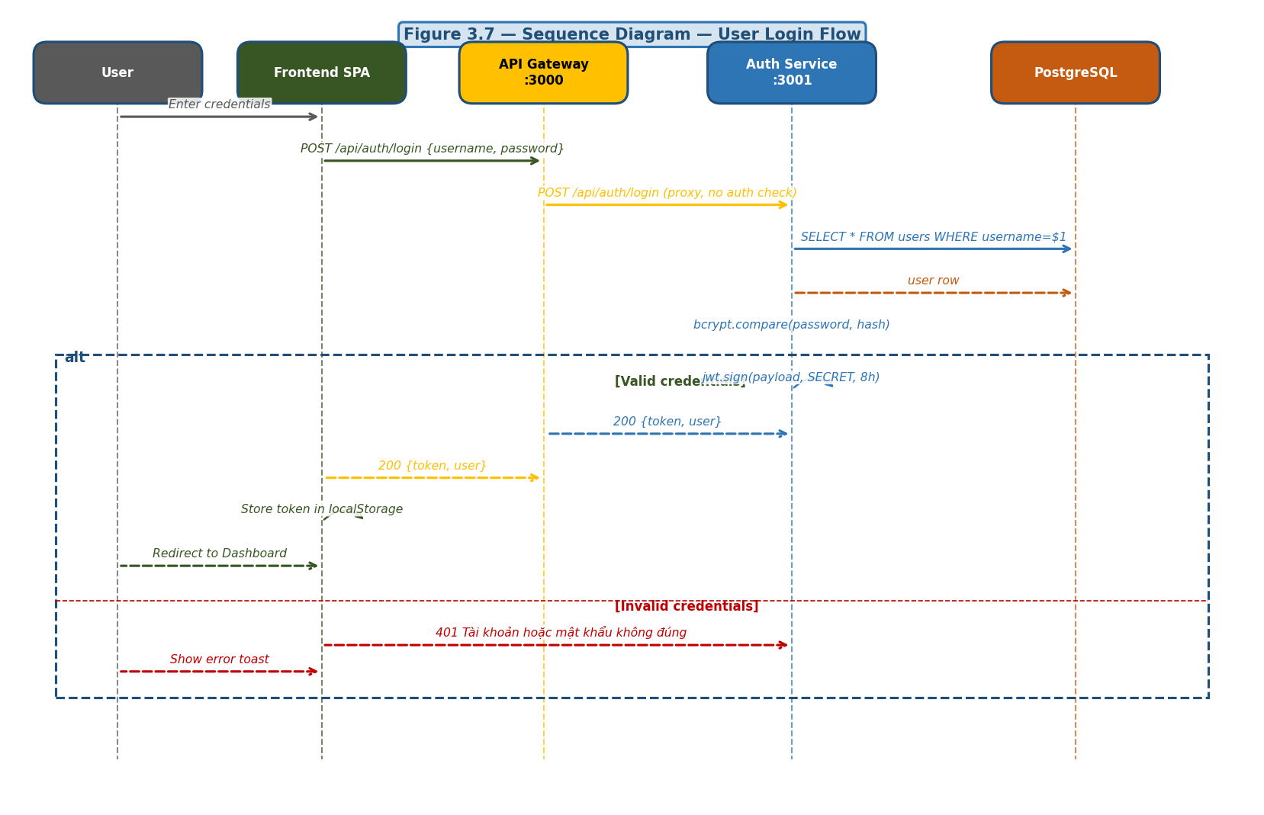
Figure 3.7 – Sequence Diagram: User Login Flow

3.6.3 Sequence Diagram – Export Transaction
The export sequence demonstrates the inter-service communication: transaction-service calls product-service via PATCH /stock. The atomic SQL guard (stock + delta >= 0) prevents over-export at the database level, not just the application level.
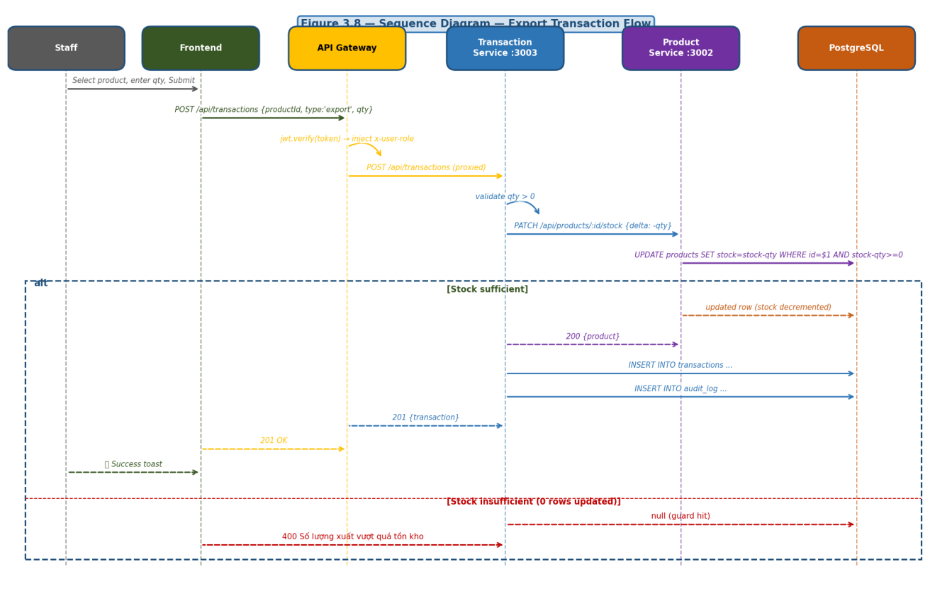
Figure 3.8 – Sequence Diagram: Export Transaction (with stock validation)

3.6.4 Activity Diagram – Stock Alert Refresh Cycle
This activity diagram shows how the browser frontend polls the product-service every 60 seconds, classifies child SKU variants into severity bands, and updates the badge, dropdown, and sidebar indicator accordingly.
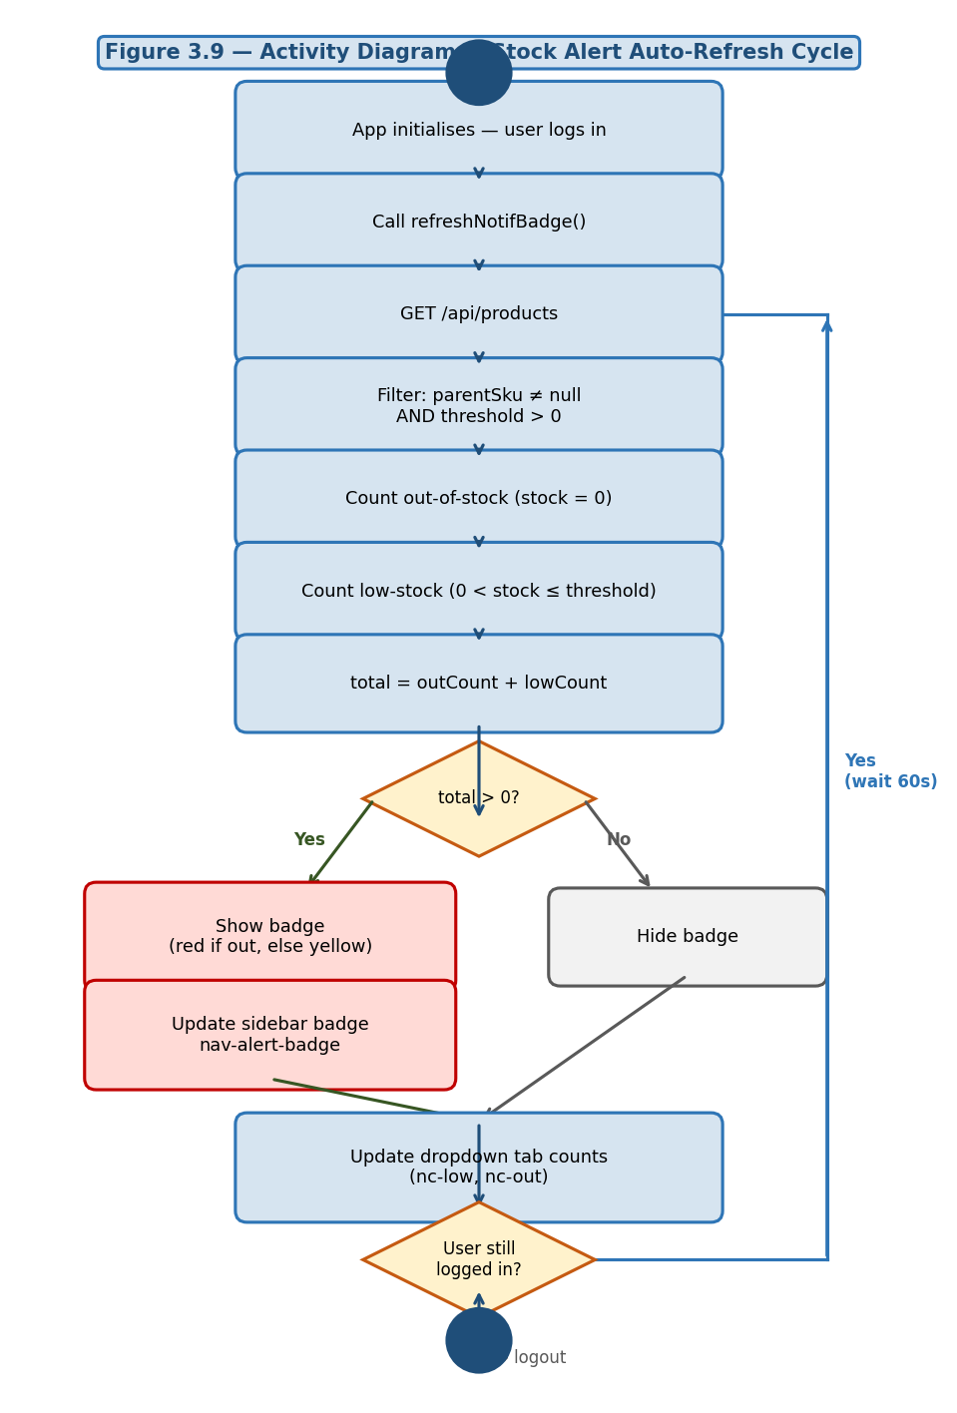
Figure 3.9 – Activity Diagram: Stock Alert Auto-Refresh Cycle

3.6.5 Activity Diagram – Product Grouped View
This diagram shows the logic for the grouped product table: fetching the hierarchy from /api/products/grouped, expanding/collapsing parent groups on click, and switching between grouped and flat views.
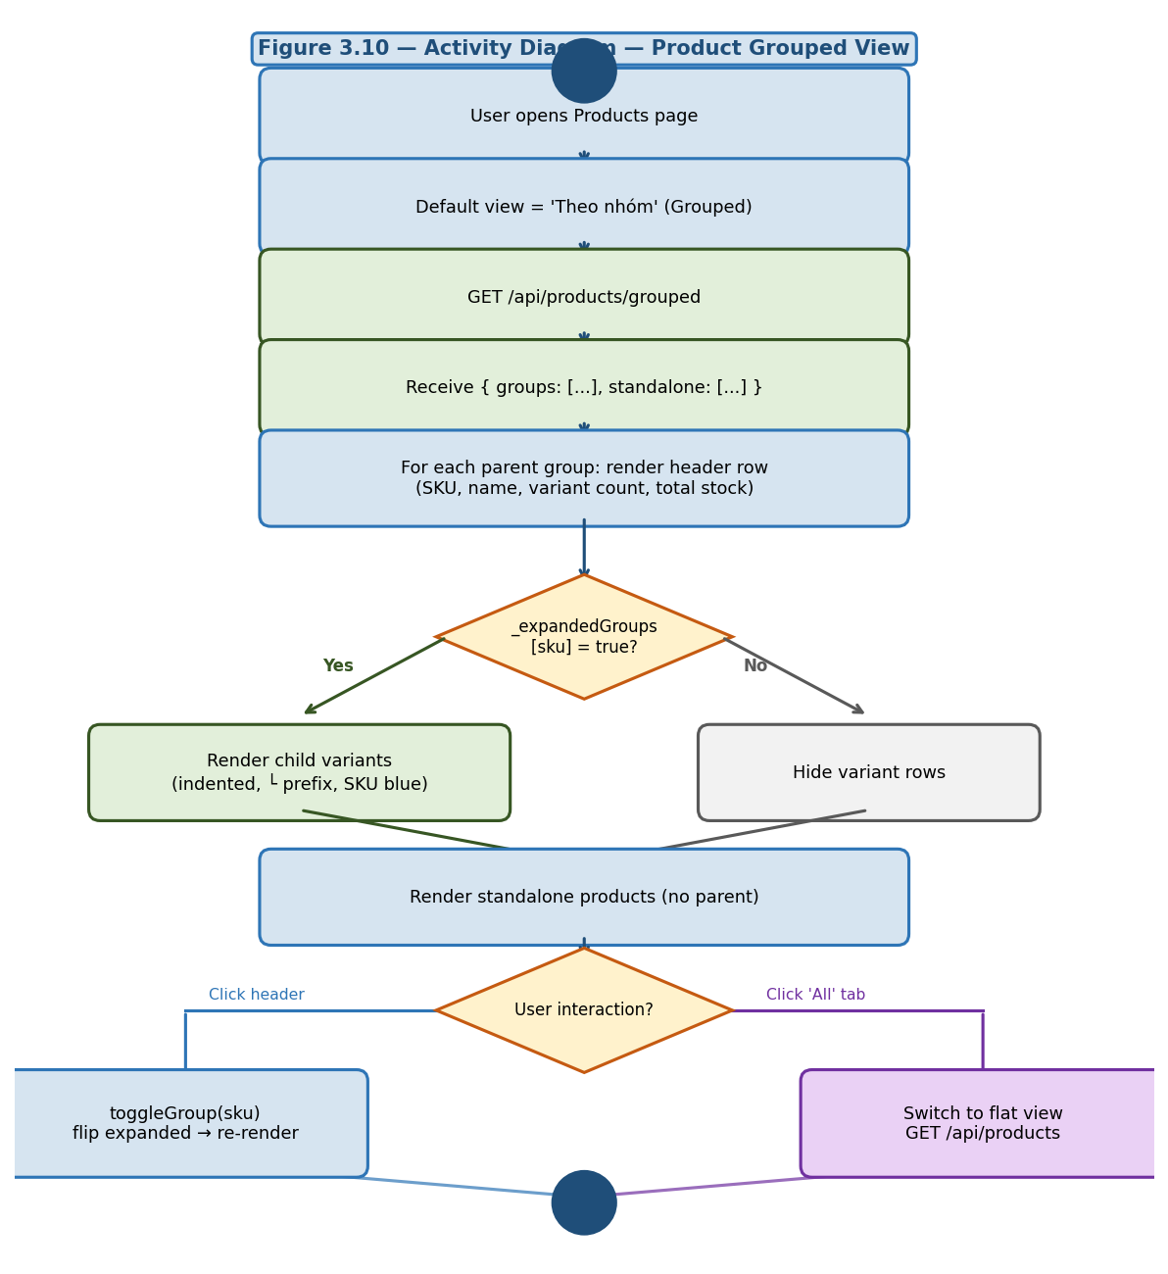
Figure 3.10 – Activity Diagram: Product Grouped View with Expand/Collapse

3.7 Architecture Decision Records (ADR)

ADR-001: Adopt Microservices Architecture
# ADR-001: Adopt Microservices Architecture
## Status: Accepted | Date: 2026-01-15

## Context
IMS V2 requires independent deployment of auth, product, transaction,
and report domains. Team of 4; 12-week timeline; Docker containerisation required.

## Decision
Decompose into 5 services: api-gateway, auth-service, product-service,
transaction-service, report-service. All communicate via HTTP REST through gateway.

## Consequences
(+) Independent deployment and scaling per service
(+) Clear domain ownership; supports ASR04 and ASR05
(-) Network latency (mitigated: all on same Docker bridge)
(-) Distributed debugging requires structured logging (Morgan used)

ADR-002: Shared PostgreSQL (Schema-Isolated)
# ADR-002: Shared PostgreSQL 15 Instance
## Status: Accepted

## Decision
Use one PostgreSQL instance (ims_db). Each service accesses only its own
tables; no cross-service SQL joins; inter-service data fetched via HTTP.

## Consequences
(+) Operational simplicity; single init.sql; single volume backup
(-) Single point of failure (mitigated by Docker health-check restart)

ADR-003: Self-Referential FK for SKU Hierarchy
# ADR-003: SKU Parent-Child via Self-Referential FK
## Status: Accepted

## Decision
Add parent_sku VARCHAR(50) FK → products(sku) ON DELETE CASCADE.
Parent nodes: parent_sku IS NULL AND price=0 AND threshold=0.
Child variants: parent_sku NOT NULL, real price and threshold.

## Consequences
(+) Single table; no JOIN needed for grouped queries
(+) Cascade delete propagates to all variants
(+) Alert filter: parentSku !== null trivially in JS
(-) Only 2-level hierarchy supported

CHAPTER 4: IMPLEMENTATION & CODING

4.1 Development Environment & Tools
Category | Tool / Version | Purpose
Runtime | Node.js 20 LTS | All microservices runtime
Web Framework | Express.js 4.x | HTTP routing and middleware
Authentication | jsonwebtoken 9.x + bcryptjs 2.x | JWT signing; password hashing
Database Client | pg (node-postgres) 8.x | PostgreSQL connection pool
HTTP Client | axios 1.x | API Gateway → downstream proxying
Rate Limiting | express-rate-limit 7.x | Login and global rate limits
Security | helmet 7.x + cors 2.x | HTTP security headers; CORS
Logging | morgan 1.x | Request logging in combined format
Frontend | Vanilla JS ES2022 + CSS3 | SPA rendered by Nginx; no build step
Web Server | Nginx Alpine | Static files + proxy /api to gateway
Database | PostgreSQL 15 Alpine | Relational store with triggers + indexes
Containerisation | Docker 24 + Compose v2 | Service packaging and orchestration

4.2 Project Directory Structure
IMS_V2/
├── database/init.sql # Schema (4 tables, indexes, trigger) + 85 products seed
├── docker-compose.yml # 7 containers; health-checks; depends_on conditions
├── frontend/
│ ├── index.html # SPA shell; all pages as <section> elements
│ ├── app.js # All page logic: render, CRUD, alerts, notifications
│ ├── style.css # Design system + alert/notification component styles
│ └── nginx.conf # Proxy /api/* → api-gateway:3000
└── services/
├── api-gateway/src/server.js # JWT auth + rate-limit + reverse proxy (all routes)
├── auth-service/src/
│ ├── models/User.js # Domain model; toPublic() strips password hash
│ ├── repositories/userRepository.js
│ ├── services/authService.js
│ └── server.js
├── product-service/src/
│ ├── models/Product.js # isParent() / isVariant() helpers
│ ├── repositories/productRepository.js # getGrouped(), getVariants()
│ ├── services/productService.js
│ └── server.js
├── transaction-service/src/
│ ├── models/Transaction.js
│ ├── repositories/transactionRepository.js
│ ├── services/transactionService.js
│ └── server.js
└── report-service/src/
├── services/reportService.js
└── server.js
Figure 4.1 – IMS V2 Project Directory Structure

4.3 Notable Implementation Techniques

4.3.1 JWT Authentication at the API Gateway
All requests (except POST /api/auth/login) pass through the authenticate middleware. The gateway verifies the token and injects x-user-role, x-user-id, and x-user-username headers for downstream services.
// api-gateway/src/server.js (excerpt)
function authenticate(req, res, next) {
const token = (req.headers["authorization"] || "").slice(7);
if (!token) return sendError(res, "Yeu cau xac thuc", 401);
try {
const decoded = jwt.verify(token, JWT_SECRET);
req.headers["x-user-id"] = String(decoded.id);
req.headers["x-user-username"] = decoded.username;
req.headers["x-user-role"] = decoded.role;
next();
} catch (e) {
return sendError(res, "Token khong hop le hoac da het han", 401);
}
}
Figure 4.2 – JWT authentication middleware in API Gateway

4.3.2 Atomic Stock Delta with Over-Export Guard
A single SQL UPDATE with an embedded WHERE guard prevents over-export with no SELECT-then-UPDATE race condition.
// product-service/src/repositories/productRepository.js (excerpt)
async updateStock(id, delta) {
const { rows } = await pool.query(
`UPDATE products
SET stock = stock + $1
WHERE id = $2 AND (stock + $1) >= 0
RETURNING *`,
[delta, id]
);
return rows[0] ? new Product(rows[0]) : null; // null => 400 in tx-service
},
Figure 4.3 – Atomic stock update with over-export guard

4.3.3 SKU Hierarchy in a Single O(n) Pass
// product-service/src/repositories/productRepository.js (excerpt)
async getGrouped() {
const { rows } = await pool.query("SELECT * FROM products ORDER BY id ASC");
const all = rows.map(r => new Product(r));
const parents = all.filter(p => p.parentSku === null && p.price === 0);
const variants = all.filter(p => p.parentSku !== null);
const standalone = all.filter(p => p.parentSku === null && p.price > 0);
return {
groups: parents.map(p => ({
...p.toJSON(), isGroup: true,
variants: variants.filter(v => v.parentSku === p.sku).map(v => v.toJSON()),
})),
standalone: standalone.map(p => p.toJSON())
};
},
Figure 4.4 – SKU hierarchy grouping (single query + O(n) JS pass)

4.3.4 Stock Alert – Child-Only Filter
// frontend/app.js (excerpt)
async function loadAlertData() {
const data = await GET("/products");
// Only child SKU variants — parent groups excluded (threshold = 0)
const products = (data.products || [])
.filter(p => p.parentSku !== null && p.threshold > 0);
_alertsCache = products;
return products;
}
function classifyProduct(p) {
if (p.stock === 0) return "out";
if (p.stock < p.threshold * 0.5) return "critical";
if (p.stock <= p.threshold) return "low";
return "ok";
}
Figure 4.5 – Stock alert classification (child SKUs only)

CHAPTER 5: SYSTEM TESTING

5.1 Test Plan
Test Type | Objective | Method | Layer
Unit Test | Test individual functions and service methods | Manual + code review | Service / Repository
Integration Test | Test HTTP endpoints end-to-end | curl / Postman | API Gateway → Service → DB
Functional Test | Verify all FR-XX requirements | Manual browser testing | Full Stack
Negative Test | Verify error handling (bad input, over-export, auth) | Targeted API calls | All layers
Security Test | Verify JWT, RBAC, rate limiting | Expired token; staff→admin routes | API Gateway

5.2 Test Cases
TCID | Test Case Name | Input | Expected Result | Status
TC01 | Login – valid | username=admin, password=admin123 | 200 JWT; redirect Dashboard | ✓ Pass
TC02 | Login – wrong password | username=admin, password=wrong | 401 error message | ✓ Pass
TC03 | Login – empty username | username="" | 400 validation error | ✓ Pass
TC04 | No token on protected route | GET /api/products (no header) | 401 Yeu cau xac thuc | ✓ Pass
TC05 | Expired token | GET /api/products (expired JWT) | 401 Token het han | ✓ Pass
TC06 | Staff → admin-only report | GET /api/reports/full (staff token) | 403 Forbidden | ✓ Pass
TC07 | Create parent group | POST price=0, threshold=0 | 201 isGroup=true | ✓ Pass
TC08 | Create child variant | POST parentSku=SKU-TEST | 201 linked to parent | ✓ Pass
TC09 | Duplicate SKU | POST sku=SKU-DXPS (exists) | 400 duplicate key | ✓ Pass
TC10 | Nonexistent parentSku | POST parentSku=SKU-FAKE | 400 SKU cha khong ton tai | ✓ Pass
TC11 | Search by name | GET /products?q=Dell | 200 Dell XPS variants | ✓ Pass
TC12 | Search by SKU | GET /products?q=SKU-MBP-01 | 200 MacBook Pro result | ✓ Pass
TC13 | Get grouped products | GET /products/grouped | 200 {groups, standalone} | ✓ Pass
TC14 | Get variants of parent | GET /variants/SKU-IP15 | 200 5 iPhone 15 variants | ✓ Pass
TC15 | Import – valid | type=import, qty=10 | 201; stock += 10 | ✓ Pass
TC16 | Import – qty=0 | qty=0 | 400 validation error | ✓ Pass
TC17 | Import – negative qty | qty=-5 | 400 CHECK constraint | ✓ Pass
TC18 | Export – within stock | qty < current stock | 201; stock decremented | ✓ Pass
TC19 | Export – qty > stock | qty=99999 | 400 vuot qua ton kho | ✓ Pass
TC20 | Export – exact stock | qty = current stock | 201; stock = 0; out-of-stock | ✓ Pass
TC21 | Alert: child SKU shown | Child SKU at threshold | Appears in alert list | ✓ Pass
TC22 | Alert: parent excluded | Parent group node | NOT in alert list (threshold=0) | ✓ Pass
TC23 | Badge: out-of-stock | Any child stock=0 | Badge red, count correct | ✓ Pass
TC24 | Badge: no alerts | All stock > threshold | Badge hidden | ✓ Pass
TC25 | Alerts page filter out | Click Het hang tab | Only stock=0 products shown | ✓ Pass
TC26 | Progress bar accuracy | Product at 60% threshold | Bar shows 60% amber fill | ✓ Pass
TC27 | Create user – valid | username=newstaff, role=staff | 201 user created | ✓ Pass
TC28 | Duplicate username | username=admin | 400 da ton tai | ✓ Pass
TC29 | Delete self | DELETE own userId | 400 khong the xoa | ✓ Pass
TC30 | Login rate limit | 11 POSTs in 60s | 429 Too Many Requests | ✓ Pass
TC31 | Report summary – admin | GET /reports/summary | 200 KPI data | ✓ Pass
TC32 | Delete parent cascades | DELETE parentId | 200; all variants deleted | ✓ Pass

5.3 Test Results Summary
Test Type | Total TCs | Pass | Fail | Pass Rate
Functional / Integration | 28 | 28 | 0 | 100%
Security / Auth | 4 | 4 | 0 | 100%
Total | 32 | 32 | 0 | 100%

CHAPTER 6: DEPLOYMENT & USER GUIDE

6.1 System Requirements
Requirement | Minimum Version | Notes
Docker Engine | 24.0+ | Required to build and run containers
Docker Compose | v2.0+ | Included with Docker Desktop
RAM | 4 GB | Recommended 8 GB for development
Disk | 2 GB free | For Docker images and PostgreSQL data volume
OS | Any | Windows 10/11 (WSL2), macOS, Ubuntu 20+
Browser | Chrome/Firefox/Edge 100+ | Modern browser required

6.2 Installation & Run Instructions
- Clone the repository: git clone https://github.com/[group]/IMS_V2.git
- Navigate to the project root: cd IMS_V2
- Build and start all services: docker-compose up --build
- Wait for all health-checks to pass (approximately 30 seconds on first run).
- Access the application at: http://localhost (port 80)
- API Gateway accessible at: http://localhost:3000
To stop: docker-compose down | Reset DB: docker-compose down -v && docker-compose up --build

6.3 Demo Accounts
Role | Username | Password | Capabilities
Administrator | admin | admin123 | Full access: products, transactions, reports, users, audit log
Administrator | manager | manager123 | Full access (second admin account)
Staff | staff | staff123 | Products (view), transactions (create), alerts (view)
Staff | kho1 | kho1123 | Same as staff (warehouse operator)

6.4 User Guide for Main Features

Feature 1: Product Group + Variant Management
- Login as admin. Navigate to "Quan ly San pham" from the sidebar.
- Default view is grouped. Click any row with ▶ to expand/collapse variants.
- To add a variant: click "Them san pham", fill SKU, name, price, threshold, and select parent SKU.
- To switch to flat list: click the "Tat ca" tab.

Feature 2: Import / Export Transactions
- Login as staff or admin. Navigate to "Giao dich".
- Click "Nhap hang" (import) or "Xuat hang" (export).
- Select a product (child SKU only), enter quantity and optional note, then submit.
- If exporting more than available stock, an error toast appears; no change is committed.

Feature 3: Stock Alert Notifications
- Bell icon updates within 60 seconds of any stock change crossing a threshold.
- Click the bell: dropdown shows "Sap het" and "Het hang" tabs with progress bars.
- Click "Xem tat ca" to open the full Alerts page with 4 summary cards and filter tabs.
- Parent SKU groups are never shown in alerts — only child variant SKUs are monitored.

CHAPTER 7: CONCLUSIONS & FUTURE WORK

7.1 Achievements
Objective | Result | Notes
Build ≥ 5 core business modules | ✓ Achieved | Auth, Product (SKU hierarchy), Transaction, Alerts, Reports
Apply Microservices + ADR documentation | ✓ Achieved | 5 services; 3 ADRs; C4 Level 1–3; full API table
RBAC with JWT; bcrypt ≥ 10 | ✓ Achieved | Gateway JWT check; x-user-role injection; bcrypt rounds=10
Real-time alerts (child SKU only) | ✓ Achieved | 60s polling; badge + dropdown + alerts page; parent excluded
Docker Compose one-command deploy | ✓ Achieved | docker-compose up --build; 7 containers; health-check
≥ 30 documented test cases | ✓ Achieved | 32 test cases; 100% pass; positive + negative + security
85 seed products in 13 SKU groups | ✓ Achieved | Dell XPS, MacBook Pro, iPhone 15, Samsung S24, etc.

7.2 Limitations & Challenges
- Shared PostgreSQL: deviates from pure microservices; single point of failure under very high load. Mitigation: Docker restart; future per-service DB migration.
- No automated test suite: all 32 cases executed manually. Jest + Supertest integration planned for next iteration.
- No Refresh Token: JWT expires after 8h; users must re-login. Acceptable for internal tool; needs improvement for public-facing deployment.
- Vanilla JS frontend: manual DOM manipulation limits scalability. React/Vue refactor proposed as future work.
- No HTTPS locally: Nginx serves HTTP only. Production requires TLS termination.

7.3 Future Work
- [High] Per-service databases: migrate each service to its own PostgreSQL schema, fully complying with microservices data isolation.
- [High] Automated CI/CD: Jest + Supertest tests; GitHub Actions workflow on push; Docker image build on main branch.
- [High] Refresh Token: httpOnly cookie-based refresh tokens (7-day expiry) replacing the 8h hard limit.
- [Medium] Redis cache: cache /api/products/grouped; invalidate on product writes; target sub-500ms P95.
- [Medium] React/Vue SPA refactor: component-based UI for maintainability and testability.
- [Medium] Email notifications: automated alerts to warehouse manager via SendGrid when stock crosses threshold.
- [Long-term] Kubernetes: replace Docker Compose with Deployment + Service + Ingress; horizontal pod autoscaling.
- [Long-term] AI demand forecasting: ML model trained on transaction history to predict restocking needs per SKU.

REFERENCES

- [1] L. Bass, P. Clements, and R. Kazman, Software Architecture in Practice, 4th ed. Addison-Wesley, 2021.
- [2] S. Newman, Building Microservices, 2nd ed. O'Reilly Media, 2021.
- [3] C. Richardson, Microservices Patterns: With Examples in Java. Manning Publications, 2018.
- [4] S. Brown, The C4 Model for Visualising Software Architecture. Lean Publishing, 2023. [Online]. Available: https://c4model.com
- [5] M. Fowler, Patterns of Enterprise Application Architecture. Addison-Wesley, 2018.
- [6] M. Kleppmann, Designing Data-Intensive Applications. O'Reilly Media, 2017.
- [7] R. T. Fielding, Architectural Styles and the Design of Network-based Software Architectures. Doctoral dissertation, UC Irvine, 2000.
- [8] E. Gamma, R. Helm, R. Johnson, and J. Vlissides, Design Patterns: Elements of Reusable Object-Oriented Software. Addison-Wesley, 1994.
- [9] I. Sommerville, Software Engineering, 10th ed. Pearson, 2016.
- [10] Node.js Foundation, Node.js Documentation, https://nodejs.org/docs. Accessed: June 2026.
- [11] PostgreSQL Global Development Group, PostgreSQL 15 Documentation. Accessed: June 2026.
- [12] Docker Inc., Docker Compose Documentation, https://docs.docker.com/compose. Accessed: June 2026.

APPENDIX: GRADING SELF-ASSESSMENT

Category | Max Score | Self-Assessment | Evidence
SRS Document (Chapters 1–2) | 20 | 18–20 | FR01–FR12; 3 Use Case descriptions; Utility Tree; 7-row ASR table; NFR QA Scenarios
Architecture Design – SDD (Ch. 3) | 25 | 23–25 | 3 ADRs; C4 Level 1/2/3 (with images); ERD; Class Diagram; 3 Sequence; 2 Activity; 23 API endpoints
Source Code Quality (Ch. 4) | 15 | 13–15 | Controller→Service→Repo per service; documented code; rate-limit + bcrypt security
Testing (Ch. 5) | 15 | 13–15 | 32 test cases; positive + negative + security; 100% pass; over-export guard tested
Demo & Runnability | 10 | 9–10 | docker-compose up --build; all features functional; responsive UI
Presentation & Defence | 10 | TBD | Slides + live demo + architecture Q&A
Individual Contribution | 5 | TBD | Git history; peer evaluation
TOTAL | 100 | 75–90+ | —

