- Executive Summary
In the context of business digitization, accurate and efficient goods management is an essential requirement for enterprises. This report focuses on the design and construction of an Inventory Management System (IMS) aimed at supporting real-time stock tracking, transaction control, and consistent product data management. The system is designed based on a Layered Architecture (3-tier), ensuring clear separation between the user interface, business logic, and data access. This choice is driven by requirements for maintainability, scalability, and a clear separation of concerns.
- Identification of Actors
The system focuses on internal organizational roles to ensure controlled operations:
- Admin (Administrator): An internal user with full system privileges. Responsibilities include managing the product catalog, viewing comprehensive reports/statistics, auditing transaction history, and managing user permissions.
- Staff (Warehouse Staff): Responsible for daily operational tasks such as updating stock levels, executing import/export transactions, and tracking their own transaction history.
- System Requirements
Functional Requirements (FR)
The core functionalities of the system include:
- FR-01 (Product Management): Allows Admins to perform CRUD operations (Create, Read, Update, Delete) on product information.
- FR-02 (Inventory Management): Enables Staff to track and update real-time stock quantities for each SKU.
- FR-03 (Warehouse Transactions): Supports the execution of stock-in (receiving) and stock-out (shipping) transactions.
- FR-04 (History & Reporting): Stores and retrieves transaction history for auditing and provides statistical reports for Admins.
- FR-05 (Authentication & Authorization): Ensures security via login mechanisms and specific role-based access control for Admins and Staff.
Non-Functional Requirements (NFR)
These quality attributes serve as the primary architectural drivers:
- Performance: The system must process CRUD operations and inventory updates with low latency.
- Reliability: Inventory data and transactions must be 100% accurate; no data loss or discrepancies are permitted.
- Scalability: The system should be capable of expanding as the number of products and users increases.
- Modifiability: The architecture must allow for easy addition of new features (e.g., advanced reporting or Redis integration) without impacting the entire system.
- Security: Only authorized users can access and manipulate data.
- Architecturally Significant Requirements (ASRs)
Based on the operational, security, scalability, and maintainability requirements of the Inventory Management System (IMS), the following ASRs are identified as the primary architectural drivers influencing the overall system design.
ASR Code | Requirement Statement | Architectural Impact (Justification)
ASR-01 | Data Consistency: Every stock-in and stock-out transaction must update inventory quantities accurately and immediately. | Requires the use of Database Transactions, ACID properties, and concurrency control mechanisms to prevent inconsistent inventory states.
ASR-02 | Strict Authorization: Clear separation of responsibilities between Admin and Staff users. | Requires Role-Based Access Control (RBAC) and centralized Authorization Services to validate every API request.
ASR-03 | Auditability: Every inventory modification must be traceable for auditing purposes. | Leads to the implementation of immutable transaction logs linked to Product and User entities.
ASR-04 | High Availability: The system should remain operational during peak warehouse activities with minimal downtime. | Encourages the adoption of Docker deployment, health checks, backup strategies, and fault-tolerant infrastructure.
ASR-05 | Performance Efficiency: Inventory searches and warehouse transactions must respond quickly. | Requires optimized database indexing, Redis caching, efficient REST APIs, and asynchronous processing mechanisms.
ASR-06 | Scalability: The system must support growing numbers of products, users, and warehouse operations. | Influences modular architecture design and future migration readiness toward Microservices architecture.
ASR-07 | Security Protection: User credentials and inventory data must be protected against unauthorized access. | Requires JWT Authentication, password hashing, HTTPS communication, API validation, and secure session management.
ASR-08 | Reliability: The system must avoid data loss even during unexpected failures. | Drives the implementation of database backup/recovery mechanisms, rollback transactions, and robust exception handling.
ASR-09 | Modifiability: New features should be integrated without significantly affecting existing modules. | Encourages Layered Architecture, Dependency Injection, and Loose Coupling principles.
ASR-10 | Maintainability: Developers should be able to maintain, test, and debug the system efficiently. | Leads to standardized coding structures, logging frameworks, unit testing, and clear layer separation.
ASR-11 | Usability: Warehouse staff should be able to use the system with minimal training. | Influences UI/UX design decisions such as simple navigation, responsive interfaces, and user-friendly validations.
ASR-12 | Real-Time Inventory Visibility: Inventory quantities should update instantly after each transaction. | Encourages the use of WebSocket communication or event-driven synchronization mechanisms.
ASR-13 | Data Integrity: Product and transaction data must remain valid and synchronized. | Requires strong database constraints, foreign key enforcement, validation rules, and input sanitization.
ASR-14 | Deployment Portability: The system should be deployable consistently across different environments. | Drives the use of Docker containers, CI/CD pipelines, and environment-based configurations.
ASR-15 | Monitoring and Logging: Operational activities and system errors must be continuously monitored. | Requires centralized logging systems, monitoring dashboards, and alert mechanisms for maintenance and troubleshooting.

Data Consistency (ASR-01)
Inventory systems heavily depend on accurate stock quantities. If multiple users update inventory simultaneously without transaction control, inconsistencies may occur. Therefore, the architecture must ensure ACID-compliant transaction processing.
Security Protection (ASR-07)
Since the system contains sensitive inventory and user information, strong authentication and authorization mechanisms are required. JWT Authentication, password hashing, and secured APIs are essential architectural components.
Scalability (ASR-06)
As the business grows, the number of warehouses, products, and users may increase significantly. The architecture should therefore support scalability and future migration toward distributed Microservices.
Real-Time Inventory Visibility (ASR-12)
Warehouse operations require inventory quantities to update immediately after every transaction. This directly affects frontend-backend synchronization and communication strategies.
Maintainability (ASR-10)
A maintainable system enables developers to debug, extend, and upgrade the application efficiently. This motivates the adoption of Layered Architecture, coding conventions, and unit testing practices
- Architectural Design & Modeling
3-Tier Layered Architecture
The system is decomposed into three distinct layers:
- Presentation Layer (Frontend): The user interface that interacts with the user and sends requests to the backend via REST APIs.
- Business Logic Layer (Application Layer): Handles core business rules, such as verifying stock availability before allowing a stock-out transaction.
- Data Access Layer (Data Layer): Manages queries and operations on the database, ensuring the integrity of entities like Product, Inventory, Transaction, and User.
Use Case Modeling
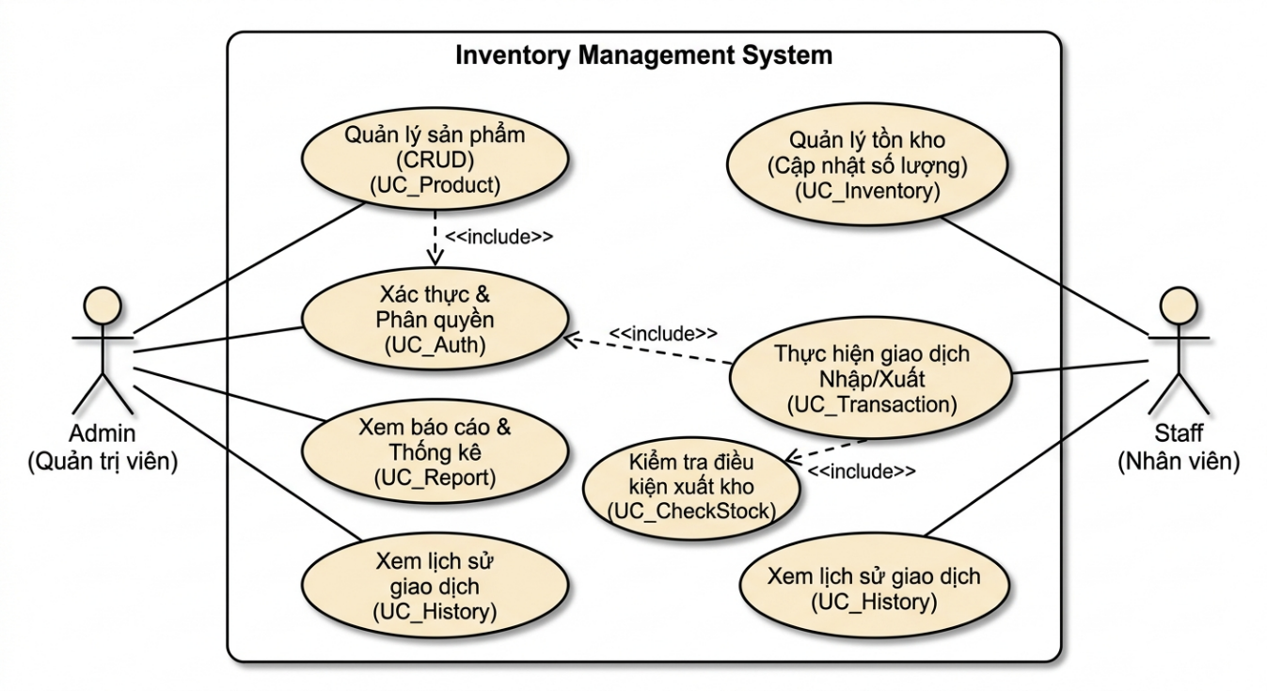
As illustrated in the system's UML diagram:
- <> Relationships:
  - "Product Management" and "Perform Transactions" both include the "Authentication & Authorization (UC_Auth)" use case for security.
  - "Perform Import/Export Transactions" must include "Check Stock Conditions (UC_CheckStock)" to ensure validity.
- Actor Assignments:
  - Admin: Linked to Product Management, Reports/Statistics, and global History viewing.
  - Staff: Linked to Inventory Management, performing Transactions, and viewing personal transaction History.
- Trade-off Analysis
Choosing a Layered Architecture over a Microservices approach (used in systems like ShopSphere) involves specific trade-offs:
- Advantages: Lower complexity, easier to develop and test, clear code structure, and highly suitable for small to medium-scale internal systems.
- Disadvantages: Potential performance overhead due to multiple layer traversals and more difficult to scale to an extreme global size compared to Microservices.
- Decision: For the current scope of an inventory application, Layered Architecture is the optimal choice, balancing simplicity and operational efficiency.
- Future Development and Improvements
To further enhance the system, the following roadmap is proposed:
- JWT Authentication: Implementing JSON Web Tokens for more secure and stateless authentication.
- Redis Cache: Integrating Redis to speed up frequent inventory status lookups.
- Docker / Cloud Deployment: Utilizing containerization for more flexible deployment and environment consistency.
- Microservices Transition: Evaluating a move to Microservices if the business expands to multiple distributed warehouse locations.

