LAB 2 REPORT: LAYERED ARCHITECTURE DESIGN (LOGICAL VIEW)
System: Inventory Management System (IMS)
- Objectives and Architectural Principles
The primary objective of this design is to formalize the static structure of the IMS using the Layered Architecture Pattern. This structure ensures a clear Separation of Concerns (SoC), where each layer is responsible for a specific role and remains oblivious to the internal workings of other layers.
The design strictly adheres to the Strict Downward Dependency rule: a component in Layer can only interact with or call services from Layer directly below it. This constraint is vital for maintaining testability and modifiability, as changes in the presentation layer will not ripple down to break the database logic.
- Activity 1: Defining Layer Responsibilities
Based on the core feature Warehouse Transactions (FR-03), the responsibilities for the three primary layers are defined as follows:
Layer | Primary Function | Input | Output
Presentation | Handles HTTP/REST API requests, user authentication, and response rendering. | HTTP Request (JSON containing SKU, quantity, and type). | HTTP Response (Status/Data) and UI updates.
Business Logic | Executes core business rules (e.g., UC_CheckStock), manages transactions, and validates data. | Data Model Objects (Transaction DTO). | Validated Domain Objects and operation results.
Persistence | Maps application objects to database records (ORM) and executes CRUD operations. | SQL/ORM Commands. | Database Records/Entities.
- Activity 2: Component and Interface Identification
Focusing on the Stock Transaction feature, the specific software components and their "contracts" (interfaces) are identified as follows:
- Presentation Layer:
  - Component: TransactionController.
  - Role: Receives requests for stock-in/out and orchestrates the flow to the business layer.
- Business Logic Layer:
  - Component: TransactionService.
  - Provided Interface (Lollipop): ITransactionService (Method: processTransaction(data)).
  - Role: Enforces business logic, such as verifying if sufficient stock exists before a stock-out is approved.
- Persistence Layer:
  - Component 1: TransactionRepository (Interface: ITransactionRepository, Method: save()).
  - Component 2: ProductRepository (Interface: IProductRepository, Method: updateStock()).
  - Role: Persists the transaction audit trail and updates real-time stock levels in the database.
- Process View: Stock-Out Transaction Flow
The data movement for a "Stock-Out" request follows this sequential path:
- User (Staff) submits a request via the browser TransactionController receives the HTTP request.
- TransactionController (Socket) calls the ITransactionService (Lollipop) to process the logic.
- TransactionService executes UC_CheckStock by calling the ProductRepository to verify current levels.
- If valid, TransactionService commands ProductRepository to decrement stock and TransactionRepository to log the event.
- Success confirmation travels back up through the layers to the Staff's browser.
- Activity 3: UML Component Diagram
The static structure is modeled in the UML Component Diagram.
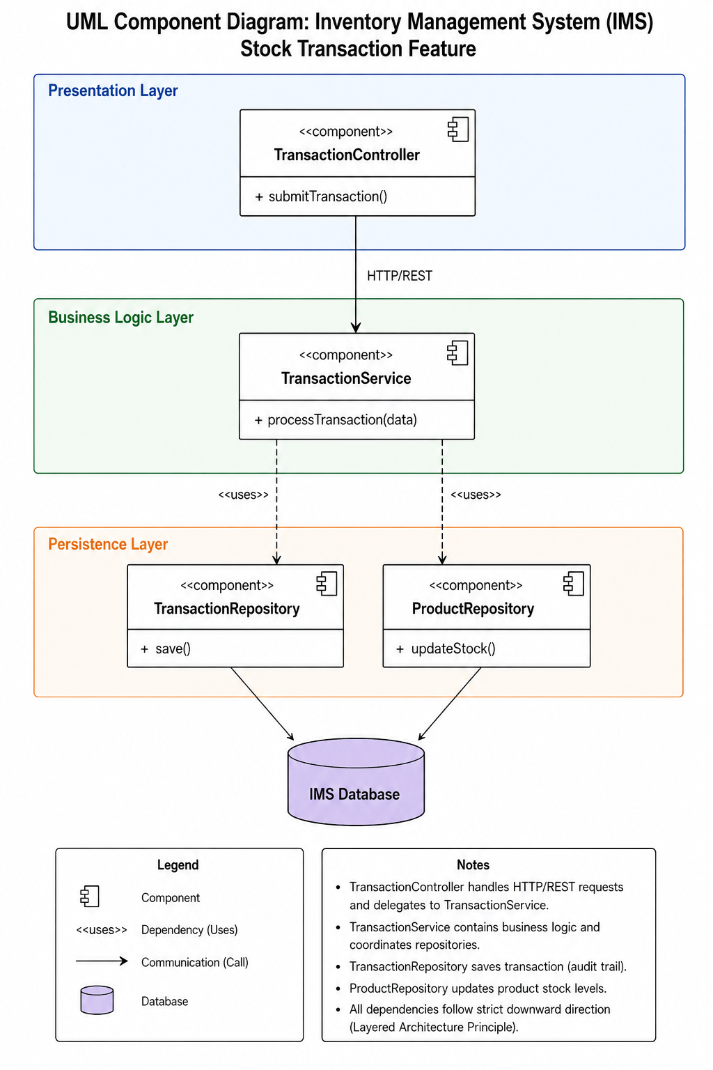
- Visual Structure: Components are organized into three horizontal stacked rectangles representing the layers.
- Connections: The Socket (required interface) of the controller plugs into the Lollipop (provided interface) of the service.
- Dependency Flow: All dashed arrows point strictly downward, visually enforcing the architectural constraint.
- Alignment with Architectural Significant Requirements (ASRs)
This design directly supports the ASRs identified in Lab 1:
- ASR-01 (Data Consistency): The Business Logic layer ensures that stock updates and transaction logging are atomic and accurate.
- ASR-02 (Strict Authorization): The Presentation layer acts as a gatekeeper, validating Staff/Admin roles before allowing access to service methods.
- ASR-03 (Auditability): An independent TransactionRepository creates an immutable audit trail for every stock change.
- Trade-off Analysis
- Advantages: This Layered Monolith is ideal for an internal IMS due to its lower complexity, ease of testing, and rapid development cycle.
- Disadvantages: It may face scaling inefficiencies compared to Microservices; if transaction volume grows exponentially, the entire system must be scaled rather than just the transaction module.
- Conclusion: For the current project scope, the Layered Architecture is the optimal choice, balancing simplicity with robust operational efficiency

