LAB 4 REPORT: MICROSERVICES DECOMPOSITION & COMMUNICATION
System: Inventory Management System (IMS)
1. Objectives
The objective of this lab is to transition the IMS from a monolithic layered architecture to a Microservices Architecture. This shift addresses critical Architecturally Significant Requirements (ASRs) such as Scalability and Fault Isolation, which were identified as weaknesses in the monolithic model.
2. Activity 1: Decomposition by Business Capability
The system is decomposed into small, independent services organized around business capabilities rather than technical layers. Each service maintains Data Ownership, meaning it owns its own database with no cross-service direct access.
Business Capability | Proposed Microservice | Data Owned (Entities)
Catalog Management | Product Service | Product details, SKU, Pricing, Descriptions.
Stock Control | Inventory Service | Stock levels, Warehouse locations.
Warehouse Operations | Transaction Service | Stock-in/out logs, Audit trails, Transaction status.
Identity & Access | User/Auth Service | User profiles, Credentials, Role-based tokens.
External Dependencies: The IMS must interact with external systems including Email/SMS Providers (for low-stock alerts) and Shipping Carrier APIs (for tracking shipments).
3. Activity 2: Defining Service Contracts
Service contracts serve as public, stable interfaces (RESTful APIs) that allow services to interact without exposing internal database details.
Product Service API (Producer):
- GET /api/products: Returns a list of all products for catalog browsing.
- GET /api/products/{id}: Retrieves full details (price, description) for a specific SKU.
- POST /api/products: Administrative endpoint to add new stock items.
Inter-service Requirement: The Transaction Service must use the Product Service's API (GET /api/products/{id}) rather than accessing the database directly to ensure service boundaries are respected.
4. Activity 3: Communication Strategy
The system utilizes two primary communication types to balance performance and resilience.
Interaction | Service Flow | Type | Rationale
Stock Verification | Transaction Inventory | Synchronous (HTTP) | Immediate stock confirmation is required before a stock-out can be processed.
Audit Logging | Transaction Audit Log | Asynchronous (Messaging) | Logging should not block the core business transaction flow.
Low-Stock Alerts | Inventory Notification | Asynchronous (Event) | Email delivery can be processed later without affecting real-time inventory updates.
5. Activity 4: C4 Model (Level 1: System Context)
The IMS system is designed using a Microservices Architecture where services are decomposed according to business capabilities. Each service owns its own data and communicates through RESTful APIs or Message Queues to ensure independence, scalability, and fault isolation.
[System] IMS Platform
IMS Platform is an Inventory Management System designed to help enterprises manage products, inventory, transactions, and users. The system is built using a Microservices Architecture to improve scalability, maintainability, and independent deployment for each business functionality.
The system allows users to perform the following operations:
- Product management
- Inventory checking
- Stock-in and stock-out transactions
- User and role management
- Transaction history tracking
- Email notifications and payment processing
- Actors
Staff (Warehouse Staff)
Staff members are the primary users who perform daily warehouse operations using the IMS platform.
Responsibilities:
- Check inventory levels
- Perform stock-in and stock-out transactions
- Monitor transaction history
- Update product status
Interacts with:
- Inventory Service
- Transaction Service
- Product Service
- Administrator (Admin)
The Administrator is responsible for managing and supervising the entire IMS platform.
Responsibilities:
- Manage product catalogs
- Manage user accounts
- Configure roles and permissions
- Monitor reports and statistics
- Manage system configurations
Interacts with:
- Product Service
- User Service
- Reporting Modules
Core Microservices
1. Product Service
Responsibilities:
- Manage product information
- Perform CRUD operations for products
- Manage SKU, pricing, and descriptions
Owned Data:
- Product
- SKU
- Product Description
2. Inventory Service
Responsibilities:
- Manage inventory quantities
- Track warehouse locations
- Synchronize inventory status
Owned Data:
- Inventory Levels
- Warehouse Locations
3. Transaction Service
Responsibilities:
- Handle stock-in and stock-out transactions
- Manage transaction history
- Confirm transaction processing
Owned Data:
- Transaction Logs
- Transaction Status
4. User Service
Responsibilities:
- User authentication
- Authorization and role management
- Manage user profiles
Owned Data:
- User Profiles
- Roles
- Authentication Data
External Systems
1. Payment Gateway
An external payment system used to process financial transactions related to warehouse operations and orders.
Communication Type:
- Synchronous Communication
- HTTPS / REST API
Responsibilities:
- Process payments
- Confirm transaction status
- Synchronize payment information
2. Email/SMS Provider
An external Email/SMS system used for sending automated notifications to users.
Communication Type:
- Asynchronous Communication
- SMTP or Email API
Responsibilities:
- Send confirmation emails
- Send low inventory alerts
- Send OTP or password reset notifications
3. Shipping Provider API
An external shipping API used to synchronize delivery and logistics information.
Responsibilities:
- Track shipment status
- Synchronize delivery information
- Support logistics operations
Communication Strategy
The IMS platform uses both synchronous and asynchronous communication methods.
Synchronous Communication
HTTP/REST APIs are used for operations requiring immediate responses.
Example:
- Transaction Service → Inventory Service
- Checking inventory availability before confirming a transaction
Asynchronous Communication
Message Queue and Event-Driven Communication are used for operations that do not require immediate responses.
Example:
- Transaction Service → Email Service
- Inventory Update Events
This approach improves fault isolation and reduces direct dependencies between services.
C4 System Context Diagram
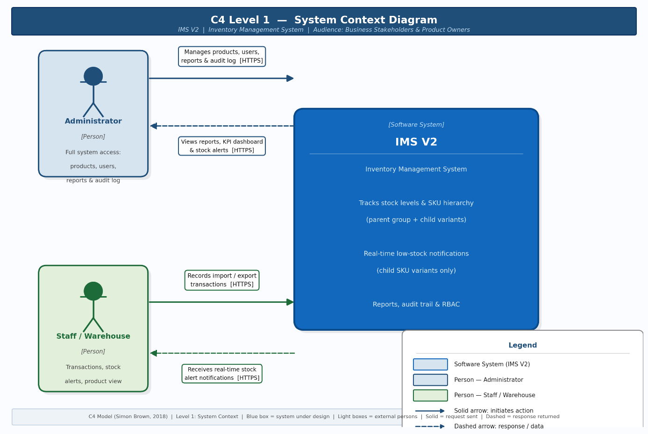
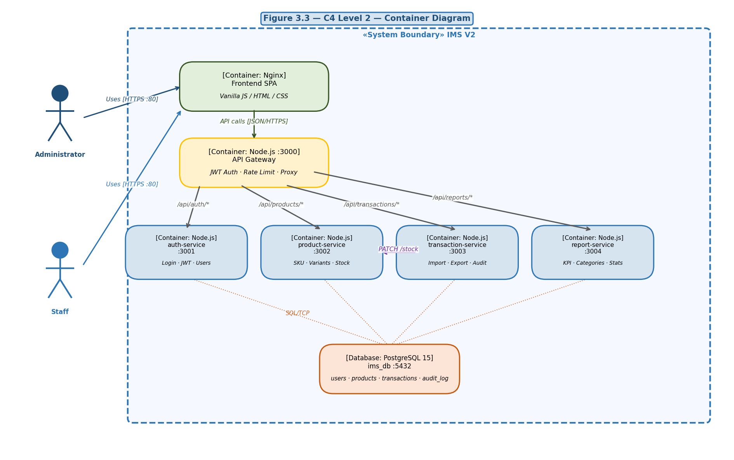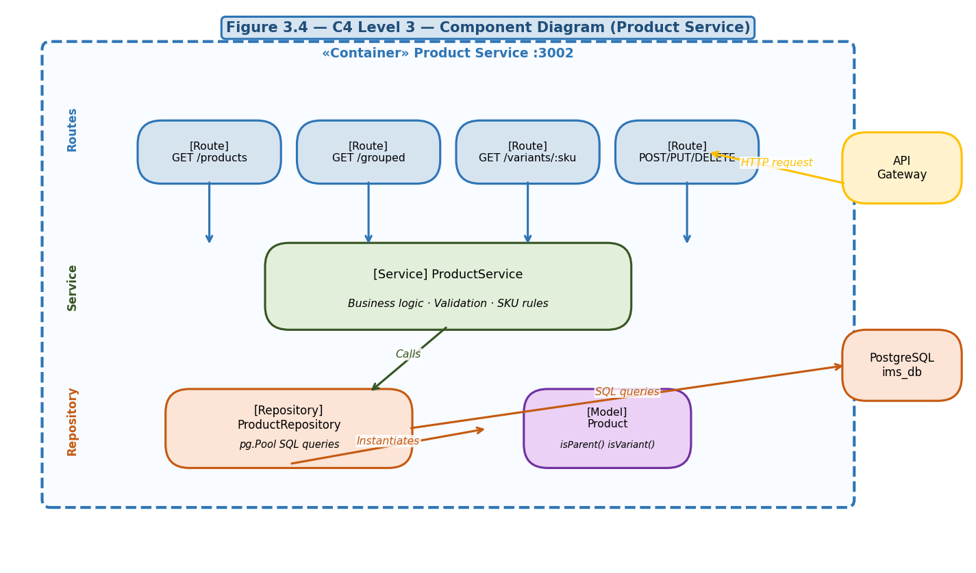
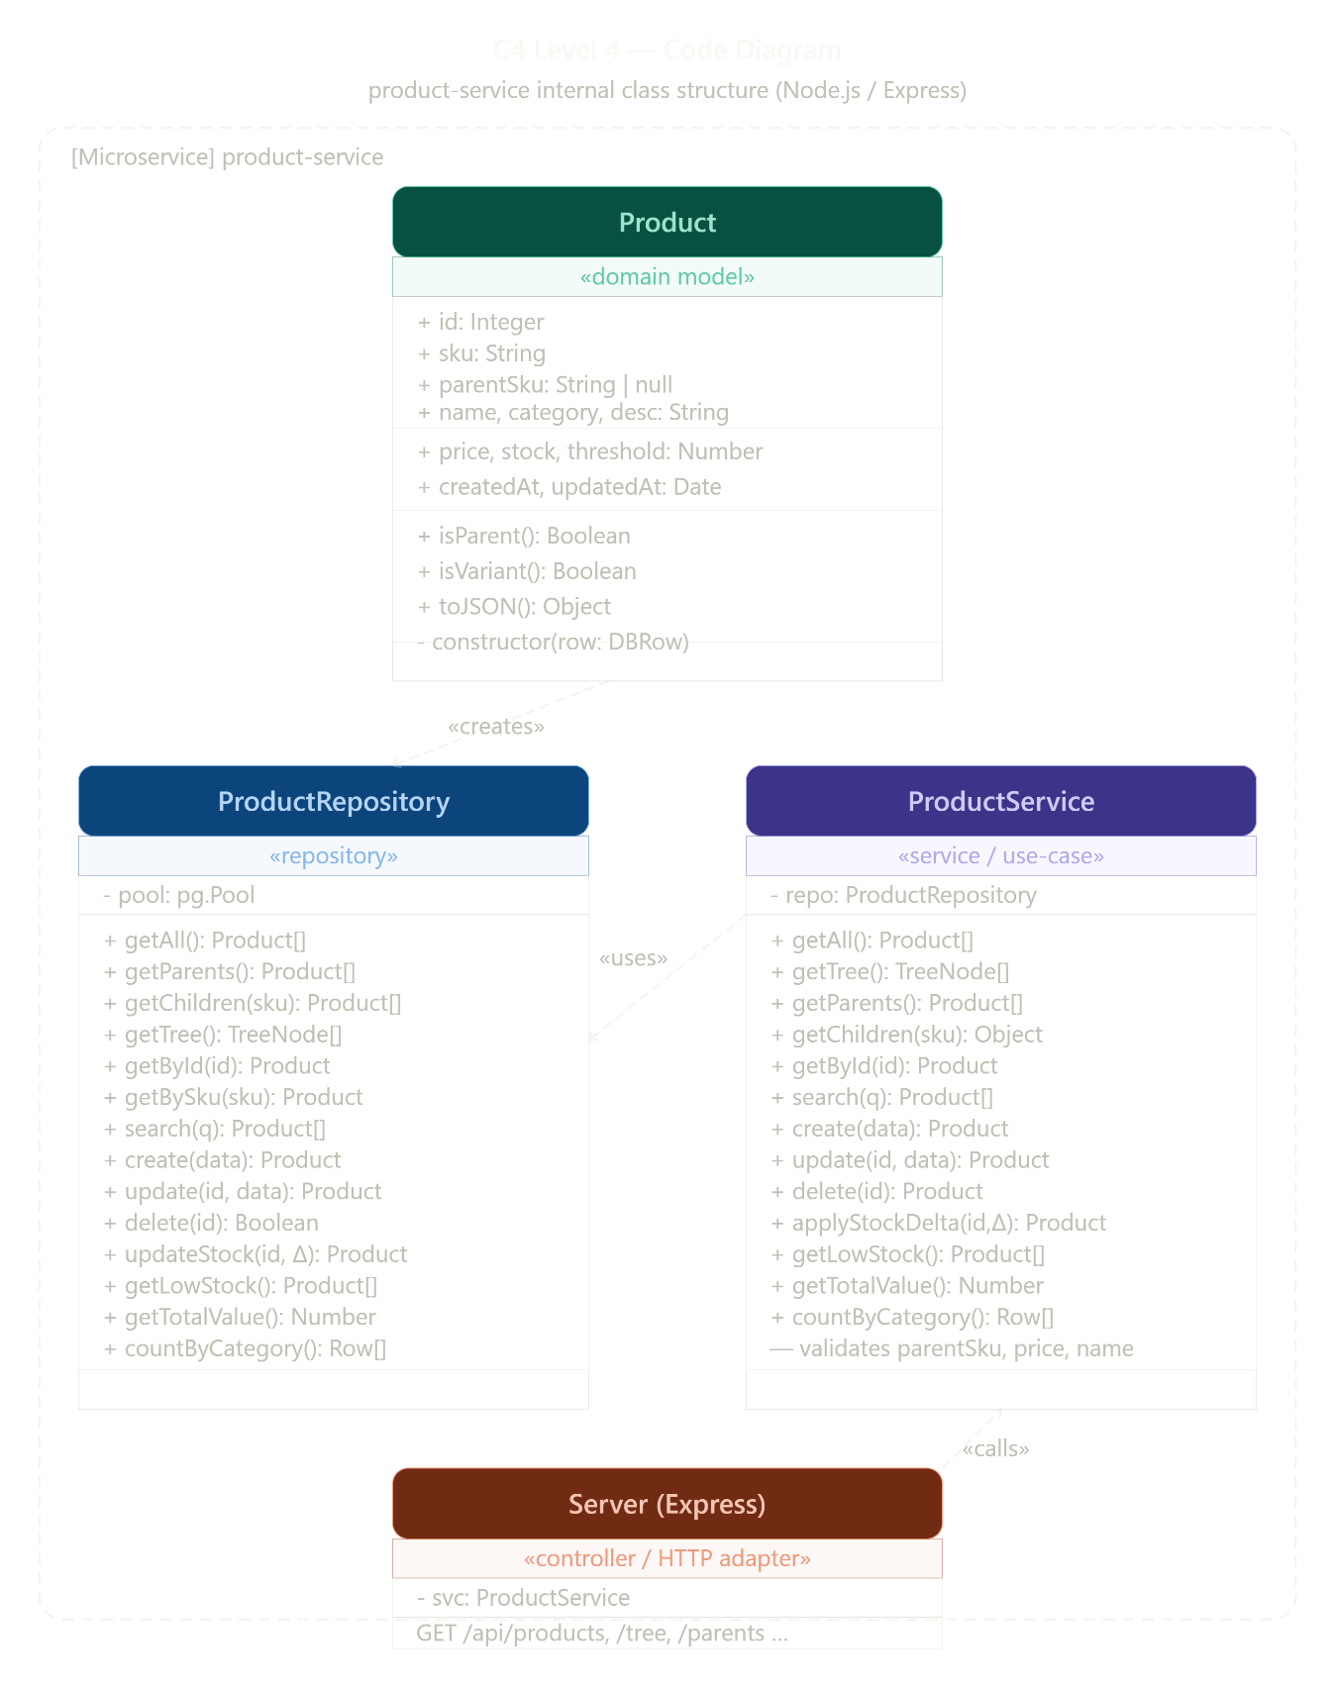
6. Architectural Trade-off Analysis
Transitioning to microservices involves significant trade-offs:
- Gains: Independent scalability (scaling only the Inventory Service during peak loads) and fault isolation (an error in the notification service does not stop warehouse staff from logging transactions).
- Costs: Increased operational complexity, distributed transaction management (replacing ACID with patterns like Saga), and networking overhead

