c

Question 1

Q 1.1 Three tasks performed by a database administrator (DBA) are:

Managing user access and security

-Database administrators are responsible for creating and managing user accounts and assigning appropriate access permissions to ensure the confidentially, integrity, and availability of data. For example, a database administrator may create a user account for a salesperson and grant them access to view customer data but not modify it.

Backup and recovery

-Database administrators are responsible for creating and managing backup and recovery plans to protect data from loss and damage due to hardware failure, natural disasters, or other unexpected events. For example, a database administrator may schedule regular backup of the database and test recovery process to ensure that it works correctly.

Performance tuning and optimization

-Database administrator for monitoring the database’s performance and identifying and resolving any issue that affect the database’s speed or efficiency. For example, a database administrator may optimize database queries or recommend hardware upgrade to improve performance

Available at: <https://www.science.com/topic/computer-science/tasks-performed-by-a-database-Administrator>

[Accessed 8 may 2023]

Q 1.2 A graphical data model is a visual representation of a database schema that uses graphical symbols and notation to represent the data structure, relationships, and constraints of the database. By using a graphical data model, a database designer can create a clear and concise representation of the database schema that can be easily understood by the inventory manager. The best example of graphical model is E-R diagram

Available at: <https://www.science.com/topic/computer-science/graphical-data>

[Accessed 8 may 2023]

Q 1.3 -A customer places many orders and each order is placed by one customer.

I arrived at this rule because a minimum of one customer can order many orders. And a minimum of one order can be placed by a maximum of one customer

* Each order contains many order items and each order items contains each order.

I got to this rule in a way that a minimum of one order contains maximum of many orders. And a minimum of one order item contains a minimum of one customer.

* Each order item includes one item and an item includes many order items.

A minimum of one order item includes a maximum of one order. And a minimum of one item includes a maximum of many order items.

Available at: <https://www.science.com/topic/computer-science/business-rules>

[Accessed 8 may 2023]

Q1.4 Ternary relationship is an association among three entities. This type of relationship is required when binary relationship are not sufficient to accurately describe the semantics of the association. Example, a student studies in a school, so student and school are two entities. But, the same student also takes some coaching classes, so he has a relation with coaching as well, so coaching class is also an entity. Here as there are 3 entities, so it is a ternary relationship

Available at: <https://www.science.com/topic/computer-science/ternary-relationship>

[Accessed 8 may 2023]

Question 2

1 Add a relationship between supplier and product entities

-According to the business rules, a supplier supplies many different product, but each product is supplied by exactly one supplier. Therefore, we need to add a relationship between the supplier and product entities. This relationship should be a one-to-many relationship as one supplier can supply many product, but each product can supplied by only one supplier

2 Add a category entity

-According to the business rules, each product belongs to a specific category, and many product can belong to the same category. Therefore, we need to add a category entity to the ERD. Each product will have a foreign key (FK) to the category entity. This relationship should be a one-to-many relationship as one category can have many product, but each product can belong to only one category

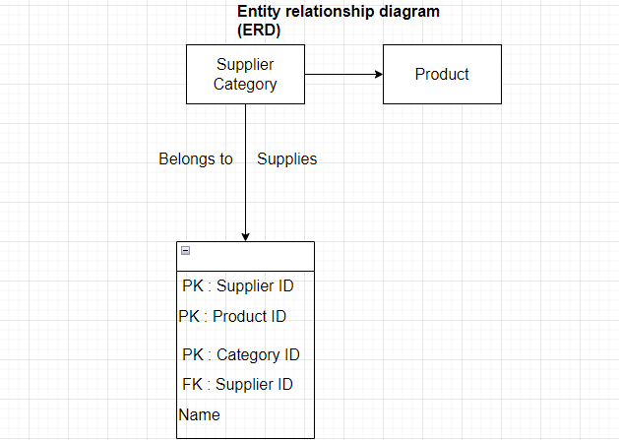

The updated ERD includes the new category entity and a one-to-many relationship between supplier and product entities. The new relationship between supplier and product entities is indicated by the “supplies” relationship with an arrow pointing from supplier to product. The relationship between product and category entities is indicated by the “belongs to” relationship with an arrow pointing form product to category. The changes are necessary to ensure that the ERD accurately represents the business rules. By adding a category entity and a relationship between supplier and product entities, we are capturing all the necessary entities and relationship required by the business rules

Available at: <https://www.sciencedirect.com/topic/computer-science/entity-relationship-diagram/supplier-and-product-entities>

[Accessed 8 may 2023]

Question 3

Entity relationship diagram (ERD)

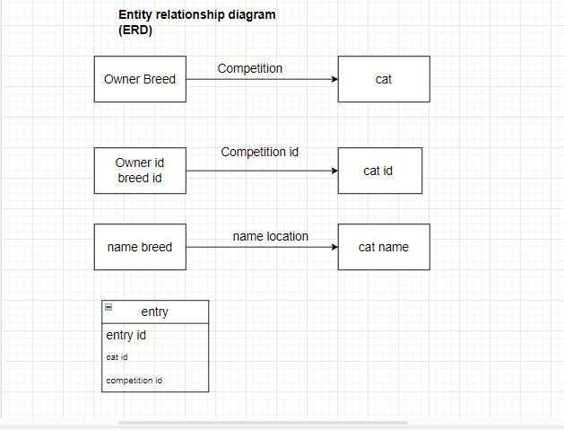

Available at: <https://www.science.com/topic/computer-science/entity-relationship-diagram>

[Accessed 8 may 2023]

Unified modelling language (UML) Notation

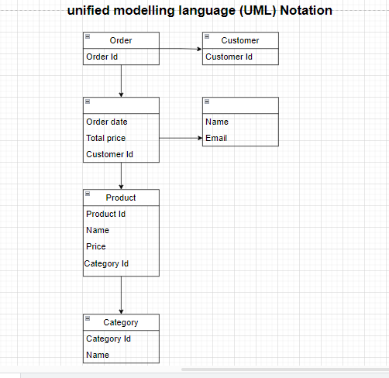

Available at: <https://www.science.com/topic/computer-science/unified-modelling-language-notation>

[Accessed 8 may 2023]

Question 4

Q 4.1 One advantage of normalizing data is that it reduce data redundancy and consistencies by breaking down table into smaller, more focused tables with unique and non-redundant data. This reduces the risk of data inconsistencies and improve data consistency and accuracy, making it easier to manage and maintain data over time

Available at: <https://www.science.com/topic/computer-science/advantage-of-normalizing-data>

[Accessed 8 may 2023]

Q 4.2

1NF

|  |  |  |  |  |  |  |  |
| --- | --- | --- | --- | --- | --- | --- | --- |
| Reporter ID | Reporter  Name | Reporter  Surname | Article  ID | Article  Title | Article  Category  ID | Article Category  Description |  |

Partial Dependency Transitive

Dependency

Partial Dependency

1NF ( Reporter ID, Article ID, Reporter Name, Reporter Surname, Article Title, Article Category ID, Article Category Description)

Partial Dependency:

(Reporter ID > Reporter Name, Reporter Surname)

(Article ID > Article title, Article Category ID, Article Category Description)

Transitive Dependency:

( Article Category ID > Article Category Description)

2NF

Table Name: Reporter

|  |  |  |
| --- | --- | --- |
| Reporter ID | Reporter Name | Reporter Surname |

Reporter (Reporter ID, Reporter Name, Reporter Surname)

Table Name: Article

|  |  |  |  |
| --- | --- | --- | --- |
| Article ID | Article Title | Article Category ID | Article Category Description |

Transitive Dependency

Article (Article ID, Article Title, Article Category ID, Article Category Description)

Transitive Dependency:

Article Category ID > Article Category Description

Table Name: Newspaper:

|  |  |  |
| --- | --- | --- |
| Reporter ID | Article ID | Newspaper Article |

Newspaper: (Reporter ID, Article ID, Newspaper Article)

Available at: <https://www.science.com/topic/computer-science/dependency-diagram-format>

[Accessed 8 may 2023

Q.4.3

Table Name: Reporter

|  |  |  |
| --- | --- | --- |
| Reporter ID | Reporter Name | Reporter Surname |

Reporter (Reporter ID, Reporter Name, Reporter Surname)

Table Name: Article

|  |  |  |
| --- | --- | --- |
| Article ID | Article Title | Article Category ID |

Article (Article ID, Article Title, Article Category ID)

Table Name: Article Category

|  |  |
| --- | --- |
| Article Category ID | Article Category Description |

Article Category: (Article Category ID, Article Category Description)

Table Name: Newspaper

|  |  |  |
| --- | --- | --- |
| Reporter ID | Article ID | Newspaper Article |

Newspaper: Reporter ID, Article ID, Newspaper Article

Available at: <https://www.science.com/topic/computer-science/dependency-diagram>

[Accessed 8 may 2023]

Question 5

One-to-many Relationship

-In a one-to-many relationship, one record in a table can be associated with one or more records in another table. For example, each customer can have many sales orders.

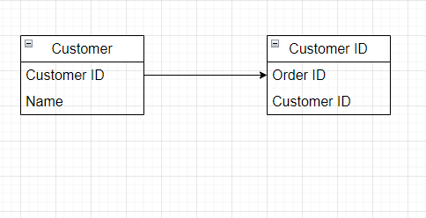

In this example the primary key field in the customers table, customer ID, is designed to contain unique value. The foreign key field in the orders table, customer ID, is designed to allow multiple instances of the same value

This relationship returns related records when the value in the customer ID field in the orders table is the same as the value in the customer ID field in the customer table

One-to-one relationship

-A one-to-one relationship, one record in a table is associated with one and only one record in another table. For example, in a school database, each student has only one student ID, and each student ID is assigned to only one person

Available at: <https://www.sciencedirect.com/topic/computer-science/one-to-many/one-to-one>

[Accessed 8 may 2023]

Question 6

Q 6.1 Redundant data refers to the unnecessary repetition of data in a database, which can lead to data inconsistencies and increase storage requirement. For example, in a bank, storing a customer’s address information in both the account table and the transaction table is redundant can be obtained through the account number.

Available at: <https://www.science.com/topic/computer-science/Redundant-data>

[Accessed 8 may 2023]

Q 6.2 changes the relationship between “member” and “Genre” to a one-to-many relationship: in the current ERD, the relationship between “member” and “Genre” is represented as a many-to-many relationship. However, according to the nosiness rules, each member can choose only one favourite genre, which suggests a one-to-many relationship. Therefore, the relationship should be changed to a one-to-many relationship.

Add a new entity to represent the “favourite Genre” relationship: in the current ERD, the “member” entity has a direct relationship with the “Genre” entity to represent the member’s favourite genre. However, according to the business rules, a genre can be chosen as the favourite of many member, which means that a new entity should be added to represent the “favourite Genre” relationship between “member” and “Genre”.

Add a many-to-many relationship between “Book” and “member”: in the current ERD, the relationship is represented as a one-to-many relationship, which means that each book can be read by many members. However, according to the business rules, each member can read many books, and each book can be read by many members, which suggests a many-to-many relationship. Therefore, a new entity should be added to represent the “Read” relationship between “Book” and “member”

Available at: <https://www.science.com/topic/computer-science/entity-relationship-diagram/business-rules>

[Accessed 8 may 2023]