C e l e r a G e n o m e B ro w s e r

User Guide

June 2007
Open Source Release 5.0

© 2 0 0 2 C e le r a G e n o m ic s, A l l r i g h t s r e s e r ve d .

Ta b l e o f Co n t e n t s

P r e f a c e

About This Guide
Product Release Notes
Conventions Used in this Guide
Finding Information in this Guide
Technical Support

1 . 0 G e n o m e B r o w s e r O v e r v i e w

viii
viii
ix
x
xi

Introduction 1.2

Release 5.0
XML Features
Specify Assembly Files
Import Feature Files
Annotate and Save Workspace Files
System Requirements
Troubleshooting Performance Issues

2 . 0 G e t t i n g S t a r t e d

Accessing the Genome Browser
About the Genome Browser Main Window
Compacting Memory
Status Messages from the Genome Browser
Setting Preferences
Setting Viewing Preferences
Creating a Preferences File
Deleting a Preferences File
Specifying a User- or Site-Specific Preference File
Modifying Genomic Axis Annotation View Settings
1.3
1.3
1.3
1.4
1.5
1.5

2.2
2.3
2.5
2.5
2.6
2.6
2.7
2.8
2.9
2.10

G e n o m e B r o w s e r

ii

Specifying SubView Preferences
Editing Alignment View Settings
Editing Consensus Sequence View Settings
Editing Transcript Translation View Settings
Specifying System Preferences
Specifying the Data Source Settings
Setting Login Information
Adding XML Directories
Specifying XML Service URLs
Setting Splice Profiles
Setting Workspace Backup Options

2.12
2.12
2.13
2.14
2.15
2.16
2.17
2.18
2.19
2.20
2.21

3 . 0 G e n o m e B r o w s e r D a t a O v e r v i e w

Genome Browser Data Classes

3.2

Assembly 3.2
Features 3.2

Precomputes
Annotations
Celera Exchange (XML) Documents
XML Assembly Files
XML Feature Files
XML Workspace Files

4 . 0 A c c e s s i n g a n d V i e w i n g D a t a

Accessing the Data
Searching for a Specific ID
Searching for Sequence Data
Searching for an XML Feature ID
3.2
3.3
3.4
3.4
3.4
3.5

4.3
4.3
4.5
4.6

C e l e r a P r o d u c t U s e r G u i d e

June 2007

Opening a Genome Version
Drilling Down to a Genomic Axis
Opening an XML Workspace (.gbw) File
Viewing an XML Workspace or Feature File
Navigating to a Feature in an XML Workspace File
Displaying Open Data Sources
Loading Precompute and Annotation Features
Showing or Hiding Data Tiers
Reverse Complementing the Axis
Displaying a Feature’s Properties
Zooming to a Selected Feature
Highlighting Evidence
Showing Edge Matches
Showing Evidence Edge Mismatches
Showing non-GT/AG Splices Matches
Finding a Feature’s Matching Subject Sequence
Displaying Consensus Sequence
Displaying the Translations or Reverse Complement
Copying Sequence to the Clipboard
Setting Color Rules For Feature Display
Creating a New Color Rule
Editing an Existing Color Rule
Deleting an Existing Color Rule
Applying a Color Rule
Resetting the View
Using Property Rules
Using a Property Rule to Create Links to
HTML BioMolecule Reports

4.6
4.7
4.9
4.9
4.10
4.11
4.12
4.14
4.15
4.17
4.17
4.18
4.18
4.19
4.19
4.20
4.20
4.23
4.24
4.25
4.25
4.28
4.30
4.30
4.30
4.31

4.33
iii

Displaying Predicted Features in the Transcript Translation View 4.35

Release 5.0
Changing the Translations Display
4.36

G e n o m e B r o w s e r

iv

Copying Transcript Sequence to the Clipboard
Evaluating Feature Homologies
Displaying the Feature Report
Running BLAST Searches
Searching for a Nucleotide or Protein Sequence String
Using Bookmarks

4.36
4.37
4.38
4.40
4.41
4.42

Creating 4.42

Opening a Bookmark
Editing or Deleting a Bookmark
Displaying Multiple Browser Windows
Closing a Browser Window
Printing a Page

5 . 0 C r e a t i n g a n d M o d i f y i n g
A n n o t a t i o n D a t a
4.42
4.42
4.43
4.43
4.43

Introduction 5.2

Edit Commands
Annotation History
Creating a Transcript or Exon Using a Computed Feature
Reviewing and Editing Comments
Adding Evidence to a Transcript or Exon
Removing Evidence from a Transcript or Exon
Splitting a Transcript
Merging Transcripts
Adjusting Exon Boundaries
5.2
5.3
5.4
5.5
5.7
5.7
5.7
5.8
5.9

Using the Consensus Sequence Window to Modify an Exon 5.9

C e l e r a P r o d u c t U s e r G u i d e
Using Evidence to Modify an Exon
Using a Splice Site to Modify an Exon
Adding or Deleting Bases in the SubView
5.10
5.10
5.11

June 2007

Finding a Long Open Reading Frame
Evaluating Subject Sequence Alignments
Deleting a Feature from the Workspace
Exporting Annotation Data

A p p e n d i x A E x c h a n g e F i l e F o r m a t

5.11
5.12
5.12
5.13
v

Introduction A.2

Release 5.0
XML Markup Element Descriptions
Document Type Definition
Example Feature File

A p p e n d i x B T r o u b l e s h o o t i n g

Troubleshooting
Memory Problems
Data Access Problems
Exception Errors
A.3
A.10
A.13

B.2
B.2
B.2
B.3

G e n o m e B r o w s e r

vi

C e l e r a P r o d u c t U s e r G u i d e

June 2007

Release 5.0

Pr e f a c e

About This Guide
Product Release Notes
Conventions Used in this Guide
Finding Information in this Guide
Technical Support

viii
viii
ix
x
xi

G e n o m e B r o w s e r
v i i i A b o u t T h i s G u i d e

C e l e r a P r o d u c t U s e r G u i d e

A B O U T T H I S G U I D E

Welcome to Celera’s Genome Browser. This guide describes the Genome
Browser’s features and functions, and provides step-by-step instructions for
using the product.

As new features are added to the Genome Browser, we will update the user
guide accordingly. This guide is available as an Acrobat PDF from the
Genome Browser help menu. Select Help|User Manual from the Main Menu.

This guide was developed for new Genome Browser users.

P r o d u c t R e l e a s e N o t e s

The Genome Browser release notes describe new features, known issues with
the product, and additional helpful information. To access the release notes,
select Help|Release Notes from the Genome Browser Main Menu.

June 2007

Release 5.0
C o n v e n t i o n s U s e d i n t h i s G u i d e i x

C O N V E N T I O N S U S E D I N T H I S
G U I D E

This guide uses the following typefaces and symbols for presentation
purposes:
Bold Text Indicates text that you should type. Brackets surround user-specific text. For
example, [search string] means that you should type the text for
which to search. You do not type the brackets. For short text strings, we also
use quotation marks to surround the text you type. You do not type the
quotation marks.
Italic text Indicates words that require special emphasis.
NOTE Highlights important information or warnings.
TIP Describes shortcuts.

G e n o m e B r o w s e r
x F i n d i n g I n f o r m a t i o n i n t h i s G u i d e

C e l e r a P r o d u c t U s e r G u i d e

F I N D I N G I N F O R M A T I O N I N
T H I S G U I D E

The following table describes where to find information in this guide:

Chapter 1.0 Describes the features and functions of the
Genome Browser Overview Genome Browser. Also describes the system
requirements.
Chapter 2.0 Explains how to access the Genome Browser and
Getting Started describes the Main Window. Explains how to set
preferences.
Chapter 3.0 Describes the Celera data that appears in the
Genome Browser Data Genome Browser. Also describes the Celera
Overview Exchange (XML) documents.
Chapter 4.0 Explains how to use the Genome Browser to
Accessing and Viewing Data access and view genomic information.
Chapter 5.0 Explains how to use the Genome Browser to
Creating and Modifying create, modify, and export annotation data.
Annotation Data
Appendix A Describes the Celera Exchange File format that
Exchange File Format you use to create XML files for importing into the
Genome Browser. Includes the Document Type
Definition.
Appendix B Explains how to troubleshoot problems you may
Troubleshooting experience with the Genome Browser.

June 2007

T E C H N I C A L S U P P O R T
T e c h n i c a l S u p p o r t x i

Release 5.0

Currently, there is no technical support for the open source release.

G e n o m e B r o w s e r

x i i T e c h n i c a l S u p p o r t

C e l e r a P r o d u c t U s e r G u i d e

June 2007

1 . 0 G e n o m e B ro w s e r O v e r v i e w

Introduction
XML Features
Specify Assembly Files
Import Feature Files
Annotate and Save Workspace Files
System Requirements
Troubleshooting Performance Issues

Release 5.0

1.2
1.3
1.3
1.3
1.4
1.5
1.5

G e n o m e B r o w s e r
1 . 2 I n t r o d u c t i o n

NOTE: All file import and export
functionality takes place on the client
side of the application, whether or not
the Genome Browser is connected to
an application server.

C e l e r a P r o d u c t U s e r G u i d e

I N T R O D U C T I O N

Genome Browser is a visualization tool that allows you to:
• graphically view Celera genome sequence information and annotation
data
• view multiple genome versions at the same time
• overlay and view your mapped feature data with Celera data
• create and save annotation

The Genome Browser is designed to support a fully functional 3-tiered application
consisting of:
• an interactive GUI client front-end
• an application server in the middle tier
• a relational database back-end

Currently, the open source release only supports the stand-alone single-tier client functionality
Future versions may provide a standard data server or access to industry standard
data protocols. This would allow the user to open the Genome Browser client and then
connect it to a variety of different data servers, as well as open local feature files and
temporary workspace files for viewing and annotating data on top of the server assembly data.

The current, stand-alone release allows you to load genomic data directly into the client
using the Celera version of the GAME XML file format known as the Celera Exchange File
Format.

June 2007

X M L Fe a t u re s
I n t r o d u c t i o n 1 . 3

See Appendix A for the detailed Celera
Exchange File Format Specification and
Document Type Definition. Also, see page
3-4 for more details about the XML
assembly files.

See page 3-4 for more details about XML
feature files.

Release 5.0

The Celera Exchange (XML) File Format allows you to import and export data
from the Genome Browser in a flexible manner that supports a variety of
different workflows and data sources. Using the Celera Exchange File Format
with the Genome Browser, you can:

• Specify assembly files
• Import feature files
• Annotate and save workspace files

The following sections provide more detail about these features.

S p e c i f y A s s e m b l y Fi l e s

For 3-tier operation, assembly data is stored in a database, which you access via data
server.

However, the open-source release only supports stand-alone operation, so assembly
Sequence information must be specified in an assembly file, usually in the form of a
FASTA file.

I m p o r t Fe a t u r e Fi l e s

You can import either precomputed or human-annotated features as
multiple feature files directly into the Genome Browser client as long as they
are specified in relation to an assembly Genomic Axis. Since the feature files
do not contain any Genomic Axes themselves – only references to them –
you may partition feature data among files in any convenient manner.
Multiple feature files may contain data on the same Genomic Axis, or a single
feature file may contain data on multiple Genomic Axes.

G e n o m e B r o w s e r

1 . 4 I n t r o d u c t i o n

See page 3-5 for more details about XML
workspace files.

C e l e r a P r o d u c t U s e r G u i d e

A n n o t a t e a n d S a ve Wo r k s p a ce Fi l e s
The Genome Browser performs all interactive annotation operations in local
memory in a data structure called the workspace. You can export the
annotation data in the workspace (modified and newly created genes,
transcripts, exons, start codons, and evidence relationships) to a single
workspace (.gbw) file, which you can reload at a later time to continue
annotating.

If you wish to commit your annotation data to your database, you can then
feed the workspace file into a promotion utility (not provided by the open-source
Genome Browser release).

June 2007

Release 5.0
S y s t e m R e q u i r e m e n t s 1 . 5

S Y S T E M R E Q U I R E M E N T S

Before you access the program, ensure your machine has the following
installed:
• Java Runtime Environment (JRE) 1.3.0_
• At least 256 MB RAM
• Adequate virtual memory settings

.

G e n o m e B r o w s e r
1 . 6 S y s t e m R e q u i r e m e n t s

C e l e r a P r o d u c t U s e r G u i d e

2 . 0 G e t t i n g S t a r te d

Accessing the Genome Browser
About the Genome Browser Main Window
Compacting Memory
Status Messages from the Genome Browser
Setting Preferences
Setting Viewing Preferences
Creating a Preferences File
Deleting a Preferences File
Specifying a User- or Site-Specific Preference File
Modifying Genomic Axis Annotation View Settings
Specifying SubView Preferences
Editing Alignment View Settings
Editing Consensus Sequence View Settings
Editing Transcript Translation View Settings
Specifying System Preferences
Specifying the Data Source Settings
Setting Login Information
Adding XML Directories
Specifying XML Service URLs
Setting Splice Profiles
Setting Workspace Backup Options

Release 5.0

2.2
2.3
2.5
2.5
2.6
2.6
2.7
2.8
2.9
2.10
2.12
2.12
2.13
2.14
2.15
2.16
2.17
2.18
2.19
2.20
2.21

G e n o m e B r o w s e r
2 . 2 A c c e s s i n g t h e G e n o m e B r o w s e r

Main Menu

Outline View

Property Inspector
View

NOTE: The Genome Browser enables
only those menu and sub-menu items
that are valid in a given context. If an
item is greyed out, it is unavailable at
that time.

C e l e r a P r o d u c t U s e r G u i d e

A C C E S S I N G T H E G E N O M E
B R O W S E R

To access the Genome Browser:

1 Make sure that a Java virtual machine is installed on your computer
2 From your desktop, double-click the Genome Browser icon.

The Genome Browser Main Window appears:

Genome Axis Annotation View
Memory Meter
Left Frame Right Frame

When you access the Genome Browser, the window is the same size and
layout and in the same location as when you last closed the application.

June 2007

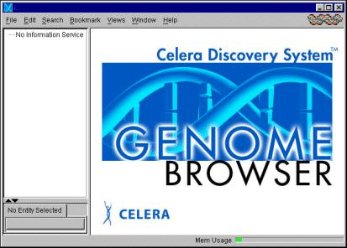
A c c e s s i n g t h e G e n o m e B r o w s e r 2 . 3

Ab o u t t h e G e n o m e B r o w s e r M a i n Wi n d o w

The following table describes the contents of the Genome Browser Main
Window and how to navigate within the window.

G e n o m e B r o w s e r M a i n W i n d o w

Release 5.0
Main Menu

Left Frame

Outline View
Displays the menu options that are available to you. The
menu options vary, depending on the data you have
open. This guide describes the available options in
greater detail when explaining how to perform tasks.
Contains two elements:
• Outline View
• Property Inspector View

If the Outline View contains more data than it can
display, Genome Browser inserts vertical and horizontal
scroll bars so that you can see the data.
To resize the frame and its elements:
1 Place your cursor over a border until the cursor
changes to double-arrow.
2 Left-click your mouse and drag the frame to the size
you want.
TIP: You can also double-click the small horizontal arrows
that appear on the border to minimize/maximize the
frames.
Displays open data arranged by genomic axes. Genomic
axes represent either an entire chromosome, or the
largest assembled portions of a chromosome (often
referred to as scaffolds). A genomic axis may contain a
single string of nucleotide residues, or it may be
comprised of multiple alignments of separate,
contiguous residue strings known as contigs. The
hierarchy for the Outline View is:

Species
Genome Version
Chromosome
Axis

• Click the + sign to expand a folder or folder name.
• Click the - sign to collapse a folder or folder name.

NOTE: When you first open the Genome Browser, the
Outline View displays “No Information Service.”

G e n o m e B r o w s e r

2 . 4 A c c e s s i n g t h e G e n o m e B r o w s e r

C e l e r a P r o d u c t U s e r G u i d e

G e n o m e B r o w s e r M a i n W i n d o w (cont’d)
Property Inspector Displays the properties associated with the entity
View currently highlighted in the outline view or in the
annotation view.
NOTE: When you first open the Genome Browser, or if
you do not have an object selected, the Property
Inspector View displays “No Entity Selected.”
Right Frame Contains the Genomic Axis Annotation View.
If you enable the SubView view, it will appear in the
bottom portion of the right frame area.
You can resize this frame, too.
Memory Usage Roughly indicates the amount of available memory while
Meter you are using the application. The meter color changes
to a yellow line if 70% of available memory is used and a
red line if 90% of available memory is used. Depending
upon what the application is doing, this meter may
fluctuate.
To find out exactly how much memory the Genome
Browser client is using:
1 Double-click the memory meter.
The Memory Usage dialog box appears, which
indicates:
Total Memory — the total memory that the
Genome Browser requires, up to the maximum it is
allowed to consume.
Free Memory — how much memory remains
available for the Genome Browser client to use.
Used Memory — how much memory the Genome
Browser is consuming at the moment.

June 2007

Co m p a c t i n g M e m o r y
A c c e s s i n g t h e G e n o m e B r o w s e r 2 . 5

NOTE: You will receive this message
only if you have the Genome Browser
open and are connected to a Celera
database.

Release 5.0

1 Double-click the Memory Usage Meter in the lower right of the Genome
Browser Main Window.
The Memory Usage dialog box appears:

2 Click Yes.

S t a t u s M e s s a g e s f r o m t h e G e n o m e B r o w s e r

If the Genome Browser has downtime scheduled, Celera will broadcast a
Status Message with the appropriate information across the server to the
Genome Browser client.

G e n o m e B r o w s e r

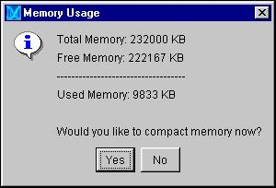
2 . 6 S e t t i n g P r e f e r e n c e s

C e l e r a P r o d u c t U s e r G u i d e

S E T T I N G P R E F E R E N C E S

Before you begin using the Genome Browser, you should review and set or
change, if necessary, the Genome Browser Preferences.

S e t t i n g V i e w i n g Pr e fe r e n c e s

The following sections explain how to:
• Create a preferences file and specify the location for group preference
files
• Modify the Genomic Axis Annotation View Settings

June 2007

C r e a t i n g a Pr e f e r e n ce s Fi l e
S e t t i n g P r e f e r e n c e s 2 . 7

Release 5.0

You may save changes you make to the View settings in a file to use for
yourself or to share with a group of users.

1 From the Main Menu, select Edit|Preferences|Genomic Axis
Annotation View.
2 Click the View Preference File tab.

3 Click New File.

G e n o m e B r o w s e r

2 . 8 S e t t i n g P r e f e r e n c e s

C e l e r a P r o d u c t U s e r G u i d e

The Create New View Setting File dialog box appears.

4 Type a name in the text box.
5 Click OK.
The new preference becomes the default.

D e l e t i n g a Pr e f e r e n ce s Fi l e

To remove a preferences file:

1 From the Main Menu, select Edit|Preferences|Genomic Axis
Annotation View.
2 Click the View Preference File tab.
The Preferences: Genomic Axis Annotation View dialog box
appears.

3 Click Delete File.
4 In the Delete File dialog box, select the file you want to delete and click
OK.
The Deleting file dialog box appears.

5 Click Yes to delete the file or No to retain it.

June 2007
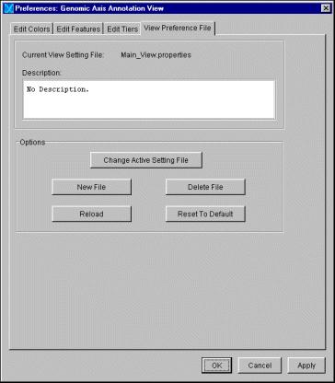

Release 5.0
S e t t i n g P r e f e r e n c e s 2 . 9

To remove any changes (e.g., color choices) from the current session, click
Reload.

To reset to default, click Reset to Default.

S p e c i f y i n g a U s e r - o r S i te - S p e c i f i c Pr e f e r e n ce Fi l e

You may wish to specify a preference file other than the default, or your site
may wish to create and use group-specific preference files so that your View
settings are the same across users. If that is the case, you need to tell the
Genome Browser to use the desired preference file and specify the location
for the new preferences file.

1 From the Main Menu, select Edit|Preferences|Genomic Axis
Annotation View.
2 Click the View Preference File tab.
3 Click Change Active Settings File.
4 Browse to locate the directory’s folder that contains your XML files, and
select the folder.

5 Click Select File.

G e n o m e B r o w s e r
2 . 1 0 S e t t i n g P r e f e r e n c e s

C e l e r a P r o d u c t U s e r G u i d e

M o d i f y i n g G e n o m i c A x i s A n n o t a t i o n V i e w S e t t i n g s

The Genome Browser provides a variety of color schemes to help you view
genomic data. You modify default settings in the Preferences: Genomic
Axis Annotation View dialog box.

1 From the Main Menu, select Edit|Preferences|Genomic Axis
Annotation View.
The Preferences: Genomic Axis Annotation View dialog box
appears.

June 2007
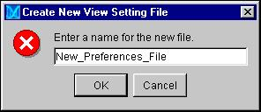
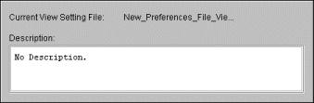
S e t t i n g P r e f e r e n c e s 2 . 1 1

The following table describes how to edit colors, features, and tiers using
this dialog box:

Release 5.0

T a b

Edit Colors

Edit Features

Edit Tiers

I n s t r u c t i o n s

To add a color:
1 Click Add Color.
2 Select a color and click OK.
The new color appears in the list.
3 Click on the new color’s row in the
Color Name column and type a name
for the new color.

To delete a color:
1 Select the color name to delete, and
click Delete Color.
2 Click OK at the prompt.
To delete a feature:
1 Select the feature name to delete, and
click Delete Feature.
2 Click OK at the prompt.

NOTE: The Genome Browser
automatically adds new features from a
.gbf file.
To reorder how the tiers appear in the
Genomic Axis Annotation View:
1 Click in the Position column for the
tier(s) you wish to reorder.
2 Specify the new position(s) for the
tier(s).
3 Press Enter to save your change.

To delete a tier:
1 Select the tier name to delete, and click
Delete Tier.
2 Click OK at the prompt.
NOTE: The Genome Browser
automatically adds tier names that appear
in XML feature (.gbf ) files if the feature
group name is new.

G e n o m e B r o w s e r

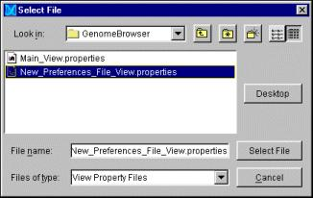
2 . 1 2 S e t t i n g P r e f e r e n c e s

C e l e r a P r o d u c t U s e r G u i d e

S p e c i f y i n g S u b V i e w Pre fe re n c e s

The following sections explain how to:
• Edit Alignment View Settings
• Edit Consensus Sequence View Settings
• Edit Transcript Translation View Settings

E d i t i n g A l i g n m e n t V i e w S e t t i n g s

You can change the Alignment View settings to accomodate your color
preferences.

1 From the Main Menu, select Edit|Preferences|SubViews.
2 Click the Edit Query Alignment View Settings tab:

3 Double-click on an item’s corresponding color and select the desired
color from the pull-down list.
4 If desired, click Reset Defaults to restore the original color scheme
selected by the Genome Browser.
5 Click Apply to save your changes and continue working in this dialog
box. Click OK to save your changes and close the dialog box.

June 2007
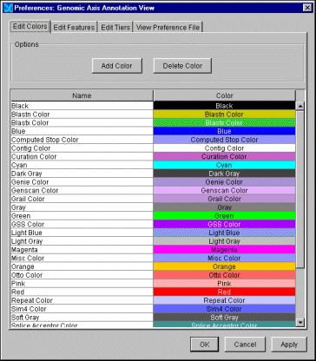

Release 5.0
S e t t i n g P r e f e r e n c e s 2 . 1 3

E d i t i n g Co n s e n s u s S e q u e n ce V i e w S e t t i n g s

You can change the Consensus Sequence View settings to accomodate your
color preferences.

1 From the Main Menu, select Edit|Preferences|SubViews.
2 Click Edit Consensus Sequence View Settings.

3 Double-click on an item’s corresponding color and select the desired
color from the pull-down list.
4 If desired, click Reset Defaults to restore the original color scheme
selected by the Genome Browser.
5 Click Apply to save your changes and continue working in this dialog
box. Click OK to save your changes and close the dialog box.

G e n o m e B r o w s e r
2 . 1 4 S e t t i n g P r e f e r e n c e s

C e l e r a P r o d u c t U s e r G u i d e

E d i t i n g Tra n s c r i p t Tra n s l a t i o n V i e w S e t t i n g s

You can change the Transcript Translation View settings to accomodate your
color preferences.

1 From the Main Menu, click Edit|Preferences|SubViews.
2 Click Edit Transcript Translation View Settings:

3 Double-click on an item’s corresponding color and select the desired
color from the pull-down list.
4 If desired, click Reset Defaults to restore the original color scheme
selected by the Genome Browser.
5 Click Apply to save your changes and continue working in this dialog
box. Click OK to save your changes and close the dialog box.

June 2007

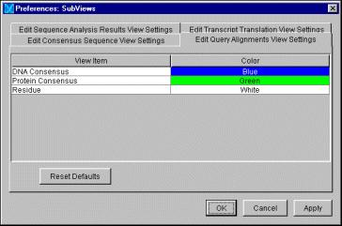

S p e c i f y i n g S ys t e m Pr e fe r e n c e s
S e t t i n g P r e f e r e n c e s 2 . 1 5

Release 5.0

1 From the Main Menu, select Edit|Preferences|System .
2 Click the Applications Settings tab:

G e n o m e B r o w s e r

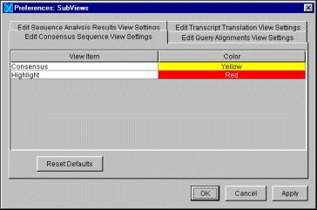
2 . 1 6 S e t t i n g P r e f e r e n c e s

C e l e r a P r o d u c t U s e r G u i d e

3 Select the desired options. Use the following table to guide you through
your choices.

O p t i o n D e s c r i p t i o n
Display SubViews When Available Check this box to display the available
SubView windows. These windows
are context-sensitive: only the
relevant windows display, depending
upon what you have selected in the
Genomic Axis Annotation View.
Focus SubViews Upon Navigation Check this box to automatically
define the SubView range when you
navigate to a feature from search
results. This will also automatically
activate the Consensus Sequence
panel.
Display Memory Usage Meter Check this box to display the Memory
Usage Meter in the lower-right corner.
See page 2.4 for more information
about the Memory Usage Meter.
Show Navigation/Search complete Check this box to show complete
messages messages when searching for data.
Look and Feel Options Click a radio button to change the
overall appearance of the Genome
Browser’s windows and dialog boxes:
• Metal
• CDE/Motif
• Windows (default)

S p e c i f y i n g t h e D a t a S o u rc e S e t t i n g s

You must specify the data source settings before you can access any data in
the Genome Browser. Depending on the data you will access, you may do
one or more of the following:
• Set login information
• Specify XML directories
• Specify XML Service URLs

June 2007

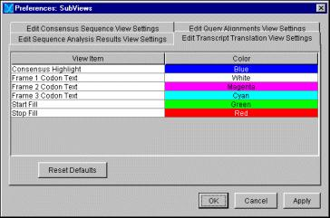

S e t t i n g L o g i n I n f o r m a t i o n
S e t t i n g P r e f e r e n c e s 2 . 1 7

NOTE: If you are not connecting to a
Celera database, you do not need to
login.

NOTE: When you select File|Open
Genome, the Preferences dialog
box appears automatically if you have
never set your login information.

Release 5.0

You will need to set your login information before you may connect to a
database. You do this from the Preferences: System dialog box.

1 From the main menu, select Edit|Preferences|System.
2 Click the Data Source Settings tab:

3 In the User Name text box, type your database user
name.
4 Type your database Password in the text box.
5 If desired, select the “Save Login Information” box.
If you do not check this box, you will need to login each time you
connect to a database.

G e n o m e B r o w s e r

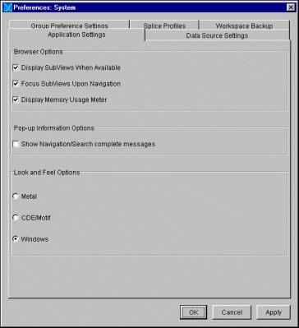
2 . 1 8 S e t t i n g P r e f e r e n c e s

NOTE: To delete an XML
directory, select the directory to
delete and click Remove
Selected Directory.

C e l e r a P r o d u c t U s e r G u i d e

6 Click Apply to save your changes and continue working in this dialog
box. Click OK to save your changes and close the dialog box.

Ad di n g XM L D i r e c to r i e s

Before you may open an XML assembly or load an XML feature file’s data, you
need to tell the Genome Browser where to look for the files.

1 From the Main Menu, select Edit|Preferences|System .
2 Click the Data Source Settings tab.
3 Click Add to Current Directories.
The Select Directory dialog box appears:

4 Browse to locate the directory’s folder that contains your XML files, and
select the folder.
5 Click Select Directory.
6 Repeat steps 3 through 5 for each directory that you wish to add.
7 If desired, specify a validation option.
8 Click Apply to save your changes and continue working in this dialog
box. Click OK to save your changes and close the dialog box.

June 2007

S p e c i f y i n g X M L S e r v i ce U R L s
S e t t i n g P r e f e r e n c e s 2 . 1 9

NOTE: For more information about
the Genome Browser XML Service,
refer to the Celera Programmer
Reference Guide for the Genome
Browser.

NOTE: To delete a URL, select the URL
you want to delete in the Current
URLs box, and click Remove
Selected URL.

Release 5.0

If your site takes advantage of the Genome Browser’s XML Service capability,
you should specify the URLs in the Preferences dialog box.

1 From the Main Menu, select Edit|Preferences|System .
2 Click the Data Source Settings tab.
3 Type the URL provided by your site programmer in the New URL text
box, and click Add to Current URLs.

4 Click Apply to save your changes and continue working in this dialog
box. Click OK to save your changes and close the dialog box.

G e n o m e B r o w s e r

2 . 2 0 S e t t i n g P r e f e r e n c e s

C e l e r a P r o d u c t U s e r G u i d e

S e t t i n g S p l i c e Pr o f i l e s

Celera provides splice profiles for Human, Mouse and Drosophila data. You
can override these default splice profiles and specify different “Acceptor,”
“Donor,” and “Neither” splice profile files you have stored on your computer.

1 From the Main Menu, select Edit|Preferences|System .
2 Click the Splice Profiles tab.

If desired, check the Override Default Splice Profiles box. This will
activate the Choose buttons that allow you to upload Donor, Acceptor
and Neither splice files.

3 Click Apply to save your changes and continue working in this dialog
box. Click OK to save your changes and close the System Preferences
dialog box.

June 2007

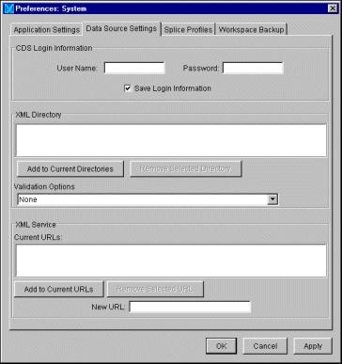

S e t t i n g Wo r k s p a c e B a c k u p O p t i o n s
S e t t i n g P r e f e r e n c e s 2 . 2 1

Release 5.0

The Genome Browser is set to periodically backup your Workspace. If you like,
you can disable this feature.

1 From the Main Menu, select Edit|Preferences|System .
2 Click the Workspace Backup tab..

3 To disable the workspace backup, turn on the No radio button.
4 If desired, click Change For Next Session to change the default
directory and/or file name for the workspace backup file..
5 Click Apply to save your changes and continue working in this dialog
box. Click OK to save your changes and close the dialog box.

G e n o m e B r o w s e r

2 . 2 2 S e t t i n g P r e f e r e n c e s

C e l e r a P r o d u c t U s e r G u i d e

June 2007

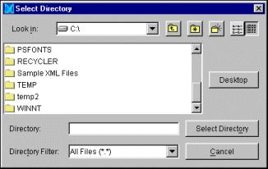

3 . 0 G e n o m e B ro w s e r D a t a O v e r v i e w

Genome Browser Data Classes

3.2

Assembly 3.2
Features 3.2

Release 5.0
Precomputes
Annotations
Celera Exchange (XML) Documents
XML Assembly Files
XML Feature Files
XML Workspace Files
3.2
3.3
3.4
3.4
3.4
3.5

G e n o m e B r o w s e r

3 . 2 G e n o m e B r o w s e r D a t a C l a s s e s

See page 3.6 for a diagram that illustrates
the Genome Browser data object flow.

C e l e r a P r o d u c t U s e r G u i d e

G E N O M E B R O W S E R D A T A
C L A S S E S

The Genome Browser supports these major data classes:
• Assembly
• Features, comprised of precomputes and annotations

A s s e m b l y

Assembly is the raw nucleotide residue data, stored as sequences of A, T, C
and G, which have been ordered together to form single base-pair
coordinate systems known as Genomic Axes. Genomic Axes represent either
an entire chromosome, or the largest assembled portions of a chromosome
(often referred to as scaffolds). A Genomic Axis may also represent a set of
scaffolds that are ordered and oriented relative to one another. A Genomic
Axis may contain either a single string of nucleotide residues, or it may be
comprised of multiple, separate, contiguous-residue strings known as
contigs, ordered and oriented within a scaffold.

Fe a t u re s

Features are comprised of precomputes and annotations.

Pr e co m p u t e s

Precomputes are features, aligned to a sequence, that have been determined
by some algorithmic process (e.g., BLAST). Precomputes may be either:
• simple form —single ranges along a genomic axis, with descriptive
information (e.g., HSP)
• compound form — adjacent simple features that are grouped by the
analysis program (e.g., BlastHits)

June 2007

A n n o t a t i o n s
G e n o m e B r o w s e r D a t a C l a s s e s 3 . 3

Release 5.0

Annotations are features, aligned to a sequence, that have been created by a
human or automated curation process. The Genome Browser supports three
annotation feature types:
• Exon — a single range on a nucleotide sequence, together with
descriptive information and zero or more evidence relationships.
Evidence relationships are references to precompute objects used as
evidence of the existence of an exon.
• Transcript — a sequence of exons separated by intron regions,
translated into a protein sequence. A transcript may also have a
Start_Codon or a Translation_Start_Position (if the Start_Codon can not
be determined), together with an optional Stop_Codon to indicate the
translation frame of the transcript.
• Gene — one or more transcripts that are associated with a single gene.

G e n o m e B r o w s e r

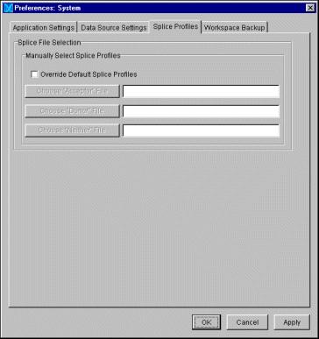
3 . 4 C e l e r a E x c h a n g e ( X M L ) D o c u m e n t s

C E L E R A E X C H A N G E ( X M L )
D O C U M E N T S

The Genome Browser supports the following types of XML exchange
documents:

NOTE: You may open only Celera-
signed XML assembly files.

NOTE: Although there is no
constraint on how to organize features
in feature files, your computer may
experience memory problems if a
feature file is too large.

C e l e r a P r o d u c t U s e r G u i d e

• Assembly
• Feature
• Workspace

These files all use the same data file format, but they contain different kinds of
data. They are distinguished by using different file name extensions to
indicate the type of data they contain.

The following sections provide more detail.

X M L A s s e m b l y Fi l e s

Assembly files (.gba extension) are the only files that can contain genomic
assembly data. An assembly file may contain features as well, but for large
data sets it is more practical to break the features into multiple feature (. gbf )
files that you can load on an as-needed basis. Celera-signed assembly files do
not contain features.

X M L Fe a t u r e Fi l e s

Feature files (.gbf extension) contain either precomputed or human-
annotated features calculated along a genomic axis. However, they are not
allowed to contain assembly (i.e., genomic axis residue) data. There is no limit
to how many or what type of features can be contained in a feature file, as
long as they each reference a valid genomic axis to which the Genome

June 2007

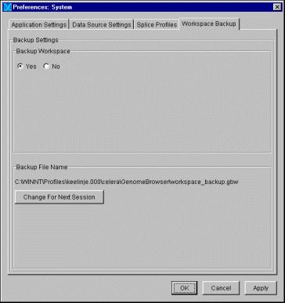

NOTE: You may load only one
workspace file in to the Genome
Browser at a time.

Release 5.0
C e l e r a E x c h a n g e ( X M L ) D o c u m e n t s 3 . 5

Browser has access. You can open any number of feature files in the Genome
Browser at one time, and a single feature file may contain features on many
different genomic axes.

Human-curated features contained in the feature files show up in the
“Promoted” tier of the browser.

X M L Wo r k s p a ce Fi l e s

A workspace file (.gbw extension) contains annotation data that have been
created and exported using the annotation capabilities of the Genome
Browser. You can then reload the file in the Genome Browser at a later time,
to edit or further annotate. A workspace file may only contain annotated
features on a valid genomic axis to which the Genome Browser has access. It
cannot contain genomic axis residue data, nor can it contain precomputed
features.

G e n o m e B r o w s e r
3 . 6 C e l e r a E x c h a n g e ( X M L ) D o c u m e n t s

The following diagram illustrates the Genome Browser data object flow.

C e l e r a P r o d u c t U s e r G u i d e

June 2007

4 . 0 A c c e s s i n g a n d V i e w i n g D a t a

Accessing the Data
Searching for a Specific ID
Searching for Sequence Data
Searching for an XML Feature ID
Opening a Genome Version
Drilling Down to a Genomic Axis
Opening an XML Workspace (.gbw) File
Viewing an XML Workspace or Feature File
Navigating to a Feature in an XML Workspace File
Displaying Open Data Sources
Loading Precompute and Annotation Features
Showing or Hiding Data Tiers
Reverse Complementing the Axis
Displaying a Feature’s Properties
Zooming to a Selected Feature
Highlighting Evidence
Showing Edge Matches
Showing Evidence Edge Mismatches
Showing non-GT/AG Splices Matches
Finding a Feature’s Matching Subject Sequence
Displaying Consensus Sequence
Displaying the Translations or Reverse Complement
Copying Sequence to the Clipboard
Setting Color Rules For Feature Display
Creating a New Color Rule
Editing an Existing Color Rule
Deleting an Existing Color Rule
Applying a Color Rule
Resetting the View
Using Property Rules

4.3
4.3
4.5
4.6
4.6
4.7
4.9
4.9
4.10
4.11
4.12
4.14
4.15
4.17
4.17
4.18
4.18
4.19
4.19
4.20
4.20
4.23
4.24
4.25
4.25
4.28
4.30
4.30
4.30
4.31

Release 5.0

G e n o m e B r o w s e r

4 . 2

Using a Property Rule to Create Links to
HTML BioMolecule Reports
Displaying Predicted Features in the
Transcript Translation View
Changing the Translations Display
Copying Transcript Sequence to the Clipboard
Evaluating Feature Homologies
Displaying the Feature Report
Running BLAST Searches
Searching for a Nucleotide or Protein Sequence String
Using Bookmarks

4.33

4.35
4.36
4.36
4.37
4.38
4.40
4.41
4.42

Creating 4.42

C e l e r a P r o d u c t U s e r G u i d e
Opening a Bookmark
Editing or Deleting a Bookmark
Displaying Multiple Browser Windows
Closing a Browser Window
Printing a Page
4.42
4.42
4.43
4.43
4.43

June 2007

Release 5.0
A c c e s s i n g t h e D a t a 4 . 3

A C C E S S I N G T H E D A T A

To access data in the Genome Browser, you may either:
• Search for a specific ID and navigate to its region on the genome
• Open one or more genome versions and drill down to a region on a
genome

S e a rc h i n g fo r a S p e c i f i c I D

1 From the Main Menu, select Search|Features...

The Search Known Features dialog box appears:

G e n o m e B r o w s e r
4 . 4 A c c e s s i n g t h e D a t a

NOTE: If you are not already
connected to an information service,
the first query type is the only
available option.

NOTE: The last ID type used will be
the topmost available option in the
list.

C e l e r a P r o d u c t U s e r G u i d e

2 Select a query type:
• Search the available Genome Version(s) — Searches all
genome versions to which you have access, whether you are
connected to a genome version or not.
• Search the loaded Genome Version(s) — Searches only the
genome versions to which you are connected. This type is
unavailable if you do not have a genome version loaded.
• Search the current Genome Version — Searches only the
genome version you have selected in the Outline View. This type is
unavailable if you do not have a folder selected in the Outline View.

3 Select one of the following ID types from the pull-down list:
• Transcript (Celera Accession)
• Gene (Celera Accession)
• Genomic Axis Name
• Protein (Celera Accession)
• Feature ID
• Unknown ID
• Chromosome
• Celera Variant (SNP)
• External ID (gi or accession)
• STS Name
• BAC accession or clone name
• Subject Sequence ID
• Gene Ontology
• Gene Family
• Regulatory Region Accession
• Conserved Segment Accession
• Gene Index Accession

June 2007

NOTE: Open New Browser is
unchecked by default. Check this box
to display the data in a separate
browser window.

See page 4.4 for more information about
the available query types.

Release 5.0
A c c e s s i n g t h e D a t a 4 . 5

4 Type or paste the ID for which to search in the blank text box and click
OK. With the exception of GA names, this search is not case-sensitive.
5 Select the desired result and click Navigate to view the data, or
Bookmark to mark the results for later use.

S e a r c h i n g fo r Ce l e ra D i s co ve r y Sy s te m S e q u e n ce D a t a

This section describes how to search for a GA (Genomic Axis) number in the
Genome Browser:

1 From the Main Menu, select Search|Features...
The Search Known Features dialog box appears.

2 Select a query type.
3 Select Genomic Axis Name from the pull-down list, and type or paste
the desired GA number (e.g., GA_x9V1BB6) in the blank text box.
TIP: Right-click to paste the GA number in the text box.

4 Click OK.
If more than one result appears, select the desired GA ID.

5 Click Navigate.
The information for this genomic axis appears in the Property Inspector
View.

From the Main Menu, select Views|Genomic Axis Annotation
View to see the data in the Genomic Axis Annotation View or double-
click on the GA number in the Outline View.

G e n o m e B r o w s e r
4 . 6 A c c e s s i n g t h e D a t a

See page 4.4 for more information about
the query types.

NOTE: You may open only Celera-
signed XML assembly files. Also, before
you can open a .gba file, you must
specify the Data Source Settings from
the Preferences dialog box. Refer to
“Setting Preferences” on page 2.6 for
instructions.

C e l e r a P r o d u c t U s e r G u i d e

S e a r c h i n g fo r a n X M L Fe a t u r e I D

You can also search for a Feature ID that appears in a XML Feature file (.gbf ).

1 From the Main Menu, select Search|Features...
The Search Known Features dialog box appears.

2 Select a query type.
3 Select Feature ID from the pull-down list and type (or paste) the
unique Feature ID in the blank text box.
4 Click OK.
The Choose Path dialog box appears with the feature selected or a list
of feature IDs. If more than one appears, select the desired ID.

5 Click Navigate.
The information for this feature appears in the Property Inspector View.

6 From the Main Menu, select Views|Genomic Axis Annotation to
see the data in the Genomic Axis Annotation View.

O p e n i n g a G e n o m e Ve r s i o n

You may open one or more genome versions to drill down to the assembly
and feature data that you want to view. You can either:
• Connect to a Celera database to view an assembly and its feature data
• Open an XML assembly (.gba) file

To open a genome version:

1 From the Main Menu, select File|Open Genome Version.
The Selection Species/Assembly dialog box appears, displaying a
list of available genome versions.

June 2007

Release 5.0
A c c e s s i n g t h e D a t a 4 . 7

2 Select the desired assembly from displayed list, and click OK, or double-
click on the selected assembly.
TIP: To open more than one genome version at a time, use Ctrl-click to
select multiple genome versions and then click OK.

The Outline View now displays the unexpanded species folder. For
example:

D r i l l i n g D o w n t o a G e n o m i c A x i s

1 Connect to the Celera database or open an assembly file.
2 Expand the species folder and the sub-folders to open the folder that
contains desired axis.
TIP: Right-click your mouse on the genomic axis, chromosome, or
scaffold position on the chromosome; and select a sort option for
viewing by size:

3 Select the genomic axis’ folder.
The axis information appears in the Property Inspector View.

G e n o m e B r o w s e r

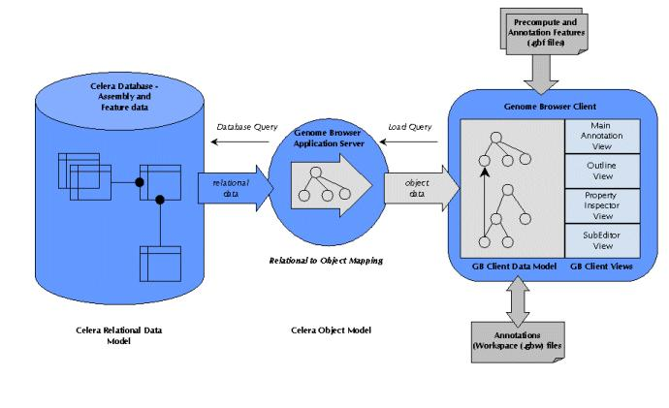
4 . 8 A c c e s s i n g t h e D a t a

4 Double-click the genomic axis’ folder.
The genomic axis appears in the Genomic Axis Annotation View :

Loading Docking

Outline
View

Genomic
Axis

Property
Inspector
View

Status
Bar
Zoom Bar

SubView
Zoom Center
Bar

Genomic Axis
Annotation View
Indicator
Area

Scroll Bar

C e l e r a P r o d u c t U s e r G u i d e

• To center around a specific region before you zoom in or out,
position the vertical Zoom Center Bar in the desired region.
• To zoom out or in, slide the zoom bar up or down.
• To pan across the genomic axis, slide the horizontal scroll bar left or
right.

June 2007

O p e n i n g a n X M L Wo r k s p a c e ( . g b w ) Fi l e
A c c e s s i n g t h e D a t a 4 . 9

See Appendix A for the detailed Exchange
File Format Specification and Document
Type Definition.

Release 5.0

You can open your own workspace file, as long as this file was created using
the Celera Exchange File Format. The Genome Browser displays the data with
the Celera data, allowing you to create or modify annotations on your data.
You may work with only one XML workspace file at a time.

1 Ensure that the file was created using the Celera Exchange File format.
2 From the Main Menu, select File|Open Workspace File.
If you have never opened an XML workspace file, the Open dialog box
appears automatically. Browse to locate the desired file, and click Open.

TIP: If you have opened one or more XML workspace files, the sub-
menu allows you to access the Open dialog box or to select from a list
of recently opened files. Select a file from this list to open it, or select
Open File... to access the Open dialog box, browse to locate the
desired file, and click Open.

V i e w i n g a n X M L Wo r k s p a c e o r Fe a t u r e Fi l e

1 Open the desired XML workspace file.
2 From the Main Menu, select File|View Celera Exchange File.
The Celera Exchange File Viewer displays.

G e n o m e B r o w s e r

4 . 1 0 A c c e s s i n g t h e D a t a

C e l e r a P r o d u c t U s e r G u i d e

3 Drill down to the desired object in the viewer to display its attributes and
properties:

N a v i g a t i n g t o a Fe a t u r e i n a n X M L Wo r k s p a ce Fi l e

1 Open the desired XML workspace file.
2 From the Main Menu, select File|View Celera Exchange File.
The Celera Exchange File Viewer displays.

3 Drill down to the desired feature and select it.
4 From the Viewer’s menu, select Genome Browser|Navigate.
The Genome Browser displays the selected feature in the Genomic Axis
Annotation View and the Property Inspector View.

June 2007

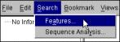
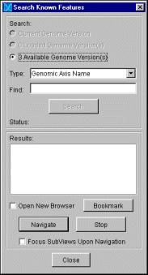

D i s p l ay i n g O p e n D a t a S o u r c e s
A c c e s s i n g t h e D a t a 4 . 1 1

Release 5.0

You can easily find out which assembly, feature, and workspace files you have
open.

1 From the Main Menu, select File|List Open Data Sources.
A dialog box appears, listing all data sources that the Genome Browser
has open now.

2 Close the dialog box.

G e n o m e B r o w s e r

4 . 1 2 L o a d i n g P r e c o m p u t e a n d A n n o t a t i o n F e a t u r e s

L O A D I N G P R E C O M P U T E A N D
A N N O T A T I O N F E A T U R E S

To conserve system resources, Genome Browser does not automatically load
contig or feature information when you navigate to an axis. You must select a
portion of the genomic axis to view, and then load the features for the
selected portion.

See “Adding XML Directories” on page 2.18
for instructions.

NOTE: Mouse over the Loading
Indicator to see the Progress Meter.

C e l e r a P r o d u c t U s e r G u i d e
1 If you wish to load features that you created using the Celera Exchange
File Format, ensure that you have specified the XML directory that
contains the feature file(s).
2 Before you select a region, you should use the zoom and horizontal scroll
bars to zoom in on the desired region.
3 Left-click and drag your mouse to select a 500Kb or less region on the
axis. The Genome Browser allows you to select a larger region, but it will
load data from the start of the selected region up to the maximum
range.
To select the entire visible region, select Options|Select Visible
Region from the Main Menu.

4 From the Main Menu, select Data Manipulation|Load Data, or right-
click on the axis and select Load Data from the sub-menu.
5 Select the annotation and precompute feature types to load from the
menu.
TIP: Loading predicted splice site, start, and stop locations can consume
a great deal of memory. We suggest that you select a smaller region from
a genomic axis when loading these feature sets.

June 2007

L o a d i n g P r e c o m p u t e a n d A n n o t a t i o n F e a t u r e s 4 . 1 3

The following table shows the Celera feature types (Your feature file may
contain different feature types).

C e l e r a F e a t u r e T y p e s

F e a t u r e T y p e
• Human Curated Features
• High Pri Computed Features
• Low Pri Computed Features
• Contigs

Predicted Splice Sites

Predicted Start Codons

Predicted Stop Codons

O p t i o n s

Select any or none to load information,
including underlying contig data,
computational analysis results, and
annotation (automatic and human-
reviewed).

NOTE: The Genome Browser loads all
pre-computed features aligned to the
genomic axis’ selected region from the
relevant feature (.gbf ) file(s) when you
select High Pri Computed Features.

TIP: The high-priority computed
features are computationally determined
to be the most important subset of
computed features, and have undergone
redundancy filtering. If your system
experiences memory problems, you may
choose to not load the low-priority
computed features.
Calculates splice site locations. You can
load splice sites on either genomic axis’
strand or on both strands. Select one or
both of the following:
• Forward
• Reverse
Calculates start codon location. Select
one or both of the following:
• Forward
• Reverse
Calculates stop codon location. Select
one or both of the following:
• Forward
• Reverse

Release 5.0

As you load the features, the Genomic Axis Annotation View displays
them. The features on the forward strand are above the axis, and those
on the reverse are below the axis. The exception would be if the axis was
reverse-complemented.

G e n o m e B r o w s e r

4 . 1 4 L o a d i n g P r e c o m p u t e a n d A n n o t a t i o n F e a t u r e s

See “Showing or Hiding Data Tiers” on
page 4.14 for more information.

NOTE: You should always expand a
data tier when you are performing
annotation.

C e l e r a P r o d u c t U s e r G u i d e

Each set of features appears on a “tier.” Genome Browser only displays
tier labels for those feature sets relevant to the selected region. The tiers
are collapsed by default.

When you click on a feature in the Genomic Axis Annotation View, the
information for the selected feature appears in the Property Inspector
View.

S h o w i n g o r H i d i n g D a t a T i e r s

Depending on the number of available feature sets, you may decide to hide
some tiers to better see the data that most interests you. Genome Browser
defaults to having all tiers available.

To hide a tier, right click on a tier label and select Hide to remove the tier
from the display.

To expand or collapse a data tier, right click on the tier’s label and select
Expand or Collapse. You can single-click on a tier name to toggle between
the Expand and Collapse options.

To see long tier names, adjust the tier column by pulling the window margin
to the right, as if to widen the window.

To move a particular feature close to the axis, right click on the feature and
select Dock. To move a feature (e.g., consensus) away from the axis, right
click on the feature and select Undock.

To move the axis tier up and down over precomputed tiers, click and hold the
top of the axis tier up/down, or until the double-arrow becomes visible.
Clicking a double-arrow at the top of the axis will move the axis to the top of
the View. Clicking the double-arrow at the bottom of the axis moves the axis
to the bottom of the View.

June 2007

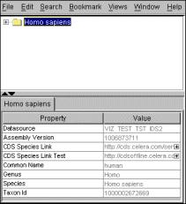
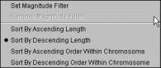

Release 5.0
L o a d i n g P r e c o m p u t e a n d A n n o t a t i o n F e a t u r e s 4 . 1 5

To change the order of the tiers, click on a tier name and drag it up or down.

To magnify results, select the area to magnify. Press the Alt key and right-
click at the same time, and you will see the image magnified in the View.

Magnified area

R e v e r s e C o m p l e m e n t i n g t h e A x i s

By default, the Genome Browser displays the forward strand from left to right
above the axis, and the reverse strand from right to left below the axis:

G e n o m e B r o w s e r
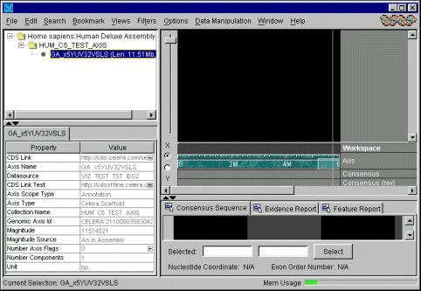
4 . 1 6 L o a d i n g P r e c o m p u t e a n d A n n o t a t i o n F e a t u r e s

When you are reviewing or annotating the reverse strand, it may be easier to
flip the display. You can reverse complement the axis to display the reverse
strand from left to right on the top of the Genomic Axis Annotation View:

NOTE: To restore the default view,
select Options from the Main Menu,
and uncheck Reverse
Complement Axis.

C e l e r a P r o d u c t U s e r G u i d e

1 From the Main Menu, select Options.
2 Select Reverse Complement Axis.
The Genome Browser reverse complements the axis:

June 2007

Release 5.0
D i s p l a y i n g a F e a t u r e ’ s P r o p e r t i e s 4 . 1 7

D I S P L A Y I N G A F E A T U R E ’ S
P R O P E R T I E S

To display any feature’s properties, you use your mouse to select it in the
Genomic Axis Annotation View.

To select a simple feature, click on the rectangle that represents the
feature in the Genomic Axis Annotation View.

A red box appears around the selected feature, and its properties appear in
the Property Inspector View.

To select a compound feature, shift-click anywhere on the feature.
• If the feature is a transcript, then simply click on an intron region to
select it.
• If the feature is a precompute, click the line linking the glyphs.

A yellow box appears around the feature, and its properties appear in the
Property Inspector View.

To select a gene, Ctrl-click on a transcript.

A green box appears around the gene, and its properties appear in the
Property Inspector View.

Zo o m i n g t o a S e l e c t e d Fe a t u re

To zoom in on a selected feature:

From the Main Menu, double-click on the feature, or select Options|Zoom
to Axis Selection or Options|Zoom to Subview Selection.

G e n o m e B r o w s e r
4 . 1 8 D i s p l a y i n g a F e a t u r e ’ s P r o p e r t i e s

The Genome Browser centers and zooms in on the feature.

H i g h l i g h t i n g Ev i d e n c e

The Genome Browser allows you to highlight precompute features that were
used to support a promoted feature. To display this information:

1 From the Main Menu, select Options.
2 Select Highlight Evidence.
To see an annotated feature’s evidence, click the feature in the Promoted
tier. The Genome Browser puts a red box around the evidence for that
feature:

S h o w i n g Ed g e M a t c h e s

The Genome Browser allows you to highlight a promoted feature’s edge
matches to precomputed features. To display this information:

1 From the Main Menu, select Options.
2 Select Show Edge Matches.

C e l e r a P r o d u c t U s e r G u i d e

June 2007

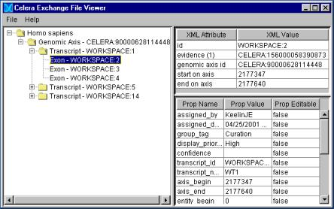

Release 5.0
D i s p l a y i n g a F e a t u r e ’ s P r o p e r t i e s 4 . 1 9

To see the edge matches for a promoted feature, click the feature in the
Promoted tier. The Genome Browser shows edge matches as yellow bars
on the precomputed features:

S h o w i n g Ev i d e n c e E d g e M i s m a t c h e s

The Genome Browser allows you to highlight where the evidence is different
than the transcript feature. To display this information:

1 From the Main Menu, select Options.
2 Select Show Evidence Edge Mismatches .

S h o w i n g n o n - G T / AG S p l i c e s M a t c h e s

The Genome Browser allows you to highlight exon edges that are
non-canonical in blue. To display this information:

1 From the Main Menu, select Options.
2 Select Show no n - G T / AG S p l i c e s M a t c h e s .

G e n o m e B r o w s e r
4 . 2 0 D i s p l a y i n g a F e a t u r e ’ s P r o p e r t i e s

Fi n d i n g a Fe a t u re’s M a t c h i n g S u b j e c t S e q u e n c e

The Genome Browser allows you to find features that have the same subject
sequence on the selected portion of the genomic axis with features loaded.
This can be useful when you are evaluating LAP, Genewise, or SIM4 features.
For example, you can select a LAP feature and use this function to locate the
corresponding BLASTx feature.

1 In the Genomic Axis Annotation View, select a range on the genomic
axis.

TIP: If you have the SubView open,
click the Subject Sequence
Report tab to review matching
subject sequence information for a
selected feature.

C e l e r a P r o d u c t U s e r G u i d e

2 Press <Shift> and click to select the feature.
A yellow box appears around the feature.

3 From the Main Menu, select Options|Find Matching Subject
Sequence.
The Genome Browser locates features with the same subject sequence
and places a box around these features.

D i s p l ay i n g Co n s e n s u s S e q u e n c e

You can display a region’s consensus sequence:
• in the Genomic Axis Annotation View
• in the SubView

June 2007

NOTE: If you move the blue glyp, the
vertical scroll in the Consensus
Sequence window will move in
unison.

Release 5.0
D i s p l a y i n g a F e a t u r e ’ s P r o p e r t i e s 4 . 2 1

To display a region’s consensus sequence in the Genomic Axis Annotation
View:

1 In the Genomic Axis Annotation View, center the Vertical Zoom Center
Bar around the region.
2 Slide the Zoom Bar, which appears on the left side of the Genomic Axis
Annotation View, down until the consensus residues appear:

To display a region’s consensus sequence in the SubView:

1 If the SubView is not displayed, select Views|Display SubViews
When Available from the Main Menu.

2 When the SubView displays, select a Genomic Axis Range Right-click
over the axis and select Select SubView Range. The SubView Range
will be initially set to the Annotation view range. The range will be
highlighted by a yellow bar, and a blue glyph will appear that allows you
to scroll across the consensus sequence. The underlying genomic

G e n o m e B r o w s e r

4 . 2 2 D i s p l a y i n g a F e a t u r e ’ s P r o p e r t i e s

Move the blue glyph to
scroll across the
sequence

Underlying genomic
sequence for the axis’
selected region

sequence for the axis’ selected region appears in the Consensus
Sequence window:

Vertical scroll

C e l e r a P r o d u c t U s e r G u i d e

3 If desired, click on a feature in the Genomic Axis Annotation View.

June 2007

Release 5.0

Yellow box indicates the
selected feature

Color of the feature’s
sequence matches the
same color in the Main
Annotation
D i s p l a y i n g a F e a t u r e ’ s P r o p e r t i e s 4 . 2 3

A yellow box indicates the selected feature, and the color of the feature’s
sequence in the Consensus Sequence window changes to the same
color that appears in the Main Annotation:

D i s p l a y i n g t h e Tra n s l a t i o n s o r R eve r s e Co m p l e m e n t

To do this from the SubView:

1 Right-click on the Consensus Sequence tab and select Show.
2 Click the desired translation and/or Reverse Complement from the sub-
menu.
A check appears next to your selection.

G e n o m e B r o w s e r
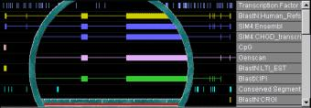
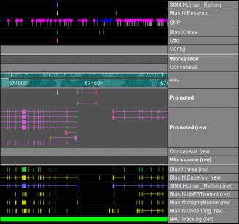
4 . 2 4 D i s p l a y i n g a F e a t u r e ’ s P r o p e r t i e s

Co py i n g S e q u e n c e t o t h e C l i p b o a r d

To copy consensus residues from the SubView to the clipboard for further use:

1 Select the desired region in the SubView. You can either click and drag to
select the region, or you can specify the coordinates in the Selected
text boxes and click Select:

2 Right-click on the Consensus Sequence tab and click Copy
Selected Sequence to Clipboard or Copy Selected Sequence
to Sequence Analysis.
3 Select one of the following from the sub-menu:
• Nucleotide Sequence
• Amino Acid Sequence

4 If you select Amino Acid Sequence, select either:
• +1 Translation
• +2 Translation
• +3 Translation

To copy sequence from the Genomic Axis Annotation View to the clipboard for
further use:

1 Select the desired range on the genomic axis.
2 From the Main Menu, select Edit|Copy Sequence.
3 Select one of the following from the sub-menu:
• Copy forward sequence
• Copy reverse complement

C e l e r a P r o d u c t U s e r G u i d e

June 2007

Release 5.0
D i s p l a y i n g a F e a t u r e ’ s P r o p e r t i e s 4 . 2 5

S e t t i n g Co l o r R u l e s Fo r Fe a t u re D i s p l ay

You can use color rules to change some or all features’ color intensity based
on the value of a specific feature property.

The following sections explain how to:
• Create a new color rule
• Edit an existing color rule
• Delete a color rule

C r e a t i n g a N e w Co l o r R u l e

1 From the Main Menu, select Edit|Color Intensity Filter.
The Color Rule Settings dialog box appears NEW SCREEN:

G e n o m e B r o w s e r
4 . 2 6 D i s p l a y i n g a F e a t u r e ’ s P r o p e r t i e s

NOTE: The Save and Delete
buttons are active only if you have
already defined a color rule. Also, the
Apply Rule and Reset View
buttons are active only if you have a
region selected on the genomic axis.

C e l e r a P r o d u c t U s e r G u i d e

2 Click New.
The Color Rule Settings|Create a New Color Rule dialog box
appears:

June 2007

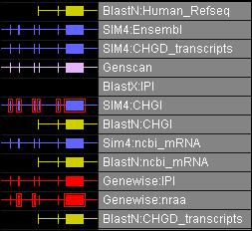
D i s p l a y i n g a F e a t u r e ’ s P r o p e r t i e s 4 . 2 7

3 Use the following table to complete this dialog box:

S t e p
1 Select Property to Trigger
From

2 Select Effected Feature
Groups

3 Choose Calculation Type

4 Enter Range Information

5 Enter The Rule Name

I n s t r u c t i o n s
Select a Feature Property from the pull-
down list. The Genome Browser will apply
the color rule based on this feature’s
property value.
Check one of the following boxes:
• Apply To All — All features that have
the selected feature property will
display in the Genomic Axis Annotation
View using this color rule.
• Apply To Specific — Only the
feature group that you select will
display using this color rule.

If you check Apply To Specific, select a
feature group from the pull-down list box.
Ctrl-click to select more than one feature
group.
Select a function to use for shading
intensity:
• Step (default)
• Interpolate
• Log Scale
Specify a value for each of the following:
• Max Intensity At Value — The
Genome Browser suggests values for
the Maximum Intensity, based on the
feature property that you select in Step
1. You may, however, change this value.
• Min Intensity At Value — The
Genome Browser suggests values for
the Minimum Intensity, based on the
feature property that you select in Step
1. You may, however, change this value.
• Ranges — Specify the number of
ranges. This is applicable for the Step
and Interpolate functions only. The Log
Scale function uses the extreme values.
Type a name for the color rule in the text
box.

Release 5.0

6 When you have completed the information in this dialog box, click OK.
7 Click OK to exit the Color Rule Settings dialog box.

G e n o m e B r o w s e r

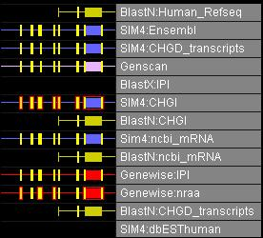
4 . 2 8 D i s p l a y i n g a F e a t u r e ’ s P r o p e r t i e s

E d i t i n g a n E x i s t i n g Co l o r R u l e

1 From the Main Menu, select Edit|Color Rules.
The Color Rule Settings dialog box appears:

Select a Rule to edit from the pull-down list.

C e l e r a P r o d u c t U s e r G u i d e

June 2007
D i s p l a y i n g a F e a t u r e ’ s P r o p e r t i e s 4 . 2 9

2 Change the existing preferences as desired. The following table
describes the settings you may change:

C o l o r R u l e S e t t i n g
Rule Settings Group

Data Points Group

Select Example Color

I n s t r u c t i o n s
Select a function to use for shading
intensity:
• Step (default)
• Interpolate
• Log Scale
Then, check one of the following
boxes:
• Apply To All — All features that
have the selected feature property
will display in the Genomic Axis
Annotation View using this color
rule.
• Apply To Specific — Only the
feature group that you select will
display using this color rule.

If you check Apply To Specific,
select a feature group from the pull-
down list box.
Finally, select a Feature Property
from the pull-down list. The Genome
Browser will apply the color rule
based on this feature’s property
value.
To edit the Value or Intensity for a
specific data point, click in the row to
edit, type your changes, and then
press <Enter>.
To add a new data point, complete
the Value and Intensity text boxes
and click Add Row.
To delete a data point, click in the
row to delete and click Remove
Row.
To use a different example color, click
Select Example Color and then
select a new color. The new color will
appear in the Example column.

Release 5.0

3 When you have made the desired changes, click Save.
4 Click OK to exit the Color Rule Settings dialog box.

G e n o m e B r o w s e r

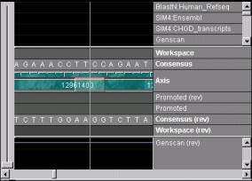
4 . 3 0 D i s p l a y i n g a F e a t u r e ’ s P r o p e r t i e s

D e l e t i n g a n E x i s t i n g C o l o r R u l e

1 From the Main Menu, select Edit|Color Rules.
2 Select a Rule to delete from the pull-down list.
3 Click Delete.
4 When the Rule Deletion confirmation message appears, click Yes.

A p p l y i n g a Co l o r R u l e

You can apply a color rule from either the Options menu or from the Color
Rule Settings dialog box.

To apply a color rule from the Options menu:

1 Select a region on the genomic axis.
2 From the Main Menu, select Options|Apply Color Rule.
3 Select a color rule from the sub-menu.

To apply a color rule from the Color Rule Settings dialog box:

1 Select a region on the genomic axis.
2 From the Main Menu, select Edit|Color Rules.
3 Click Apply Rule.
4 Click OK to exit the dialog box.

R e s e t t i n g t h e V i e w

You can reset the color intensity to 100% from either the Options menu or
from the Color Rule Settings dialog box.

To reset the color intensity to 100% from the Options menu:

1 From the Main Menu, select Options|Apply Color Rule.
2 Select Reset Intensities from the sub-menu.

C e l e r a P r o d u c t U s e r G u i d e

June 2007

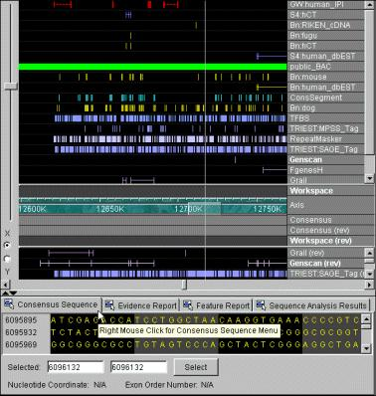

Release 5.0
D i s p l a y i n g a F e a t u r e ’ s P r o p e r t i e s 4 . 3 1

To reset the color intensity to 100% from the Color Rule Settings dialog
box:

1 From the Main Menu, select Edit|Color Rules.
2 Click Reset View.
3 Click OK to exit the dialog box.

U s i ng Pr o p e r t y R u l e s

You can define property rules for feature types and/or tiers that appear in the
Genomic Axis Annotation View. When you define a property rule, the
Genome Browser will include the information or hyperlink you specify in the
Property Inspector View for the selected entity.

1 From the Main Menu, select Edit|Property Rules.
2 Click Add.

G e n o m e B r o w s e r
4 . 3 2 D i s p l a y i n g a F e a t u r e ’ s P r o p e r t i e s

3 The Add Property Rule dialog box appears:

The following table explains how to complete this dialog box:

C e l e r a P r o d u c t U s e r G u i d e

S e c t i o n
Selection

Rule Name = text box

Conditions

I n s t r u c t i o n s
This displays the current selection’s ID,
Entity Type (feature type), and Discovery
Environment (tier name).
Type a name for the rule you are creating
in this text box. You may use spaces.
1 Select one or more feature types from
the When Entity Type = section.
2 Select one or more tier names from
the When Discovery Env =
section.
3 Click either the And or the Or radio
button.

June 2007

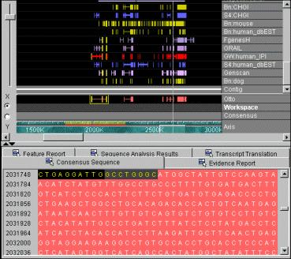

S e c t i o n
Create Property
D i s p l a y i n g a F e a t u r e ’ s P r o p e r t i e s 4 . 3 3

I n s t r u c t i o n s
1 Type a name for the property in the
Name = text box. Do not type spaces
or hyphens.
2 Type a value for the property in the
Value = text box. For example type a
URL to link to an internal or external
web site. To insert a property as a
variable, click Insert, select a
property from the list, and click OK.

Release 5.0

3 When you have completed the information in this dialog box, click OK.

U s i n g a Pr o p e r t y R u l e t o C r e a t e L i n k s t o C D S B i o M o l e c u l e
R e p o r t s

The following example explains how to add a property rule that will create a
link from a Transcript feature in the Genome Browser to a web-based
BioMolecule Report — mRNA view.

1 From the Main Menu, select Edit|Property Rules.
2 Click Add.
3 In the Rule Name = text box, type a name for the rule; for example,
“BioMolecule Report link”.
4 In the When Entity Type = section, select “Transcript”.
5 In the Name = text box, type a property name; for example,
“BMR_mRNA_View”.
6 In the Value = text box, type the URL to use as follows:
http://myserver/servlet/
com.celera.gateway.GatewayURL?&page=bmr
&species=Homo+sapiens&id=<transcript_accession>

G e n o m e B r o w s e r

4 . 3 4 D i s p l a y i n g a F e a t u r e ’ s P r o p e r t i e s

When you have finished completing the dialog box, it should appear
similar to this:

C e l e r a P r o d u c t U s e r G u i d e

7 Click OK.

Double-click link to
access the HTML
BioMolecule Report for
this transcript.

June 2007

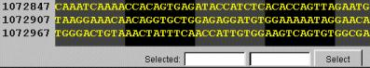

Release 5.0
D i s p l a y i n g a F e a t u r e ’ s P r o p e r t i e s 4 . 3 5

D i s p l ay i n g Pr e d i c t e d Fe a t u re s i n t h e Tra n s c r i p t
Tra n s l a t i o n V i e w

To review a predicted or promoted feature in the Transcript Translation View:

1 If the SubView is not displayed, select Views|Display SubViews
when available from the Main Menu.
2 Select a transcript in the Genomic Axis Annotation View.
The Transcript Translation tab appears in the SubView.

3 Click the Transcript Translation tab.

G e n o m e B r o w s e r
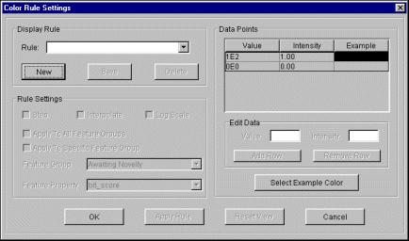
4 . 3 6 D i s p l a y i n g a F e a t u r e ’ s P r o p e r t i e s

C h a n g i n g t h e Tra n s l a t i o n s D i s p l a y

If you wish to change the display:

1 Right-click on the Transcript Translation tab and select Show.

2 Select or deselect a menu item.
3 Repeat steps 1 through 2 until the display is as you wish.

Co py i n g Tra n s c r i p t S e q u e n ce t o t h e Cl i p b o a r d

To copy transcript sequence to the clipboard for further use:

1 Right-click on the Transcript Translation tab and select Copy to
Clipboard or Copy Transcript Sequence to Sequence Analysis.
2 Select one of the following:
• Selected Region — copies the region you have highlighted in
the view (if nothing is highlighted then nothing is copied)
• Transcript ORF — copies from the start codon to the stop codon
• Entire Transcript — copies the entire spliced transcript from the
beginning to end

3 Select one of the following from the sub-menu:
• Nucleotide Sequence
• Amino Acid Sequence

C e l e r a P r o d u c t U s e r G u i d e

June 2007

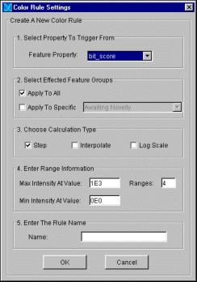

NOTE: You must select a feature that
is completely within the range you
have selected on the axis. The double-
arrow in the upper left of the the
Subview allows you to expand or
collapse the View.

NOTE: To review an HTML report,
right-click on the DbAlignView tab
and select HTML Report| Show
HTML Report.

Release 5.0
D i s p l a y i n g a F e a t u r e ’ s P r o p e r t i e s 4 . 3 7

4 If you select Amino Acid Sequence, select one of the following:
• +1 ORF
• +2 ORF
• +3 ORF
• -1 ORF
• -2 ORF
• -3 ORF

Eva l u a t i n g Fe a t u r e H o m o l o g i e s

The Genome Browser allows you to view the alignment between the Celera
consensus sequence and the sequence for any homology feature. This is
particularly useful for BLAST, SIM4, Genewise, and LAP.

1 In the Genomic Axis Annotation View, select a region from the axis that is
larger than the feature you want to view.
2 If the SubView is not displayed, select Views|Display SubViews
when available from the Main Menu.
3 Click on a homology feature in the Genomic Axis Annotation View.
The Query Sequence Alignments tab appears in the SubView.

4 The Query Sequence Alignments includes a zoom and zoom center bar.
Zoom in the Query Sequence Alignments to review the sequence
homologies.
TIP: If a feature has more than one exon, the Genome Browser will
automatically zoom in on the first exon. To zoom in on the second or
other exon, click on it before you zoom in.

Depending upon the analysis program for the selected feature, the
window displays either nucleotides or amino acids (i.e., a BLASTN feature
displays DNA sequence, and a BLASTX feature displays protein
sequence). The Celera sequence is on top, and the subject sequence is

G e n o m e B r o w s e r

4 . 3 8 D i s p l a y i n g a F e a t u r e ’ s P r o p e r t i e s

below. The frames are relative to the entire sequence of the genomic
axis.

The Query Sequence Alignments indicates homology by varying shades
of color. For protein sequences, bright green indicates a perfect match,
and for nucleotide sequences, bright blue indicates a perfect match.

NOTE: The Feature Report displays
information for only the data within
the selected SubView range on the
axis.

NOTE: Clicking on a feature in the
Genomic Axis Annotation View
highlights the corresponding row in
the Feature Table (if selected).

C e l e r a P r o d u c t U s e r G u i d e

5 Select another feature, if desired.
6 To delete the contents of the Query Sequence Alignments window,
right-click on the Query Sequence Alignments tab and select
Clear.

D i s p l ay i n g t h e Fe a t u re R e p o r t

1 In the Genomic Axis Annotation View, select a region from the axis that
contains the features you wish to view in the report, and load the
features for the range.
2 If the SubView is not displayed, select Views|Display SubViews
when available from the Main Menu.
3 In the SubView, click the Feature Report tab.
4 Select Options|Populate.

The Genome Browser populates the Feature Report. The following table
explains how to find information in this report.

June 2007

Release 5.0

T o :

Sort data by a column heading
in descending order.
Sort data by a column heading
in ascending order.
Highlight report data in the
Genomic Axis Annotation View.
D i s p l a y i n g a F e a t u r e ’ s P r o p e r t i e s 4 . 3 9

D o t h i s :

Click on the column
heading.
Shift-click on the column
heading.
Click in the row that you
want to highlight to select
an individual feature, or
shift-click to select the
composite feature. A
colored box appears around
the feature in the Genomic
Axis Annotation View.

G e n o m e B r o w s e r
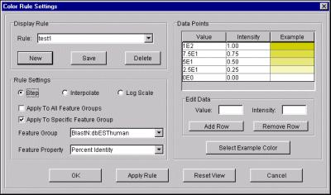
4 . 4 0 R u n n i n g B L A S T S e a r c h e s

C e l e r a P r o d u c t U s e r G u i d e

R U N N I N G B L A S T S E A R C H E S

The Genome Browser allows you to compare a public or proprietary
sequence against a selected range on a Celera genomic axis.

1 Navigate to the region on the genome against which you wish to run
BLAST and select the region.
2 From the main menu, select Search|Sequence Analysis.
3 From the Blast Type pull-down list box, select an analysis program:
• blastx
• blastn
• sim4
• genewise
4 Click User Defined and type or paste your sequence in the
Sequence text box. It does not matter whether you include the
definition line.
5 Click Search.
When the Search button becomes active again, the search is complete.

6 Click the Sequence Analysis Results tab in the SubView to review
your results.

June 2007

NOTE: If you select Nucleotide
Reverse Complement or an Amino
Acid option, you do not need to be
displaying that type of data in the
Consensus Residues or Transcript
Translation window. For example, the
Genome Browser will find the reverse
complement of ATG, even if the
window is not displaying the
Nucleotide Reverse Complement
when you search.

Release 5.0
S e a r c h i n g f o r a N u c l e o t i d e o r P r o t e i n S e q u e n c e S t r i n g 4 . 4 1

S E A R C H I N G F O R A
N U C L E O T I D E O R P R O T E I N
S E Q U E N C E S T R I N G

You can search for a nucleotide or amino acid sequence string in either the
Consensus Sequence or Transcript Translation window.

1 If the SubView is not displayed, select Views|Display SubViews
when available.
2 Select either the Consensus Sequence or Transcript Translation
tab.
3 Right-click your mouse and select Find... or press <Ctrl-F>.
4 Type or paste a search string in the Find what box.
TIP: You can use keyboard shortcuts for copying (<Ctrl-C>) and
pasting in this box (<Ctrl-V>).

5 Select an option from the Look in pull-down list:
• Nucleotide
• Nucleotide Reverse Complement
• ORF +1
• ORF +2
• ORF +3
• All ORF’s

6 If you selected an Amino Acid option from the Look in pull-down list,
select either one-letter or three-letter from the Translation box.
7 Click Find Next or Find All.
If you click Find Next, the Genome Browser will return the next
occurrence of the search string.

If you click Find All, the Genome Browser will return a table that
displays all occurrences of the search string, with the corresponding
locations.

G e n o m e B r o w s e r
4 . 4 2 U s i n g B o o k m a r k s

C e l e r a P r o d u c t U s e r G u i d e

U S I N G B O O K M A R K S

Genome Browser allows you to create and edit bookmarks. You can
bookmark contigs and precomputed and annotated features.

C re a t i n g

1 Click the item you want to bookmark to select it.
2 From the Main Menu, select Bookmark|Bookmark Current
Selection.

O p e n i n g a B o o k m a r k

1 Ensure that you have an information service open.
2 From the Main Menu, select Bookmark|Select Bookmark .
3 Select your bookmark from the sub-menu.

Ed i t i n g o r D e l e t i n g a B o o k m a r k

1 From the Main Menu, select Bookmark|Select Bookmark .
2 Select the bookmark that you wish to delete or modify.
3 Select Delete or Edit.
If you select Delete, the bookmark disappears from the window. If you
select Edit, the Bookmark Properties box appears, and you can type
over the existing name.

4 Click Close when you are done.

June 2007

NOTE: Depending on your system’s
resources, displaying multiple browser
windows may consume more
memory than is acceptable for your
computer.

Release 5.0
D i s p l a y i n g M u l t i p l e B r o w s e r W i n d o w s 4 . 4 3

D I S P L A Y I N G M U L T I P L E
B R O W S E R W I N D O W S

Genome Browser allows you to display more than one browser window at a
time. This allows you to review multiple views of the same genome.

1 From the Main Menu, select Window.
2 Select New Browser Window.
Genome Browser displays a duplicate of the window that you already
have open. You can either review different features for the same data, or
you can select different data to review.

C l o s i n g a B ro w s e r W i n d ow

1 Click in the browser window you want to close to activate it.
2 From the Main Menu, select Window.
3 Select Close Browser Window.

P R I N T I N G A P A G E

To print any screen while you’re in Genome Browser, select File|Print
Screen.

G e n o m e B r o w s e r
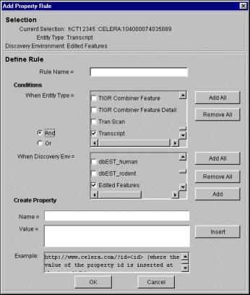
4 . 4 4 D i s p l a y i n g M u l t i p l e B r o w s e r W i n d o w s

C e l e r a P r o d u c t U s e r G u i d e

June 2007

5 . 0 C re a t i n g a n d M o d i f y i n g A n n o t a t i o n D a t a

Introduction
Edit Commands
Annotation History
Creating a Transcript or Exon Using a Computed Feature
Reviewing and Editing Comments
Adding Evidence to a Transcript or Exon
Removing Evidence from a Transcript or Exon
Splitting a Transcript
Merging Transcripts
Adjusting Exon Boundaries

5.2
5.2
5.3
5.4
5.5
5.7
5.7
5.7
5.8
5.9

Using the Consensus Sequence Window to Modify an Exon 5.9

Release 5.0
Using Evidence to Modify an Exon
Using a Splice Site to Modify an Exon
Adding or Deleting Bases in the SubView
Finding a Long Open Reading Frame
Evaluating Subject Sequence Alignments
Deleting a Feature from the Workspace
Exporting Annotation Data
5.10
5.10
5.11
5.11
5.12
5.12
5.13

G e n o m e B r o w s e r

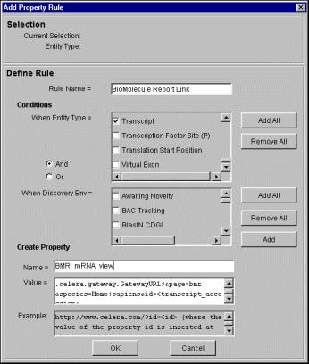
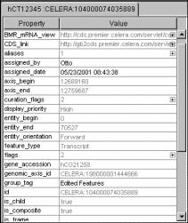
5 . 2 I n t r o d u c t i o n

See “Specifying System Preferences” on
page 2.15 if you do not know how to
disable curation.

See page 4.18 to learn how to highlight
evidence and page 4.18 to learn how to
show edge matches. See page 4.14 to
learn how to expand the data tiers.

C e l e r a P r o d u c t U s e r G u i d e

I N T R O D U C T I O N

As you review the Celera assembly and annotation information, you may
need to create, modify, and export annotation data. When you enable
curation, the Genome Browser allows you to create new features or modify
existing features in the Workspace area:
• transcripts
• genes
• exons
• start and stop codons
• evidence relationships

By default, the Genome Browser enables curation. If you want to create or
modify features, you need to enable curation, which you do from the
Preferences dialog box.

Before you begin annotating, you should:
• Enable the Highlight Evidence and Show Edge Matches features
(default).
• Expand the data tiers with which you are working.
• Open the SubView.

E d i t C o m m a n d s

As you are creating and modifying annotation data, you can use the
following edit commands:

To undo a change, select Edit|Undo from the Main Menu, or use the
keyboard shortcut, Ctrl-Z.

To redo an undone change, select Edit|Redo from the Main Menu, or use
the keyboard shortcut, Ctrl-Y.

June 2007
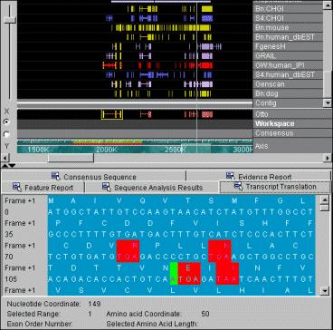

Release 5.0
I n t r o d u c t i o n 5 . 3

To copy information from the Property Inspector View to the clipboard, select
the information and use the keyboard shortcut, Ctrl-C. To paste the
contents of the clipboard, position your cursor in the appropriate place, and
use the keyboard shortcut, Ctrl-V.

A n n o t a t i o n H i s to r y

The Genome Browser tracks the annotation that you create and modify. You
can review the annotation history for either:
• the current annotation session
• the open Workspace file

To view the annotation history for the current annotation session:

1 From the Main Menu, select File.
2 Select View Current Annotation Log.
The Annotation Log for Current Session dialog box appears:

3 Click X to close the dialog box.

To view the annotation history for the open Workspace file:

1 From the Main Menu, select File.
2 Select View Open Workspace Annotation Log.
The Workspace Log dialog box appears:

TBA

3 Click X to close the dialog box.

G e n o m e B r o w s e r
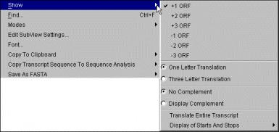
5 . 4 C r e a t i n g a T r a n s c r i p t o r E x o n U s i n g a C o m p u t e d F e a t u r e

C R E A T I N G A T R A N S C R I P T O R
E X O N U S I N G A C O M P U T E D
F E A T U R E

To create a transcript or exon using a predicted feature:

1 Zoom in and click on a predicted feature.
2 Drag it down to the Workspace and release your mouse button.
The feature appears in the Workspace. If you drag a promoted feature
into the Workspace, the Genome Browser includes the gene and
everything that is attached to it, including multiple transcripts, and the
transcripts’ exons and start and stop codons.

NOTE: To select a transcript, click on
an intron region, or shift-click on one
of its exons.

C e l e r a P r o d u c t U s e r G u i d e

3 Click the new feature to select it.
The Property Inspector View displays the information for this feature.

The Genome Browser automatically sets the assigned by and assigned
date fields in the Property Inspector View. The Genome Browser uses your
system login id for the modified by
value. Also, if you drag a transcript from the Promoted tier into the
Workspace, the modified by and modified date are automatically set,
too. You can modify the release status, reviewed by, and reviewed date fields.

June 2007

NOTE: If a feature does not have
comments to display, the comments
field does not appear.

Release 5.0
R e v i e w i n g a n d E d i t i n g C o m m e n t s 5 . 5

R E V I E W I N G A N D E D I T I N G
C O M M E N T S

You may create and edit comments for transcripts and exons in the
workspace. Precompute and promoted feature comments are read-only.

To access comments for any feature, select it in the Genomic Axis Annotation
View and click the + that appears in the comments field value column in
the Property Inspector view. You may need to scroll down to see it.

If the comments are read-only, the following dialog box appears:

G e n o m e B r o w s e r
5 . 6 R e v i e w i n g a n d E d i t i n g C o m m e n t s

C e l e r a P r o d u c t U s e r G u i d e

If the comments are not read-only, the following dialog box appears:

The following table describes this dialog box.

E l e m e n t D e s c r i p t i o n / I n s t r u c t i o n s

New Comments Allows you to to add comments to this feature:
Type the information in the New Comments text box, and
click Add Comment.

You can add multiple comments in this text box; simply
click Add Comment after each item.
Existing Displays existing comments for this gene.
Comments

June 2007

NOTE: The Genome Browser will not
add the evidence to the transcript if
you place the evidence on an intron
region. You must drag it on top of an
exon.

Release 5.0
A d d i n g E v i d e n c e t o a T r a n s c r i p t o r E x o n 5 . 7

A D D I N G E V I D E N C E T O A
T R A N S C R I P T O R E X O N

To add computed evidence to a transcript or exon that appears in the
Workspace:

1 Click the evidence in the Genomic Axis Annotation View to select it.
2 Drag it down to the Workspace on top of an exon.
3 Release your mouse button.

R E M O V I N G E V I D E N C E F R O M A
T R A N S C R I P T O R E X O N

To remove evidence:

1 Click the exon in the Workspace.
2 Right-click on the evidence to display the Evidence Options menu,
and select Remove as evidence for current curation.

S P L I T T I N G A T R A N S C R I P T

To split a transcript in the Workspace:

1 Click on the intron region in the area where you wish to split the
transcript.
2 Right-click your mouse and select Split Transcript.
The Genome Browser splits the transcript in the location where you
right-clicked.

G e n o m e B r o w s e r
5 . 8 M e r g i n g T r a n s c r i p t s

C e l e r a P r o d u c t U s e r G u i d e

M E R G I N G T R A N S C R I P T S

First, you need to ensure that the transcripts are attached to the same gene:

1 Click the transcript in the Workspace to select it.
2 Right-click on an intron region and select Create New Gene from the
context menu.
3 Ctrl-click to select the newly created gene to which the transcript will be
attached.
4 Right-click your mouse on the transcript to attach and then click Attach
Transcript to Selected Gene.
5 Ctrl-click on either feature, and a green box appears around both.

Next, you can merge the two transcripts in the Workspace:

1 Select the first transcript in the Workspace.
2 Right-click on an intron region in the second transcript.
The context menu appears:

3 Select Merge with Selected Transcript.
The Genome Browser merges the transcripts in the Workspace.

June 2007

NOTE: The SubView Range should be
greater or equal to the Parent Feature
range to view the colored nt’s.

NOTE: You must begin with the first/
last base of the exon, or the boundary
will not change. You can not move
exon boundaries past a Start or Stop
codon.

Release 5.0
A d j u s t i n g E x o n B o u n d a r i e s 5 . 9

A D J U S T I N G E X O N
B O U N D A R I E S

You can modify exon boundaries using:
• the Consensus Sequence window
• Evidence
• Splice sites

The following sections provide instructions for each method.

U s i ng t h e Co n s e n s u s S e q u e n c e W i n d o w t o M o d i f y a n E xo n

1 If the SubView is not displayed, select Views|Display SubViews
when available from the Main Menu.
2 Select a range along the axis. A red bar appear marking the range you
selected.

3 Select the Subview range by selecting Data Manipulation|SubView
Range. A yellow bar marks the range you selected.
4 Select the exon to modify from the Axis.
5 Click the Consensus Residues tab, if it is not on top.
The underlying genomic sequence information appears in the box, in
the area of the selected feature. A yellow bar on the Genomic Axis
indicates the relative position. Exon sequence appears as purple, and
intron sequence appears as yellow.

6 Starting at the exon’s edge, drag the edge to the desired position.
The boundary change is reflected on the axis.

G e n o m e B r o w s e r
5 . 1 0 A d j u s t i n g E x o n B o u n d a r i e s

NOTE: The Genome Browser will not
add the evidence if you drag it to an
intron region. You must drag it on top
of an exon.

NOTE: To undo a change, select
File|Edit|Undo... from the Main
Menu.

C e l e r a P r o d u c t U s e r G u i d e

U s i ng Ev i d e n c e t o M o d i f y a n E xo n

If you have added evidence to a transcript in the Workspace, you can tell the
Genome Browser to use the evidence to modify an exon:

1 Click the evidence in the Genomic Axis Annotation View to select it.
2 Drag it down to the Workspace on top of the exon.
3 Click the exon to modify in the Workspace to select it.
4 Right-click on the evidence to display the Evidence Options menu:

5 Select an option from the menu.
You can set the left and right edge of a current curation, as well as
remove any evidence.

U s i ng a S p l i c e S i t e t o M o d i f y a n E xo n

1 Load the Predicted Splice Sites data for the selected axis range.
TIP: Loading predicted splice site locations can consume a great deal of
memory. We suggest that you select a smaller region from the genomic
axis before you load splice sites.

2 Click on the splice site to use.
3 Drag it down, and place your mouse pointer over the exon.
4 Release your mouse button.

June 2007

NOTE: You can not save these
changes.

Release 5.0
A d j u s t i n g E x o n B o u n d a r i e s 5 . 1 1

A D D I N G O R D E L E T I N G B A S E S
I N T H E S U B V I E W

You can add or delete bases to a transcript in the SubView to see the effect
on a translation.

1 If the SubView is not displayed, select Views|Display SubViews
when available from the Main Menu.
2 In the Genomic Axis Annotation View, click on a feature.
3 Select the Transcript Translation tab in the SubView.
4 In the SubView, type or delete bases in the sequence.

F I N D I N G A L O N G O P E N
R E A D I N G F R A M E

1 If the SubView is not displayed, select Views|Display SubViews
when available from the Main Menu.
2 In the Genomic Axis Annotation View, click on a feature in the workspace
to select it.
3 Select the Transcript Translation tab in the SubView.
4 In the SubView, right-click your mouse any where in the sequence.
The Curation Options sub-menu appears:

G e n o m e B r o w s e r
5 . 1 2 A d j u s t i n g E x o n B o u n d a r i e s

NOTE: The changes may not be
apparent in the Genomic Axis
Annotation View.

NOTE: Query Sequence Alignments
View allows you to see nt-nt HSPs and
aa-aa HSPs in color.

C e l e r a P r o d u c t U s e r G u i d e

5 Select one of the following:

• Set Longest Open Reading Frame — calculates the longest
open reading frame from Stop to Stop codon.
• Set Longest ATG to Stop — calculates the longest open reading
frame from Start to Stop codon.
• Stop Codon

E V A L U A T I N G S U B J E C T
S E Q U E N C E A L I G N M E N T S

1 If the SubView is not displayed, select Views|Display SubViews
when available.
2 In the Genomic Axis Annotation View, click on a feature to select it.

3 Select the Subject Sequence Alignments tab.
The Genome Browser displays the Celera data hits along the subject
sequence’s axis.

D E L E T I N G A F E A T U R E F R O M
T H E W O R K S P A C E

To delete a transcript, exon, and gene from the Workspace:

1 Click the feature to select it, and right-click your mouse.
2 Select Delete Transcript (or Exon) from Workspace.

June 2007

Release 5.0
E x p o r t i n g A n n o t a t i o n D a t a 5 . 1 3

E X P O R T I N G A N N O T A T I O N
D A T A

When you export the data, the Genome Browser saves the Workspace file as
XML in the Celera Exchange File Format. You can then reload this file at a later
time to modify the annotation data.

1 From the Main Menu, select File|Save Workspace .
2 In the Save dialog box, browse to locate the desired folder.
3 Type a file name, and click Save.
A dialog box appears asking whether you want to clear the workspace.

G e n o m e B r o w s e r
5 . 1 4 E x p o r t i n g A n n o t a t i o n D a t a

C e l e r a P r o d u c t U s e r G u i d e

June 2007

A p p e n d i x A . E xc h a n g e Fi l e Fo r m a t

Introduction
XML Markup Element Descriptions
Document Type Definition
Example Feature File

Release 5.0

A.2
A.3
A.10
A.13

G e n o m e B r o w s e r
A . 2 I n t r o d u c t i o n

C e l e r a P r o d u c t U s e r G u i d e

I N T R O D U C T I O N

The Celera Data Model is based on the concept of data objects with identity.
This means that every piece of genomic data has a permanent independent
existence and can be referenced via a unique object id, known as a UID. Data
objects come in various types, which can form relationships with other data
objects via references to their UIDs.

UIDs are alphanumeric strings that can uniquely identify any data object
created. Since they are by definition unique over all data sources and over all
time, UIDs allow a data object to reference any other data object, even when
they are located in separate data storage media or created at different times.

Not all data providers have access to a common source of unique identifiers,
so the UID format is broken into parts separated by a colon: an alphanumeric
prefix, called the UID Space, and a decimal suffix which represents an integer
less than 264 power. The prefix, which is case-insensitive, identifies the UID
space and represents the authority guaranteeing the uniqueness of the suffix
integer. UIDs generated by the Celera UID server, for example, all have the
“CELERA” prefix. For example:
CELERA:nnnnn

You can open data objects from other sources with unique identifiers into
the Genome Browser without fear of UID collisions, simply by picking a
unique UID space prefix. The Genome Browser can open data objects with
up to 216 distinct UID spaces simultaneously. This UID specification is
consistent with the XML attribute definitions of ids and idrefs that can fail to
pass a validating parser if they are simple numeric strings.

June 2007

Release 5.0
X M L M a r k u p E l e m e n t D e s c r i p t i o n s A . 3

X M L M A R K U P E L E M E N T
D E S C R I P T I O N S

The Celera Exchange File Format is based on a subset of the GAME DTD, with
a small number of minor extensions. The following table describes the syntax
of each XML element, or tag, and any file (.gbf, or .gbw) restrictions.

G e n o m e B r o w s e r

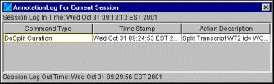
A . 4 X M L M a r k u p E l e m e n t D e s c r i p t i o n s

A t t r i b u t e s a n d E l e m e n t s
E l e m e n t a n d D e s c r i p t i o n
R e q u i r e d

X M L M a r k u p D e s c r i p t i o n s

O p t i o n a l

<game>
The root node, or document element, for
a valid Celera Exchange Format file.

<annotation>
This corresponds directly to a Gene data
object, and is used to represent a
human-curated gene.

C e l e r a P r o d u c t U s e r G u i d e
ATTRIBUTES:
version — the version of game DTD to
which this document conforms.

ATTRIBUTES:
id — the UID for the gene. It must
appear once and only once.
ELEMENTS:
<feature_set> — represents
Transcript data objects. This element
may occur more than once.
<name> — an alphanumeric string
containing the accession number for the
curated gene. For Celera-annotated
genes, this should have a “CG” prefix
followed by a decimal integer. This
element appears once and only once.
Annotations saved out in (.gbw) files
have <name> elements with “WG”
prefix followed by decimal integer,
representing workspace genes
generated on the client. The Genome
Browser automatically generates these
elements.
ATTRIBUTES:
assembly_version — the version of
the assembly data in the database. This
attribute is for feature (.gbf ) and
workspace (.gbw) files that import data
on top of the database.
taxon — the scientific name of the
species of organism with which the data
is associated.
ELEMENTS:
<annotation>
<computational_analysis>
<feature_set>
<seq> — a single feature (.gbf ) or
workspace (.gbw) file may contain any
number of elements of type “SUBJECT”.
ELEMENTS:
<description> — descriptive
information about the curation, such as
similarity with a known gene.
<property> — stores arbitrary
property values on the gene, such as URL
hyperlinks. This element may occur more
than once.
The following optional element is for
Workspace (.gbw) files, only:
<replaced> — the promoted Gene
objects that are intended to be modified.

June 2007

E l e m e n t a n d D e s c r i p t i o n

<computational_analysis>

A t t r i b u t e s a n d E l e m e n t s

R e q u i r e d
ATTRIBUTES:
X M L M a r k u p E l e m e n t D e s c r i p t i o n s A . 5

X M L M a r k u p D e s c r i p t i o n s

O p t i o n a l
ELEMENTS:

This represents a group of precomputed
features generated by a particular
algorithm or analysis program.

<feature_set>
This corresponds directly to a
Transcript data object and is used to
describe a human-curated transcript.
Feature sets contained within
<annotation> elements correspond
to Transcript data objects that have been
assigned to a specific Gene data object.
However, <feature_set> elements can
also exist directly under a <game>
element, in which case they describe
Transcript data objects not assigned to
any Gene data object.

Release 5.0
id — stores a UID, which can be used by
evidence relationships that refer to an
entire computational algorithm, rather
than an individual result set.
ELEMENTS:
<result_set> —Represents the
precomputed features.
<program> —This must contain a
name, which is used by the Genome
Browser to establish a horizontal tier for
displaying the precomputed features.
ATTRIBUTES:
id —the UID for the transcript.
ELEMENTS:
<type> — must contain the string
“transcript" and must occur once and
only once.
<name> — an alphanumeric string
containing the accession number for the
curated transcript. For Celera-annotated
transcripts, this should have a “CT” prefix
followed by a decimal integer.
Feature_sets saved out in (.gbw) files
have <name> elements with “WT” prefix
followed by decimal integer,
representing workspace transcripts
generated on the client.
<feature_span> —represents the
Exon, Start_Codon, Stop_Codon,
and Translation_Start_Position
data objects that make up the transcript.
This element may occur more than once.
<date> — indicates when the program
was run.
<database> — indicates against
which database the analysis program
was run.
<parameter> — represents the type
of algorithm (e.g. blastx, blastn) used by
each run of the program.

ELEMENTS:
<replaced> — refers to the promoted
Transcript data objects that are
intended to be modified. This element is
for Workspace (.gbw) files only, and it
may occur more than once.

G e n o m e B r o w s e r

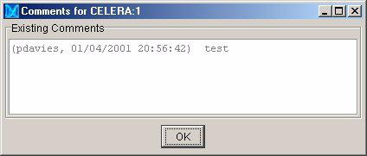
A . 6 X M L M a r k u p E l e m e n t D e s c r i p t i o n s

A t t r i b u t e s a n d E l e m e n t s
E l e m e n t a n d D e s c r i p t i o n
R e q u i r e d

X M L M a r k u p D e s c r i p t i o n s

O p t i o n a l

<seq>
This represents a piece of nucleotide
sequence against which
<result_span> and
<feature_span> elements may be
aligned.
In a feature (.gbf ) or a workspace (.gbw)
file, the <seq> element may represent
some other subject sequence against
which a feature is aligned.

<feature_span>
This describes simple human-curated
features that can be combined to make a
feature set.
The <feature_span> element may
not stand alone. It must be contained
within a <feature_set> element.

C e l e r a P r o d u c t U s e r G u i d e
ATTRIBUTES:
id — The UID for the data object.
type — Use one of the following values:
• DNA
• RNA
• AA

ATTRIBUTES:
id — the UID for the data object.
ELEMENTS:
<seq_relationship> — indicates the
<feature_span> element's location
on an assembly sequence.
<type> — contains one of the
following values:
• exon
• start-codon
• stop-codon
• frame
These values correspond to the Exon,
Start_Codon, Stop_Codon and
Translation_Start_Position data
objects.
ATTRIBUTES:
length — the number of nucleotides in
the sequence.
ELEMENTS:
<residues> —the raw sequence data
stored as characters.
<dbxref> — the database source for
this sequence data.
<description> — general information.
The following optional may be used
more than one time:
<seq_alignment> — refers to other
<seq> elements, possibly located in
separate files, allowing sequences to be
composed of multiple subsequences. In
this case, the composite sequence is
considered to be a GenomicAxis data
object, while the referenced
subsequences are treated as Contigs. If
the composite seq contains no
<residues> element, then its residue
information will be derived by stitching
together the aligned residues of its
subsequences. Otherwise, any residue
information in the subsequences will be
ignored.
ELEMENTS:
<evidence> — refers to precomputed
results on which the feature span is
based.
<replaced> — refers to the promoted
data objects that are intended to be
modified. This element is for workspace
(.gbw) files only, and it may occur more
than once.

June 2007

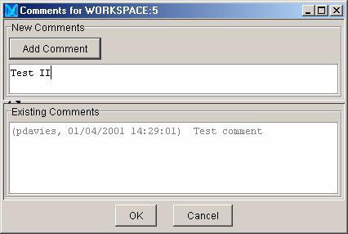

E l e m e n t a n d D e s c r i p t i o n

<seq_relationship>
This describes the geometric relationship

A t t r i b u t e s a n d E l e m e n t s

R e q u i r e d
ATTRIBUTES:
id — a UID reference to the <seq>
X M L M a r k u p E l e m e n t D e s c r i p t i o n s A . 7

X M L M a r k u p D e s c r i p t i o n s

O p t i o n a l
ELEMENTS:
<alignment> — contains a sequence

between a <feature_span> or
<result_span> element and its
<seq> element.

<result_set>
This represents a compound-
precomputed feature data object,
and is a precomputed analog to the
<feature_set> element for human-
curated features.

<result_span>
This describes simple precomputed
features that can be combined to make a
feature set , and is a precomputed analog
of the <feature_span> element.
The <result_span> element may not
stand alone. It must be contained within
a <result_set> element.

Release 5.0
element representing the GenomicAxis
data object to which it is aligned.
type — contains one of the following
values:
• subject
• query

ELEMENTS:
<span> — defines the start and end
points on the sequence.
ATTRIBUTES:
id —the UID for the precomputed
feature.
ELEMENTS:
<result_span> — represents a simple
precomputed feature from which the
compound feature is composed. It may
occur more than once.
<type> — represents the type of
analysis tool used to generate the feature
(e.g. Genscan, Blast).

ATTRIBUTES:
id — the UID for the data object.
string, formatted with gaps and spaces
that allow it to be aligned to other
<seq_ relationship> elements.

ELEMENTS:
<description> — describes
information such as similarity to specific
proteins.
<score> — indicates the quality of the
match.
<dbxref> —refers to model organism
database where the annotations are
generated and maintained. This element
may occur more than once.
<output> — Of particular interest are
outputs of type “expect”. This element
may occur more than once.
ELEMENTS:
<span_type> — the type of data
object (e.g., HSP).
<seq_relationship> —positions the
<result_span> on a <seq> element.
Seq relationships of type “subject” and
“query” refer to spans on a subject and
query sequences respectively
<score> — indicates the quality of the
match. This element may occur more
than once.
<output> — This takes sub-elements
<type> and <value>, when type is
“Expect” <value> is the expect value. This
element may occur more than once.

G e n o m e B r o w s e r

A . 8 X M L M a r k u p E l e m e n t D e s c r i p t i o n s

A t t r i b u t e s a n d E l e m e n t s
E l e m e n t a n d D e s c r i p t i o n
R e q u i r e d

X M L M a r k u p D e s c r i p t i o n s

O p t i o n a l

<seq_alignment>
This indicates that the containing <seq>
should derive a portion of its sequence
from a referenced <seq> element.

C e l e r a P r o d u c t U s e r G u i d e
ATTRIBUTES:
seq_id — references the UID of the
subsequence <seq> element.
ATTRIBUTES:
start and end — indicate the range
and orientation on the composite
sequence where the subsequence is to
be aligned
entity_start and entity_end — the
corresponding range and orientation on
the subsequence.
file_path — the path string for an
assembly (.gba) file that contains the
subsequence. If no file is specified, the
subsequence is assumed to be in the
same file as the composite sequence.

June 2007

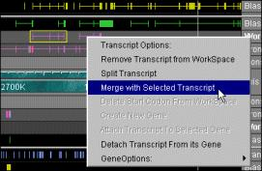

E l e m e n t a n d D e s c r i p t i o n

<property>
This stores a name-value attribute pair
representing some piece of information
attached to a specific instance of a data
object (e.g., a URL).
The properties are displayed in the
Genome Browser in the Property Panel,
and properties containing valid URLs can
be used to hyperlink via a web browser.
<comments>
This stores a single comment text.
An <annotation> element may
contain multiple comments.
<replaced>
This is used only by human-curated

A t t r i b u t e s a n d E l e m e n t s

R e q u i r e d
ATTRIBUTES:
name
value

ATTRIBUTES:
id — the UID of the reference to a
X M L M a r k u p E l e m e n t D e s c r i p t i o n s A . 9

X M L M a r k u p D e s c r i p t i o n s

O p t i o n a l
ATTRIBUTES:
editable — indicates whether the
attribute can be modified by the user,
and is by default “false”. Only human-
curated features (e.g., Gene, Transcript)
may have modifiable properties.
ELEMENTS:
<property> — enables hierarchies of
<property> elements to any depth.
ATTRIBUTES:
author
date

features in workspace (.gbw) files.

Release 5.0
promoted human-curated feature, that is
intended to be modified.
type — indicates the nature of the
modification. Use one of the following
values:
• update
• obsolete
• split
• merge
• unmodified
• change_exon_edge
• add_exon
• delete_exon
• add_transcript
• delete_transcript
• set_start_codon
• remove_start_codon
• changed_properties
• added_comment

G e n o m e B r o w s e r

A . 1 0 D o c u m e n t T y p e D e f i n i t i o n

C e l e r a P r o d u c t U s e r G u i d e

D O C U M E N T T Y P E D E F I N I T I O N

<?xml encoding='UTF-8' ?>

<!ELEMENT game ( (annotation | computational_analysis |
feature_set | seq )* )>
<!ATTLIST game version CDATA #IMPLIED
assembly_version CDATA #IMPLIED
taxon CDATA #IMPLIED >
<!ELEMENT annotation (name , description? ,
annotation_source? , comments* , feature_set+ , replaced* ,
property* )>
<!ATTLIST annotation id CDATA #REQUIRED >
<!ELEMENT computational_analysis (date? , program ,
version? , parameter* , database? , result_set+ )>
<!ATTLIST computational_analysis id CDATA #REQUIRED >
<!ELEMENT feature_set (name , type , annotation_source? ,
author? , creation_date? , version? , replaced* , property*
, feature_span+ )>
<!ATTLIST feature_set id CDATA #REQUIRED >
<!ELEMENT seq (dbxref? , description , residues? ,
seq_alignment* )>
<!ATTLIST seq length CDATA #IMPLIED
id CDATA #REQUIRED
type CDATA #REQUIRED >
<!ELEMENT name (#PCDATA )>

<!ELEMENT description (#PCDATA )>

<!ELEMENT date EMPTY>
<!ATTLIST date day CDATA #REQUIRED
year CDATA #REQUIRED
month CDATA #REQUIRED >
<!ELEMENT progra• (#PCDATA )>

<!ELEMENT version (#PCDATA )>

<!ELEMENT parameter (type , value )>

<!ELEMENT database (name , date? , version? )>
<!ATTLIST database id CDATA #IMPLIED >
<!ELEMENT result_set (description? , type? , score? ,
dbxref* , output* , result_span* , property* )>
<!ATTLIST result_set id CDATA #REQUIRED >
<!ELEMENT type (#PCDATA )>

<!ELEMENT author (#PCDATA )>

<!ELEMENT creation_date (#PCDATA )>

<!ELEMENT feature_span (type , annotation_source? ,
seq_relationship , property* , replaced* , evidence* )>
<!ATTLIST feature_span id CDATA #REQUIRED >
<!ELEMENT dbxref (xref_db , db_xref_id , version? )>

June 2007

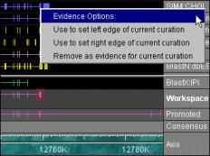

<!ELEMENT value (#PCDATA )>

<!ELEMENT score (#PCDATA )>
D o c u m e n t T y p e D e f i n i t i o n A . 1 1

<!ELEMENT output (type , value )>

<!ELEMENT result_span (span_type? , score? , output* ,
value? , seq_relationship* , property* )>
<!ATTLIST result_span id CDATA #REQUIRED >
<!ELEMENT seq_relationship (span , alignment? )>
<!ATTLIST seq_relationship id CDATA #REQUIRED
type (query | sbjct ) #IMPLIED >
<!ELEMENT evidence (#PCDATA )>
<!ATTLIST evidence type (homology | gene_prediction )
#IMPLIED
result CDATA #IMPLIED >
<!ELEMENT xref_db (#PCDATA )>

<!ELEMENT db_xref_id (#PCDATA )>

<!ELEMENT span_type (#PCDATA )>

<!ELEMENT span (start , end )>

<!ELEMENT alignment (#PCDATA )>

<!ELEMENT start (#PCDATA )>

<!ELEMENT end (#PCDATA )>

<!ELEMENT replaced (#PCDATA )>
<!ATTLIST replaced type (unmodified |
modified |
obsolete |
new |
split |
merge |
deep-modified ) #REQUIRED
id CDATA #REQUIRED >
<!ELEMENT property (property* )>

<!ATTLIST property name
CDATA #REQUIRED

value CDATA #REQUIRED
editable (true | false ) #IMPLIED >
<!ELEMENT seq_alignment (#PCDATA )>

<!ATTLIST seq_alignment start
end
CDATA #IMPLIED
CDATA #IMPLIED

entity_start CDATA #IMPLIED
entity_end CDATA #IMPLIED
file_path CDATA #IMPLIED

seq_id
<!ELEMENT residues (#PCDATA )>

<!ELEMENT comments (#PCDATA )>
CDATA #REQUIRED >

Release 5.0
<!ATTLIST comments author CDATA #IMPLIED
date CDATA #IMPLIED >

G e n o m e B r o w s e r

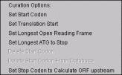
A . 1 2 D o c u m e n t T y p e D e f i n i t i o n

C e l e r a P r o d u c t U s e r G u i d e

<!ELEMENT annotation_source (#PCDATA )>

June 2007

Release 5.0
E x a m p l e F e a t u r e F i l e A . 1 3

E X A M P L E F E A T U R E F I L E

This section provides an example Celera Exchange Format feature (.gbf ) file.
There are additional example files on the Genome Browser download page:
<game version="1.001">
<!-- transport -->
<computational_analysis
id="CLIENT:155000040997423">
<date year="100" day="12" month="8"></date>
<program>
Test_Program
</program>
<version>
Test
</version>
<parameter>
<type>
Sim4
</type>
<value>
/work/chrom/tools/sim4/bin/sim4 none
given none given A=3
</value>
</parameter>
<database>
<name>
CHGI_V3_TA.fasta
</name>
<version>
Test
</version>
</database>
<result_set id="CLIENT:155000040991938">
<property name="link" value="http://
www.celera.com/" editable="true">
</property>
<description>
CRA|335000014763425 /altid=TA|67966 /
dataset=chgi_v3 /def=NOT ASSIGNED /taxon=9606 /org=Homo
sapiens
</description>
<parent>
<type>
blastn_parent
</type>
<value>
155000040915142
</value>
</parent>
<score>
0
</score>
<result_span id="CLIENT:155000040991939">

G e n o m e B r o w s e r
A . 1 4 E x a m p l e F e a t u r e F i l e

C e l e r a P r o d u c t U s e r G u i d e

<span_type>
MSSP
</span_type>
<seq_relationship type="query"
id="CELERA:285347054">
<span>
<start>
147743
</start>
<end>
149268
</end>
</span>
<alignment>

TGACACACACCAGGTTAATATCTTTAATATATACCGAGCTCATACAAATTTATCTGACCC
CAGAAGATAGAGCAAAGGACACTGACAATCCACAAAGGAGGAAATACAATCGCTCCACAT
GAAAGATGTTCAACCGTGCTAGAAGTCAGTGAAATGCCAACTGAAACACGATGCTATTTT
TTCATTATCAAATTAGCAAATATTTAGCCAGATGATAATTCCCAATACGGGCAAGATGGA
CATGTTTATCCTTGCTGGTGGCAGTGTAAGGGGATACAAATATTTCCGGAAACCATTTTG
TCAATATGTAGTAAAAGCCTCAAAGGTTTTCATATTCTTTAGTTGAAGAATCCCACCTCC
TGGAGTCTACCCTAATAACTTGACATTGGGAAACAGCCTGTGCACAAAGATATTCATCAA
TTTATAACTGAAAAGTTAGTAACAGCATTAGTGATTGGCAACTGGCACAATGGTCCATCT
AGTCAATGGGAGAGTACACAGCCACTCCAAAATAAAATATTTAGTAATCATAAGGGGAGA
TGCCCACGATATGCTAAGTGAAAACAGCTGCACAAAACTGTATCATTACAGAAGACAGCA
ACAAAACTATGTTAAAACAAAAAGCAAAGAAACCATAGTTGGGGGGGAAAGCCTGAGAGA
CACCAAAATGTGATGTTTTATTTCCTTCTTTCCTCTACTTGCAAAAATTTATCTAACATG
TGGTTTACATGGGTAATGAGAAGACCTAGTAGGTTTGGTGCTTGTGTATGCAAAGGCATG
AGGCACACGGAAGTGAGGAGCTGGGTTTCCTCCCATCTCTACCGCATCTGCGCTGTGCCA
ACTGCCACCCCACCCAAACTCAGGTCCCCAAGAGACAGAGACACAGGGGCTGTCTGTTCC
ACGTGGAAGGCCCTACACCCCAACCTTCTCCCCTACTCTGGGGAGCTTCTCCTGTTGGCC
CAACAGTCTGCTCTTGCTTCCCTTACCCAGGAGACCCACCTTGTGCCTACCTCTCTAAGT
CCCTAAACCAGTGCTTTCCAAGCAGAGGTGCCATGAGCCTTACAACTGTGGTTGCAGATG
GAGGCGCCTCCATTAGGATCTCTTCCcTCTTCCACCCAGAGCTCTGCCCCCAGTCAGTGG
CTGCAGCATGGGCCCTTTTGTCCAATCCCAGGGCTTGTTCCCTAAGTCAACCTCAGCACA
TGCCCAGCTCAGCCATGTCCCTTCACTCCCCTACAGGCTGGAACTGcCAgGGTGGTGCCC
ACCCAAGGCGGCTGTCTGCCATGACAACAGGAGCGTGTGCGTCAGGCTGGTCCTGCCGCA
CTTTCTGGGTTTTGTTTTCCACTCCTCCTCATTGCTCATCACATACTTACCTGGGGACAA
TGAAATAGGTCTTTGCTATTCCCTAGAAGTCACCAAAATGCTTTAGGACATTAAGTTAGT
CCCAGGGTCACACTATACTAGGCCAGGGAGTCACCCCTTCACTAACTCCCATCTCCAGTG
ATACCCTGGTATGCACTGAAGCCTA
</alignment>
</seq_relationship>
<seq_relationship type="sbjct"
id="CLIENT:335000014763425">
<span>
<start>
9
</start>
<end>
1534
</end>
</span>
<alignment>

TGACACACACCAGGTTAATATCTTTAATATATACCGAGCTCATACAAATTTATCTGACCC

June 2007

Release 5.0
E x a m p l e F e a t u r e F i l e A . 1 5

CAGAAGATAGAGCAAAGGACACTGACAATCCACAAAGGAGGAAATACAATCGCTCCACAT
GAAAGATGTTCAACCGTGCTAGAAGTCAGTGAAATGCCAACTGAAACACGATGCTATTTT
TTCATTATCAAATTAGCAAATATTTAGCCAGATGATAATTCCCAATACGGGCAAGATGGA
CATGTTTATCCTTGCTGGTGGCAGTGTAAGGGGATACAAATATTTCCGGAAACCATTTTG
TCAATATGTAGTAAAAGCCTCAAAGGTTTTCATATTCTTTAGTTGAAGAATCCCACCTCC
TGGAGTCTACCCTAATAACTTGACATTGGGAAACAGCCTGTGCACAAAGATATTCATCAA
TTTATAACTGAAAAGTTAGTAACAGCATTAGTGATTGGCAACTGGCACAATGGTCCATCT
AGTCAATGGGAGAGTACACAGCCACTCCAAAATAAAATATTTAGTAATCATAAGGGGAGA
TGCCCACGATATGCTAAGTGAAAACAGCTGCACAAAACTGTATCATTACAGAAGACAGCA
ACAAAACTATGTTAAAACAAAAAGCAAAGAAACCATAGTTGGGGGGGAAAGCCTGAGAGA
CACCAAAATGTGATGTTTTATTTCCTTCTTTCCTCTACTTGCAAAAATTTATCTAACATG
TGGTTTACATGGGTAATGAGAAGACCTAGTAGGTTTGGTGCTTGTGTATGCAAAGGCATG
AGGCACACGGAAGTGAGGAGCTGGGTTTCCTCCCATCTCTACCGCATCTGCGCTGTGCCA
ACTGCCACCCCACCCAAACTCAGGTCCCCAAGAGACAGAGACACAGGGGCTGTCTGTTCC
ACGTGGAAGGCCCTACACCCCAACCTTCTCCCCTACTCTGGGGAGCTTCTCCTGTTGGCC
CAACAGTCTGCTCTTGCTTCCCTTACCCAGGAGACCCACCTTGTGCCTACCTCTCTAAGT
CCCTAAACCAGTGCTTTCCAAGCAGAGGTGCCATGAGCCTTACAACTGTGGTTGCAGATG
GAGGCGCCTCCATTAGGATCTCTTCCCTCTTCCACCCAGAGCTCTGCCCCCAGTCAGTGG
CTGCAGCATGGGCCCTTTTGTCCAATCCCAGGGCTTGTTCCCTAAGTCAACCTCAGCACA
TGCCCAGCTCAGCCATGTCCCTTCACTCCCCTACAGGCTGGAACTGCCAGGGTGGTGCCC
ACCCAAGGCGGCTGTCTGCCATGACAACAGGAGCGTGTGCGTCAGGCTGGTCCTGCCGCA
CTTTCTGGGTTTTGTTTTCCACTCCTCCTCATTGCTCATCACATACTTACCTGGGGACAA
TGAAATAGGTCTTTGCTATTCCCTAGAAGTCACCAAAATGCTTTAGGACATTAAGTTAGT
CCCAGGGTCACACTATACTAGGCCAGGGAGTCACCCCTTCACTAACTCCCATCTCCAGTG
ATACCCTGGTATGCACTGAAGCCTA
</alignment>
</seq_relationship>
</result_span>
</result_set>
<result_set id="CLIENT:155000040991940">
<property name="link" value="http://
www.celera.com/" editable="true">
</property>
<description>
CRA|335000014716891 /altid=TA|21432 /
dataset=chgi_v3 /def=NOT ASSIGNED /taxon=9606 /org=Homo
sapiens
</description>
<parent>
<type>
blastn_parent
</type>
<value>
155000040915145
</value>
</parent>
<score>
0
</score>
<result_span id="CLIENT:155000040991941">
<span_type>
MSSP
</span_type>
<seq_relationship type="query"
id="CELERA:285347054">
<span>

G e n o m e B r o w s e r

A . 1 6 E x a m p l e F e a t u r e F i l e

</span>

<start>
142075
</start>
<end>
141452
</end>

C e l e r a P r o d u c t U s e r G u i d e
<alignment>

AATCTCAGTATTTTTATAAATTGTAAAGTTATTTTCCGTATCTCTTGGACATAATGGTAT
TTTTGTGACTGTGATATTTTGTCATTTTATTTTCTTCTCTCACAGCGTCAGTGGAGGTCA
GCAGGAGGTCCcTGCAGgCTTGCACTGCCCTGCTGGTTATCACTGCTGGTGACTCATGCA
GCCAGCCTGCTGATGCCCTGAGCTGGCCTGTTCAGCTTGGTGTCCAGAGGGCTCTGCTGT
GGGCCCGGGGGGAGGGAACCACGCACCTTCCTCTGTGGAACTGTGGCTGCTTTCCCCCTT
CCTCATCCTGTTCTTCATCTGCCCCAGCCTGTGAAGGGAACTCCTCGTGCCTGGGCAGGC
TTATGGGTGCCGGGAGGCTGGGGAGCTGGcTCACGCTCTGAGTGGGCTTCCCTGGCCAGT
CCTGTGCCCCATCACCAGCCTCGCTCTGTGGTCTTTGCCCTGGTGCACTGGGCGGTACCA
CTTCACCACGTCTTTCAGTGGTCCTTCCGTGTGTTCCAAAGCTTCTGGATTTCAAATGTT
GCTGTGCTCACAGAAACCTGATGGTTTACACACCAAGCAATACCACCACCACCACCGCCA
CCACCACAACAACAAAAAAAAAA
</alignment>
</seq_relationship>
<seq_relationship type="sbjct"
id="CLIENT:335000014716891">
<span>
<start>
623
</start>
<end>
0
</end>
</span>
<alignment>

AATCTCAGTATTTTTATAAATTGTAAAGTTATTTTCCGTATCTCTTGGACATAATGGTAT
TTTTGTGACTGTGATATTTTGTCATTTTATTTTCTTCTCTCACAGCGTCAGTGGAGGTCA
GCAGGAGGTCCCTGCAGGCTTGCACTGCCCTGCTGGTTATCACTGCTGGTGACTCATGCA
GCCAGCCTGCTGATGCCCTGAGCTGGCCTGTTCAGCTTGGTGTCCAGAGGGCTCTGCTGT
GGGCCCGGGGGGAGGGAACCACGCACCTTCCTCTGTGGAACTGTGGCTGCTTTCCCCCTT
CCTCATCCTGTTCTTCATCTGCCCCAGCCTGTGAAGGGAACTCCTCGTGCCTGGGCAGGC
TTATGGGTGCCGGGAGGCTGGGGAGCTGGCTCACGCTCTGAGTGGGCTTCCCTGGCCAGT
CCTGTGCCCCATCACCAGCCTCGCTCTGTGGTCTTTGCCCTGGTGCACTGGGCGGTACCA
CTTCACCACGTCTTTCAGTGGTCCTTCCGTGTGTTCCAAAGCTTCTGGATTTCAAATGTT
GCTGTGCTCACAGAAACCTGATGGTTTACACACCAAGCAATACCACCACCACCACCGCCA
CCACCACAACAACAAAATAATGA
</alignment>
</seq_relationship>
</result_span>
</result_set>
<result_set id="CLIENT:155000040991942">
<property name="link" value="http://
www.celera.com/" editable="true">
</property>
<description>
CRA|335000014938129 /altid=TA|242670 /
dataset=chgi_v3 /def=NOT ASSIGNED /taxon=9606 /org=Homo

June 2007

sapiens

</description>
<parent>
<type>
E x a m p l e F e a t u r e F i l e A . 1 7

Release 5.0
blastn_parent
</type>
<value>
155000040915147
</value>
</parent>
<score>
0
</score>
<result_span id="CLIENT:155000040991943">
<span_type>
MSSP
</span_type>
<seq_relationship type="query"
id="CELERA:285347054">
<span>
<start>
50110
</start>
<end>
49607
</end>
</span>
<alignment>

CAGCACAGAGGGTGAAGAAATGACCCCCCCTCCACCCTTCCCCACTCAGGCTGCTGCCCA
GGCTCACAGCTCCACGATCAGGGTTGGGAGCTCCACGGTCAAGGTTGAGGGCCTCTGCAA
TCCAGGTGGAACAACCAAAAATCGCTTGACGGCCCTTTGTCAATGGACTCATTCTACACG
TTGGAAATTAACAAAGAAGCCGATGTTAGCATTGCGTGGGGGTCATTCCCTGAGGAACCT
CAGAGTGTGATTGAACCCACAGACTAGGAAATGTGGTTCCAGCTCCTGAAAACCTGTGCT
TAGGAGAATCCACCCAGCAGCGACTGCCGCACAGGCGTTTTCACCTGCTTCTTGTCTCGC
AGCTGCTCTGCGTTGCCTTGGAAGCCCCTGTCCCCCGATCTGATGCTGCCTTGCTCCTTG
GGCCCCTGGCTTAATGTACAAGCAGCTCTCAAACTCTGTGCATGCATCCTAAATGCGGTG
TGCGTGCAGCCTGGGCTGGGGCTTATAT
</alignment>
</seq_relationship>
<seq_relationship type="sbjct"
id="CLIENT:335000014938129">
<span>
<start>
508
</start>
<end>
0
</end>
</span>
<alignment>

CAGCACAGAGGGTGAAGAAATGACCCCCCCTCCACCCTTCCCCACTCAGGCTGCTGCCCA
GGCTCACAGCTCCACGATCAGGGTTGGGAGCTCCACGGTCAAGGTTGAGGGCCTCTGCAA
TCCAGGTGGAACAACCAAAAATCGCTTGACGGCCCTTTGTCAATGGACTCATTCTACACG
TTGGAAATTAACAAAGAAGCCGATGTTAGCATTGCGTGGGGGTCATTCCCTGAGGAACCT

G e n o m e B r o w s e r

A . 1 8 E x a m p l e F e a t u r e F i l e

C e l e r a P r o d u c t U s e r G u i d e

CAGAGTGTGATTGAACCCACAGACTAGGAAATGTGGTTCCAGCTCCTGAAAACCTGTGCT
TAGGAGAATCCACCCAGCAGCGACTGCCGCACAGGCGTTTTCACCTGCTTCTTGTCTCGC
AGCTGCTCTGCGTTGCCTTGGAAGCCCCTGTCCCCCGATCT ATGCTGCCTT
CTCCTTGG CCCCTG CTTAAT
TACAAGCAGCTCTCAAACTCTGTGCATGCATCCTAAATGCGGTGTGCGTGCAGCCTGGGC
TGGGGCTTATAT
</alignment>
</seq_relationship>
</result_span>
</result_set>
</computational_analysis>
</game>

June 2007

A p p e n d i x B . Tro u b l e s h o o t i n g

Troubleshooting
Memory Problems
Data Access Problems
Exception Errors

Release 5.0

B.2
B.2
B.2
B.3

G e n o m e B r o w s e r
B . 2 T r o u b l e s h o o t i n g

C e l e r a P r o d u c t U s e r G u i d e

T R O U B L E S H O O T I N G

This appendix contains answers to some common troubleshooting
questions.

If after reviewing this appendix, you still can’t solve your issue, you should
contact your Celera Technical Support Specialist.

M e m o r y Pr o b l e m s

In general, you can solve many issues by ensuring that you have allocated
adequate memory for the Genome Browser. For instructions, please refer to
"Troubleshooting Performance Issues" on page 1-5.

D a t a Ac c e s s Pro b l e m s

If you are not properly logged in, you will receive the following message
when you attempt to open an information service:

You will need to restart the Genome Browser and re-enter your login
information. For instructions, please refer to "Setting Preferences" on page
2-6.

June 2007

E xc e p t i o n E r ro r s
T r o u b l e s h o o t i n g B . 3

NOTE: If you prefer to be contacted
by telephone, you should include your
name and telephone number in the
description box.

Release 5.0

If the Genome Browser experiences an exception error, an error dialog box
will appear that allows you to send a message to the Celera support staff. If
this happens, you should:

1 Click Send email to Celera Support.
2 Type your e-mail address in the box provided, and click OK.
3 Type a description of what you were doing when the exception
occurred in the box provided, and click OK.
A message appears indicating that your problem was sent to the Celera
Support staff.

4 Click OK.
A Celera Support representative will contact you.

G e n o m e B r o w s e r

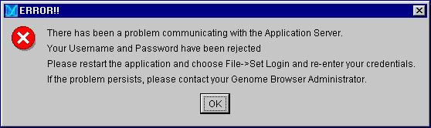
B . 4 T r o u b l e s h o o t i n g

C e l e r a P r o d u c t U s e r G u i d e

June 2007

