CELESTIAL CODEX REPORT

Abstract

The following document contains a detailed report of the works carried out by Celestial Codex members. The aim was to develop solutions to the given challenges using the C language. The group successfully achieved this by leveraging various control structures and programming techniques.

The group members are as follows:

* Benedict Xavier
* Gabriel Opiyo
* Debra Gitonga
* Victor Gachogu
* Brian Ireri
* Owen Ouna
* Tracy
* Prince Michael
* Felix Mwangi
* Bongo Sydney

# Introduction

## Objective

This report is objectively written to promote team work ensuring each solution is well-reasoned thus avoiding any loopholes and that the results for the test data are accurate and properly documented to enable even new users get a gist of the programs before working on them

## Scope

It covers the expectations for all four questions given in the assignment as well as their solutions.

# Question One

## Problem Statement

Write a C program that takes an integer value and returns the number with its digits reversed. For example, given the number 7631, the program should return 1367.

## Problem Analysis

The C program is for a computer program that reads values as inputted by the user, stores this value, reverses the order of digits in which the value appears, stores that as the new value then outputs the new value.

Input: 7631

Process: To reverse the digits of the number

Output: 1367

## Testing and Results

The test data is as follows:

* Number: 7631

The results of the program are as follows:

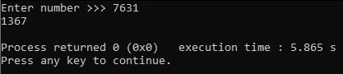

Discussion: using loops, each digit of the initial number is extracted then added to a new number starting from zero; the last digit is divided by 10 to remove it from the original number. The final result of the loop is the reversed number.

# Question Two

## Problem Statement

Write a C program that plays "Stone Knife Paper" game, where Stone blunts Knife, Knife cuts Paper, and Paper wraps Stone. You play against the computer. The program inputs the computer choice (randomly generated. 0 for S (Stone), 1 for K (Knife) otherwise P (Paper)) and your choice, which is S, K or P. You win if either your input Stone blunts computers’ input Knife or your input Knife cuts computers’ input Paper or your input Paper wraps computers’ input Stone otherwise the computer wins. If your input equals computer, no one wins. Your program displays an appropriate message.

## Problem Analysis

The program is for a computer game simulating the childhood game “Rock-Paper-Scissors”. The program generates a choice between the three, reads your choice then determines the winner according to the stated rules. Nobody wins if the choices are similar. An appropriate message is then displayed.

Input: S, K, P

Process: Generating random choice, compare the choices of the user with that randomly generated, determine if there is a winner, display an appropriate message to show the same.

Output: Appropriate message to show winner and loser or a draw.

## Testing and Results

The test data is as follows

Case One:

* Choice:S

The result of Case One is as follows

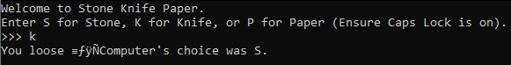

Case Two:

* Choice:P

The result of Case Two is as follows

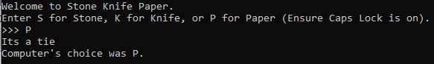

Case Three:

* Choice:P

The result of Case Three is as follows

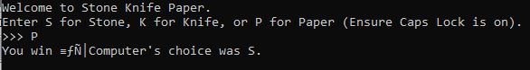

# Question Three

## Problem Statement

Write a program that computes the value of ex by using the formula ex=1+x/1! +x2/2! +x3/3! +--------

## Problem Analysis

This is a C program that computes the value of ex using the series expansion formula.

Input: value of x, number of terms

Process: using the formula to compute the value of ex given the formula.

Output: result of operation

## Testing and Results

The test results are follows

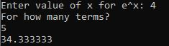

# Question Four

## Problem Statement

Write a program that prompts the user for two integers and one of the letter codes a, s, m or d. The interpretation is given by the following table:

**Letter** **Meaning**

* **a add**
* **s subtracts**
* **m multiply**
* **d divide**

The function main issues the prompt and stores the user's input in the variables num1, num2 and operator. Then main checks the letter code. If the letter code is a, main invokes the function add with numbers as the arguments num1 and similarly for s, m, and d. Each of the functions add, subtract, multiply and divide invokes the function printf_result, which prints the result of the arithmetic operation.

## Problem Analysis

The program is for a simple computer calculator that reads two integer numbers and an operator code character, carries out the operation specified by the operator code character on the two numbers then gives the arithmetic result.

Input: two integers, an operator code.

Process: store the numbers inputted, carry out the operations specified by the operator on the number.

Output: output of the operator and the given numbers

## Testing and Results

The test data is as follows

Case One

* Num1:34
* Num2:56

The result of Case One is as follows

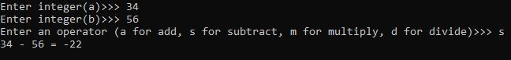

Case Two

* Num1:34
* Num2:56

The result of Case Two is as follows

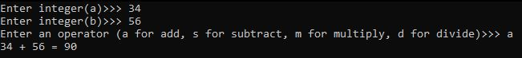

Case Three

* Num1:34
* Num2:56

The result of Case Three is as follows

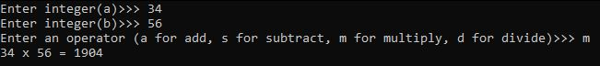

Case Four

* Num1:100
* Num2:10

The result of Case Four is as follows

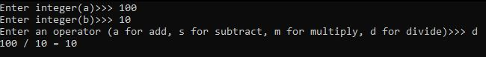

# Question Five

## Problem Statement

A company distributes 5 different items around Nairobi through its 10 salesmen in Nairobi. Using arrays write a C program to input a salesman name and the corresponding sales made by each of the salesman for each of the item. The program should then output each of the salesman’s name, sales, total sales as well as grand total using the format shown below.

Name Item1 Item2 Item3 Item3 Item4 Item5 TotalSales ___________________________________________________

Brian: 20 50 25 10 0 15 120

Joan: 45 55 10 25 5 30 170

Grand Total xx

## Problem Analysis

The program is for a computer application that reads the name of a sales man, as well as each of the sales for the five items, computes the total sales then displays them in the format shown including the grand total of sales

Input: name of sales man, number of sales per item.

Process: compute total sales per salesman, computes the grand total sales for the company.

Output: total sales, grand total sales.

## Testing and Results

The test data and results are as follows

